Companions of St. Luke
Spring 2005 Convocation at Conception Abbey
Part 3 of 5

NOTE: Disc is dated 28 May 2003 but the people present and other documents show this is Spring 2005.

~Edited by Br. Steven Olderr, 19 May 2022 with the assistance of Br. Thomas Ferrell; if you find any errors or omissions, please notify Br. Steven at olderr@ameritech.net

People are identified from left to right.

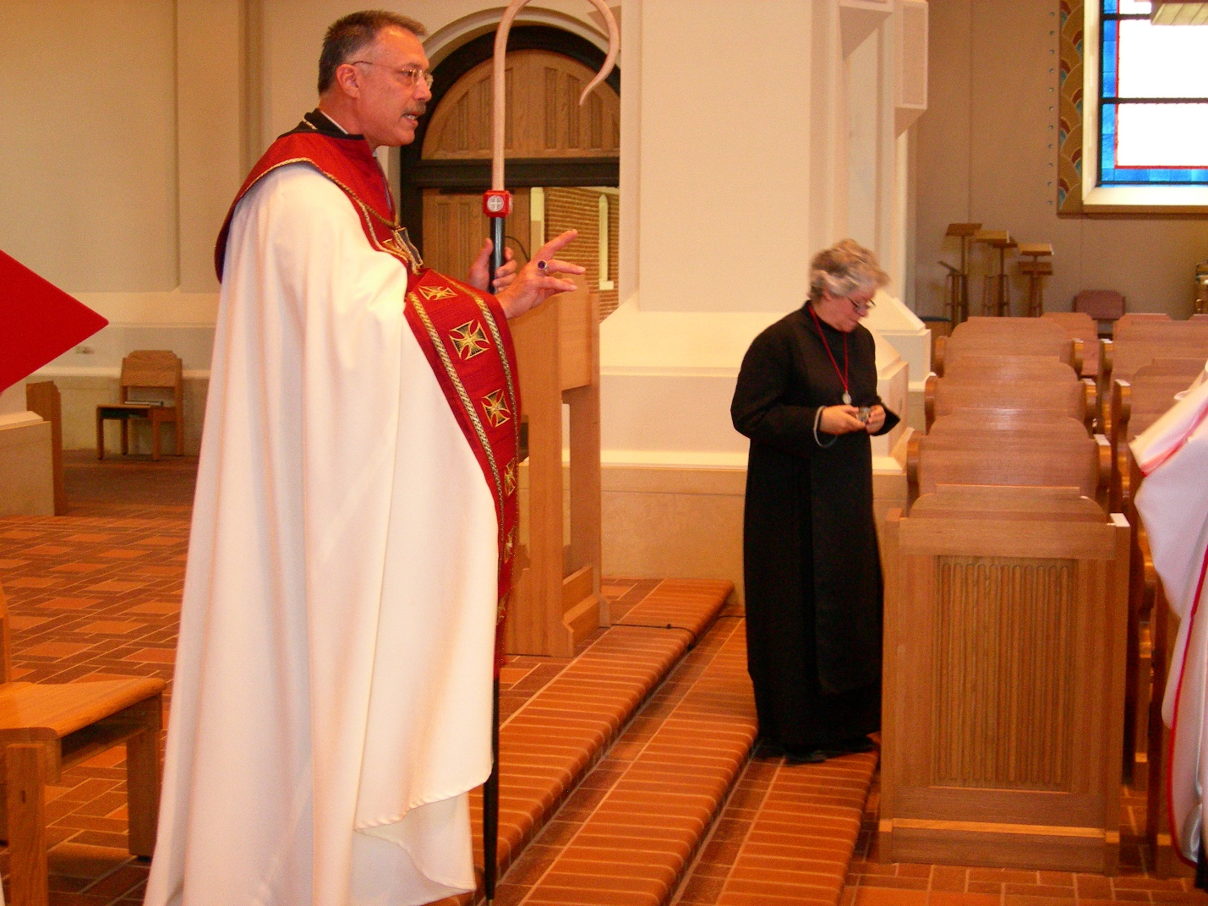
DSCN0278 Abbot Michael John Austin; Sr. Johanna Kirkpatrick
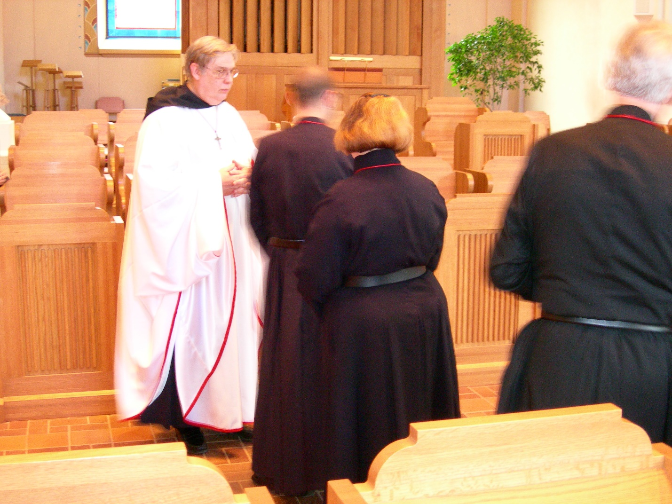
DSCN0279 Br. Chad Anselm Gerns; Br. Eckhart Sowers; Sr. Hillary Grace Lundgren; Br. Luke Doucettte
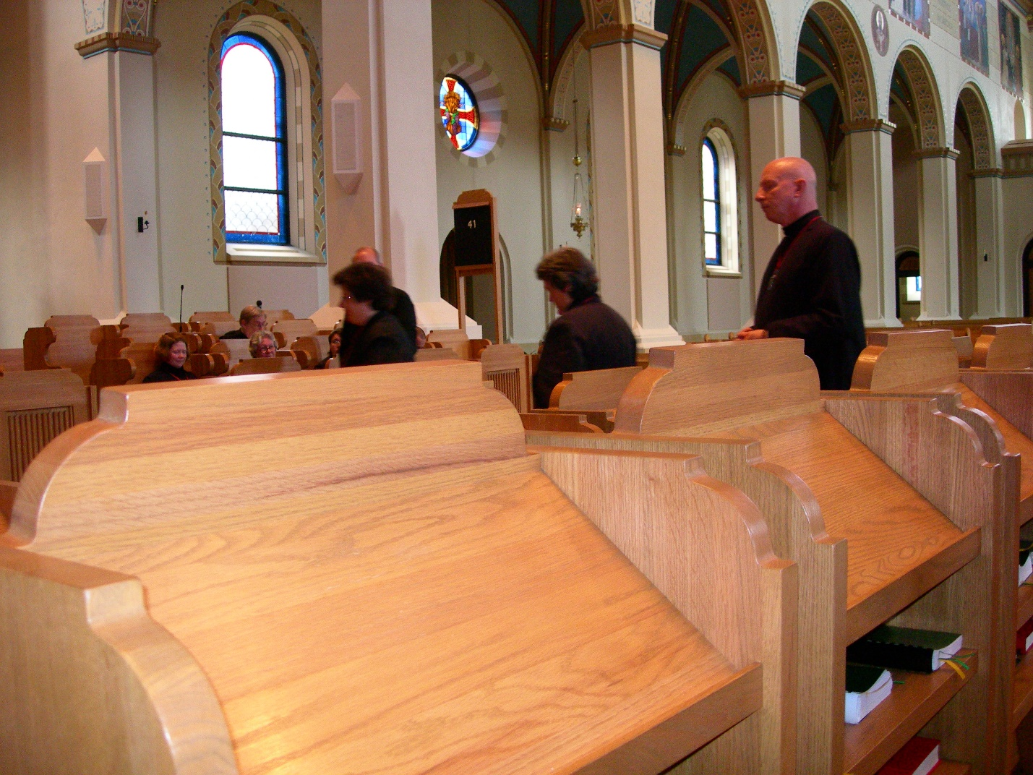
DSCN0280 Sr. Cecelia Lamoy; Sr. Vincent Marie Rittenhouse; Br. David Vincent Cotton
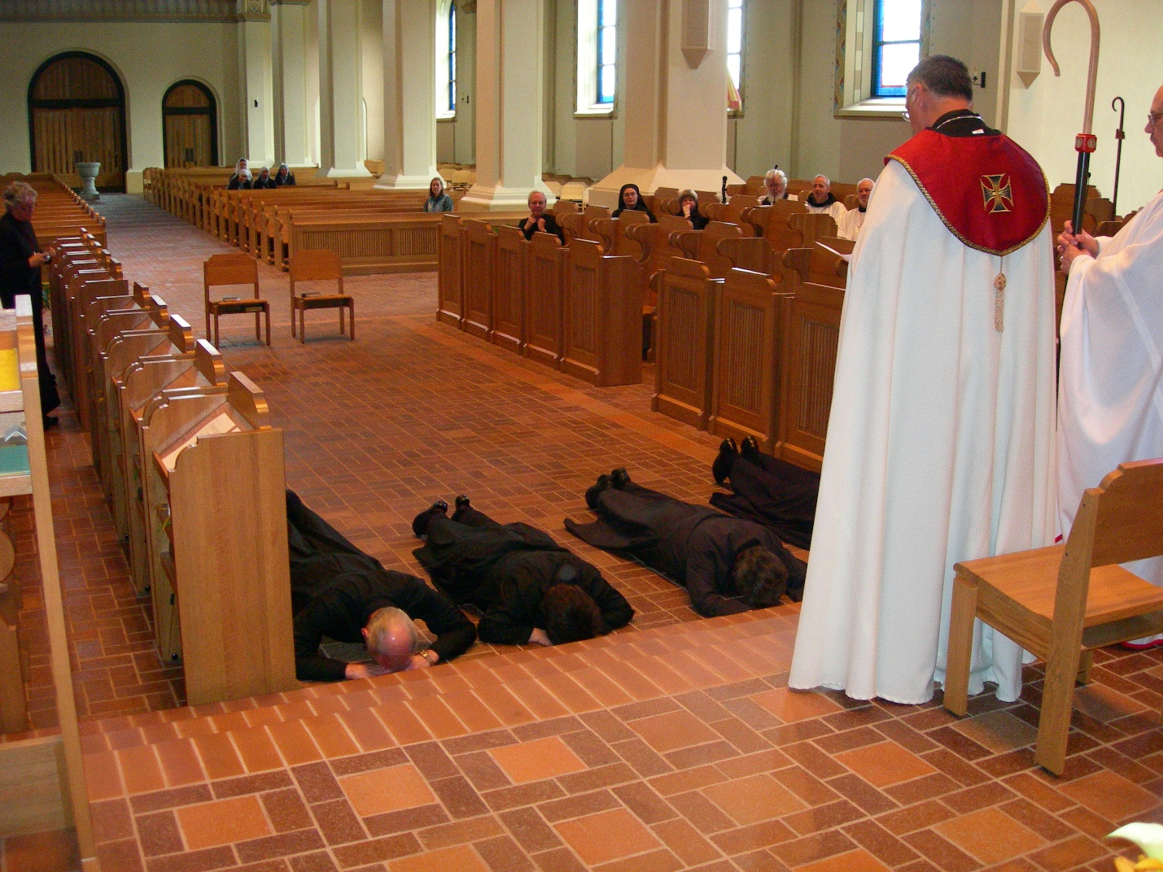
DSCN0281 Br. Daniel Joseph Schroeder; Sr. Cecilia Lamoy; Sr. Vincent Marie Rittenhouse; Br. David Vincent Cotton; Abbot Michael John Austin; Br. Raymond Owens
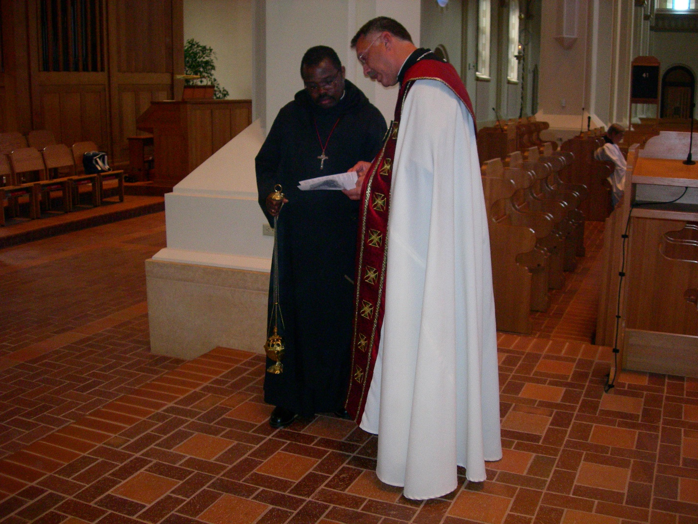
DSCN0282 Br. Thomas Ferrell; Abbot Michael John Austin
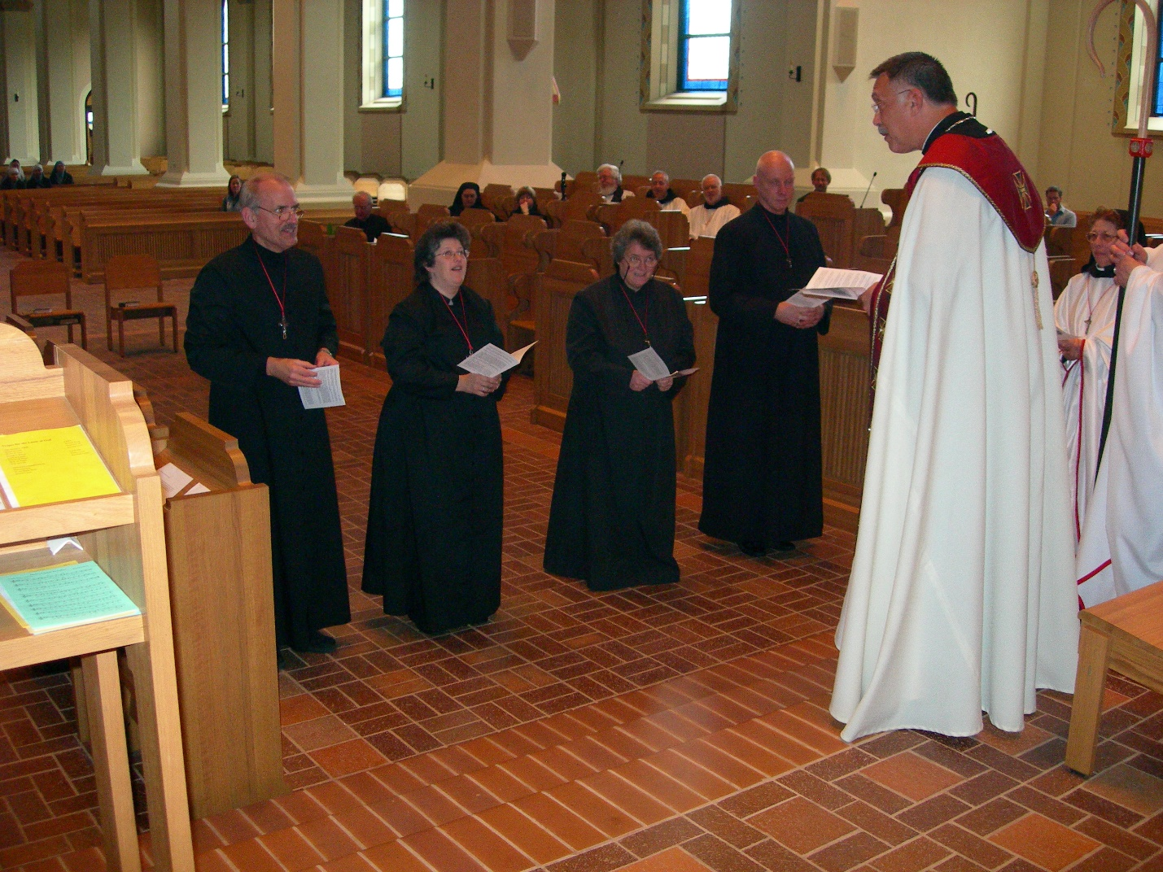
DSCN0283 Br. Daniel Joseph Schroeder; Sr. Cecilia Lamoy; Sr. Vincent Marie Rittenhouse; Br. David Vincent Cotton; Abbot Michael John Austin; Sr. Monica Ruth Mullen
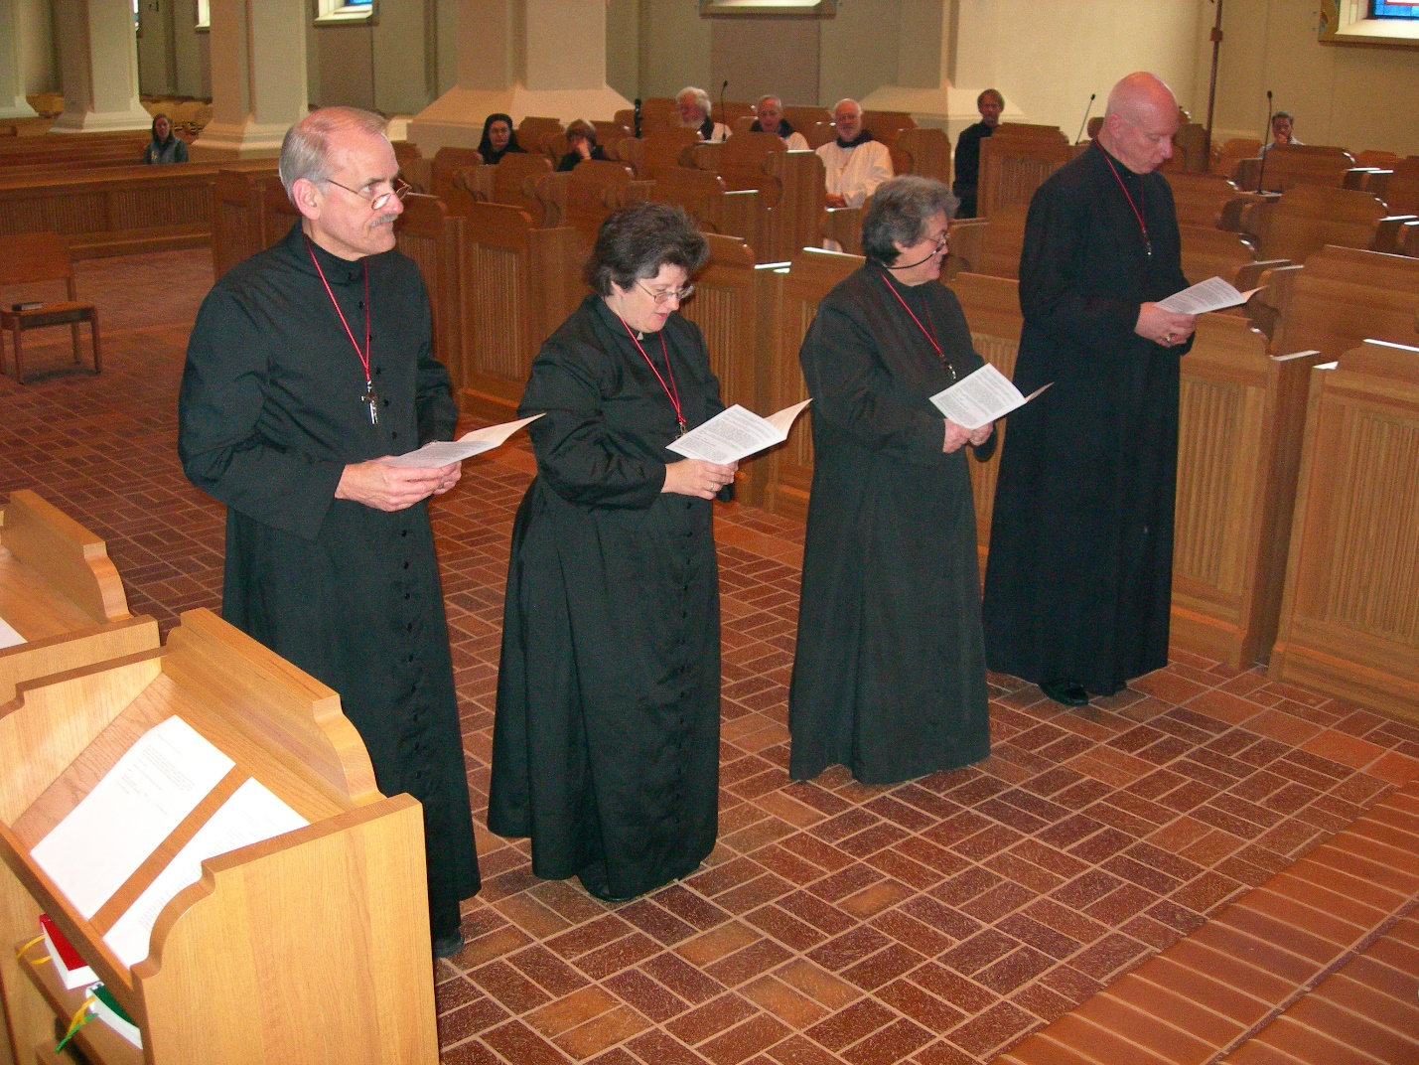
DSCN0284 Br. Daniel Joseph Schroeder; Sr. Cecilia Lamoy; Sr. Vincent Marie Rittenhouse; Br. David Vincent Cotton

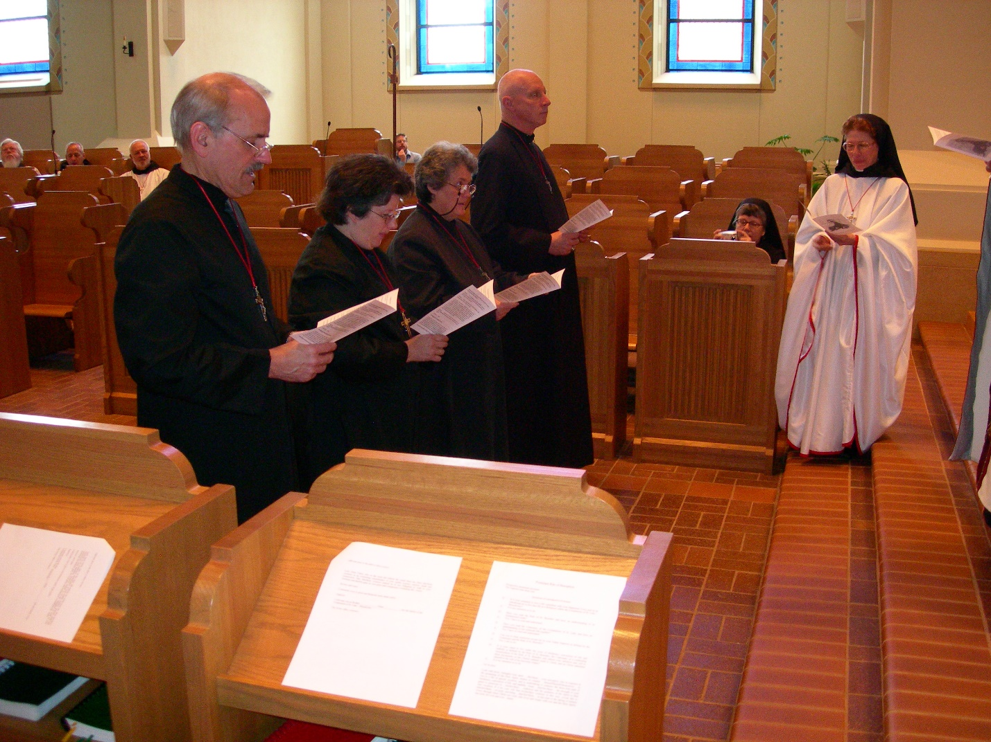
DSCN0285 Br. Daniel Joseph Schroeder; Sr. Cecilia Lamoy; Sr. Vincent Marie Rittenhouse; Br. David Vincent Cotton; Sr. Anna Grace Madden; Sr. Monica Ruth Mullen

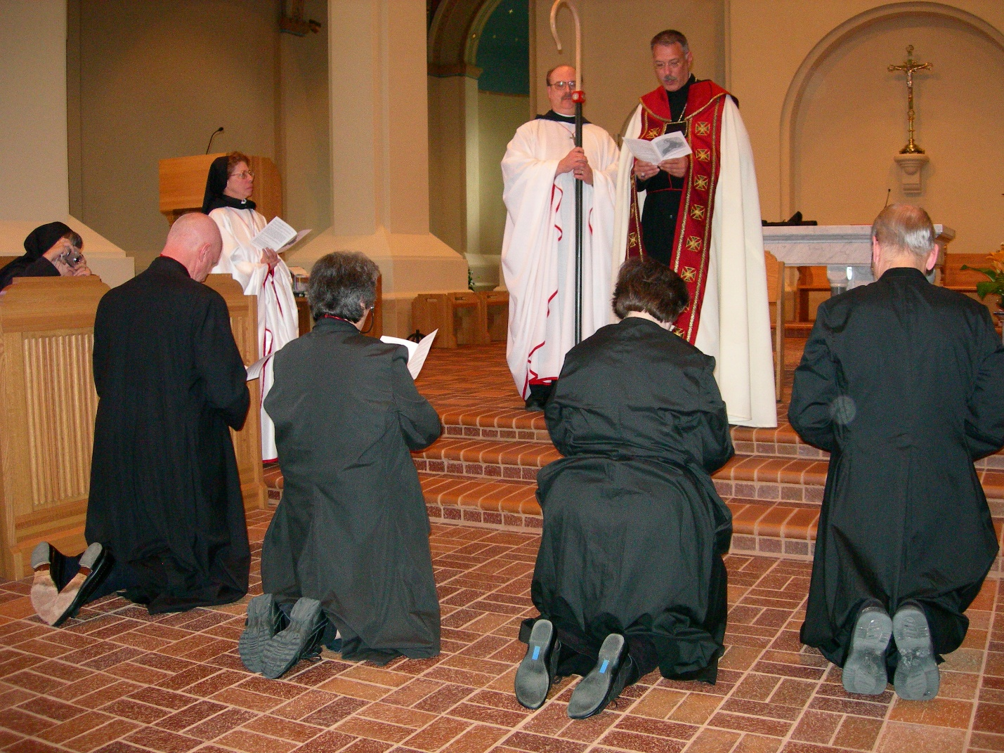
DSCN0286 Sr. Anna Grace Madden; Br. David Vincent Cotton; Sr. Vincent Marie Rittenhouse; Br. Raymond Owens; Sr. Cecelia Lamoy; Abbot Michael John Austin; Br. Daniel Joseph Schroeder
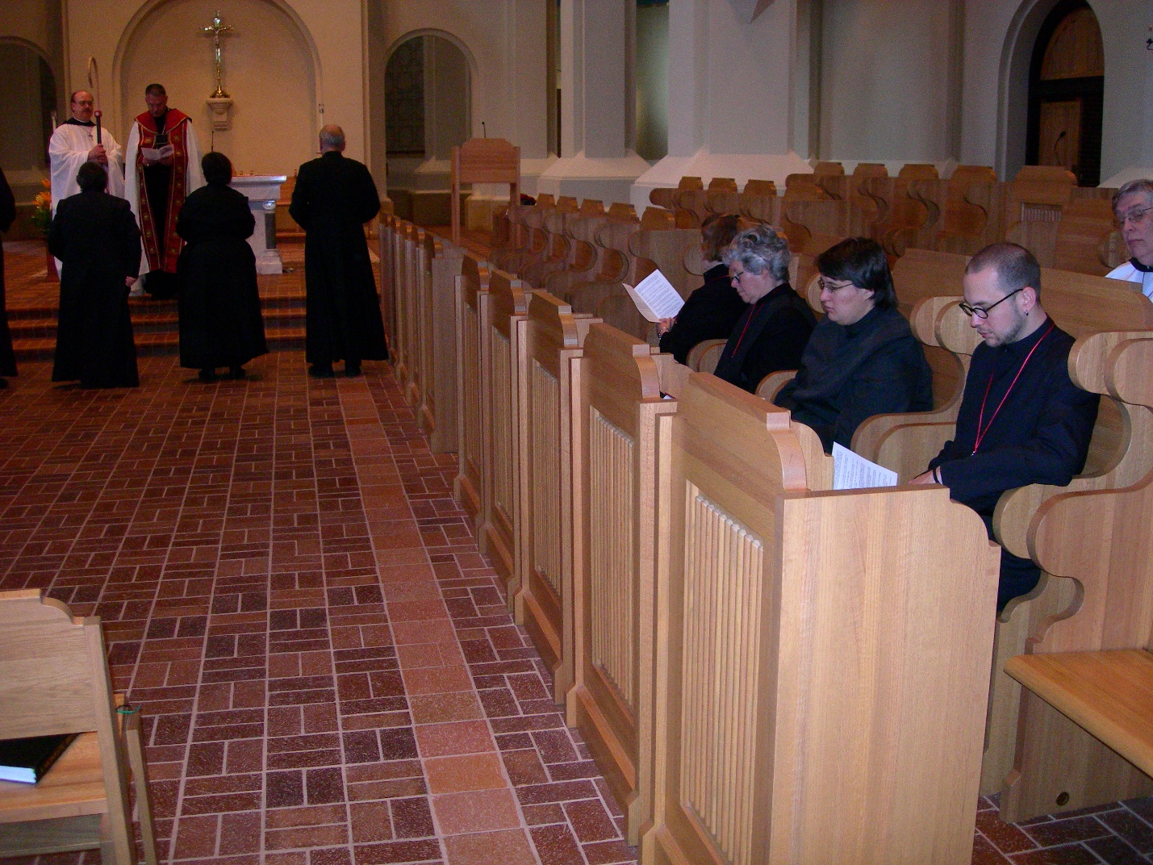
DSCN0287 Br. Raymond Owens; Sr. Vincent Marie Rittenhouse; Abbot Michael John Austin; Sr. Cecelia Lamoy; Br. Daniel Joseph Schroeder; Sr. Hillary Grace Lundgren; Sr. Vincent Marie Rittenhouse; Sr. Pauline Tysol; Br. Eckhart Sowers; Br. Chad Anselm Gerns

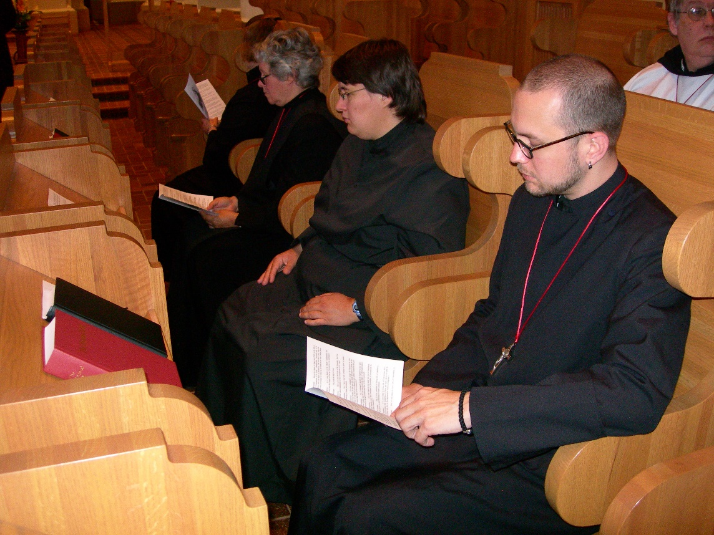
DSCN0288 Sr. Hillary Grace Lundgren; Sr. Vincent Marie Rittenhouse; Sr. Pauline Tysol; Br. Eckhart Sowers; Br. Chad Anselm Gerns

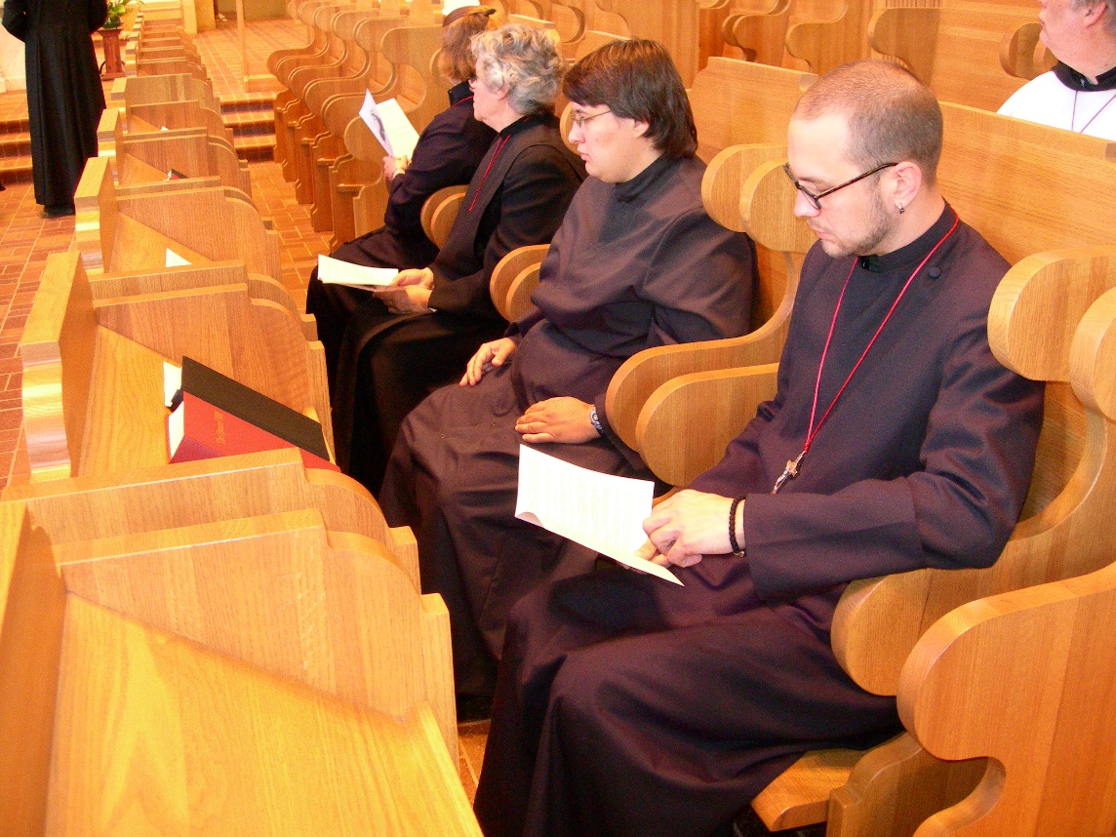
DSCN0289 Sr. Hillary Grace Lundgren; Sr. Vincent Marie Rittenhouse; Sr. Pauline Tysol; Br. Eckhart Sowers; Br. Chad Anselm Gerns
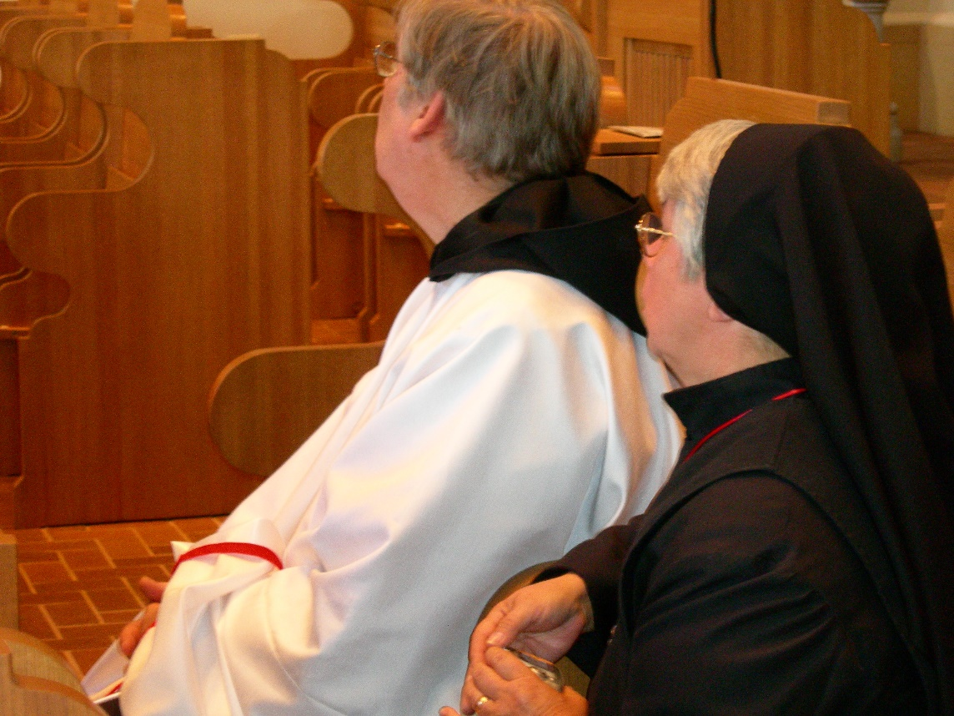
DSCN0290 Br. Chad Anselm Gerns; Sr. Clare Benedicta Meyers

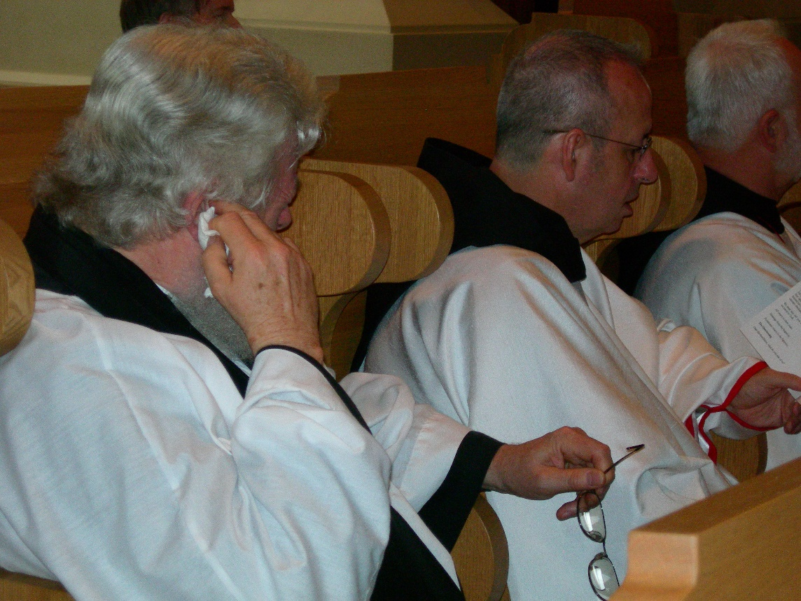
DSCN0291 Fr. Wayne Kamm; Br. Gabriel Hale; Br. Christopher John Baumann
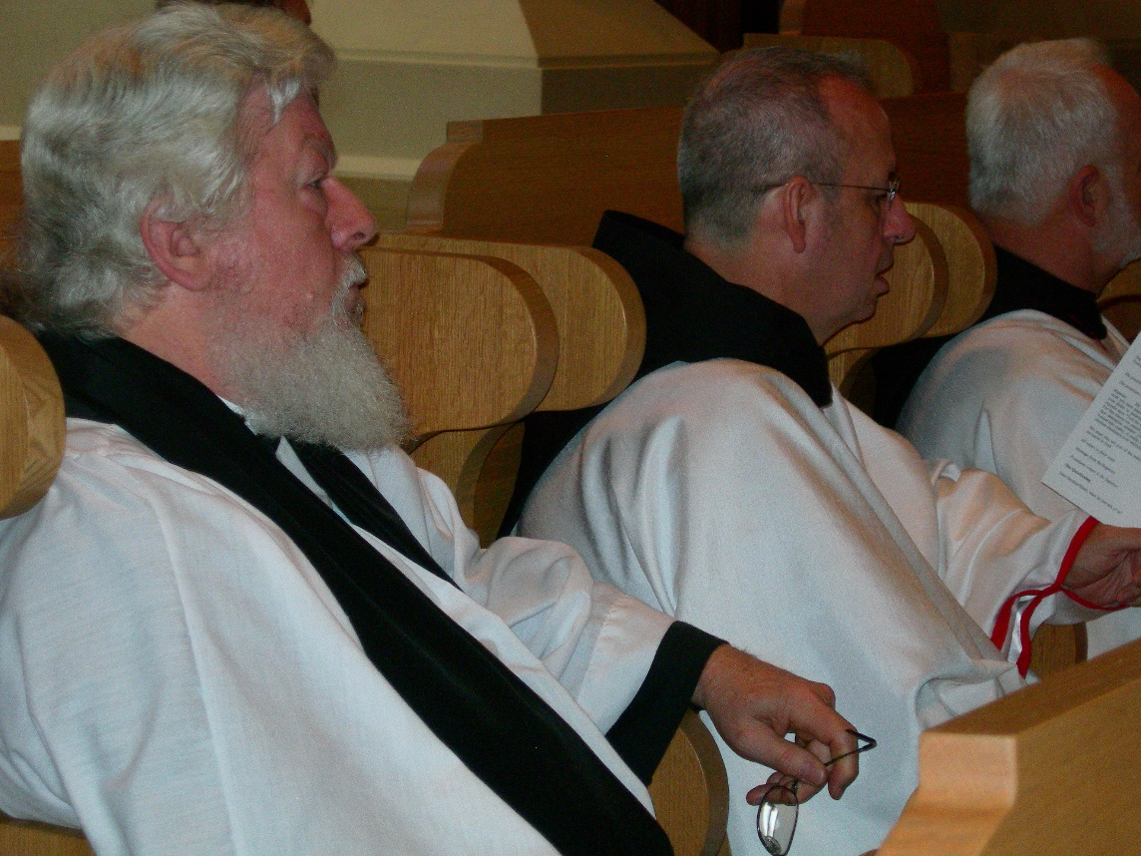
DSCN0292 Fr. Wayne Kamm; Br. Gabriel Hale; Br. Christopher John Baumann

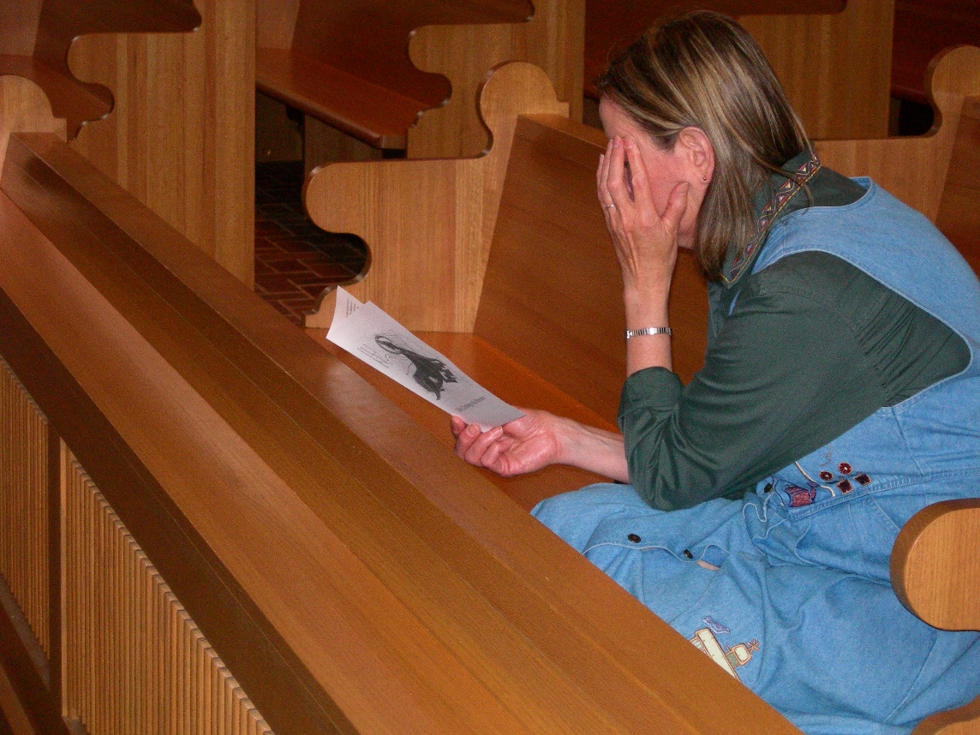
DSCN0293 Mary Schroeder
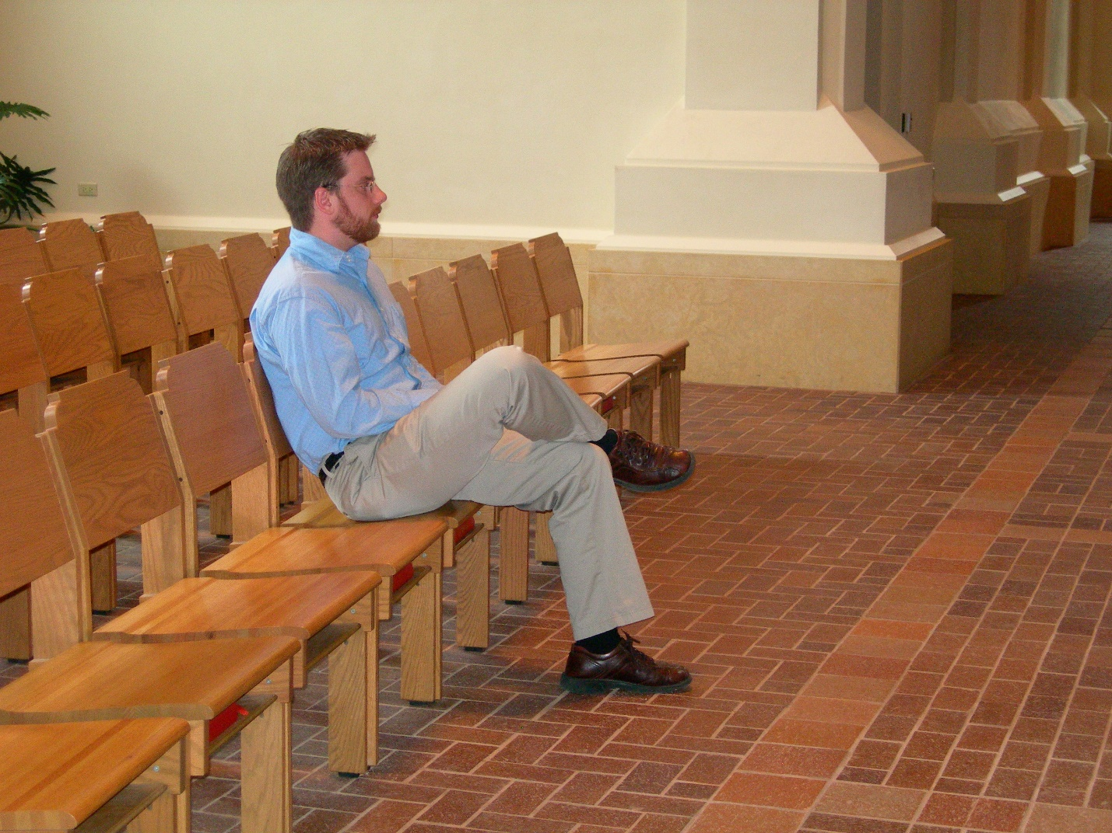
DSCN0295 Friend of Br. Eckhart Sowers
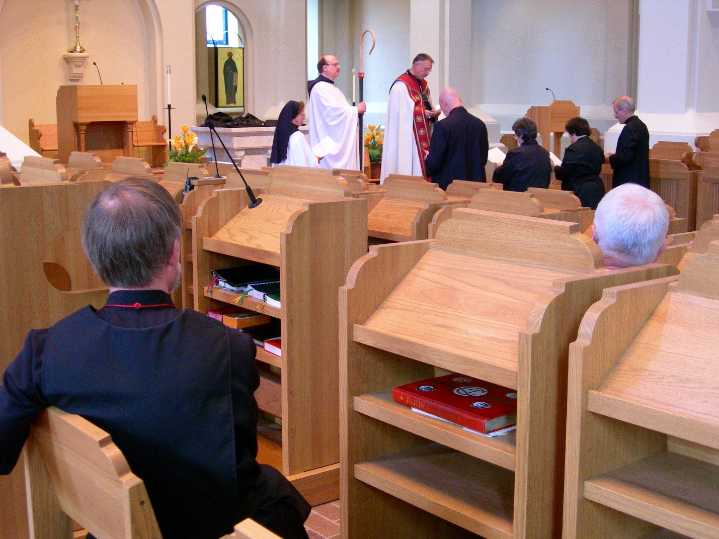
DSCN0296 Br. Lawrence Mullen; Sr. Monica Ruth Mullen; Br. Raymond Owens; Abbot Michael John Austin; Br. David Vincent Cotton; Sr. Vincent Marie Ritenhouse; Sr. Cecelia Lamoy; Br. Christopher John Baumann; Br. Daniel Joseph Schroeder
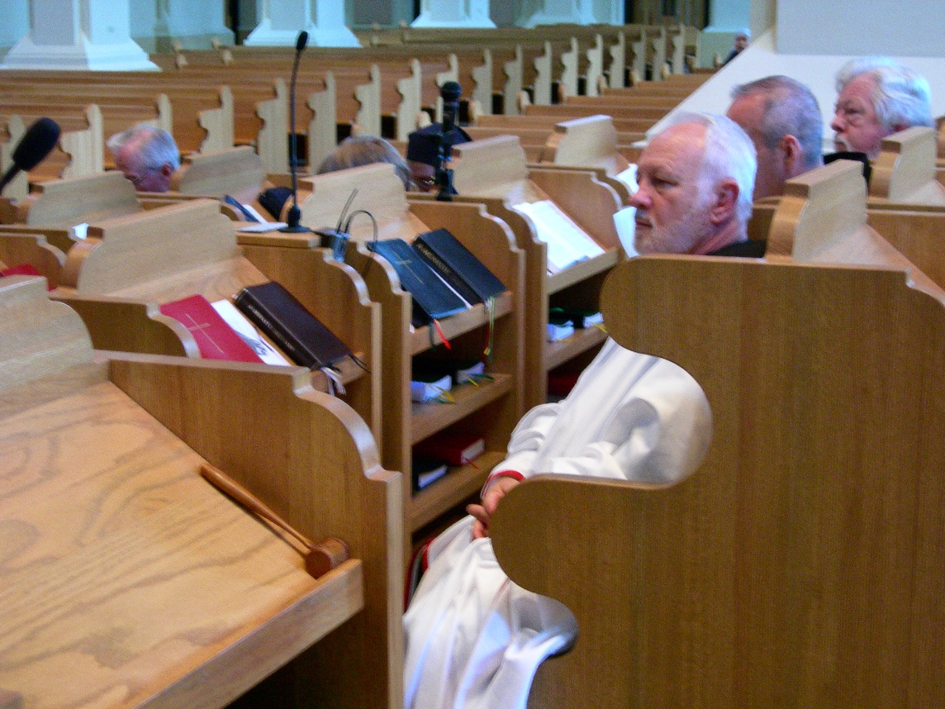
DSCN0297 Br. Christopher John Baumann; Br. Gabriel Hale ;Fr. Wayne Kamm

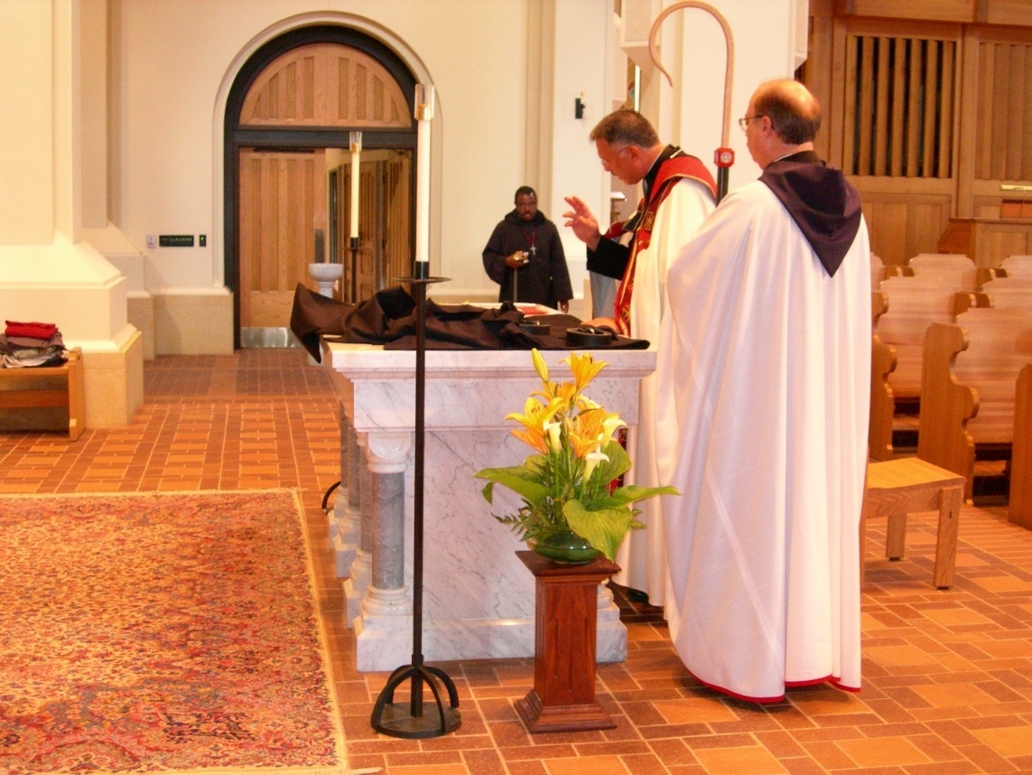
DSCN0299 Br. Thomas Ferrell; Abbot Michael John Austin; Br Raymond Owens
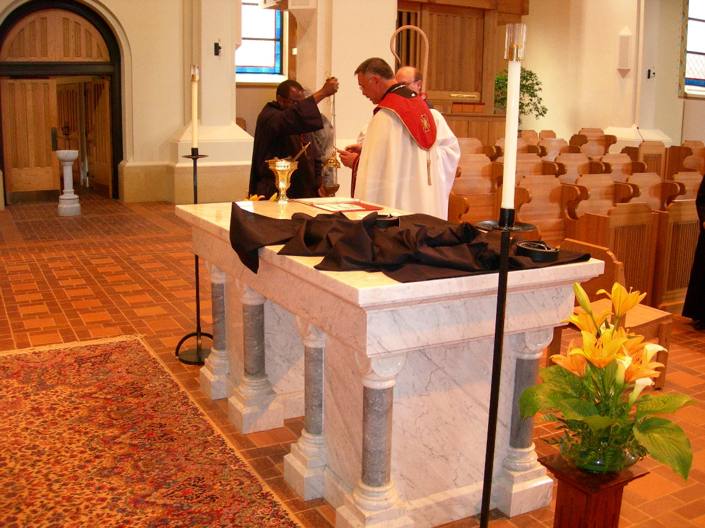
DSCN0300 Br. Thomas Ferrell; Abbot Michael John Austin

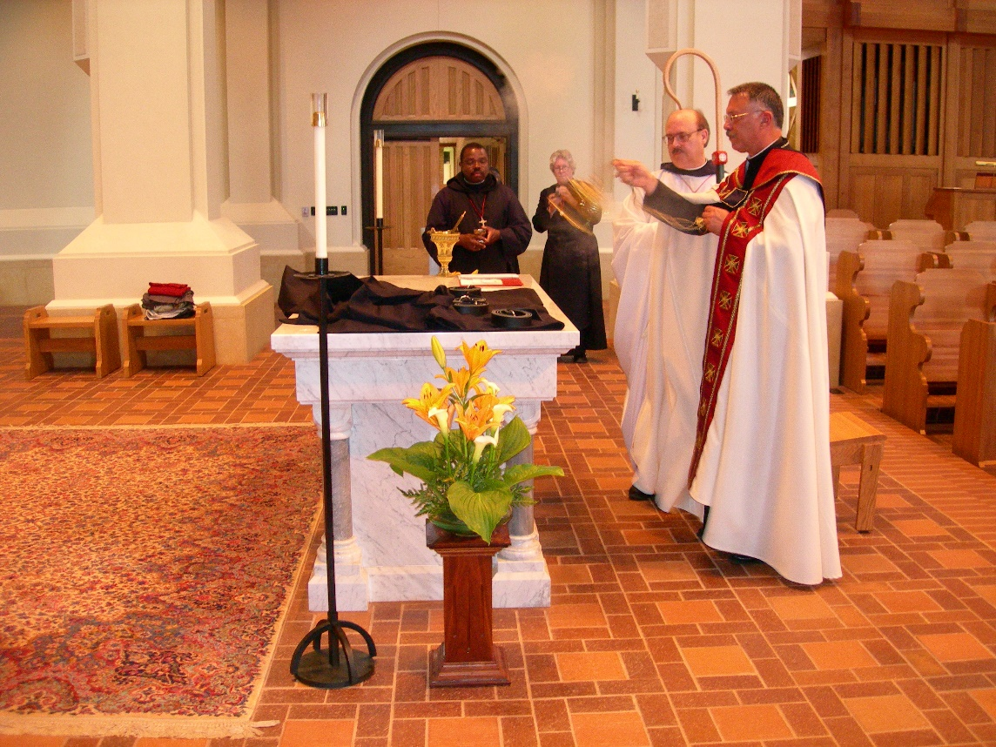
DSCN0301 Br. Thomas Ferrell; Sr. Johanna Kirkpatrick; Br. Raymond Owens; Abbot Michael John Austin
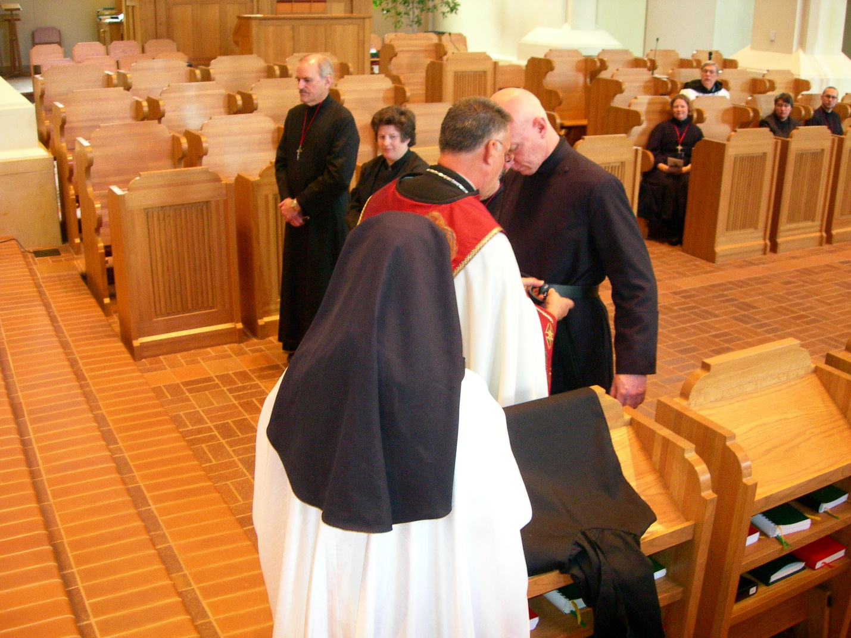
DSCN0302 Br. Daniel Joseph Schroeder; Sr. Cecelia Lamoy; Sr. Monica Ruth Mullen; Br. David Vincent Cotton; Sr. Hillary Grace Lundgren
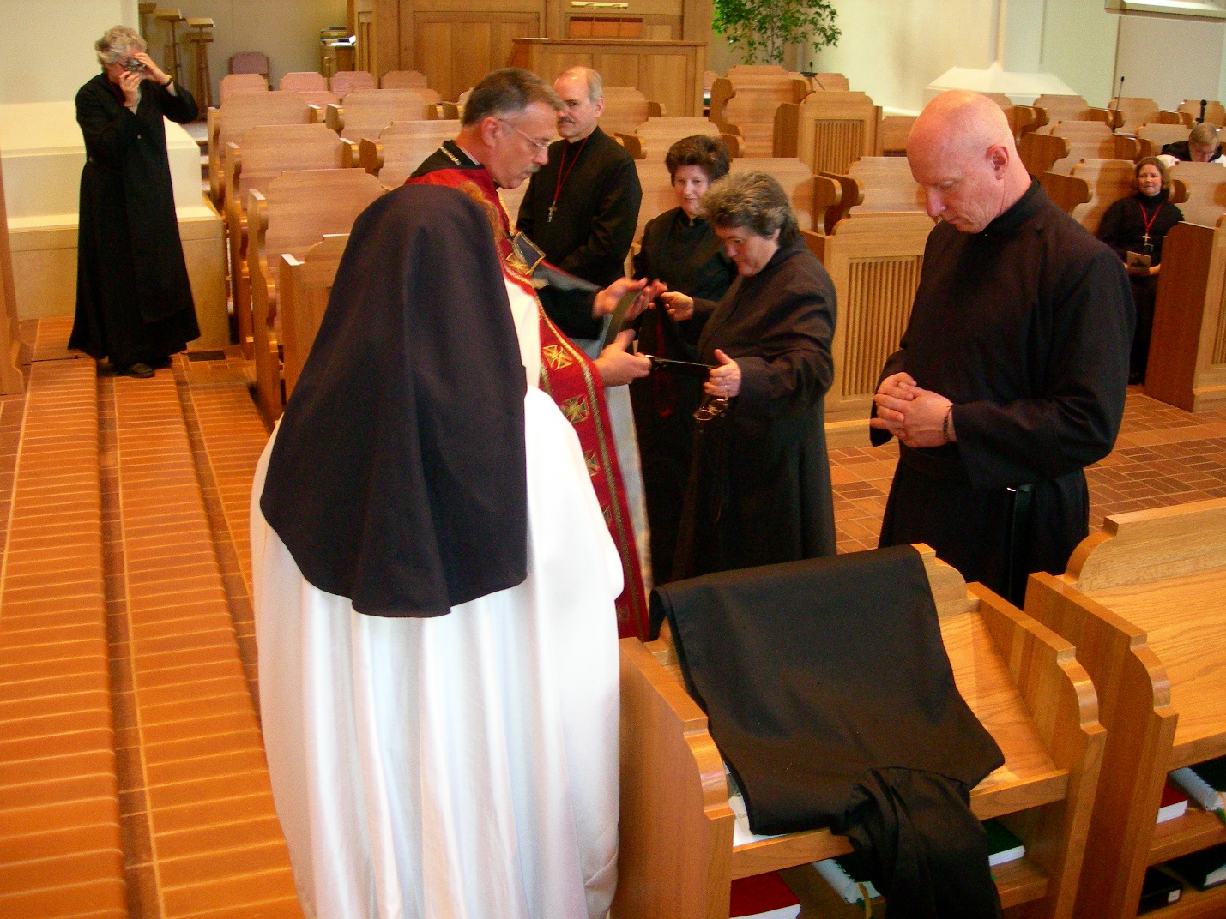
DSCN0303 Sr. Johanna Kirkpatrick; Sr. Monica Ruth Mullen; Abbot Michael John Austin; Br. Daniel Joseph Schroeder; Sr. Cecelia Lamoy; Sr. Vincent Marie Rittenhouse; Br. David Vincent Cotton; Sr. Hillary Grace Lundgren

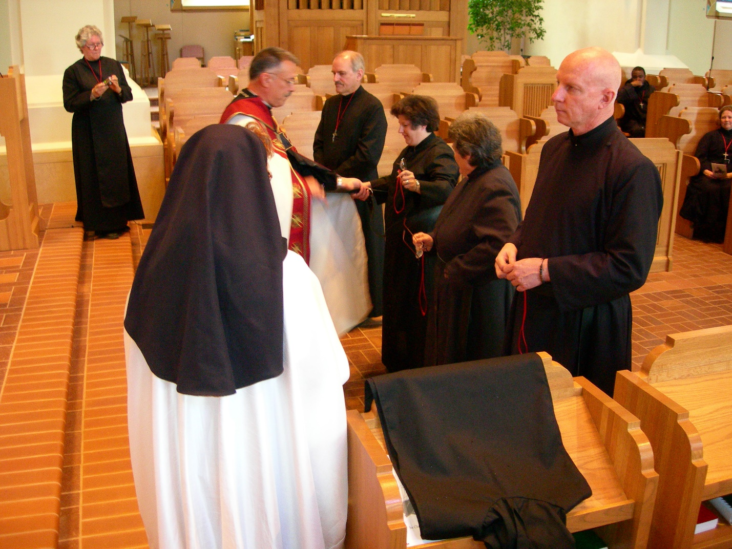
DSCN0304 Sr. Johanna Kirkpatrick; Sr. Monica Ruth Mullen; Abbot Michael John Austin; Br. Daniel Joseph Schroeder; Sr. Cecelia Lamoy; Sr. Vincent Marie Rittenhouse; Br. David Vincent Cotton; Sr. Hillary Grace Lundgren
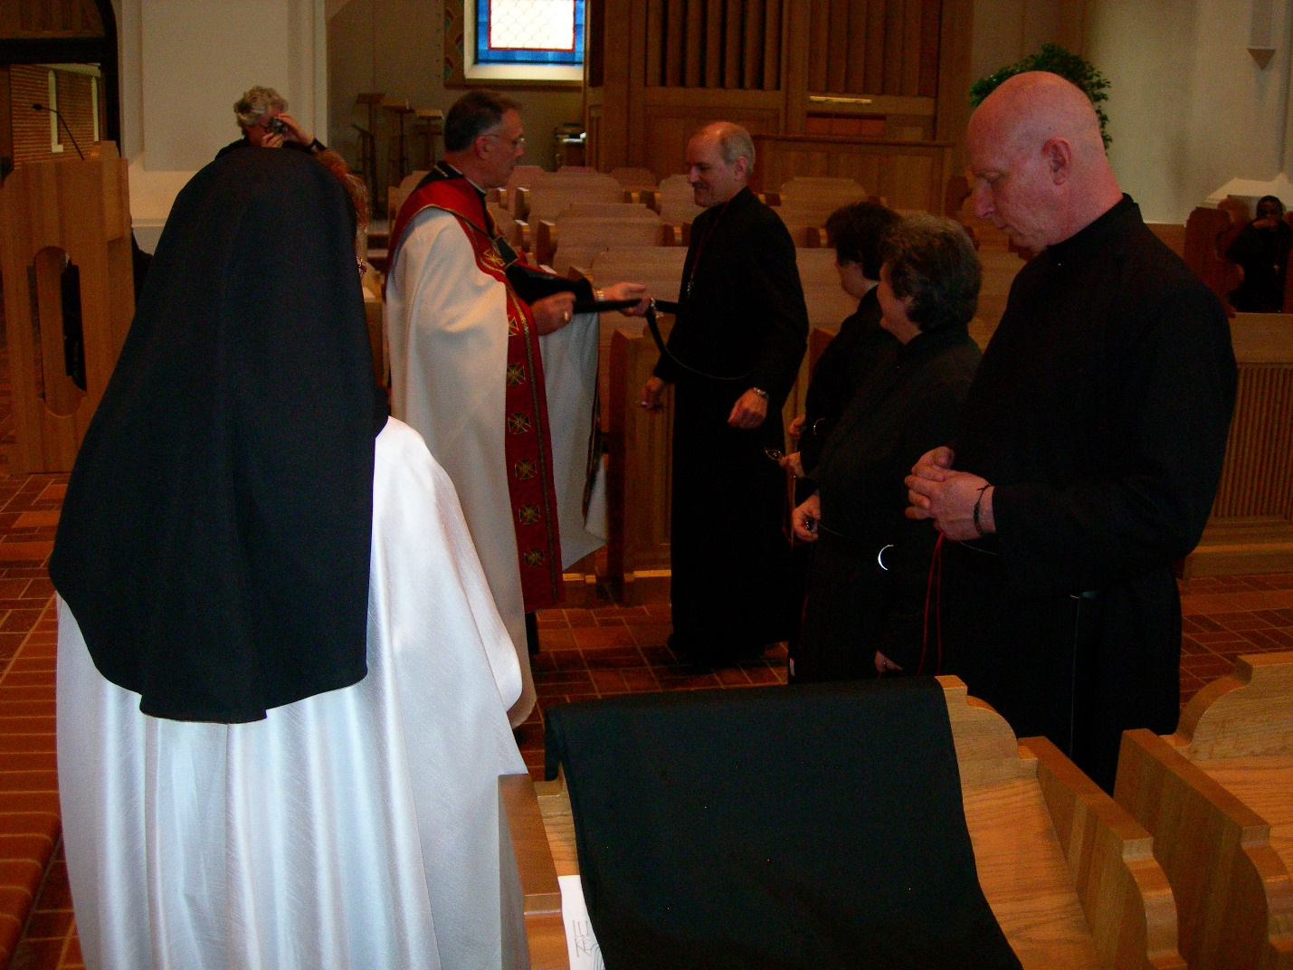
DSCN0305 Sr. Monica Ruth Mullen; Sr. Johanna Kirkpatrick; Abbot Michael John Austin; Br. Daniel Joseph Schroeder; Sr. Cecelia Lamoy; Sr. Vincent Marie Rittenhouse; Br. David Vincent Cotton
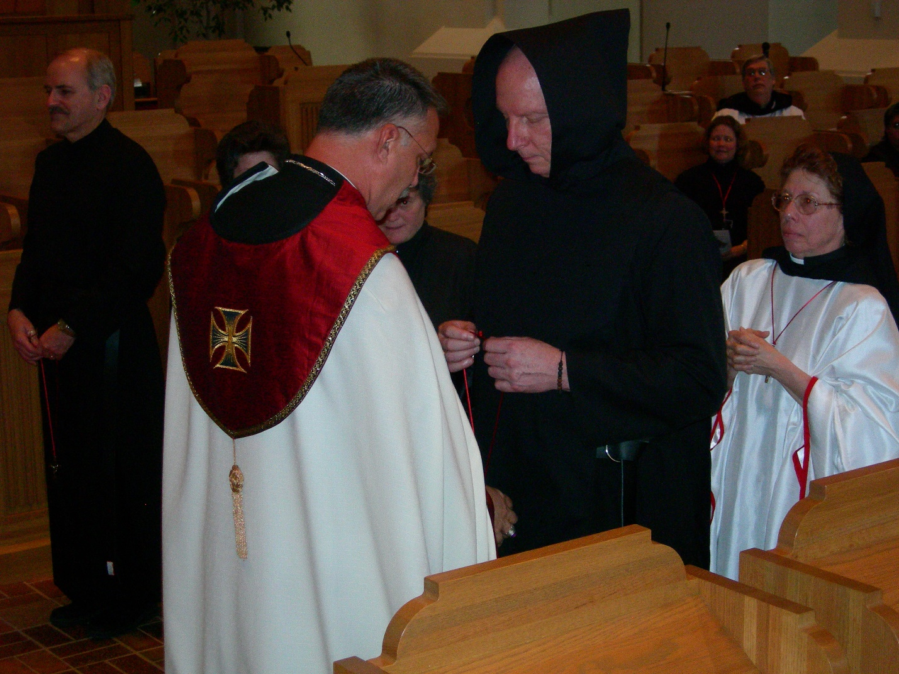
DSCN0306 Br. Daniel Joseph Schroeder; Sr. Cecelia Lamoy; Abbot Michael John Austin; Sr. Vincent Marie Rittenhouse; Br. David Vincent Cotton; Sr. Hillary Gace Lundgren; Br. Chad Anselm Gerns; Sr. Monica Ruth Mullen
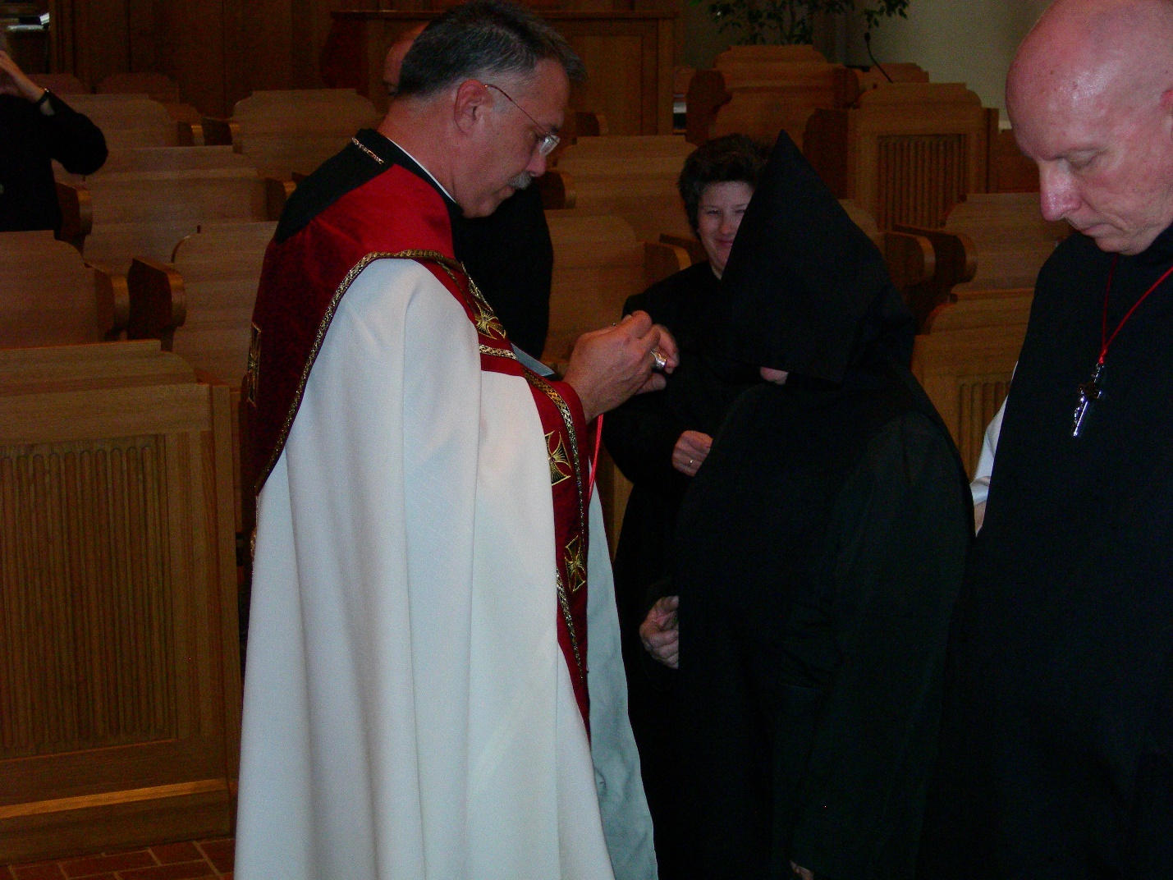
DSCN0307 Br. Daniel Joseph Schroeder; Sr. Cecelia Lamoy; Sr. Vincent Marie Rittenhouse; Br. David Vincent Cotton

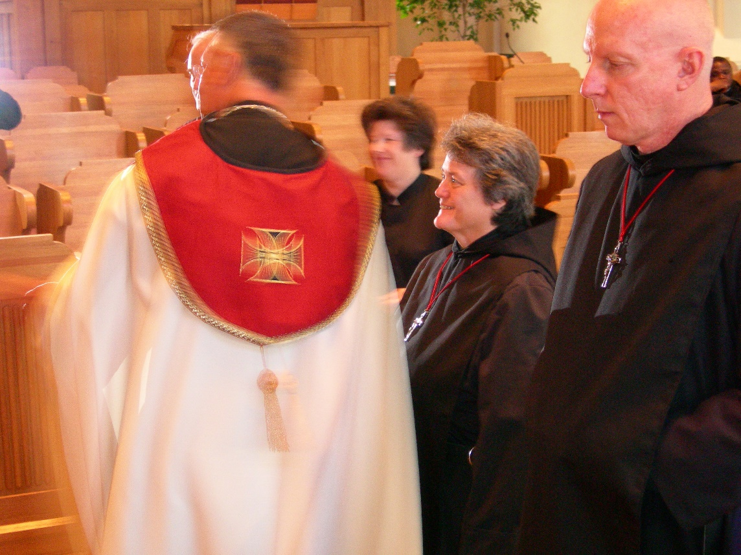
DSCN0308 Abbot Michael John Austin; Sr. Ceclia Lamoy; Sr. Vincent Marie Rittenhouse; Br. David Vincent Cotton

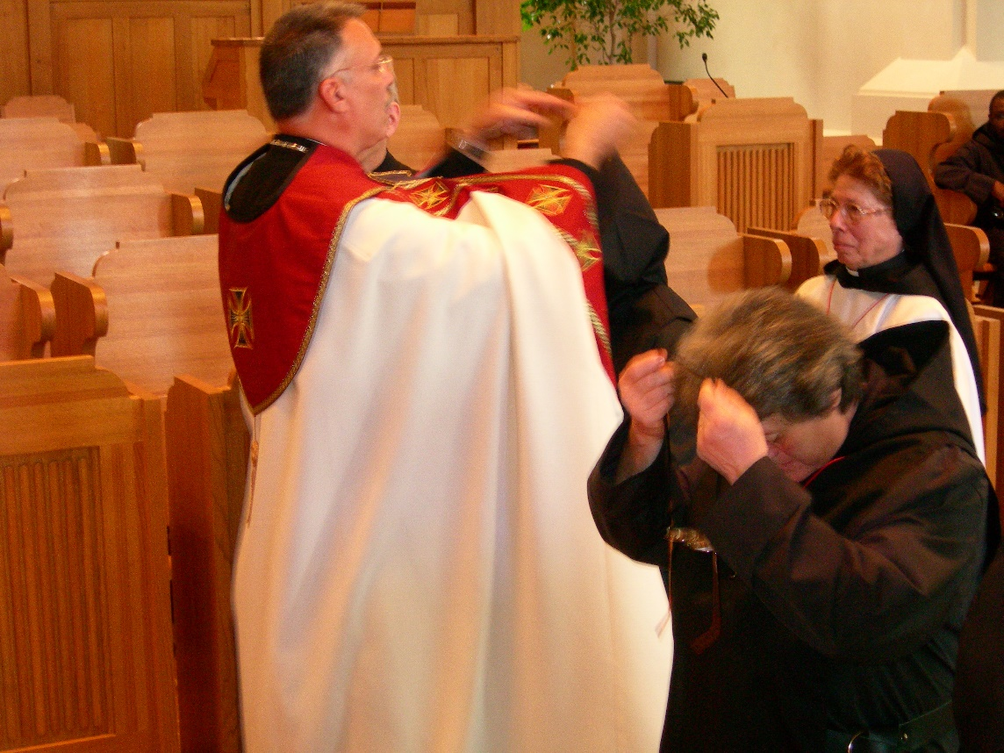
DSCN0309 Abbot Michael John Austin; Sr. Ceclia Lamoy; Sr. Vincent Marie Rittenhouse; Sr. Monica Ruth Mullen
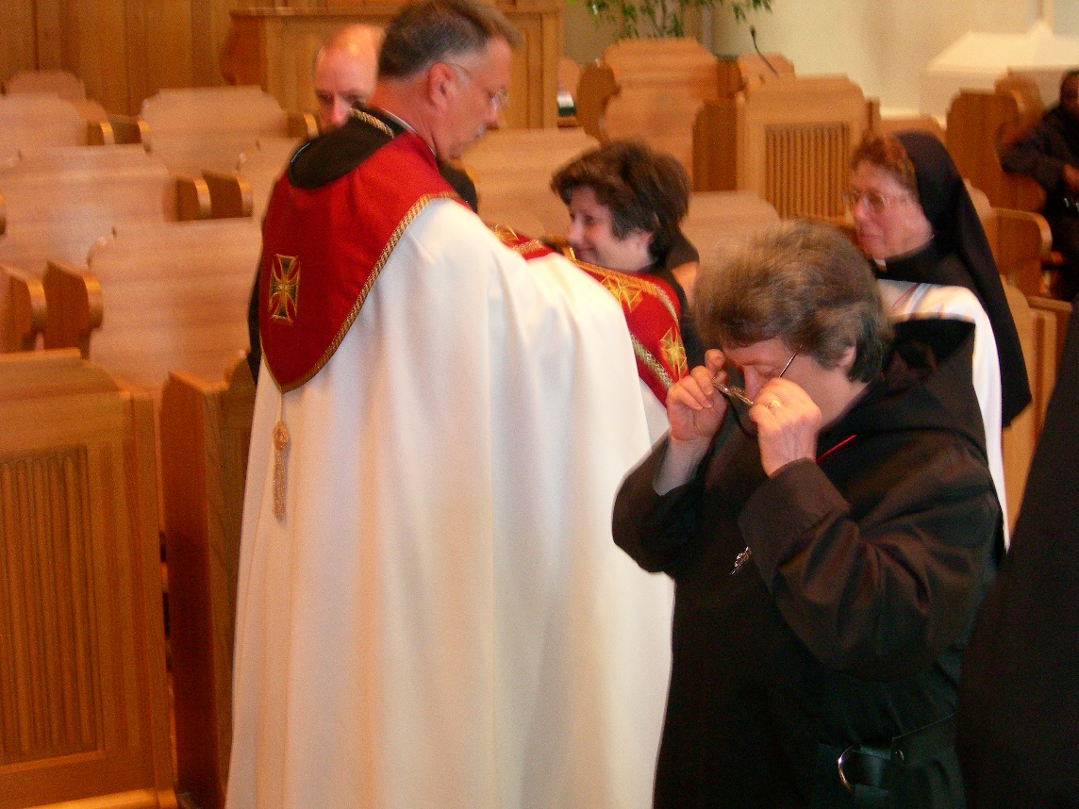
DSCN0310 Abbot Michael John Austin; Sr. Ceclia Lamoy; Sr. Vincent Marie Rittenhouse; Sr. Monica Ruth Mullen

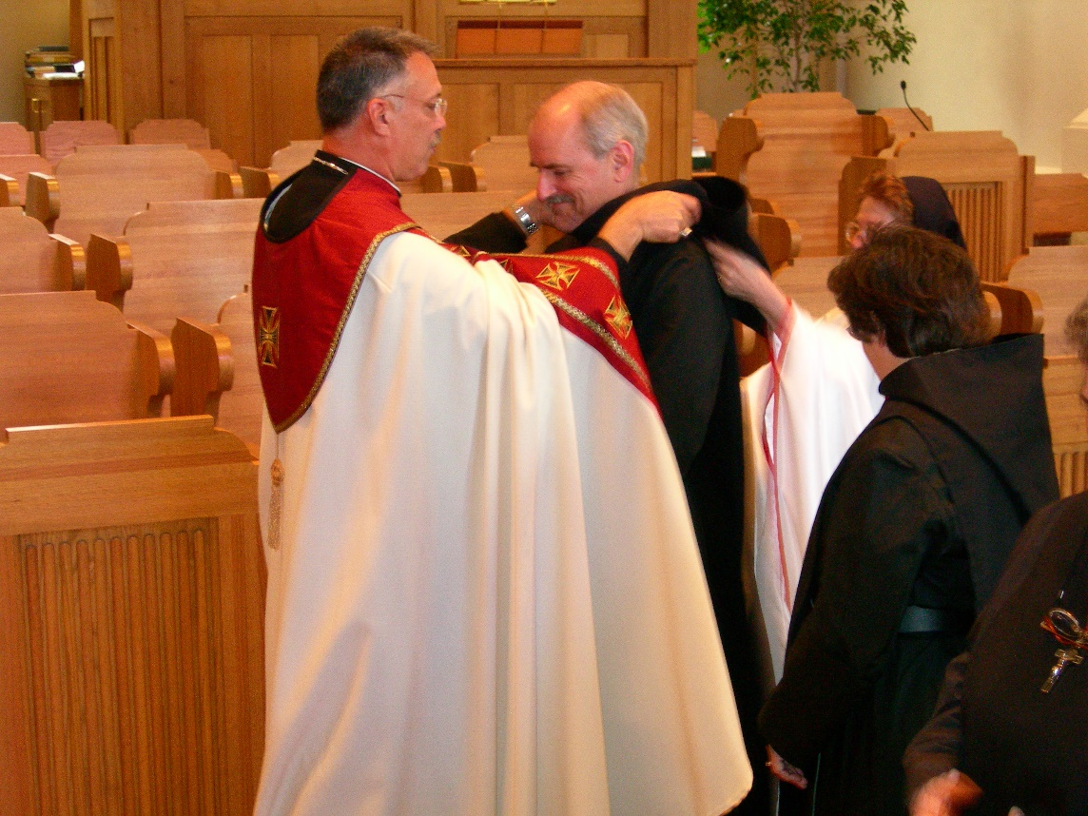
DSCN0311 Abbot Michael John Austin; Br. Daniel Joseph Schroeder; Sr. Ceclia Lamoy; Sr. Monica Ruth Mullen; Sr. Vincent Marie Rittenhouse

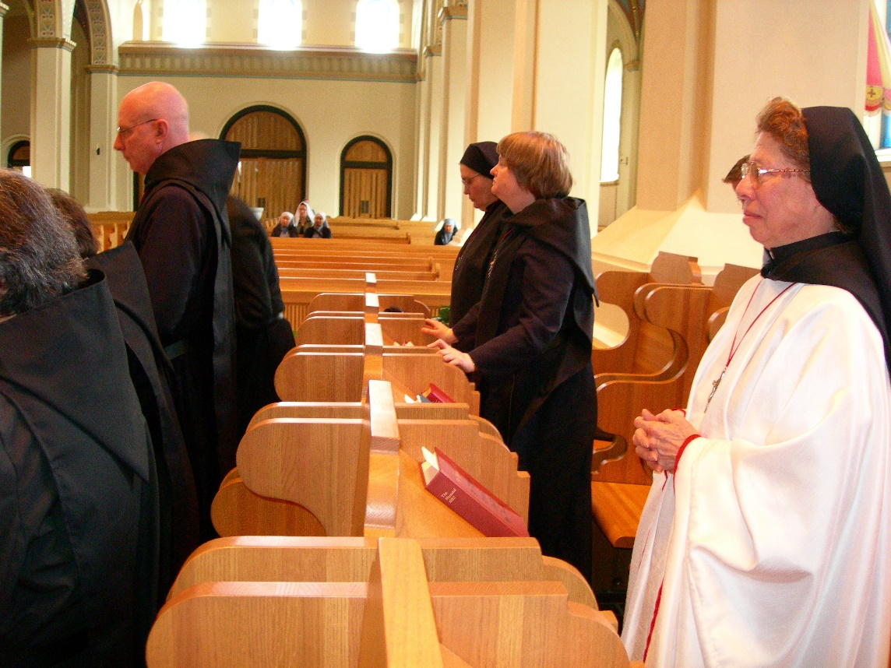
DSCN0313 Sr. Cecelia Lamoy; Br. David Vincent Cotton; Sr. Theodora of Jesus Perecca; Sr. Catherine Unterseher; Sr. Monica Ruth Mullen

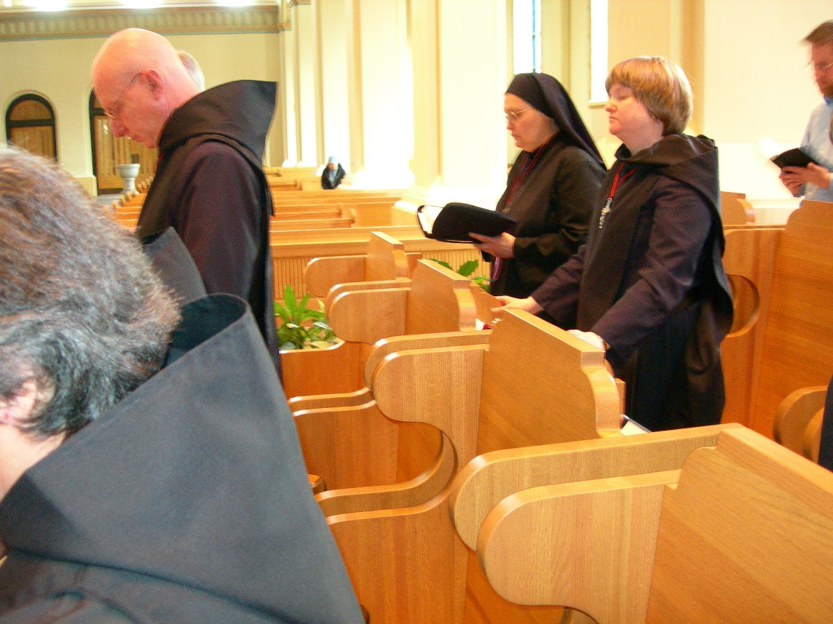
DSCN0314 Sr. Cecelia Lamoy; Br. David Vincent Cotton; Sr. Theodora of Jesus Perecca; Sr. Catherine Unterseher; Friend of Br. Eckhart Sowers
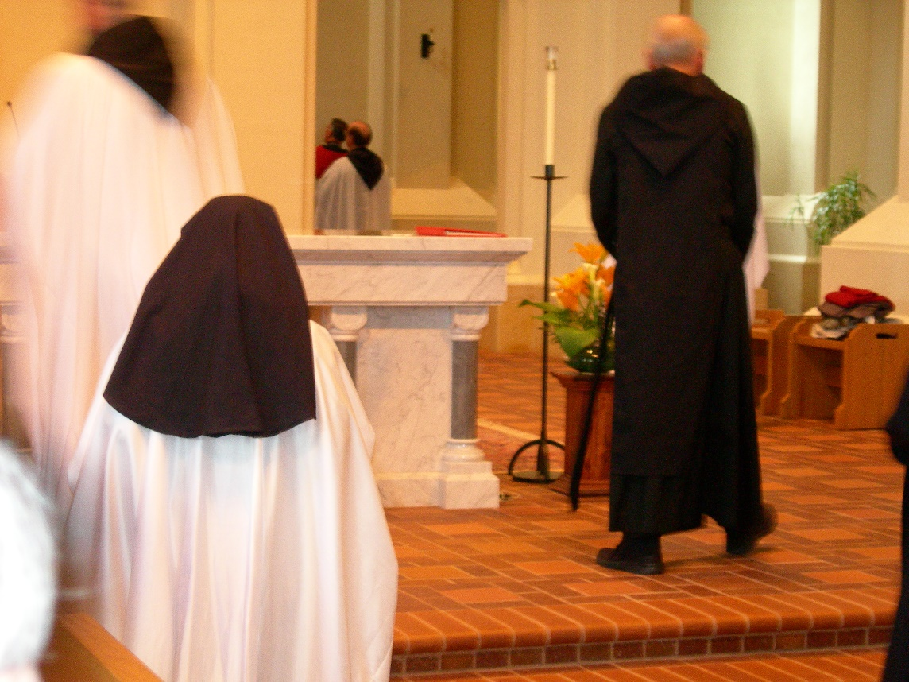
DSCN0315 Sr. Monica Ruth Mullen; Br.Daniel Joseph Schroeder

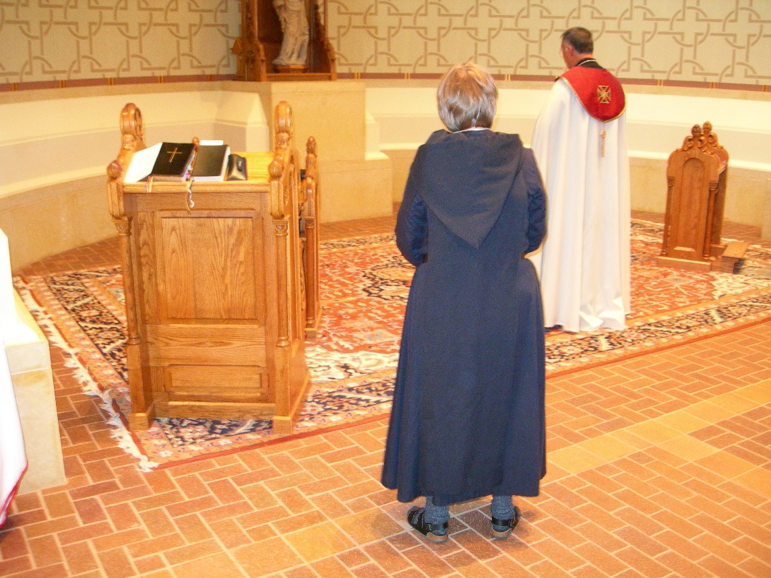
DSCN0316 Sr. Catherine Unterseher; Abbot Michael John Austin
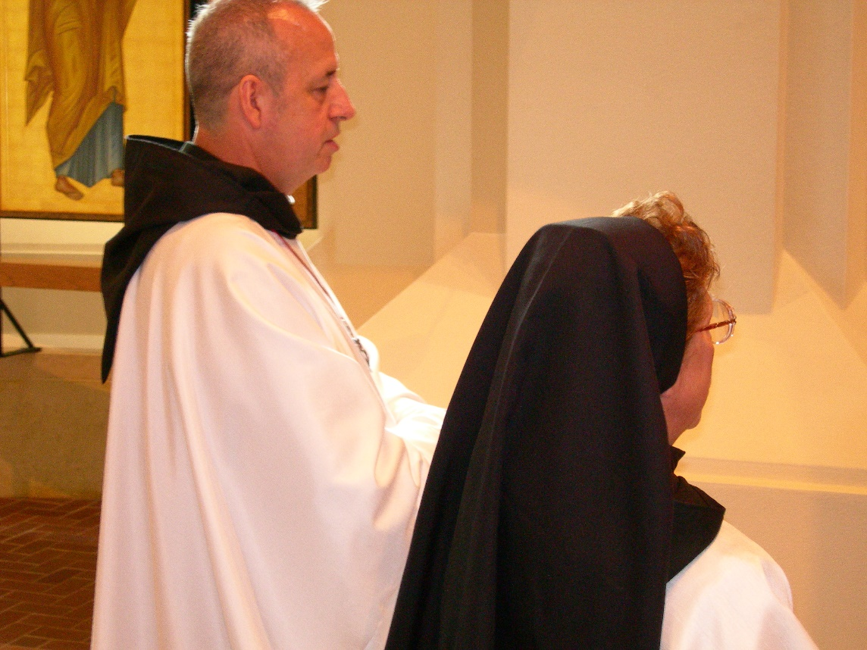
DSCN0317 Br. Gabriel Hale; Sr. Monica Ruth Mullen

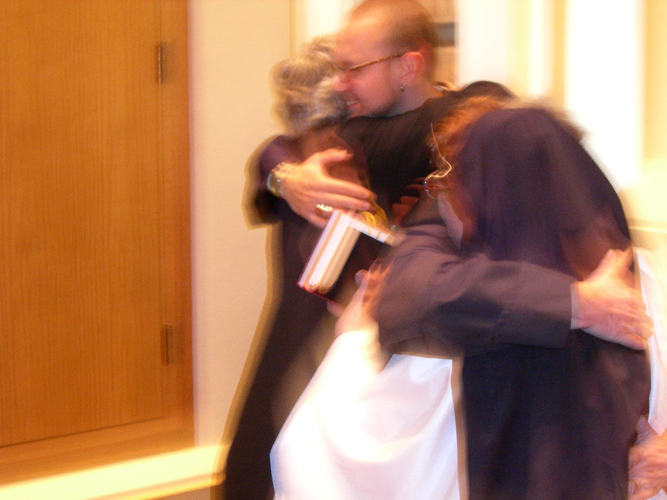
DSCN0318 Sr. Johanna Kirkpatrick; Br. Eckart Sowers; Sr. Hillary Grace Lundgren; Sr. Monica Ruth Mullen
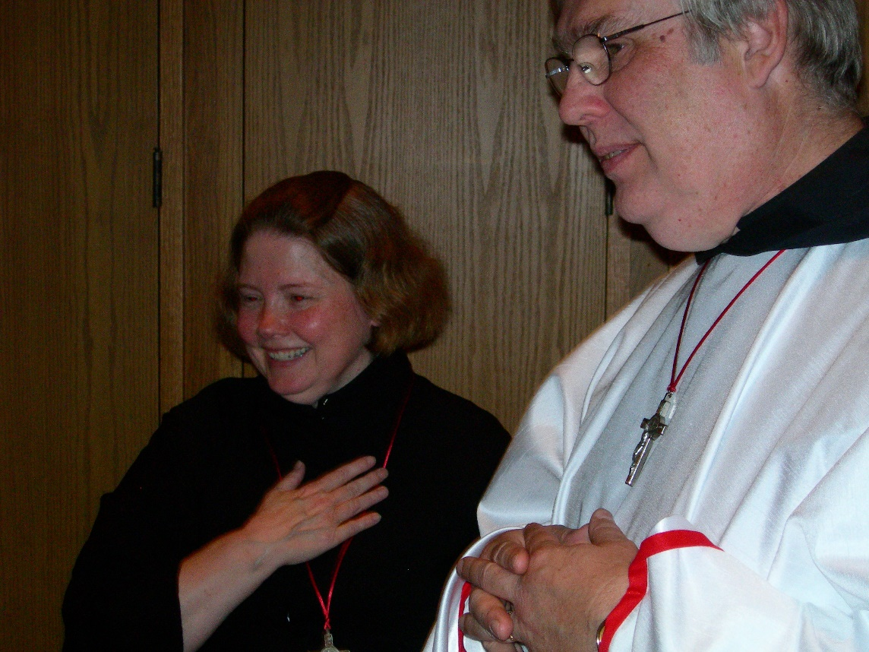
DSCN0319 Sr. Hillary Grace Lundgren; Br. Chad Anselm Gerns

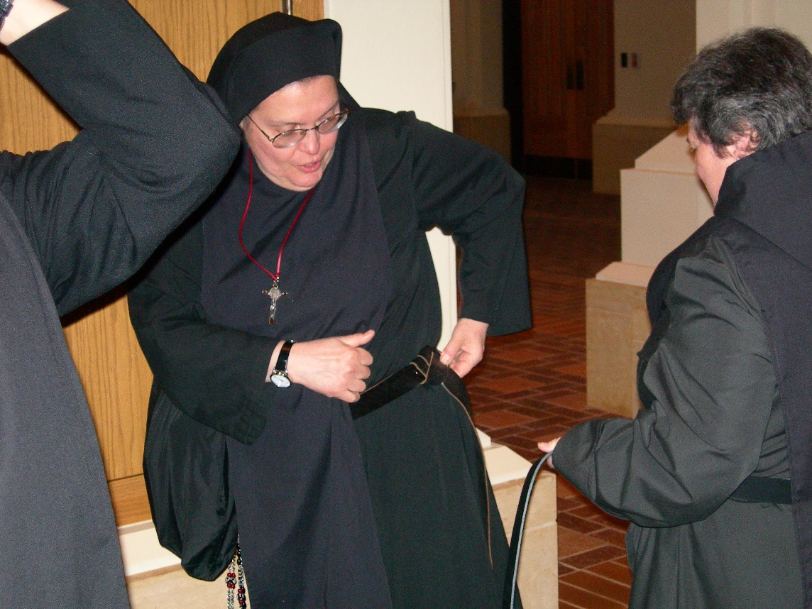
DSCN0320 Sr. Theodora of Jesus Perecca; Sr. Sr. Vincent Marie Rittenhouse

