Companions of St. Luke
Spring 2005 Convocation at Conception Abbey
Part 2 of 5

NOTE: Disc is dated 28 May 2003 but the people present and other documents show this is Spring 2005.

~Edited by Br. Steven Olderr, 19 May 2022 with the assistance of Br. Thomas Ferrell; if you find any errors or omissions, please notify Br. Steven at olderr@ameritech.net

People are identified from left to right.

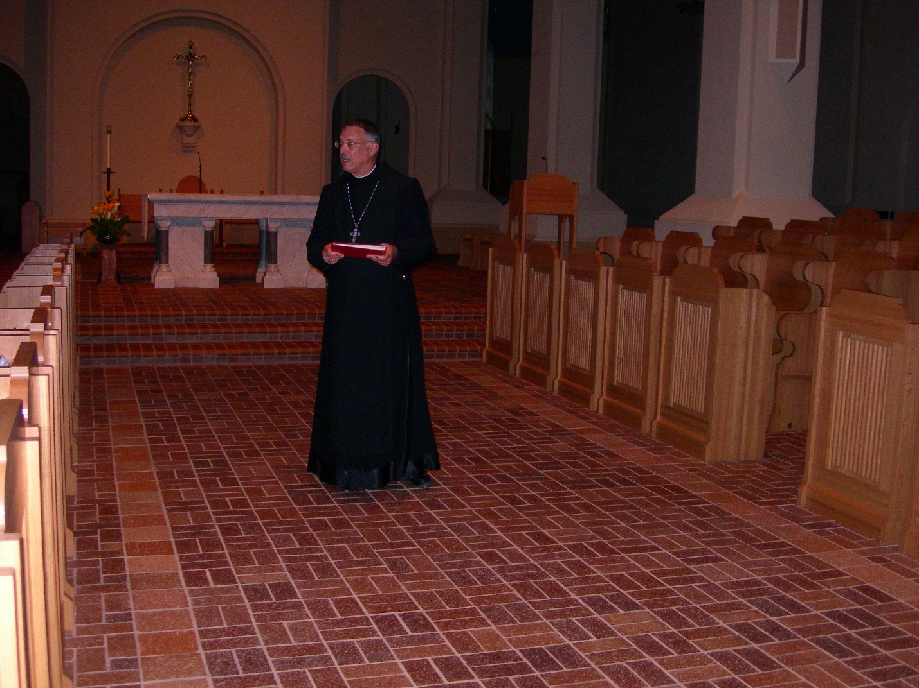
DSCN0219 Abbot Michael John Austin

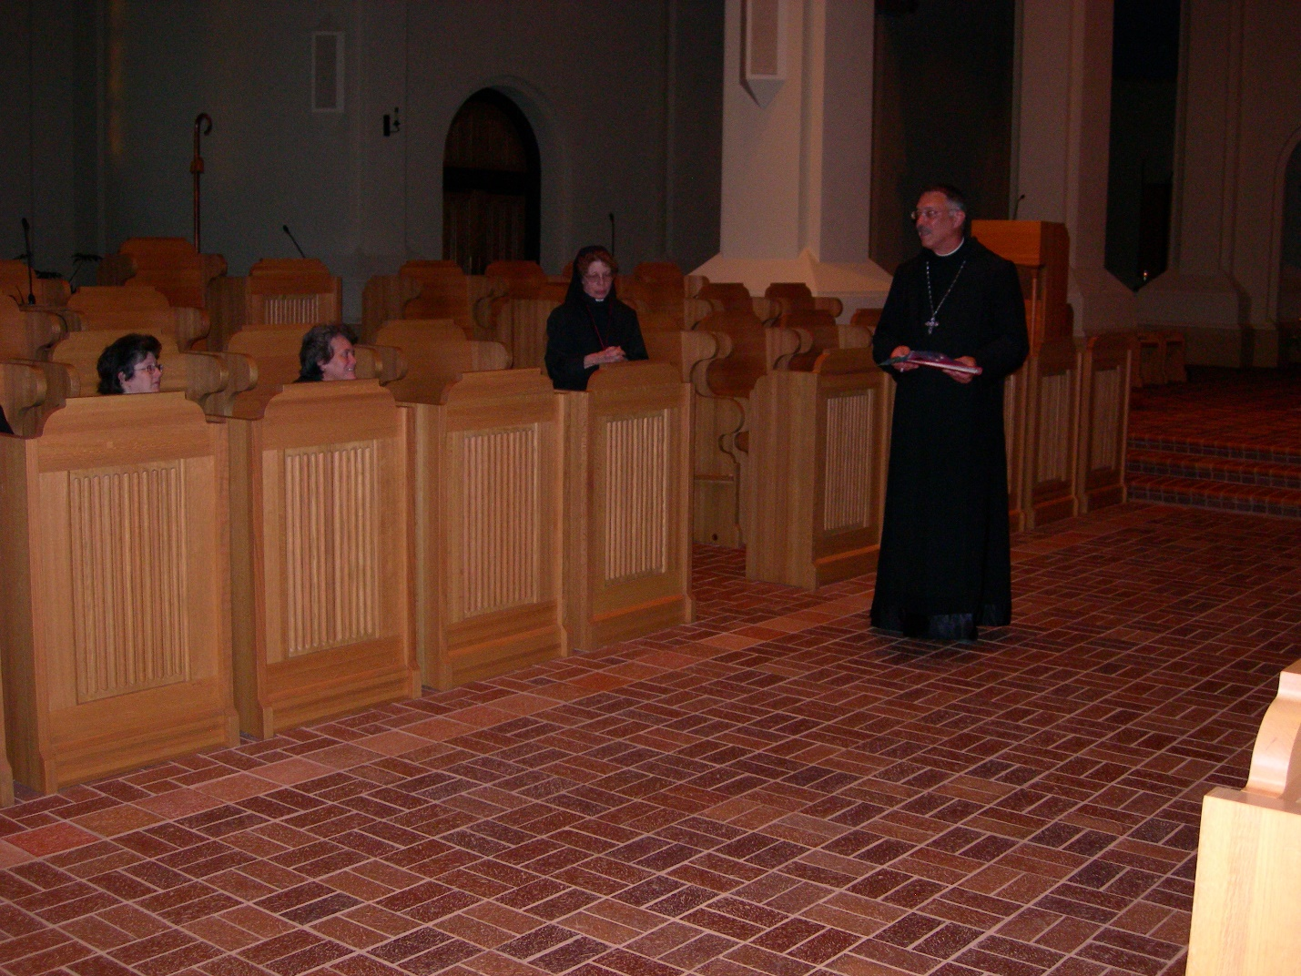
DSCN0220 Abbot Michael John Austin

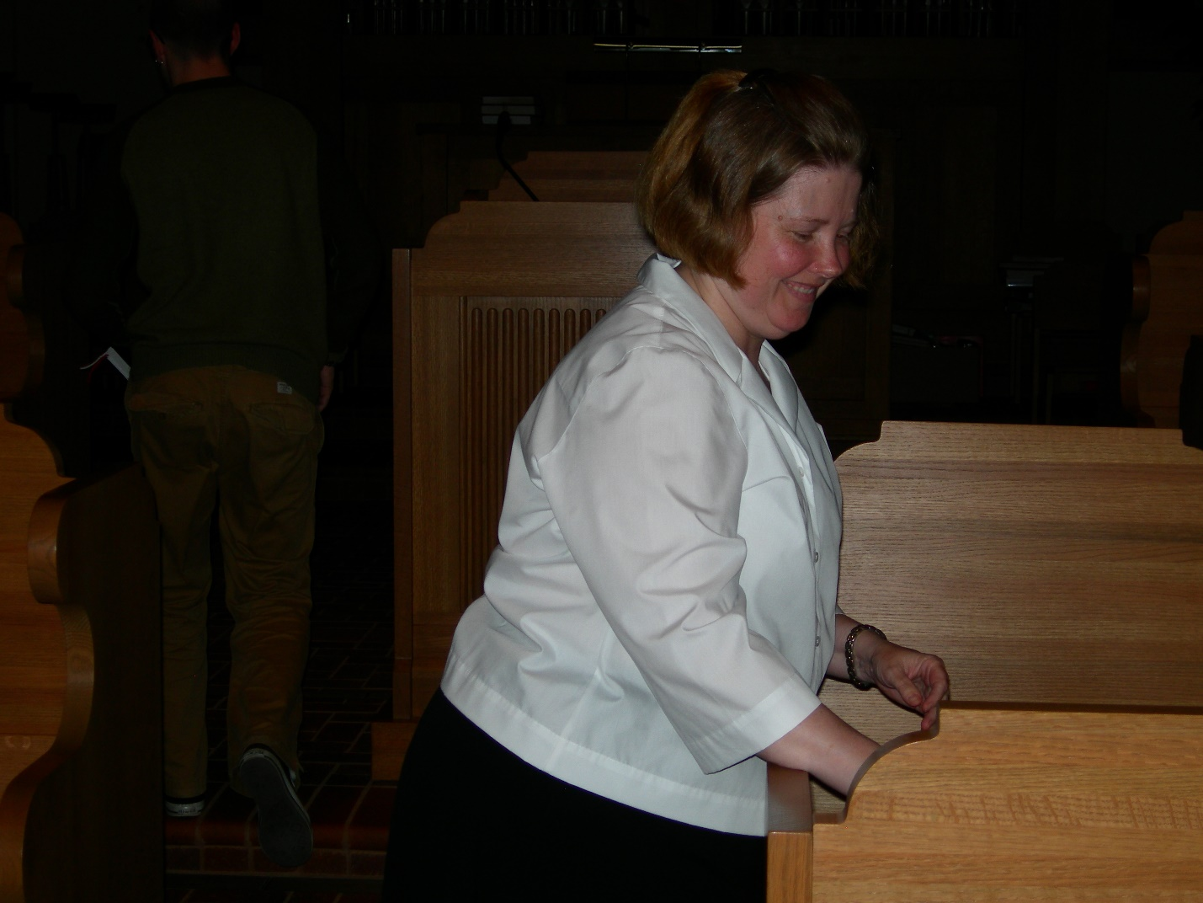
DSCN0221 Maria Lungdren

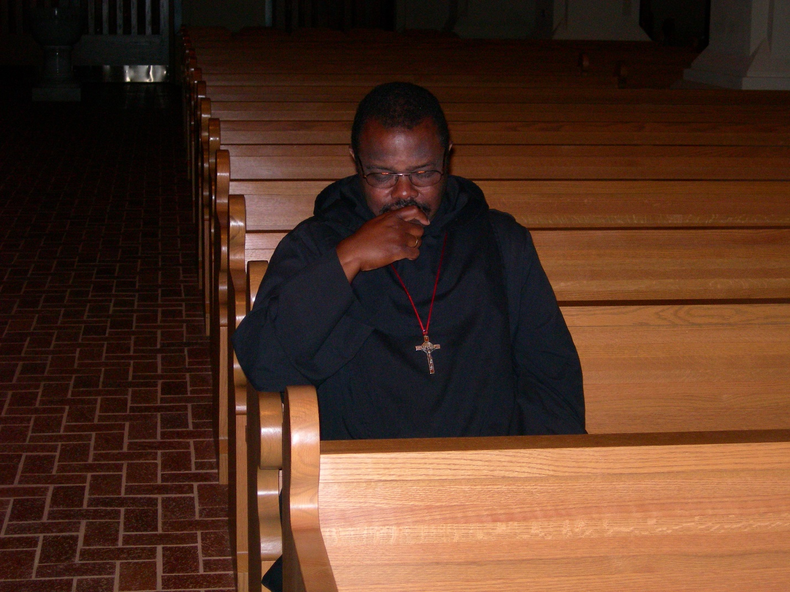
DSCN0222 Br. Thomas Ferrell
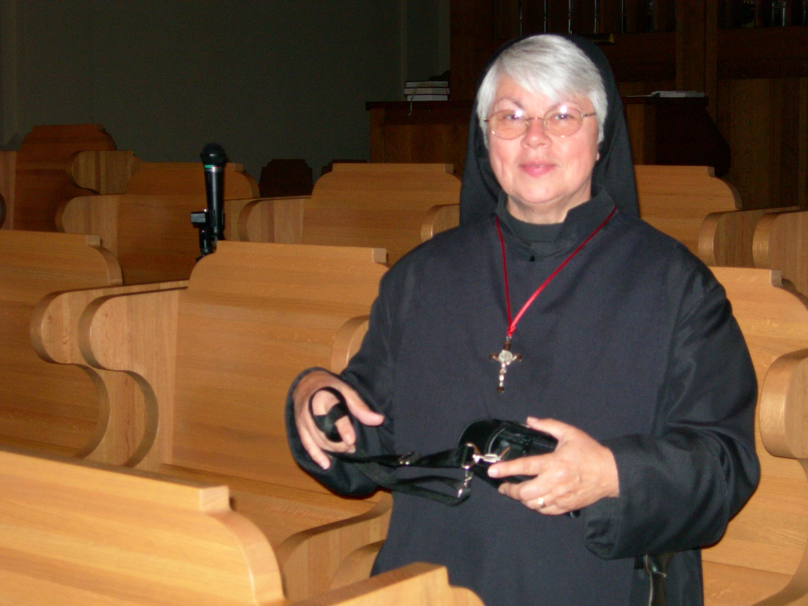
DSCN0223 Sr. Clare Benedicta Meyers
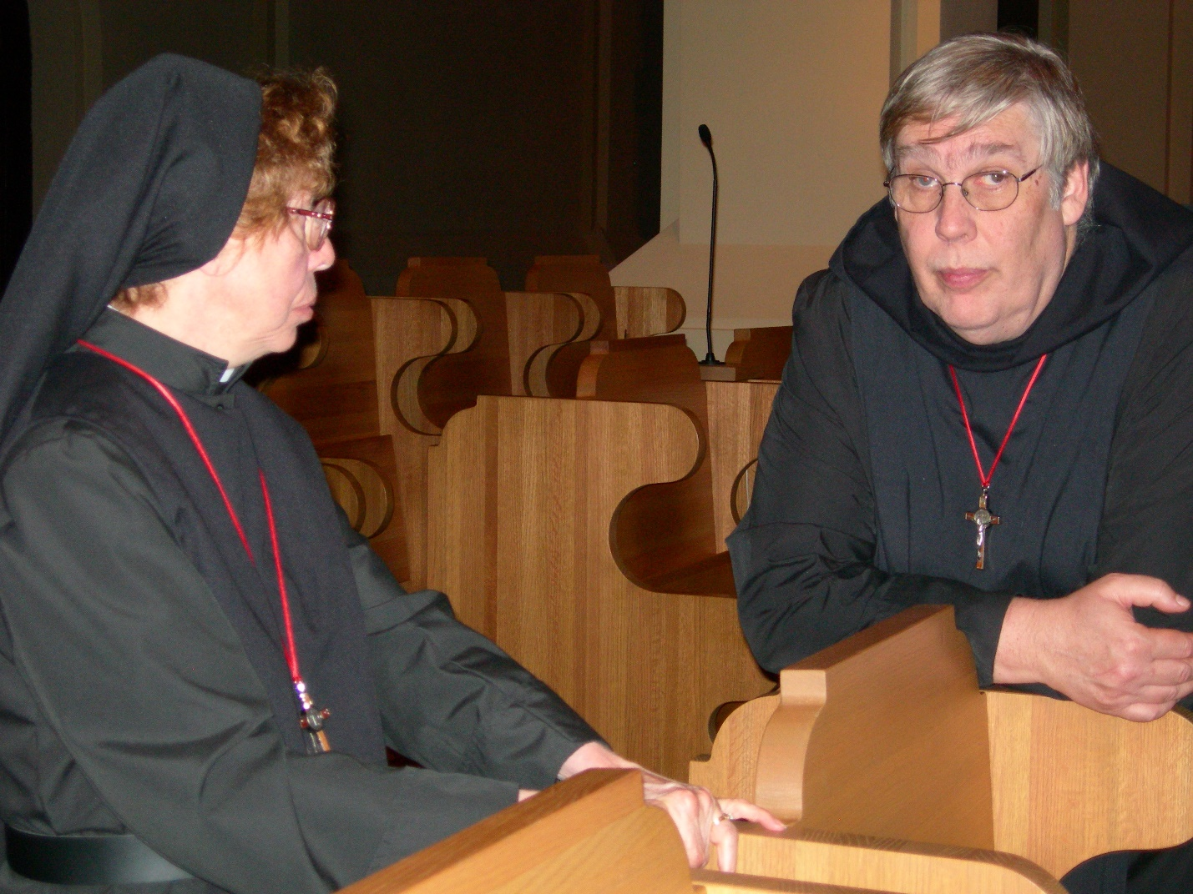
DSCN0224 Sr. Monica Ruth Mullen; Br. Chad Anselm Gerns
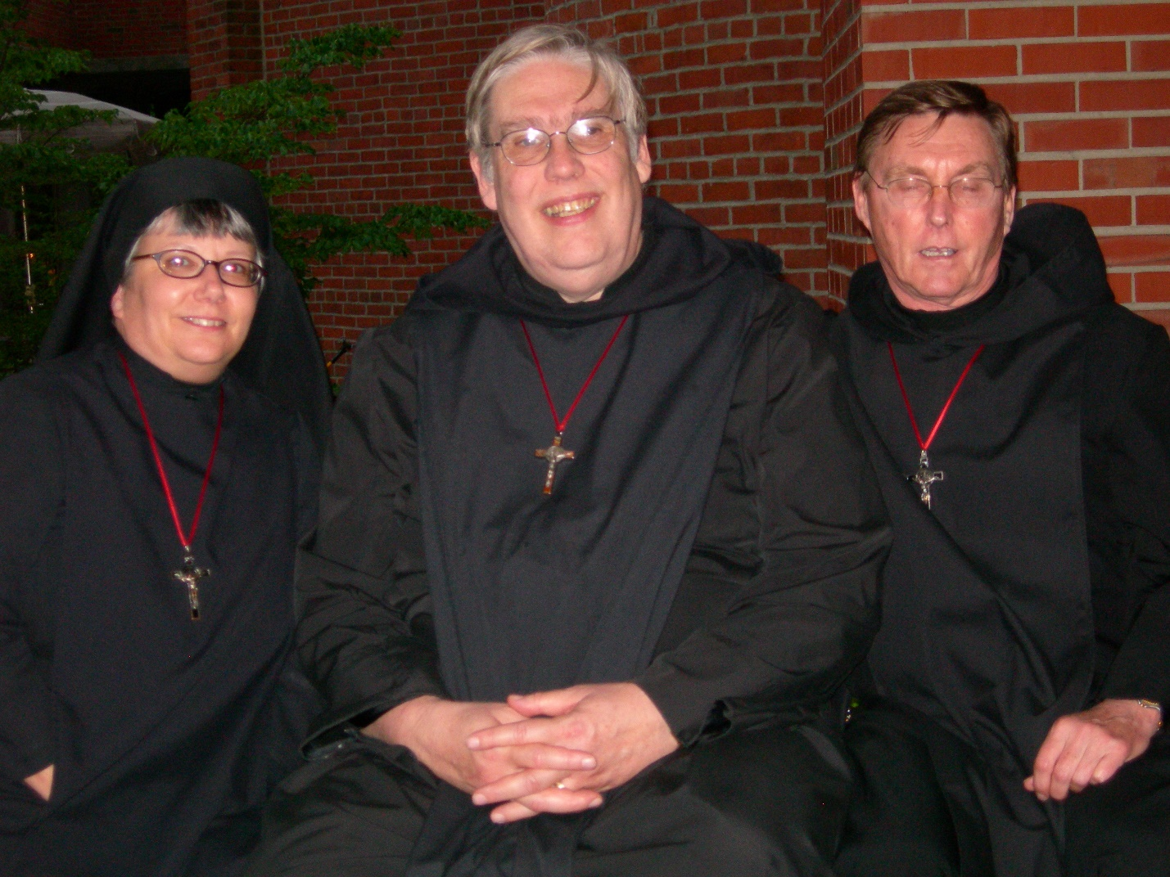
DSCN0227 Sr. Anna Grace Madden; Br. Chad Anselm Gerns; Br. Camillus Converse
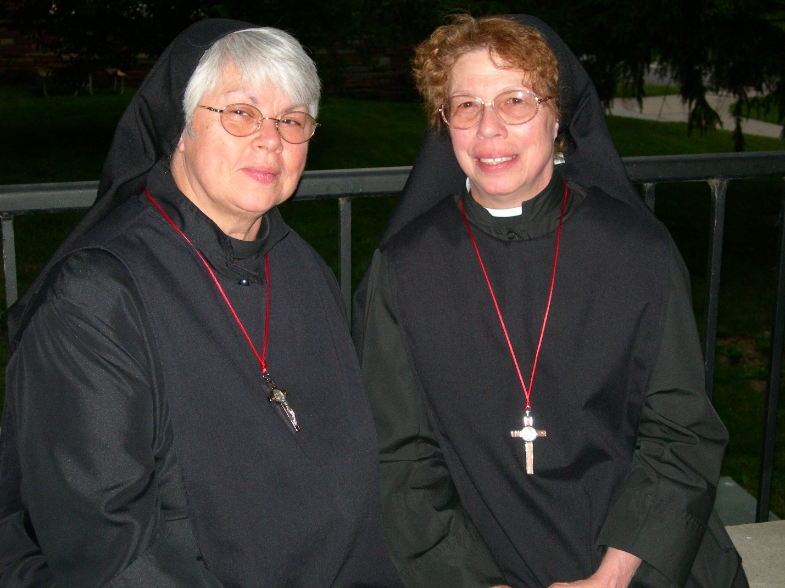
DSCN0228 Sr. Clare Benedicta Meyers; Sr. Monica Ruth Mullen
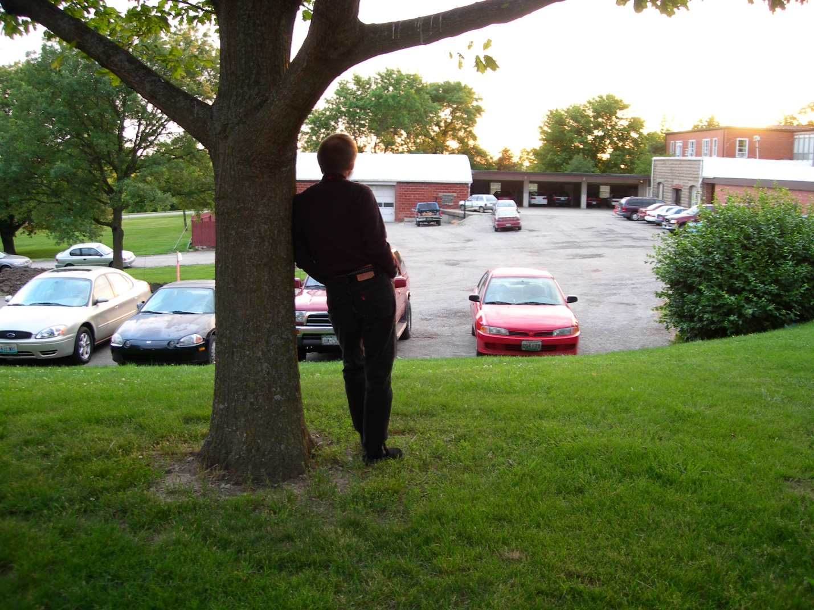
DSCN0229 Br. Lawrence Mullen
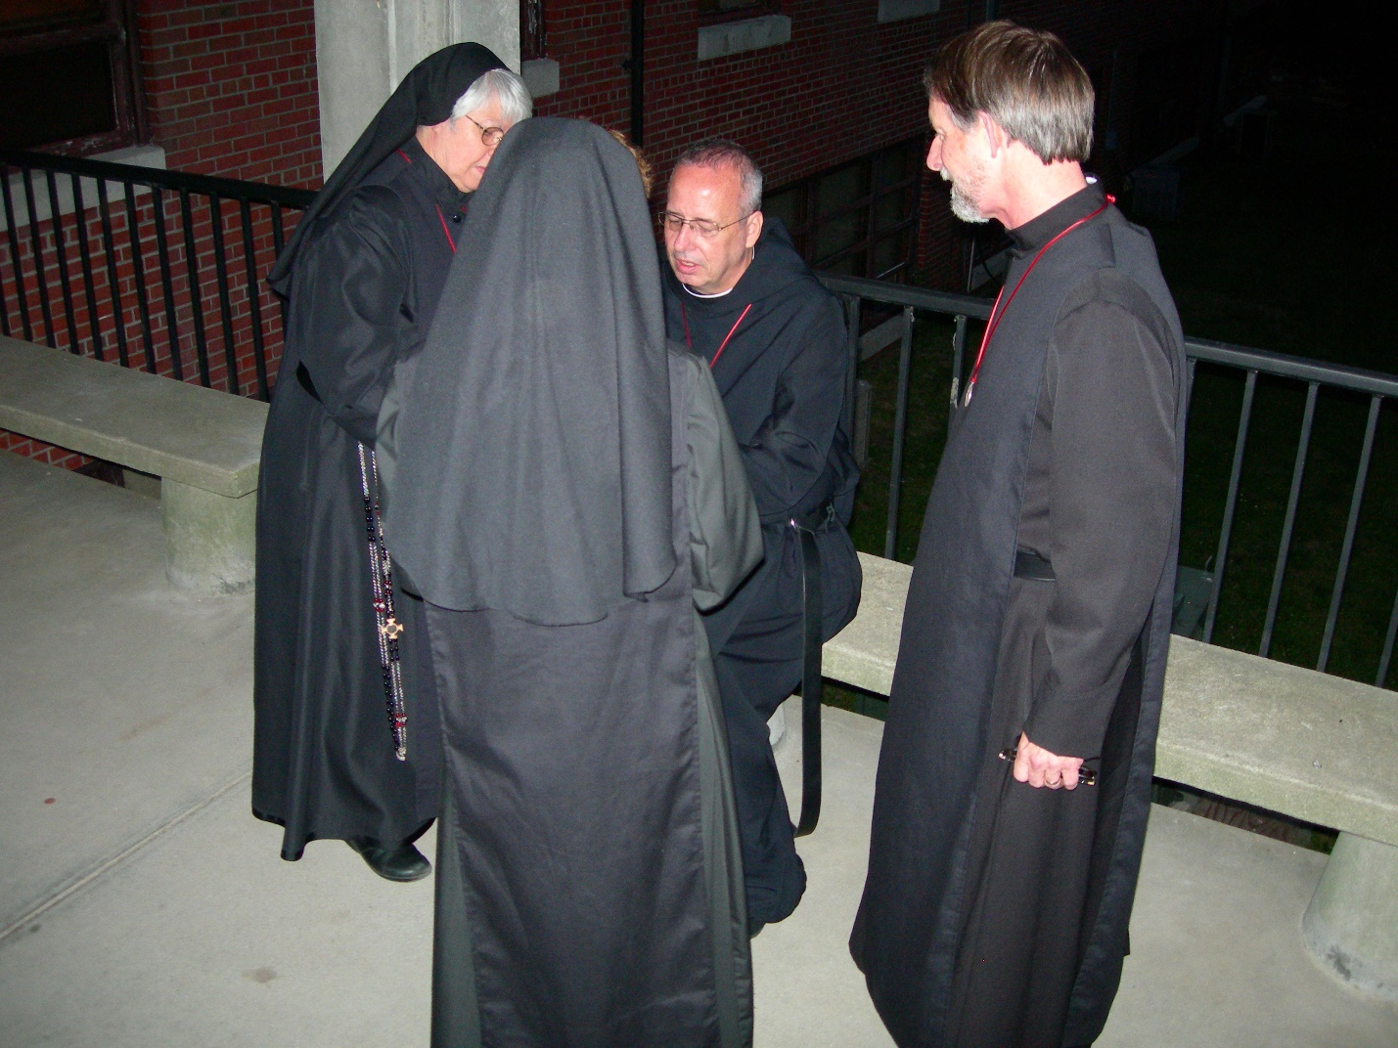
DSCN0236 Sr. Clare Benedicta Meyers; Sr. Monica Ruth Mullen; Br. Gabriel Hale; Br. Lawrence Mullen
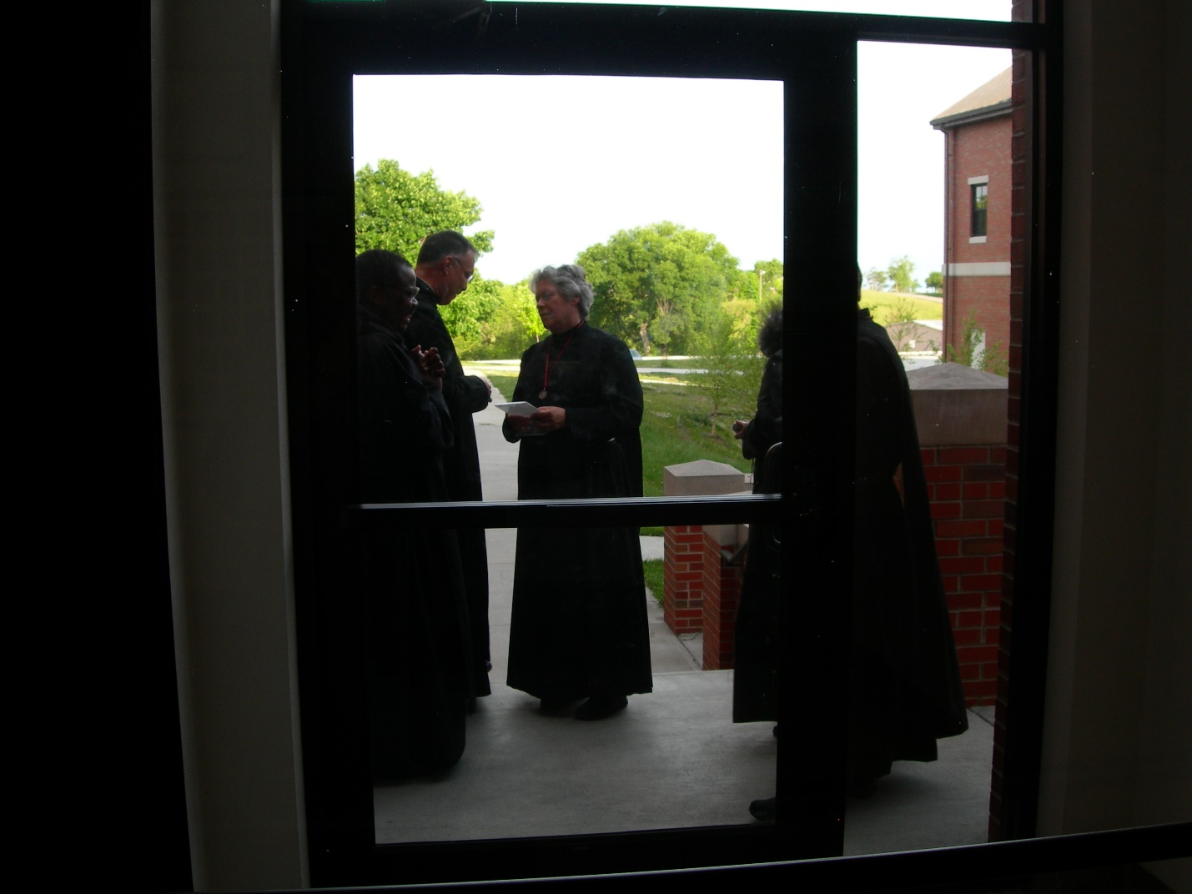
DSCN0237Br. Thomas Ferrell; Abbot Michael John Austin; Sr. Johanna Kirkpatrick
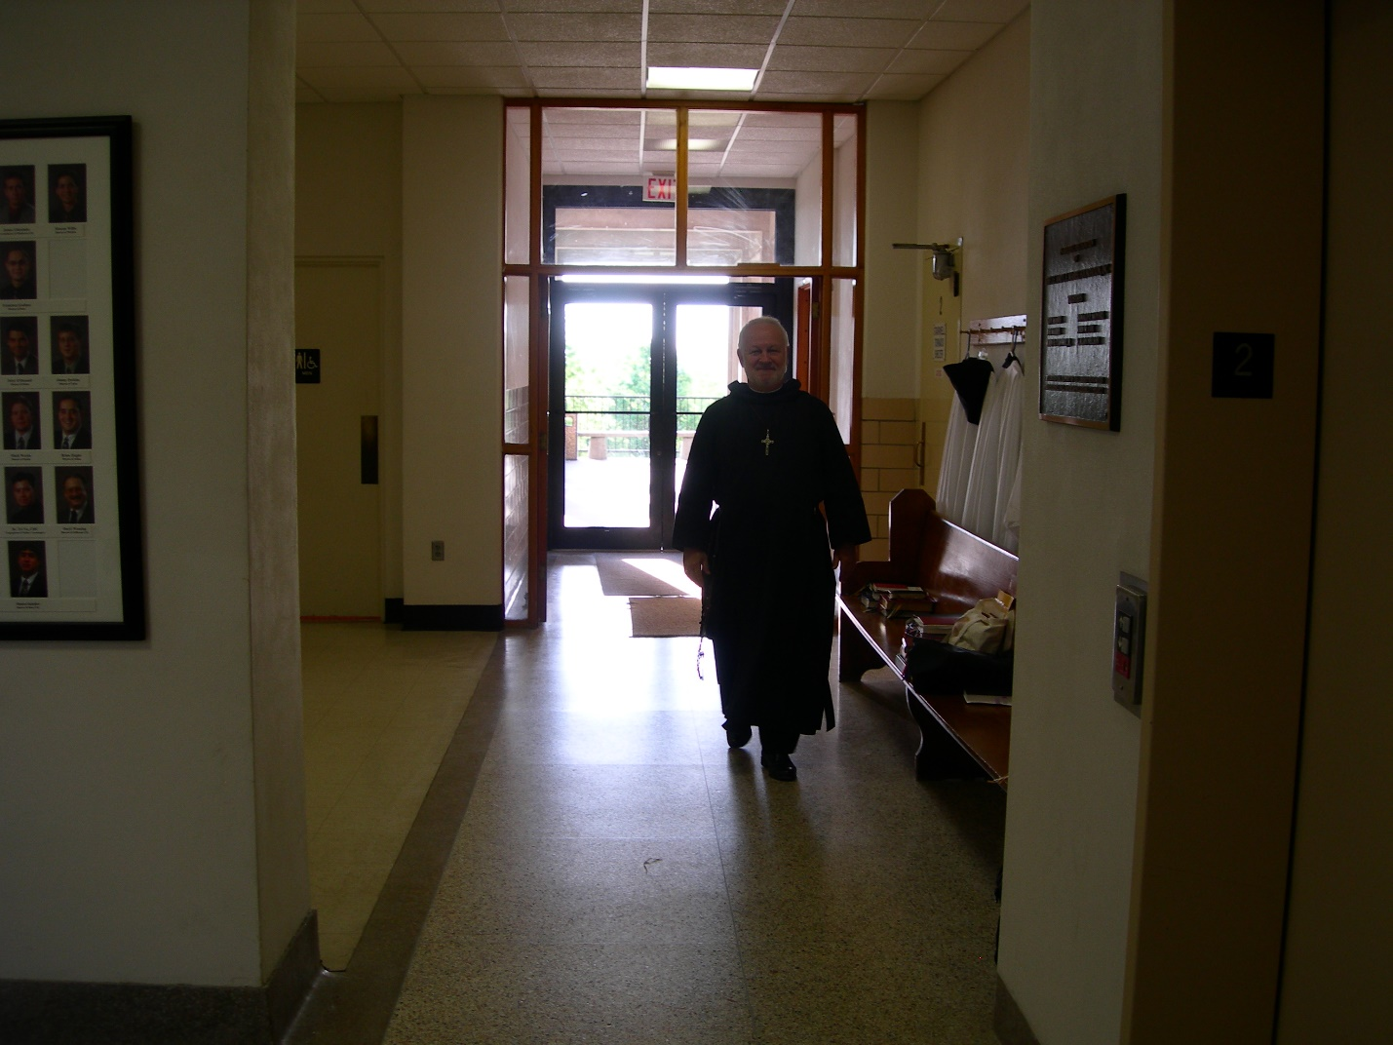
DSCN0238 Br. Christopher John Baumann
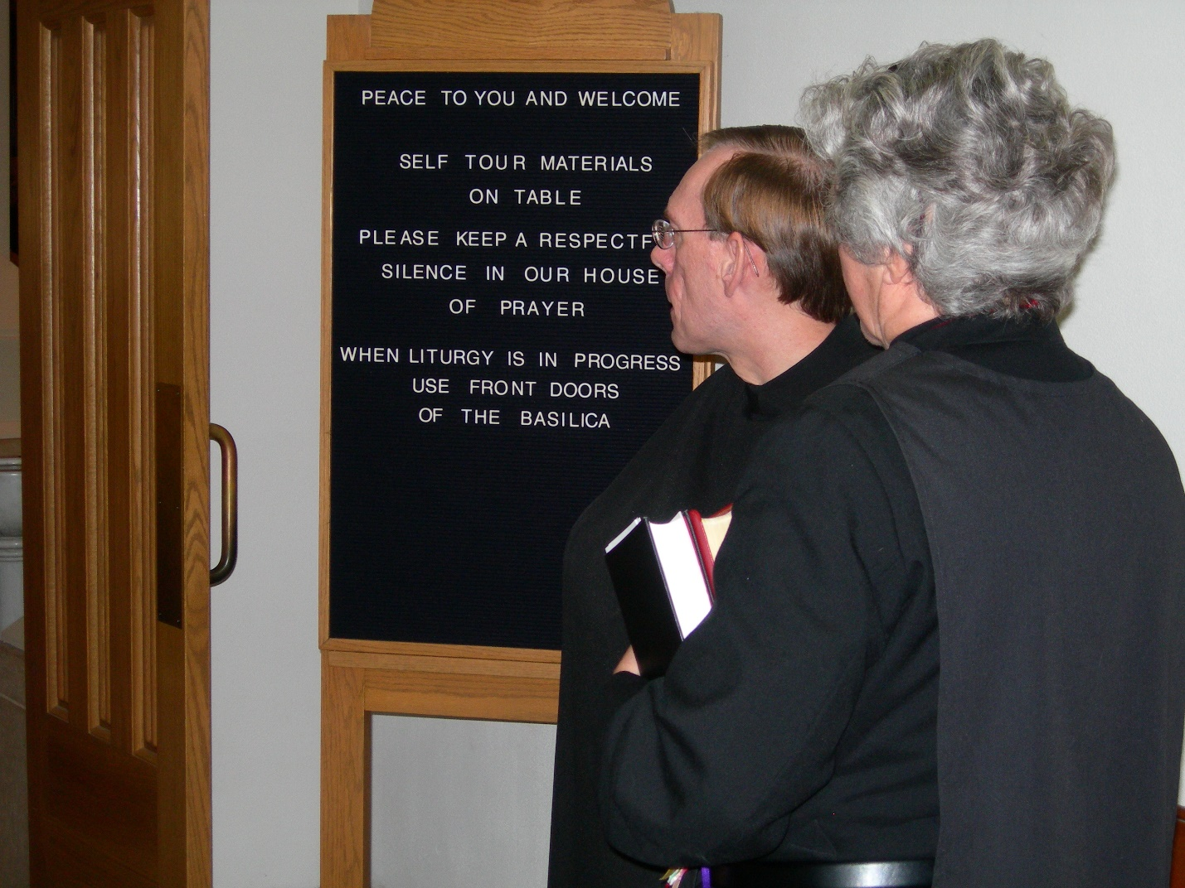DSCN0239 Br. Cyprian (Conception Abbey guestmaster); Sr. Johanna Kirkpatrick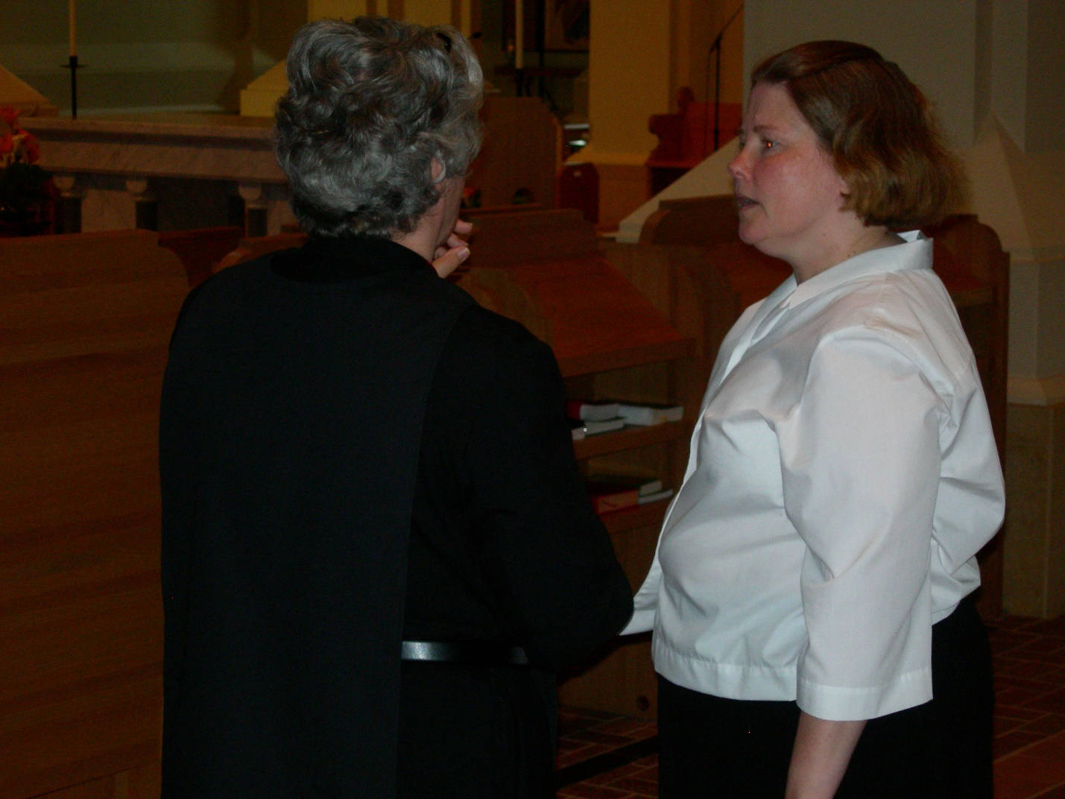
DSCN0241 Sr. Johanna Kirkpatrick; Maria Lundgren
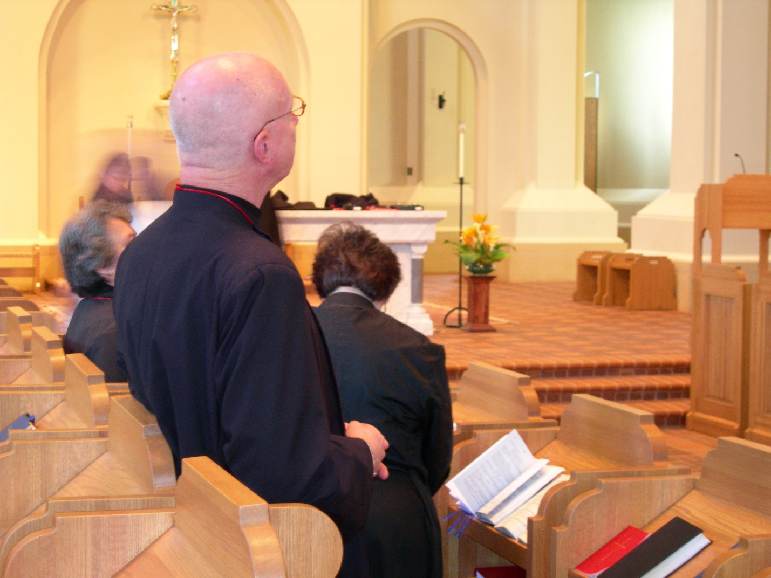
DSCN0242 Sr. Vincent Marie Rittenhouse; Br. David Vincent; Sr. Cecelia Lamoy
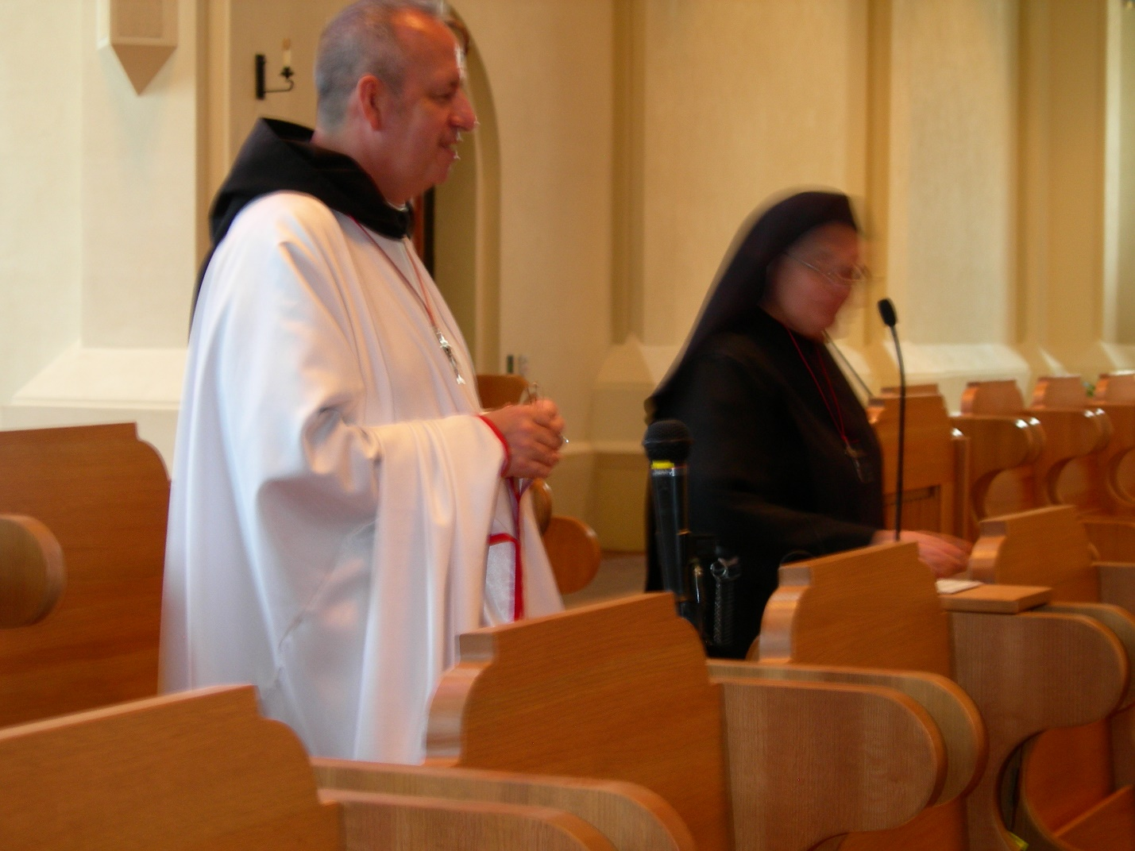
DSCN0243 Br. Gabriel Hale; Sr. Theodora of Jesus Perecca
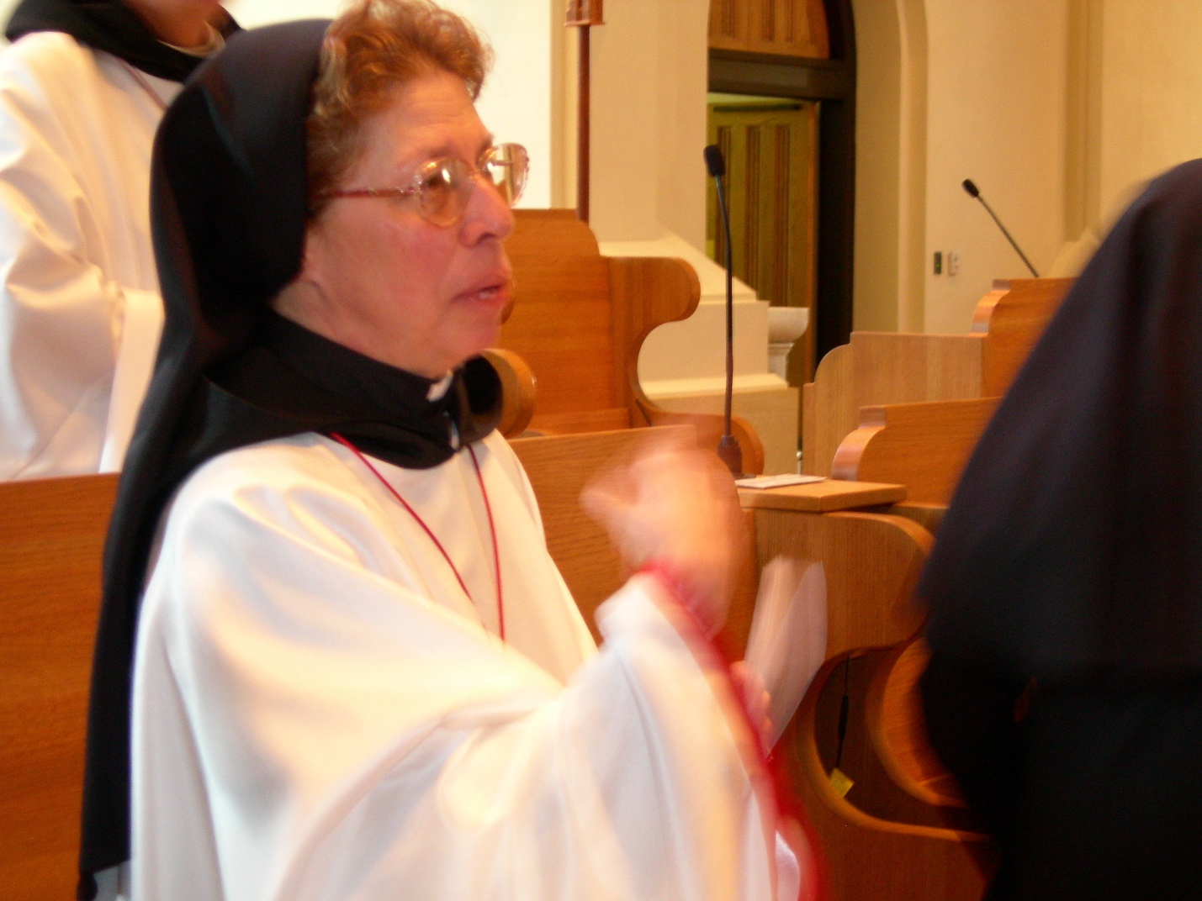
DSCN0245 Sr. Monica Ruth Mullen
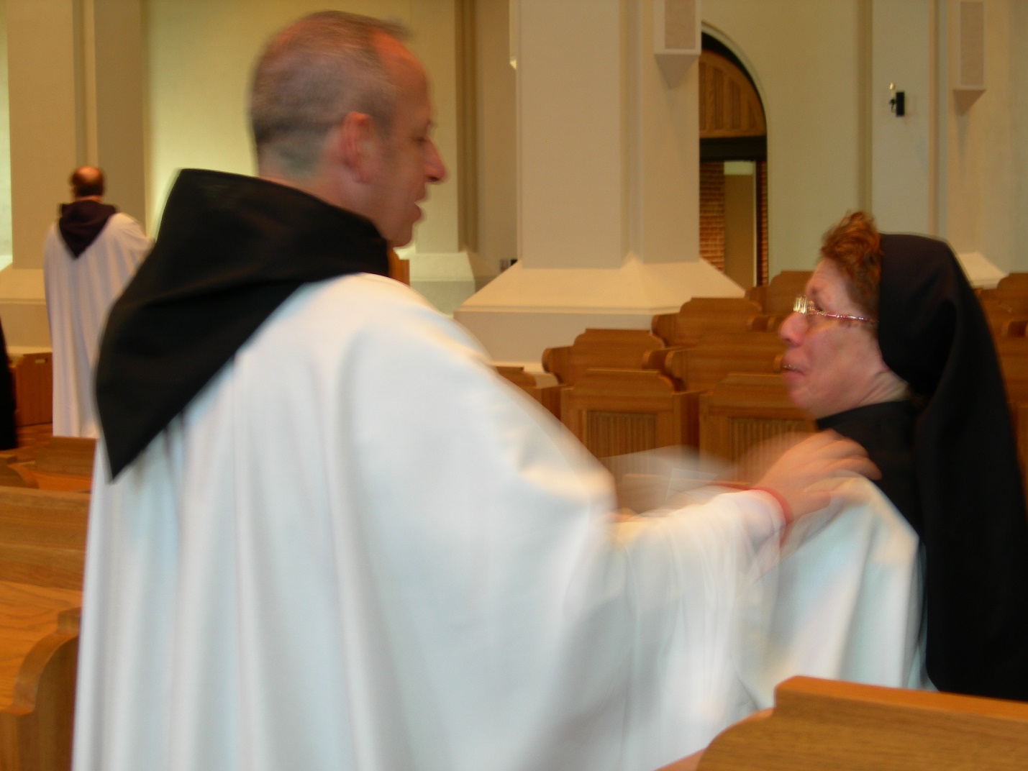
DSCN0247 Br. Raymond Owens; Br. Gabriel Hale; Sr. Monica Ruth Mullen
DSCN0248 Br. Raymond Owens; Br. Gabriel Hale; Sr. Monica Ruth Mullen
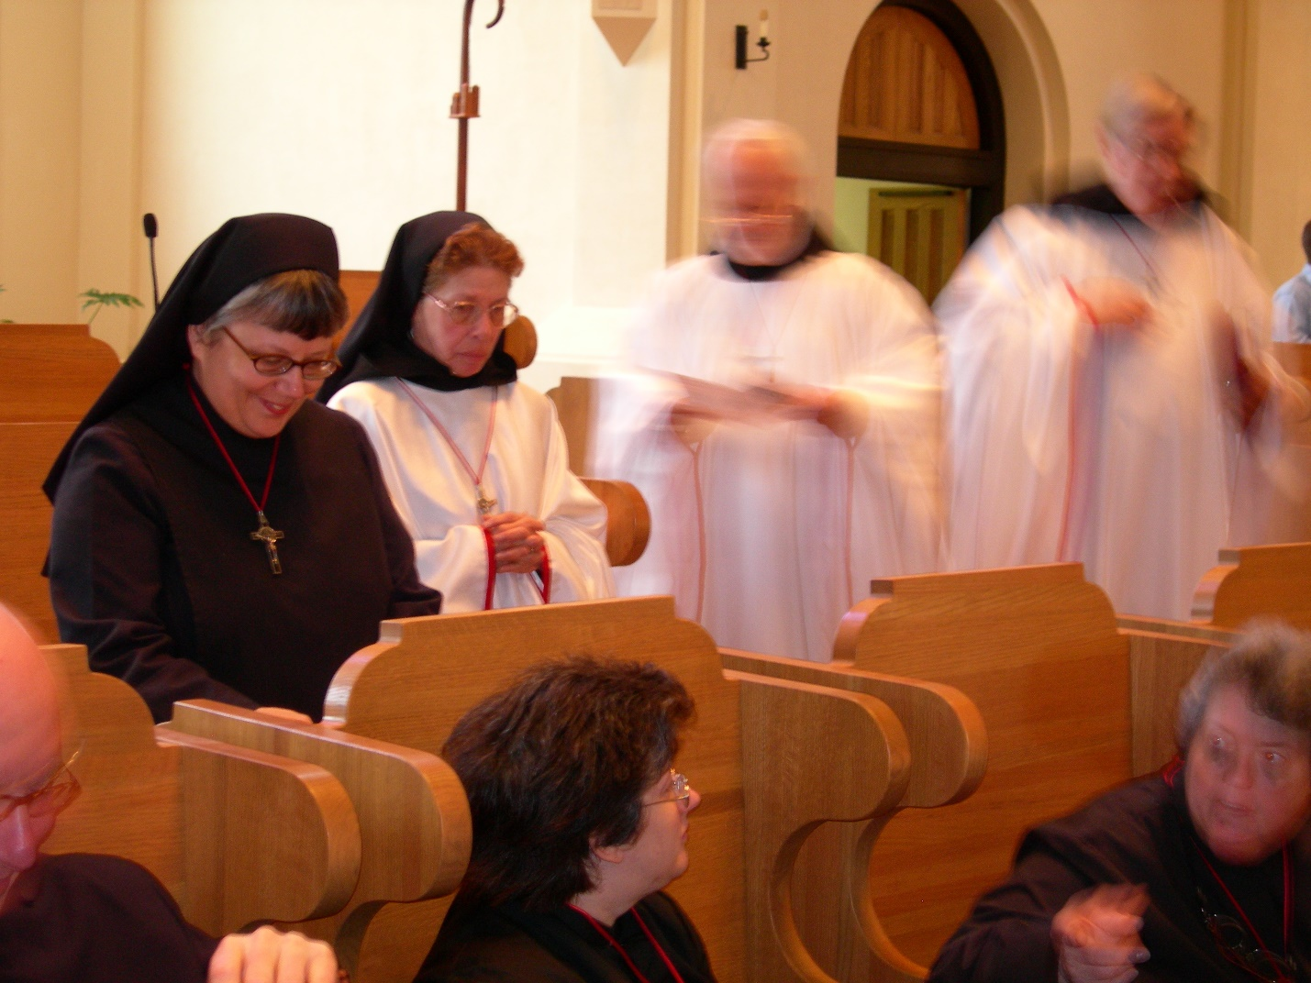
DSCN0250 First row: Br. David Vincent Cotton; Sr. Cecelia Lamoy; Sr. Vincent Marie Rittenhouse
Second row: Sr. Anna Grace Madden; Sr. Monica Ruth Mullen; Br. Christopher John Bau,mann; Br. Chad Anselm Gerns
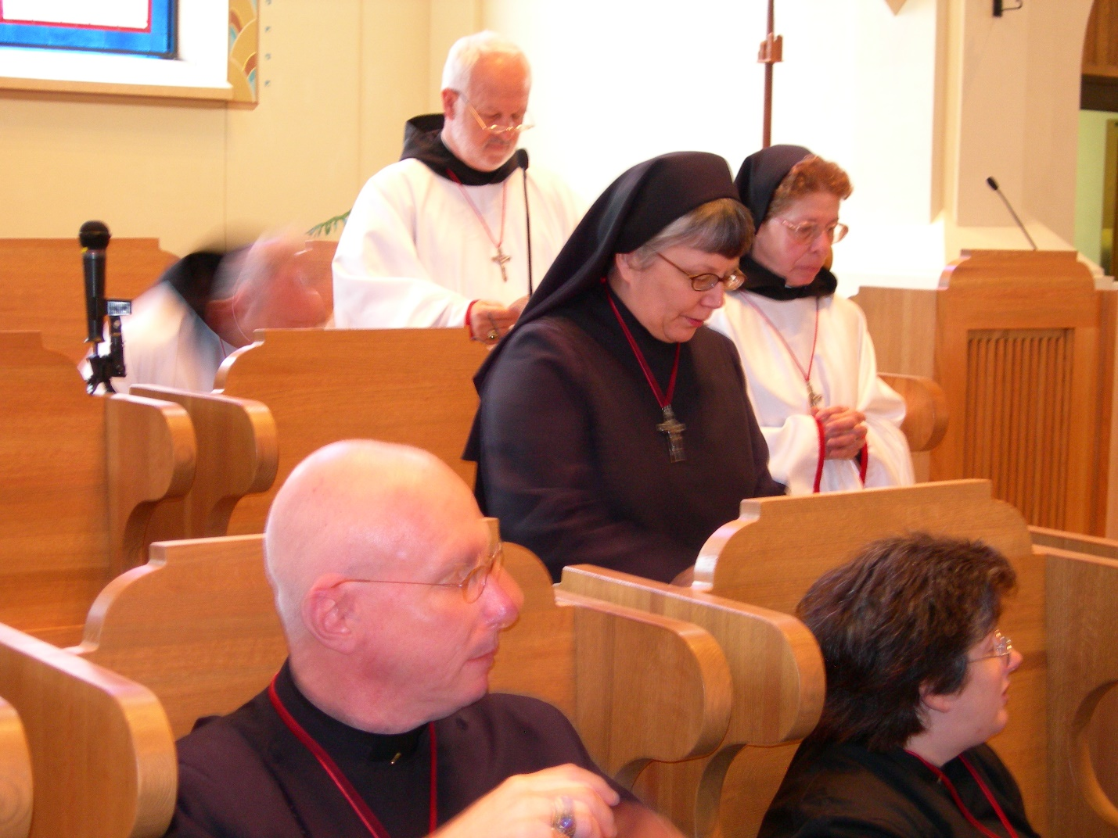
DSCN0251 Br. David Vincent Cotton; Br. Christopher John Baumann; Sr. Anna Grace Madden; Sr. Monica Rith Mullen; Sr. Cecilia Lamoy
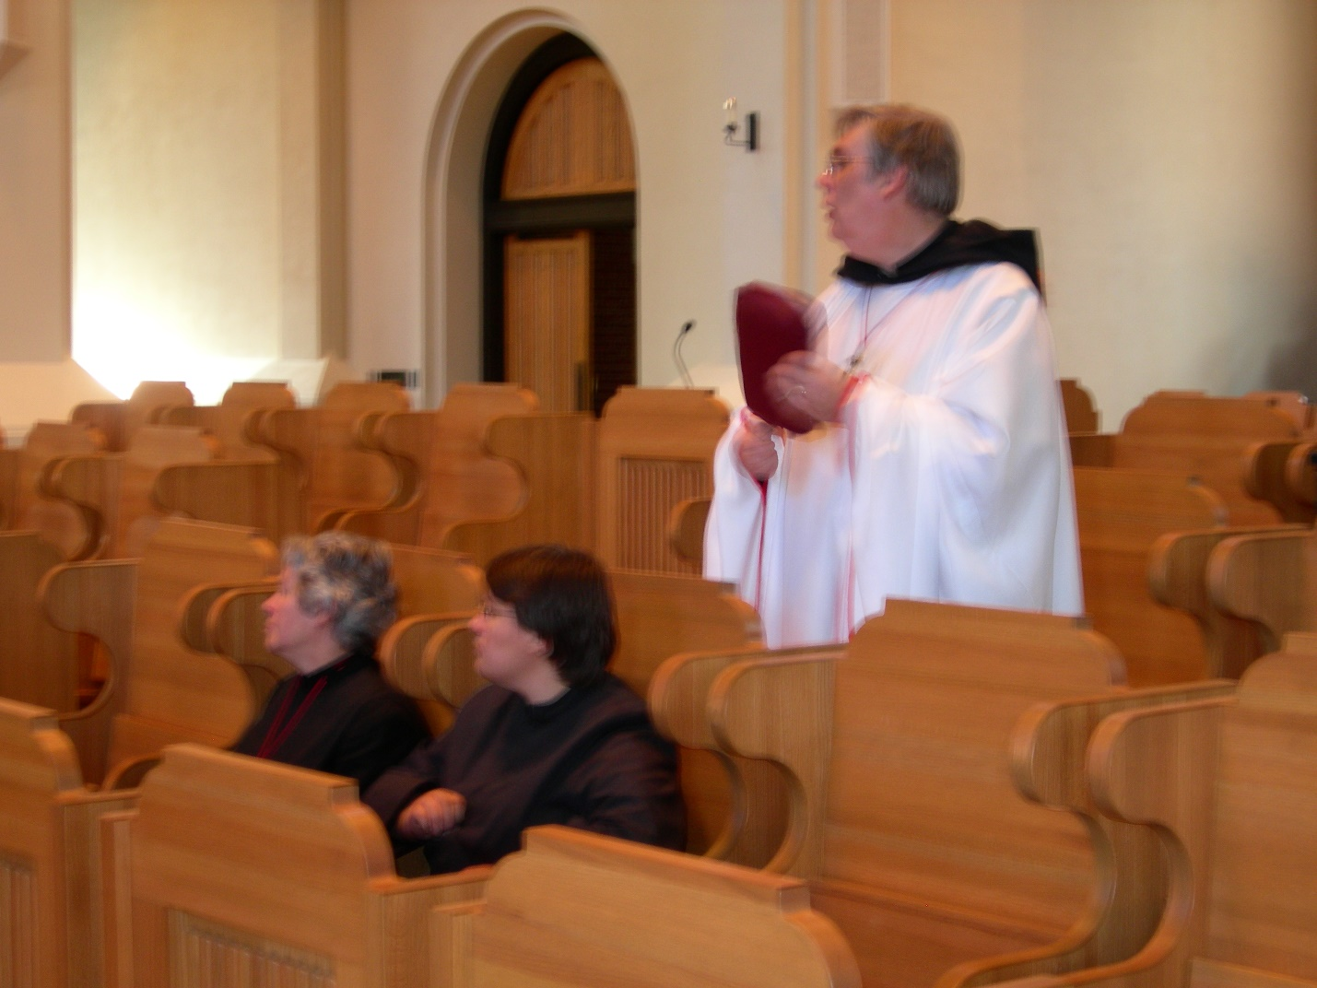
DSCN0252 Sr. Johanna Kirkpatrick; Sr. Pauline Tysol; Br. Chad Anselm Gerns
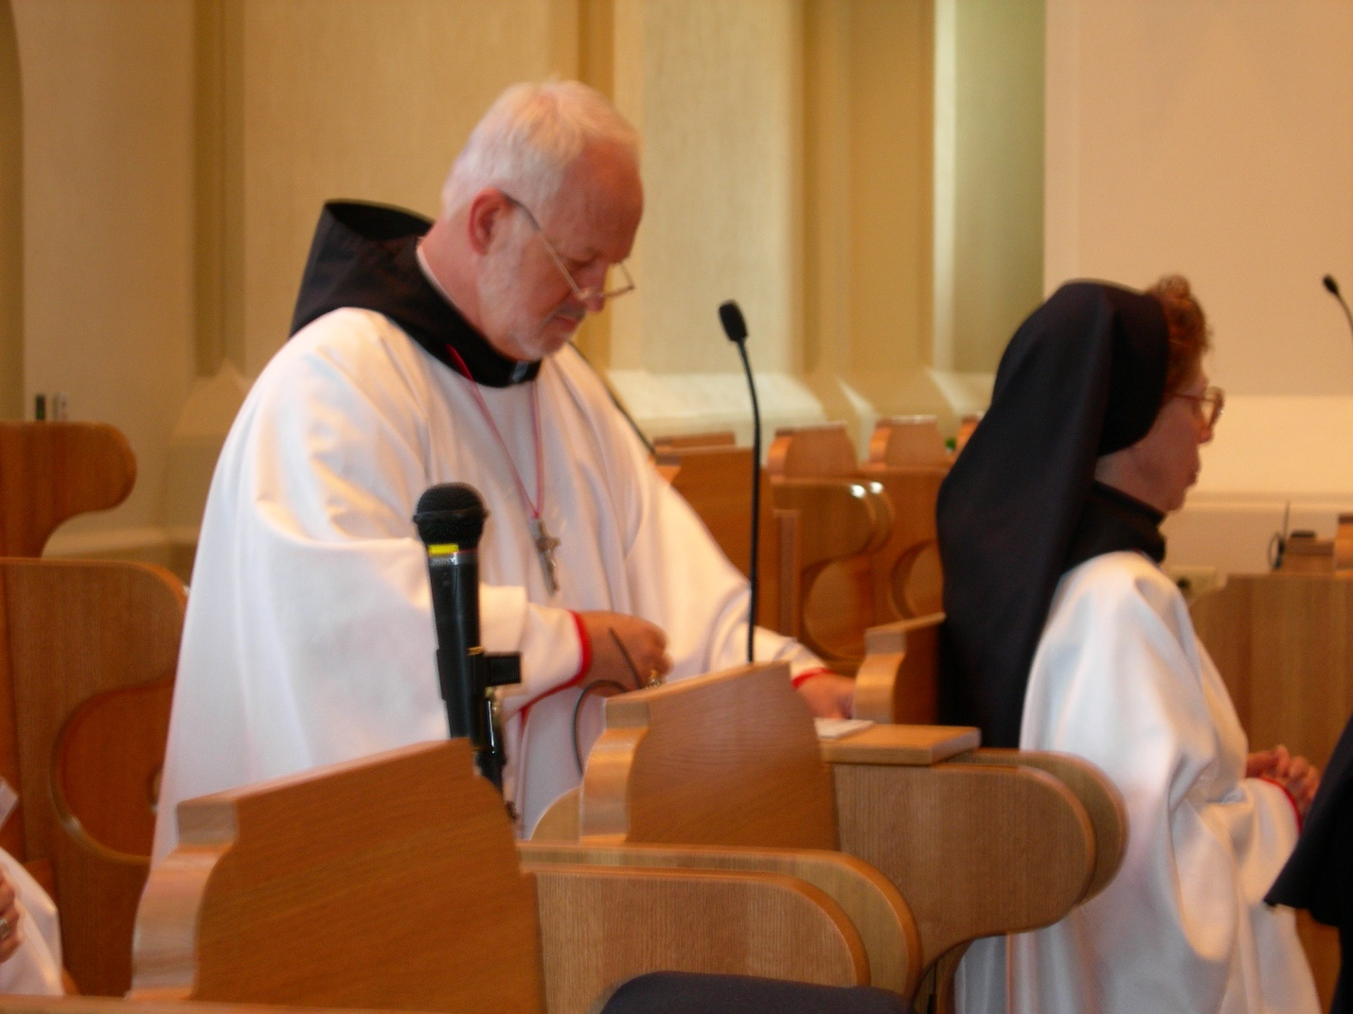
DSCN0252 Br. Christopher John Baumann; Sr. Monica Ruth Mullen
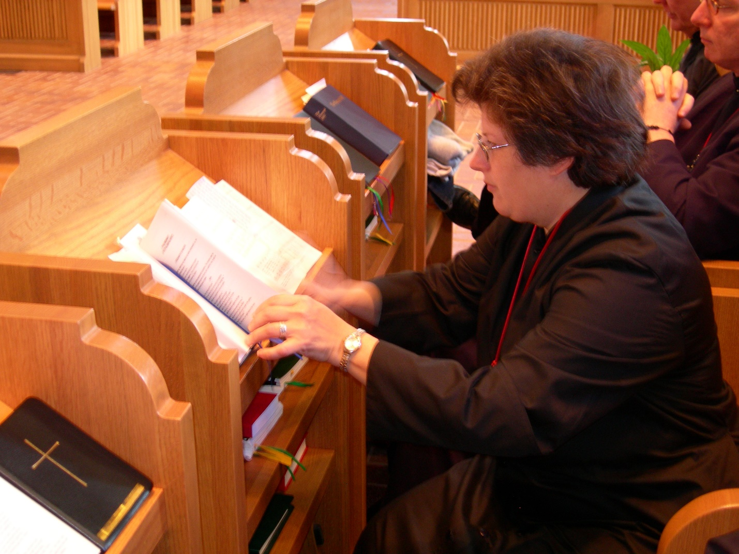
DSCN0254 Sr. Cecilia Lamoy; Br. David Vincent Cotton
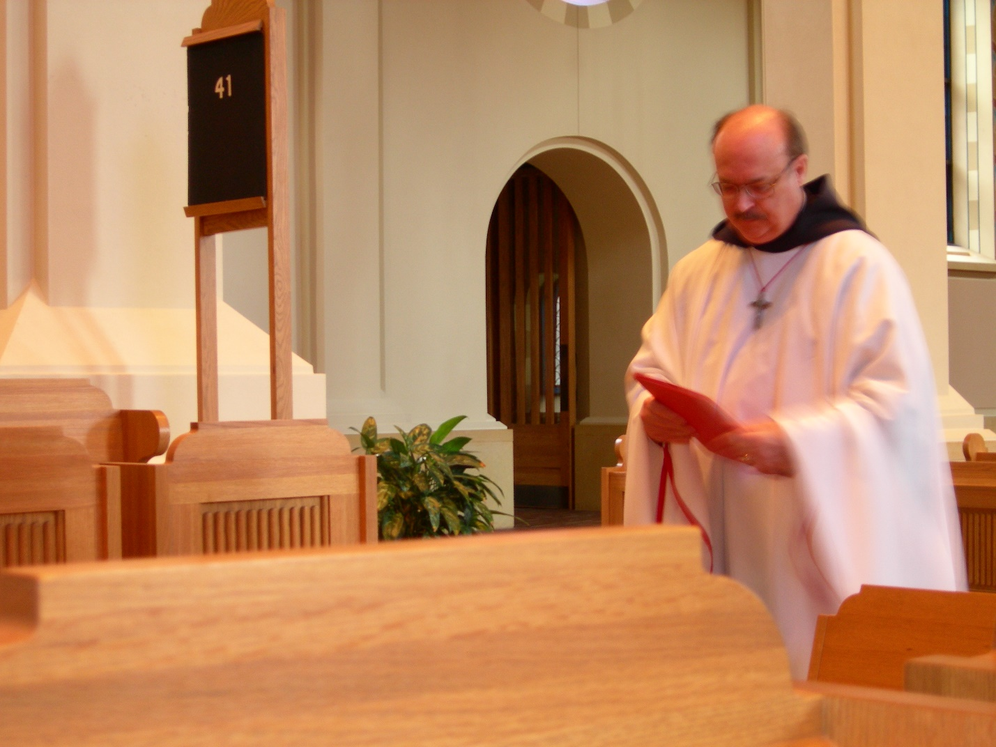
DSCN0255 Br. Raymond Owens
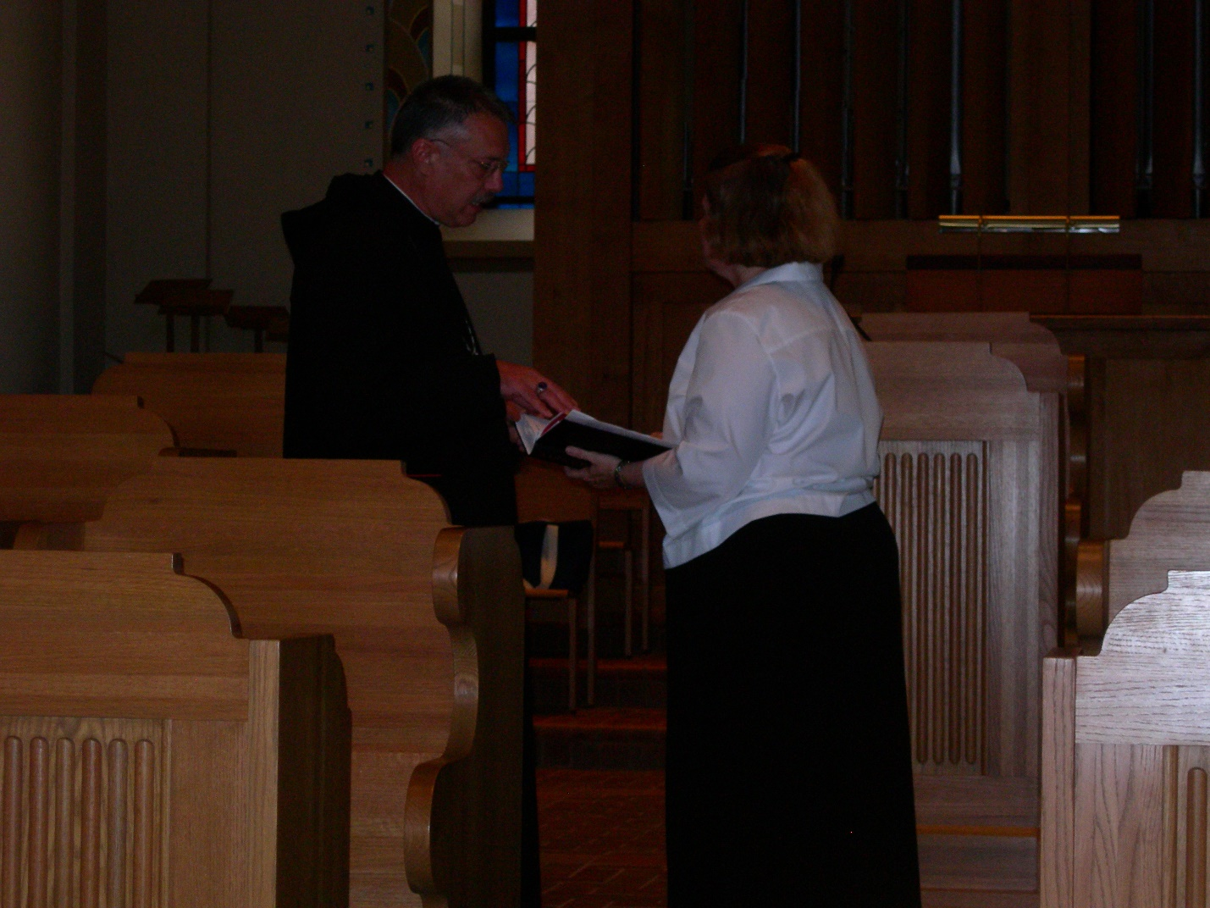
DSCN0258 Abbot Michael John Austin; Maria Lundgren
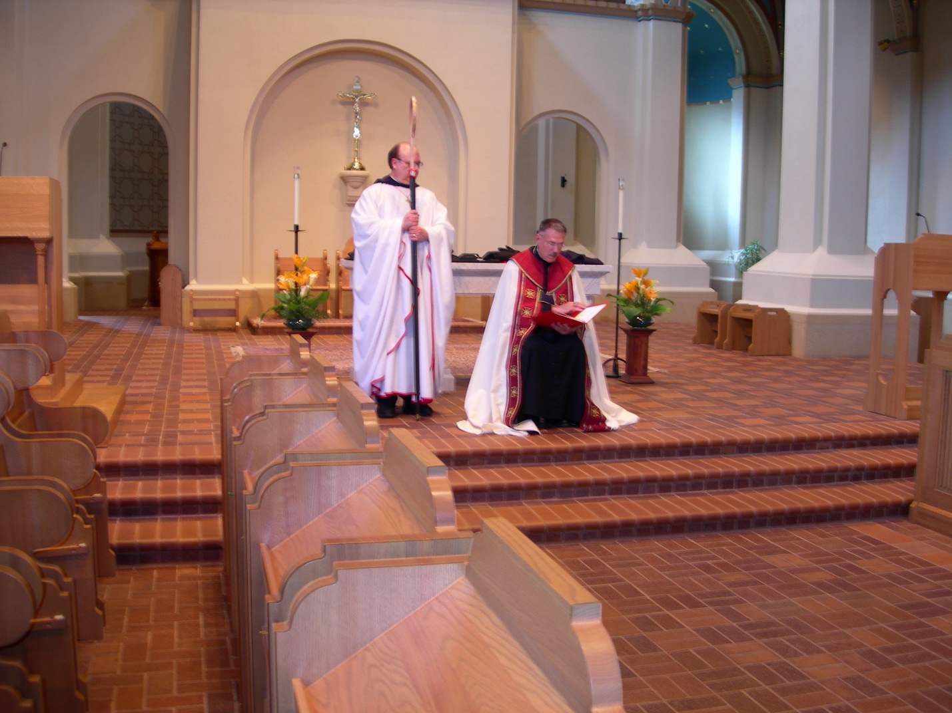
DSCN0259 Br. Raymond Owens; Abbot Michael John Austin
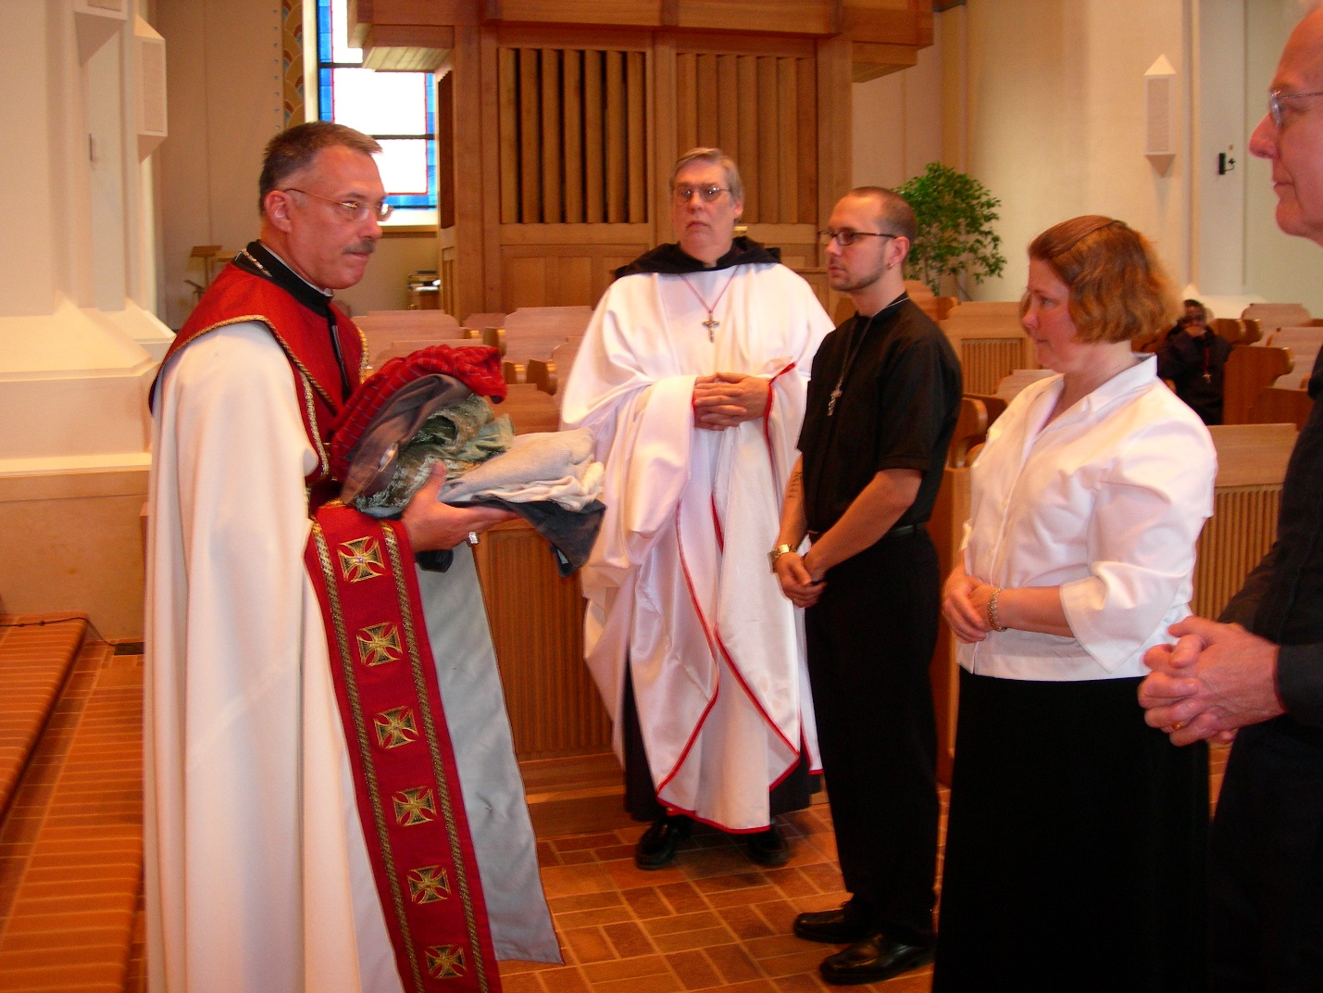
DSCN0260 Abbot Michael John Austin; Br. Chad Anselm Gerns; Christopher Sowers; Maria Lundgren; Lee Doucette
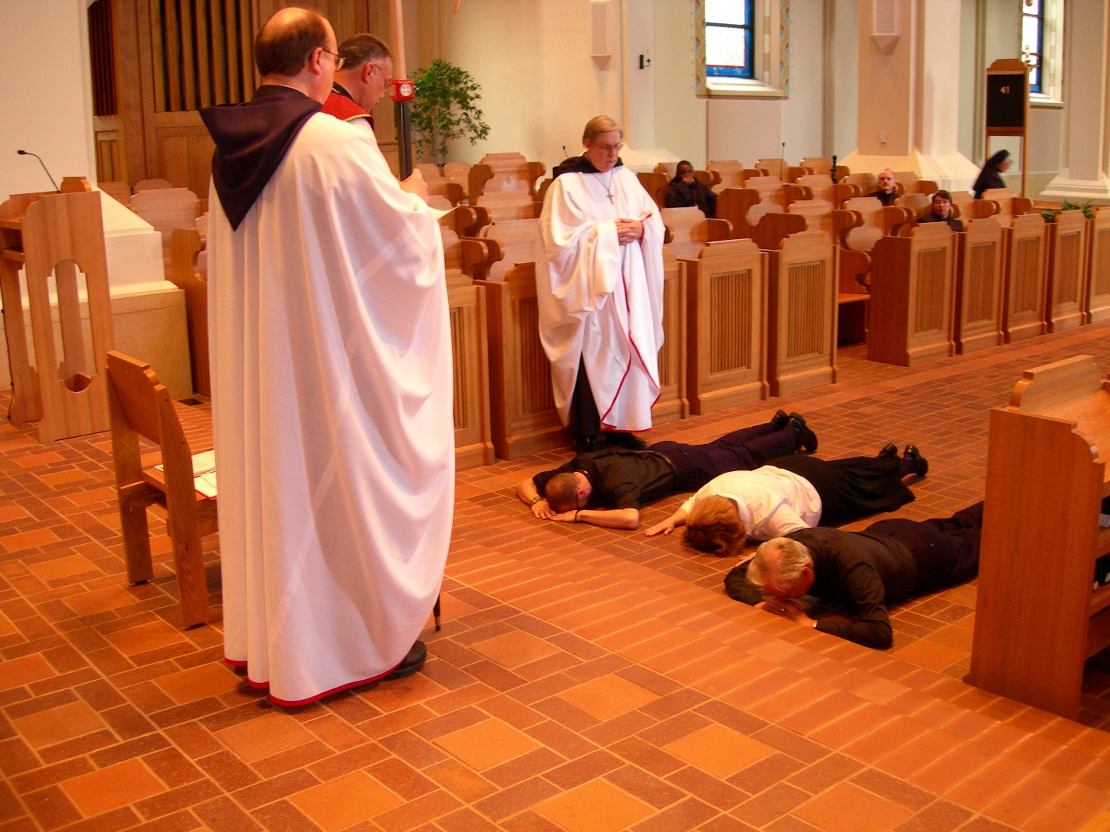
DSCN0261 Br. Raymond Owens; Abbot Michael John Austin; Br. Chad Anselm Gerns; Christopher Sowers; Maria Lundgren; Lee Doucette
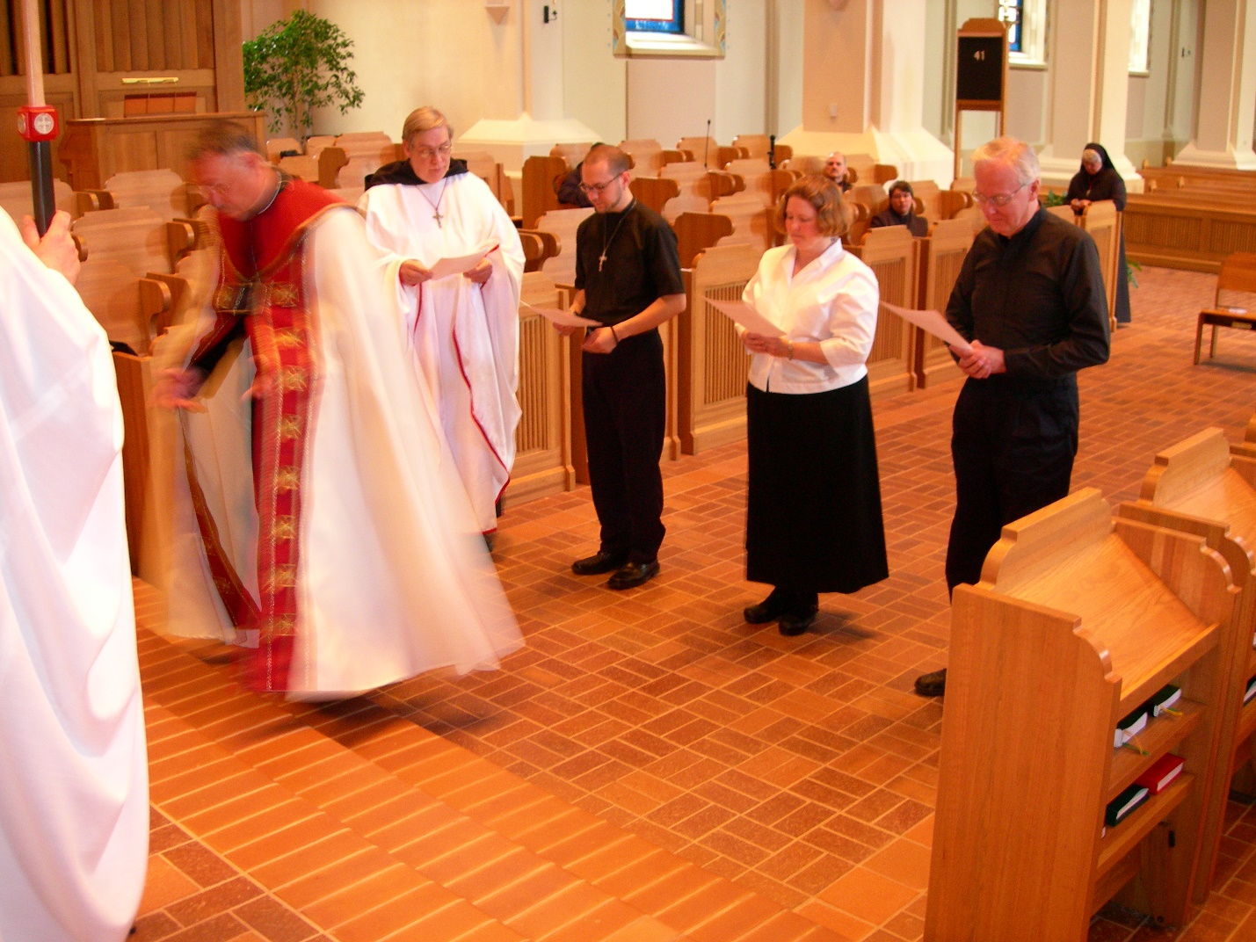
DSCN0262 Br. Raymond Owens; Abbot Michael John Austin; Br. Chad Anselm Gerns; Christopher Sowers; Maria Lundgren; Lee Doucette

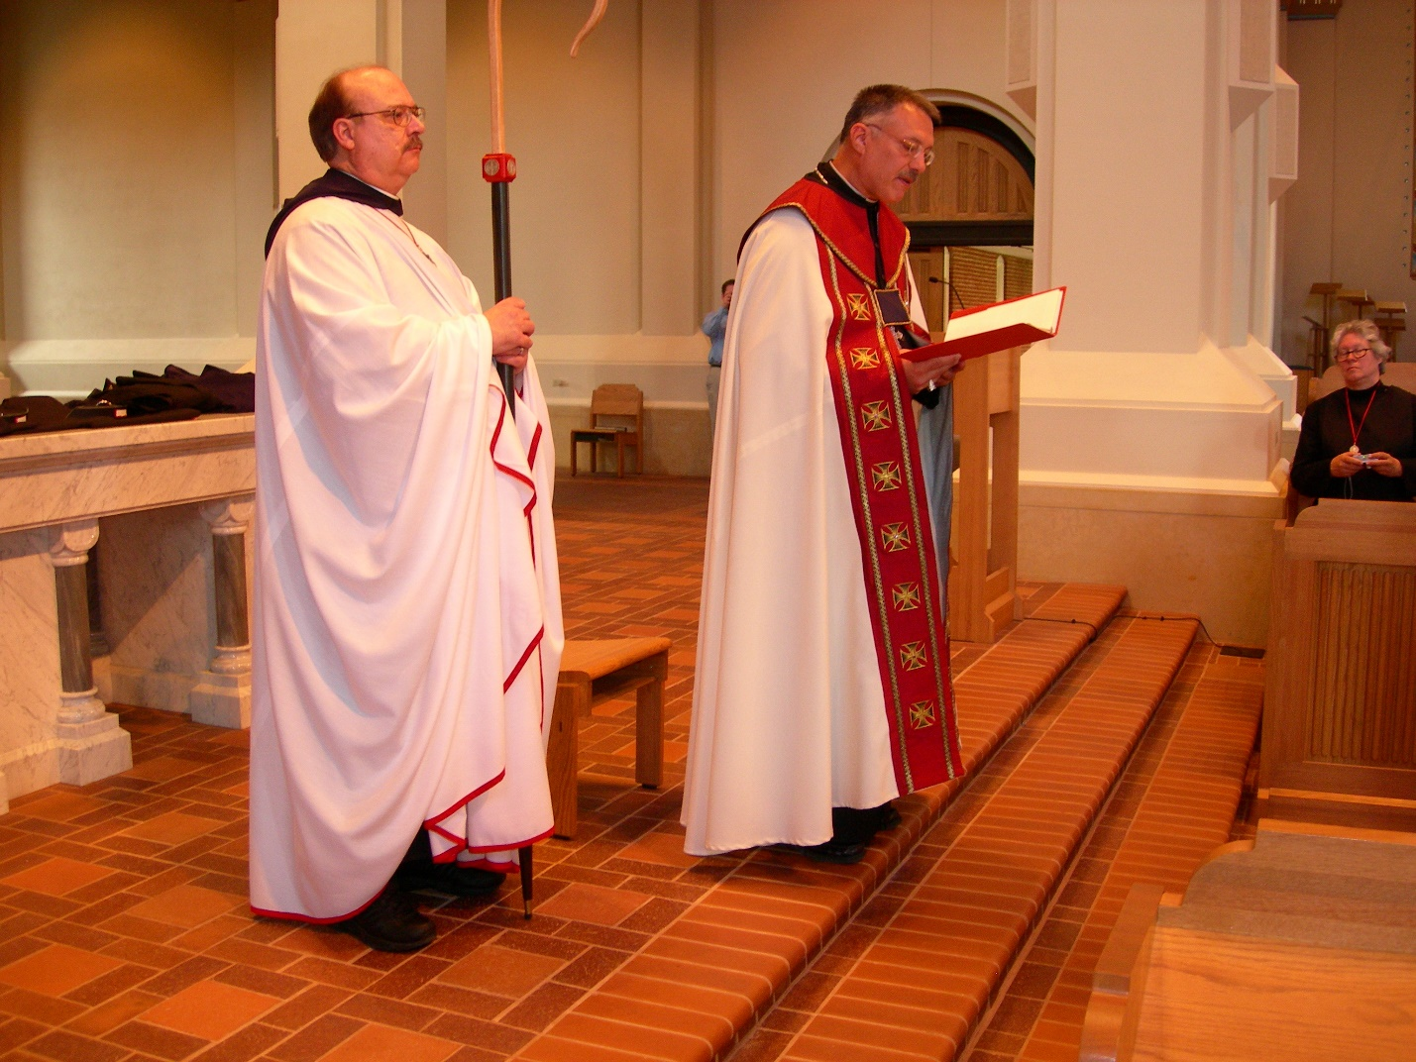
DSCN0263 Br. Raymond Owens; Abbot Michael John Austin; Sr. Johanna Kirkpatrick
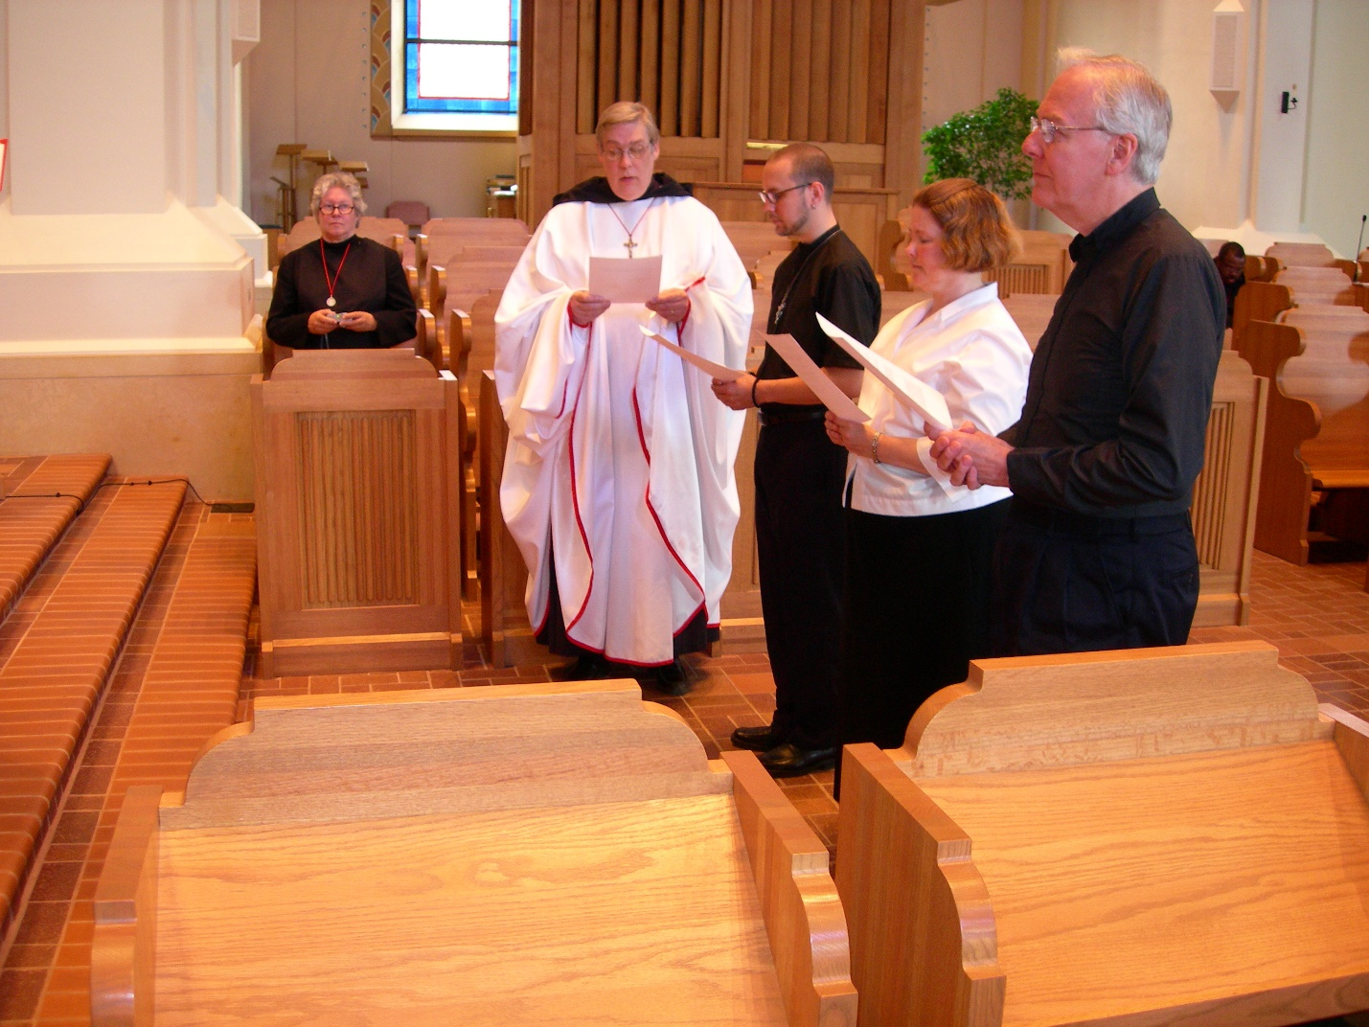
DSCN0264 Sr. Johanna Kirkpatrick; Br. Chad Anselm Gerns; Christopher Sowers; Maria Lundgren; Lee Doucette
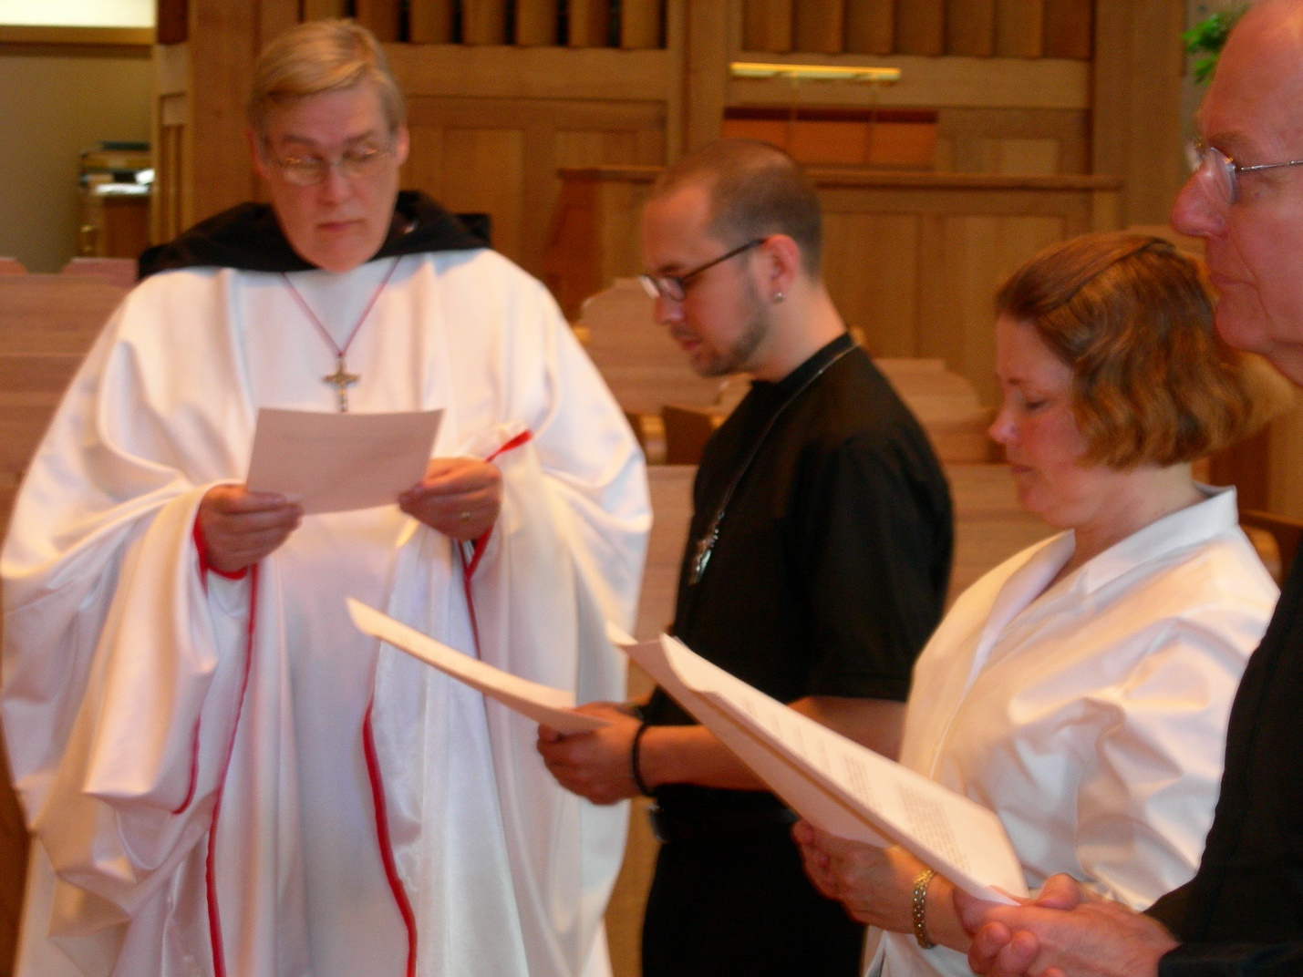
DSCN0265 Br. Chad Anselm Gerns; Christopher Sowers; Maria Lundgren; Lee Doucette

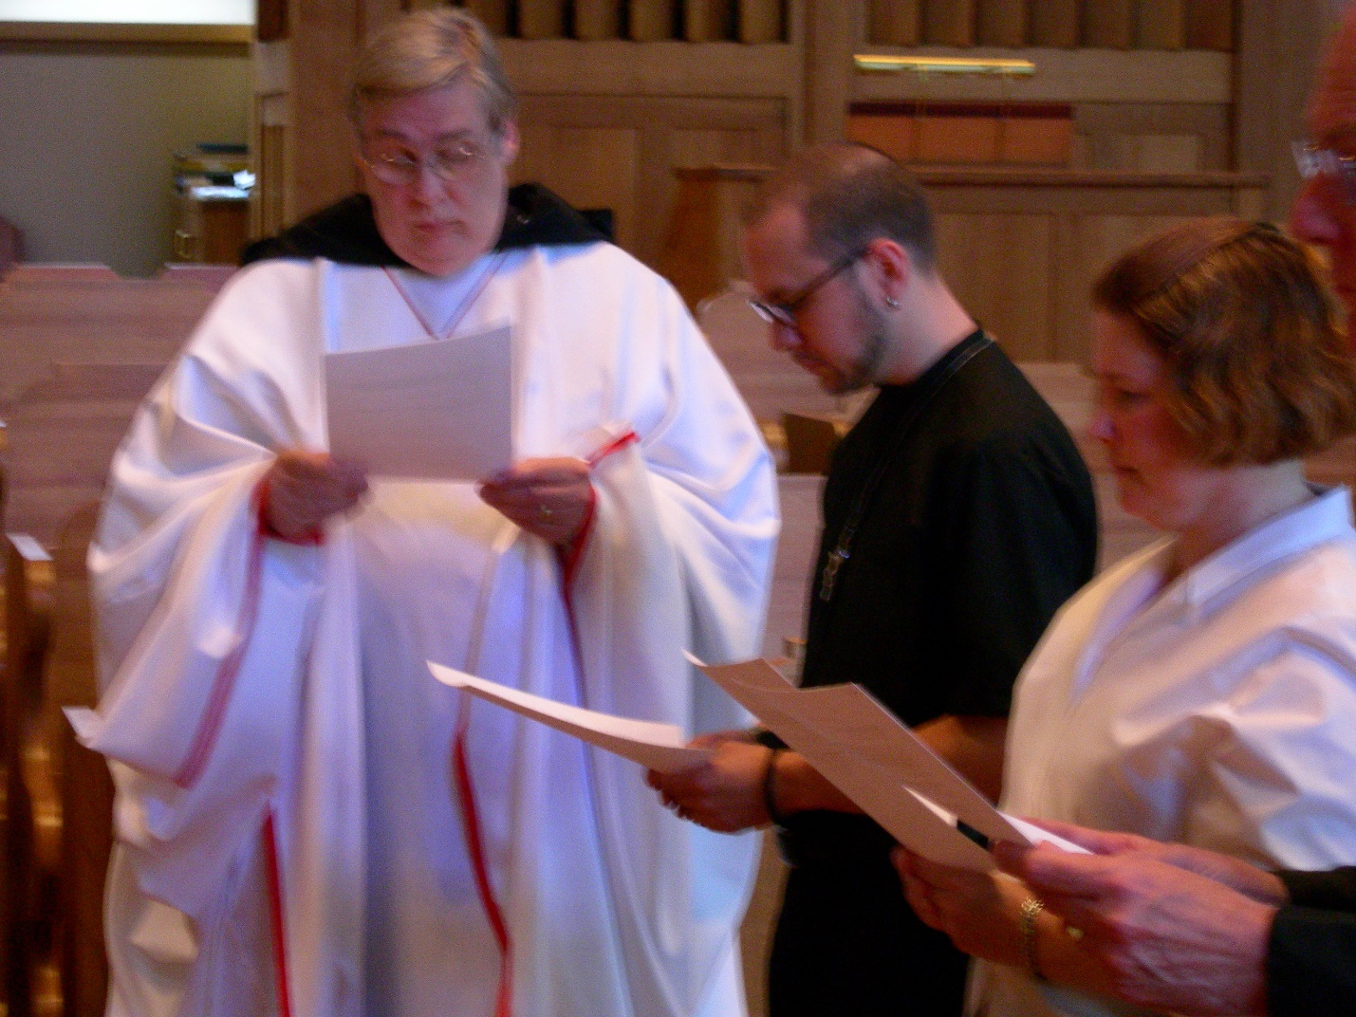
DSCN0266 Br. Chad Anselm Gerns; Christopher Sowers; Maria Lundgren; Lee Doucette

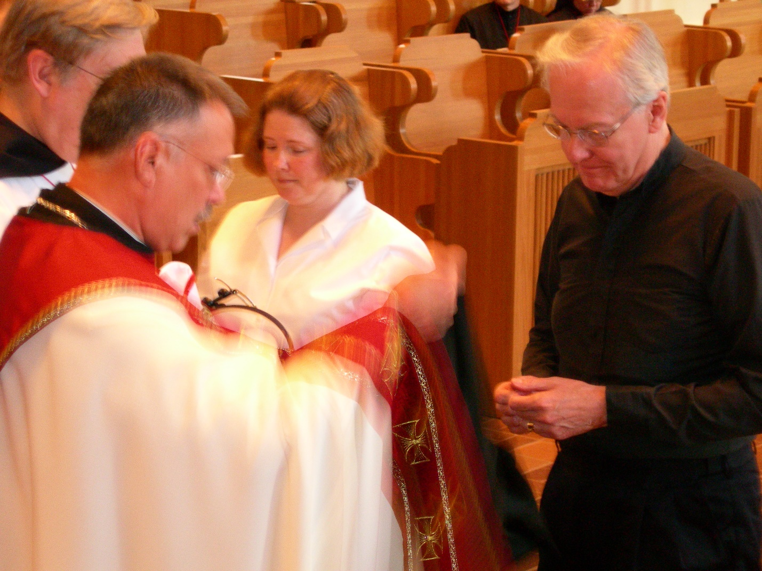
DSCN0267 Abbot Michael John Austin; Br. Chad Anselm Gerns; Maria Lundgren; Lee Doucette

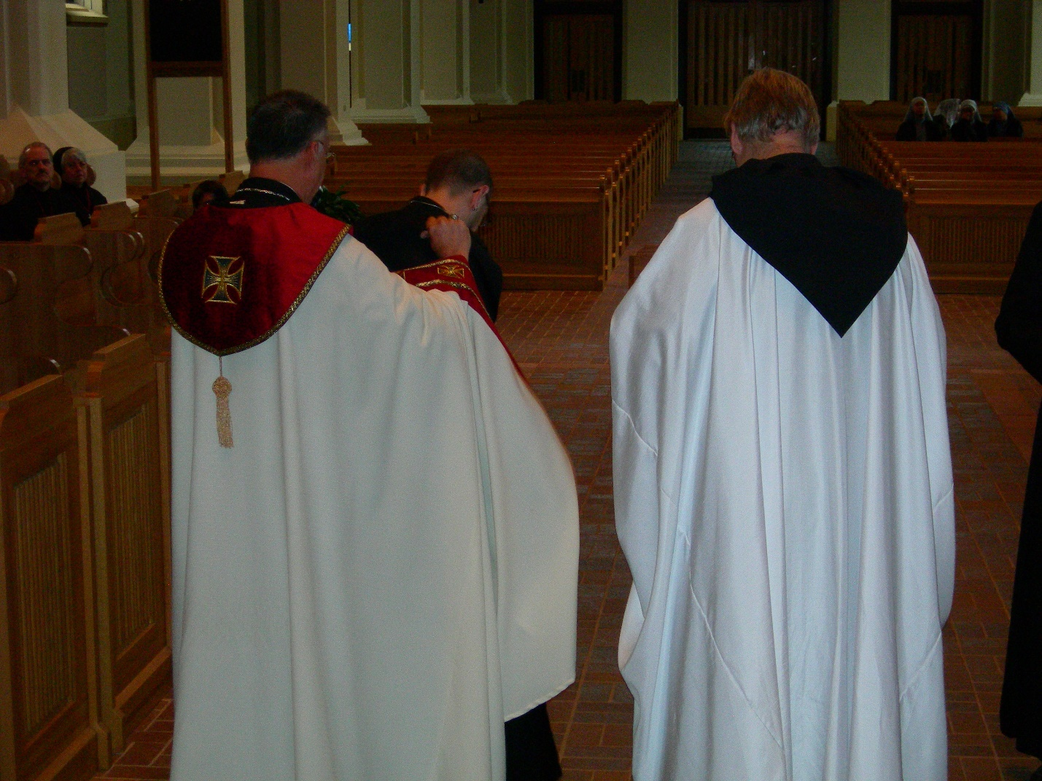
DSCN0270 Abbot Michael John Austin; Br. Eckhart Sowers; Br. Chad Anselm Gerns

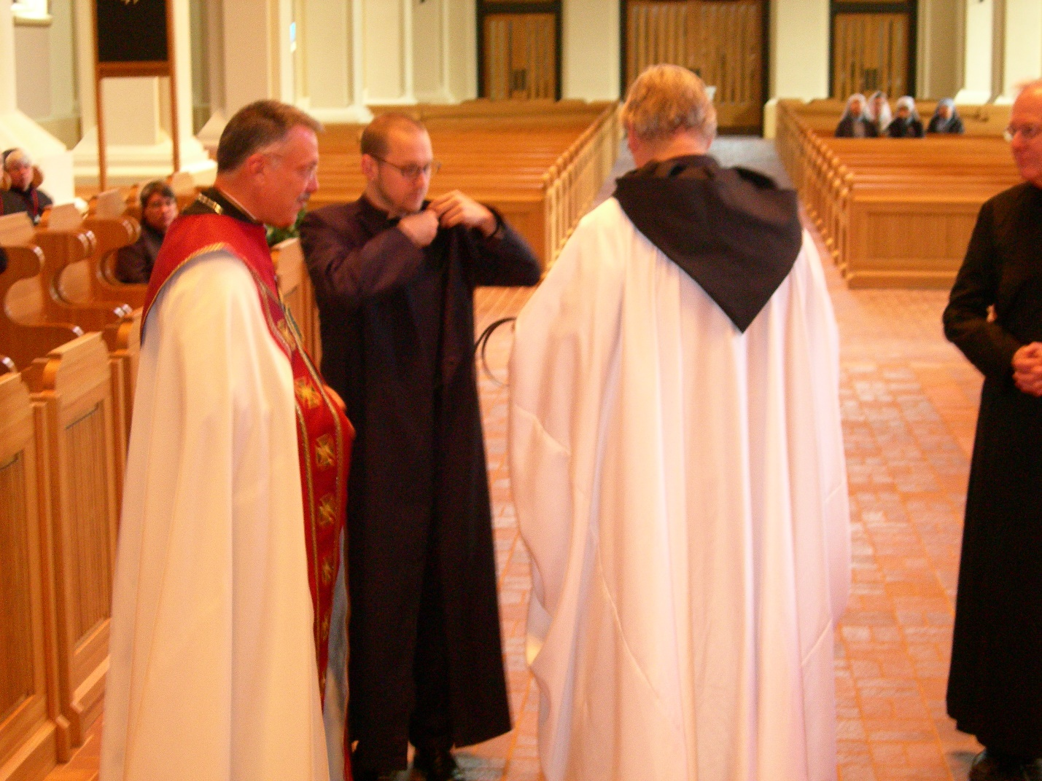
DSCN0271 Abbot Michael John Austin; Br. Eckhart Sowers; Br. Chad Anselm Gerns; Br. Luke Doucette

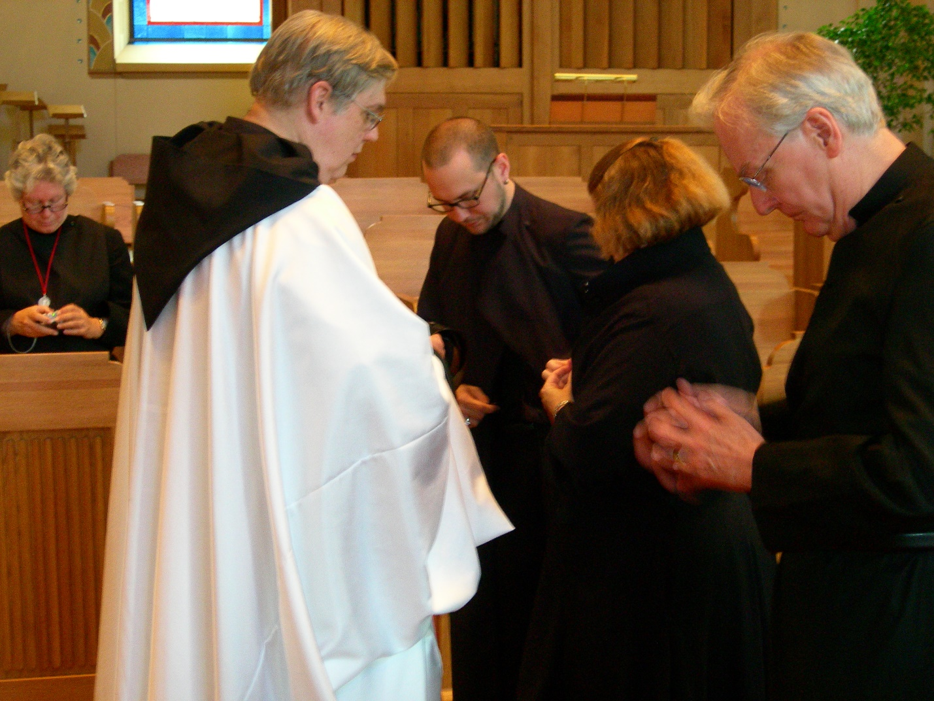
DSCN0272 Sr. Johnana Kirkpatrick; Br. Chad Anselm Gerns; Br. Eckhart Sowers; Sr. Hilary Grace Lundgren; Br. Luke Doucette
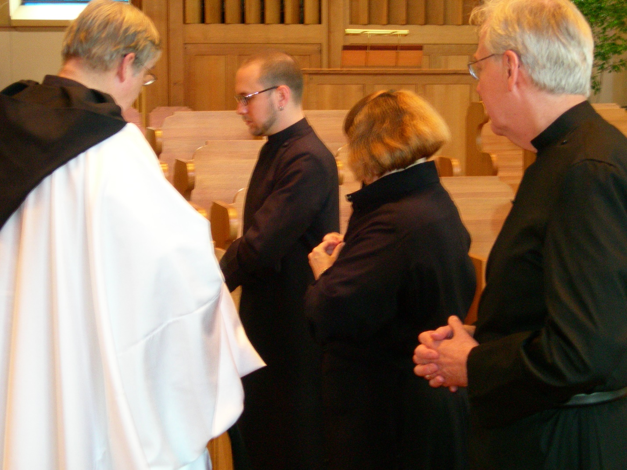
DSCN0273 Br. Chad Anselm Gerns; Br. Eckhart Sowers; Sr. Hilary Grace Lundgren; Br. Luke Doucette
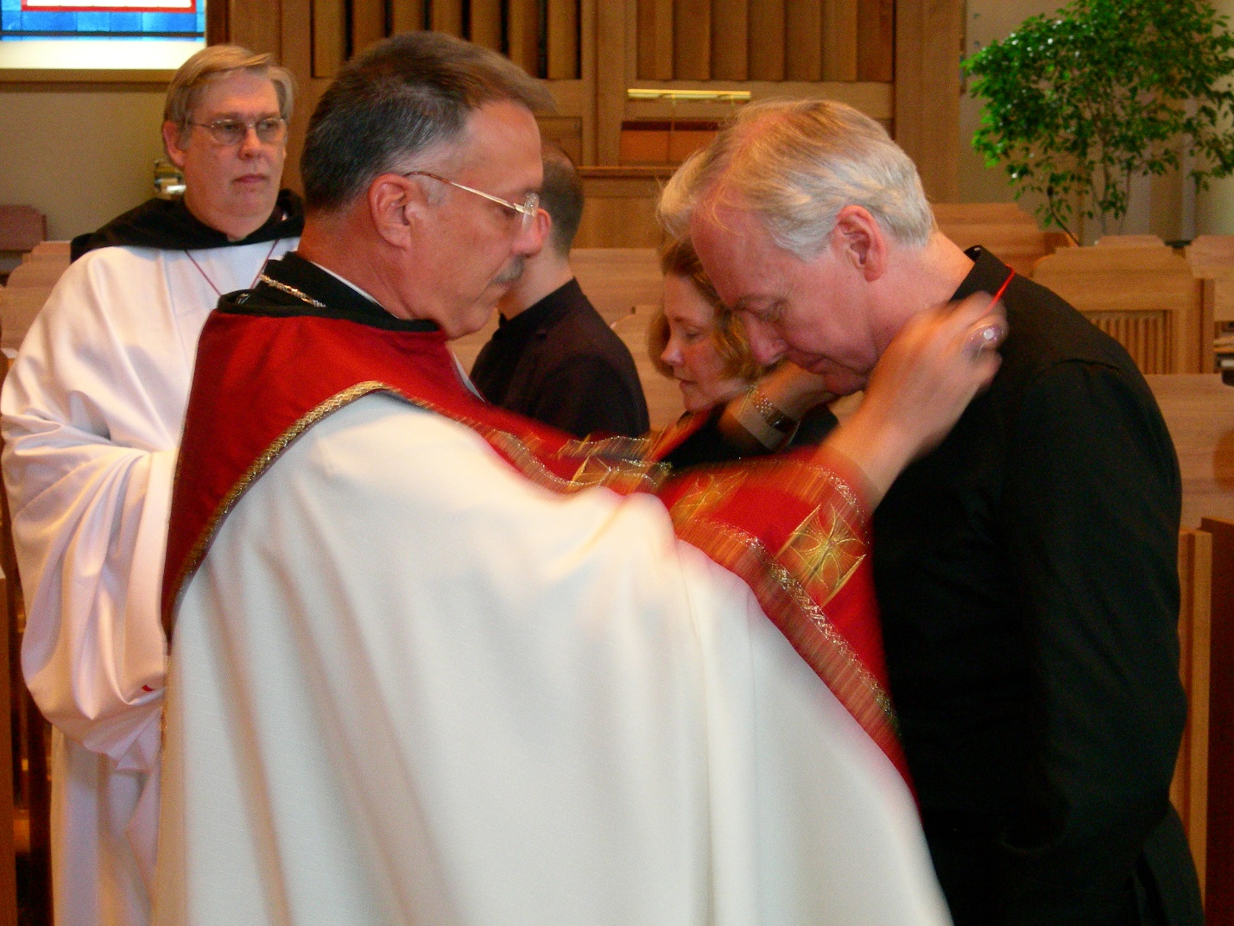
DSCN0274 Br. Chad Anselm Gerns; Abbot Michael John Austin; Br. Eckhart Sowers; Sr. Hilary Grace Lundgren; Br. Luke Doucette
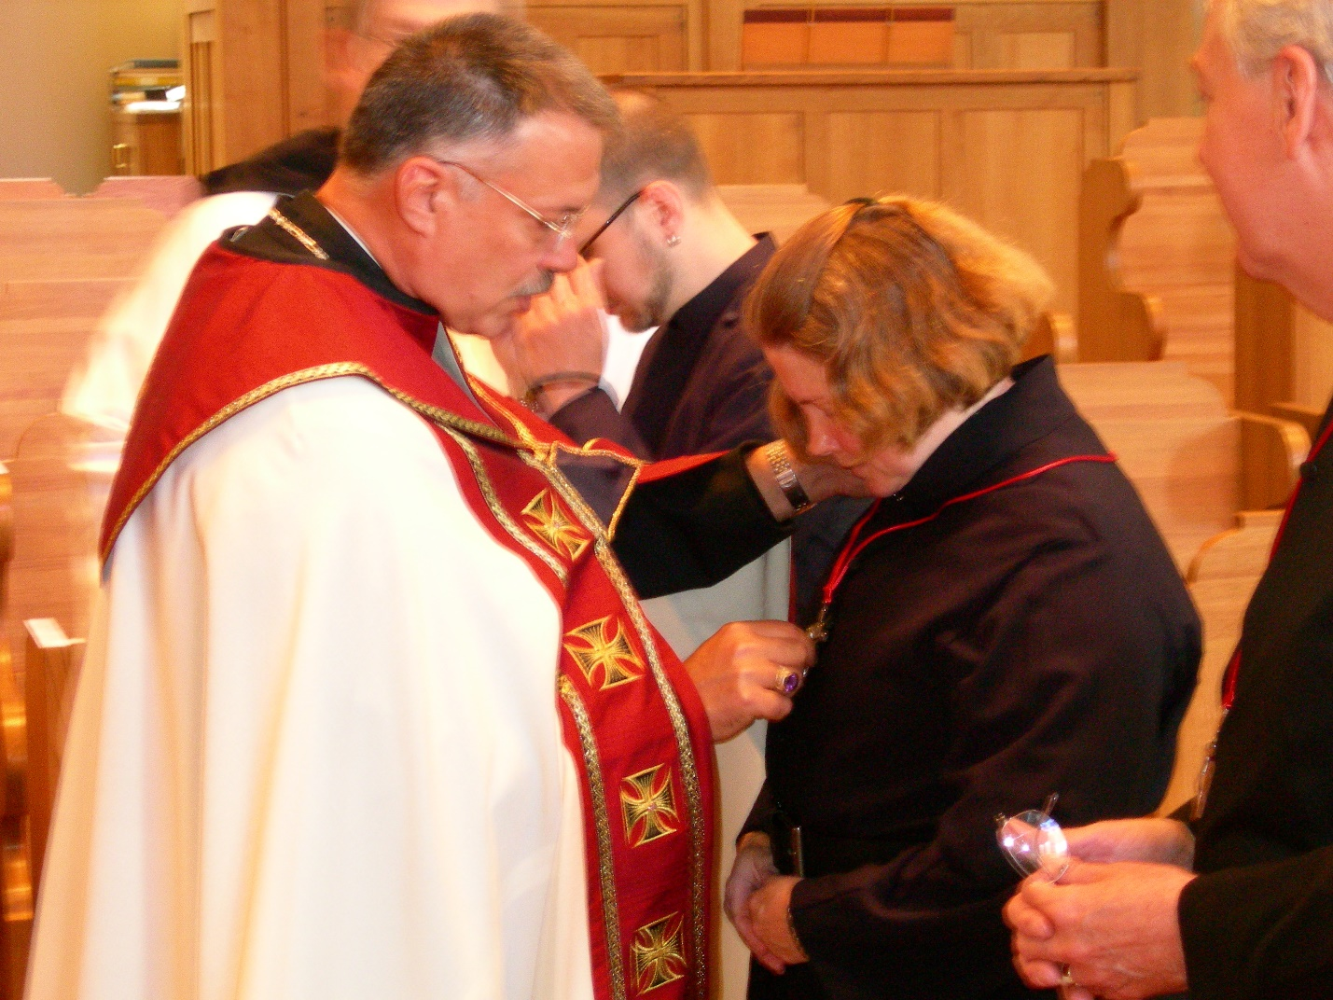
DSCN0275 Br. Chad Anselm Gerns; Abbot Michael John Austin; Br. Eckhart Sowers; Sr. Hilary Grace Lundgren; Br. Luke Doucette
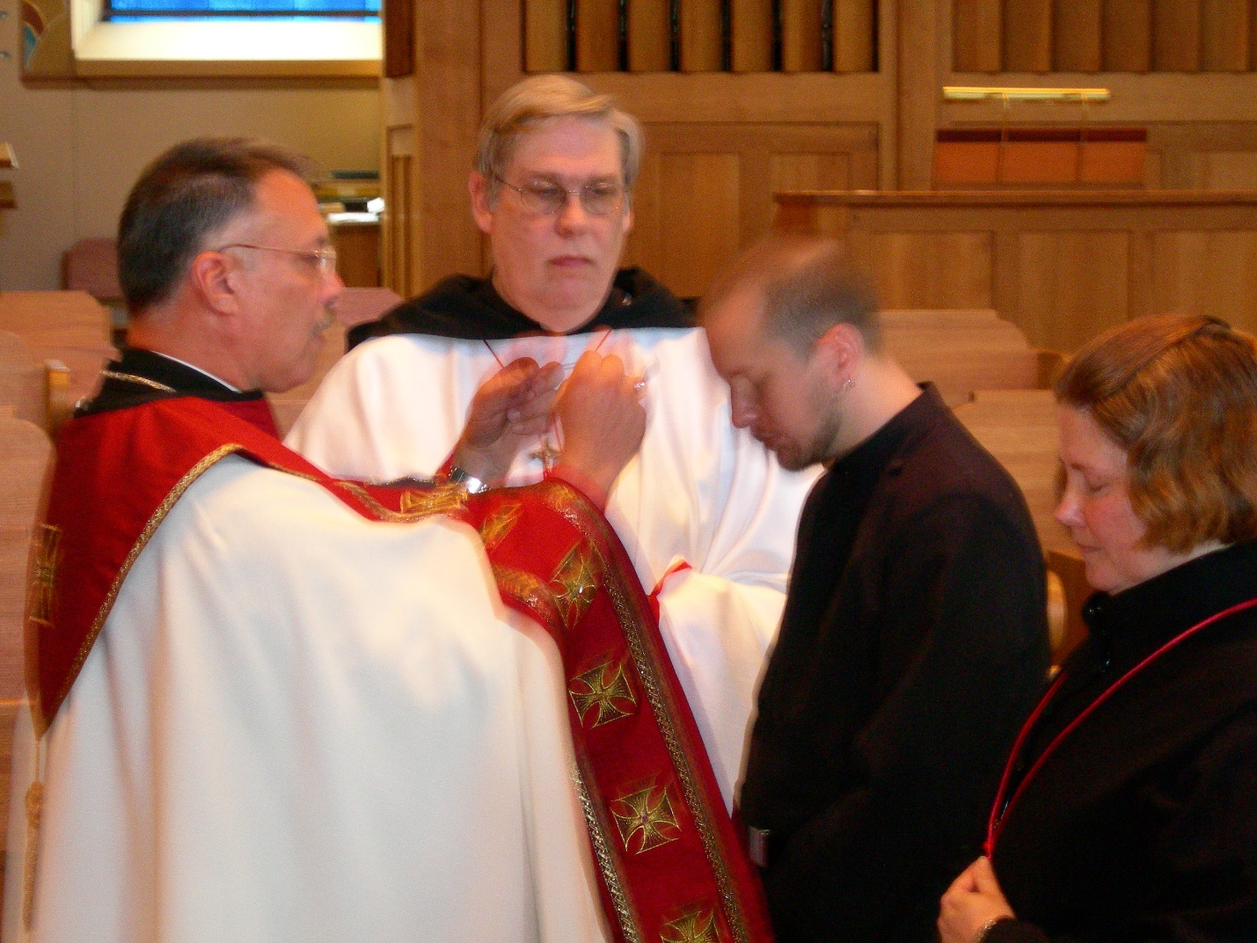DSCN0276 Abbot Michael John Austin; Br. Chad Anselm Gerns; Br. Eckhart Sowers; Sr. Hilary Grace Lundgren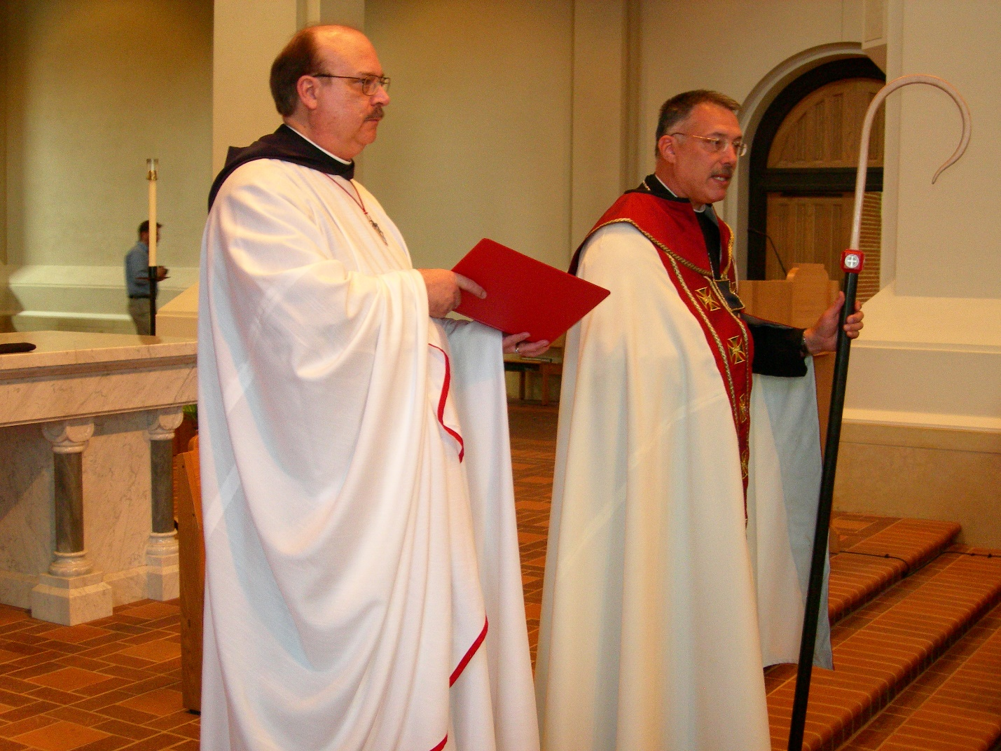
DSCN0277 Br. Raymond Owens; Abbot Michael John Austin

