Companions of St. Luke
Spring 2005 Convocation at Conception Abbey
Part 1 of 5

NOTE: Disc is dated 28 May 2003 but the people present and other documents show this is Spring 2005.

~Edited by Br. Steven Olderr, 19 May 2022 with the assistance of Br. Thomas Ferrell; if you find any errors or omissions, please notify Br. Steven at olderr@ameritech.net

People are identified from left to right.

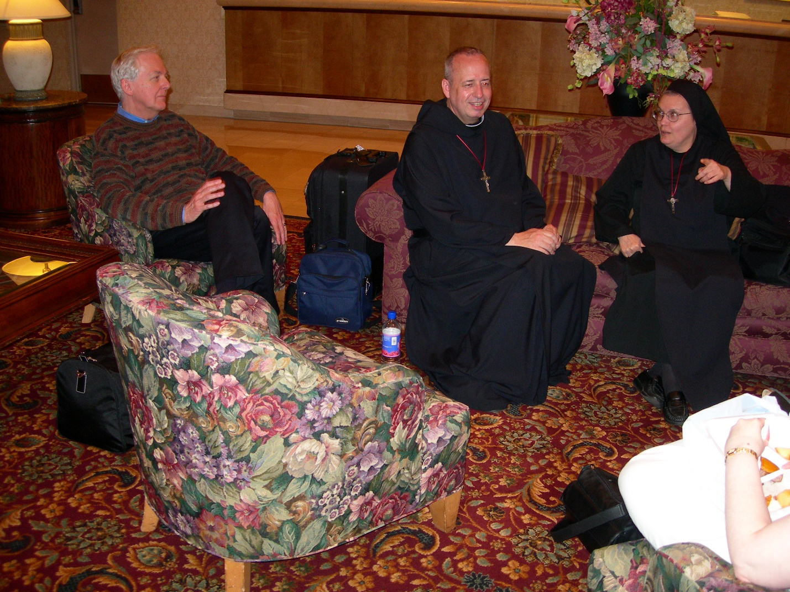
DSCN0156 Lee Doucette; Br. Gabriel Hale; Sr. Theodora of Jesus Perecca
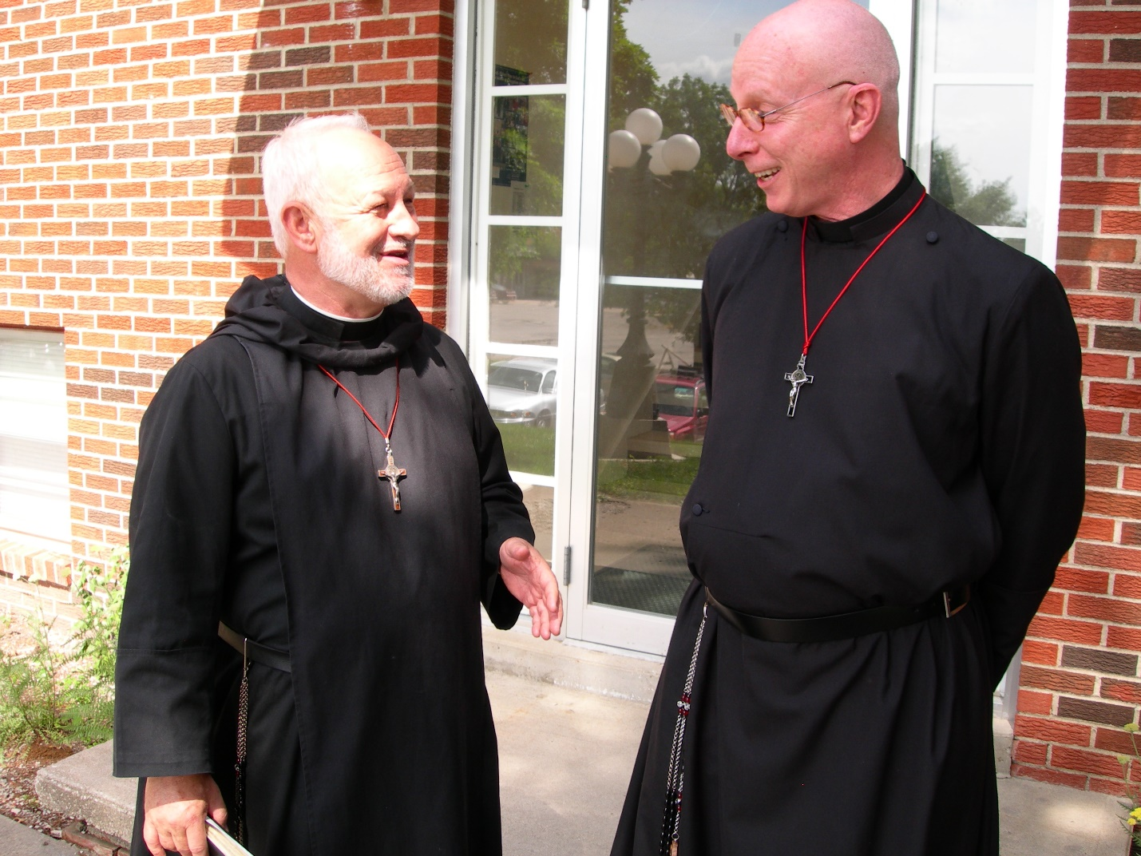
DSCN0158 Br. Christopher John Baumann; Br. David Vincent Cotton
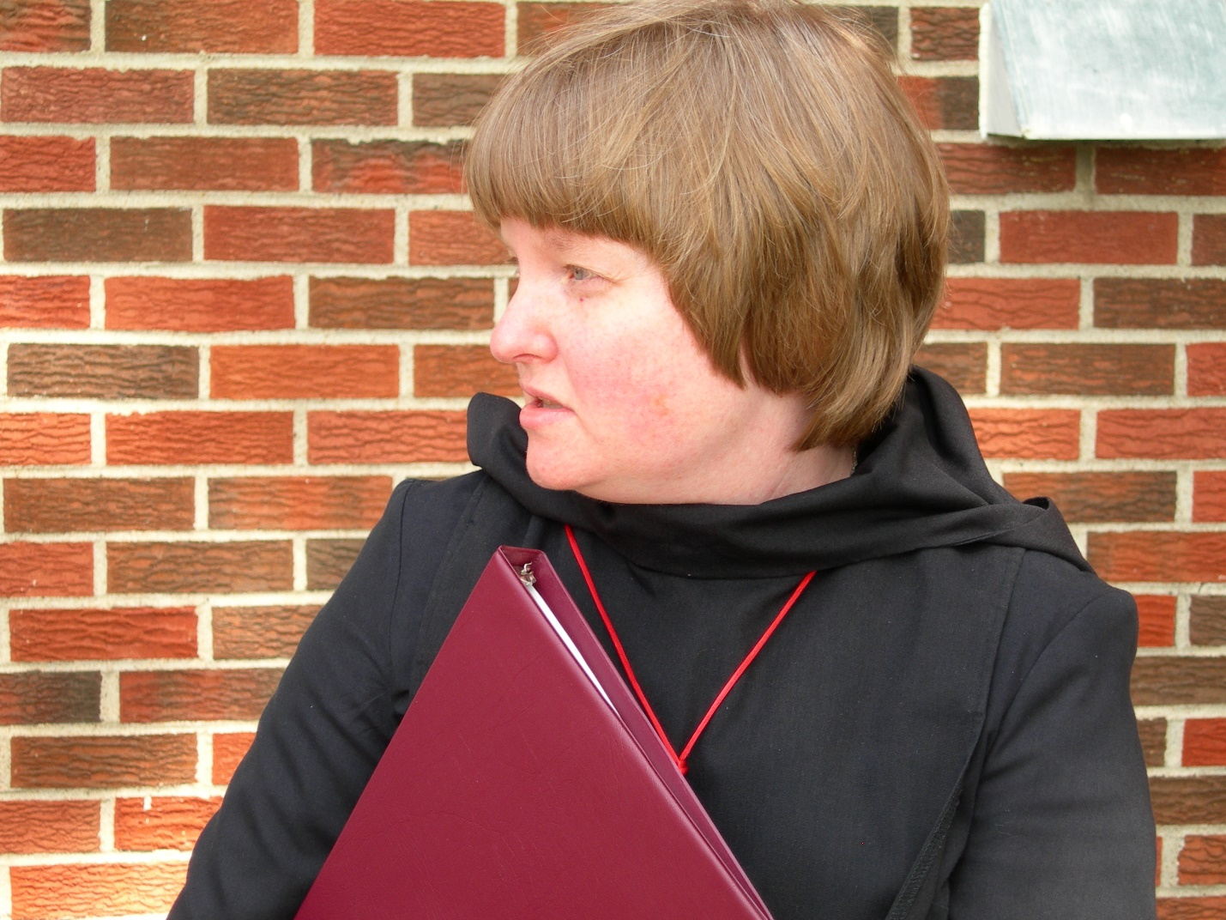
DSCN0159 Sr. Catherine Unterseher
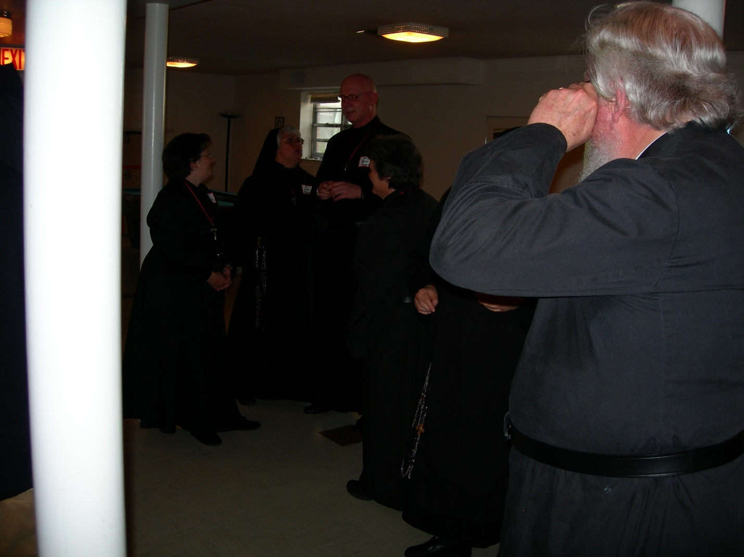
DSCN0160 Sr. Cecilia Lamoy; Sr. Clare Benedicta Meyers; Br. David Vincent Cotton; Sr. Vincent Marie Rittenhouse; Fr. Wayne Kamm
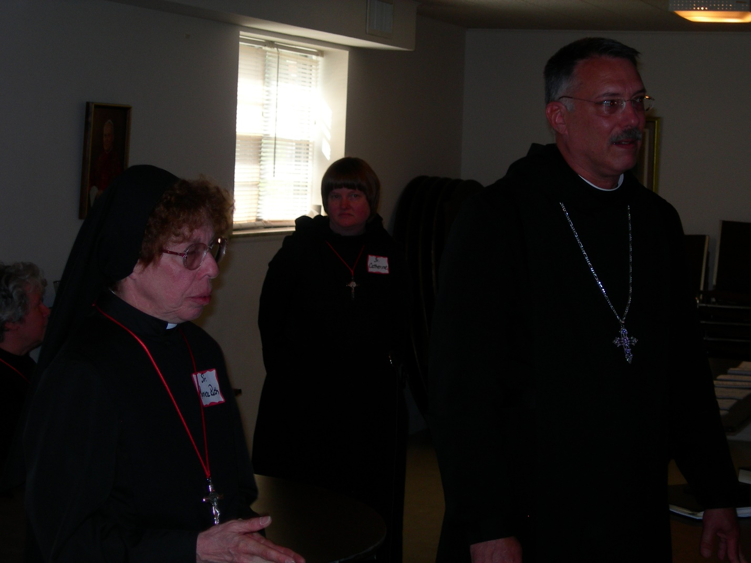
DSCN0161 Sr. Monica Ruth Mullen; Sr. Catherine Unterseher; Prior Michael John Austin
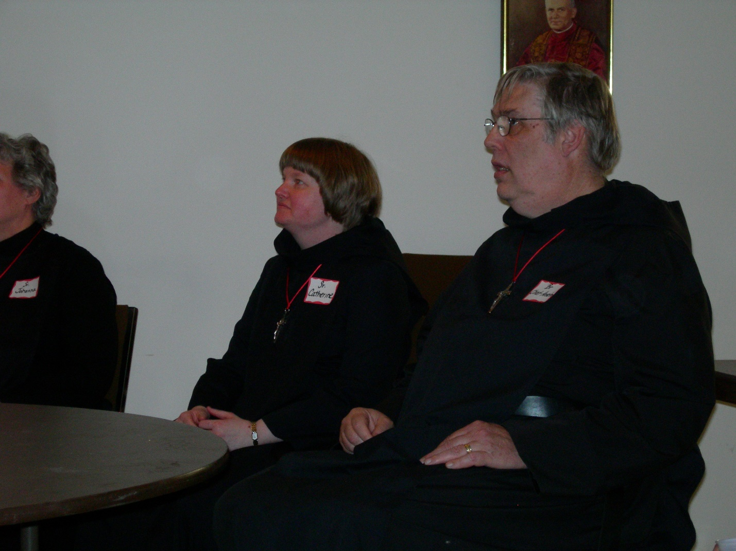
DSCN0162 Sr. Johanna Kirkpatrick; Sr. Catherine Unterseher; Br. Chad Anselm Gerns
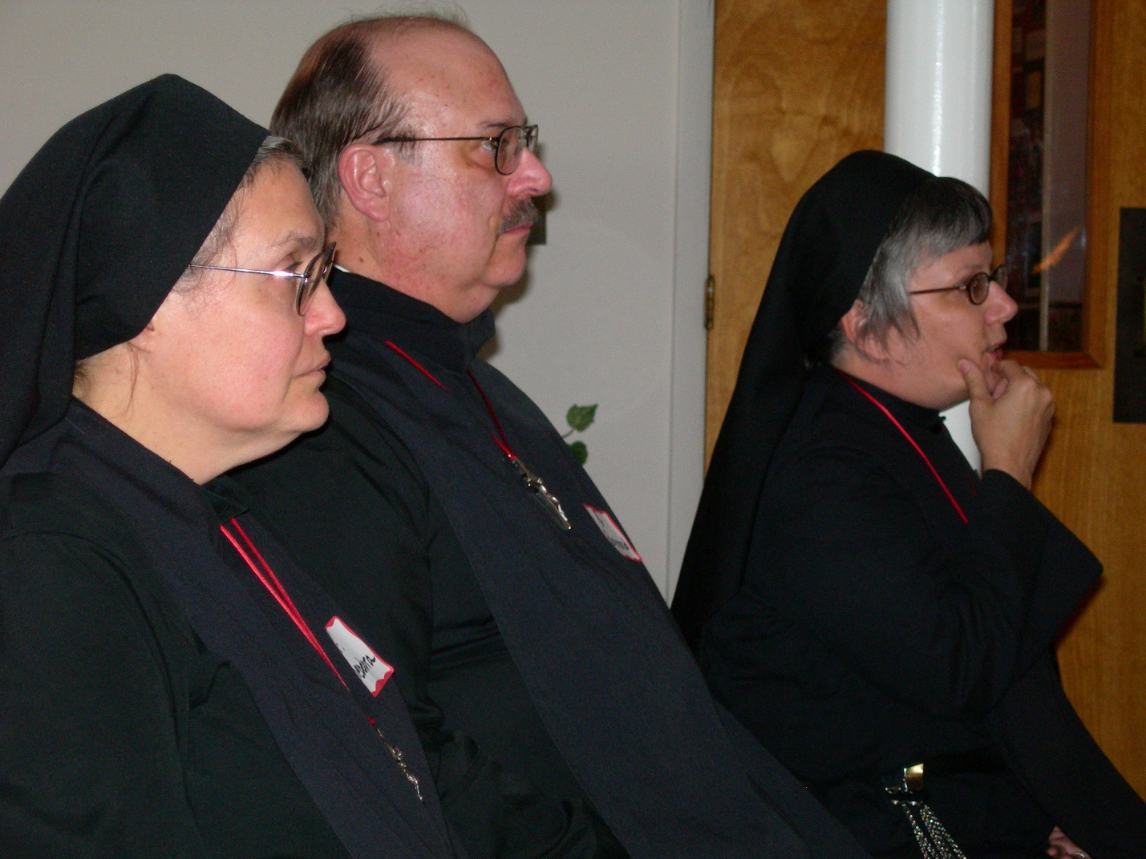
DSCN0163 Sr. Theodora of Jesus Perecca; Br. Raymond Owens; Sr. Anna Grace Madden
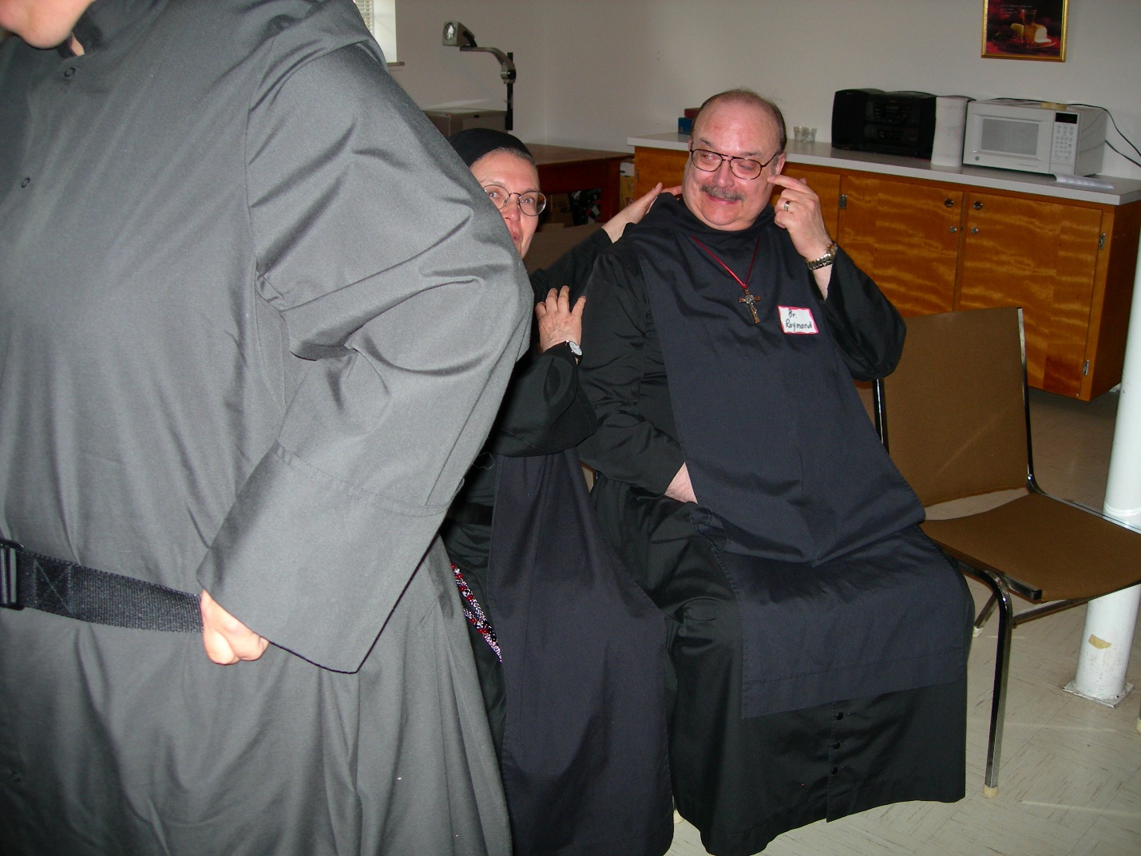
DSCN0164 Sr. Theodora of Jesus Perecca; Br. Raymond Owens
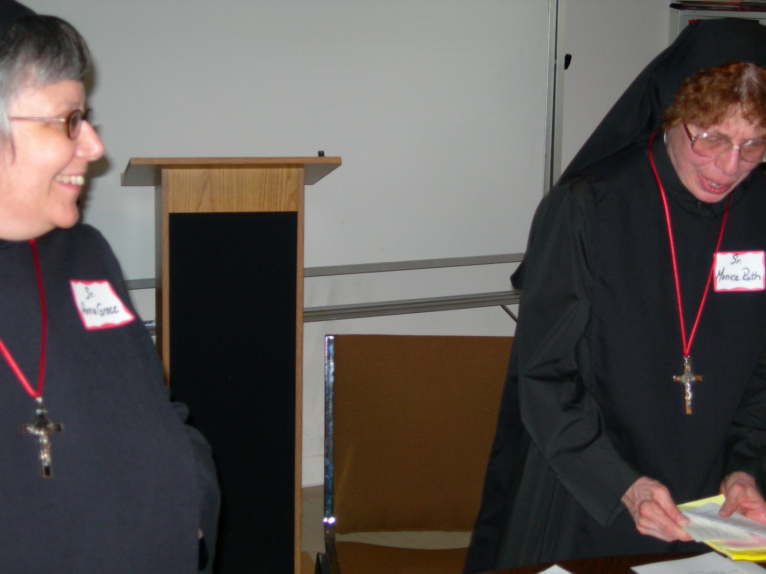
DSCN0165 Sr. Anna Grace Madden; Sr. Monica Ruth Mullen
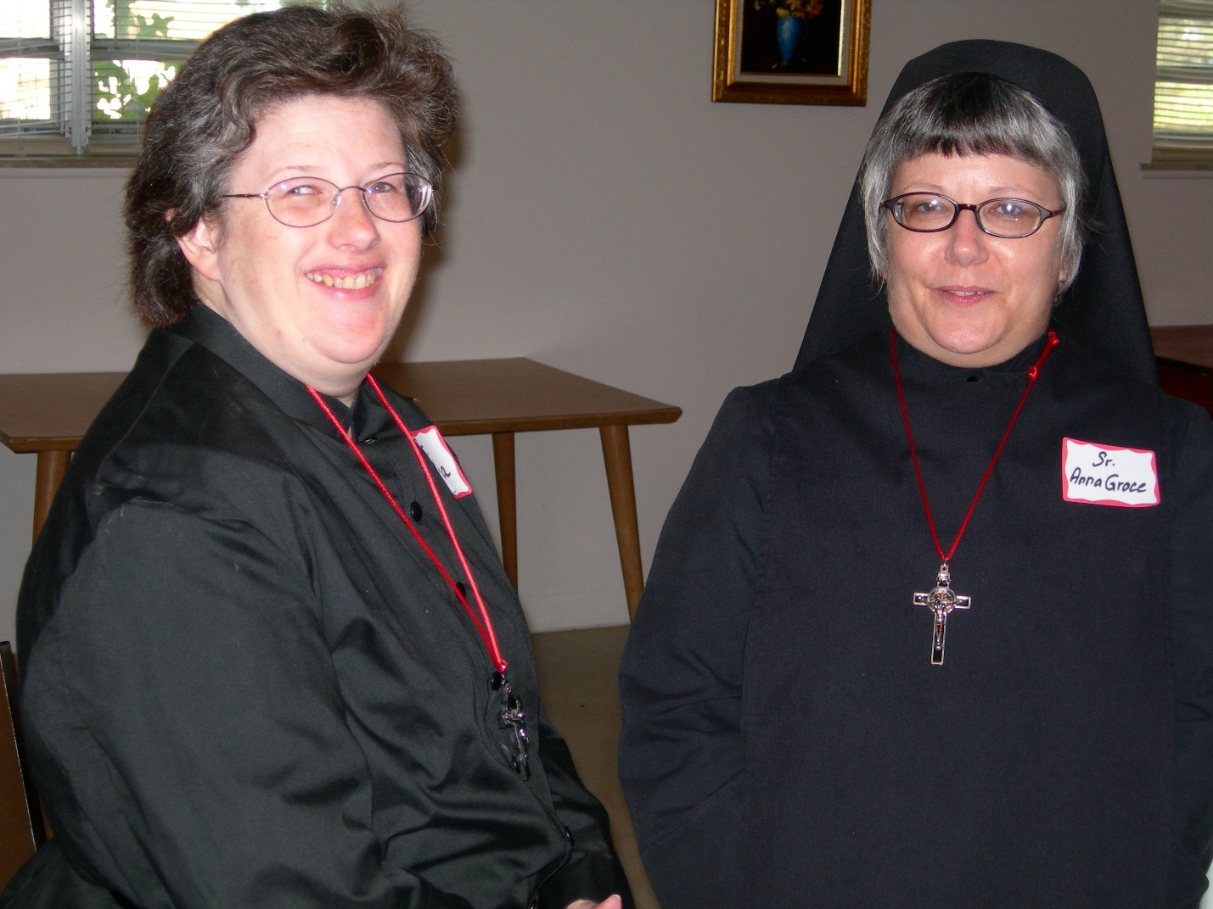
DSCN0167 Sr. Cecelia Lamoy; Sr. Anna Grace Madden
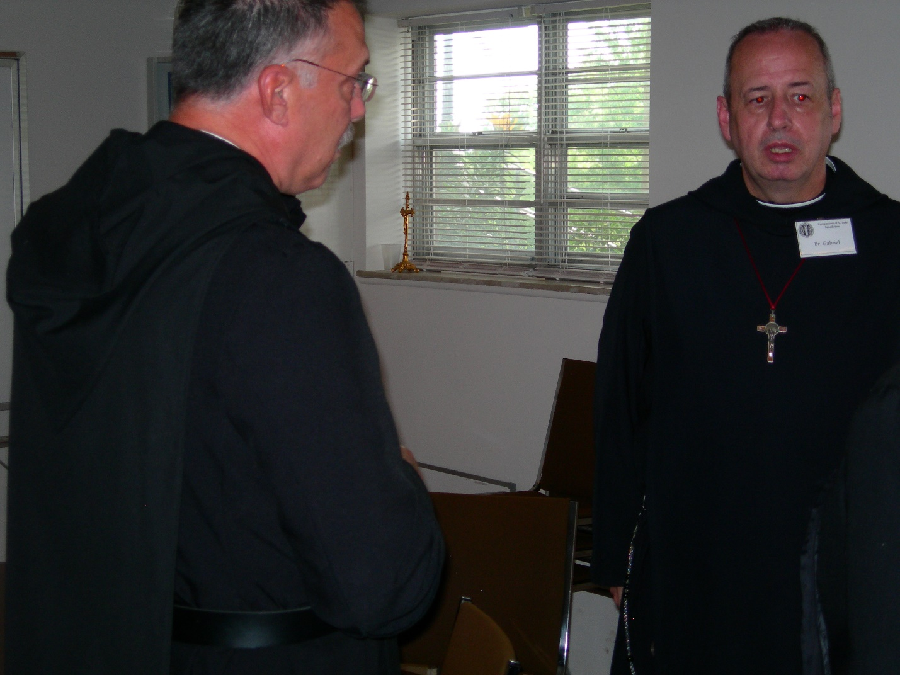
DSCN0168 Prior Michael John Austin; Br. Gabriel Hale
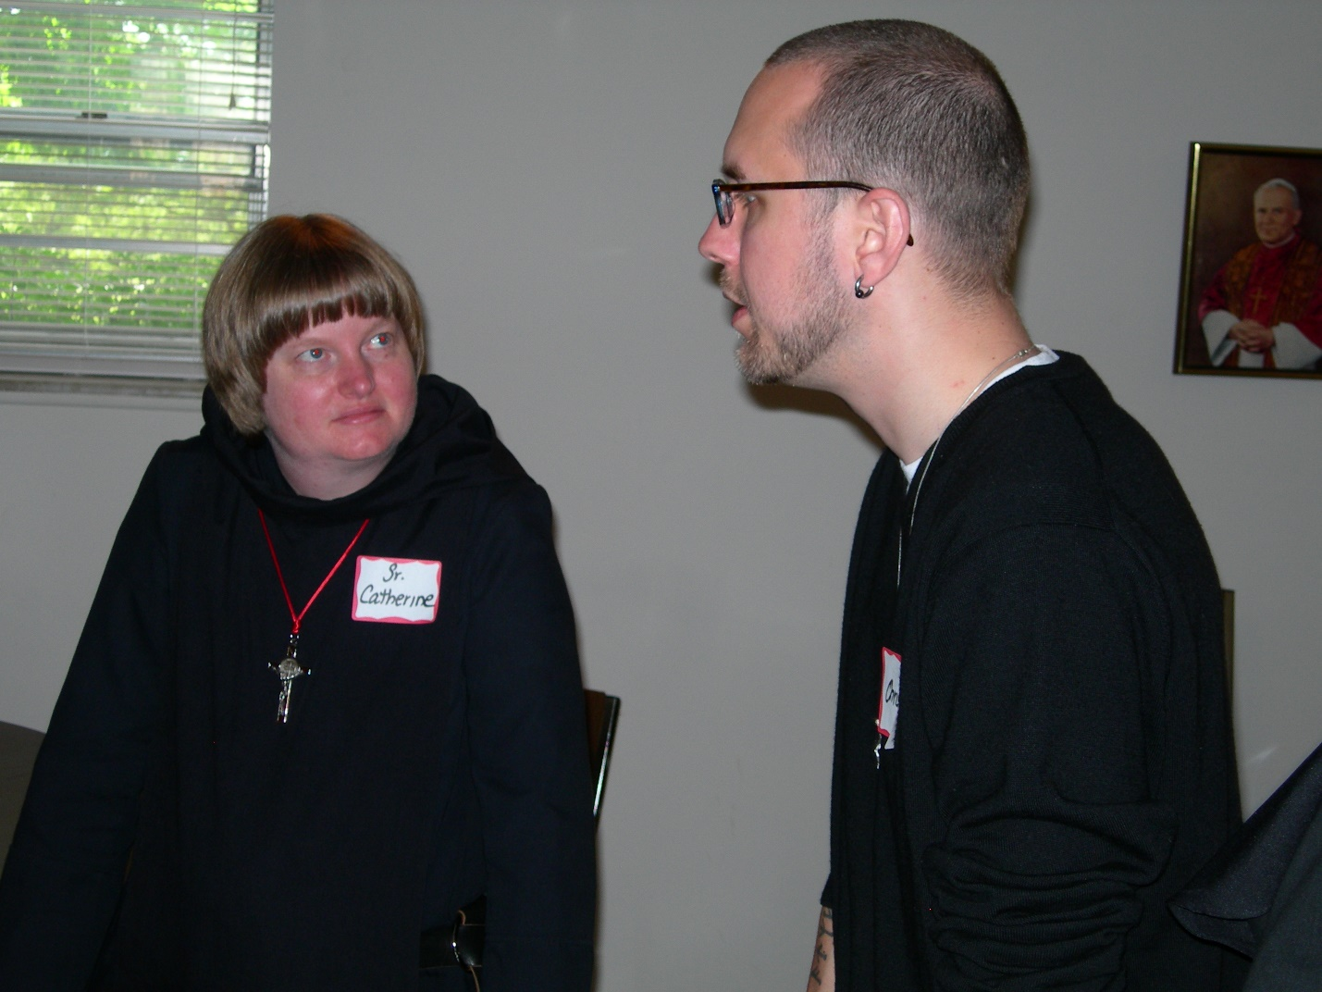
DSCN0169 Sr. Catherine Unterseher; Christopher Sowers
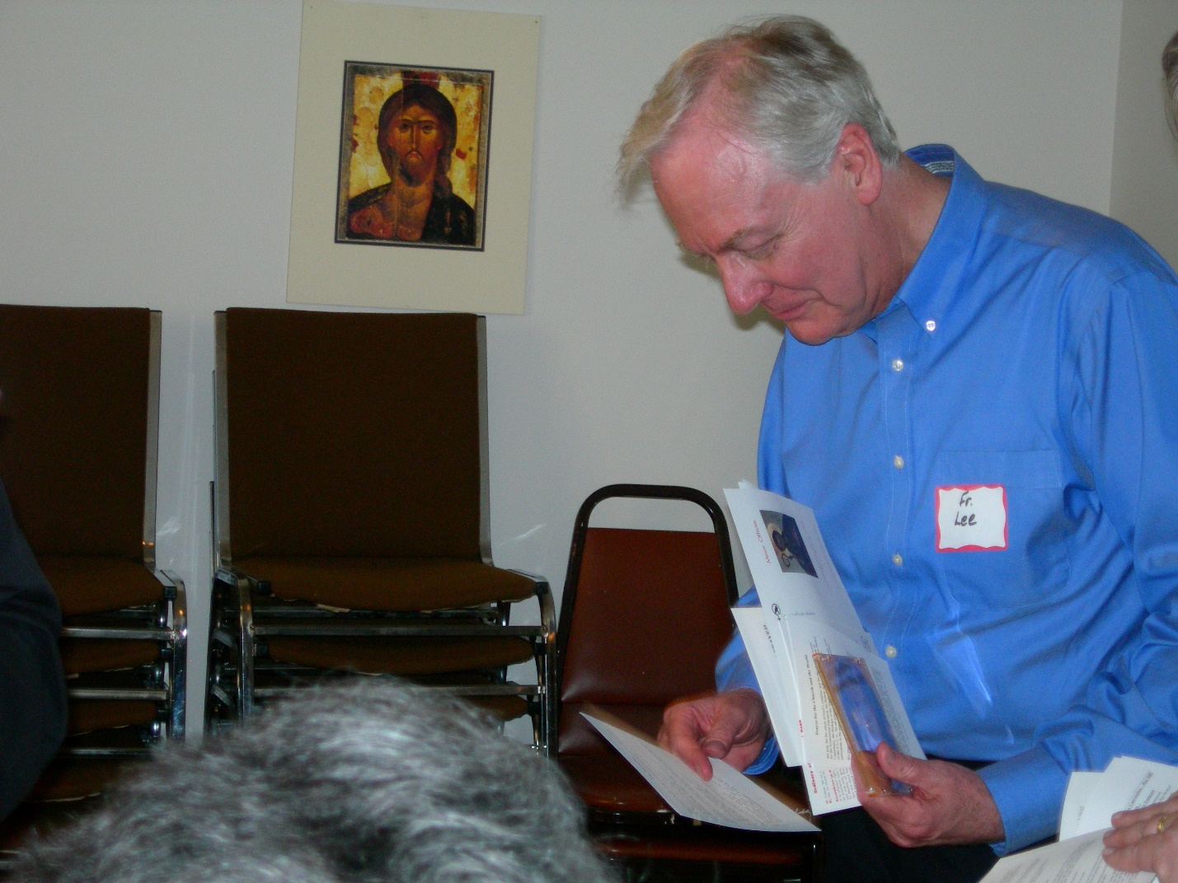
DSCN0170 Lee Doucette

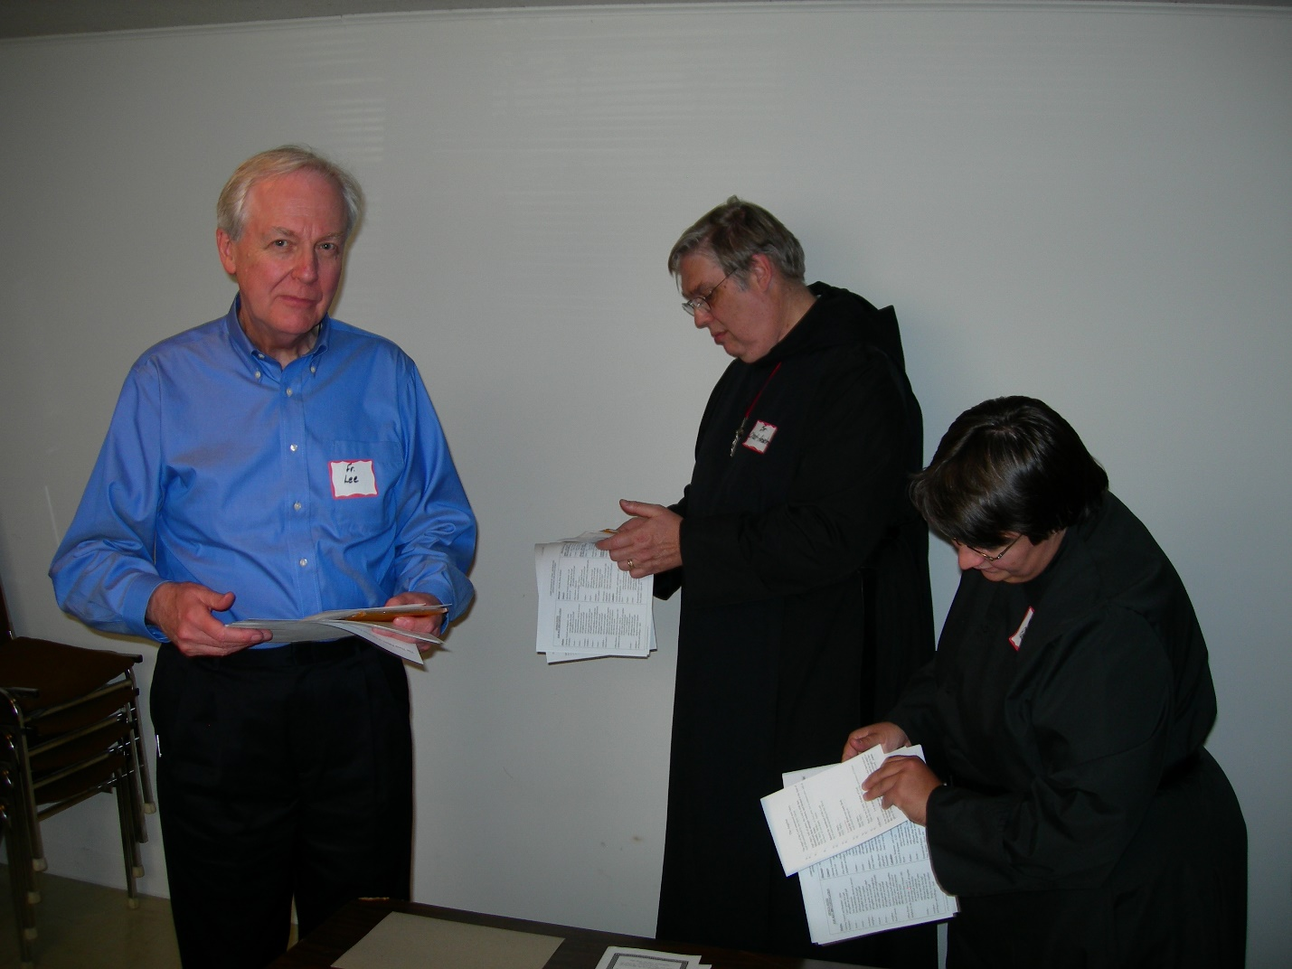
DSCN0171 Lee Doucette; Br. Chad Anselm; Sr. Pauline Tysol
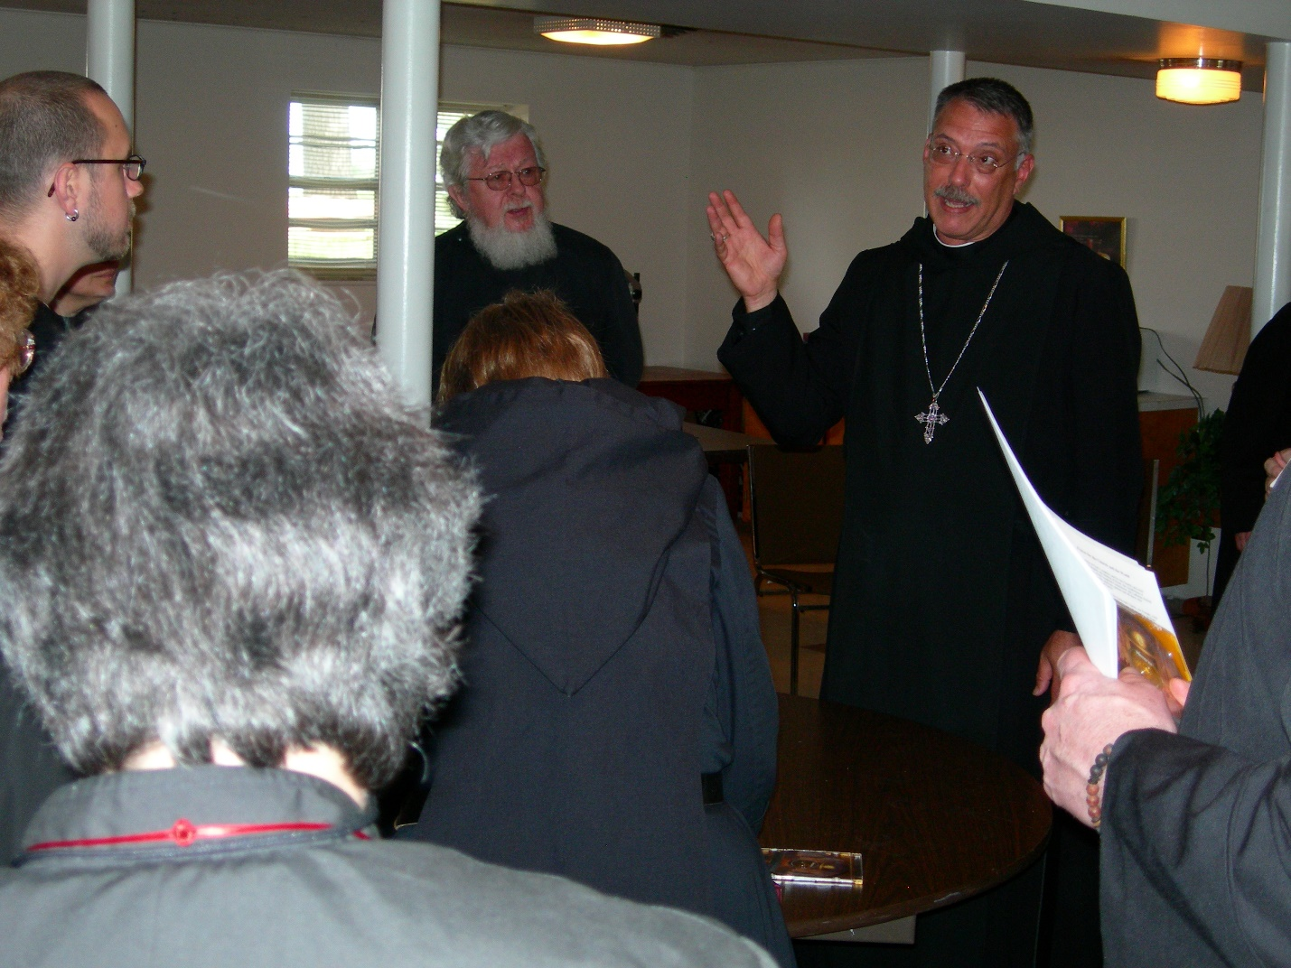
DSCN0172 Christopher Sowers; Fr. Wayne Kamm; Prior Michael John Austin
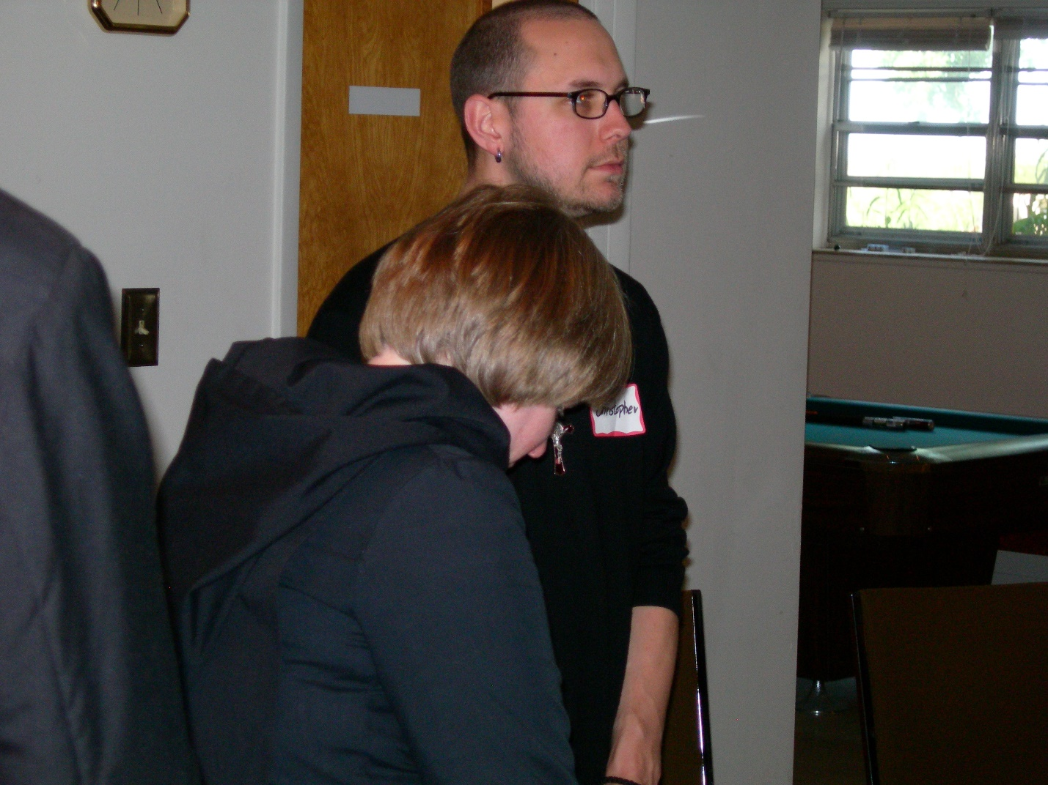
DSCN0173 Sr. Catherine Unterseher; Christopher Sowers
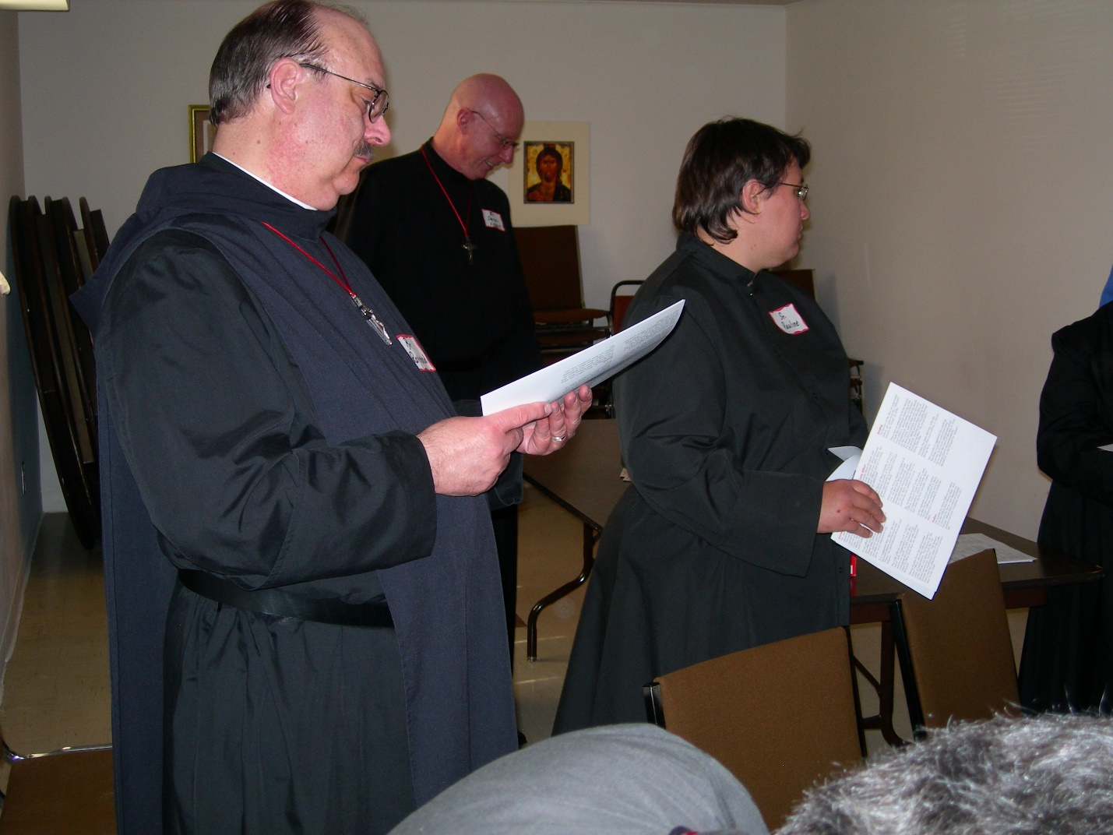
DSCN0174 Br. Raymond Owens; Br, David Vincent Cotton; Sr. Pauline Tysol
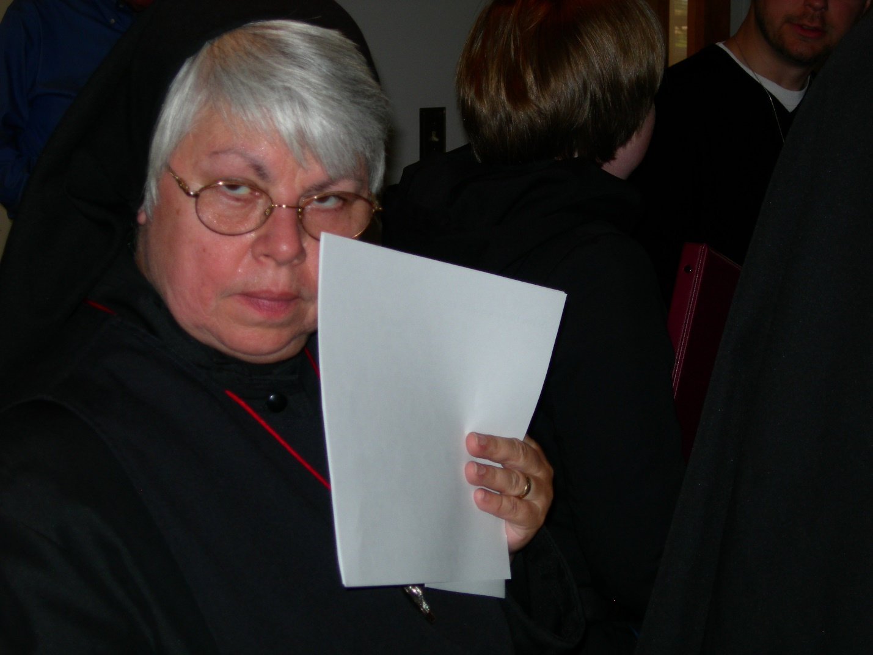
DSCN0175 Sr. Clare Benedicta Meyers
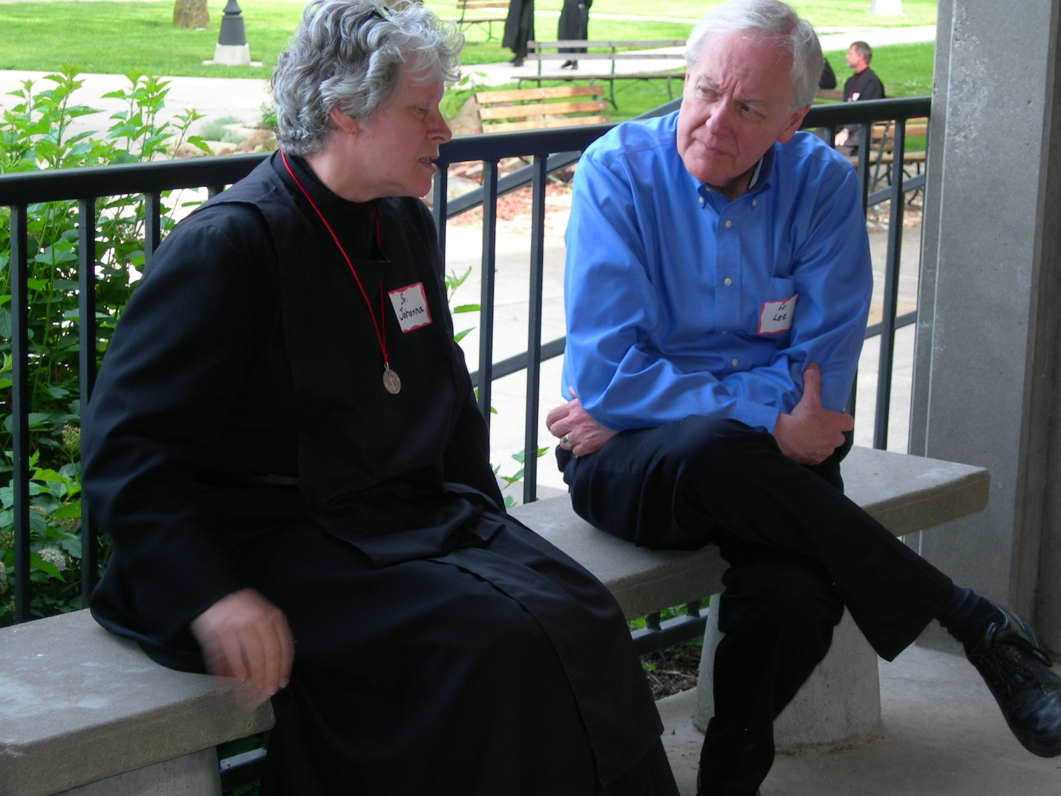
DSCN0176 Sr. Johanna Kirkpatrick; Lee Doucette
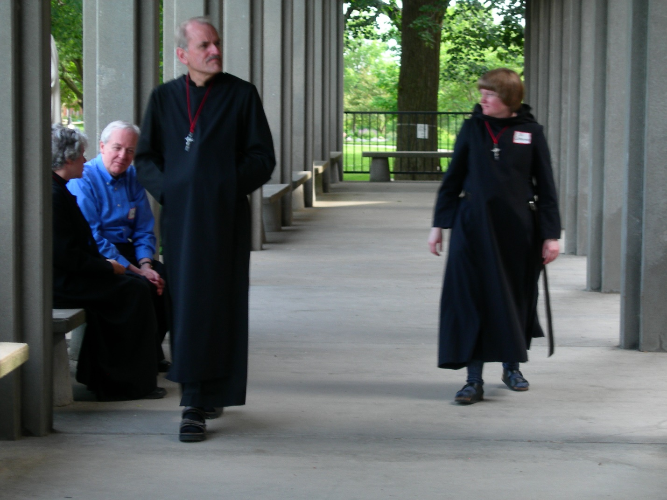
DSCN0177 Sr. Johanna Kirkpatrick; Lee Doucette; Br. Daniel Joseph Schroeder; Sr. Catherine Unterseher
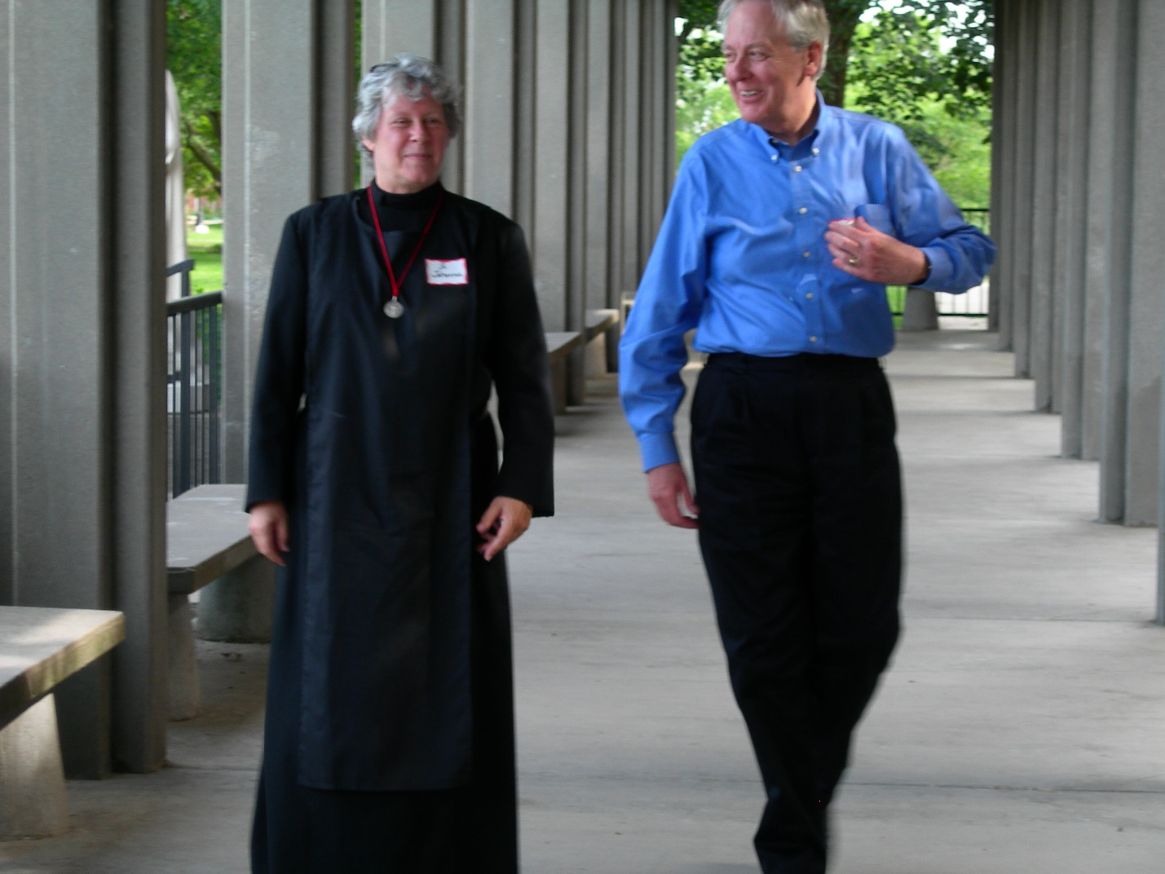
DSCN0178 Sr. Johanna Kirkpatrick; Lee Doucette
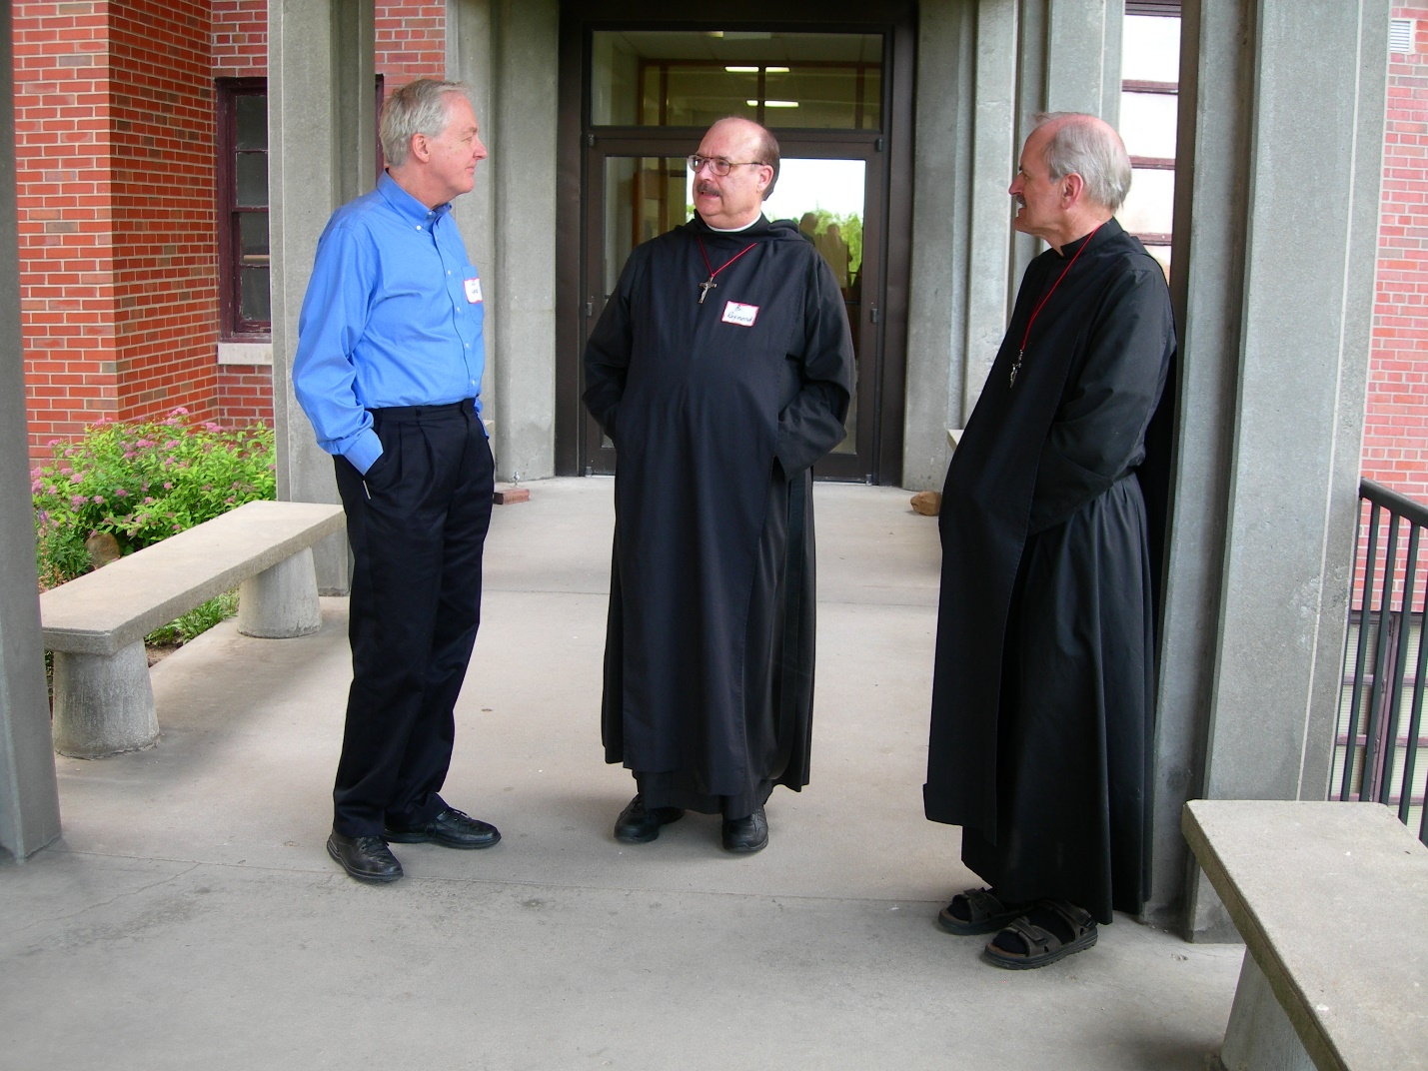
DSCN0179 Lee Doucette; Br. Raymond Owens; Br. Daniel Joseph Schroeder
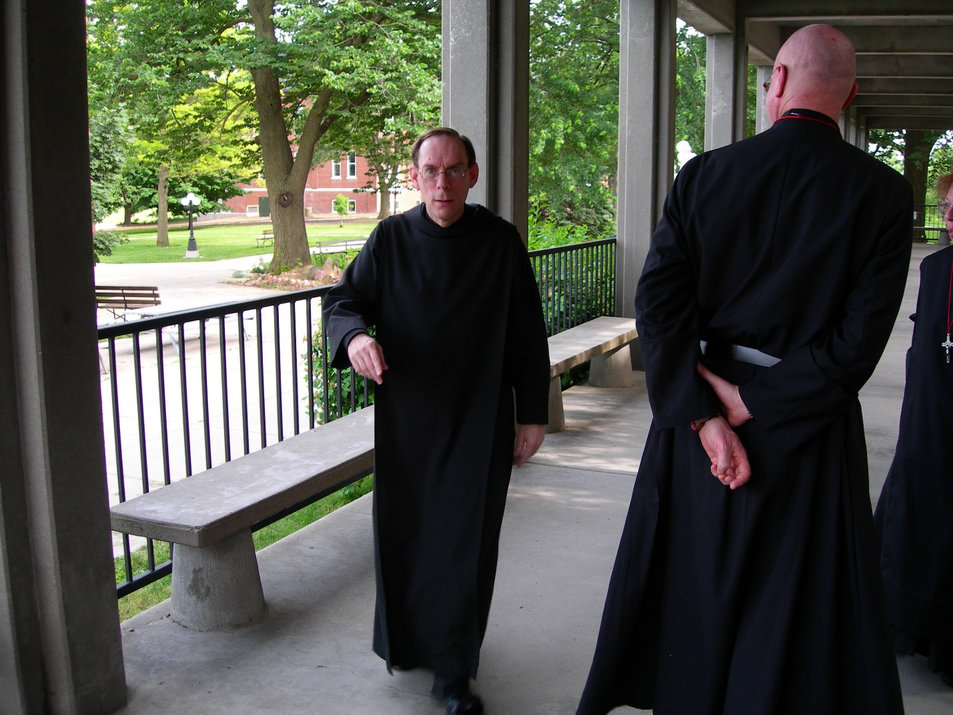
DSCN0180 Br. Cyprian (monk of Conception Abbey); Br. David Vincent Cotton
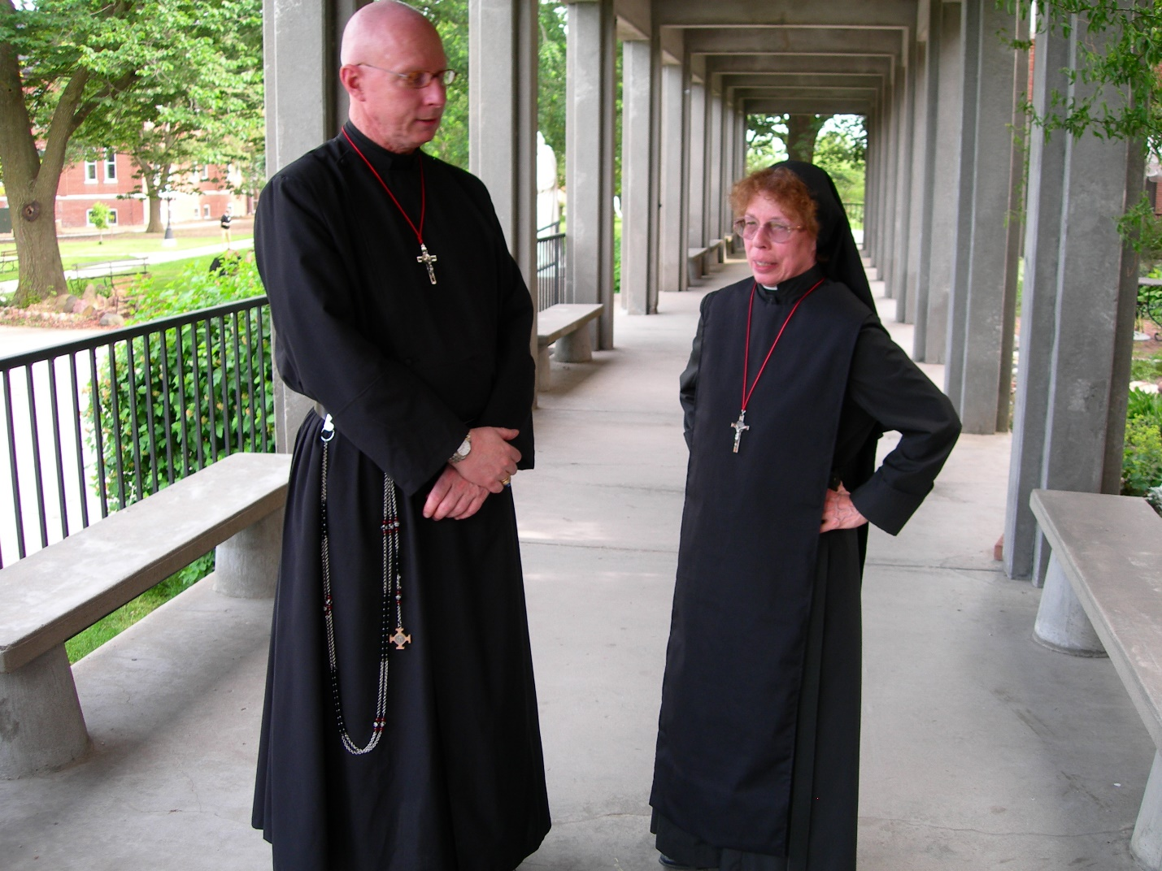
DSCN0181 Br. David Vincent Cotton; Sr. Monica Ruth Mullen
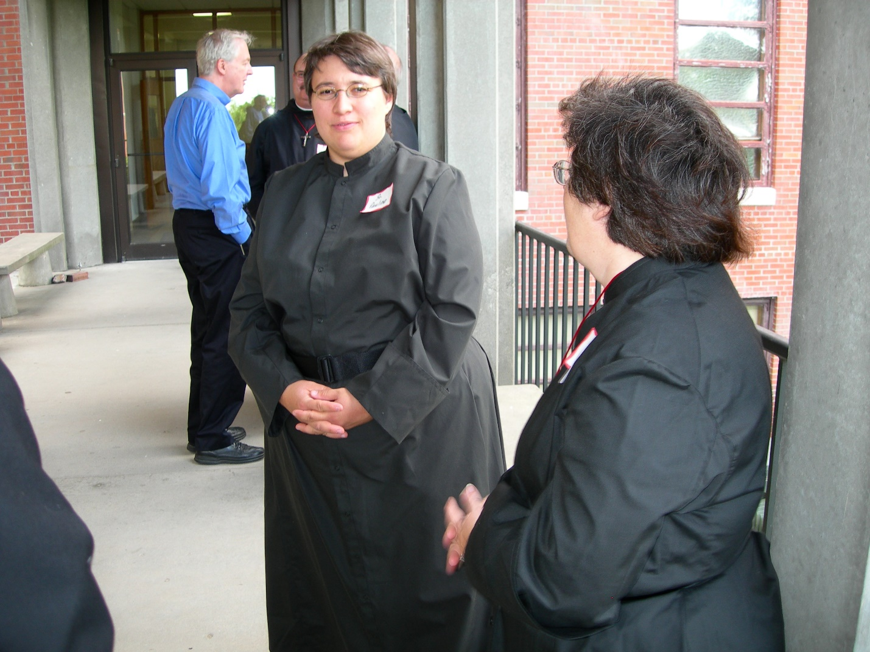
DSCN0182 Lee Doucette; Br. Raymond Owens; Sr. Pauline Tysol; Sr. Cecelia Lamoy
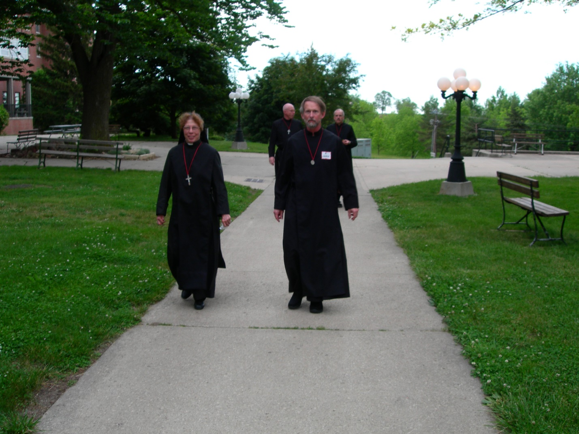
DSCN0185 Sr. Monica Ruth Mullen; Br. David Vincent Cotton; Br. Lawrence Mullen; Br. Daniel Joseph Schroeder
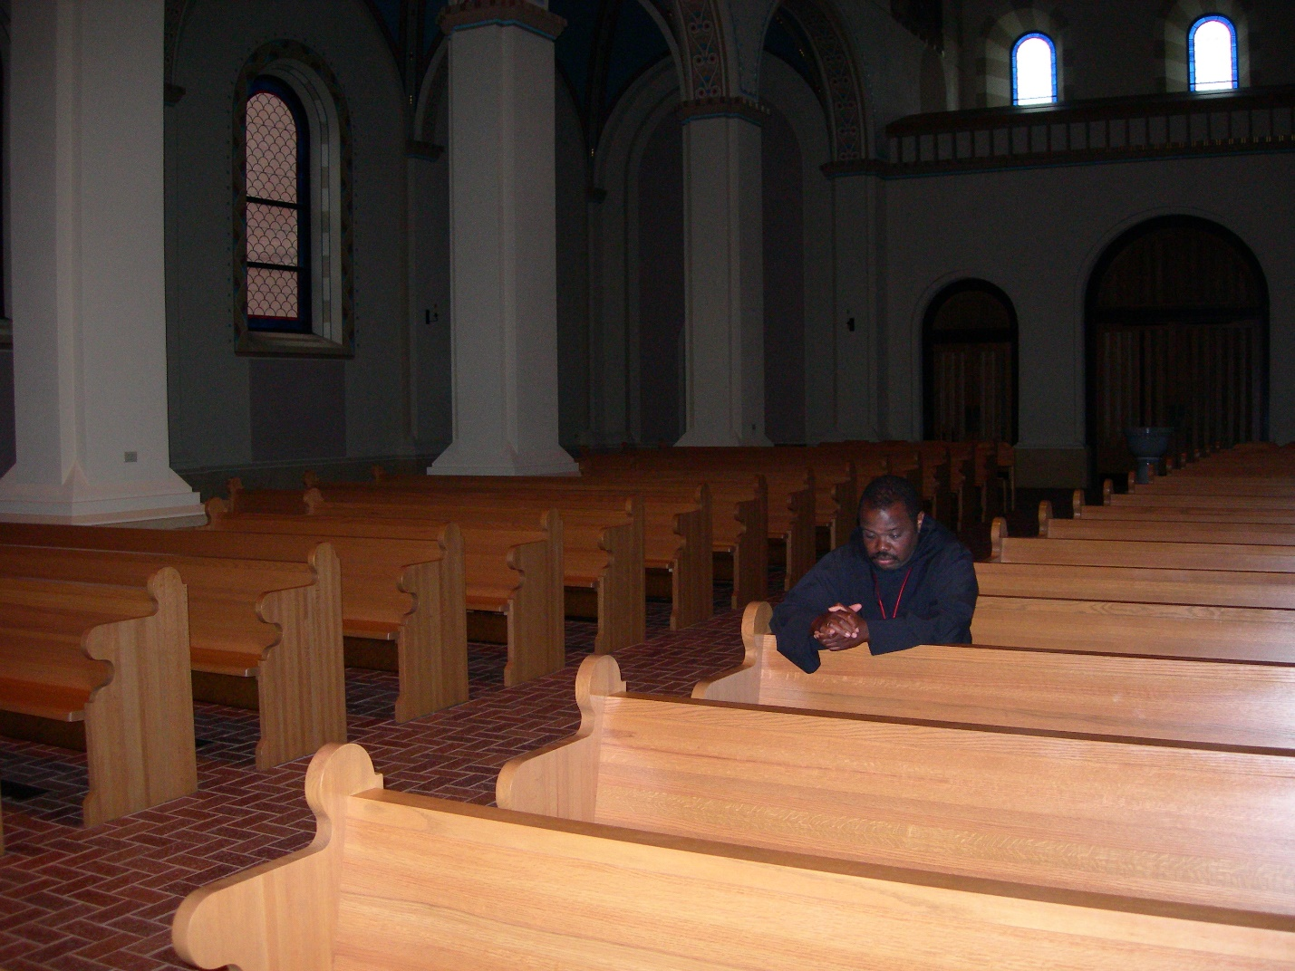
DSCN0200 Br. Thomas Ferrell
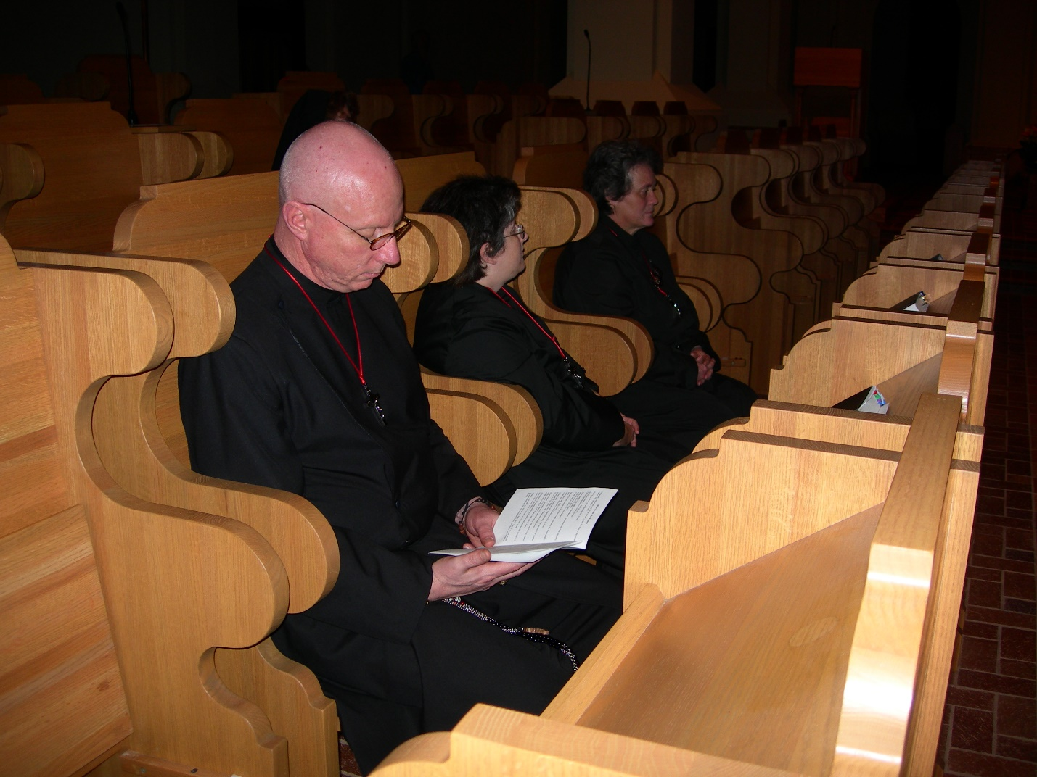
DSCN0201 Br. David Vincent Cotton; Sr. Cecelia Lamoy; Sr. Vincent Marie Rittenhouse
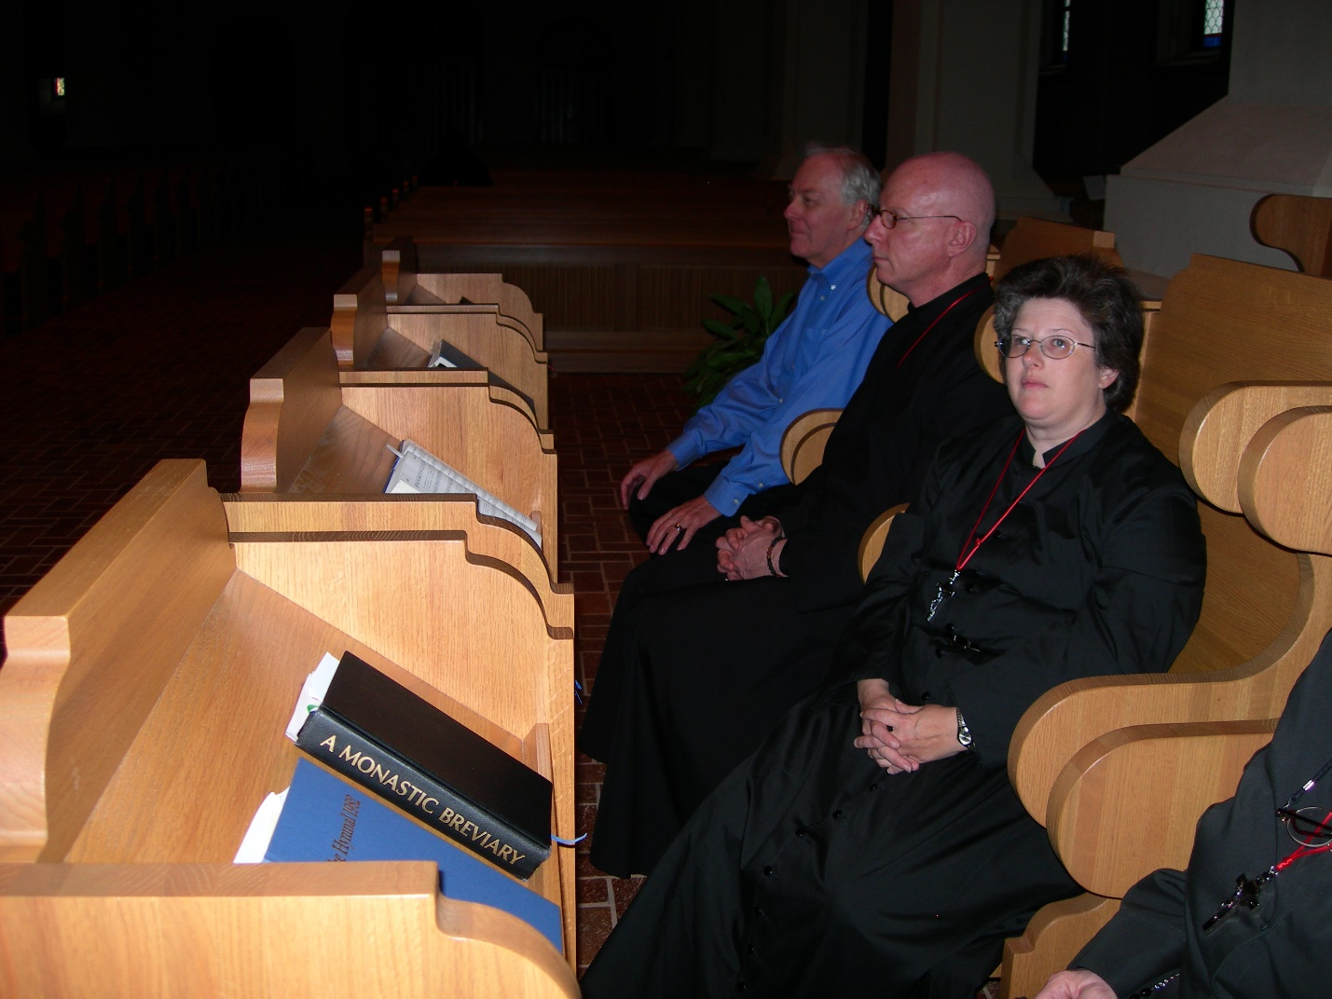
DSCN0202 Lee Doucette; Br. David Vincent Cotton; Sr. Cecelia Lamoy
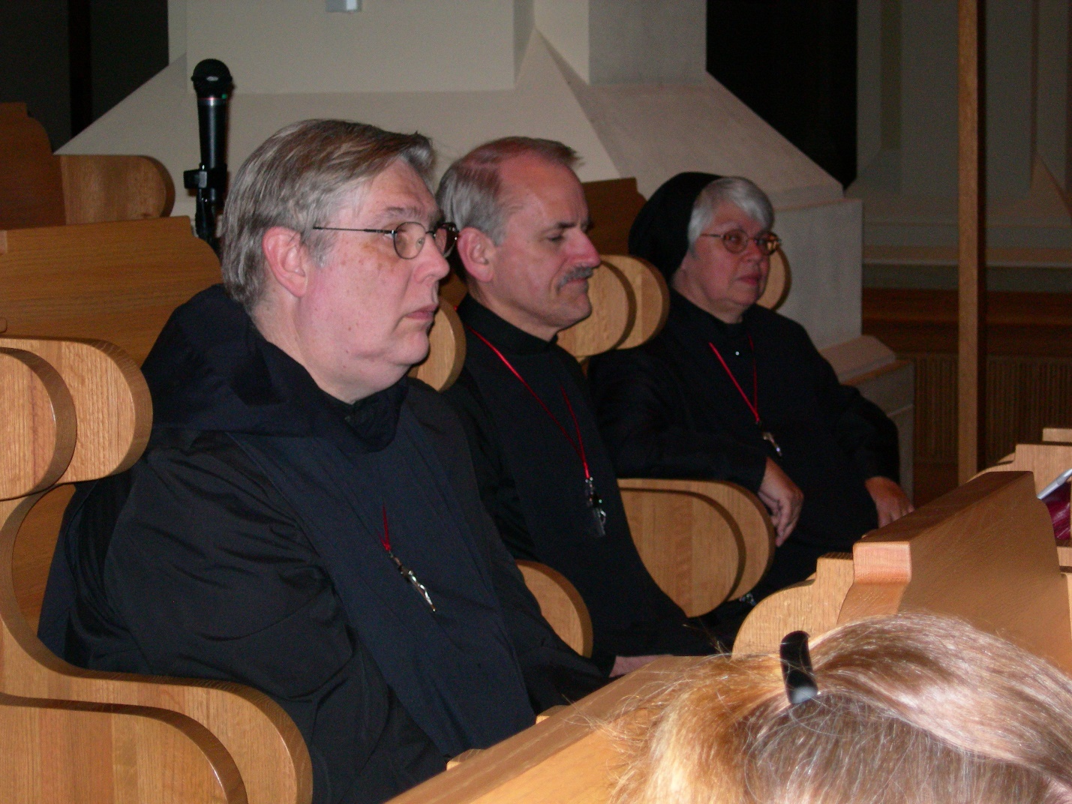
DSCN0203 Br. Chad Anselm Gerns; Br. Daniel Joseph Schroeder; Sr. Clare Benedicta Meyers
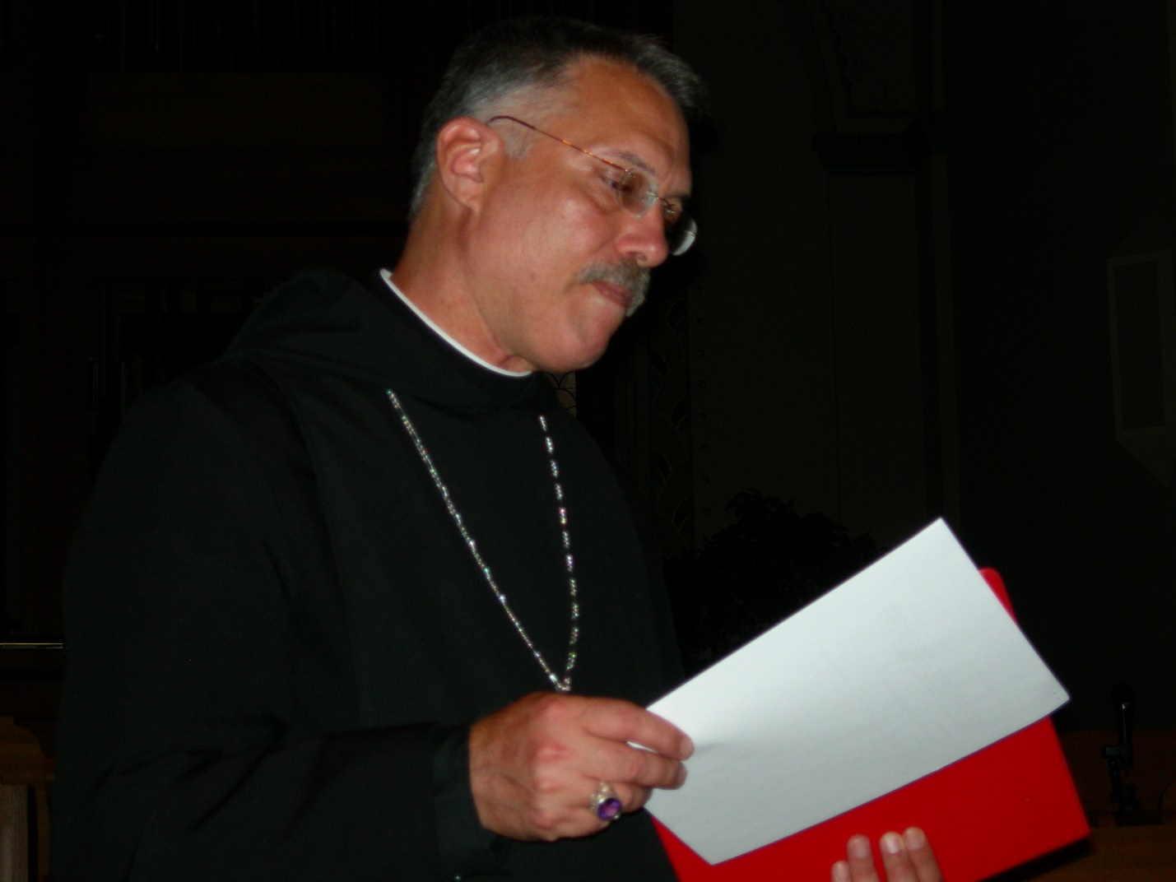
DSCN0204 Prior Michael John Austin
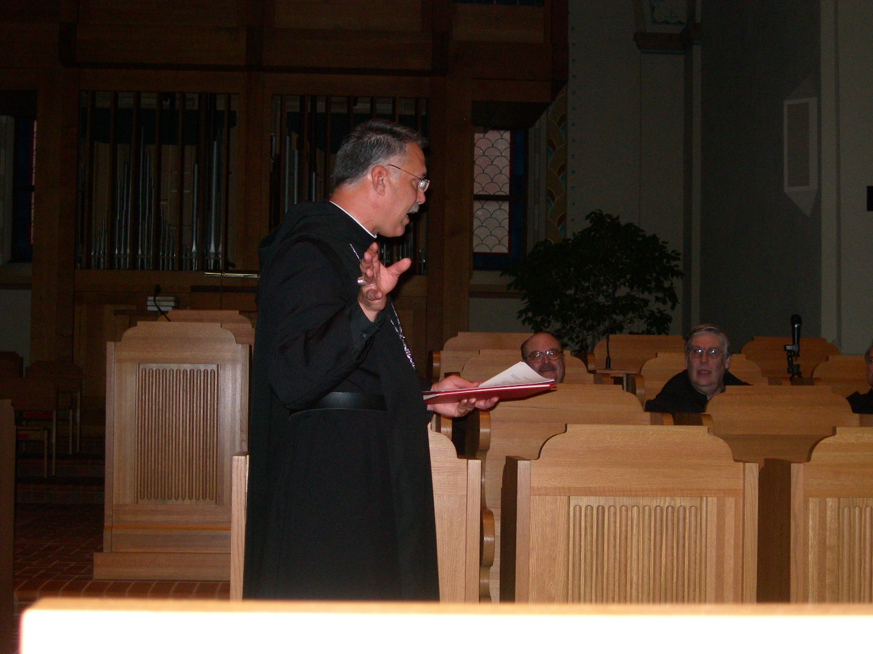
DSCN0205 Prior Michael John Austin; Br. Raymond Owens; Br. Chad Anselm Gerns
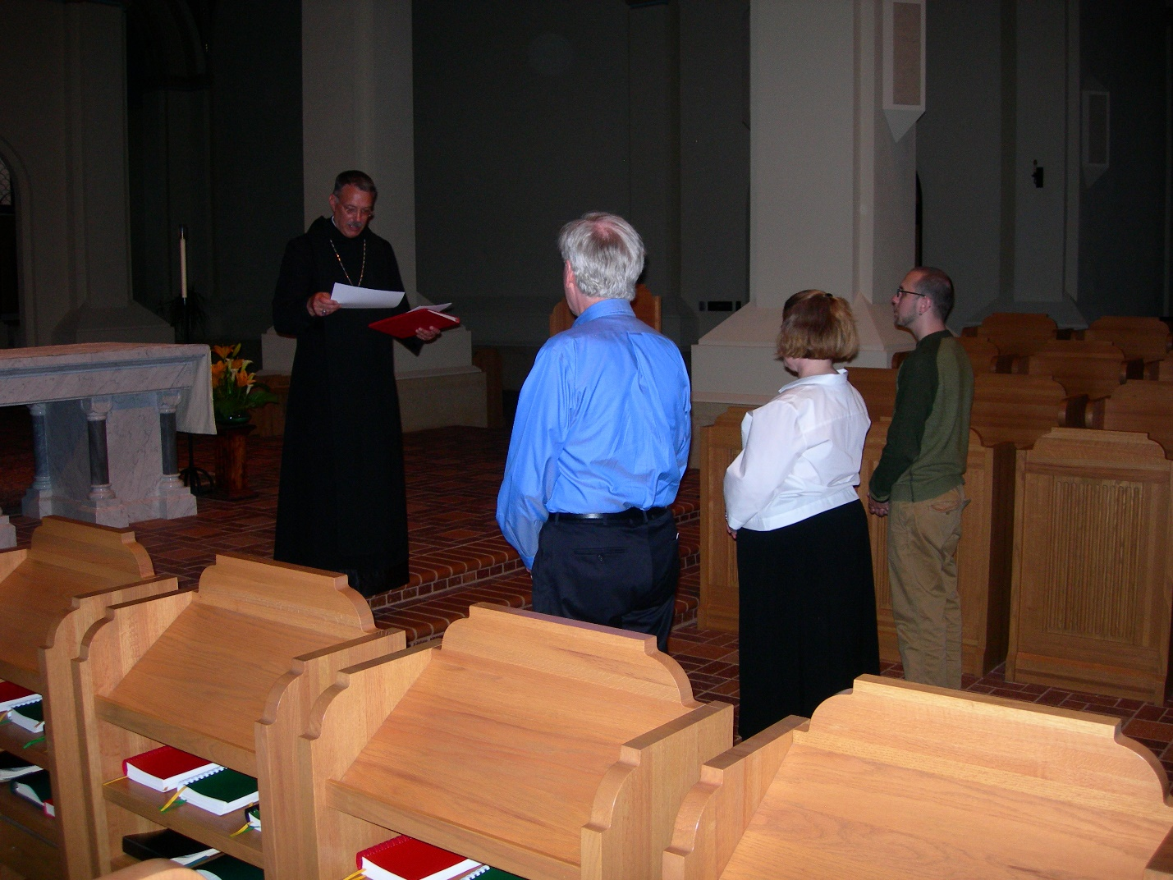
DSCN0206 Prior Michael John Austin; Lee Doucette; Maria Lundgren; Christopher Sowers
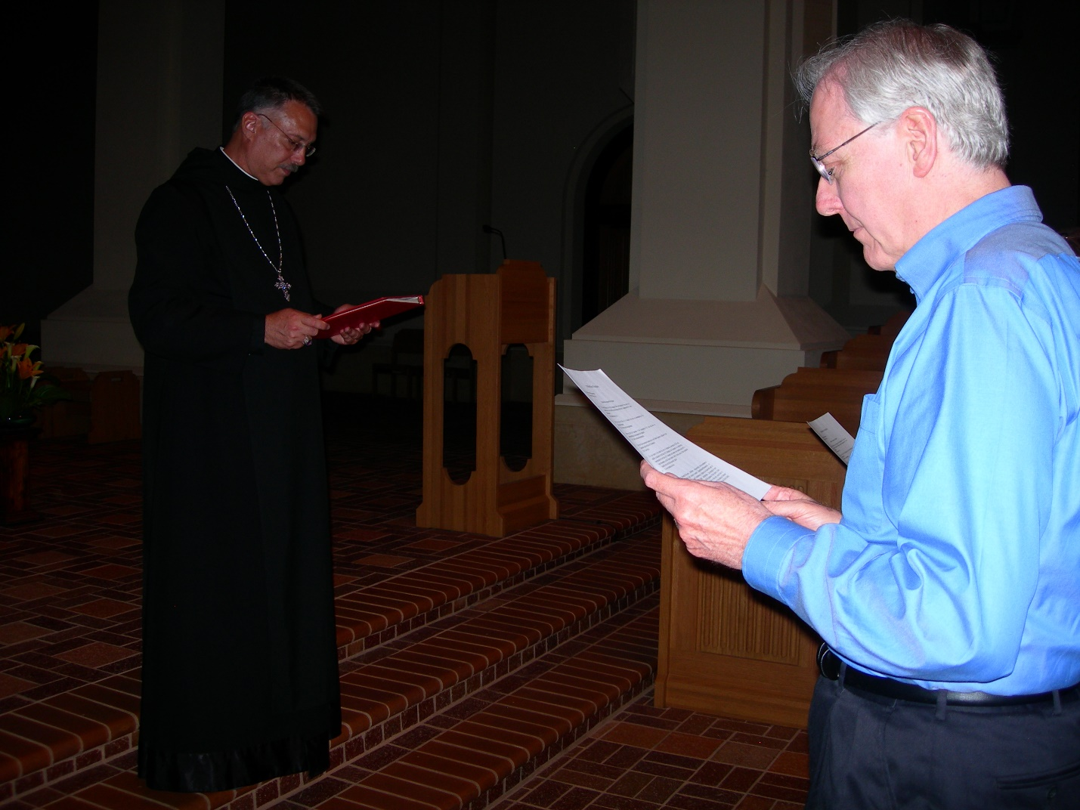
DSCN0207 Prior Michael John Austin; Lee Doucette
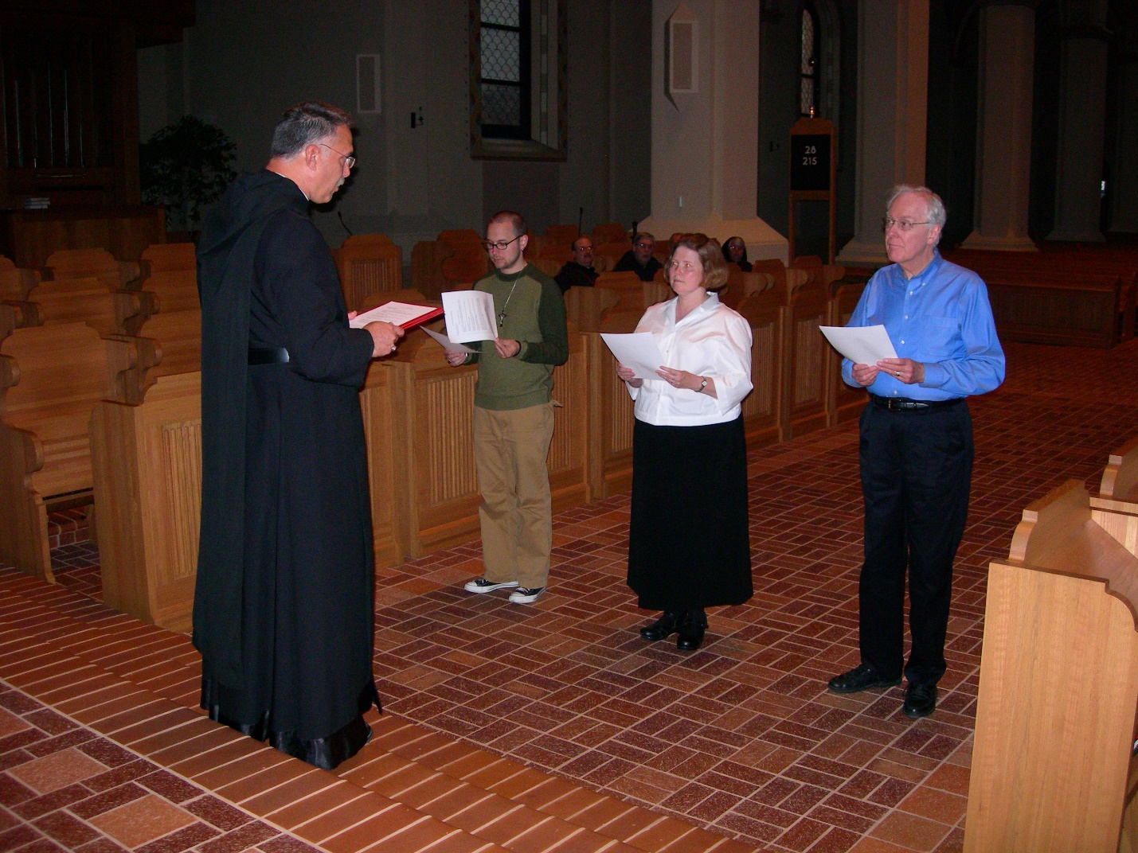
DSCN0208 Prior Michael John Austin; Christopher Sowers; Maria Lundgren; Lee Doucette
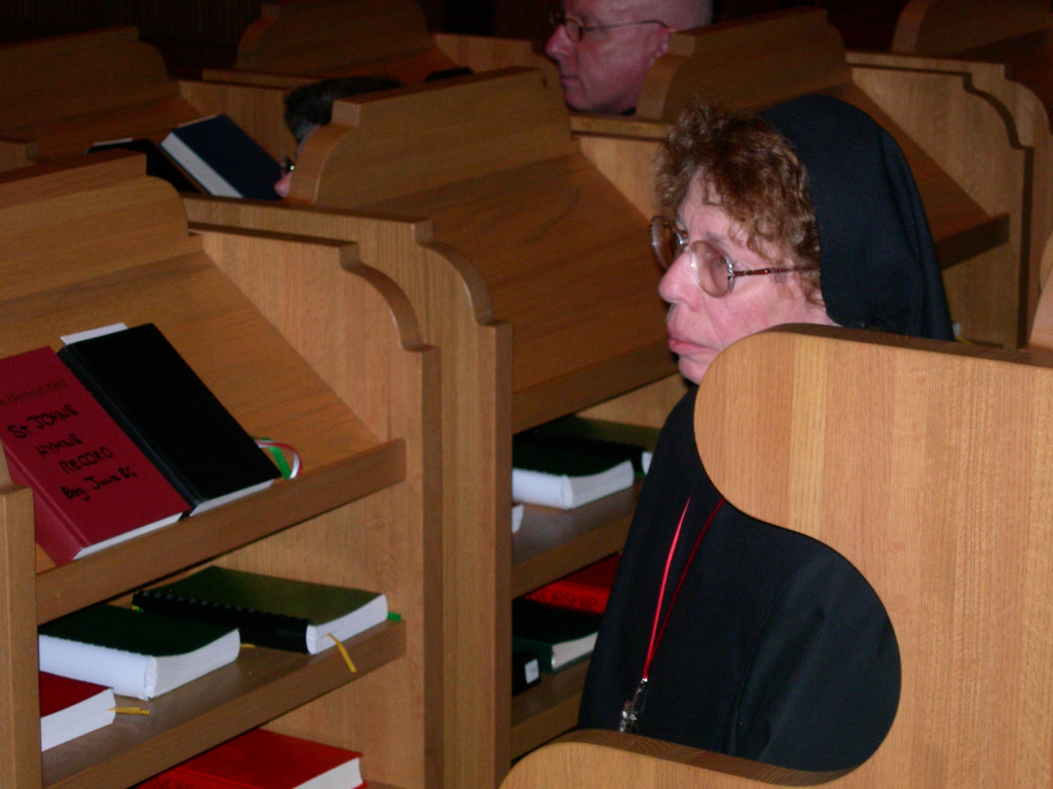
DSCN0209 Br. David Vincent Cotton; Sr. Monica Ruth Mullen
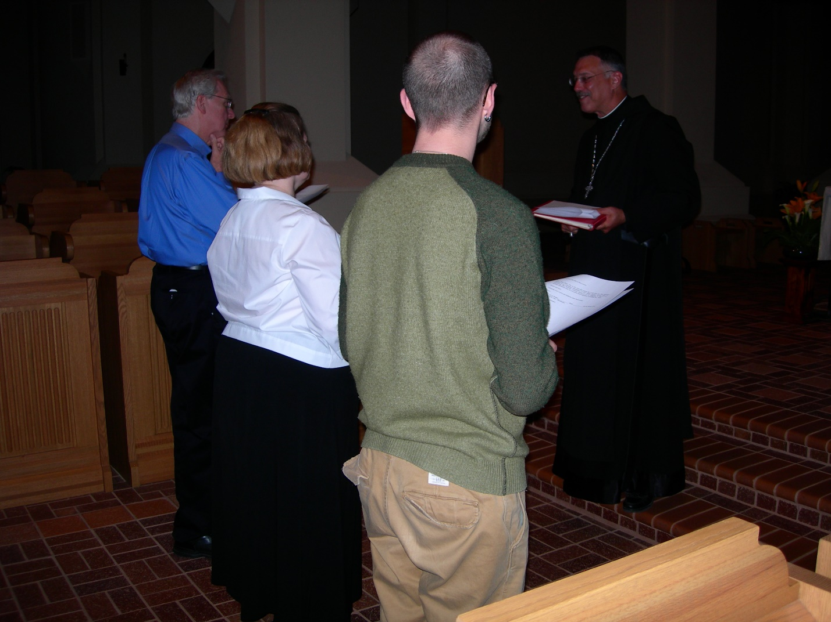
DSCN0210 Lee Doucette; Maria Lundgren; Christopher Sowers; Prior Michael John Austin
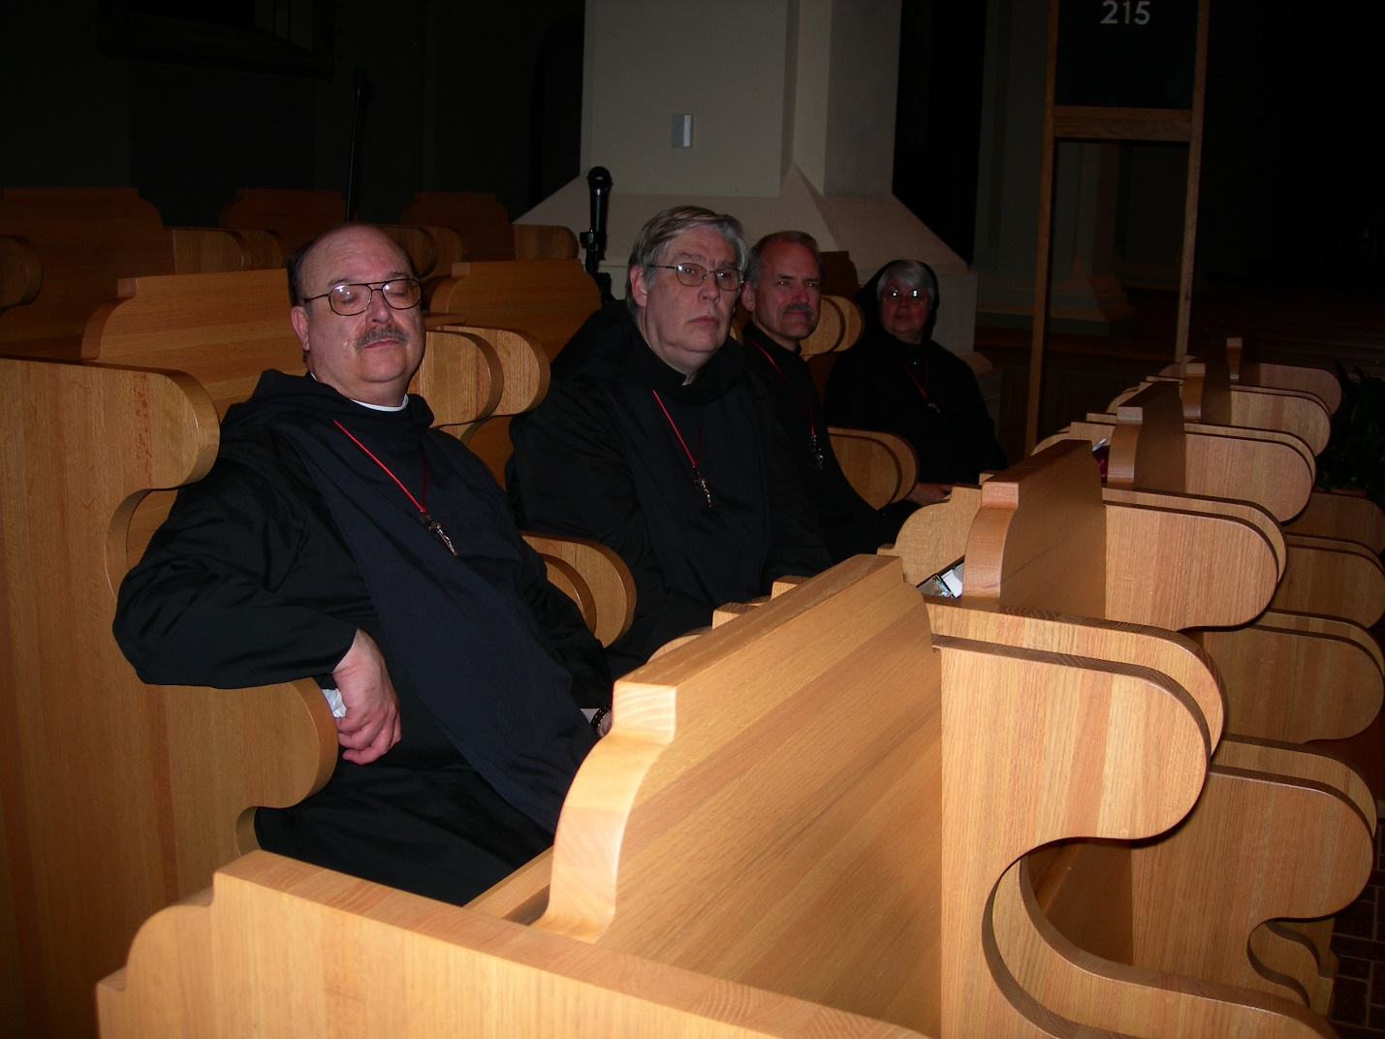
DSCN0211 Br. Raymond Owens; Br. Chad Anselm Gerns; Br. Daniel Joseph Schroeder; Sr. Clare Benedicta Meyers
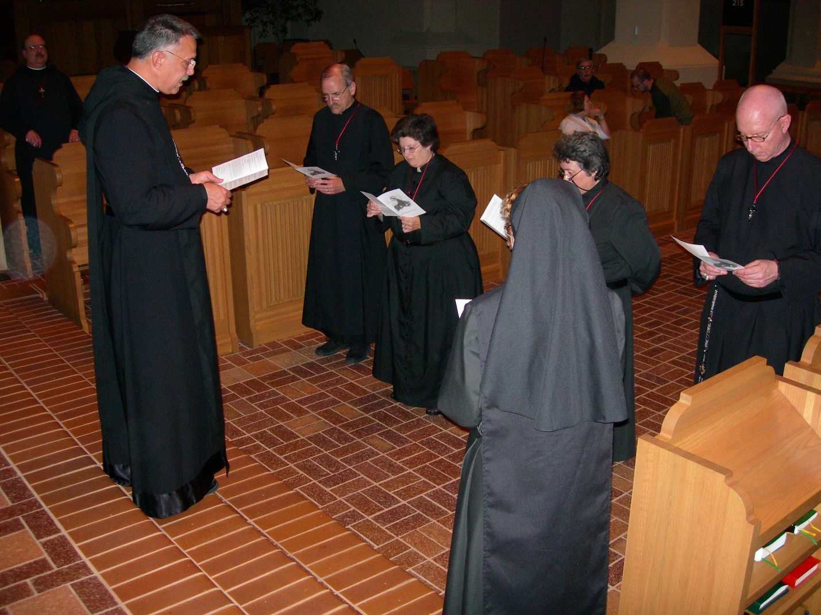
DSCN0212 Br. Raymond Owens; Prior Michael John Austin; Br. Daniel Joseph Schroeder; Sr. Cecilia Lamoy; Sr. Monica Ruth Mullen; Sr. Vincent Marie Rittenhouse; Br. David Vincent Cotton
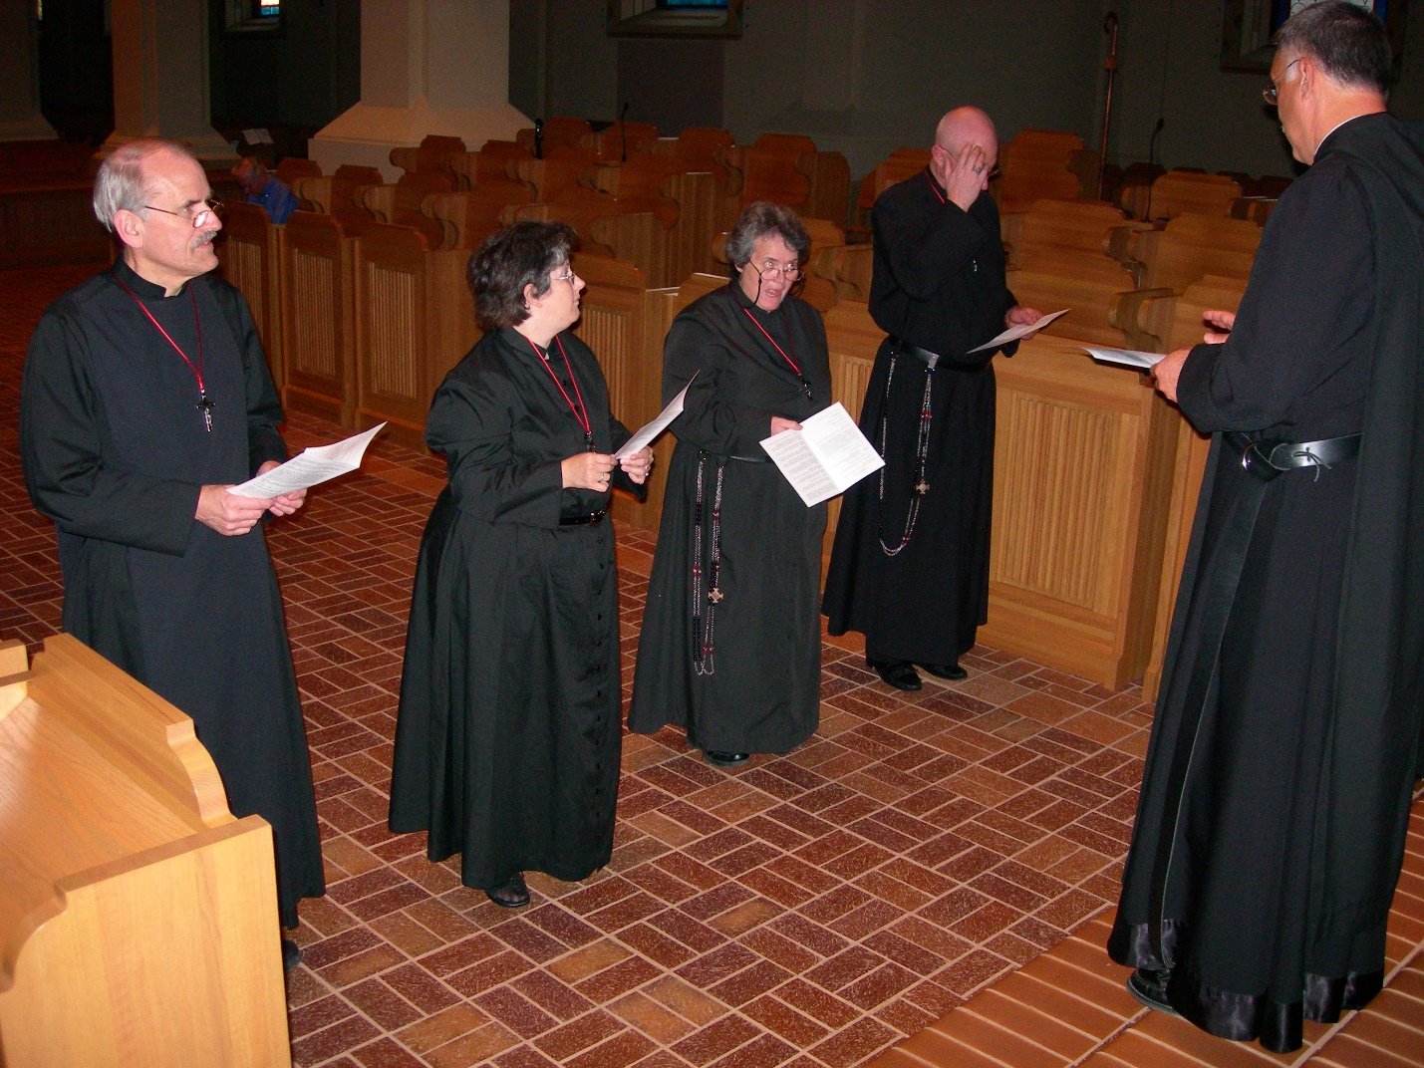
DSCN0213 Br. Daniel Joseph Schroeder; Sr. Cecilia Lamoy; Sr. Vincent Marie Rittenhouse; Br. David Vincent Cotton; Br. Prior Michael John Austin

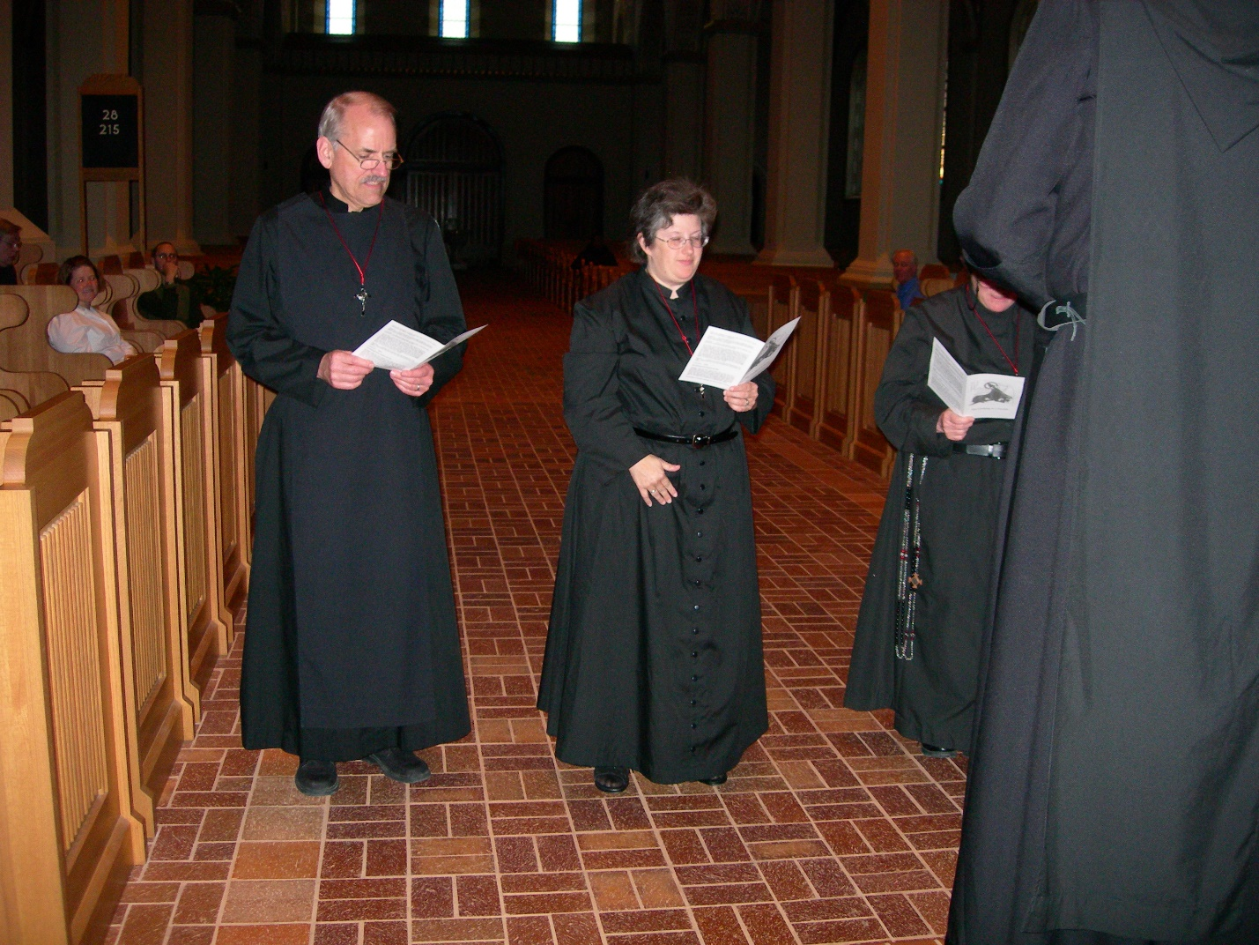
DSCN0214 Maria Lundgren; Br. Daniel Joseph Schroeder; Sr. Cecilia Lamoy; Sr. Vincent Marie Rittenhouse; Prior Michael John Austin
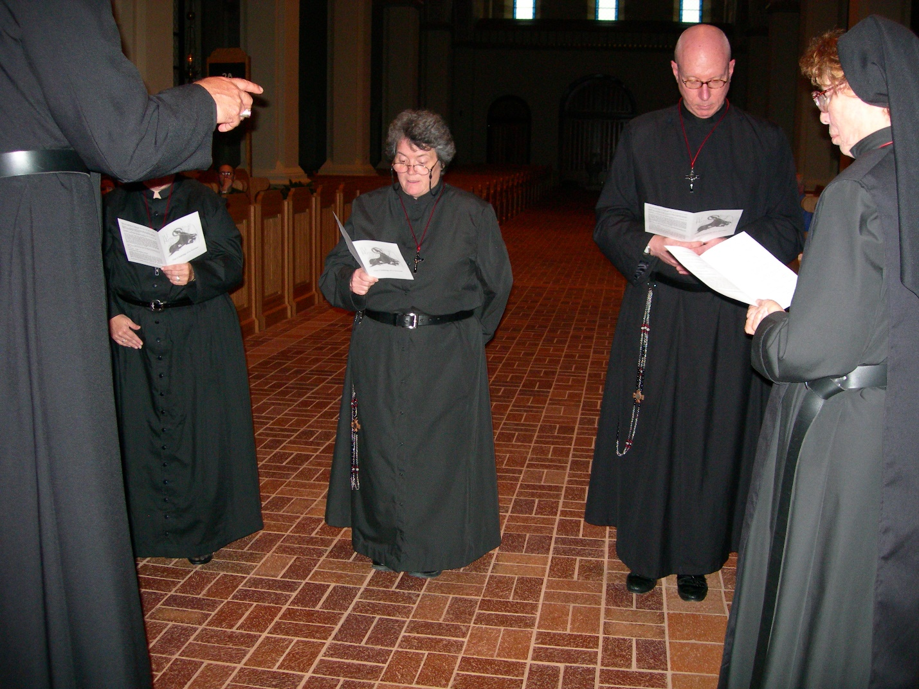
DSCN0215 Prior Michael John Austin; Sr. Cecelia Lamoy; Sr. Vincent Marie Rittenhouse; David Vincent Cotton; Sr. Monica Ruth Mullen
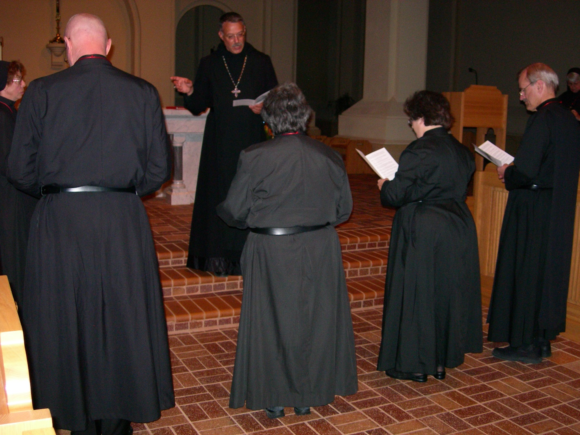
DSCN0216 Sr. Monica Ruth Mullen; Br. David Vincent Cotton; Prior Michael John Austin; Sr. Vincent Marie Rittenhouse; Sr. Cecelia Lamoy; Br. Daniel Joseph Schroeder
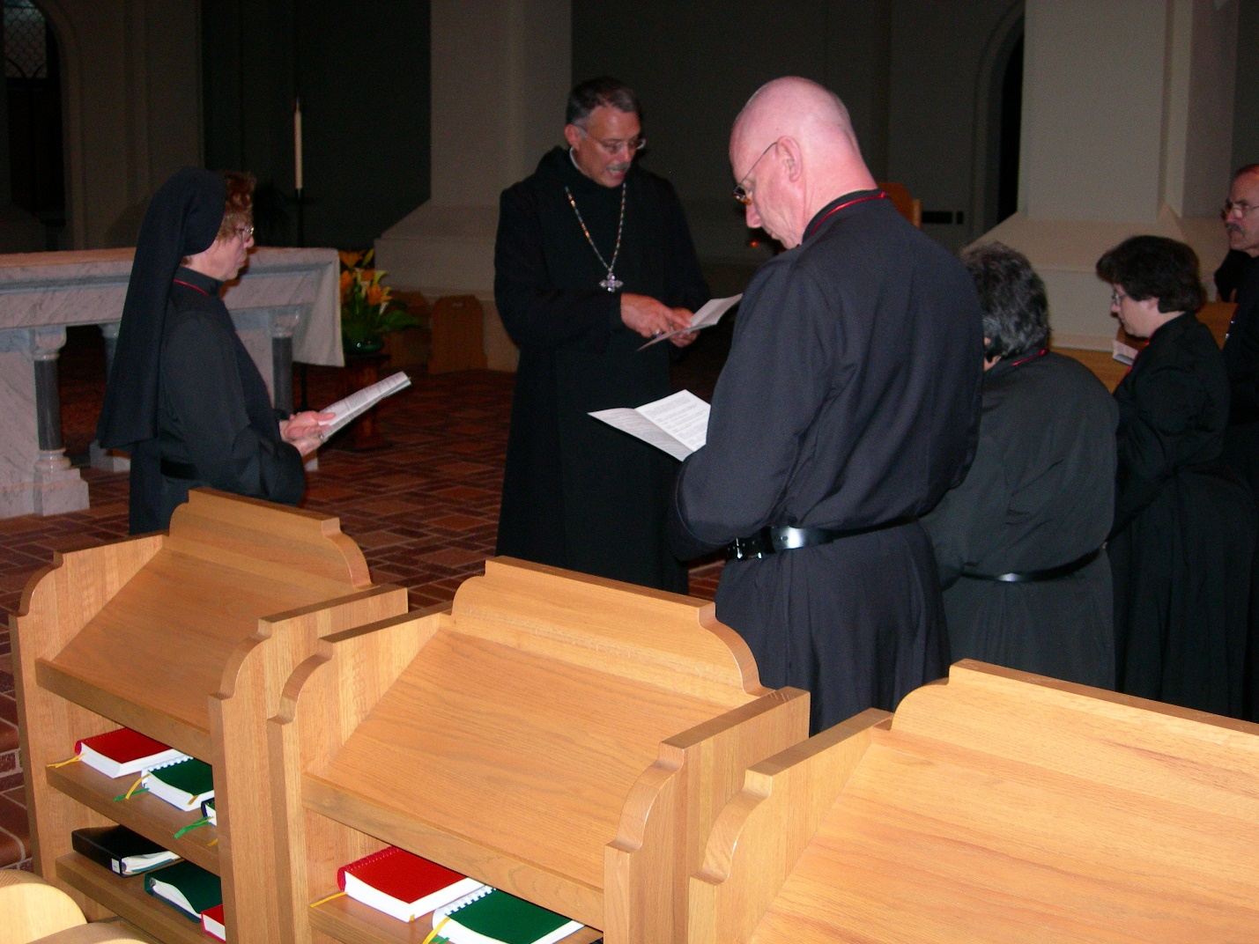
DSCN0217 Sr. Monica Ruth Mullen; Prior Michael John Austin; Br. David Vincent Cotton; Sr. Vincent Marie Rittenhouse; Sr. Cecelia Lamoy; Br. Daniel Joseph Schroeder
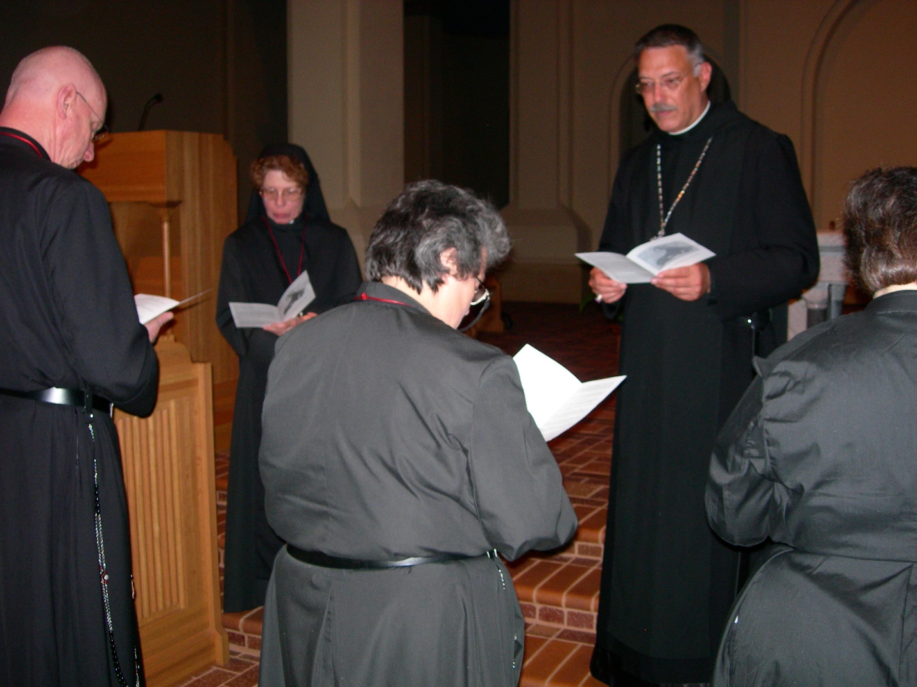
DSCN0218 Br. David Vincent Cotton; Sr. Monica Ruth Mullen; Sr. Vincent Marie Rittenhouse; Prior Michael John Austin; Sr. Cecelia Lamoy

