Companions of St. Luke
Fall 2003 Convocation at Conception Abbey
Part 6 of 6

~Edited by Br. Steven Olderr, 17 May 2022 with the assistance of Br. Thomas Ferrell; if you find any errors or omissions, please notify Br. Steven at olderr@ameritech.net

People are identified from left to right.

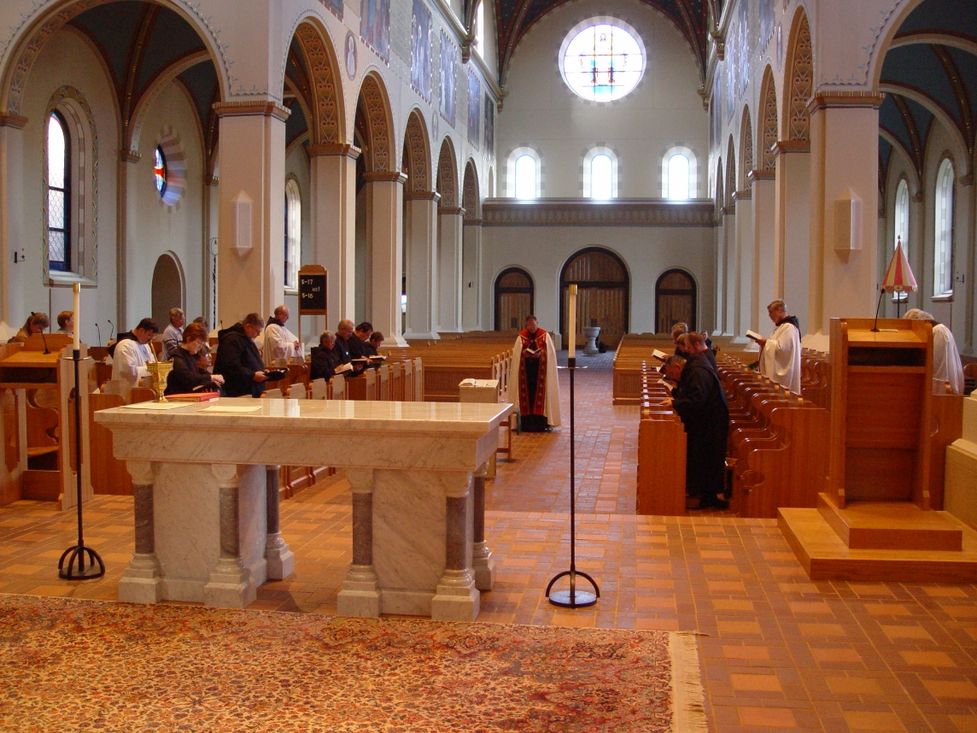
COSL 255
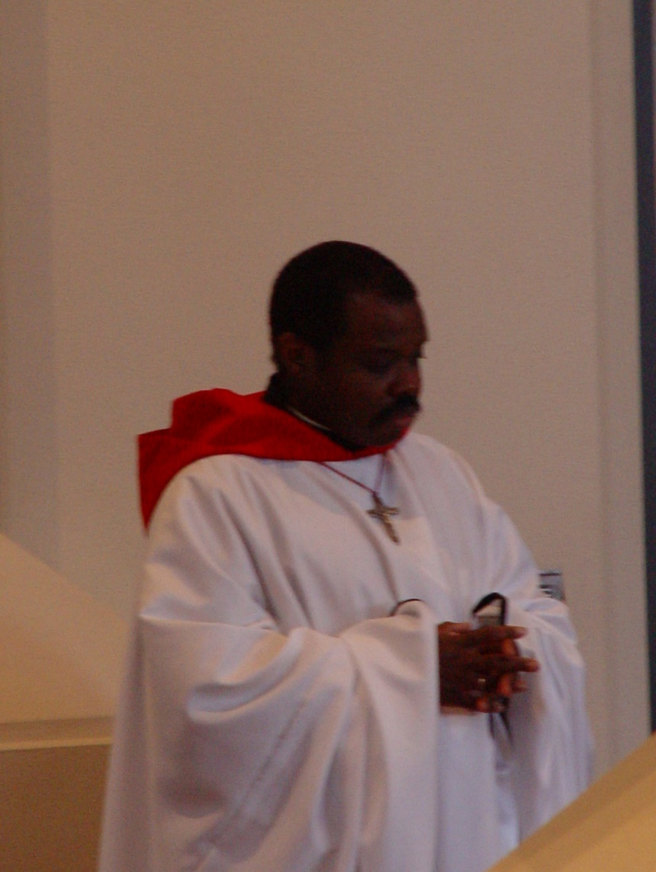
COSL 256 Br. Thomas Ferrell
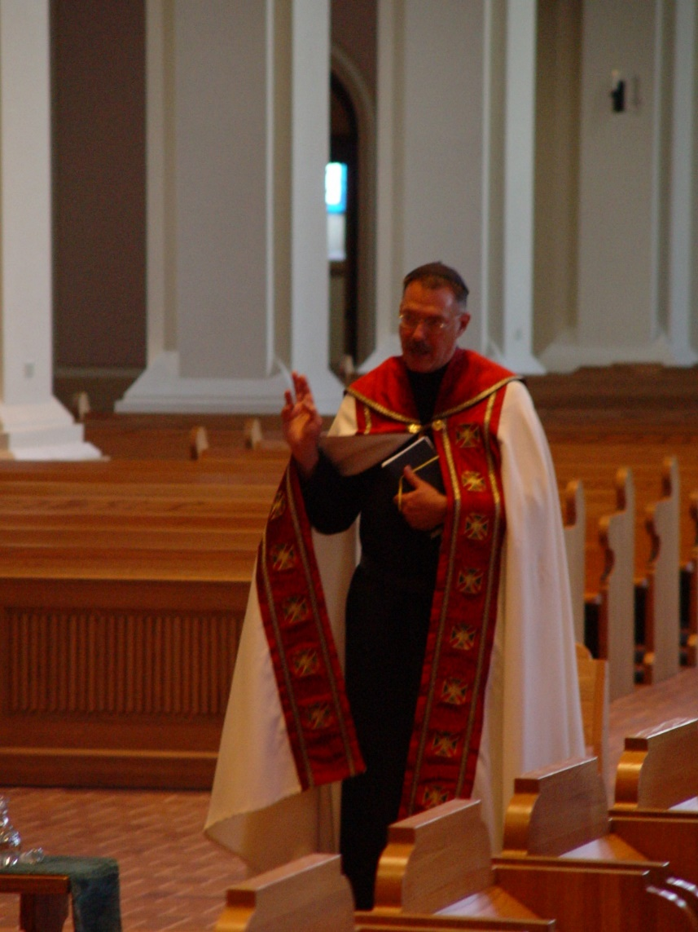
COSL 257 Prior Michael John Austin
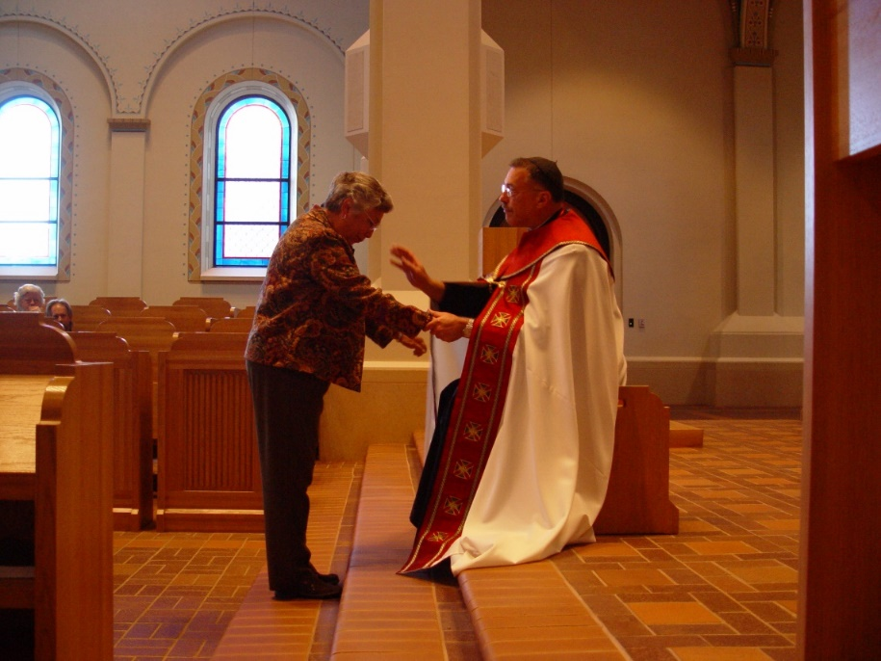
COSL 258 Jeanetta Doan; Prior Michael John Austin

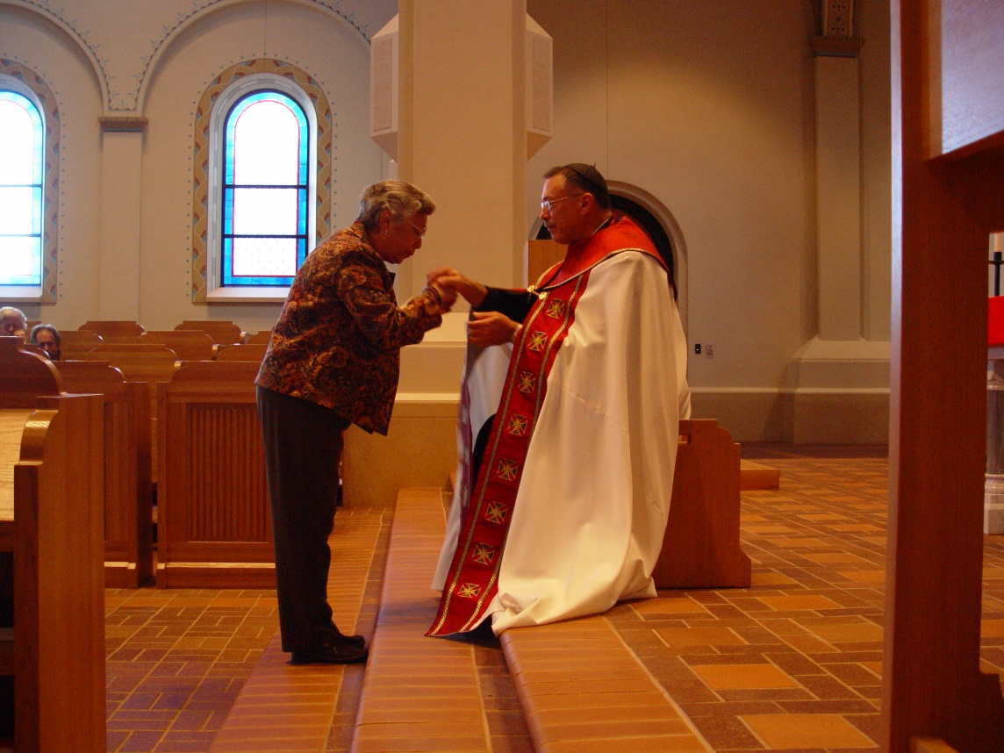
COSL 259 Jeanetta Doan; Prior Michael John Austin
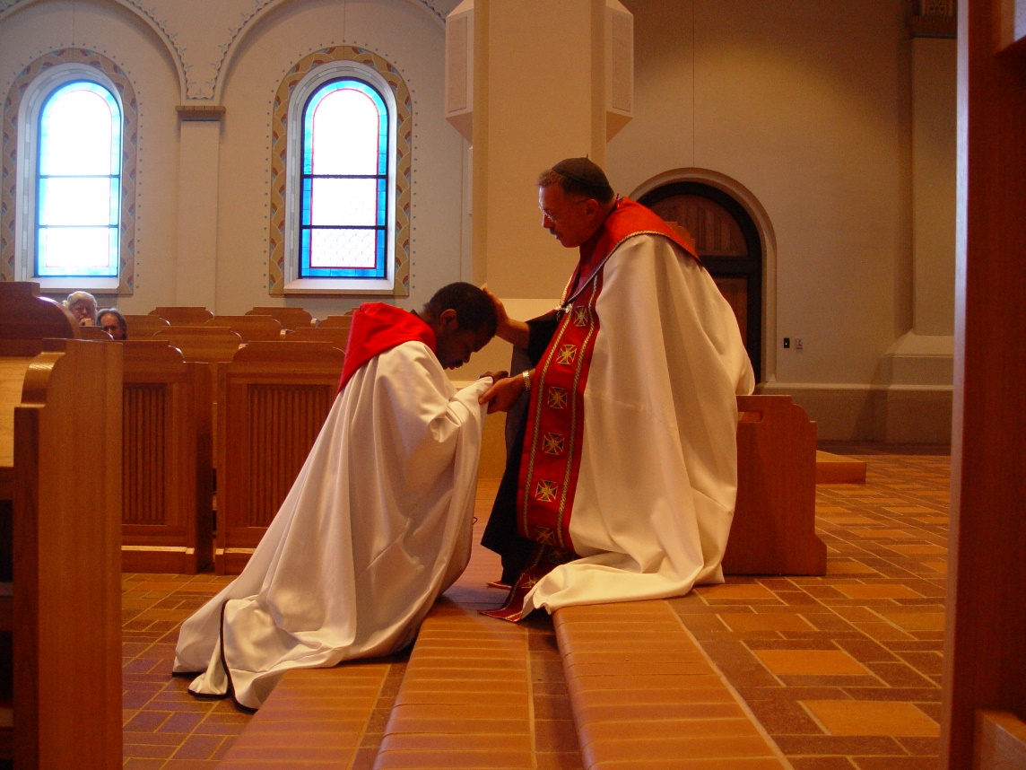
COSL 260 Br. Thomas Ferrell; Prior Michael John Austin

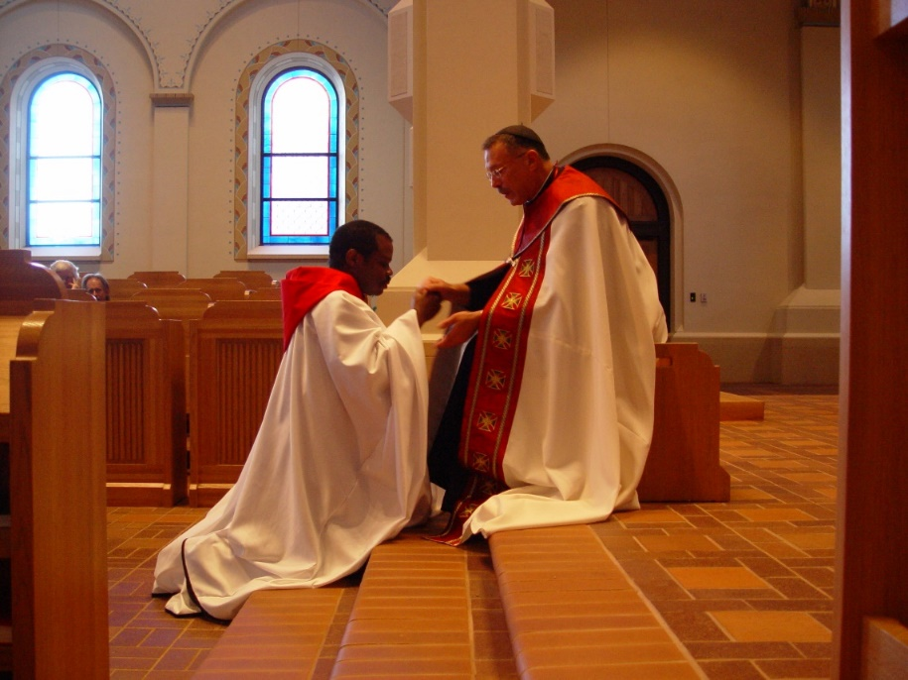
COSL 261 Br. Thomas Ferrell; Prior Michael John Austin

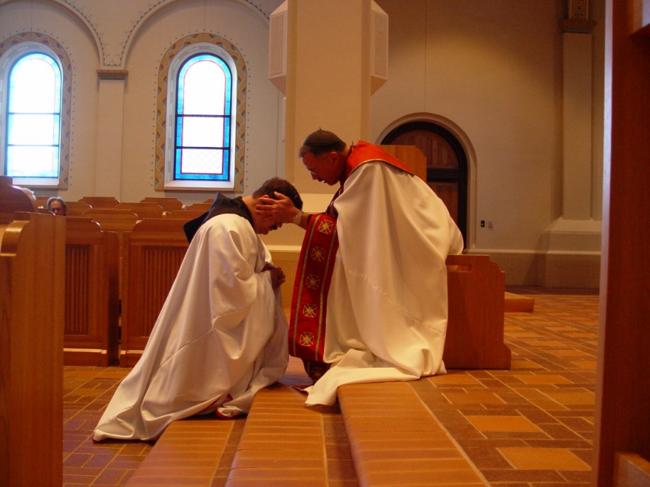
COSL 262 Br. Paul Howard; Prior Michael John Austin

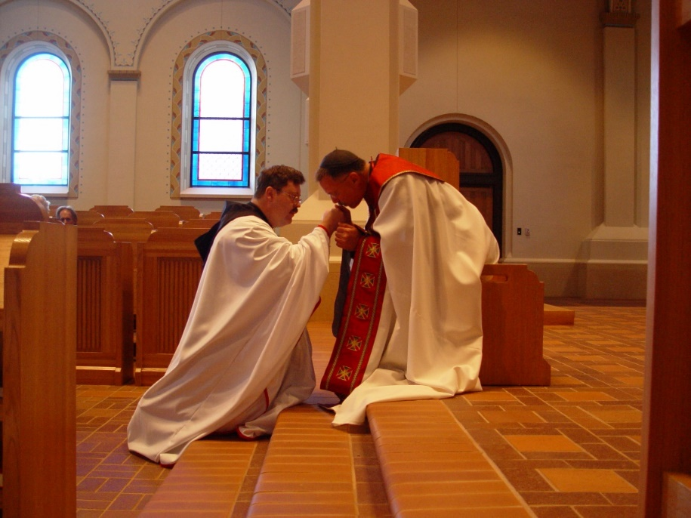
COSL 263 Br. Paul Howard; Prior Michael John Austin

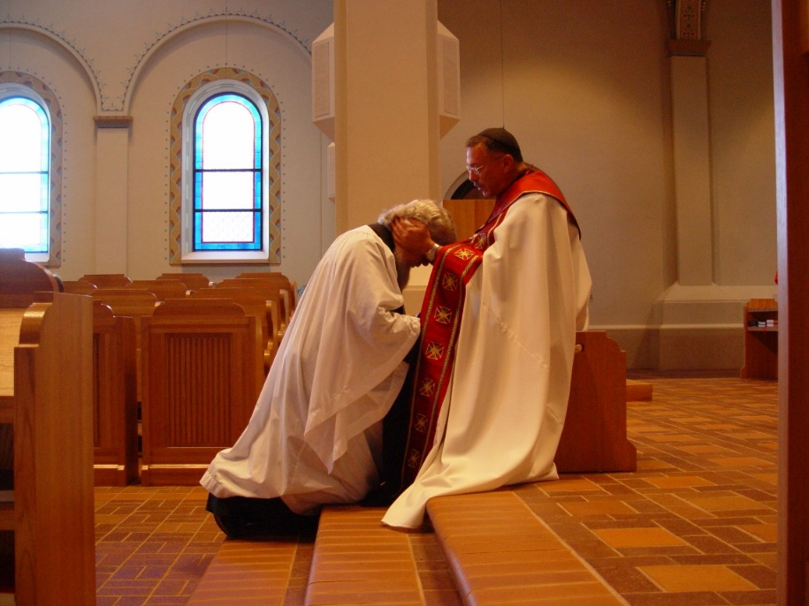
COSL 264 Fr. Wayne Kamm; Prior Michael John Austin

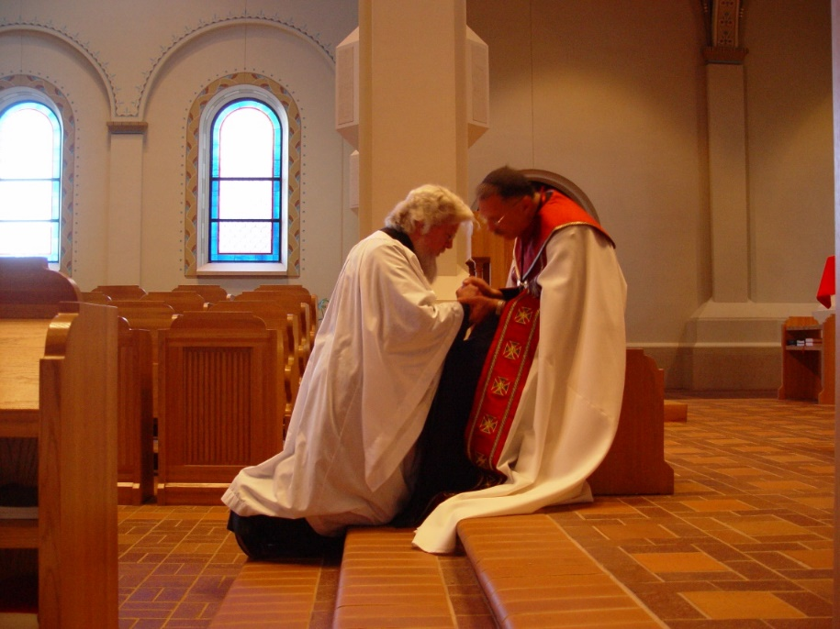
COSL 265 Fr. Wayne Kamm; Prior Michael John Austin

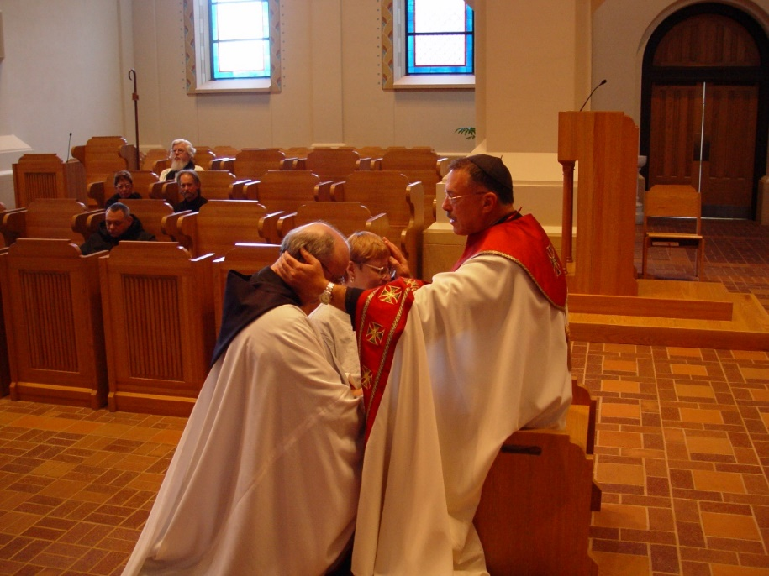
COSL 266 Br. Raymond Owens; Lynn Owens; Prior Michael John Austin

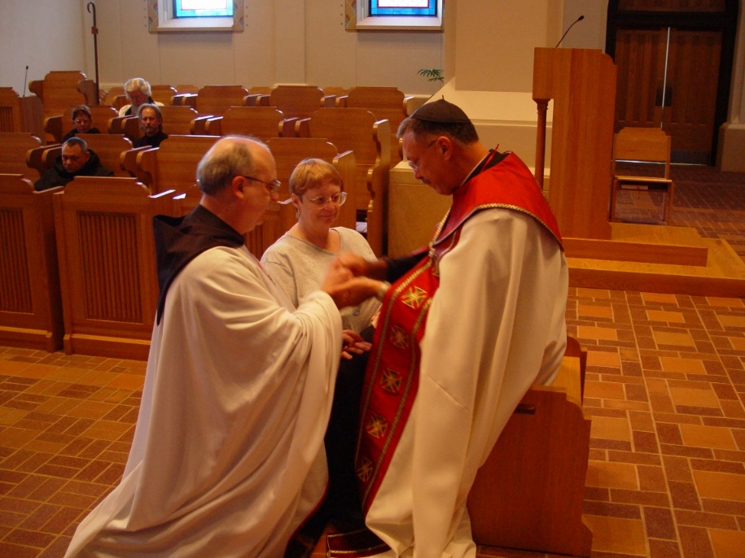
COSL 267 Br. Raymond Owens; Lynn Owens; Prior Michael John Austin
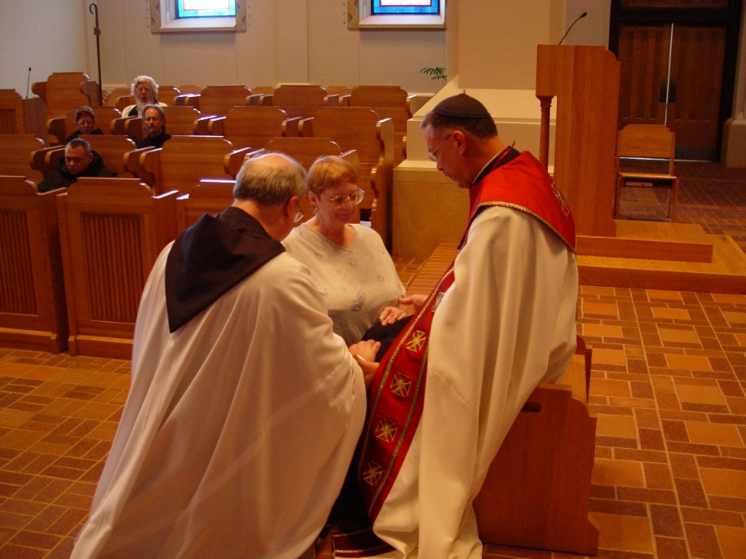
COSL 268 Br. Raymond Owens; Lynn Owens; Prior Michael John Austin

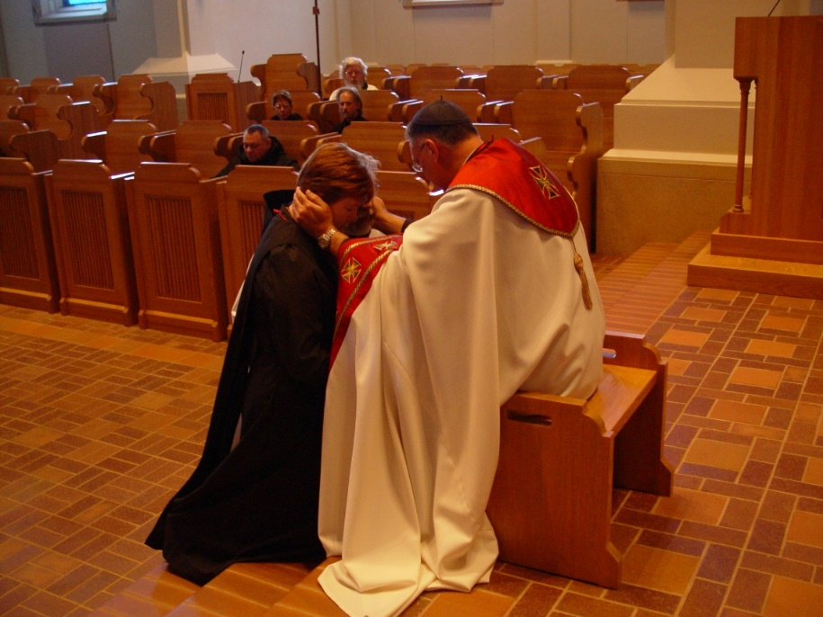
COSL 269 Sr. Ann Gerns; Prior Michael John Austin
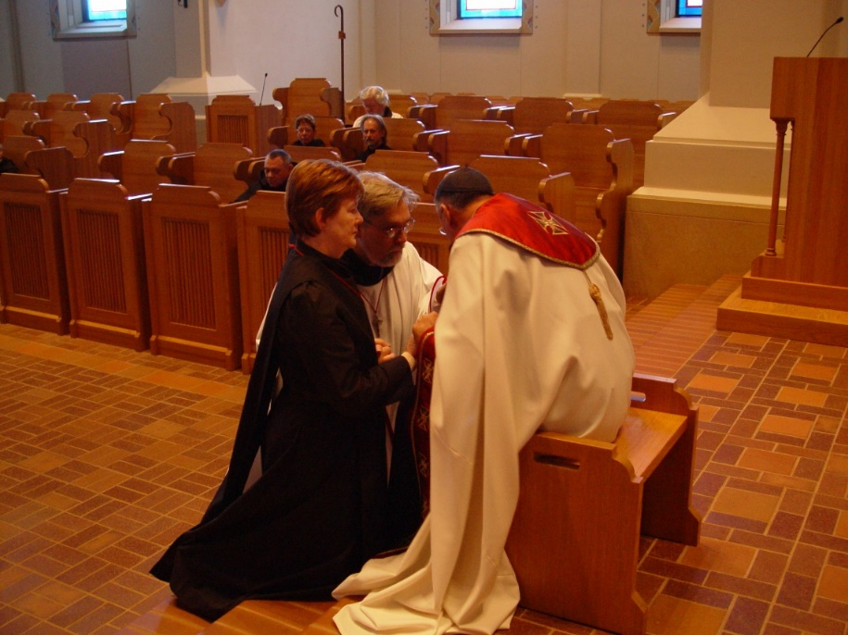
COSL 270 Sr. Ann Gerns; Br. Chad Anselm Gerns; Prior Michael John Austin
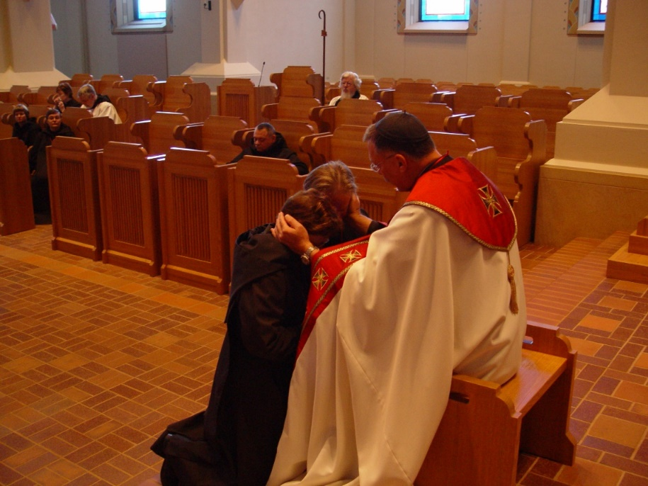
COSL 271 Sr. Monica Ruth Mullen; Br. Lawrence Mullen; Prior Michael John Austin
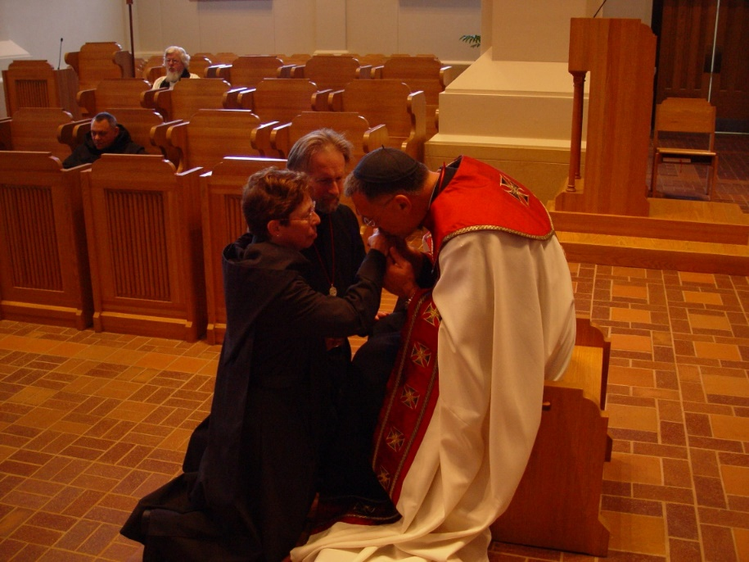
COSL 272 Sr. Monica Ruth Mullen; Br. Lawrence Mullen; Prior Michael John Austin

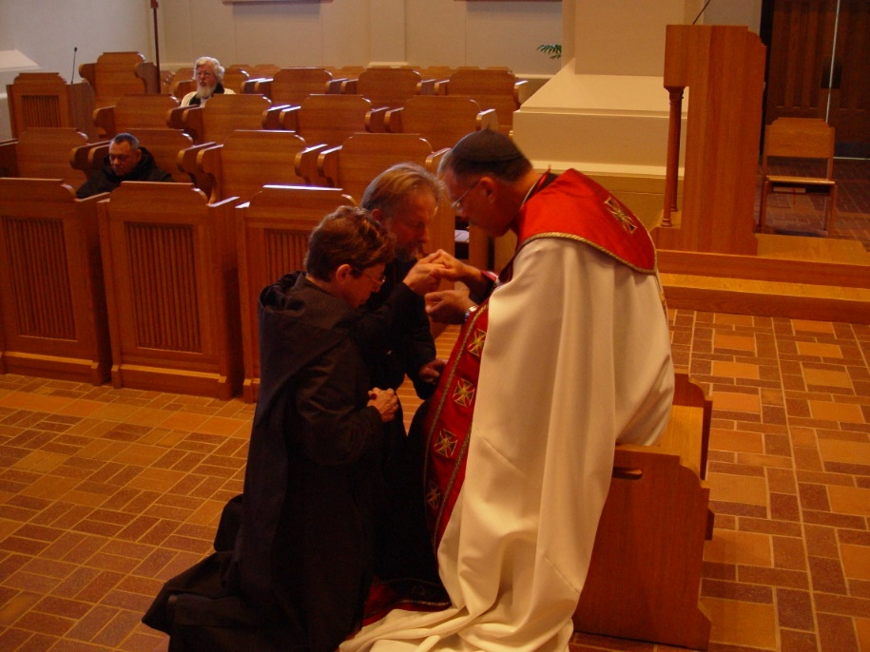
COSL 273 Sr. Monica Ruth Mullen; Br. Lawrence Mullen; Prior Michael John Austin
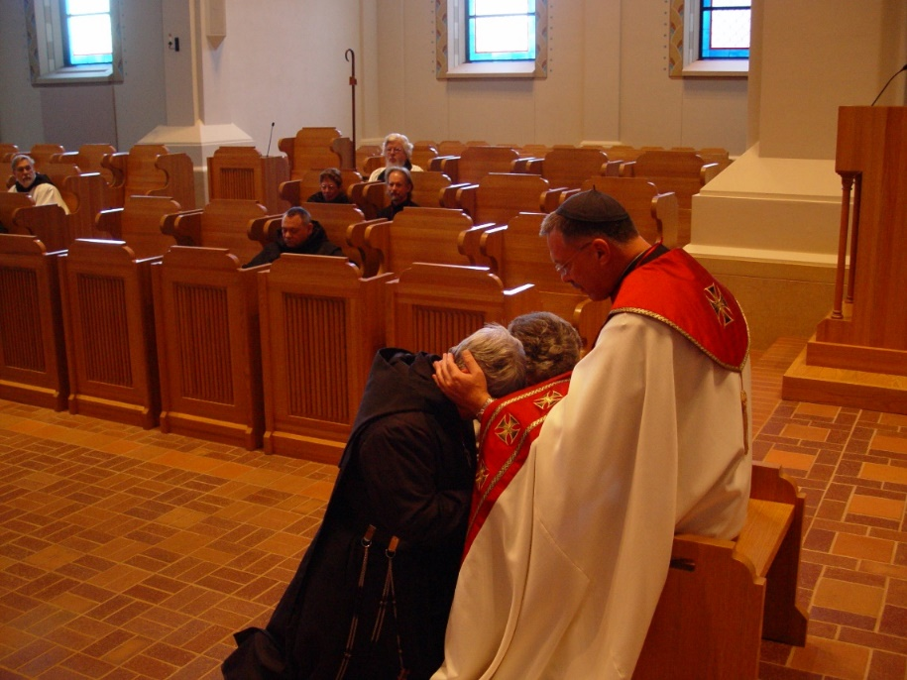
COSL 274 Sr. Clare Benedicta Meyers; Becky Rittenhouse; Prior Michael John Austin

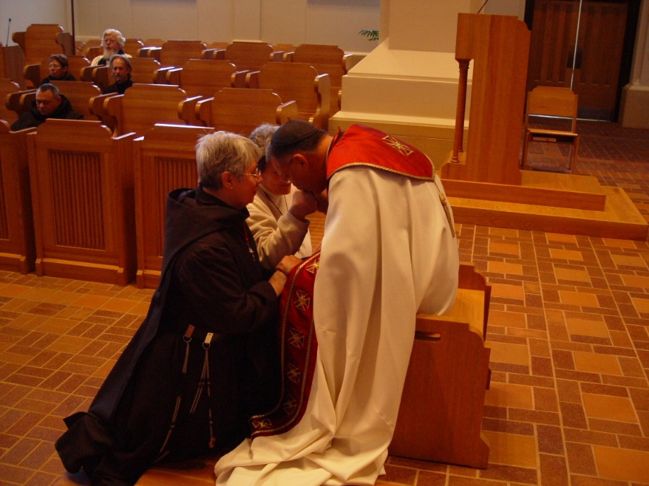
COSL 275 Sr. Clare Benedicta Meyers; Becky Rittenhouse; Prior Michael John Austin

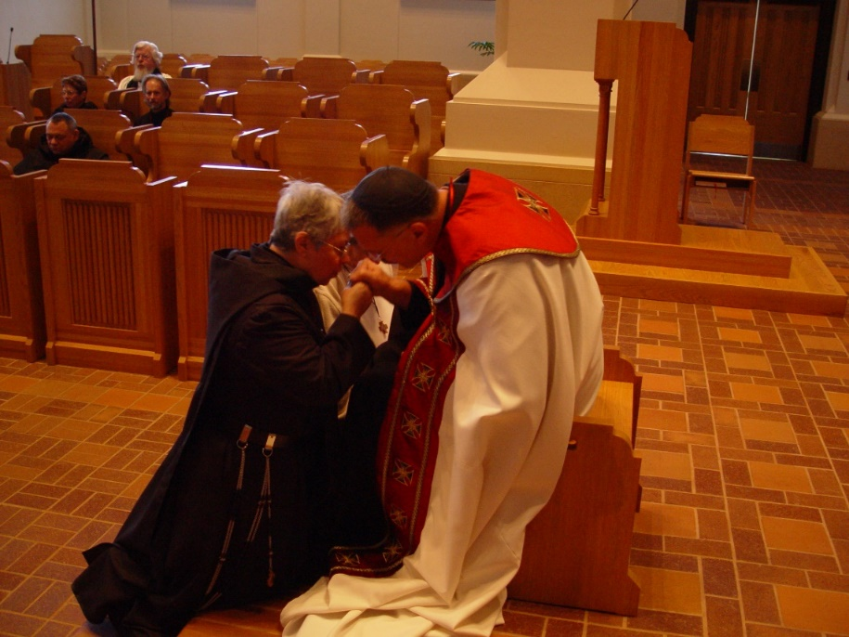
COSL 276 Sr. Clare Benedicta Meyers; Becky Rittenhouse; Prior Michael John Austin

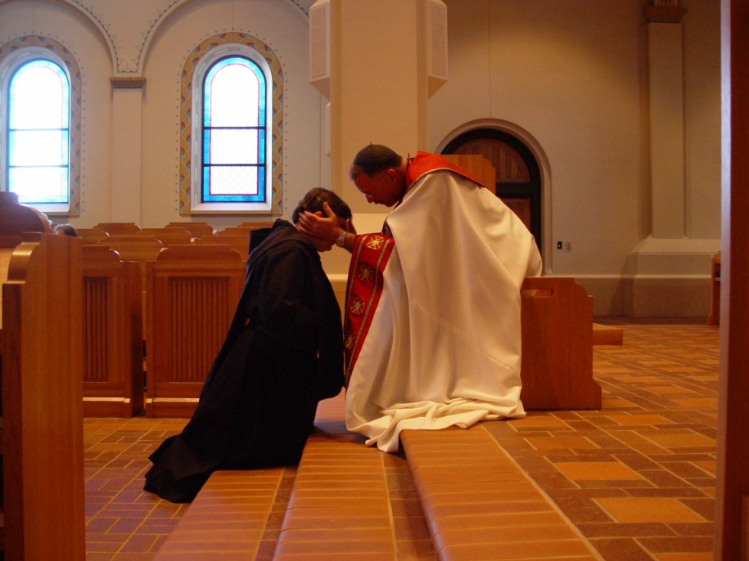
COSL 277 Sr. Theodora of Jesus Perecca; Prior Michael John Austin

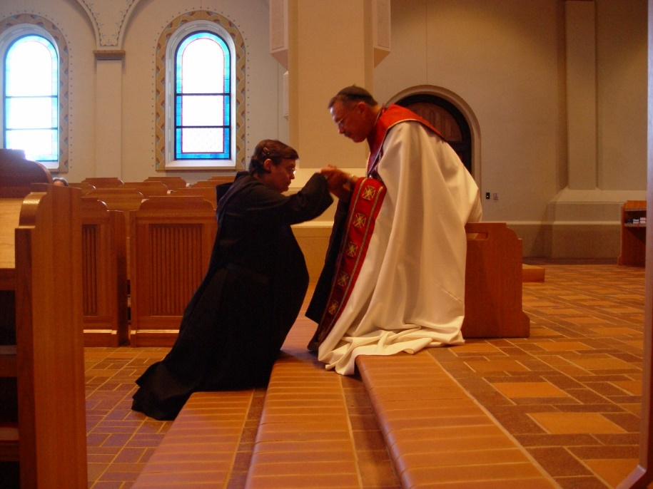
COSL 278 Sr. Theodora of Jesus Perecca; Prior Michael John Austin

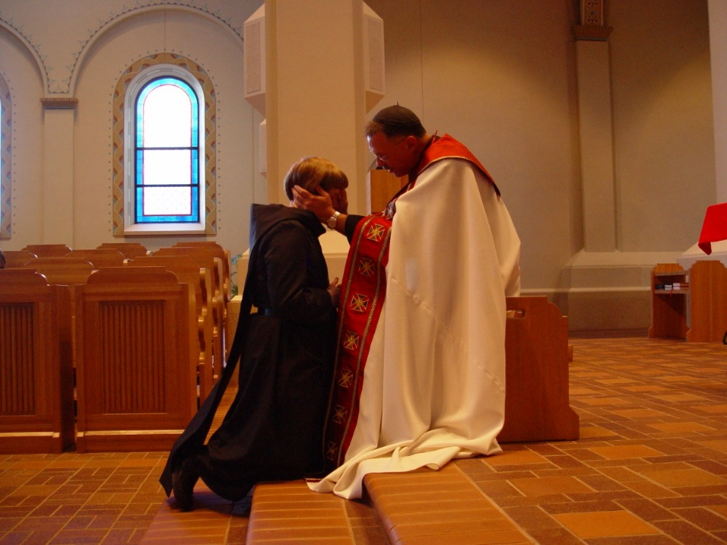
COSL 279 Sr. Catherine Unterseher; Prior Michael John Austin

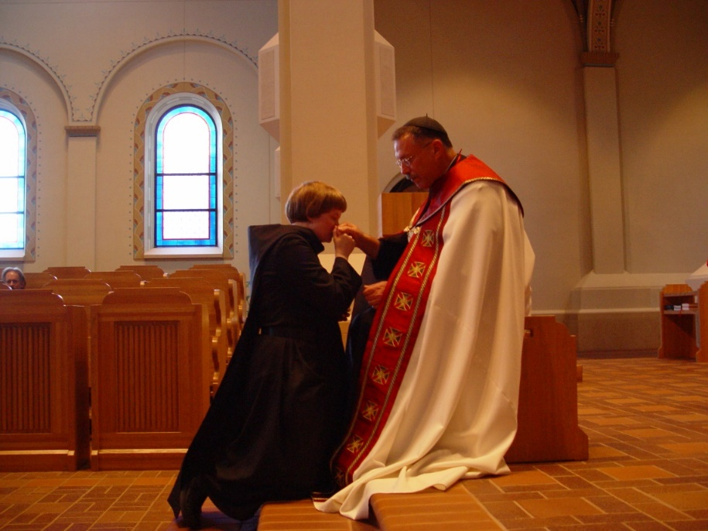
COSL 280 Sr. Catherine Unterseher; Prior Michael John Austin

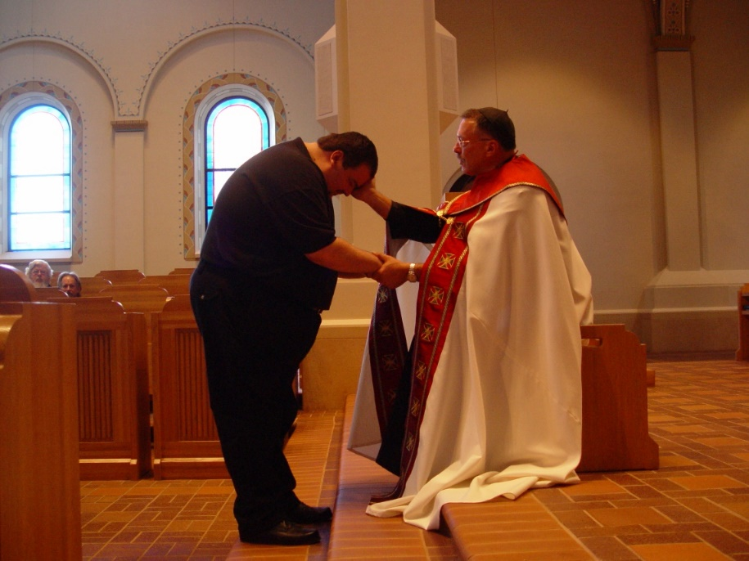
COSL 281 Regan Fox; Prior Michael John Austin
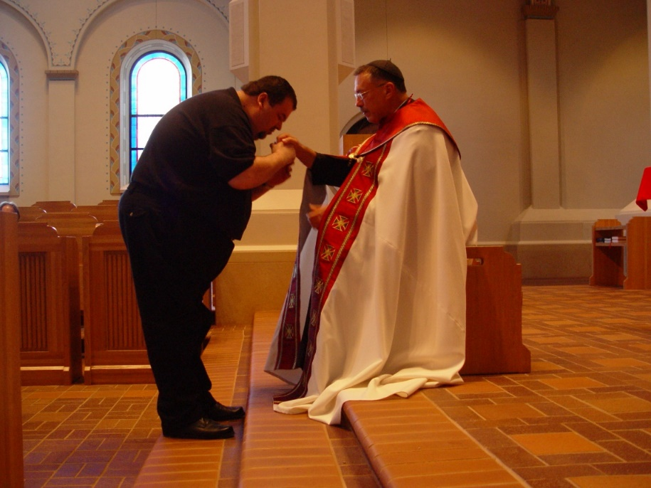
COSL 282 Regan Fox; Prior Michael John Austin

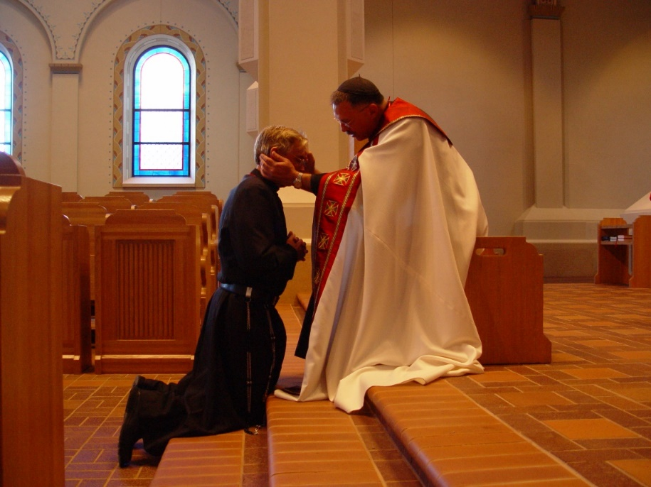
COSL 283 Br. Camillus Converse; Prior Michael John Austin

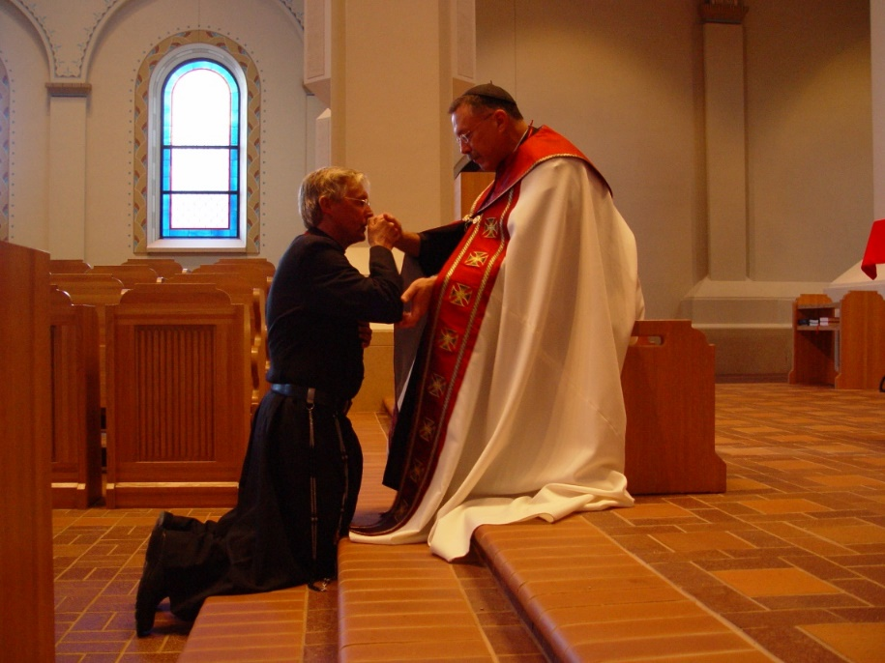
COSL 284 Br. Camillus Converse; Prior Michael John Austin

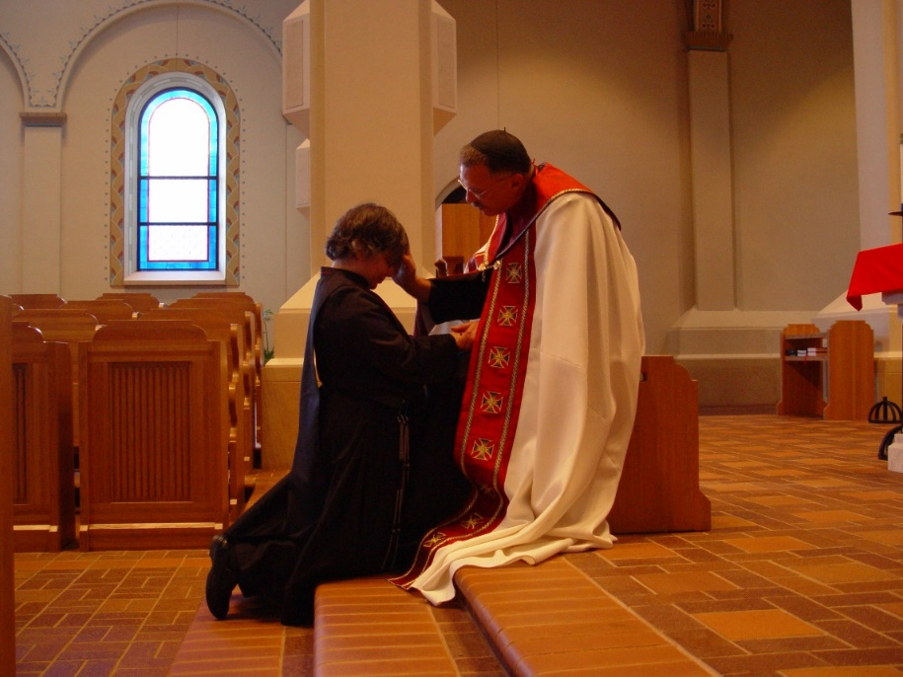
COSL 285 Sr. Anna Grace Madden; Prior Michael John Austin

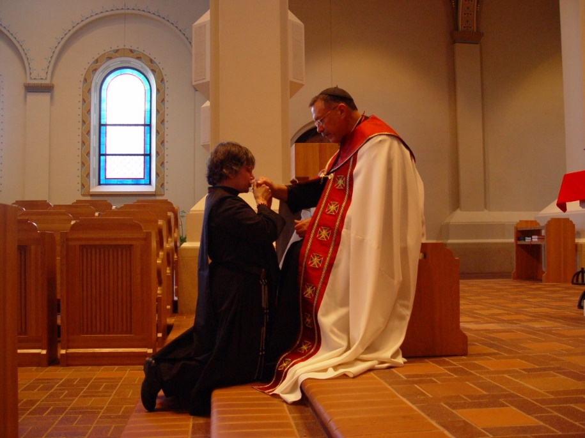
COSL 286 Sr. Anna Grace Madden; Prior Michael John Austin
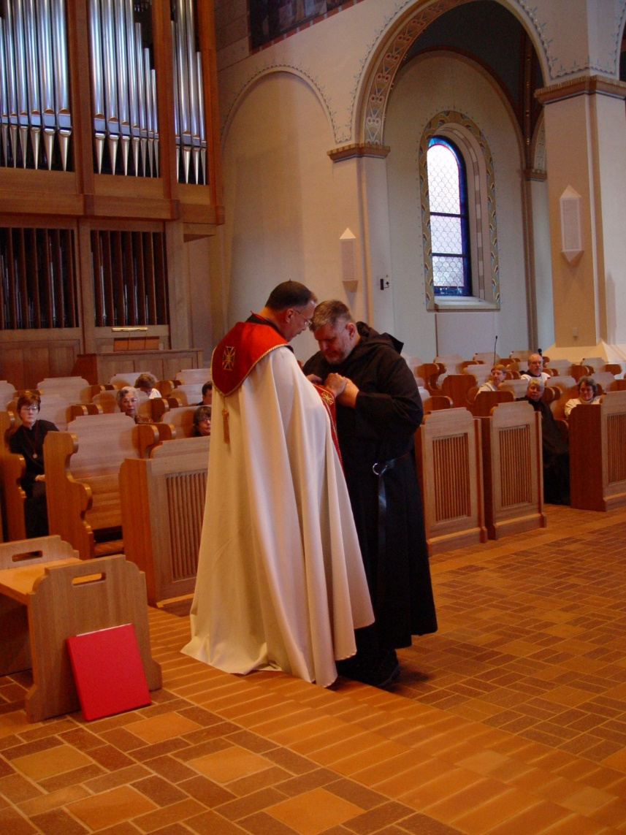
COSL 287 Br. Nathan Gregory Miller; Prior Michael John Austin
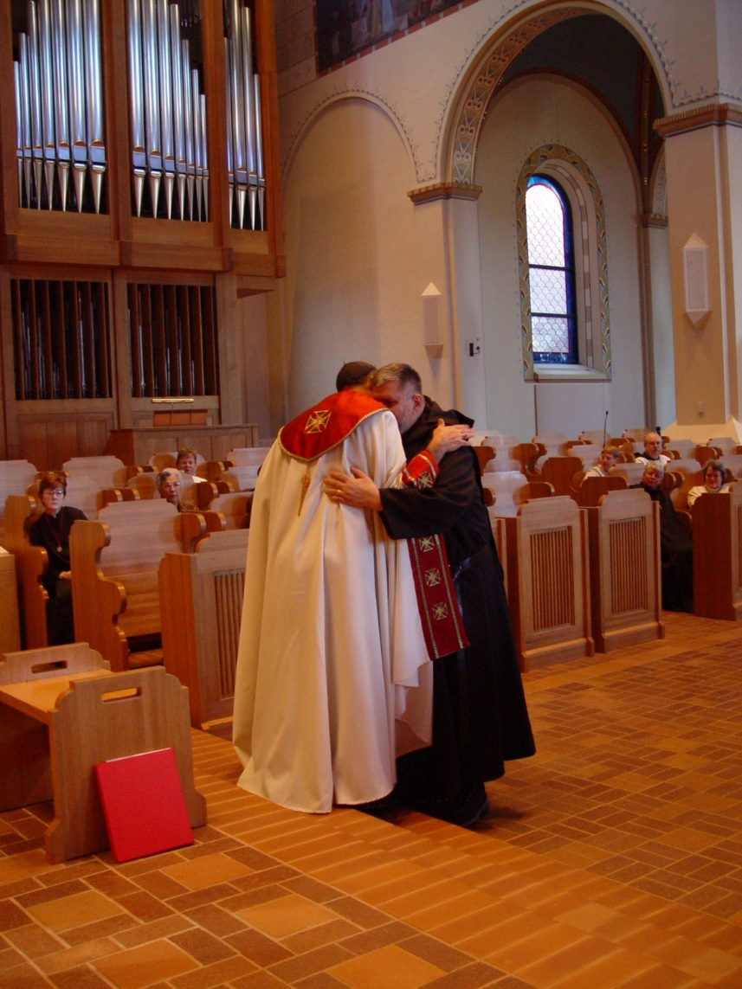
COSL 288 Br. Nathan Gregory Miller; Prior Michael John Austin
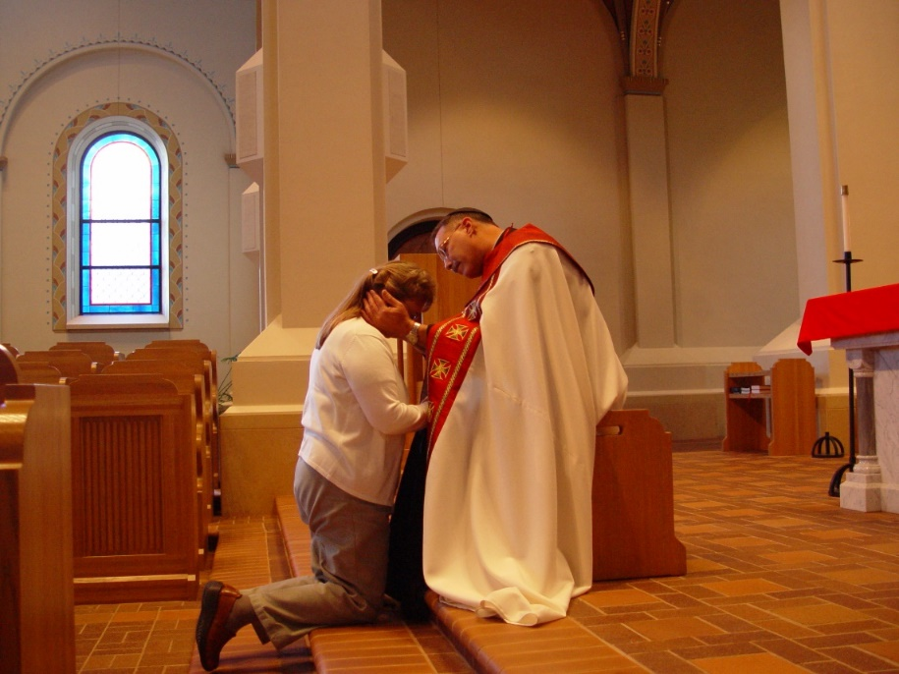
COSL 289 Becky Fredregill; Prior Michael John Austin

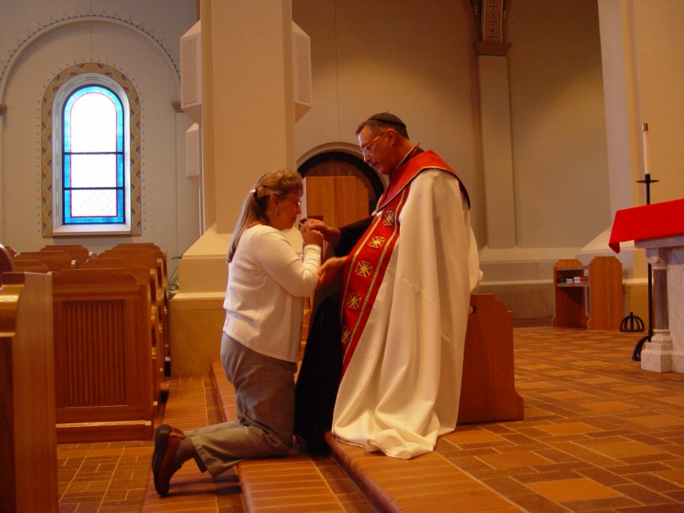
COSL 290 Becky Fredregill; Prior Michael John Austin
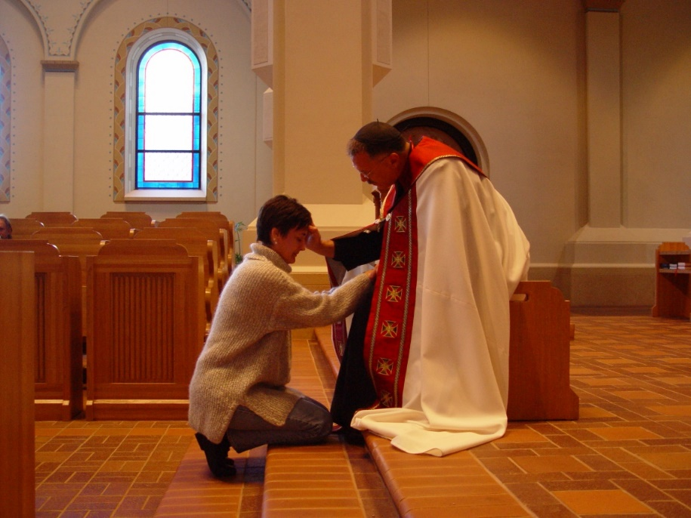
COSL 291 Deanna Flak; Prior Michael John Austin

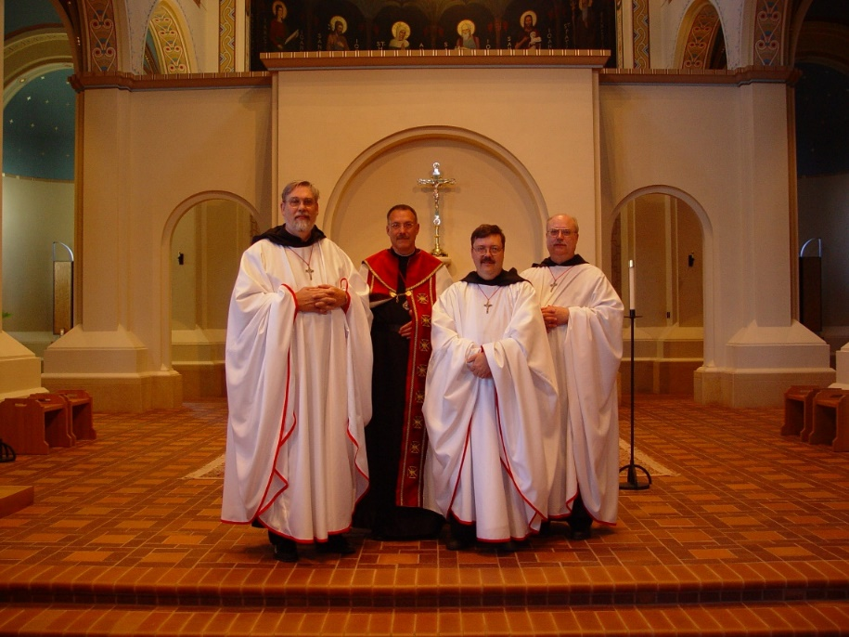
COSL 292 Br. Chad Anselm Gerns; Prior Michael John Austin; Br. Paul Howard; Br. Raymond Owens
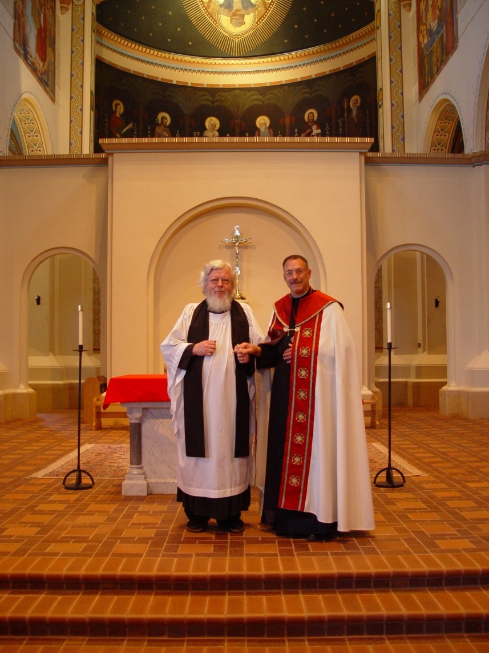
COSL 293 Fr. Wayne Kamm; Prior Michael John Austin
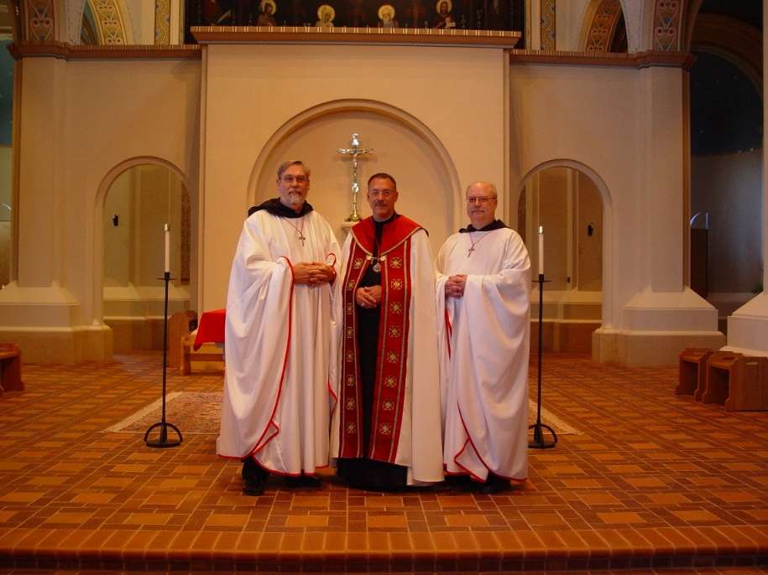
COSL 294 Br. Chad Anselm Gerns; Prior Michael John Austin; Br. Raymond Owens

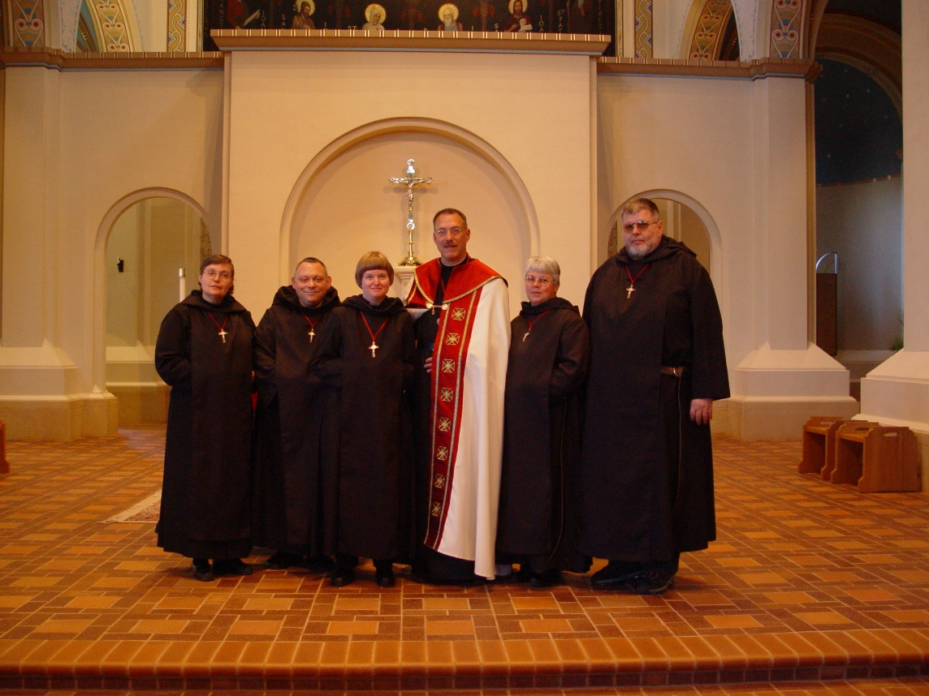
COSL 295 Sr. Theoroa of Jesus Preecca; Br. Ambrose Heroux; Sr. Catherine Unterseher; Prior Michael John Austin; Sr. Clare Benedicta Meyers; Br. Nathan Gregory Miller
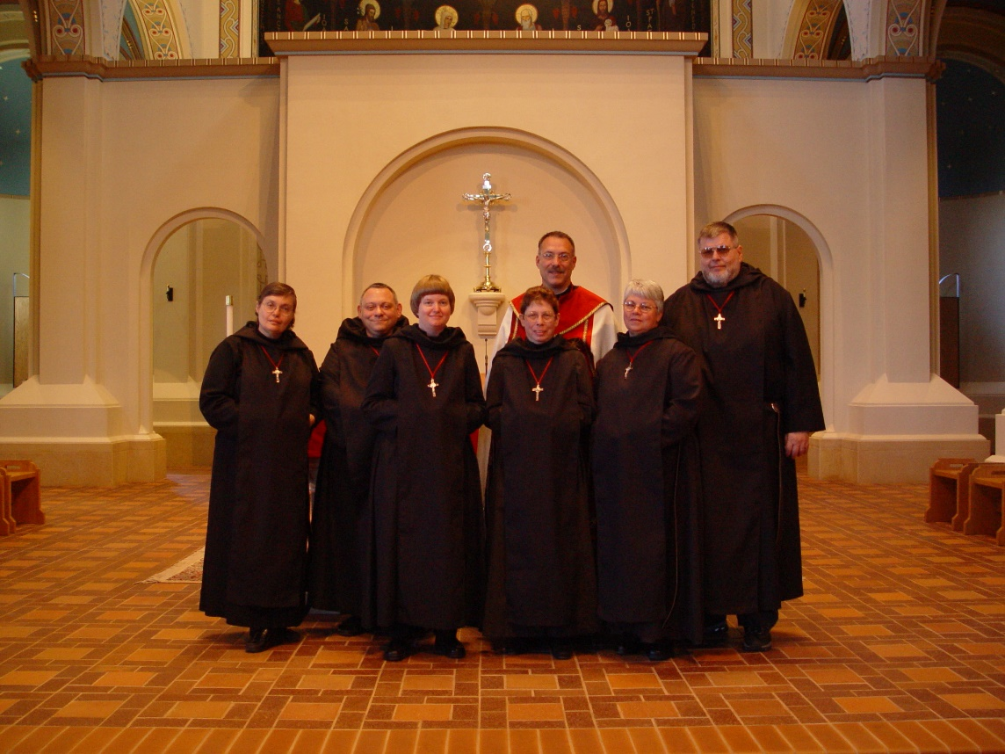
COSL 296 Sr. Theoroa of Jesus Preecca; Br. Ambrose Heroux; Sr. Catherine Unterseher; Sr. Monica Ruth Mullen; Prior Michael John Austin; Sr. Clare Benedicta Meyers; Br. Nathan Gregory Mille
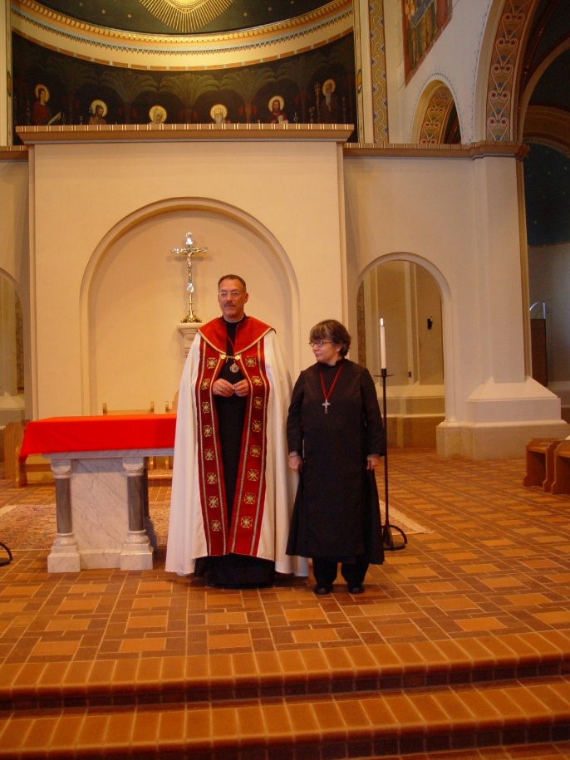
COSL 297 Prior Michael John Austin; Sr. Anna Grace Madden
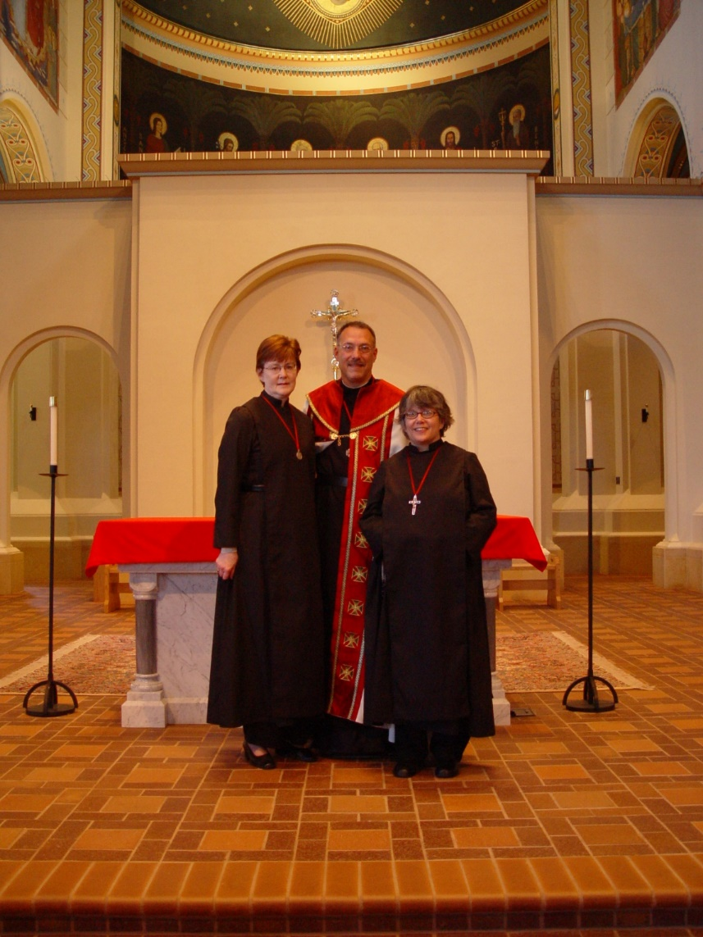
COSL 298 Sr Ann Gerns; Prior Michael John Austin; Sr. Anna Grace Madden
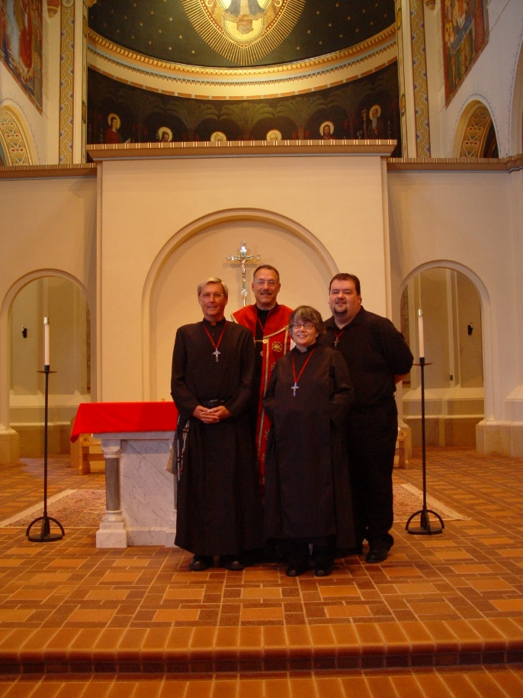
COSL 299 Br. Camillus Converse; Prior Michael John Austin; Sr. Anna Grace Madden; Regan Fox
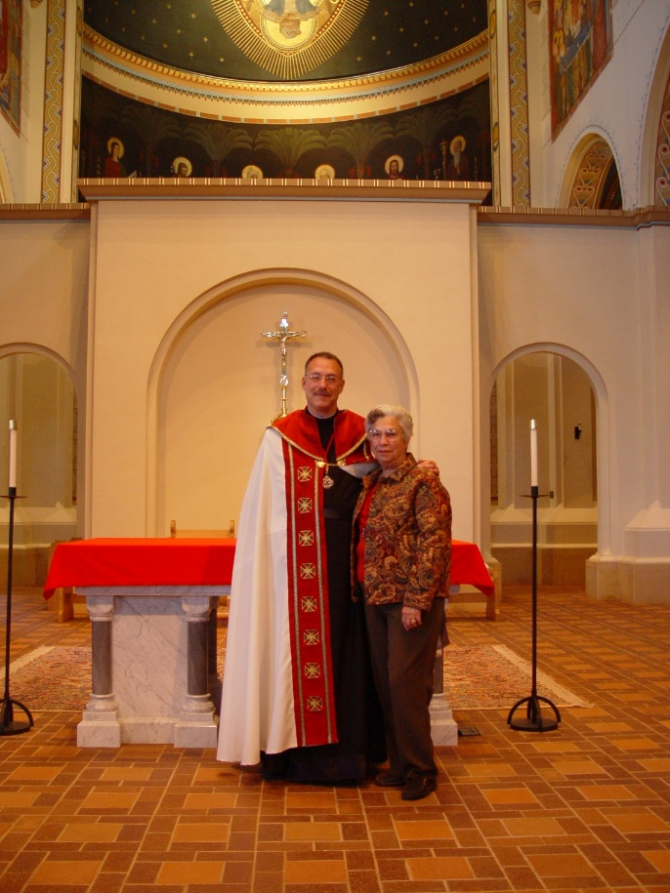
COSL 300 Prior Michael John Austin; Jeanetta Doan
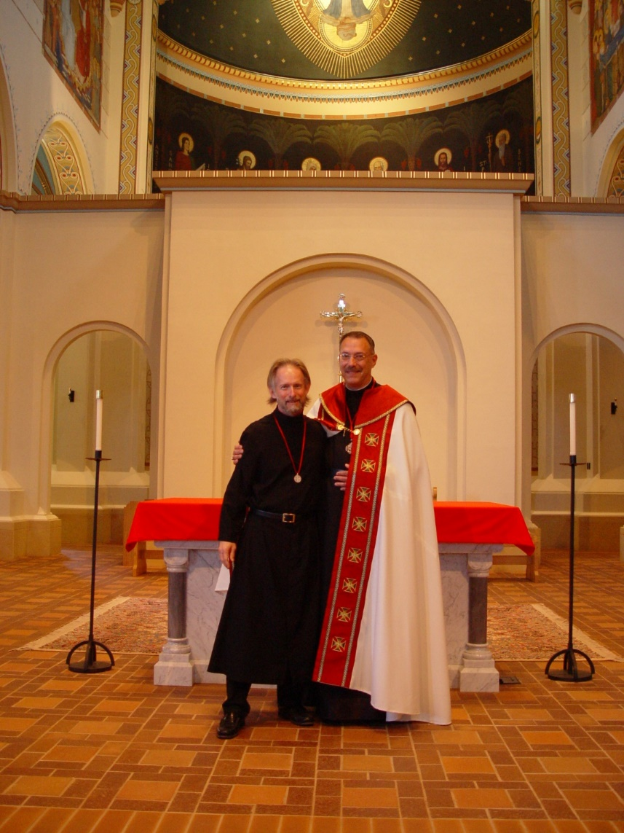
COSL 301 Br. Lawrence Mullen; Prior Michael John Austin
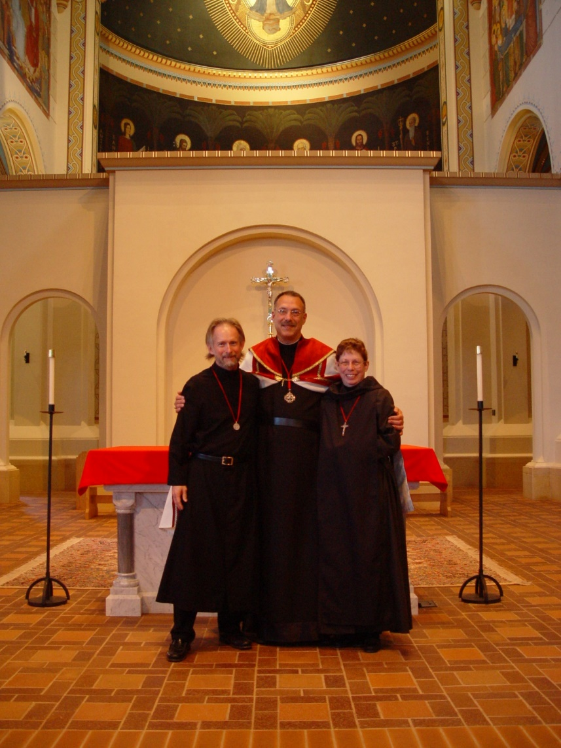
COSL 302 Br. Lawrence Mullen; Prior Michael John Austin; Sr. Monica Ruth Mullen
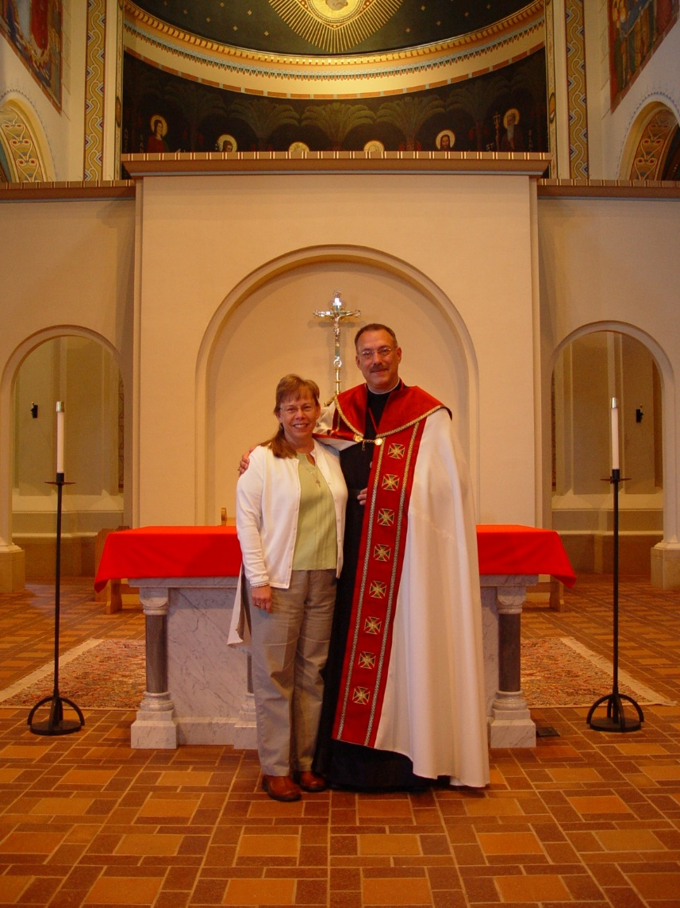
COSL 303 Becky Fredregill; Prior Michael John Austin
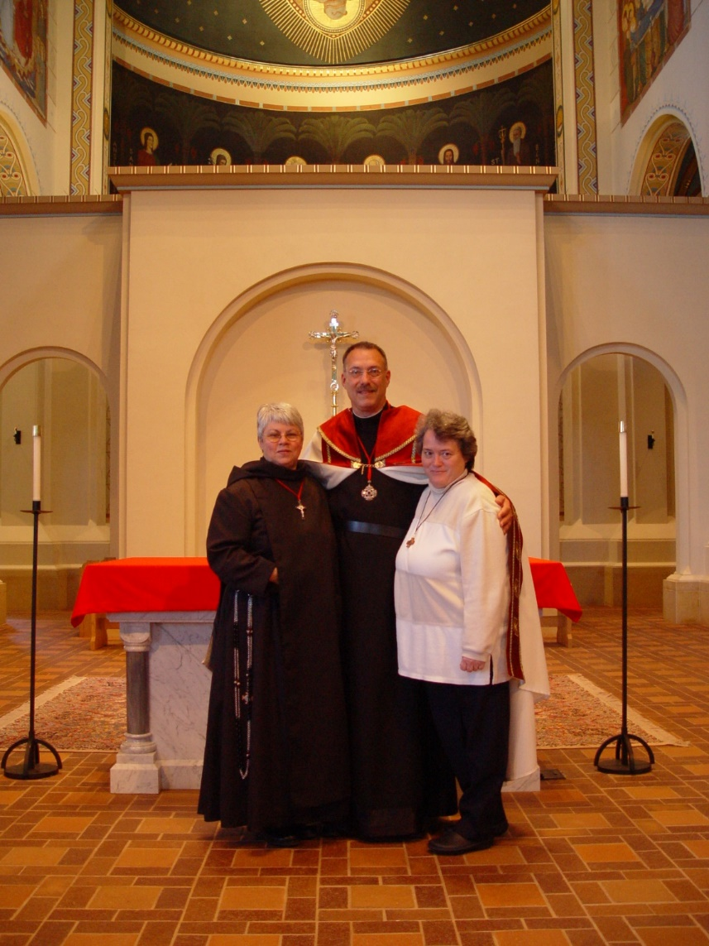
COSL 304 Sr. Clare Benedicta; Prior Michael John Austin; Becky Rittenhouse
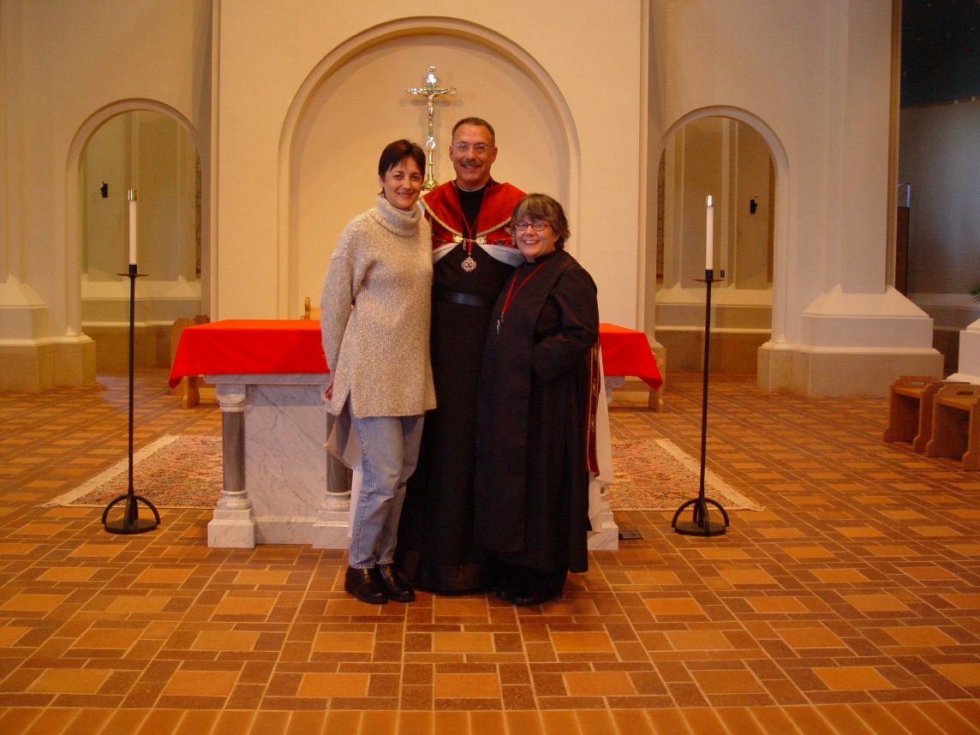
COSL 305 Deana Flak; Prior Michael John Austin; Sr. Anna Grace Madden
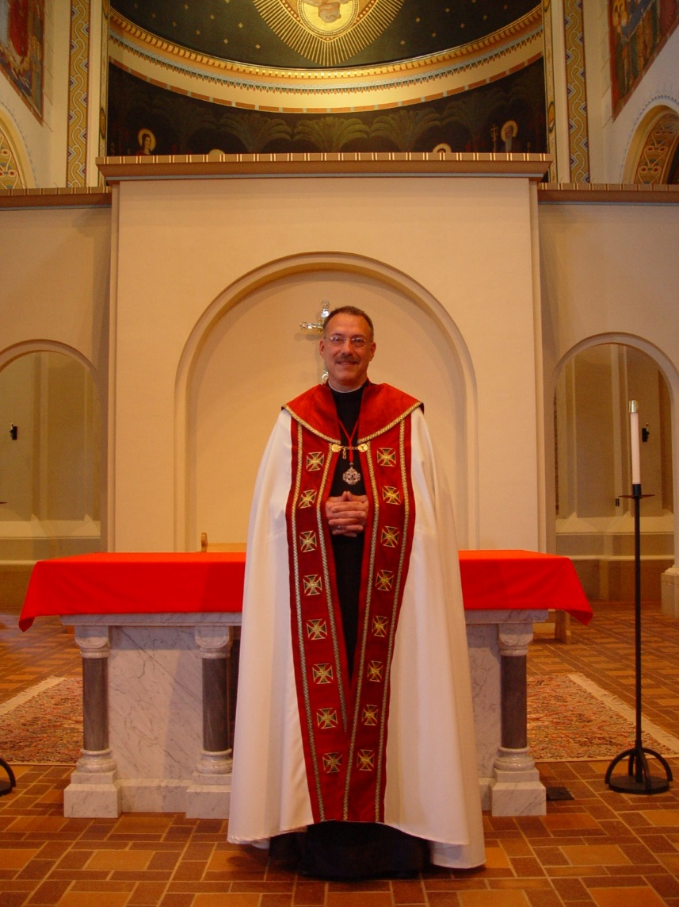
COSL 306 Prior Michael John Austin
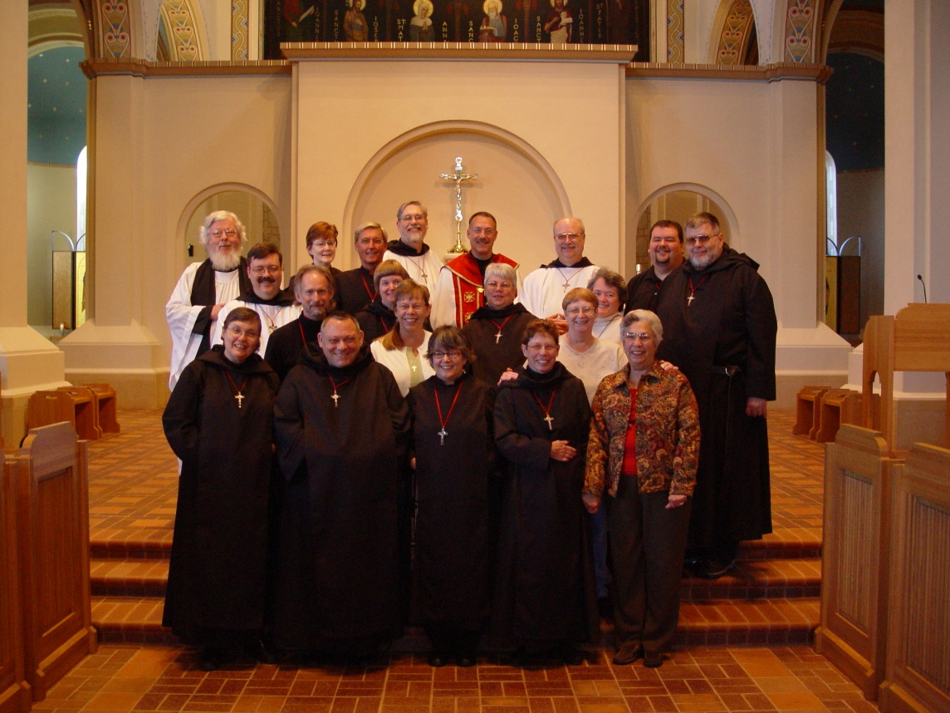
COSL 307 First row: Sr. Theodora of Jesus Perecca; Br. Ambrose Heroux; Sr. Anna Grace Mullen; Sr. Monica Ruth Mullen; Jeanetta Doan

Middle: Br. Paul Howard; Br. Lawrence Mullen; Sr. Catherine Unterseher; Becky Fredregill; Sr. Clare Benedicta Meyers; Lynn Owens; Becky Rittenhouse

Back row: Fr. Wayne Kamm; Sr. Ann Gerns; Br. Camillus Converse; Br. Chad Anselm Gerns; Prior Michael Jon Austin; Br. Raymond Owens; Regan Fox; Br. Nathan Gregory Miller

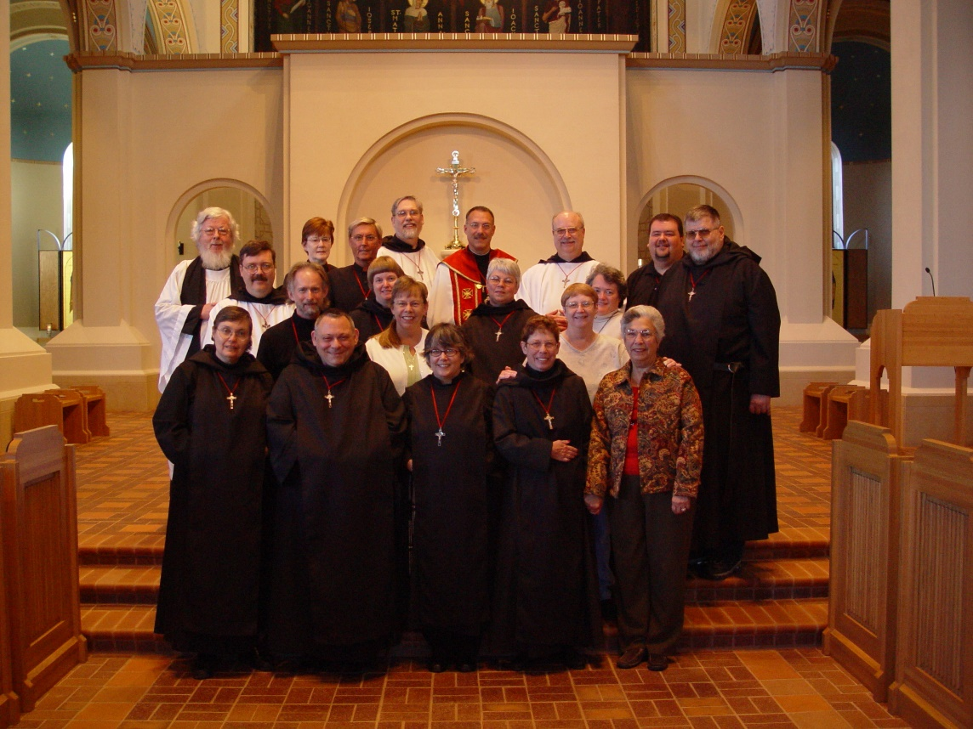
COSL 308 First row: Sr. Theodora of Jesus Perecca; Br. Ambrose Heroux; Sr. Anna Grace Mullen; Sr. Monica Ruth Mullen; Jeanetta Doan

Middle: Br. Paul Howard; Br. Lawrence Mullen; Sr. Catherine Unterseher; Becky Fredregill; Sr. Clare Benedicta Meyers; Lynn Owens; Becky Rittenhouse

Back row: Fr. Wayne Kamm; Sr. Ann Gerns; Br. Camillus Converse; Br. Chad Anselm Gerns; Prior Michael Jon Austin; Br. Raymond Owens; Regan Fox; Br. Nathan Gregory Miller
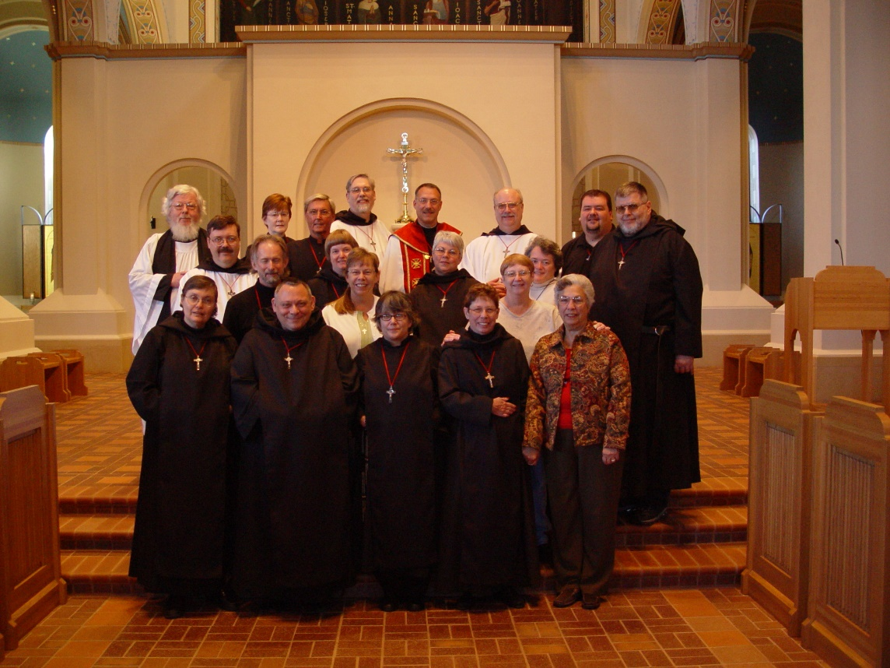
COSL 309 First row: Sr. Theodora of Jesus Perecca; Br. Ambrose Heroux; Sr. Anna Grace Mullen; Sr. Monica Ruth Mullen; Jeanetta Doan

Middle: Br. Paul Howard; Br. Lawrence Mullen; Sr. Catherine Unterseher; Becky Fredregill; Sr. Clare Benedicta Meyers; Lynn Owens; Becky Rittenhouse

Back row: Fr. Wayne Kamm; Sr. Ann Gerns; Br. Camillus Converse; Br. Chad Anselm Gerns; Prior Michael Jon Austin; Br. Raymond Owens; Regan Fox; Br. Nathan Gregory Miller

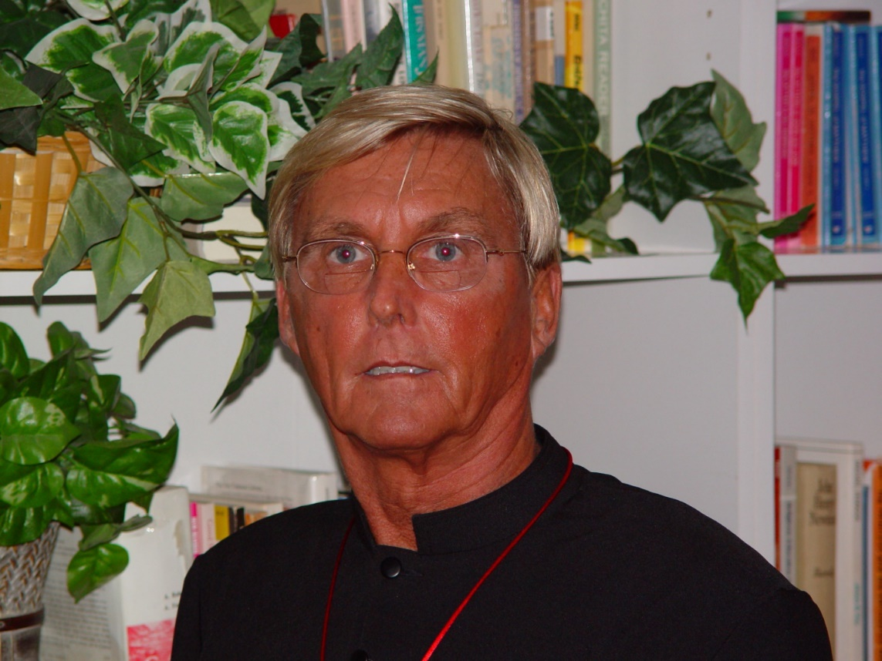
COSL 310 Br. Camillus Converse

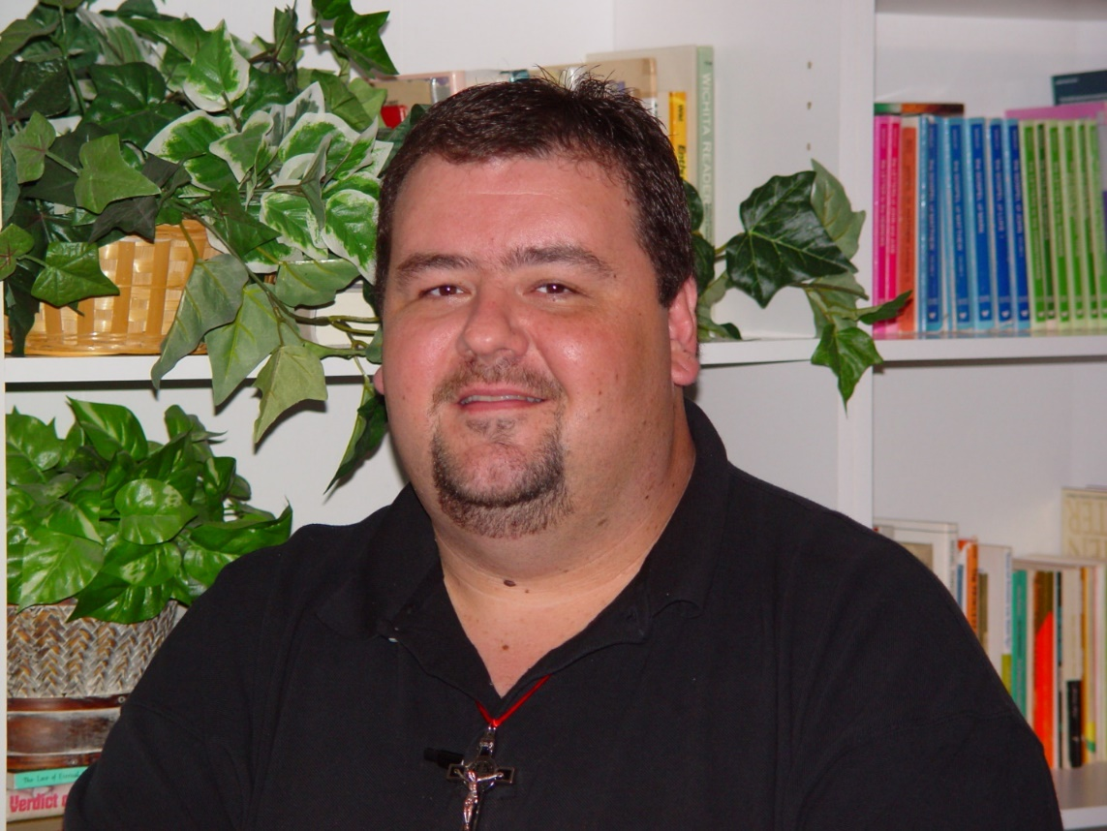
COSL 311 Regan Fox

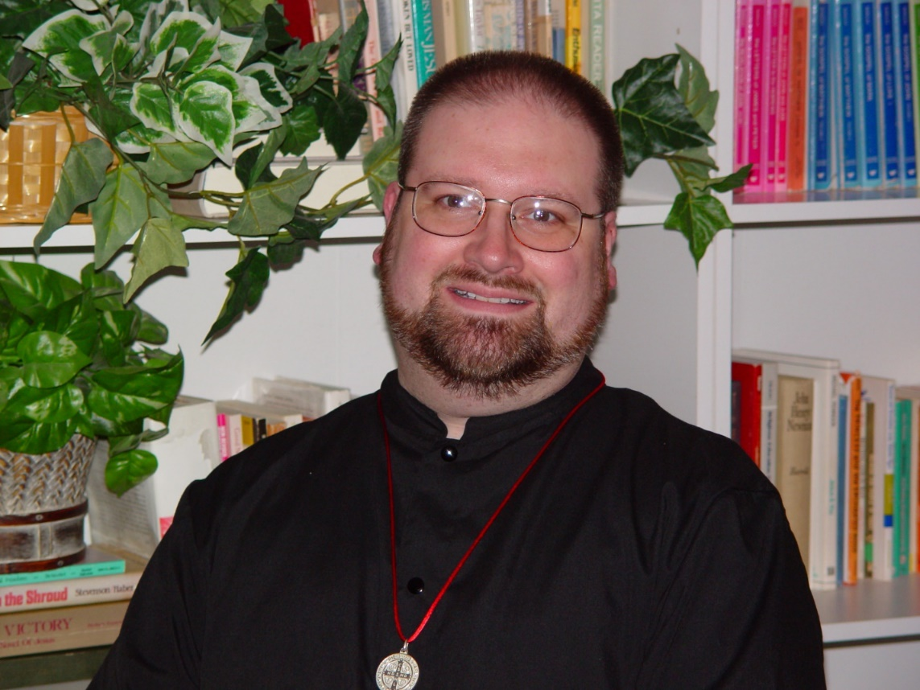
COSL 312 Br. Willard Moore (later Br. Daniel)

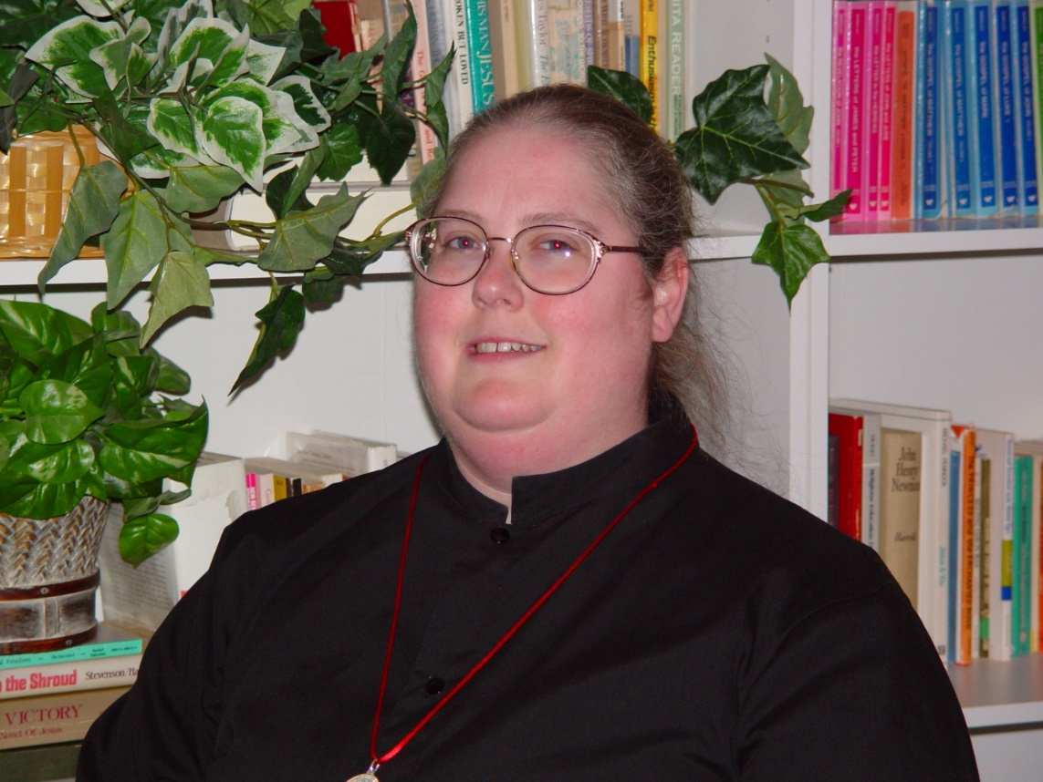
COSL 313 Sr. Margaret Moore (later Sr. Denise)

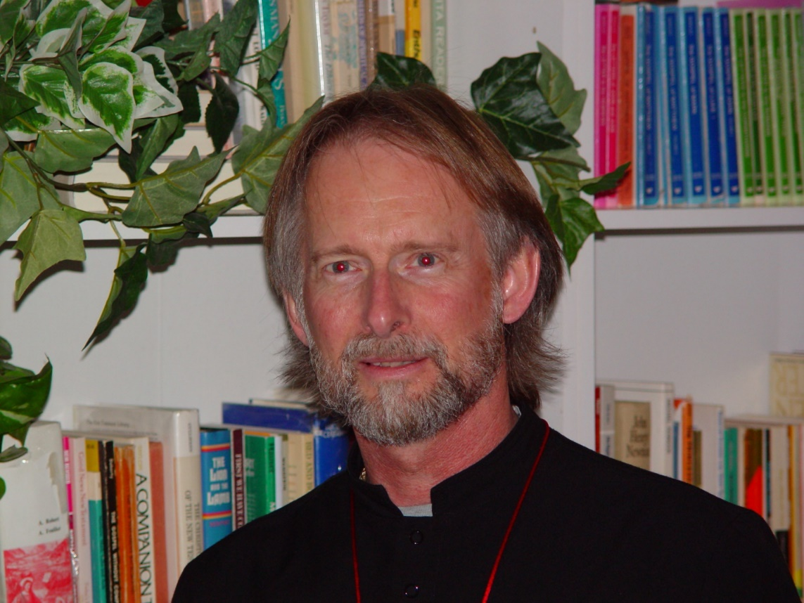
COSL 314 Br. Lawrence Mullen

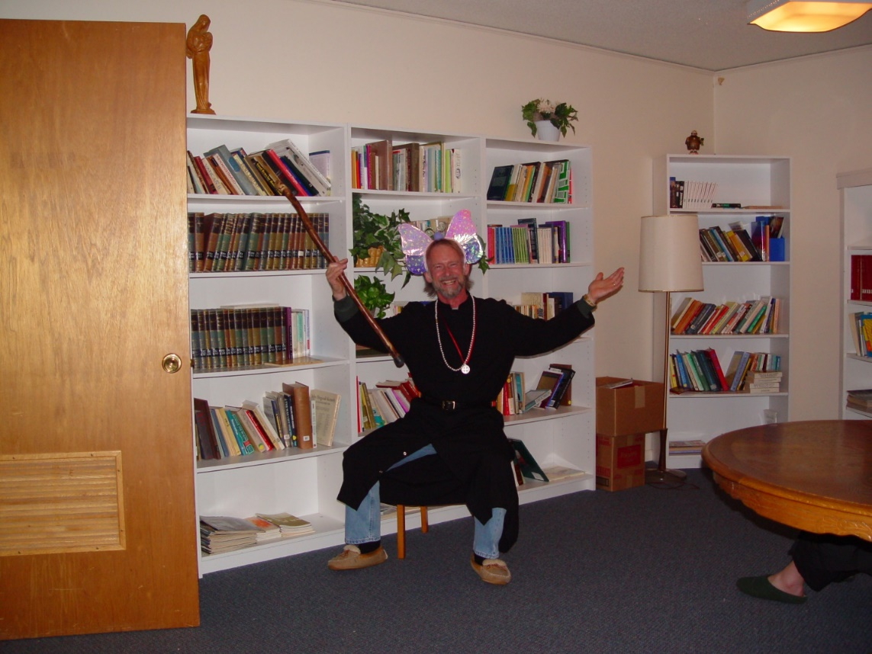
COSL 315 Br. Lawrence Mullen

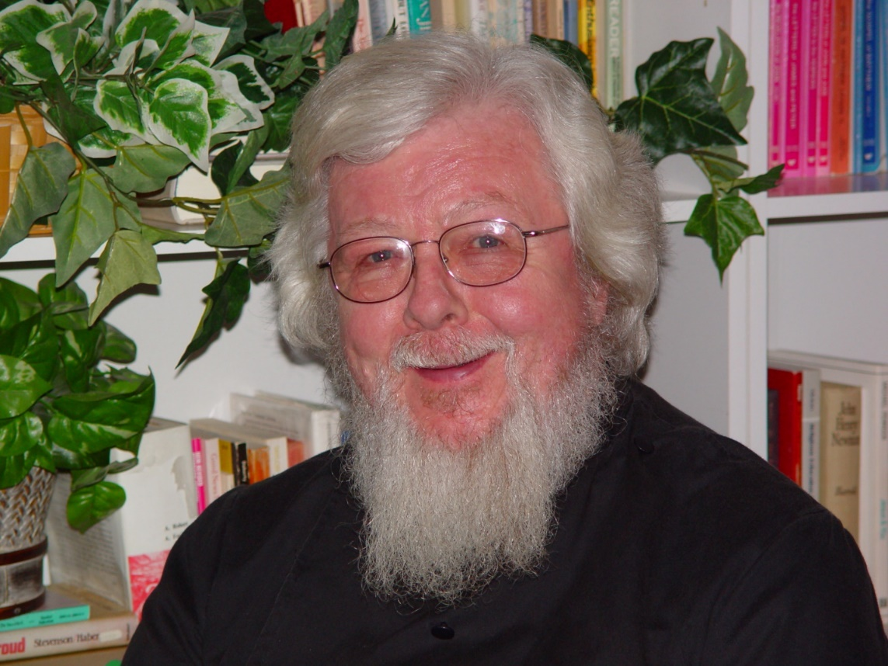
COSL 316 Fr. Wayne Kamm

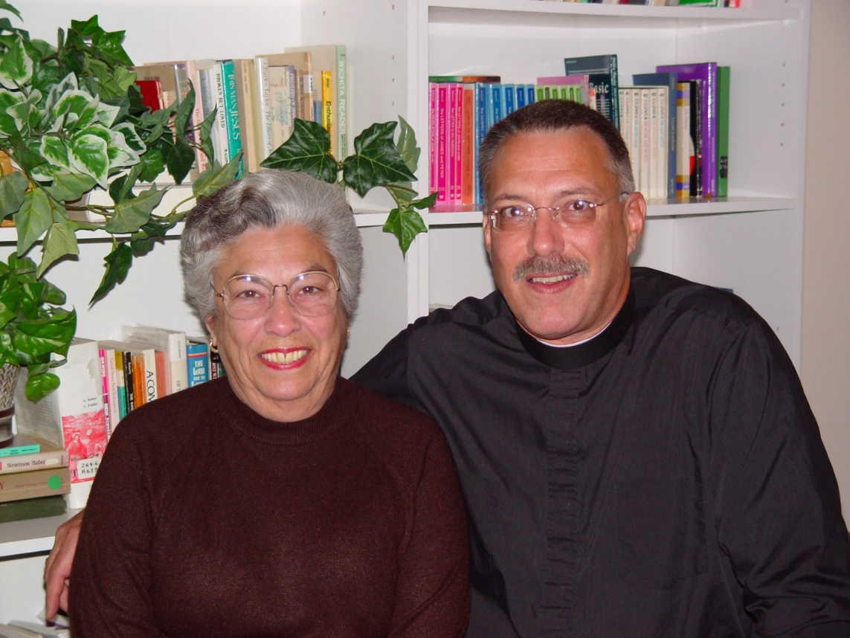
COSL 317 Jeanetta Doan; Prior Michael John Austin

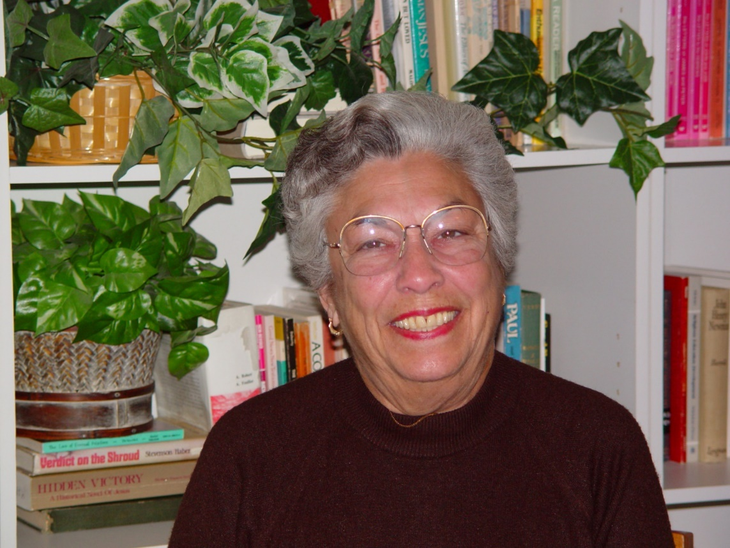
COSL 318 Jeanetta Doan

