Companions of St. Luke
Fall 2003 Convocation at Conception Abbey
Part 4 of 6

~Edited by Br. Steven Olderr, 16 May 2022 with the assistance of Br. Thomas Ferrell; if you find any errors or omissions, please notify Br. Steven at olderr@ameritech.net

People are identified from left to right.

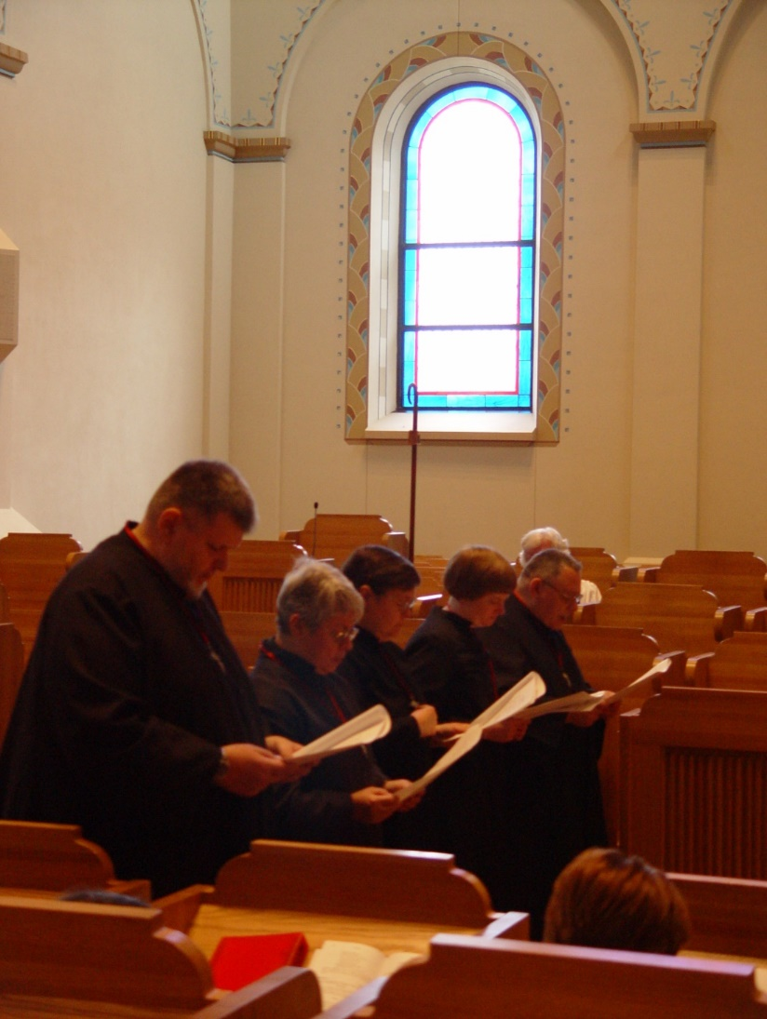
COSL 144 Br. Nathan Gregory Owens; Sr. Clare Beendicta Meyers; Sr. Theodora of Jesus Perecca; Sr. Catherine Unterseher; Br. Ambrose Heroux
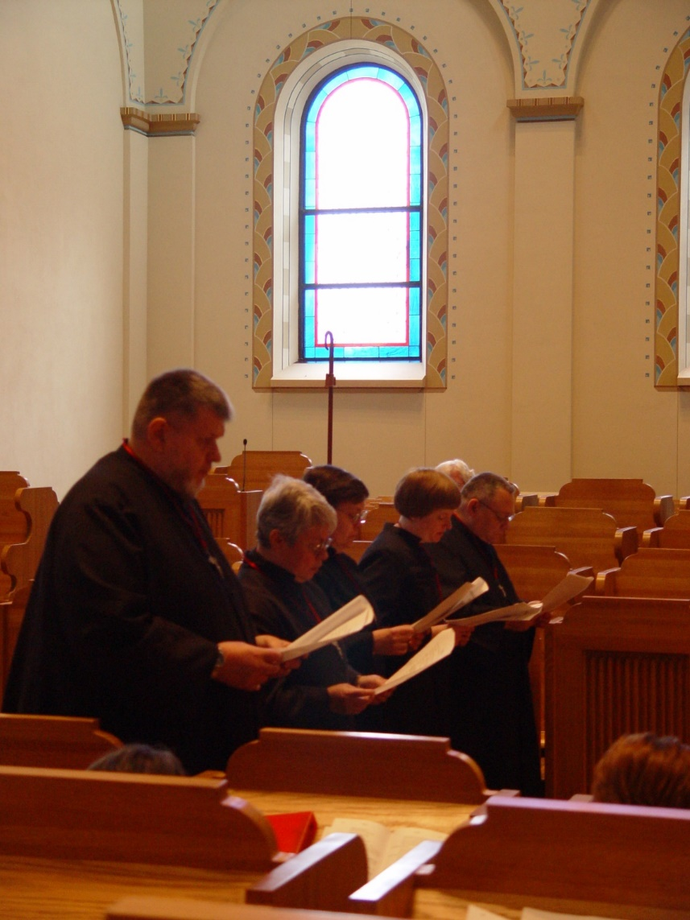
COSL 145 Br. Nathan Gregory Owens; Sr. Clare Beendicta Meyers; Sr. Theodora of Jesus Perecca; Sr. Catherine Unterseher; Br. Ambrose Heroux

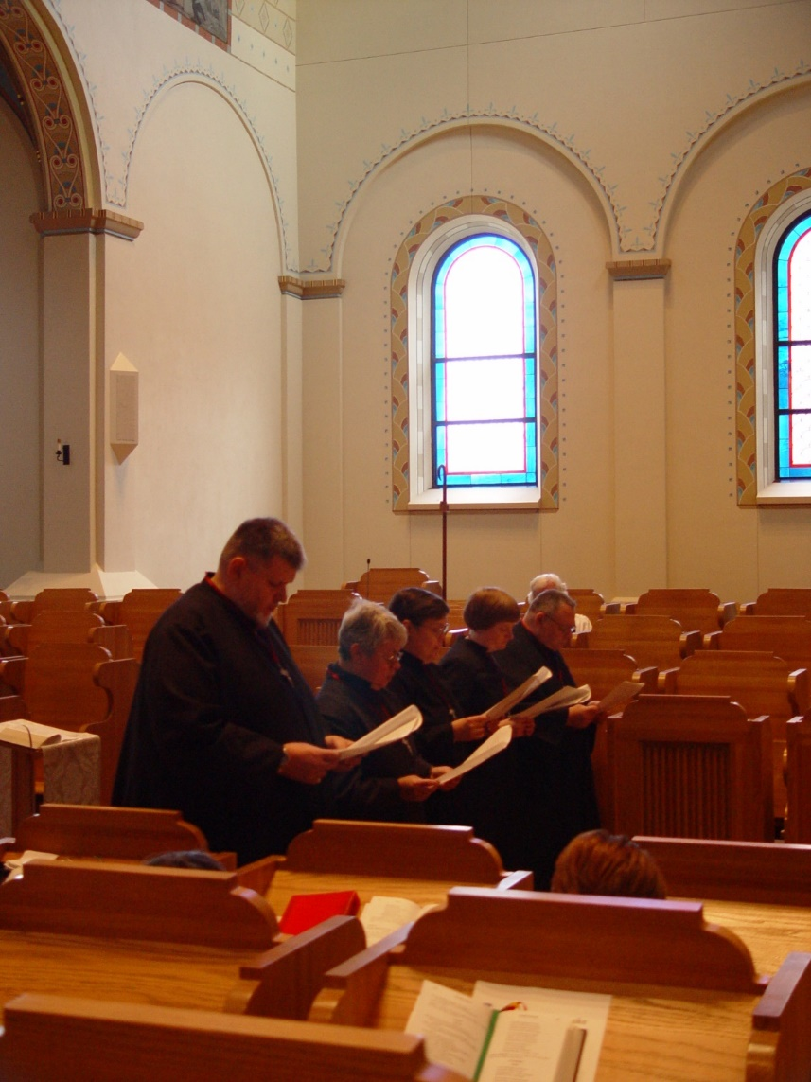
COSL 146 Br. Nathan Gregory Owens; Sr. Clare Beendicta Meyers; Sr. Theodora of Jesus Perecca; Sr. Catherine Unterseher; Br. Ambrose Heroux

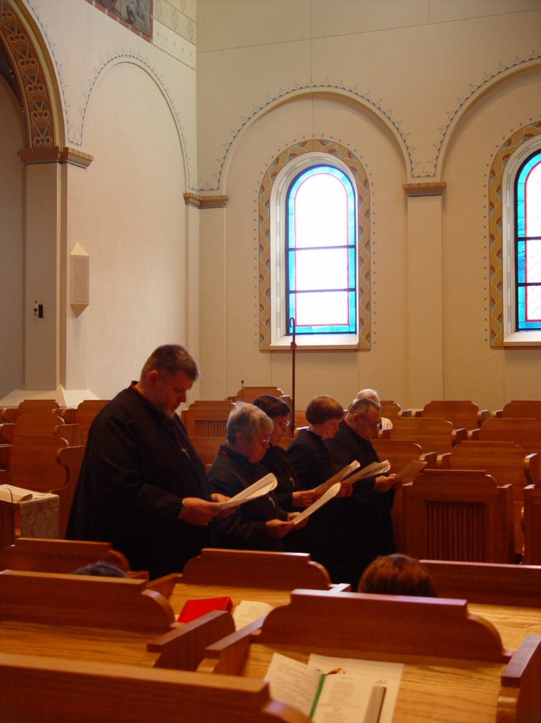
COSL 147 Br. Nathan Gregory Owens; Sr. Clare Beendicta Meyers; Sr. Theodora of Jesus Perecca; Sr. Catherine Unterseher; Br. Ambrose Heroux

COSL 148 Br. Nathan Gregory Owens; Sr. Clare Beendicta Meyers; Sr. Theodora of Jesus Perecca; Sr. Catherine Unterseher; Br. Ambrose Heroux

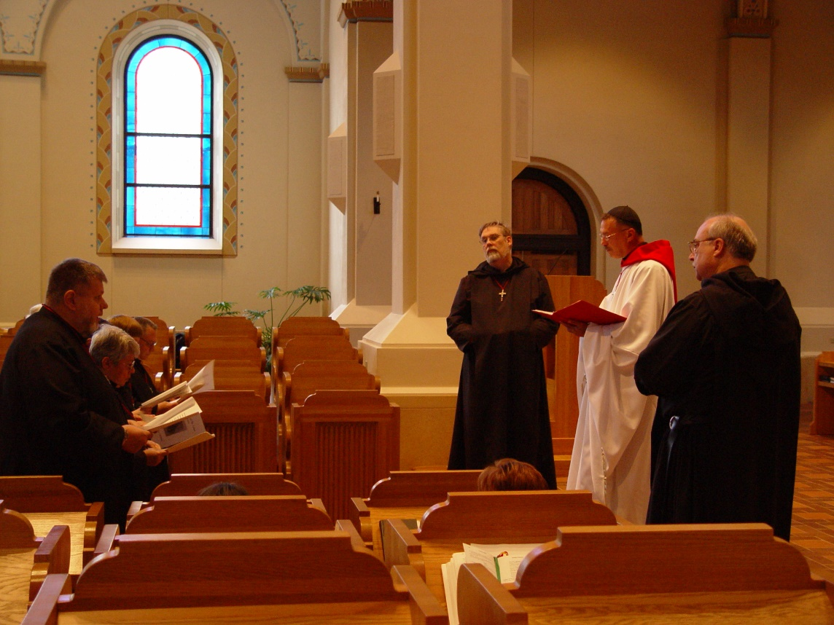
COSL 149 Br. Nathan Gregory Owens; Sr. Clare Benedicta Meyers; Sr. Theodora of Jesus Perecca; Sr. Catherine Unterseher; Br. Ambrose Heroux; Br. Chad Anselm Gerns (later Br. David); Prior Michael John Austin; Br. Raymond Owens

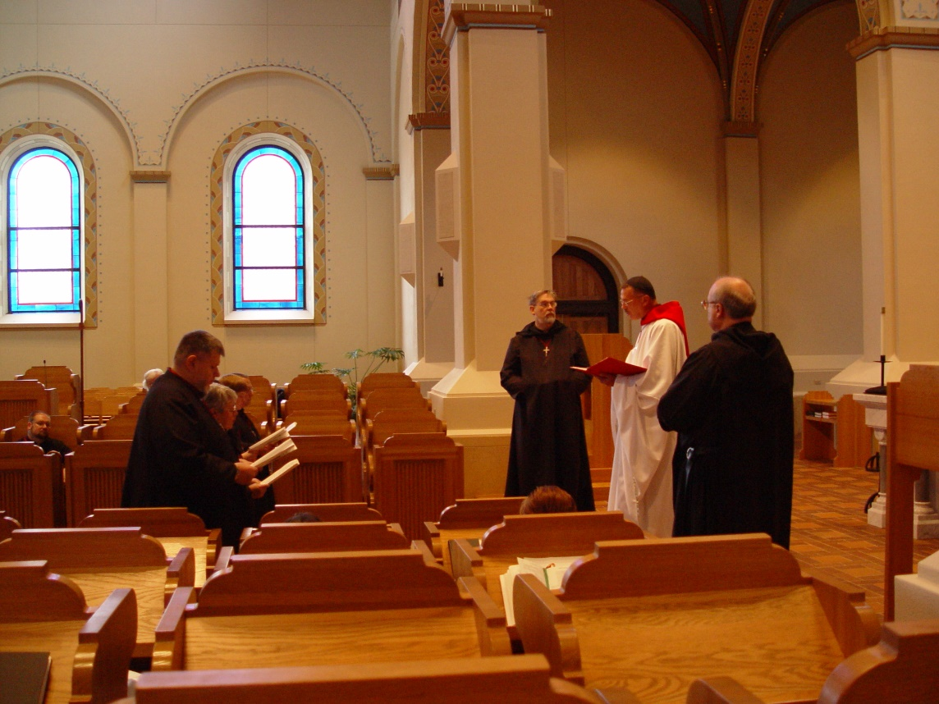
COSL 150 Br. Nathan Gregory Owens; Sr. Clare Benedicta Meyers; Sr. Theodora of Jesus Perecca; Sr. Catherine Unterseher; Br. Ambrose Heroux; Br. Chad Anselm Gerns (later Br. David); Prior Michael John Austin; Br. Raymond Owens

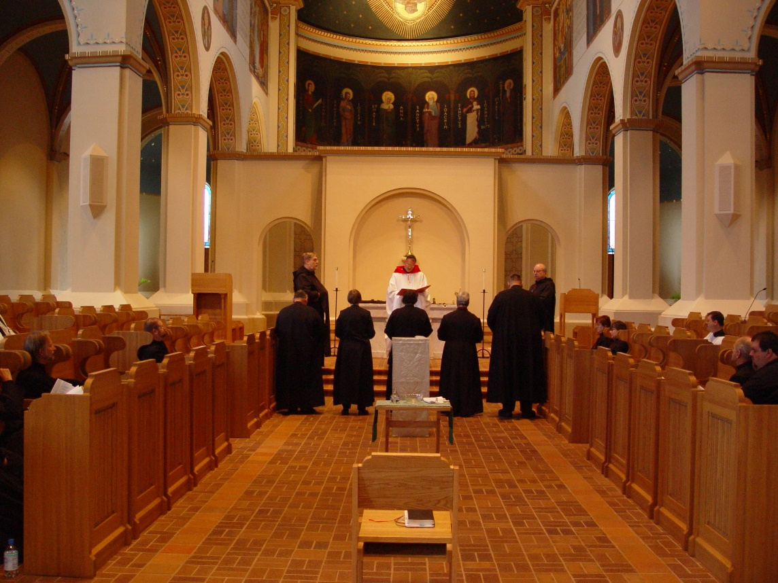
COSL 151

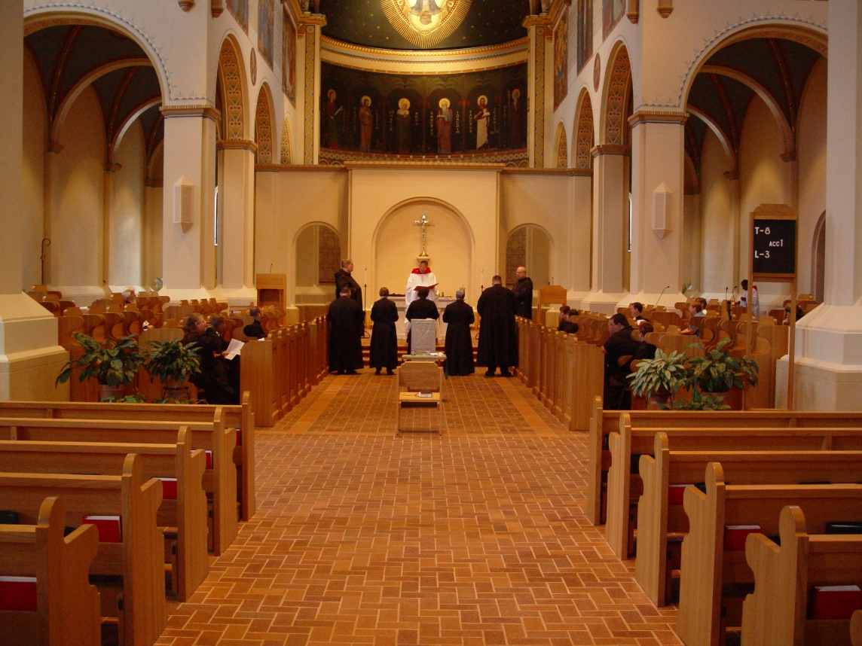
COSL 152
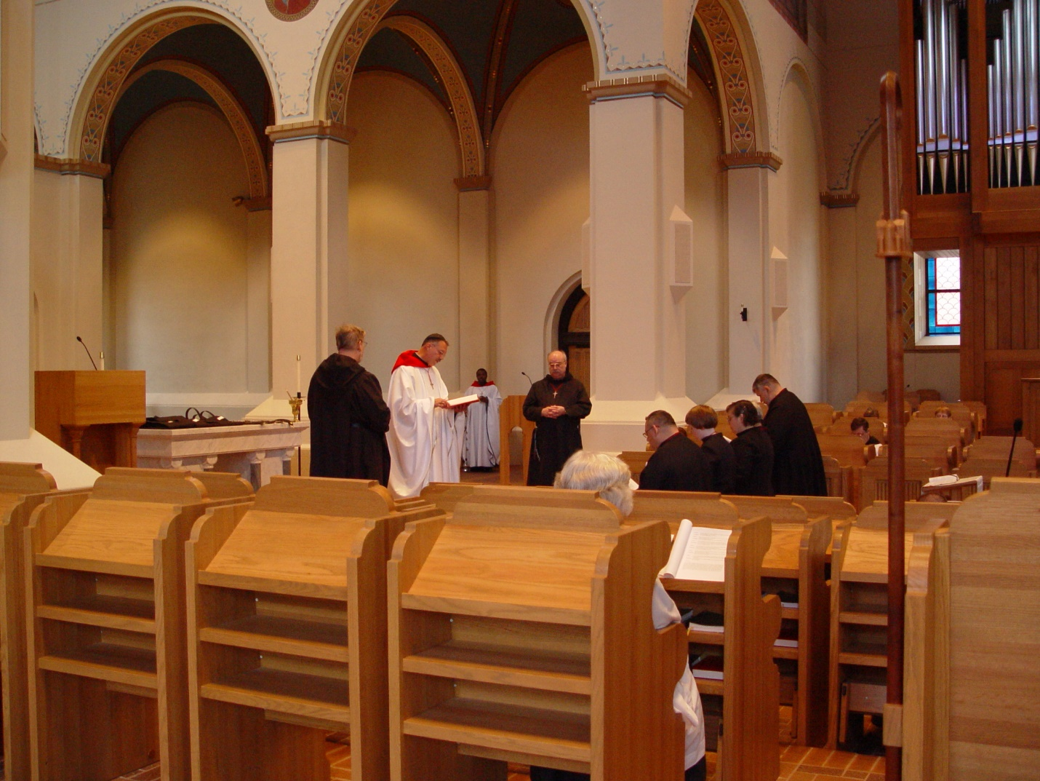
COSL 153 Br. Chad Anselm Gerns (later Br. David) Prior Michael John Austin; Br. Raymond Owens; Fr. Wayne Kamm; Br. Ambrose Heroux; Sr. Catherine Unterseher; Sr. Theodora of Jesus Perecca; Br. Nathan Gregory Miller
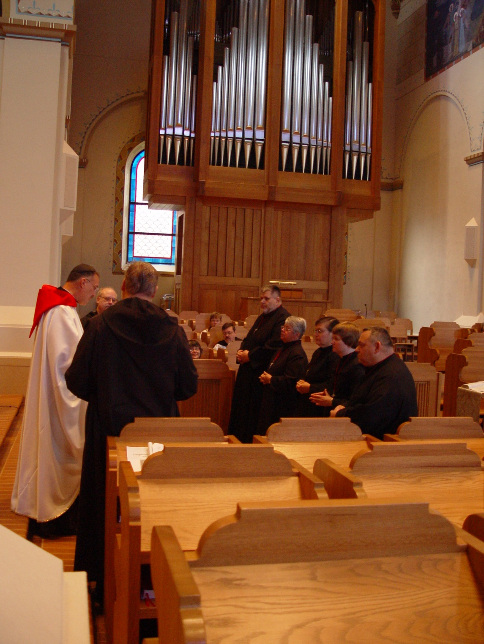
COSL 154 Prior Michael John Austin; Br. Raymond Owens; Br. Chad Anselm Gerns (later Br. David); Br. Nathan Gregory Miller; Sr. Clare Benedicta Meyers; Sr. Theodora of Jesus Perecca; Sr. Catherine Unterseher; Br. Ambrose Heroux
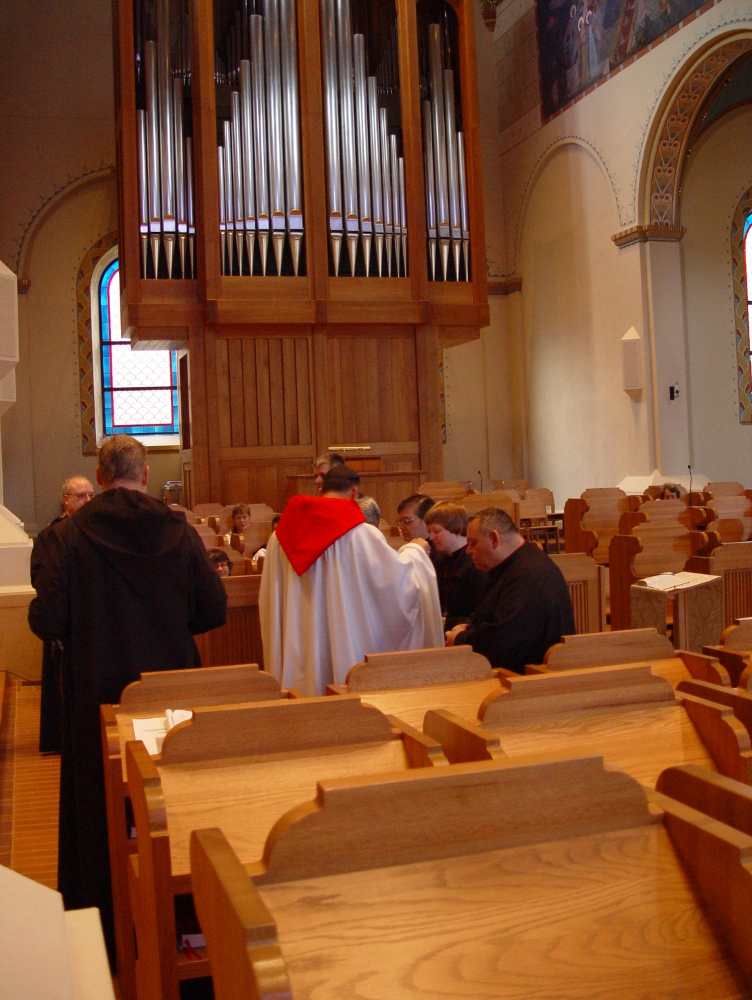
COSL 155 Br. Raymond Owens; Br. Chad Anselm Gerns (later Br. David); Prior Michael John Austin; Sr. Theodora of Jesus Perecca; Sr. Catherine Unterseher; Br. Ambrose Heroux

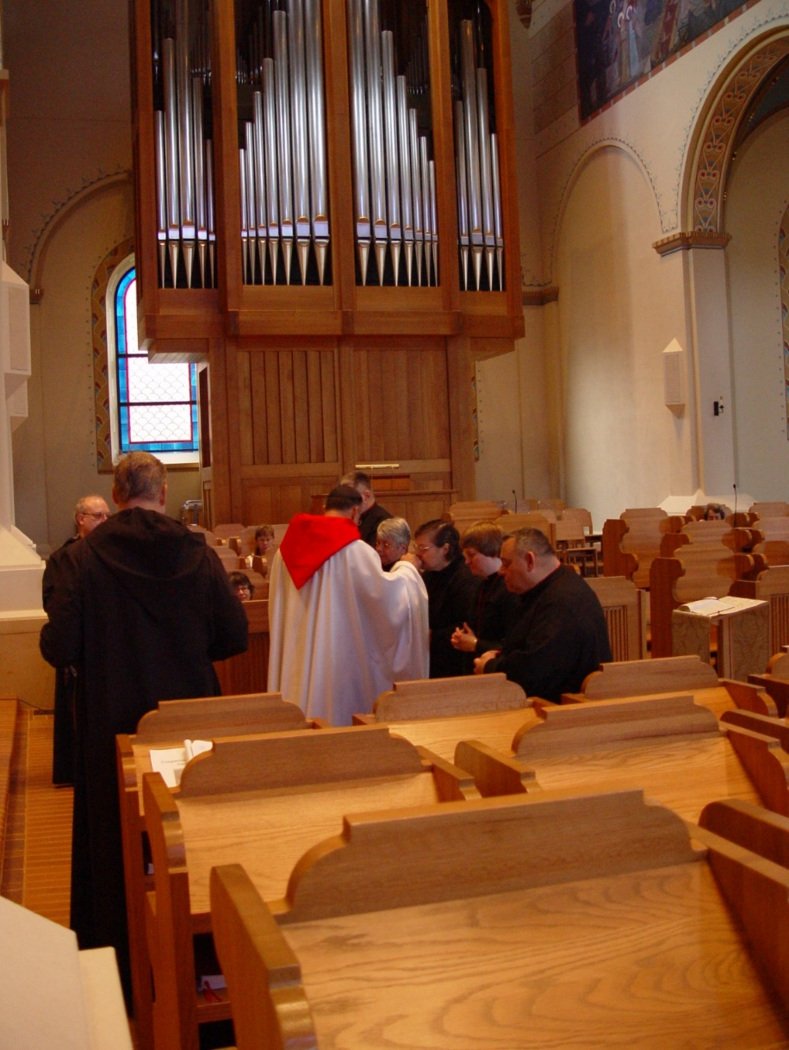
COSL 156 Br. Raymond Owens; Br. Chad Anselm Gerns (later Br. David); Prior Michael John Austin; Br. Nathan Gregory Miller; Sr. Clare Benedicta Meyers; Sr. Theodora of Jesus Perecca; Sr. Catherine Unterseher; Br. Ambrose Heroux
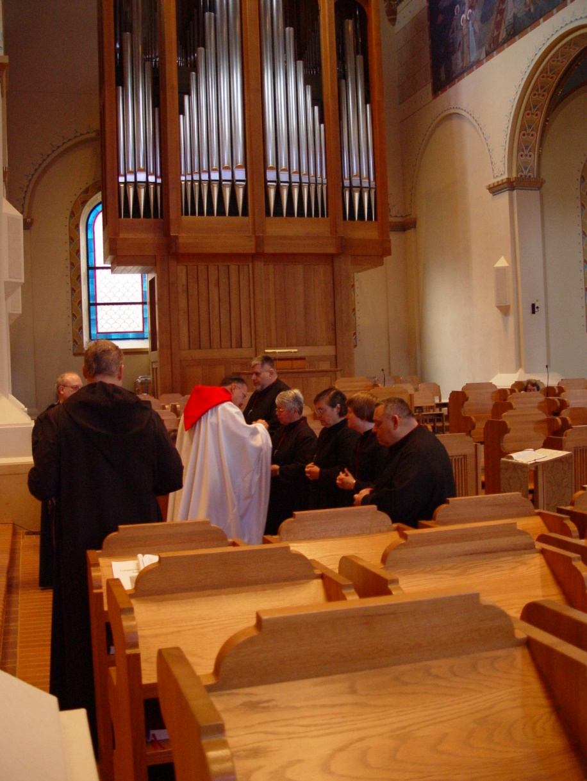
COSL 157 Br. Raymond Owens; Br. Chad Anselm Gerns (later Br. David); Prior Michael John Austin; Br. Nathan Gregory Miller; Sr. Clare Benedicta Meyers; Sr. Theodora of Jesus Perecca; Sr. Catherine Unterseher; Br. Ambrose Heroux

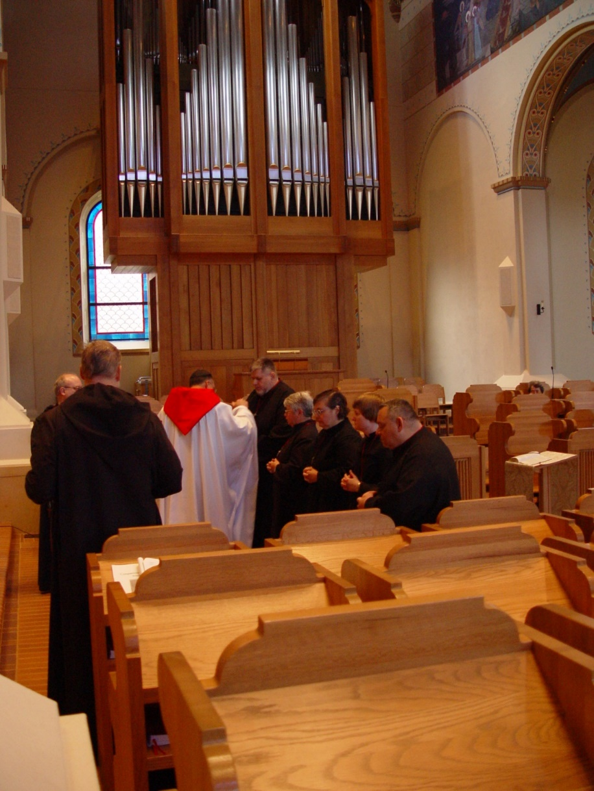
COSL 158 Br. Raymond Owens; Br. Chad Anselm Gerns (later Br. David); Prior Michael John Austin; Br. Nathan Gregory Miller; Sr. Clare Benedicta Meyers; Sr. Theodora of Jesus Perecca; Sr. Catherine Unterseher; Br. Ambrose Heroux

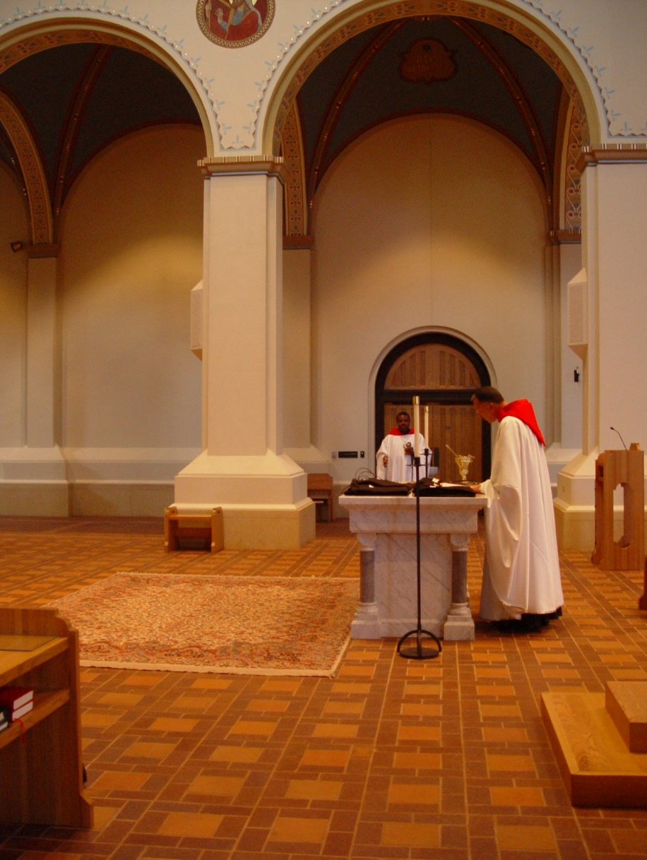
COSL 159 Br. Thomas Ferrell; Prior Michael John Austin
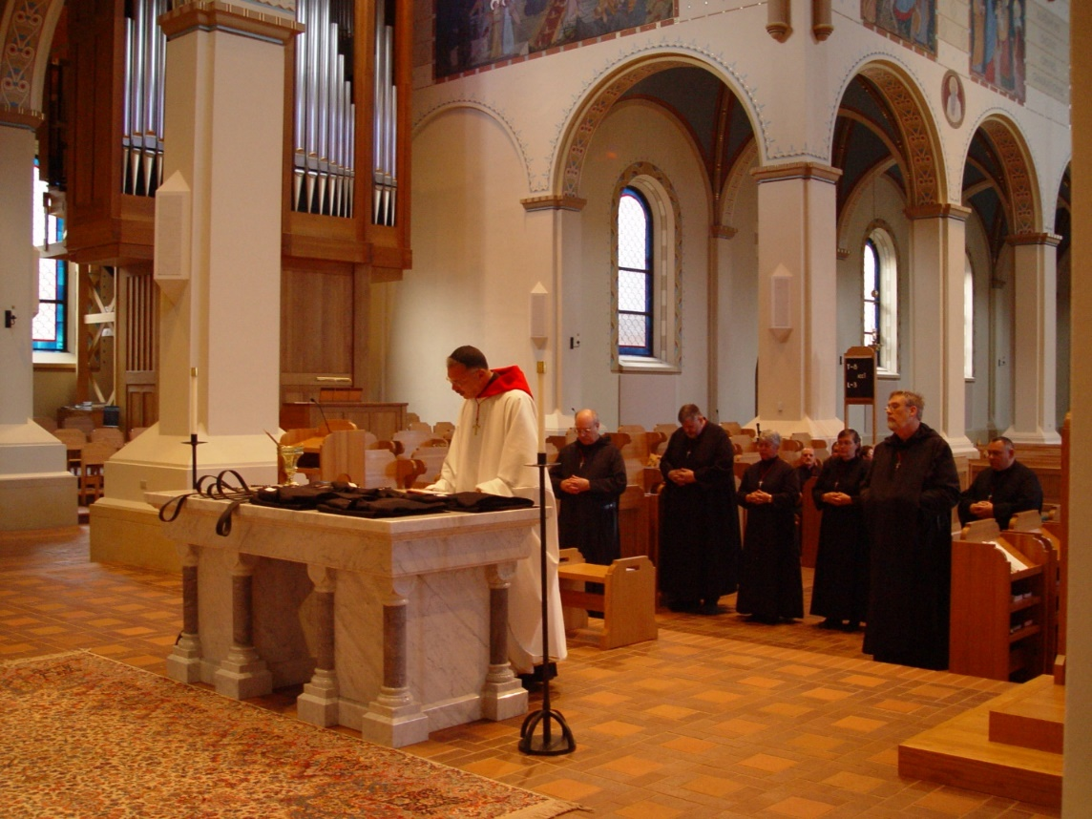
COSL 160 Prior Michael John Austin; Br. Raymond Owens; Br. Nathan Gregory Miller; Sr. Clare Benedicta Meyers; Sr. Theodora of Jesus Perecca; Br. Chad Anselm Gerns (later Br. David); Br. Ambrose Heroux
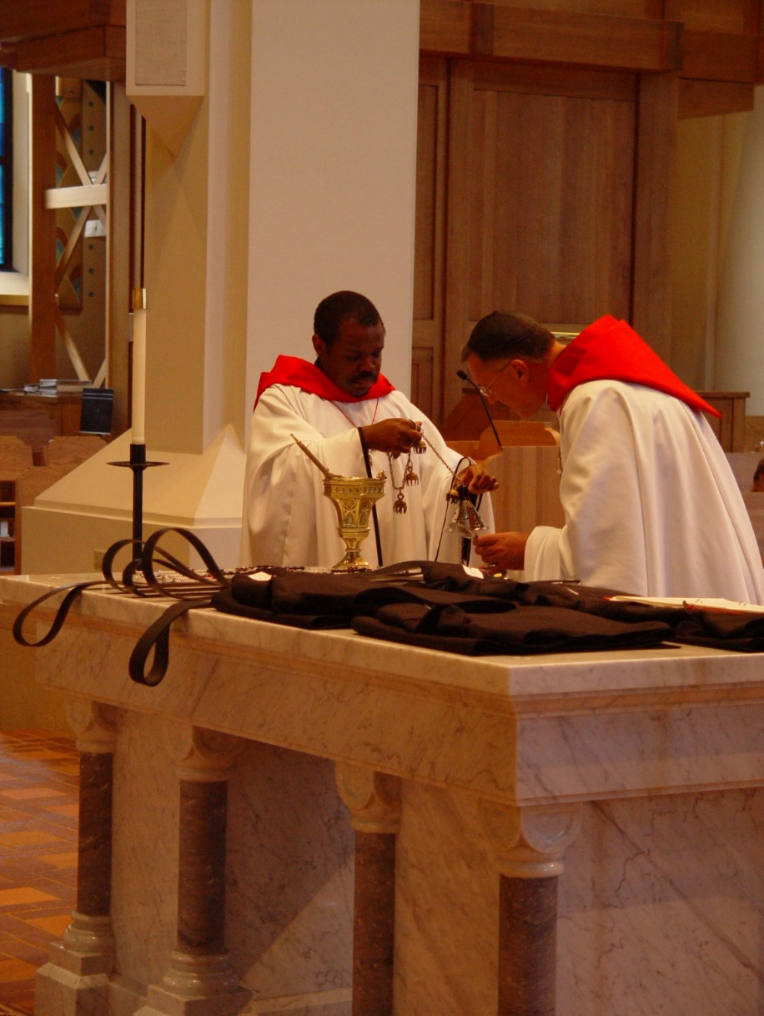
COSL 161 Br. Thomas Ferrell; Prior Michael John Austin
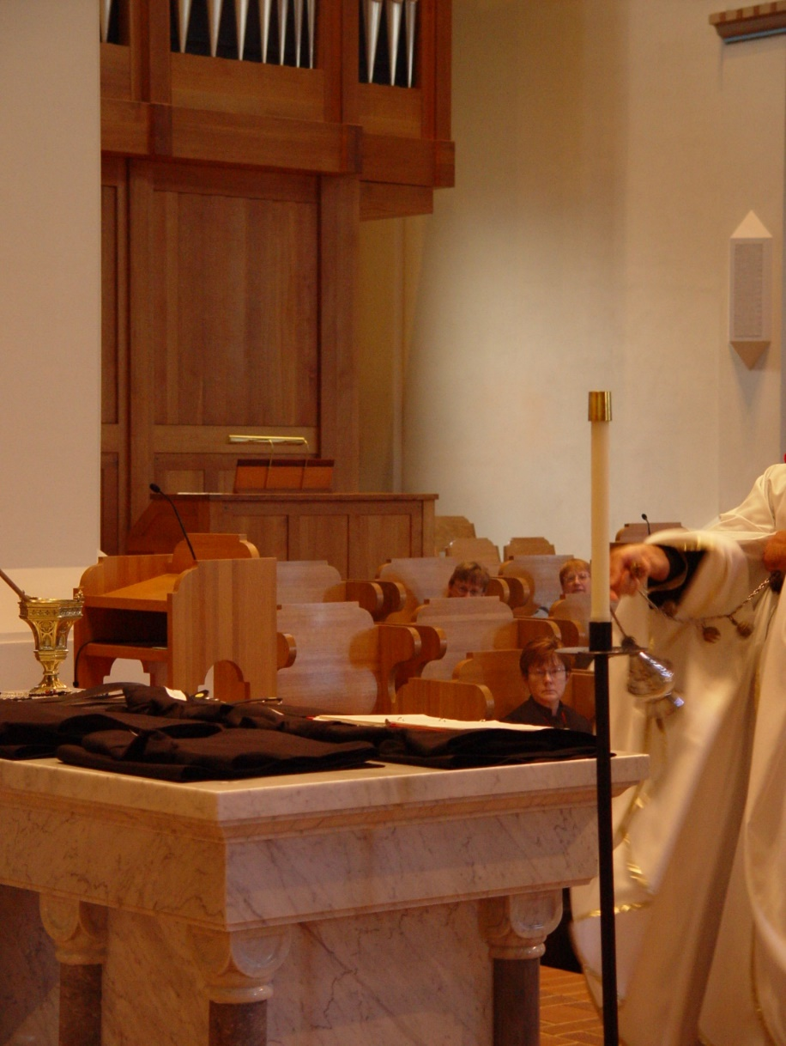
COSL 162 Sr. Ann Gerns; Prior Michael John Austin
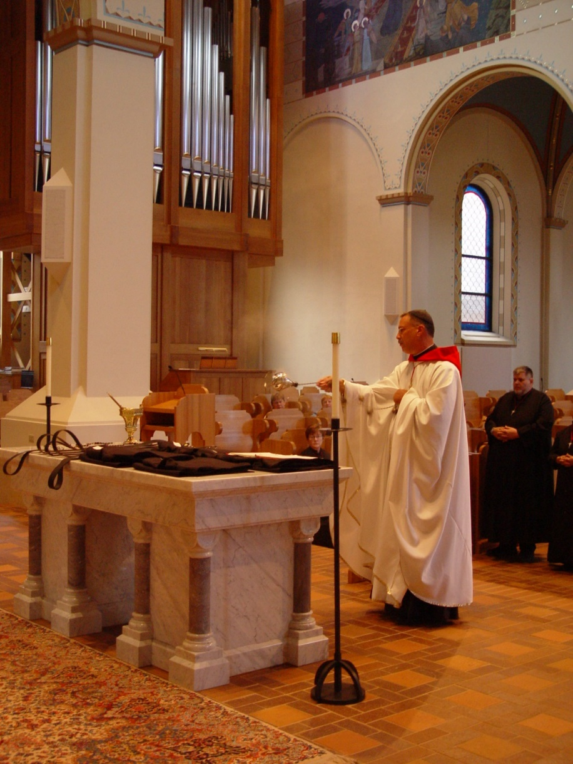
COSL 163 Sr. Ann Gerns; Prior Michael John Austin; Br. Nathan Gregory Miller
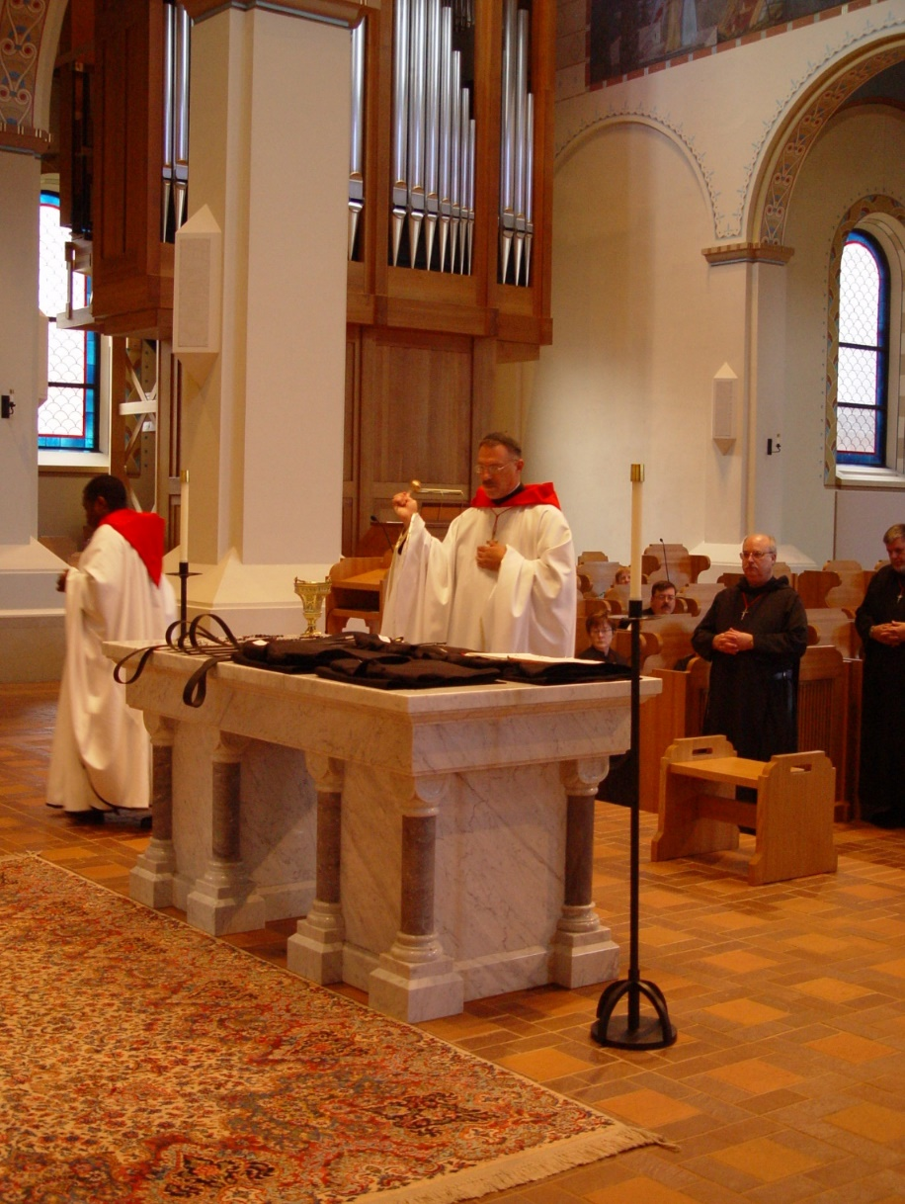
COSL 164 Br. Thomas Ferrell; Prior Michael John Austin; Sr. Ann Gerns; Br. Paul Howard; Br. Raymond Owens; Br. Nathan Gregory Mille
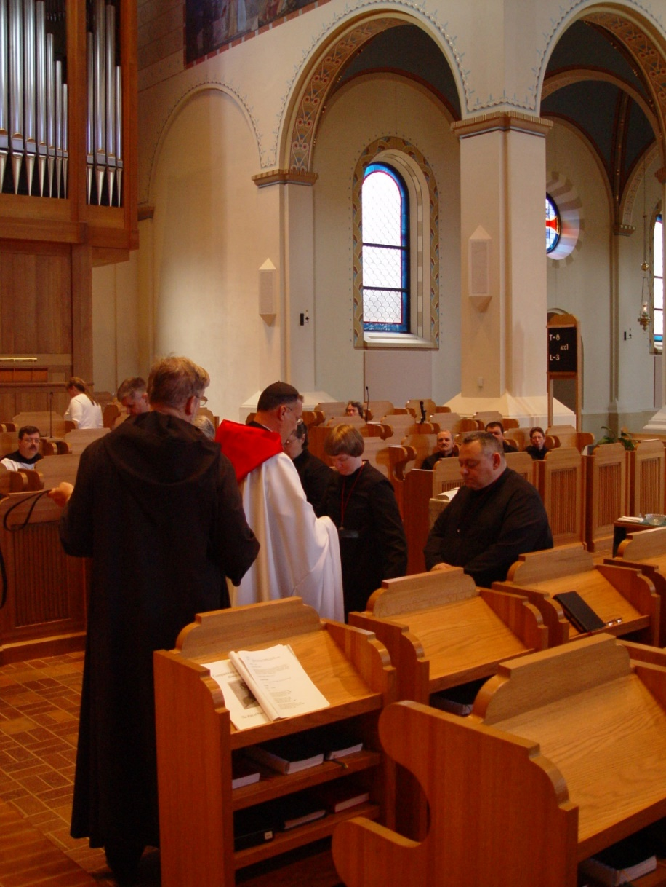
COSL 165 Br. Paul Howard; Br. Chad Anselm Gerns (later Br. David); Prior Michael John Austin; Sr. Theodora of Jesus Perecca; Sr. Catherine Unterseher; Br. Ambrose Heroux
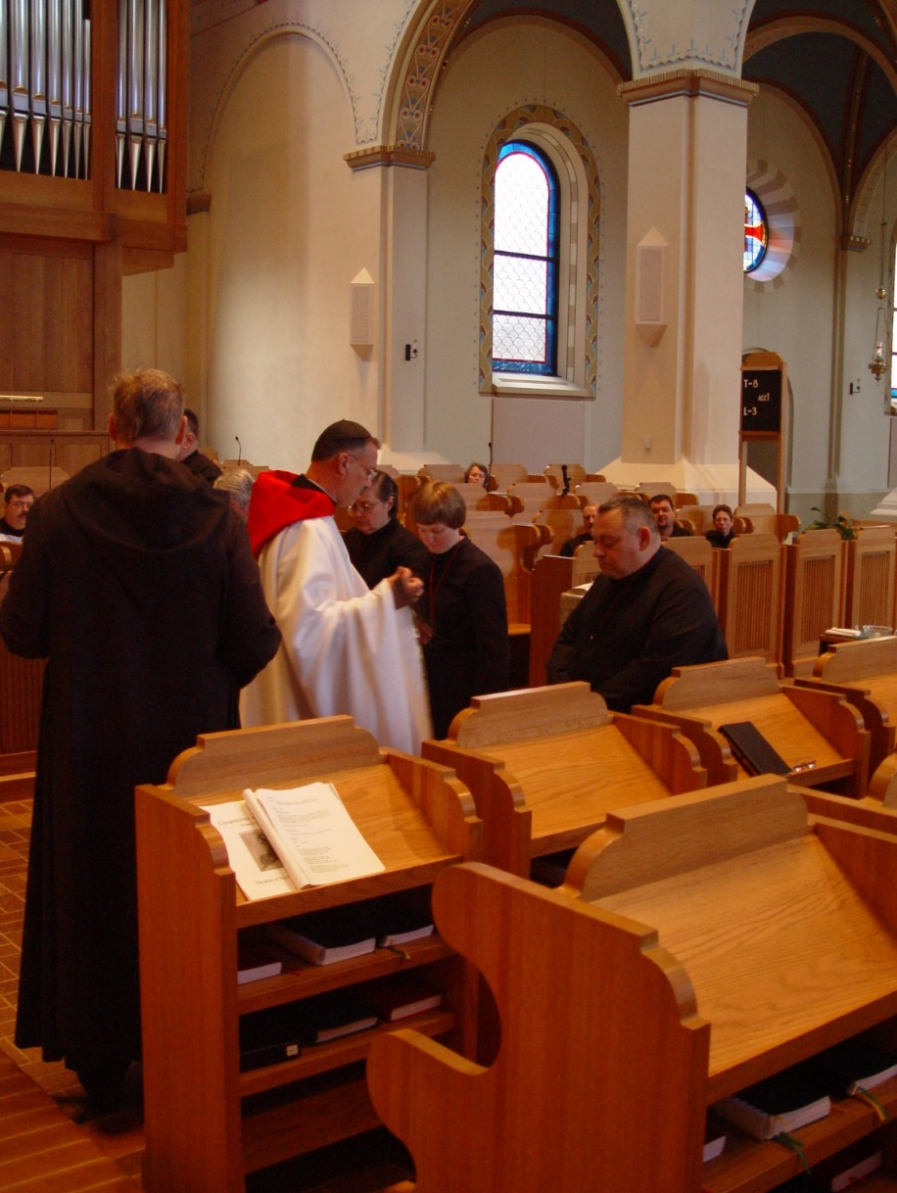
COSL 166 Br. Paul Howard; Br. Chad Anselm Gerns (later Br. David); Prior Michael John Austin; Sr. Theodora of Jesus Perecca; Sr. Catherine Unterseher; Br. Ambrose Heroux
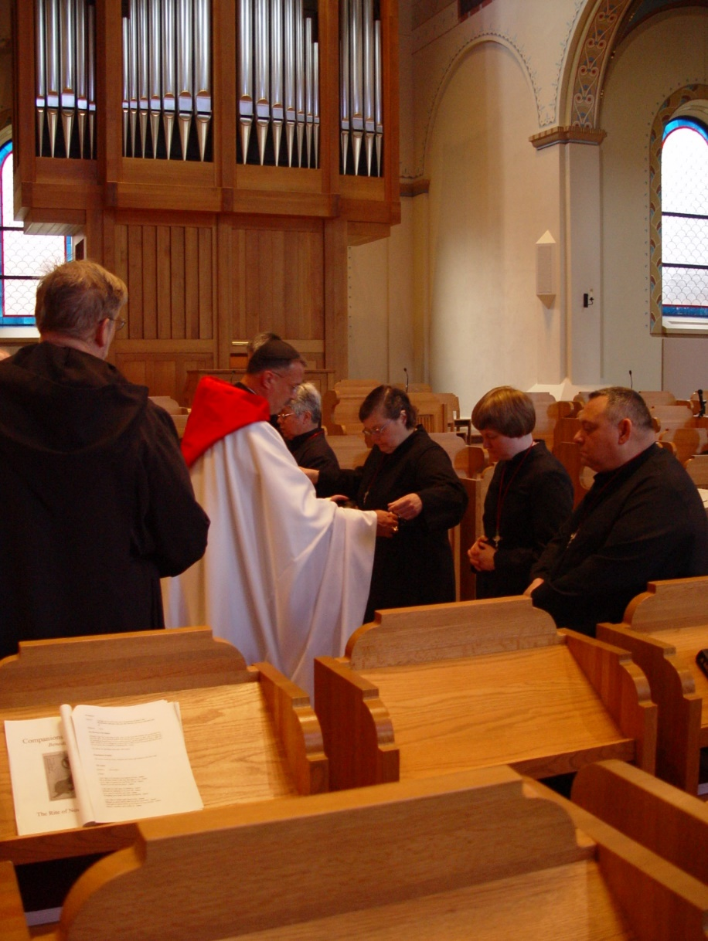
COSL 167 Br. Chad Anselm Gerns (later Br. David); Prior Michael John Austin; Sr. Clare Benedicta Meyers; Sr. Theodora of Jesus Perecca; Sr. Catherine Unterseher; Br. Ambrose Heroux
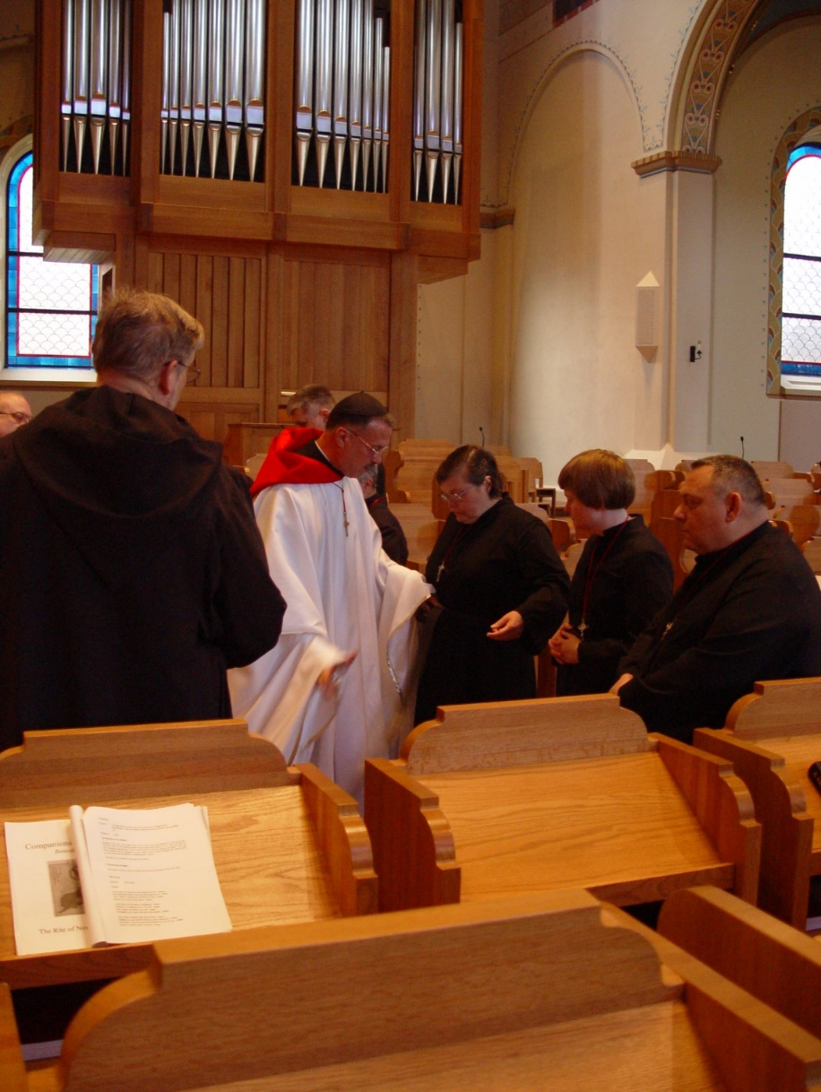
COSL 168 Br. Chad Anselm Gerns (later Br. David); Prior Michael John Austin; Sr. Theodora of Jesus Perecca; Sr. Catherine Unterseher; Br. Ambrose Heroux

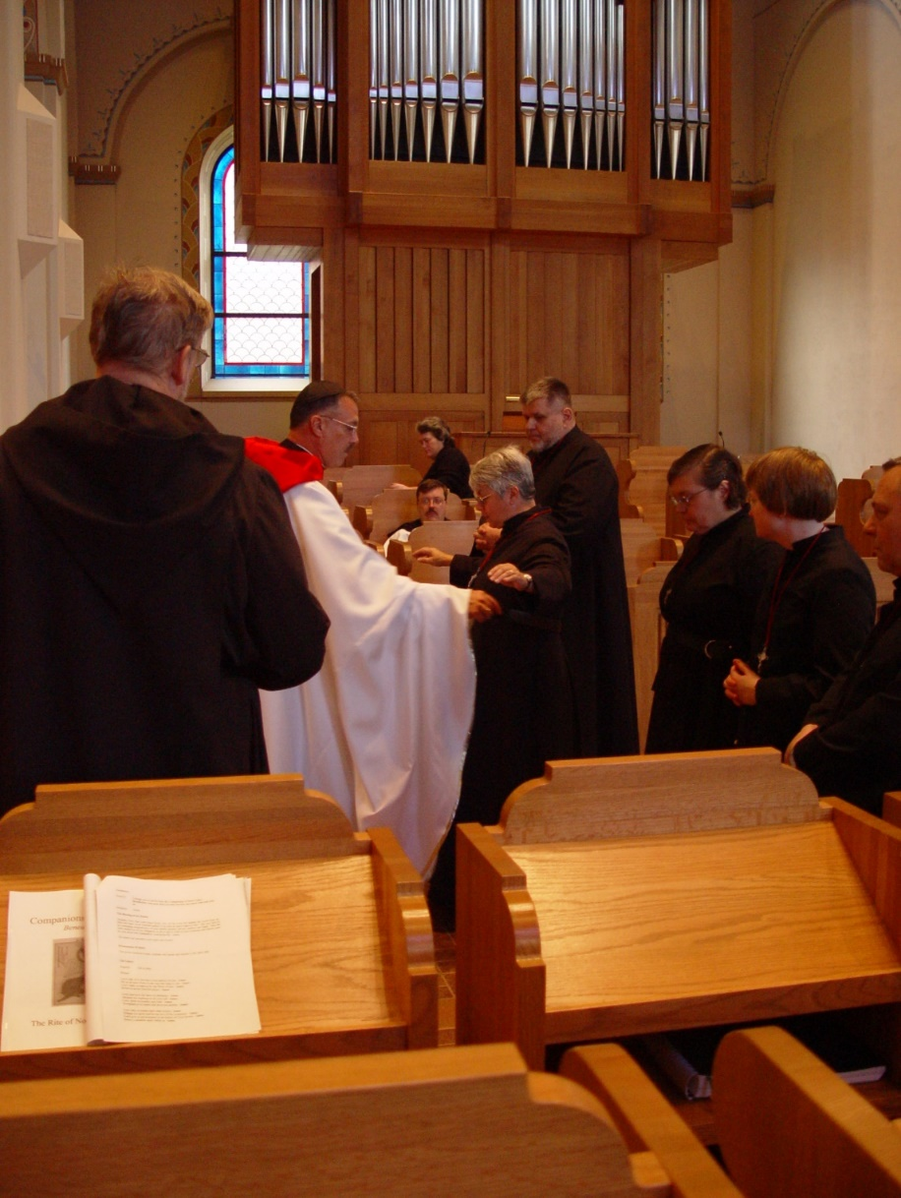
COSL 169 Br. Chad Anselm Gerns (later Br. David); Prior Michael John Austin; Br. Paul Howard; Becky Fredregill; Sr. Clare Benedicta Meyers; Br. Nathan Gregory Miller; Sr. Theodora of Jesus Perecca; Sr. Catherine Unterseher; Br. Ambrose Heroux

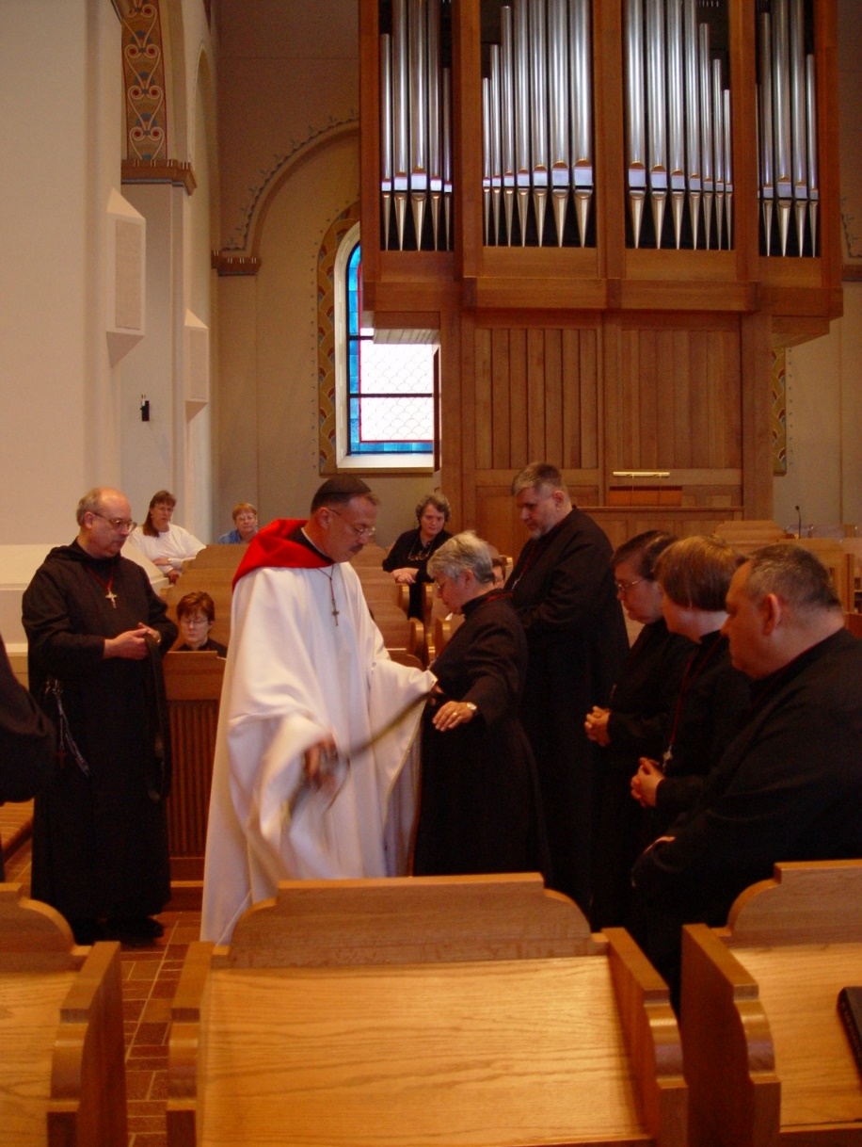
COSL 170 Br. Raymond Owens; Becky Rittehouse; Sr. Ann Gerns; Prior Michael John Austin; Becky Fredregill; Sr. Clare Benedicta Meyers; Br. Nathan Gregory Miller; Sr. Theodora of Jesus Perecca; Sr. Catherine Unterseher; Br. Ambrose Heroux
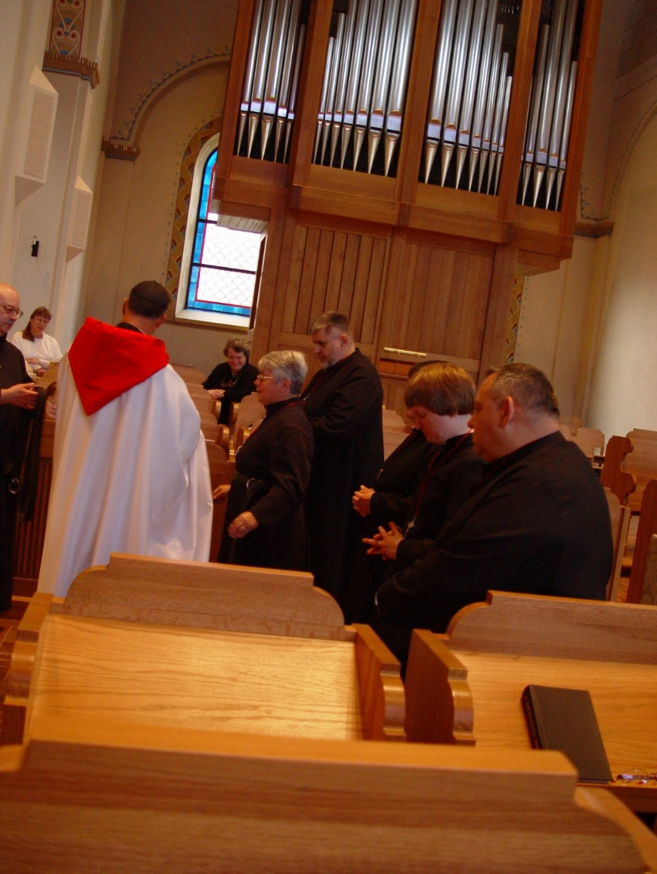
COSL 171 Br. Raymond Owens; Becky Rittenhouse; Prior Michael John Austin; Becky Fredregill; Sr. Clare Benedicta Meyers; Br. Nathan Gregory Miller; Sr. Theodora of Jesus Perecca; Sr. Catherine Unterseher; Br. Ambrose Heroux

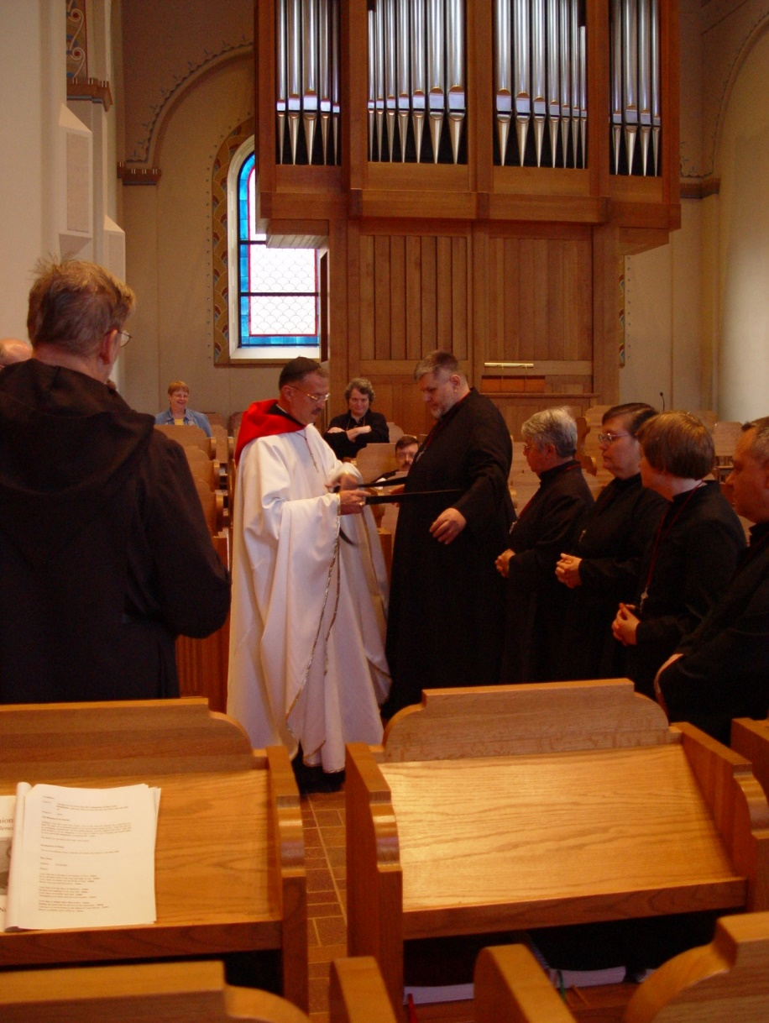
COSL 172 Br. Chad Anselm Gerns (later Br. David); Lynn Owens; Prior Michael John Austin; Becky Rittenhouse; Br. Nathan Gregory Miller; Sr. Clare Benedicta Meyers; Sr. Theodora of Jesus Perecca; Sr. Catherine Unterseher; Br. Ambrose Heroux

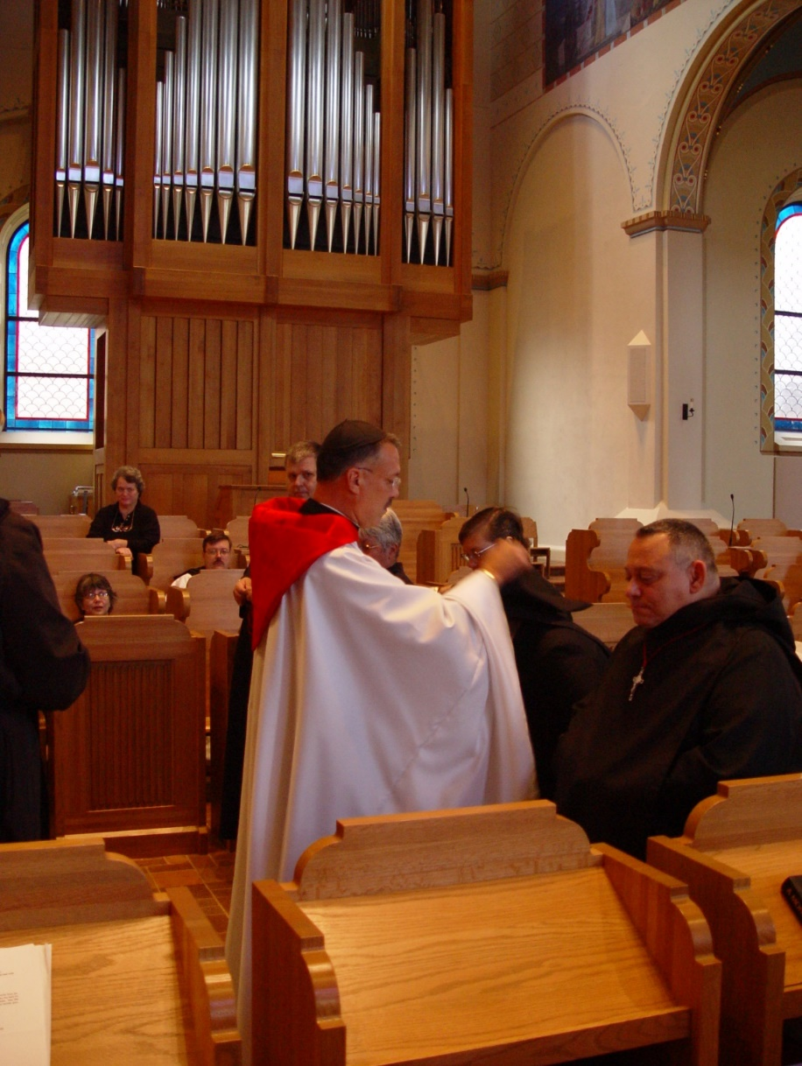
COSL 173 Sr. Anna Grace Madden; Becky Rittenhouse; Br. Paul Howard; Prior Michael John Austin; Sr. Clare Benedicta Meyers; Sr. Theodora of Jesus Perecca; Br. Ambrose Heroux
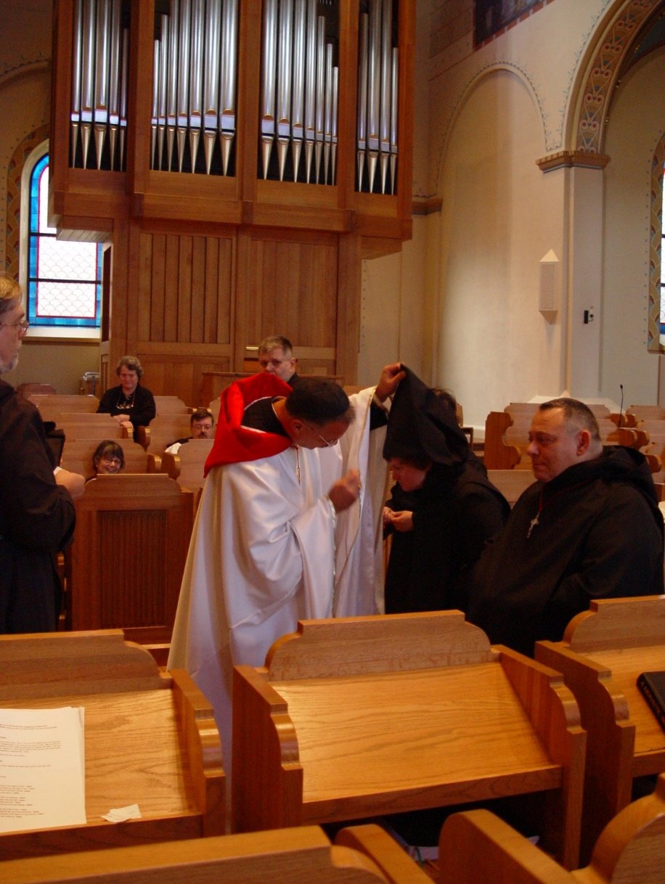
COSL 174 Br. Chad Anselm Gerns (later Br. David); Sr. Anna Grace Madden; Becky Rittenhouse; Br. Paul Howard; Prior Michael John Austin; Sr. Theodora of Jesus Perecca; Br. Ambrose Heroux

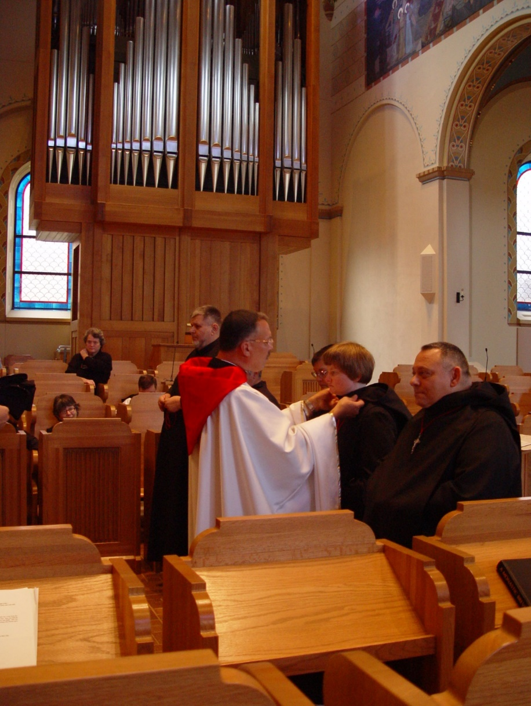
COSL 175 Sr. Anna Grace Madden; Becky Rittenhouse; Br. Paul Howard; Br. Nathan Gregory Miller; Prior Michael John Austin; Sr. Theodora of Jesus Perecca; Sr. Catherine Unterseher; Br. Ambrose Heroux

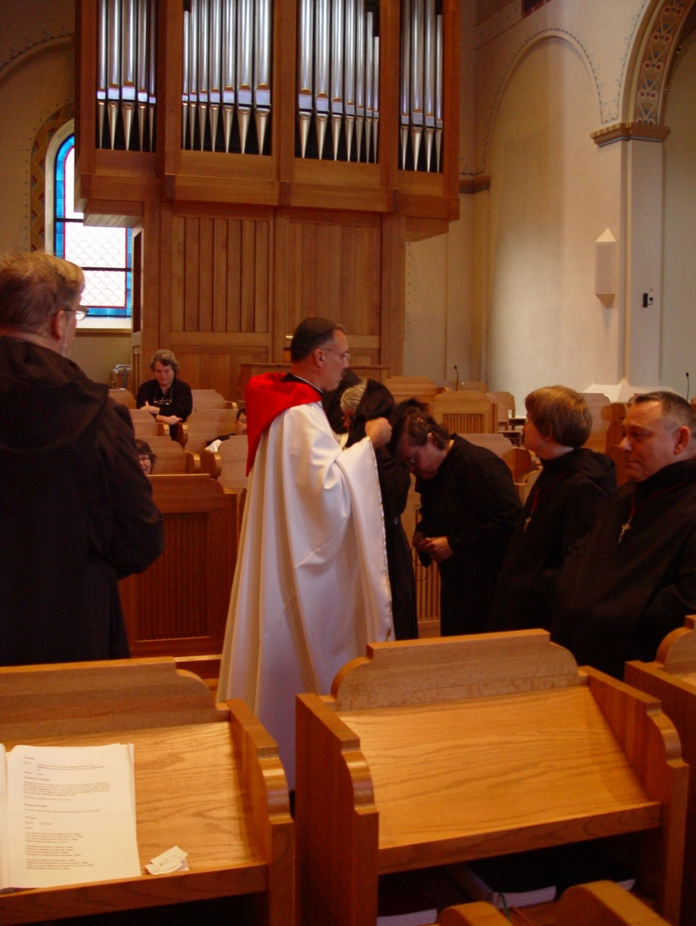
COSL 176 Br. Chad Anselm Gerns (later Br. David); Becky Rittenhouse; Br. Paul Howard; Sr. Anna Grace Madden; Prior Michael John Austin; Sr. Theodora of Jesus Perecca; Sr. Catherine Unterseher; Br. Ambrose Heroux

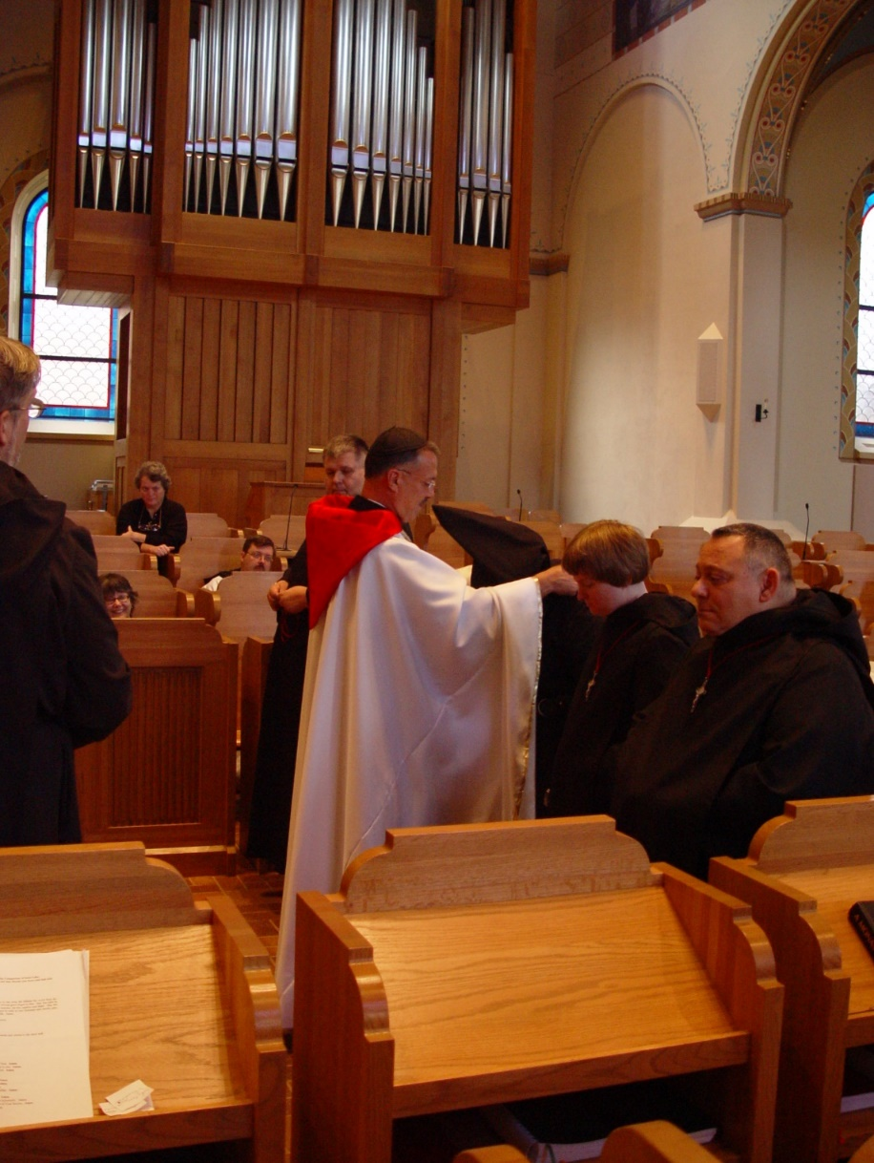
COSL 177 Br. Chad Anselm Gerns (later Br. David); Sr. Anna Grace Madden; Becky Rittenhouse; Br. Paul Howard; Br. Nathan Gregory Miller; Prior Michael John Austin; Theodora of Jesus Perecca; Sr. Catherine Unterseher; Br. Ambrose Heroux
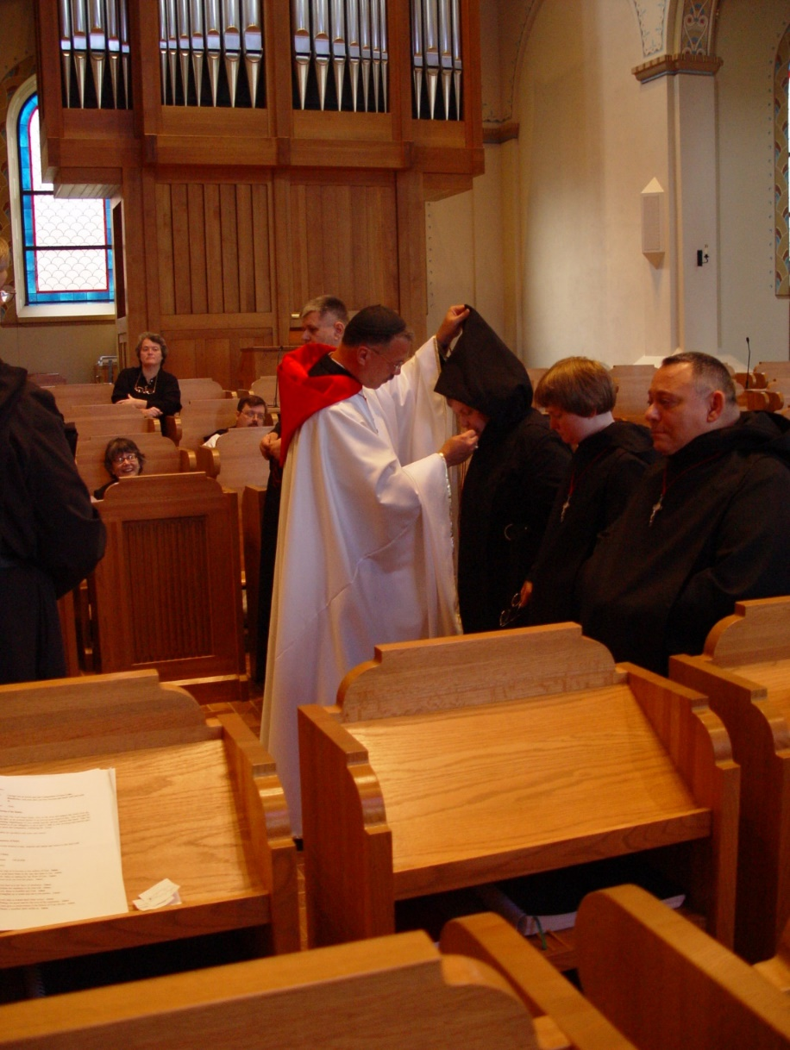
COSL 178 Br. Chad Anselm Gerns (later Br. David); Sr. Anna Grace Madden; Becky Rittenhouse; Br. Paul Howard; Br. Nathan Gregory Miller; Prior Michael John Austin; Sr. Theodora of Jesus Perecca; Sr. Catherine Unterseher; Br. Ambrose Heroux

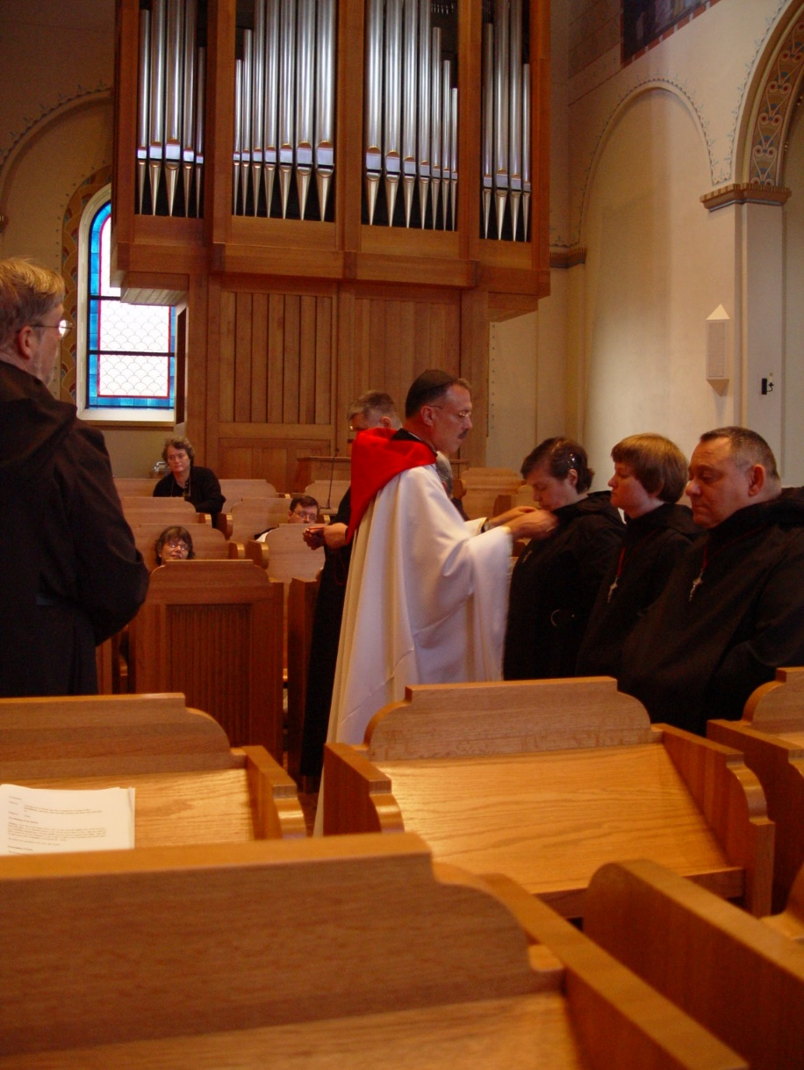
COSL 179 Br. Chad Anselm Gerns (later Br. David); Sr. Anna Grace Madden; Becky Rittenhouse; Br. Paul Howard; Br. Nathan Gregory Miller; Prior Michael John Austin; Sr. Theodora of Jesus Perecca; Sr. Catherine Unterseher; Br. Ambrose Heroux

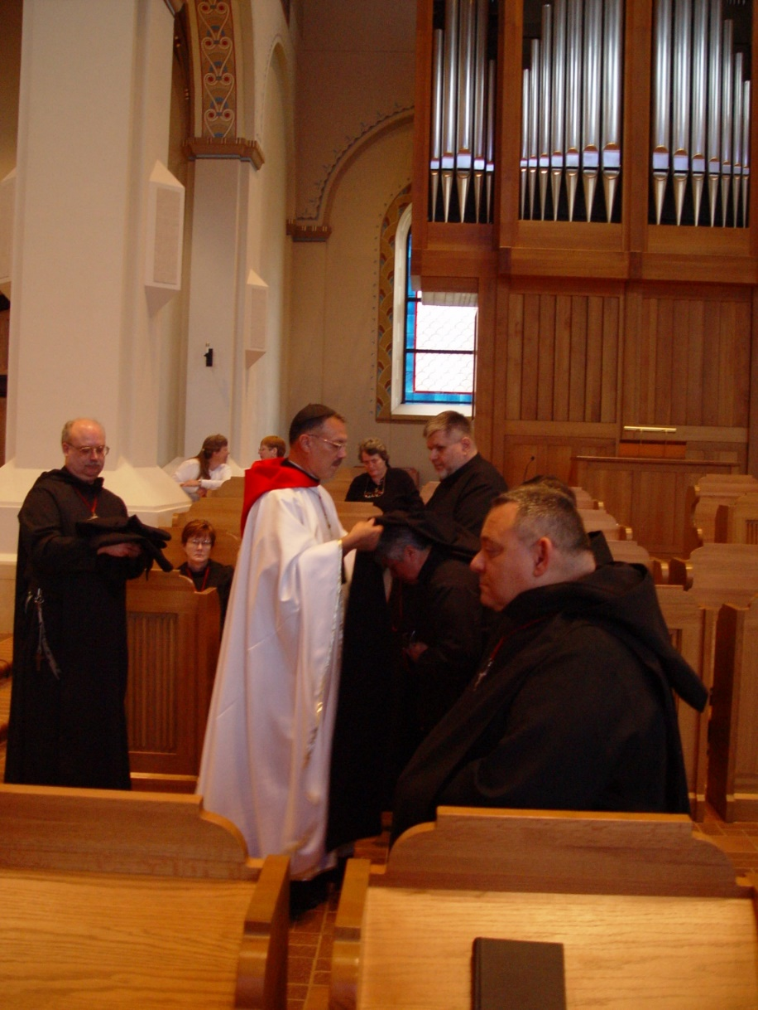
COSL 180 Br. Raymond Owens; Becky Fredregill; Lynn OwnsSr. Ann Gerns; Prior Michael John Austin; Becky Rittenhouse; Br. Nathan Gregory Miller; Sr. Theodora of Jesus Perecca; Br. Ambrose Heroux

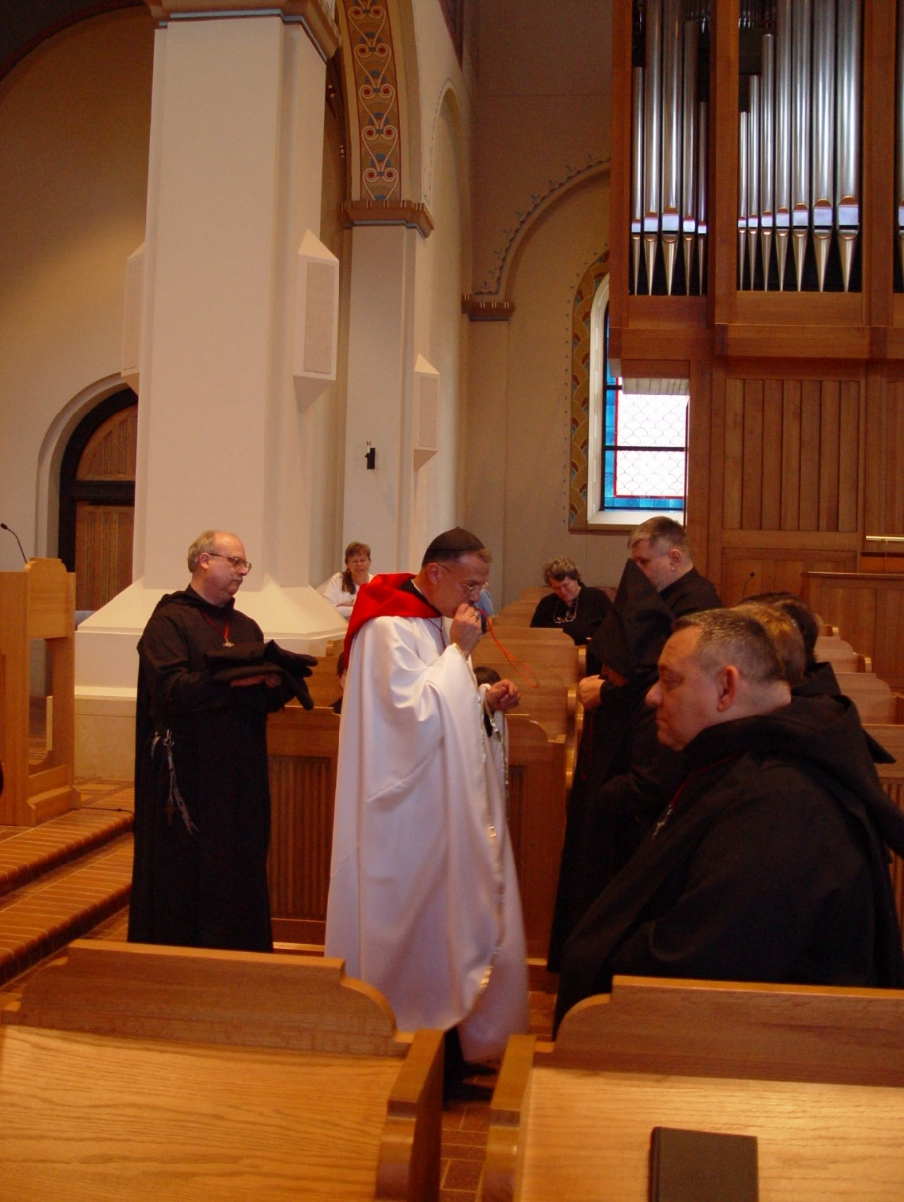
COSL 181 Br. Raymond Owens; Prior Michael John Austin; Becky Rittenhouse; Sr. Theodora of Jesus Perecca; Br. Nathan Gregory; Br. Ambrose Heroux
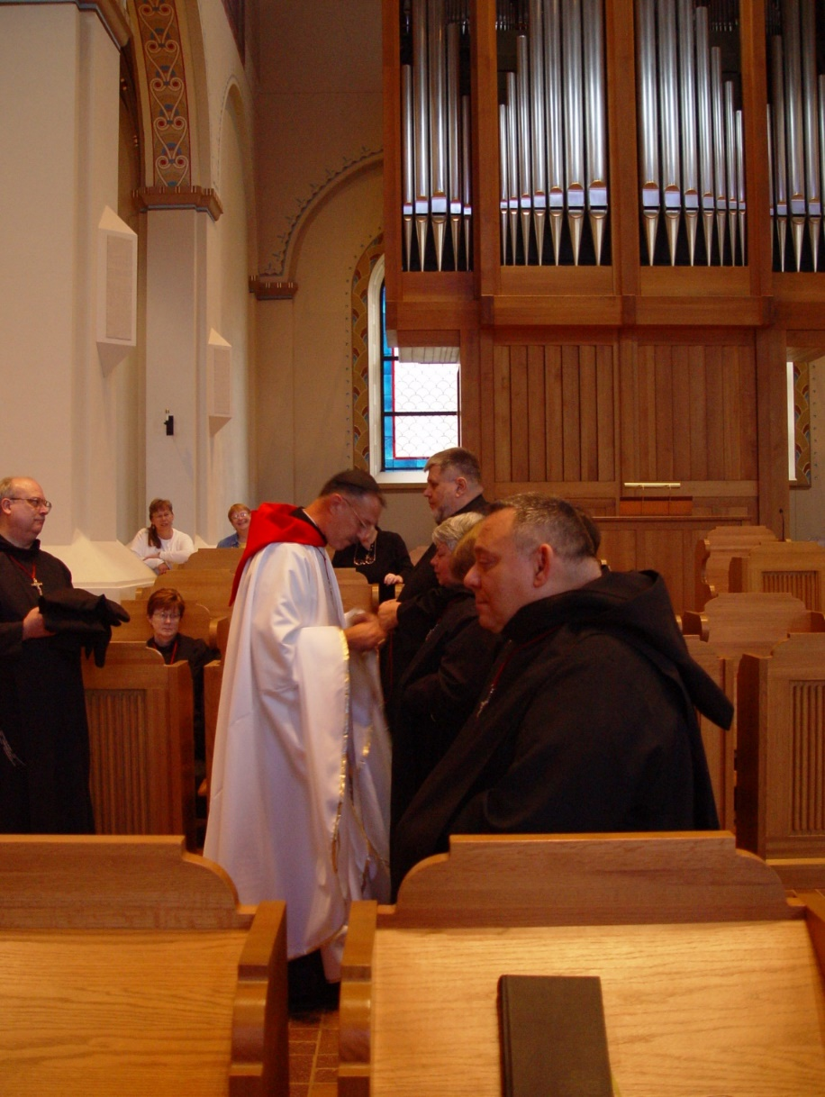
COSL 182 Br. Raymond Owens; Sr. Ann Gerns; Prior Michael John Austin; Br. Nathan Gregory; Sr. Clare Benedicta Meyers; Br. Ambrose Heroux

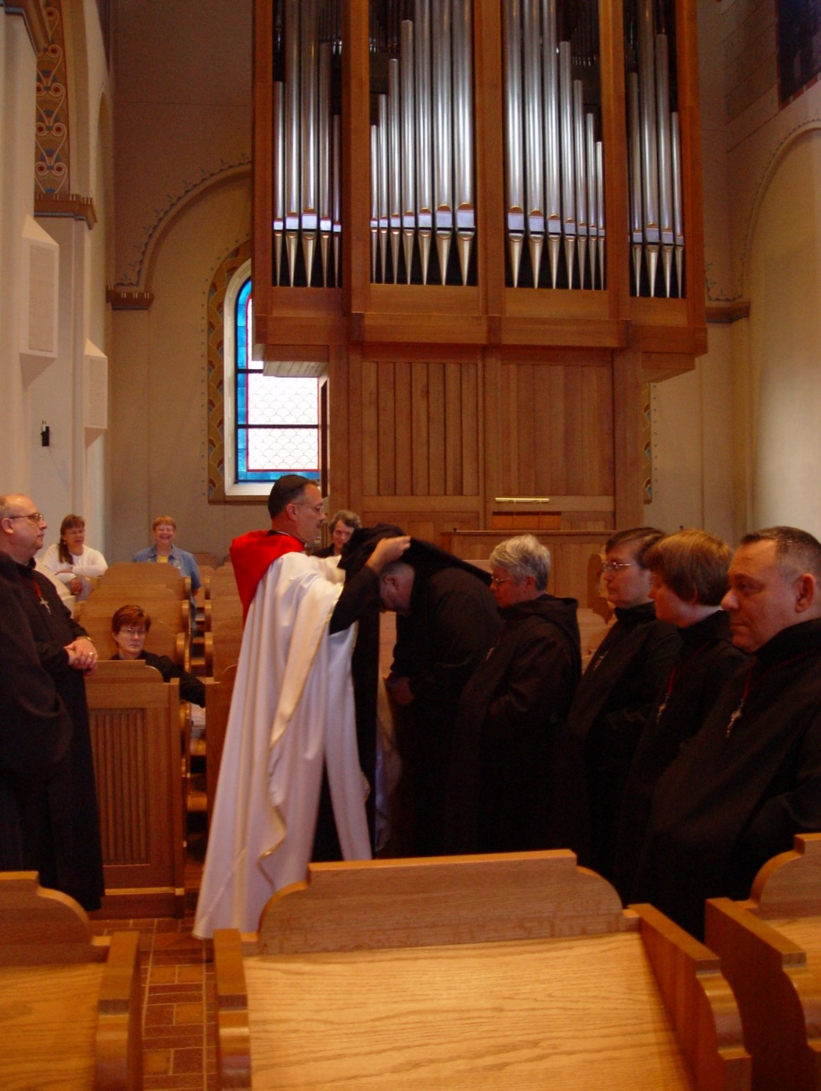
COSL 183 Br. Raymond Owens; Becky Fredregill; Sr. Ann Gerns; Lynn Owens; Prior Michael John Austin; Br. Nathan Gregory; Sr. Clare Benedicta Meyers; Sr. Theodora of Jesus Perecca; Sr. Catherine Unterseher; Br. Ambrose Heroux

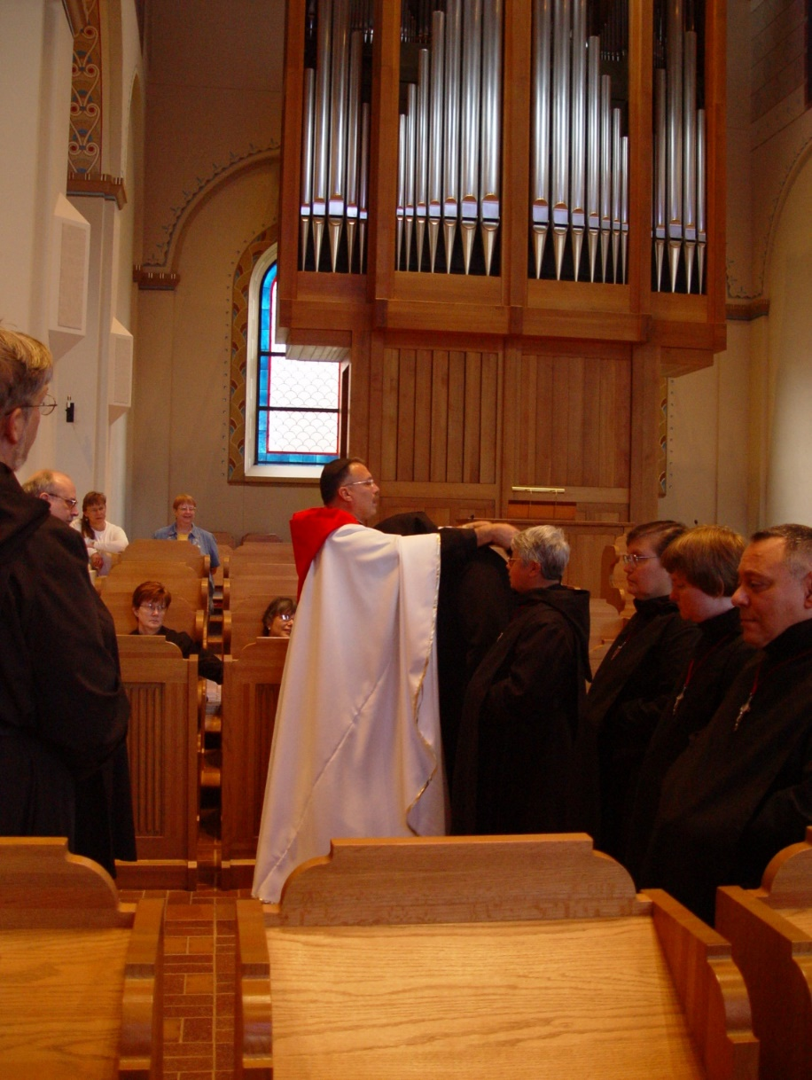
COSL 184 Br. Chad Anselm Gerns (later Br. David); Br. Raymond Owens; Becky Fredregill; Sr. Ann Gerns; Lynn Owens; Sr. Anna Grace Madden; Prior Michael John Austin; Br. Nathan Gregory; Sr. Clare Benedicta Meyers; Sr. Theodora of Jesus Perecca; Sr. Catherine Unterseher; Br. Ambrose Heroux
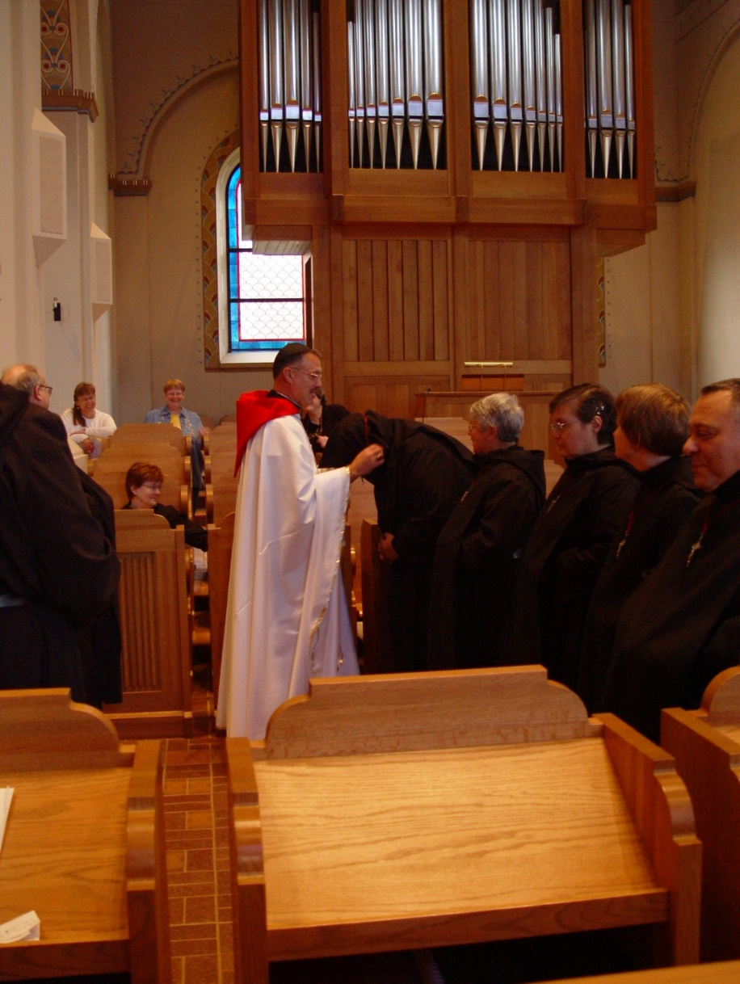
COSL 185 Br. Raymond Owens; Becky Fredregill; Sr. Ann Gerns; Lynn Owens; Prior Michael John Austin; Br. Nathan Gregory; Sr. Clare Benedicta Meyers; Sr. Theodora of Jesus Perecca; Sr. Catherine Unterseher; Br. Ambrose Heroux
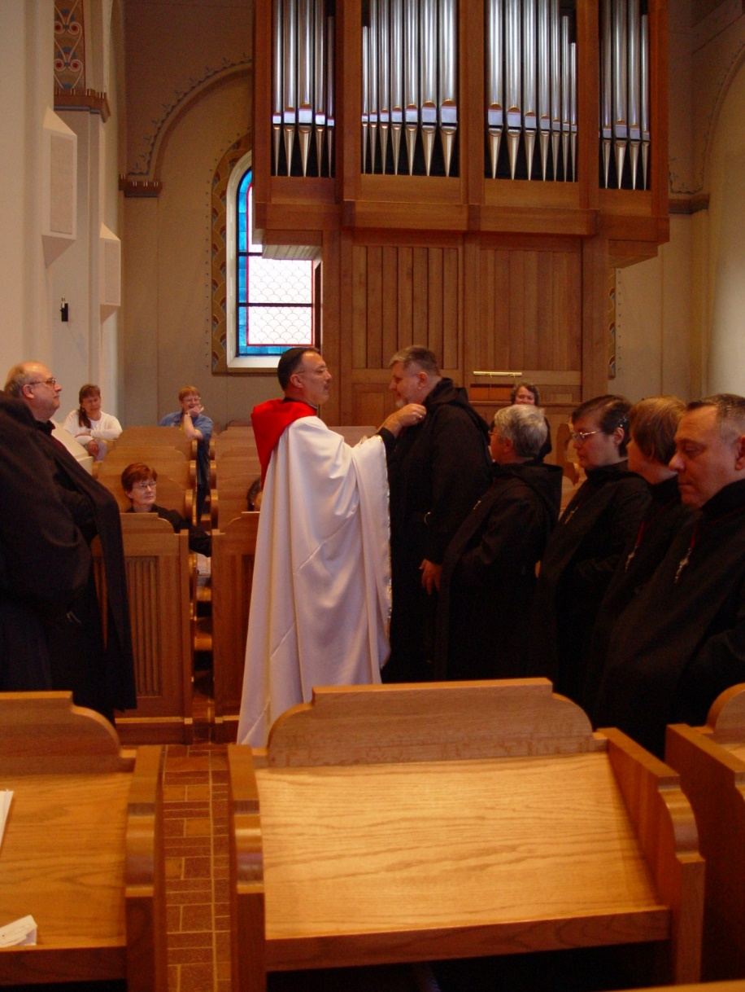
COSL 186 Br. Raymond Owens; Becky Fredregill; Sr. Ann Gerns; Lynn Owens; Prior Michael John Austin; Br. Nathan Gregory; Sr. Clare Benedicta Meyers; Sr. Theodora of Jesus Perecca; Sr. Catherine Unterseher; Br. Ambrose Heroux

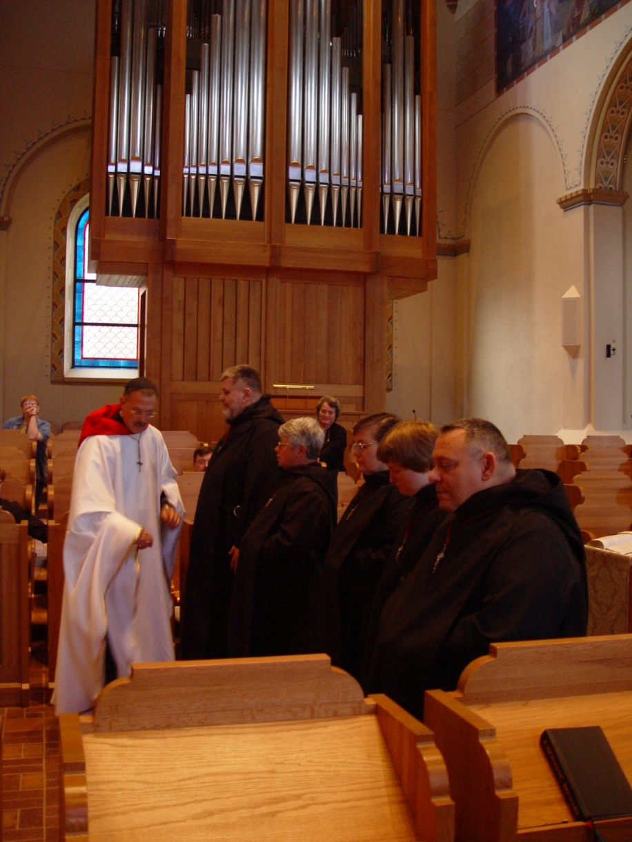
COSL 187 Lynn Owens; Prior Michael John Austin; Br. Nathan Gregory; Sr. Clare Benedicta Meyers; Becky Rittenhouse; Sr. Theodora of Jesus Perecca; Sr. Catherine Unterseher; Br. Ambrose Heroux

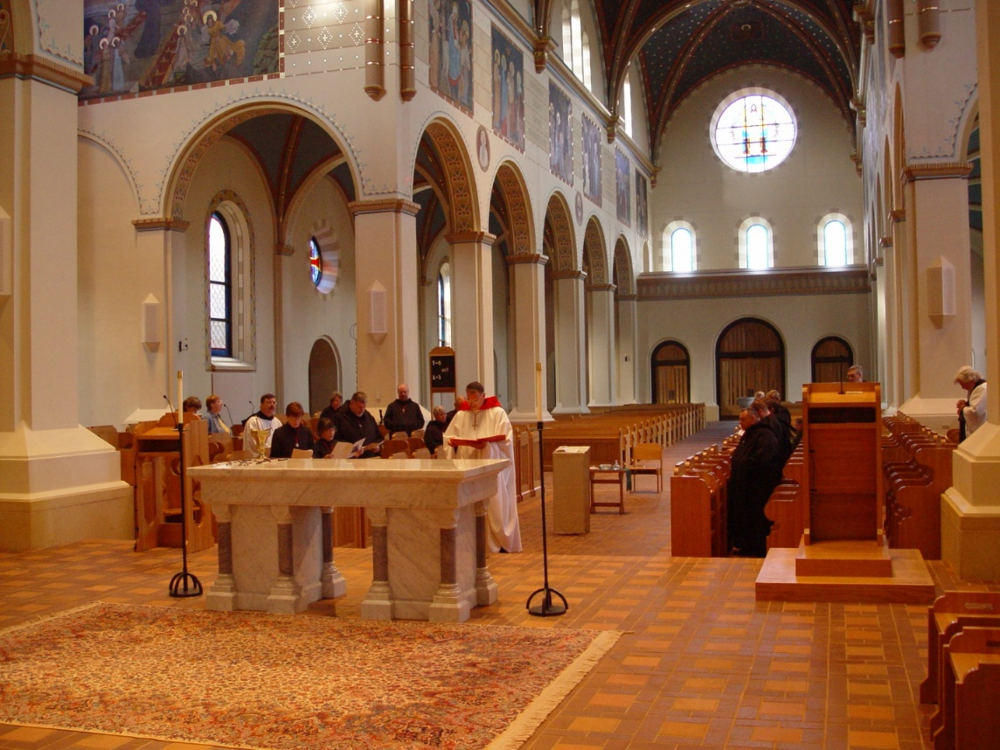
COSL 188
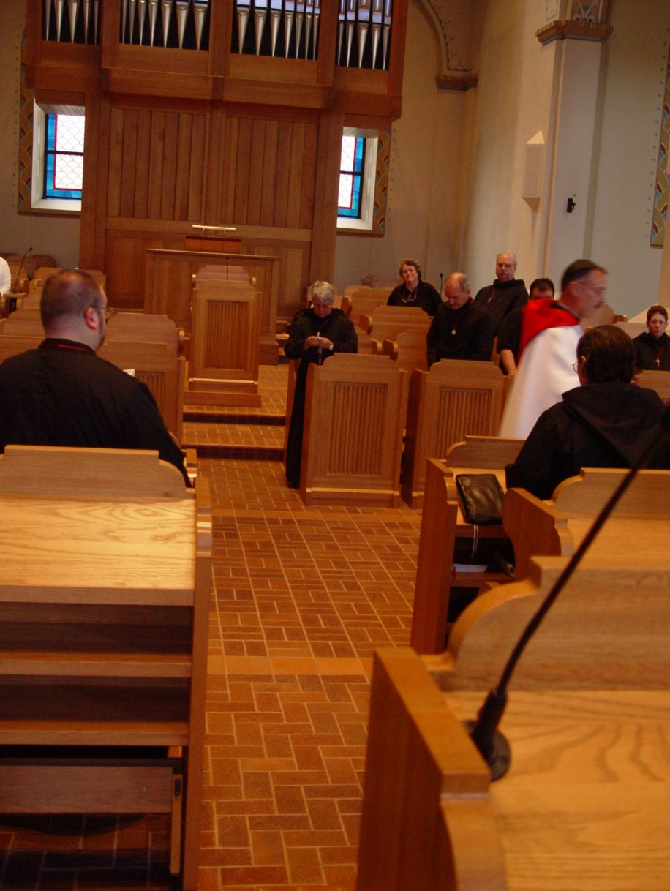
COSL 189 Br. Willard Moore (later Br. Daniel); Sr. Clare Benedicta Meyers; Becky Rittenhouse; Br. Daniel Joseph Schroeder; Br. Paul Howard; Regan Fox; Prior Michael John Austin; Sr. Theodora of Jesus Perecca; Sr. Monica Ruth Mullen

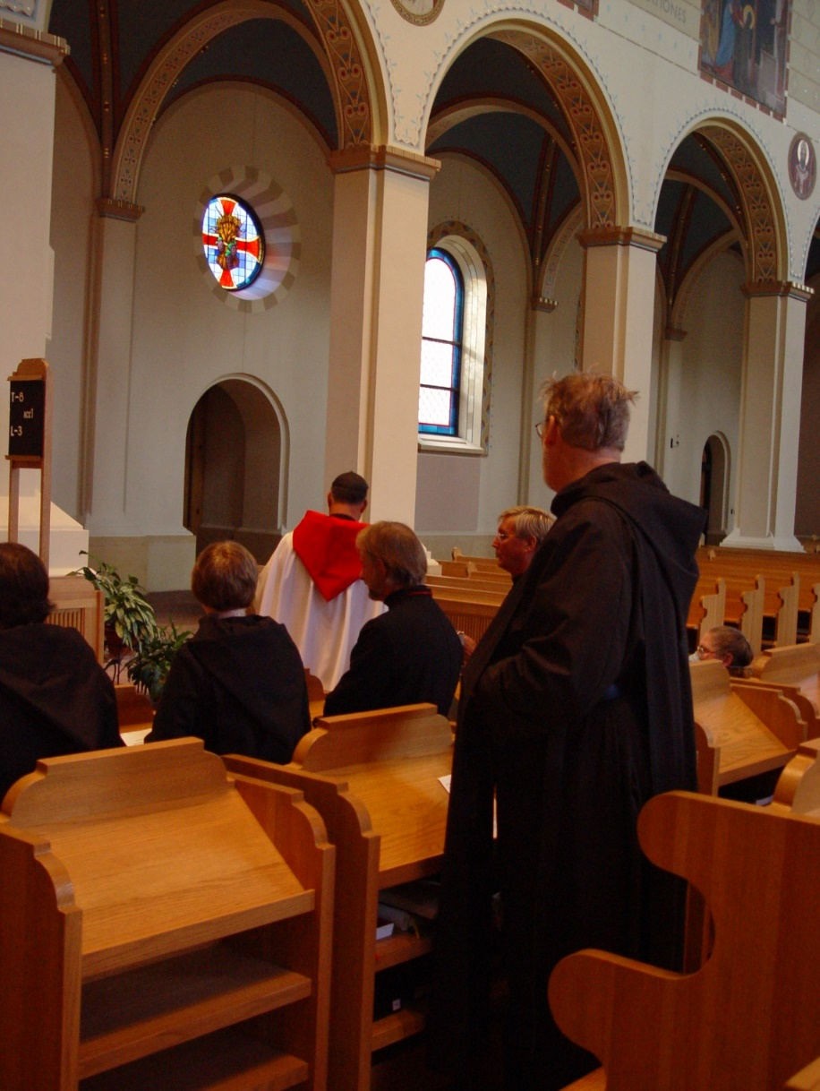
COSL 190 Sr. Theodora of Jesus Perecca; Sr. Catherine Unterseher; Prior Michael John Austin; Barry Mullen (later Br. Lawrence); Glen Converse (later Br. Camillus); Br. Chad Anselm Gerns (later Br. David); Sr. Margaret Moore (later Sr. Denise)
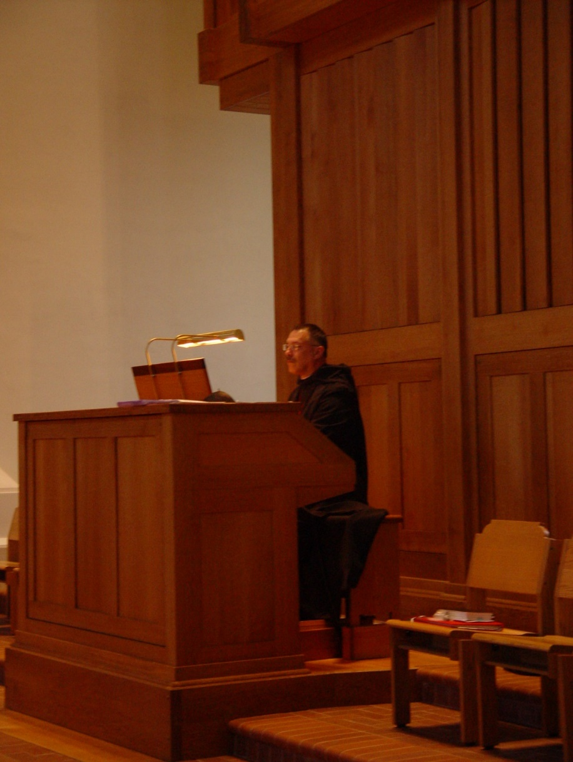
COSL 191 Prior Michael John Austin

