Companions of St. Luke
Fall 2003 Convocation at Conception Abbey
Part 5 of 6

~Edited by Br. Steven Olderr, 17 May 2022 with the assistance of Br. Thomas Ferrell; if you find any errors or omissions, please notify Br. Steven at olderr@ameritech.net

People are identified from left to right.

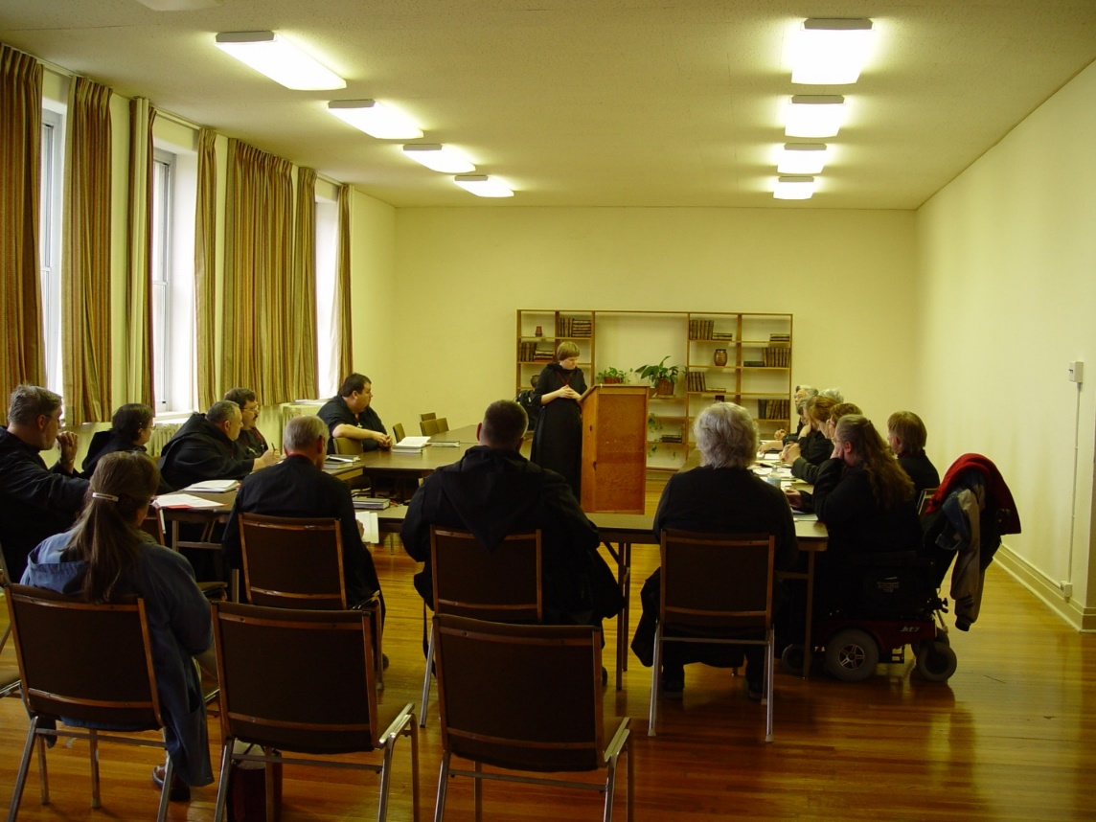
COSL 192 Br. Chad Anselm Gerns; Becky Fredregill; Sr. Theodora of Jesus Perecca; Br. Ambrose Heroux; Br. Paul Howard; Br. Daniel Joseph Schroeder; Regan Fox; Br. Nathan Gregory Miller; Sr. Catherine Unterseher; Fr. Wayne Kamm; Sr. Margaret Moore; Br. Lawrence Mullen
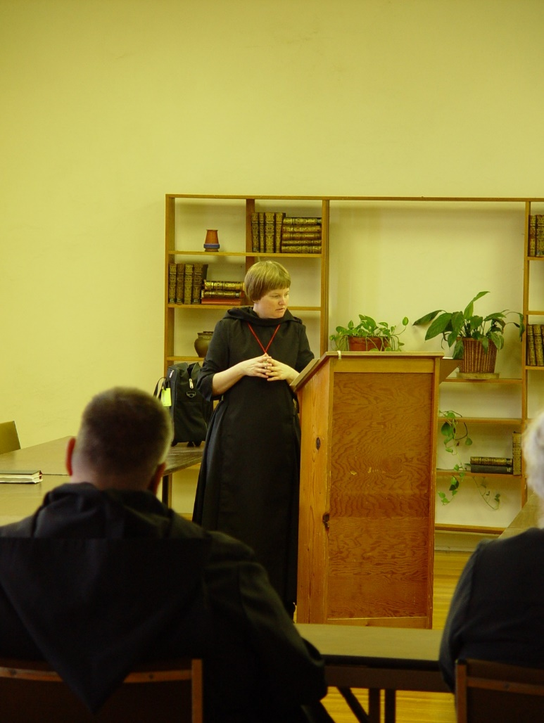
COSL 126 Br. Nathan Gregory Miller; Sr. Catherine Unterseher; Fr. Wayne Kamm
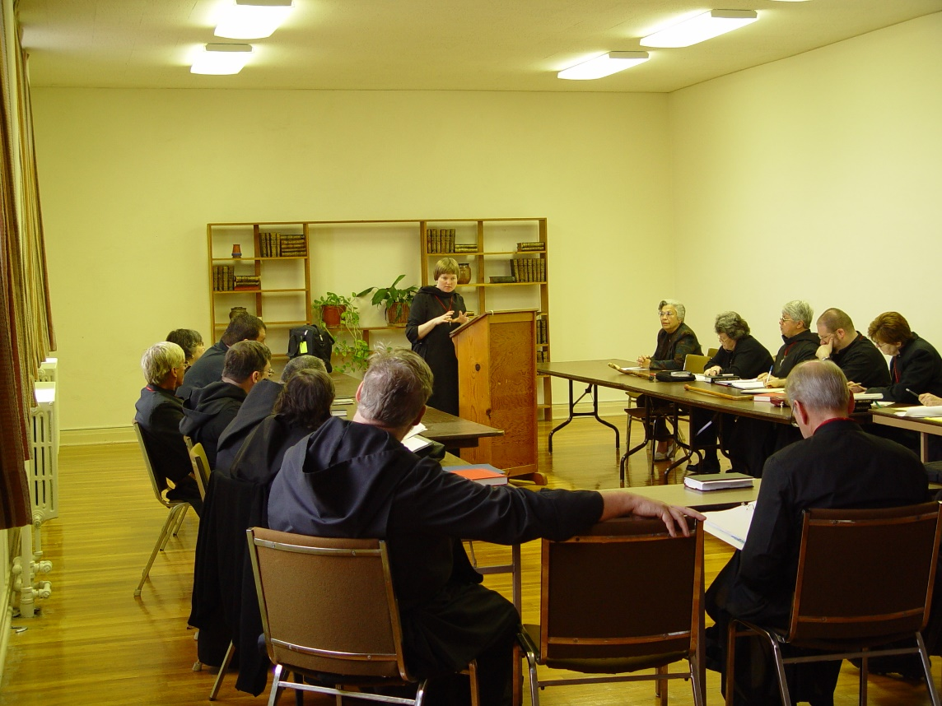
COSL 194 Br. Camillus Converse; Regan Fox; Br. Ambrose Heroux; Sr. Theodora of Jesus Perecca; Br. Chad Anselm Gerns; Sr. Catherine Unterseher; Jeanetta Doan; Becky Rittenhouse; Sr. Clare Benedicta Meyers; Br. Daniel Joseph Schroeder; Br. Willard Moore; Sr. Ann Gerns

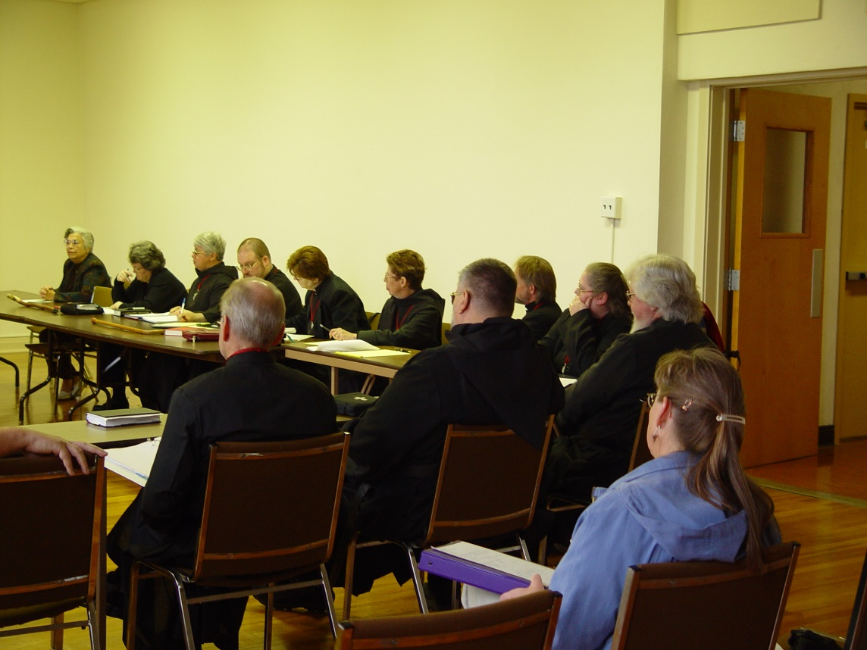
COSL 195 Jeanetta Doan; Becky Rittenhouse; Sr. Clare Benedicta Meyers; Sr. Ann Gerns; Sr. Monica Ruth Mullen; Br. Lawrence Mullen; Sr. Margaret Moore
Backs to camera: Br. Daniel Joseph Schroeder; Br. Nathan Gregory Miller; Becky Fredregill; Fr. Wayne Kamm

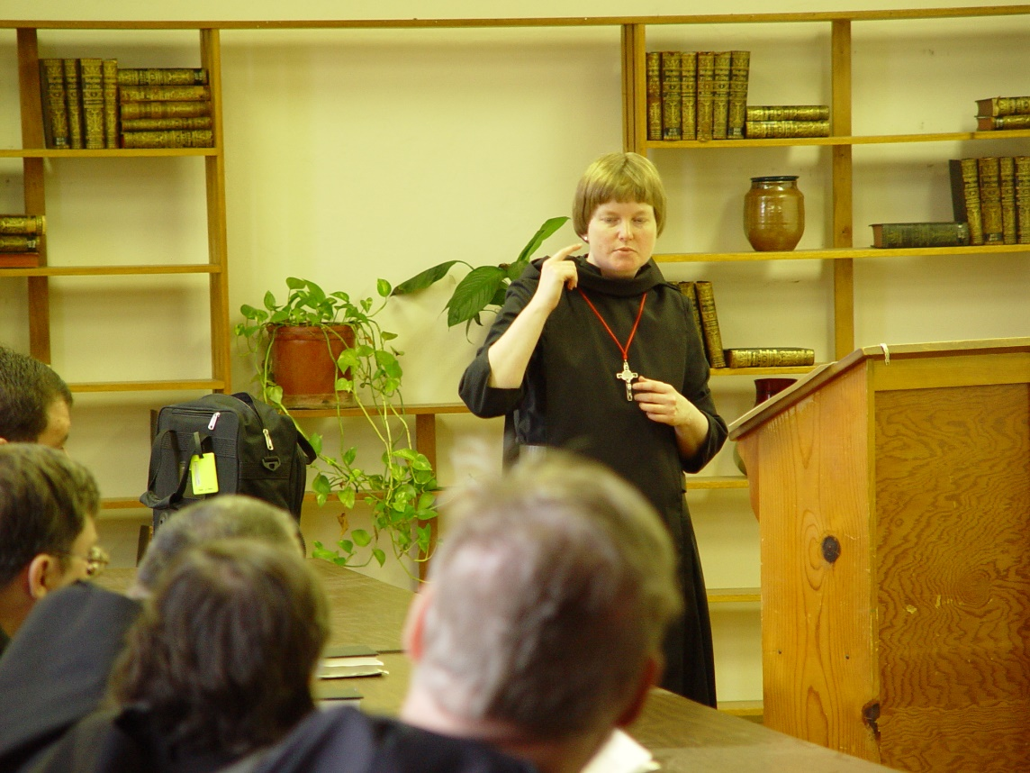
COSL 196 Regan Fox; Br. Paul Howard; Br. Ambrose Heroux; Sr. Theodora of Jesus Perecca; Br. Chad Anselm Gerns (later Br. David)Sr. Catherine Unterseher

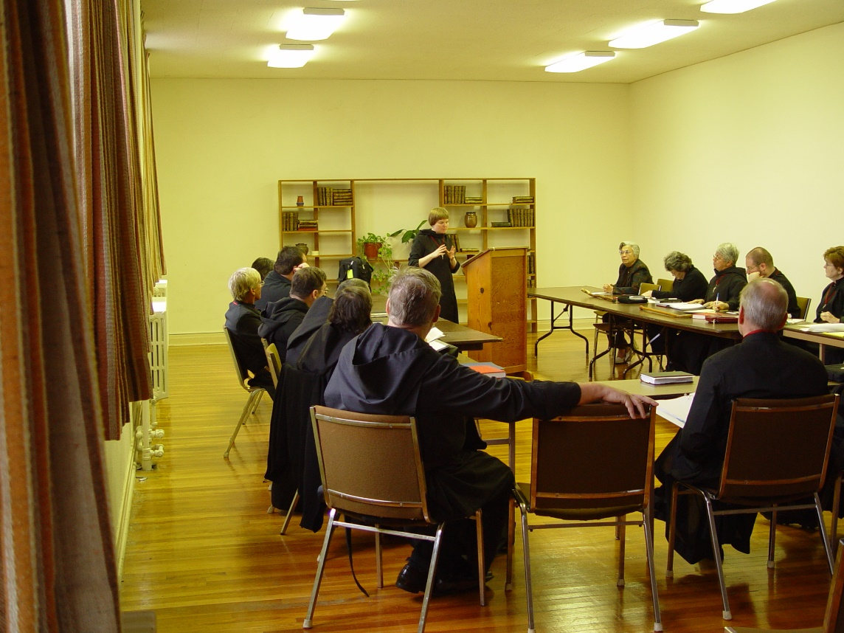
COSL 197 Br. Camillus Converse; Regan Fox; Br. Paul Howard; Br. Ambrose Heroux; Sr. Theodora of Jesus Perecca; Br. Chad Anselm Gerns; Sr. Catherine Unterseher; Br. Daniel Joseph Schroeder; Jeanetta Doan; Becky Rittenhouse; Sr. Clare Benedicta Meyers; Br. Willard Moore; Sr. Ann Gerns

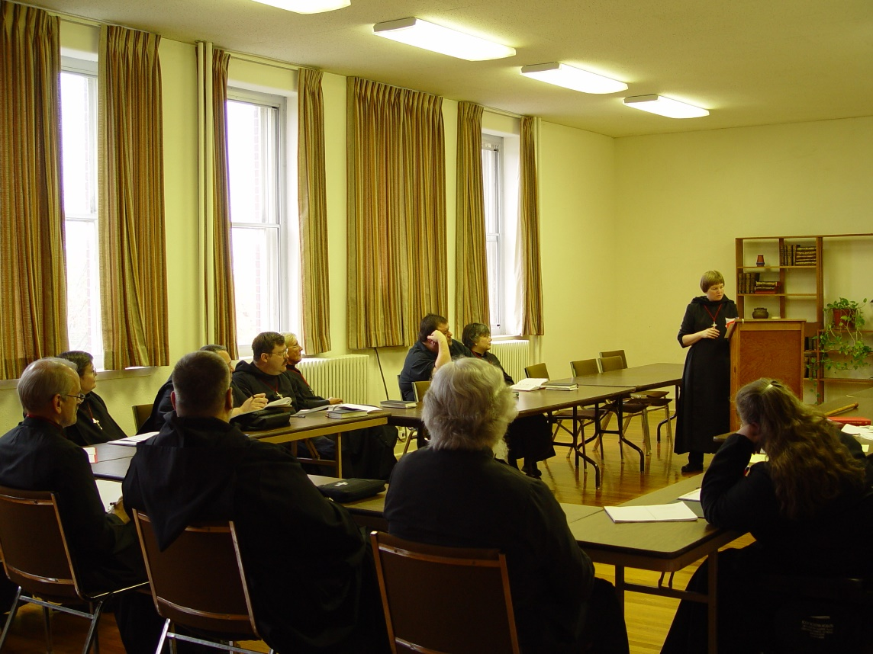
COSL 198 Br. Daniel Joseph Schroeder; Sr. Theodora of Jesus Perecca; Br. Paul Howard; Br. Camillus Converse; Regan Fox; Fr. Wayne Kamm; Sr. Anna Grace Madden; Sr. Catherine Unterseher: Sr. Margaret Moore
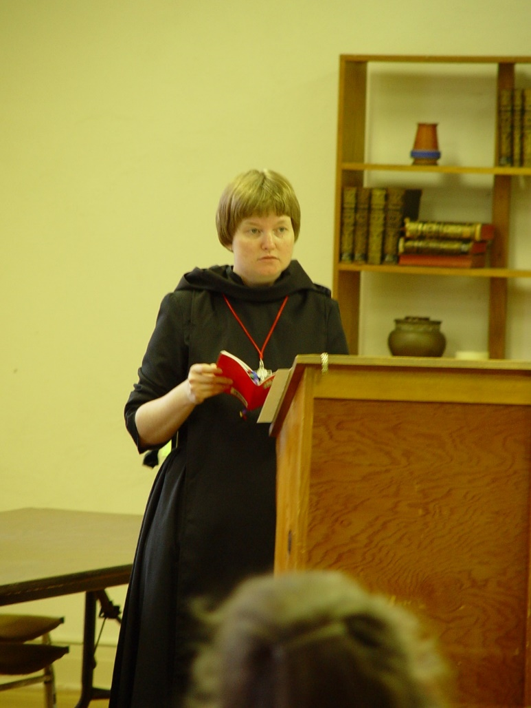
COSL 199 Sr. Catherine Unterseher
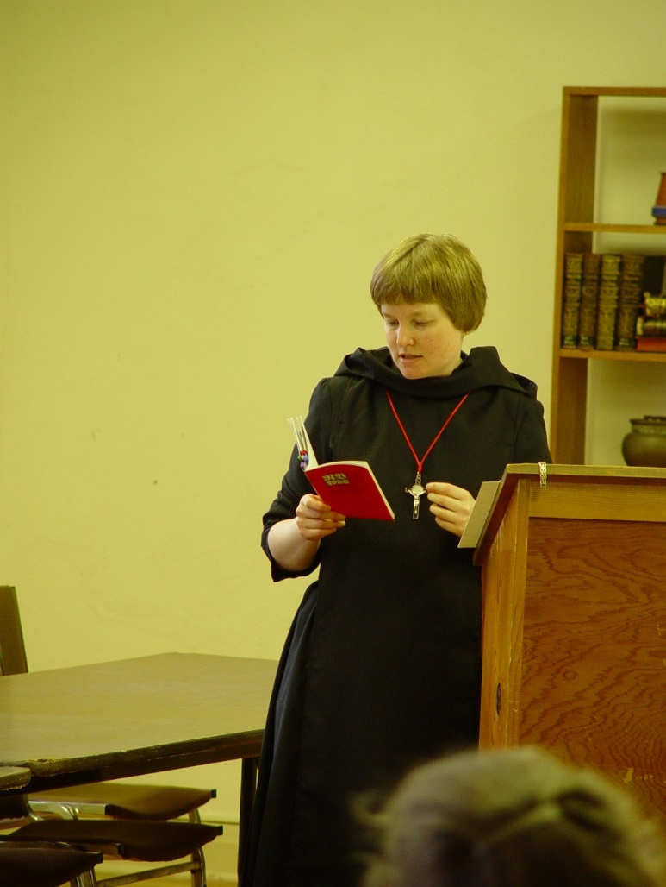
COSL 200 Sr. Catherine Unterseher
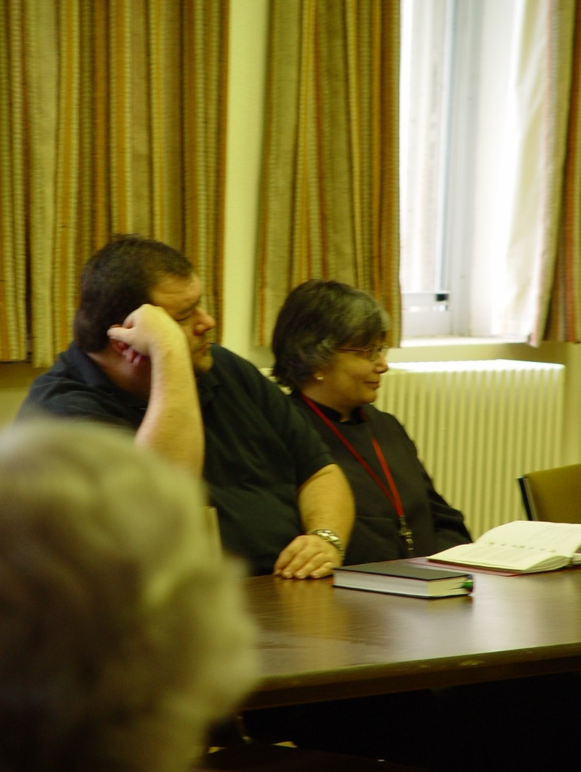
COSL 201 Regan Fox; Sr. Anna Grace Madden
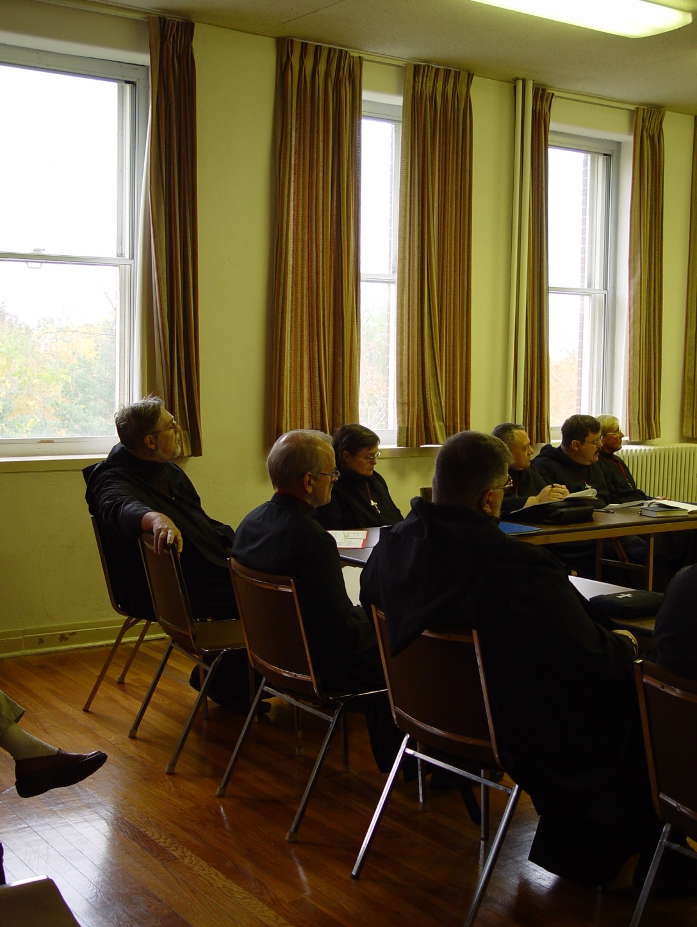
COSL 202 Br. Chad Anselm Gerns (later Br. David); Br. Daniel Joseph Schroeder; Sr. Theodora of Jesus Perecca; Br. Nathan Gregory Miller; Br. Ambrose Heroux; Br. Paul Howard; Br. Camillus Converse

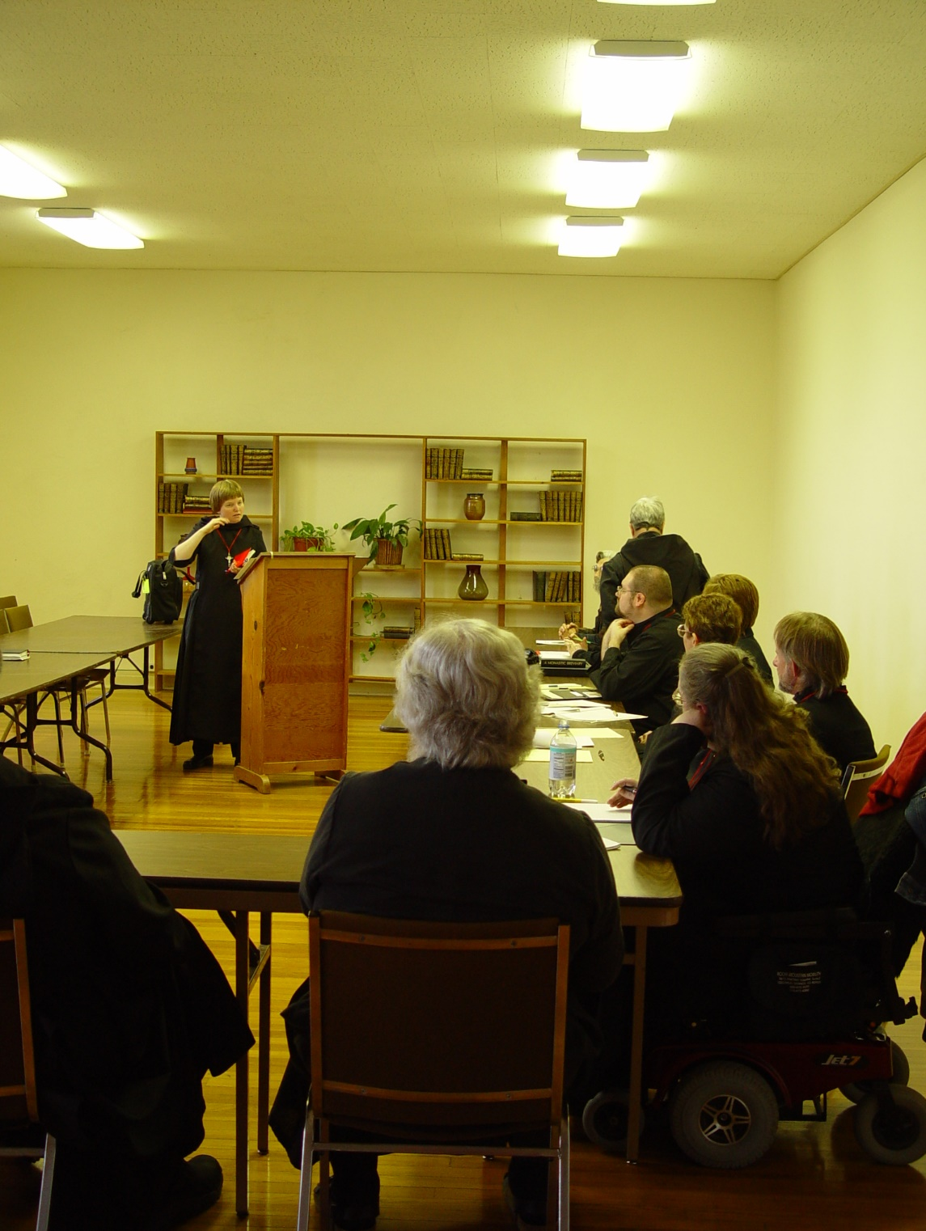
COSL 203 Sr. Catherine Unterseher; Fr. Wayne Kamm; Sr. Clare Benedicta Meyers; Sr. Clare Benedicta Meyers; Br. Willard Moore; Sr. Ann Gerns; Sr. Monica Ruth Mullen; Br. Lawrence Mullen; Sr. Margaret Moore
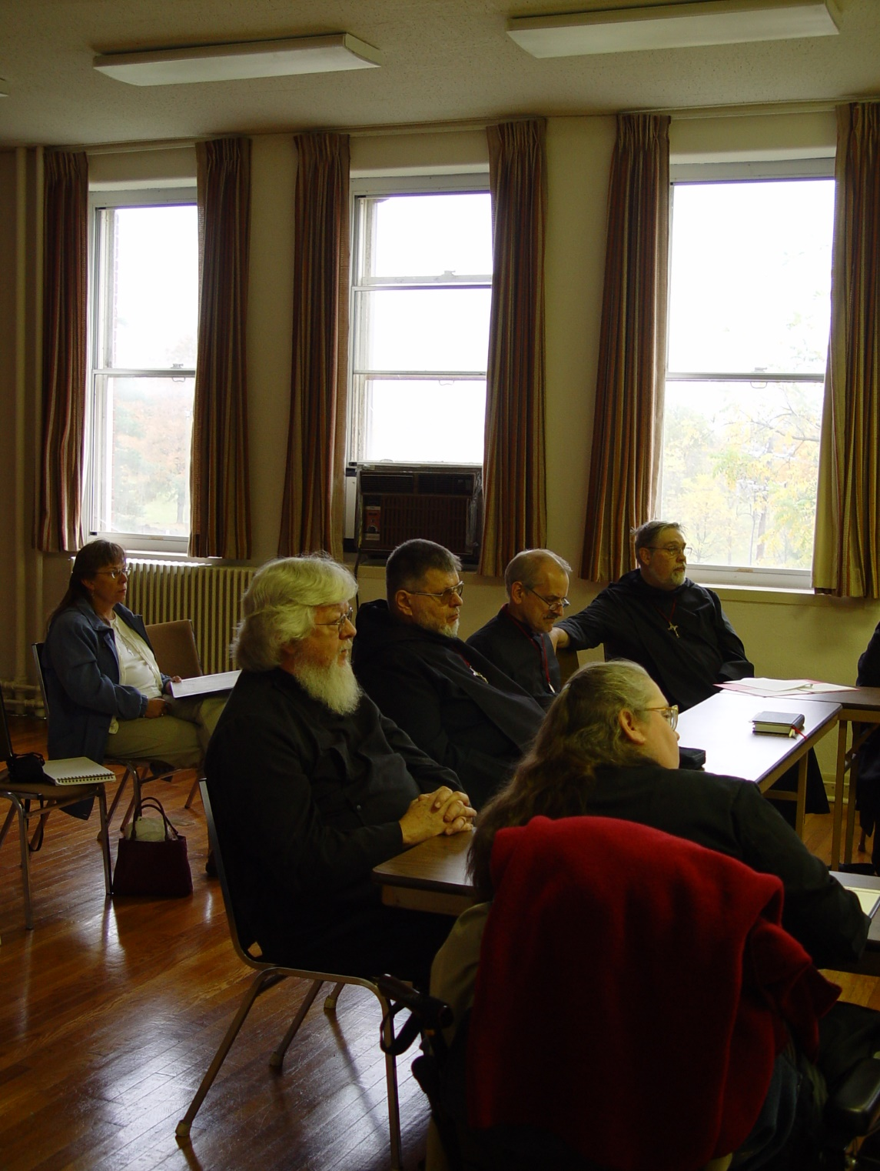
COSL 204 Becky Fredregill; Fr. Wayne Kamm; Br. Nathan Gregory Miller; Br. Daniel Joseph Schroeder; Sr. Margaret Moore; Br. Chad Anselm Gerns (later Br. David)
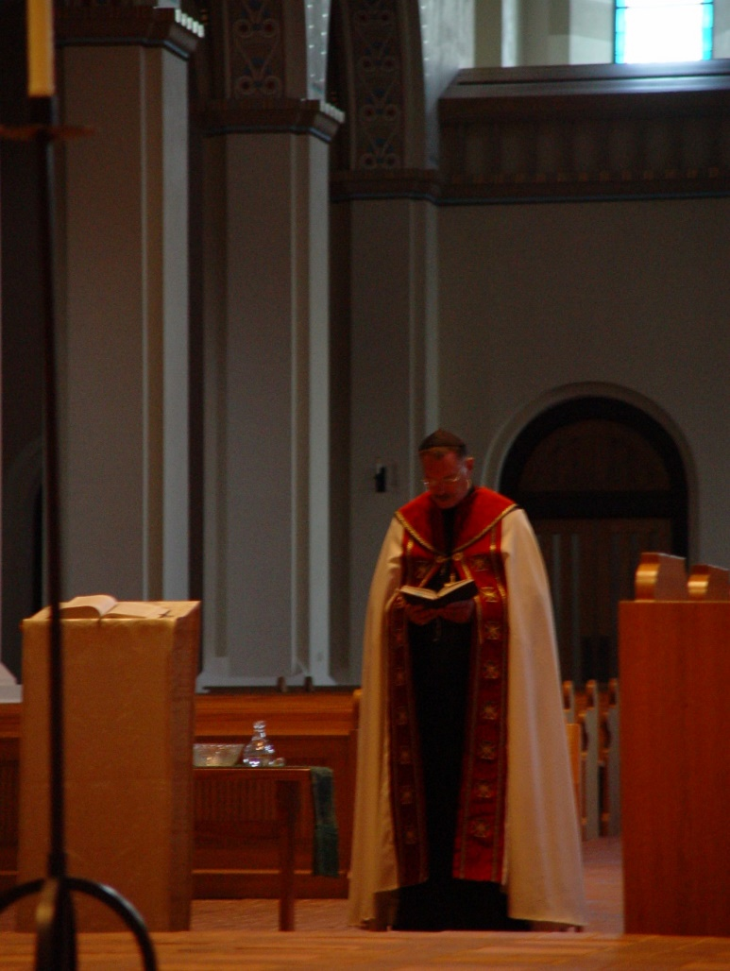
COSL 205 Prior Michael John Austin
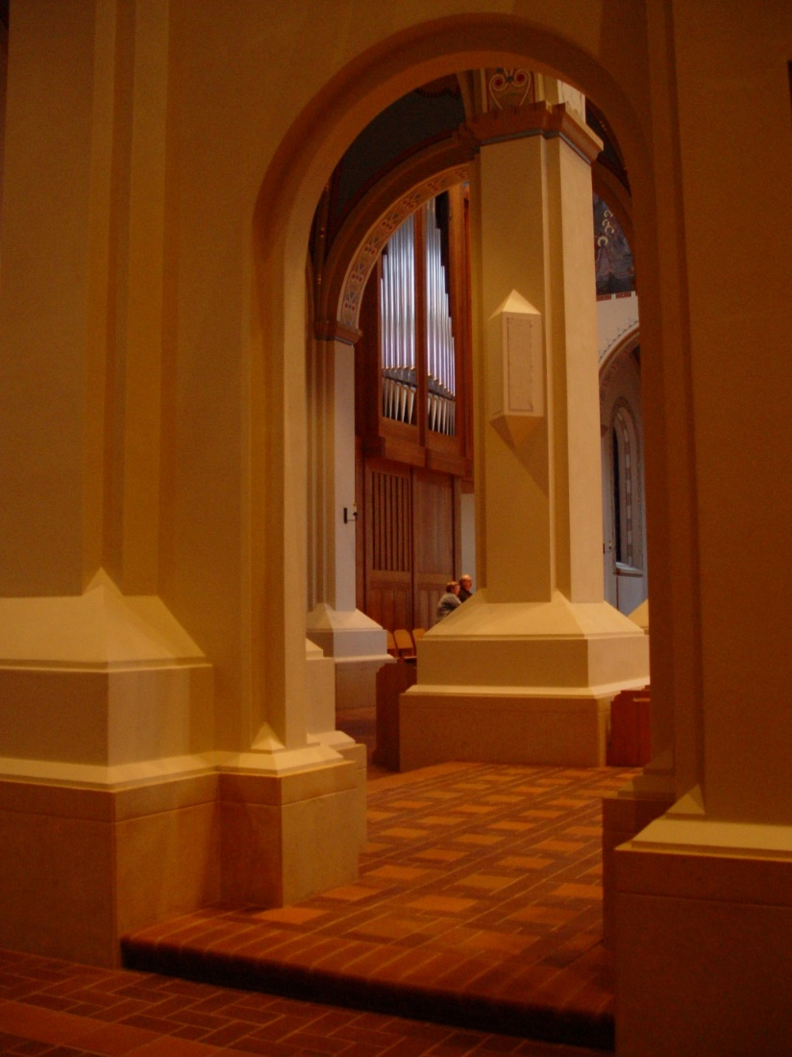
COSL 206 Lynn Owens; Br. Raymond Owens
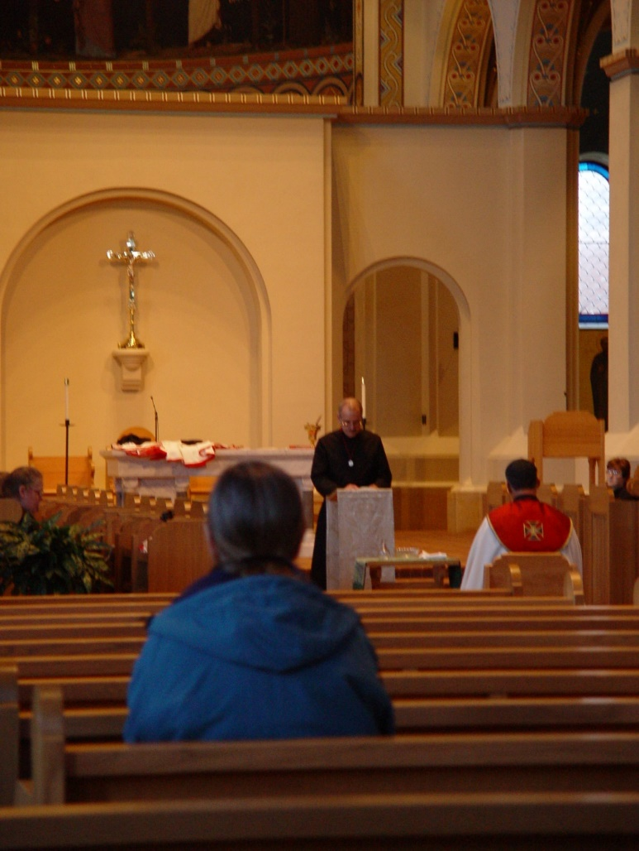
COSL 207 Sr. Margaret Moore; Mary Schroeder; Br. Daniel Joseph Schroeder; Prior Michael John Austin
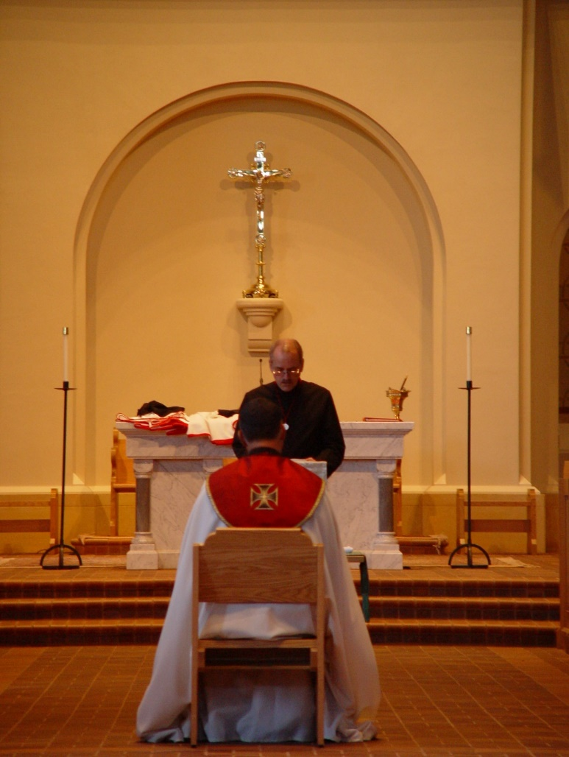
COSL 208 Prior Michael John Austin; Br. Daniel Joseph Schroeder

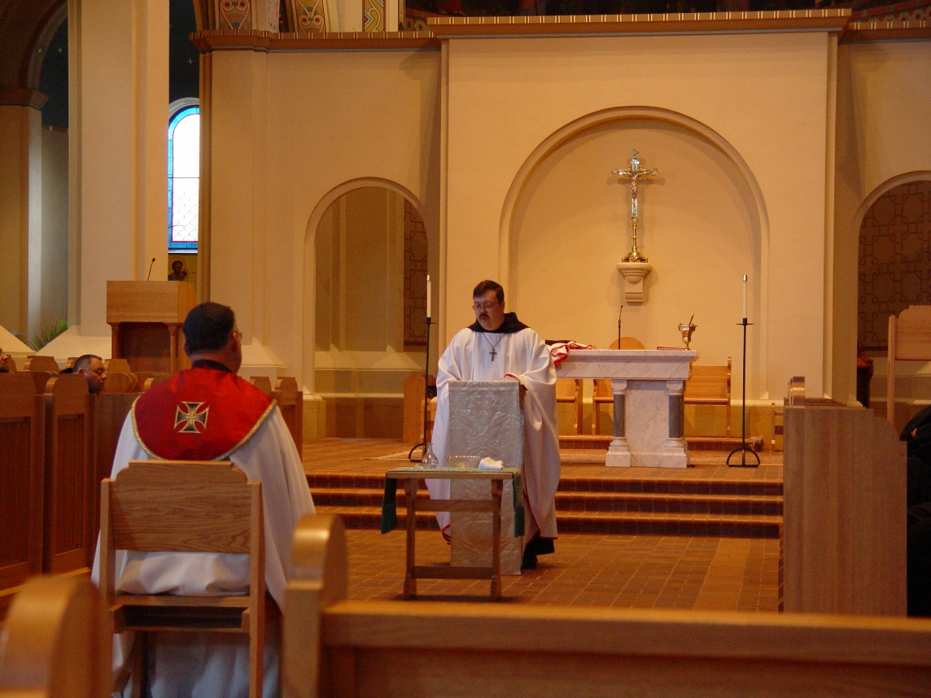
COSL 209 Br. Ambrose Heroux; Prior Michael John Austin; Br. Paul Howard

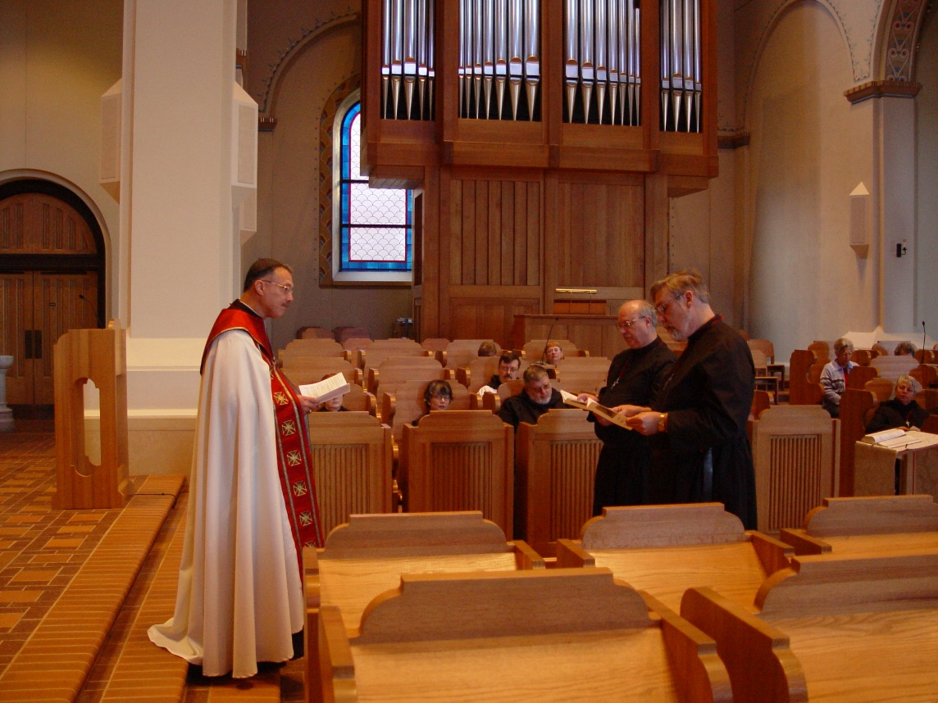
COSL 210 Prior Michael John Austin; Sr. Ann Gerns; Sr. Anna Grace Madden; Br. Nathan Gregory Miller; Br. Raymond Owens; Br. Chad Anselm Gerns (later Br. David); Jeanetta Doan; Sr. Clare Benedicta Meyers
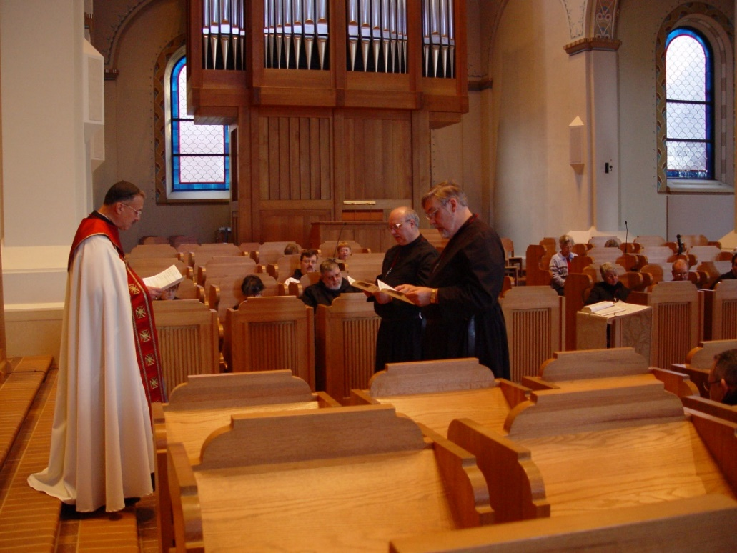
COSL 211 Sr. Ann Gerns; Sr. Anna Grace Madden; Becky Fredregill; Br. Paul Howard; Br. Nathan Gregory Miller; Lynn Owens; Br. Raymond Owens; Br. Chad Anselm Gerns (later Br. David); Jeanetta Doan; Sr. Clare Benedicta Meyers; Br. Daniel Joseph Schroeder; Br. Ambrose Heroux

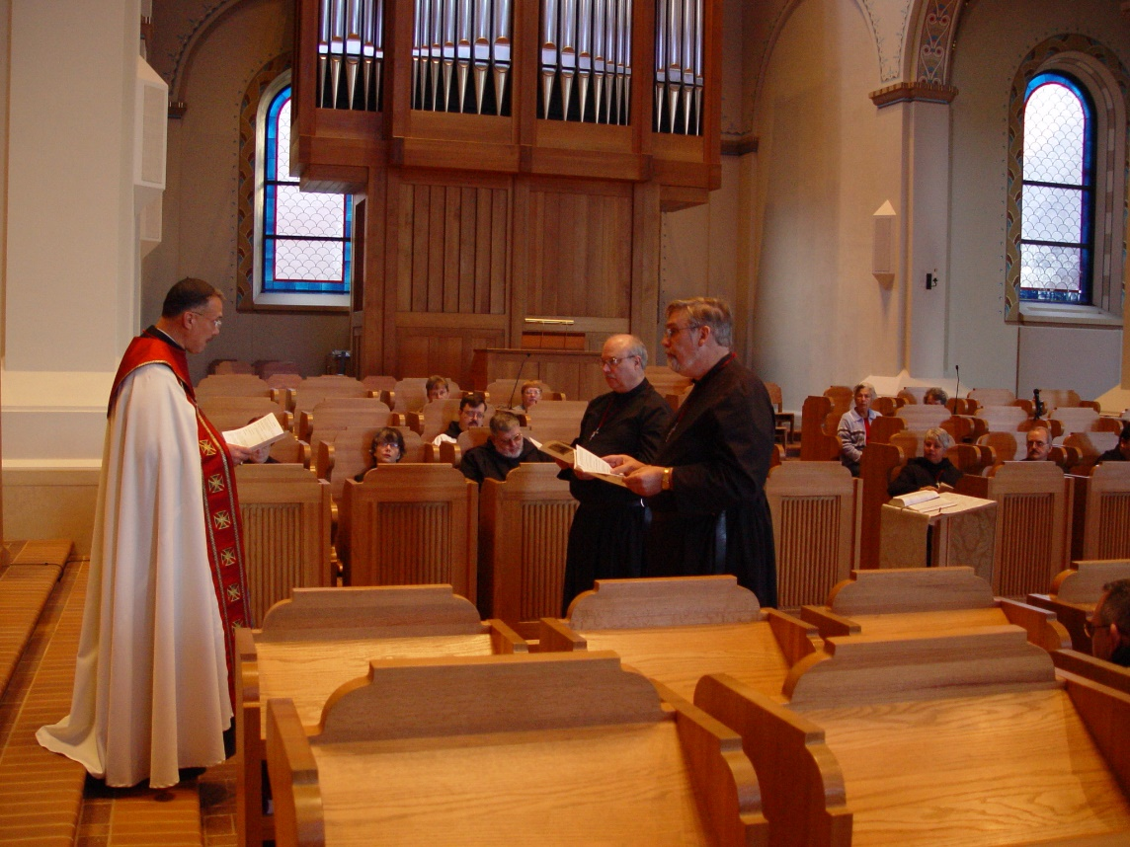
COSL 212 Prior Michael John Austin; Sr. Ann Gerns; Sr. Anna Grace Madden; Becky Fredregill; Br. Paul Howard; Lynn Owens; Br. Nathan Gregory Miller; Br. Raymond Owens; Br. Chad Anselm Gerns (later Br. David); Jeanetta Doan; Sr. Clare Benedicta Meyers; Br. Daniel Joseph Schroeder; Br. Ambrose Heroux
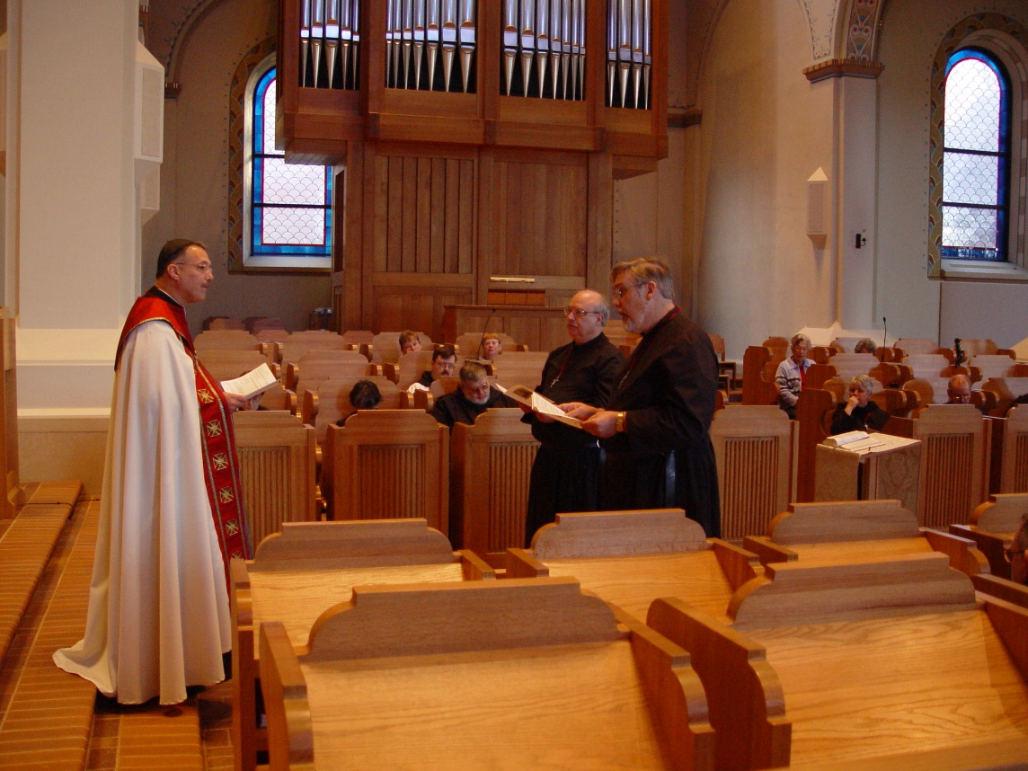
COSL 213 Prior Michael John Austin; Sr. Ann Gerns; Sr. Anna Grace Madden; Br. Paul Howard; Becky Fredregill; Br. Nathan Gregory Miller; Lynn Owens; Br. Raymond Owens; Br. Chad Anselm Gerns (later Br. David); Jeanetta Doan; Sr. Clare Benedicta Meyers; Br. Daniel Joseph Schroeder; Br. Ambrose Heroux

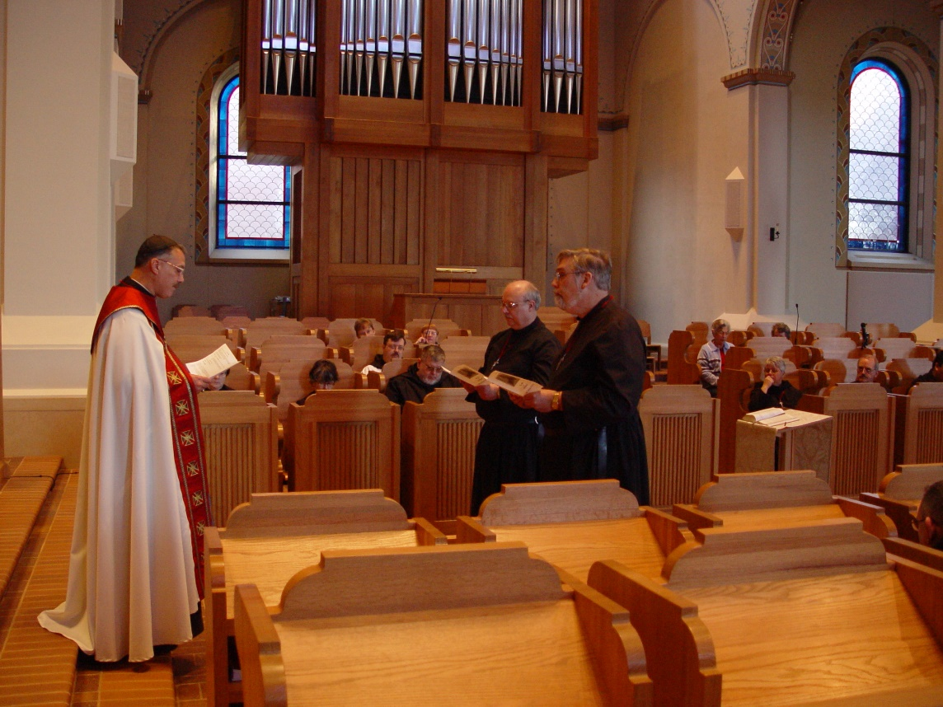
COSL 214 Prior Michael John Austin; Sr. Ann Gerns; Sr. Anna Grace Madden; Becky Fredregill; Br. Paul Howard; Br. Nathan Gregory Miller; Lynn Owens; Br. Raymond Owens; Br. Chad Anselm Gerns (later Br. David); Jeanetta Doan; Sr. Clare Benedicta Meyers; Br. Daniel Joseph Schroeder; Br. Ambrose Heroux

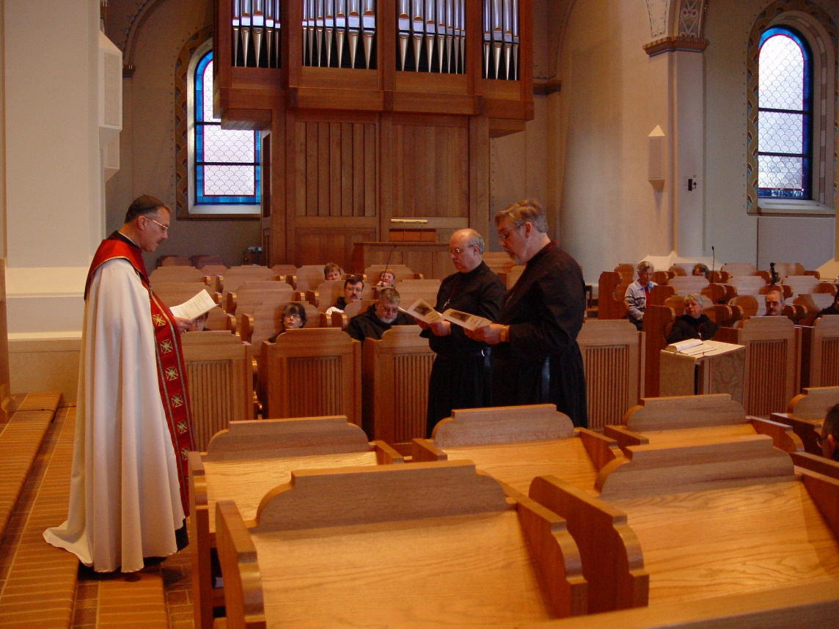
COSL 215 Prior Michael John Austin; Sr. Ann Gerns; Sr. Anna Grace Madden; Becky Fredregill; Br. Paul Howard; Br. Nathan Gregory Miller; Lynn Owens; Br. Raymond Owens; Br. Chad Anselm Gerns (later Br. David); Jeanetta Doan; Sr. Clare Benedicta Meyers; Br. Daniel Joseph Schroeder; Br. Ambrose Heroux

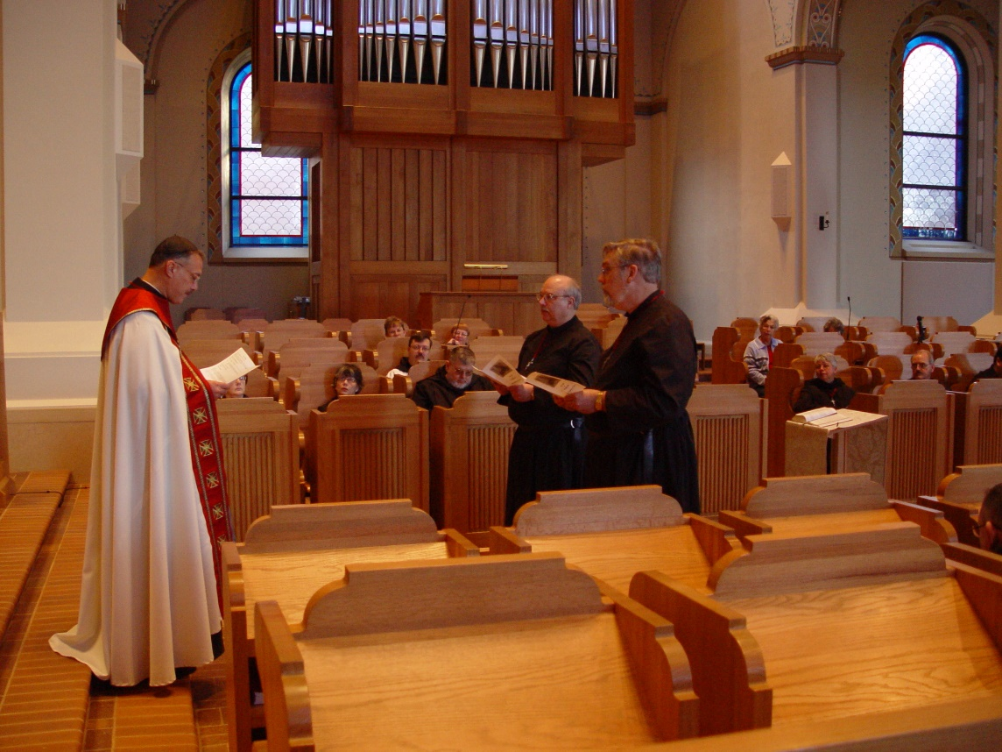
COSL 216 Prior Michael John Austin; Sr. Ann Gerns; Sr. Anna Grace Madden; Becky Fredregill; Br. Paul Howard; Br. Nathan Gregory Miller; Lynn Owens; Br. Raymond Owns; Br. Chad Anselm Gerns (later Br. David); Jeanetta Doan; Sr. Clare Benedicta Meyers; Br. Daniel Joseph Schroeder; Br. Ambrose Heroux
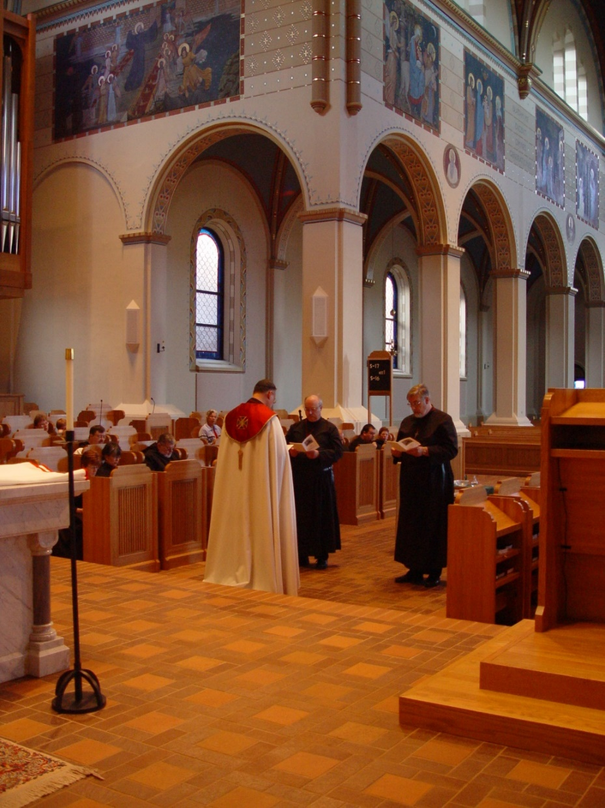
COSL 217 Becky Fredregill; Lynn Owens; Sr. Ann Gerns; Sr. Anna Grace Madden; Br. Paul Howard; Br. Nathan Gregory Miller; Jeanetta Doan; Prior Michael John Austin; Br. Raymond Owens; Regan Fox; Sr. Monica Ruth Mullen; Br. Chad Anselm Gerns (later Br. David)

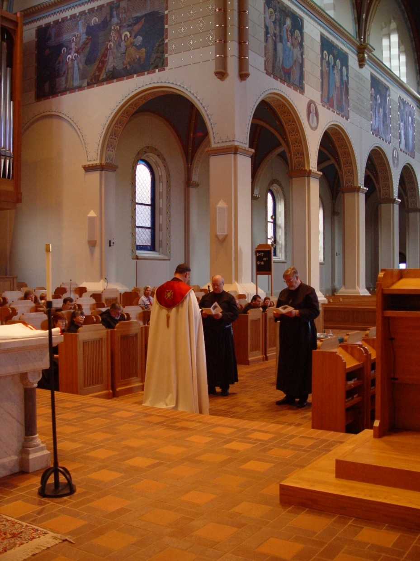
COSL 218 Becky Fredregill; Lynn Owens; Sr. Ann Gerns; Sr. Anna Grace Madden; Br. Paul Howard; Br. Nathan Gregory Miller; Jeanetta Doan; Prior Michael John Austin; Br. Raymond Owens; Regan Fox; Sr. Monica Ruth Mullen; Br. Chad Anselm Gerns (later Br. David)

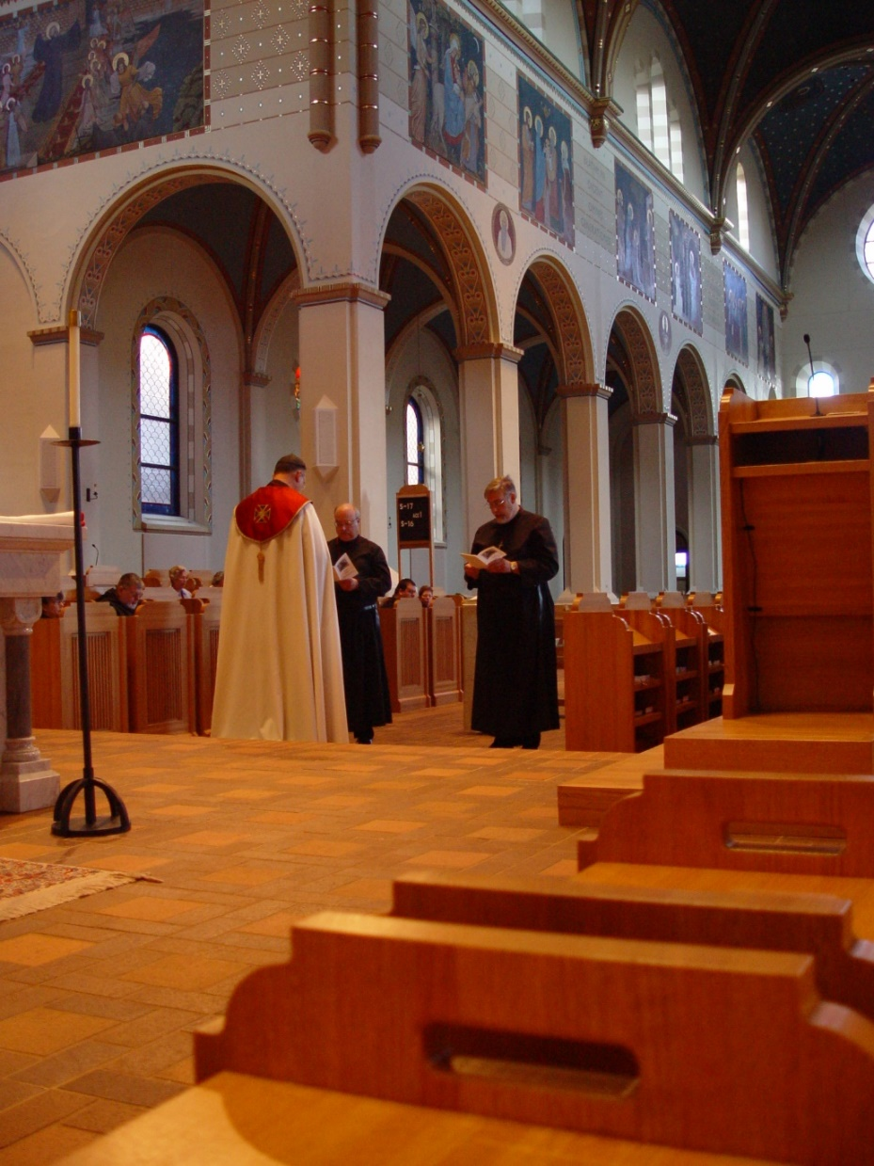
COSL 219 Sr. Anna Grace Madden; Br. Nathan Gregory Miller; Jeanetta Doan; Prior Michael John Austin; Br. Raymond Owens; Regan Fox; Sr. Monica Ruth Mullen; Br. Chad Anselm Gerns (later Br. David)

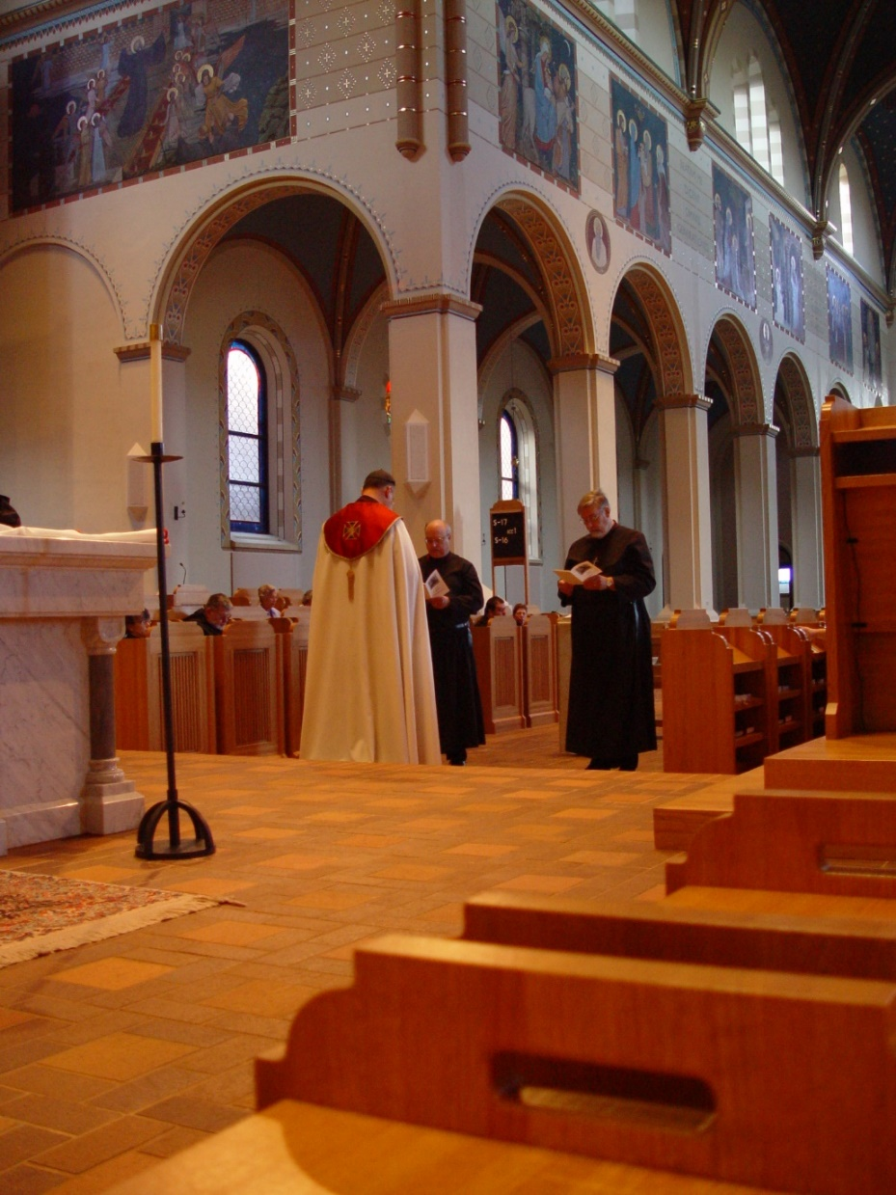
COSL 220 Sr. Anna Grace Madden; Br. Nathan Gregory Miller; Jeanetta Doan; Prior Michael John Austin; Br. Raymond Owens; Regan Fox; Sr. Monica Ruth Mullen; Br. Chad Anselm Gerns (later Br. David)

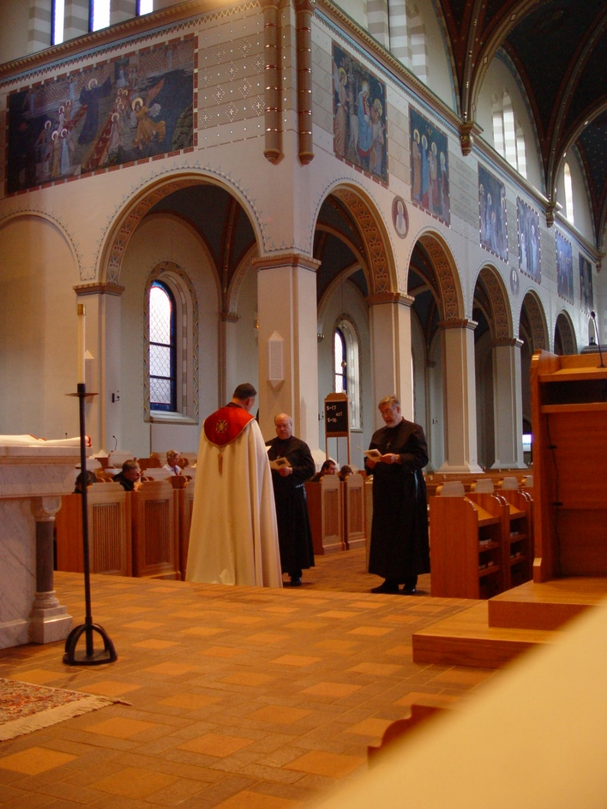
COSL 221 Sr. Anna Grace Madden; Br. Nathan Gregory Miller; Jeanetta Doan; Prior Michael John Austin; Br. Raymond Owens; Regan Fox; Sr. Monica Ruth Mullen; Br. Chad Anselm Gerns (later Br. David)
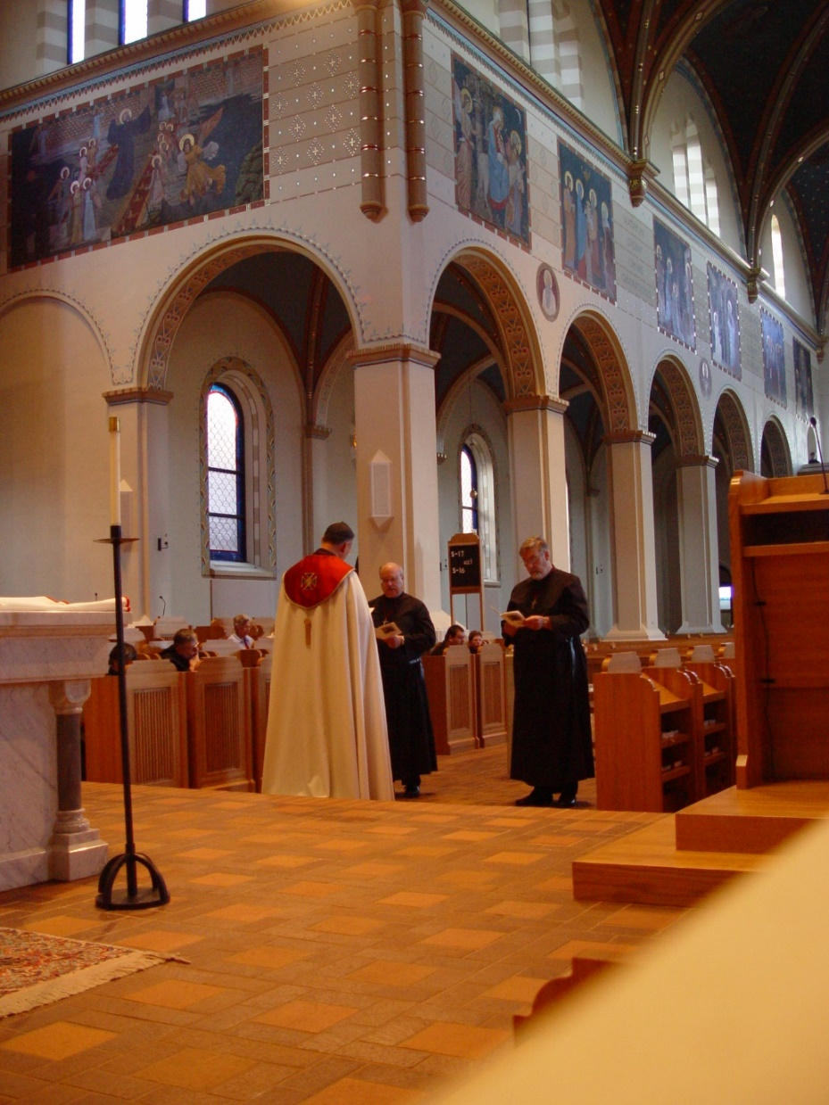
COSL 222 Sr. Anna Grace Madden; Br. Nathan Gregory Miller; Jeanetta Doan; Prior Michael John Austin; Br. Raymond Owens; Regan Fox; Sr. Monica Ruth Mullen; Br. Chad Anselm Gerns (later Br. David)

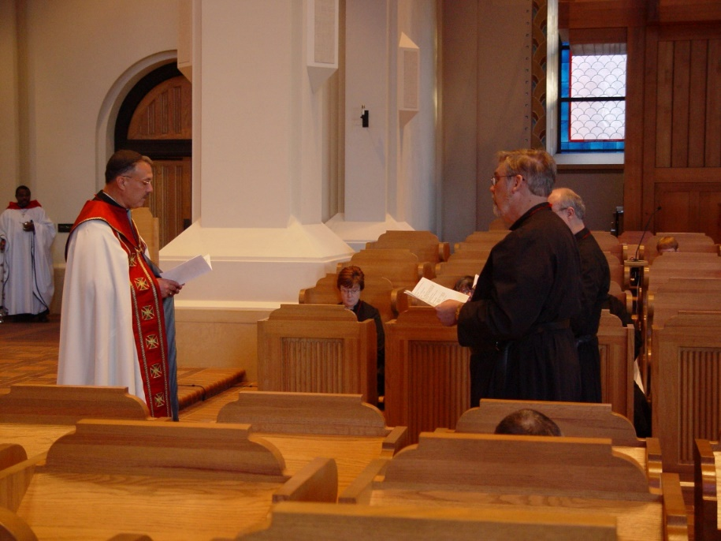
COSL 223 Prior Michael John Austin; Sr. Ann Gerns; Br. Chad Anselm Gerns (later Br. David)
Br. Raymond Owens; Br. Chad Anselm Gerns (later Br. David)

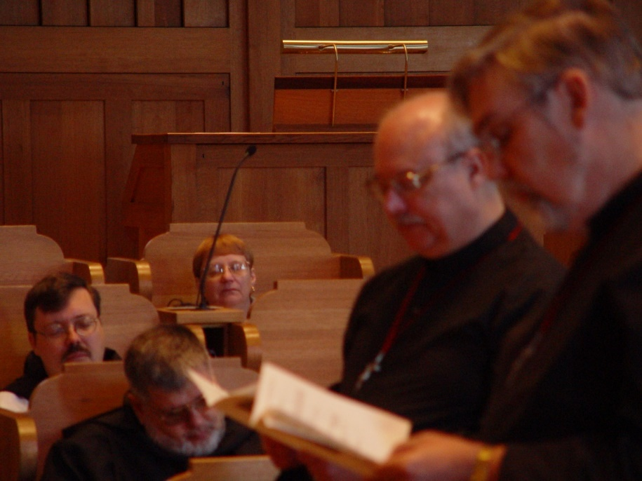
COSL 224 Br. Paul Howard; Br. Nathan Gregory Miller; Lynn Owens; Br. Raymond Owens; Br. Chad Anselm Gerns (later Br. David)

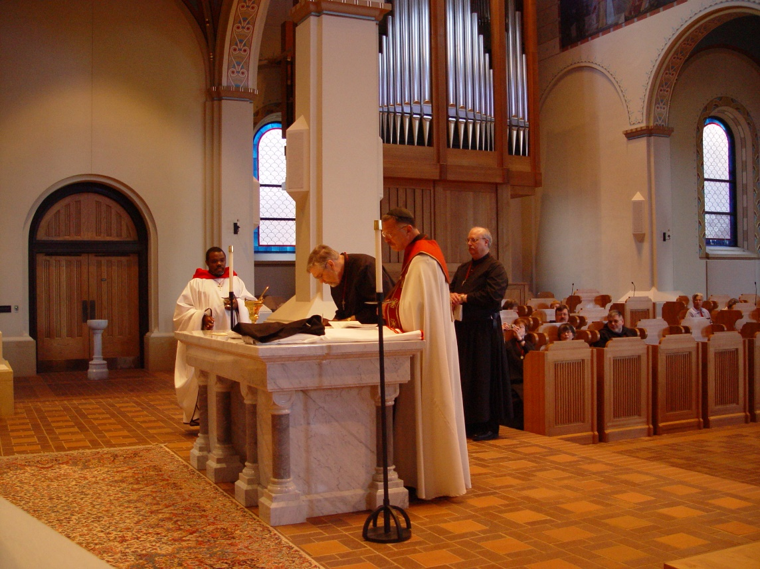
COSL 225 Br. Thomas Ferrell; Br. Chad Anselm Gerns (later Br. David); Prior Michael John Austin; Br. Raymond Owens; Sr. Ann Gerns; Sr. Anna Grace Madden Br. Paul Howard; Br. Nathan Gregory Miller; Jeanetta Doan

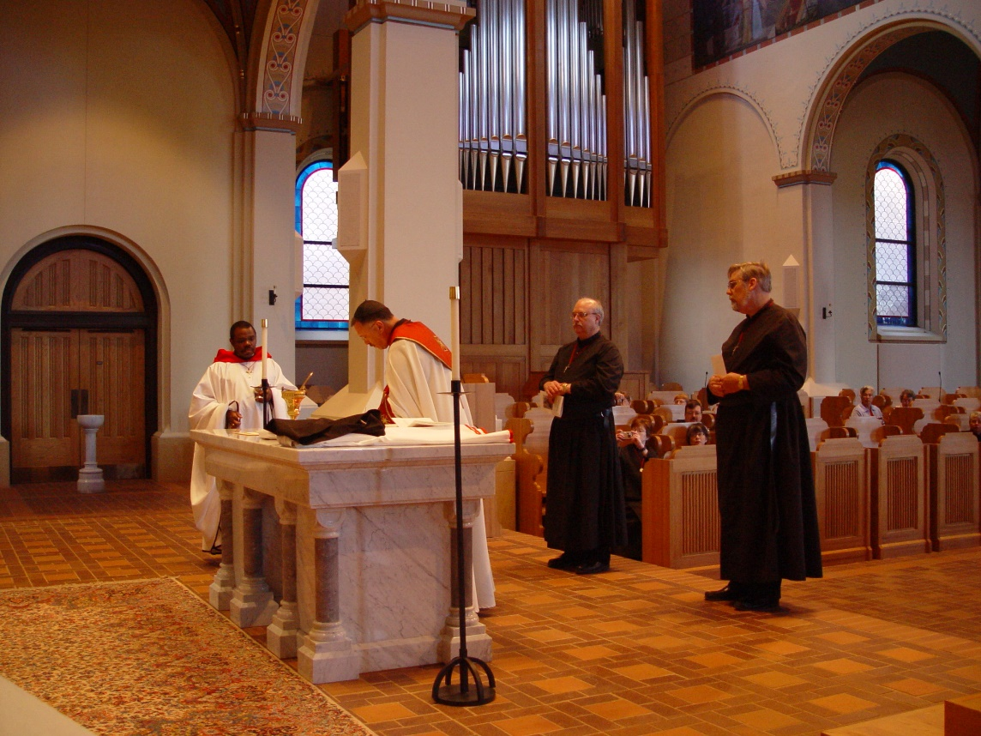
COSL 226 Br. Thomas Ferrell; Prior Michael John Austin; Br. Raymond Owens; Sr. Ann Gerns; Sr. Anna Grace Madden; Br. Paul Howard; Br. Chad Anselm Gerns (later Br. David); Jeanetta Doan

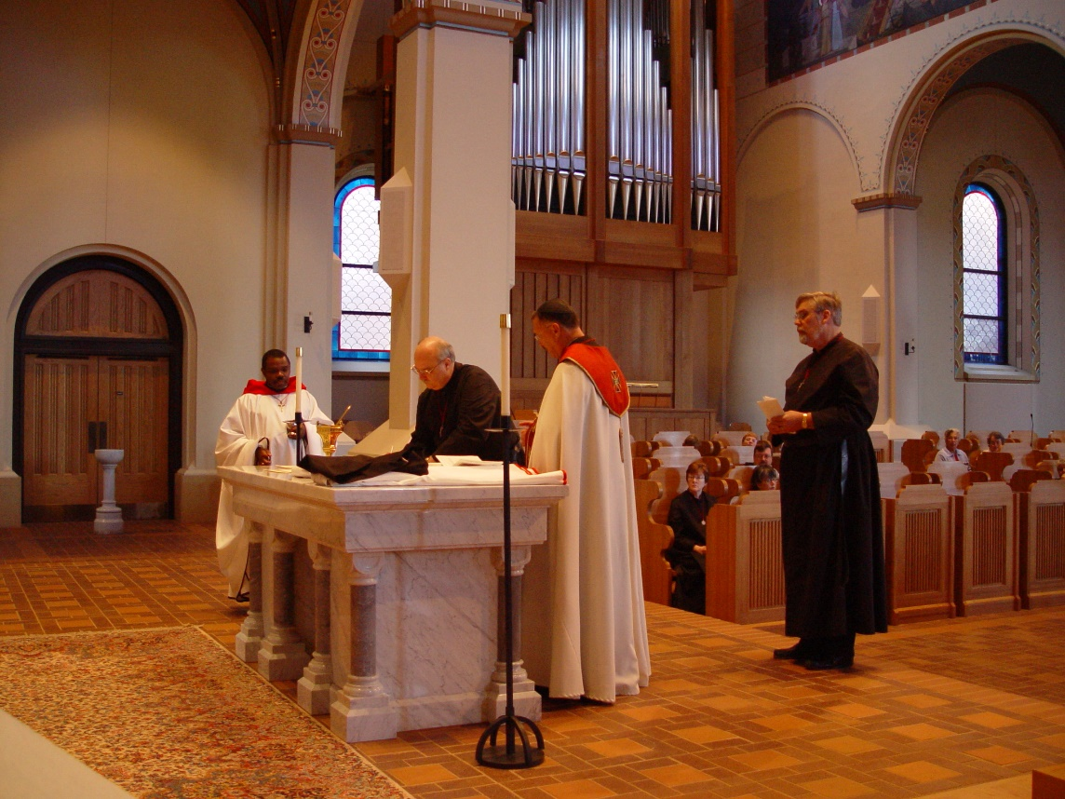
COSL 227 Br. Thomas Ferrell; Br. Raymond Owens; Prior Michael John Austin; Sr. Ann Gerns; Sr. Anna Grace Madden Br. Paul Howard; Br. Chad Anselm Gerns (later Br. David); Jeanetta Doan

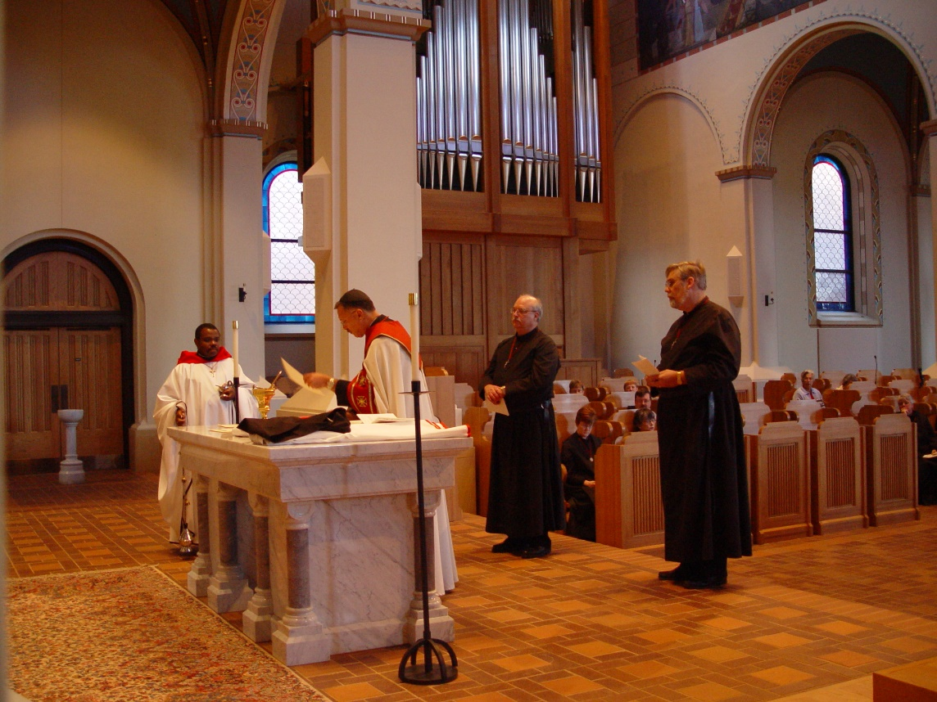
COSL 228 Br. Thomas Ferrell; Br. Raymond Owens; Prior Michael John Austin; Becky Fredegill; Sr. Ann Gerns; Lynn Owens; Sr. Anna Grace Madden; Br. Paul Howard; Br. Chad Anselm Gerns (later Br. David); Jeanetta Doan
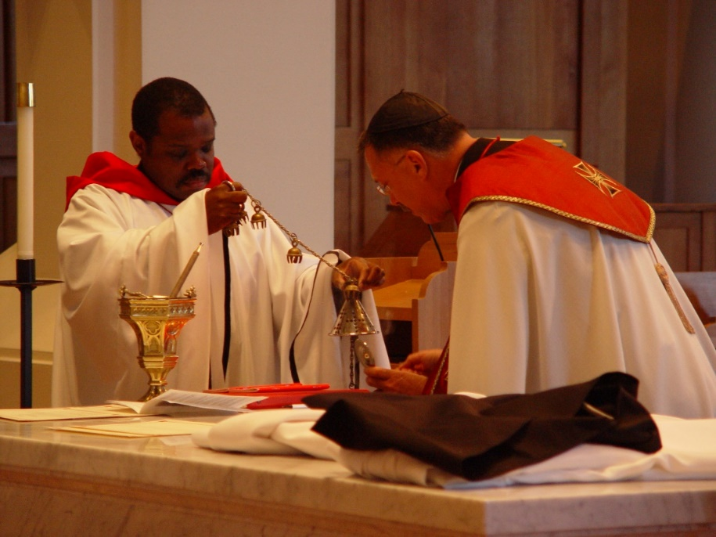
COSL 229 Br. Thomas Ferrell; Prior Michael John Austin

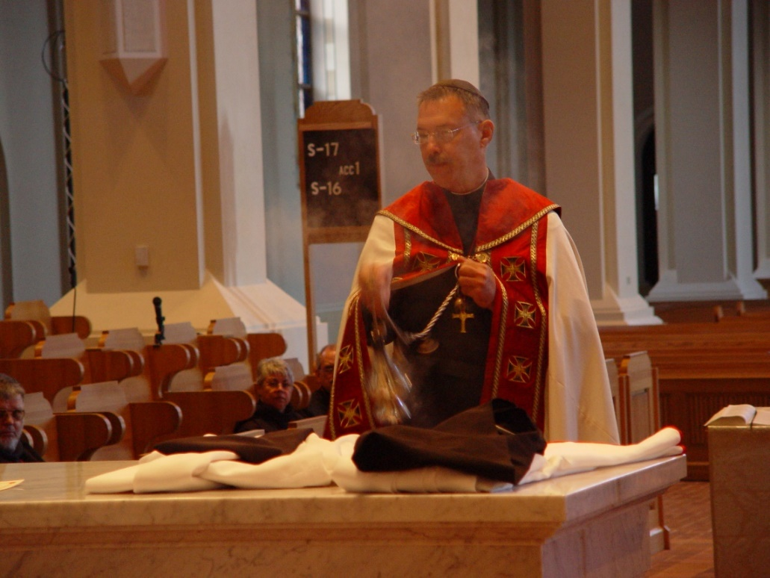
COSL 230 Br. Nathan Gregory Miller; Sr. Clare Benedicta Meyers; Br. Daniel Joseph Schroeder; Br. Thomas Ferrell; Prior Michael John Austin

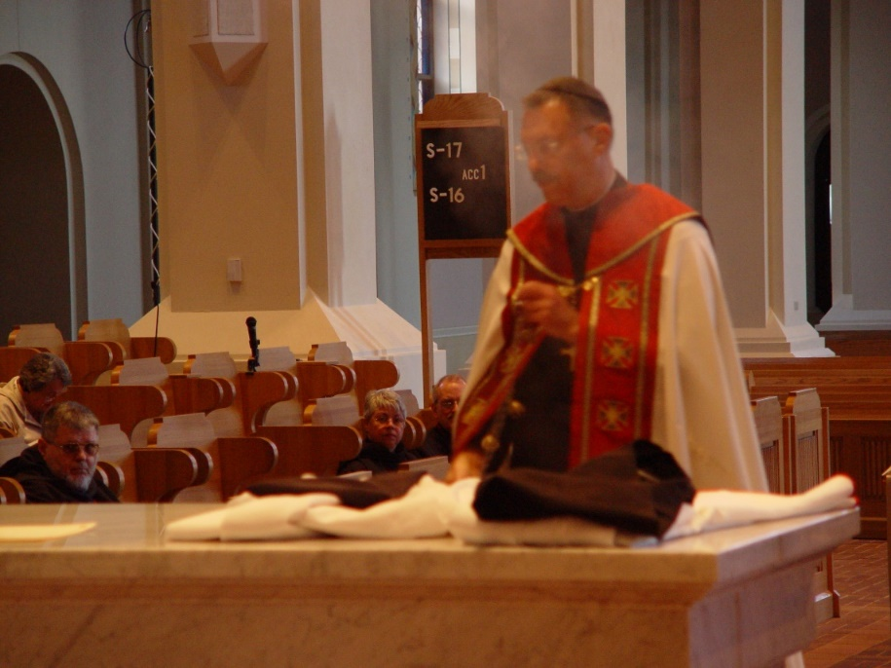
COSL 231 Becky Rittenhouse; Br. Nathan Gregory Miller; Sr. Clare Benedicta Meyers; Br. Paul Schroeder; Prior Michael John Austin

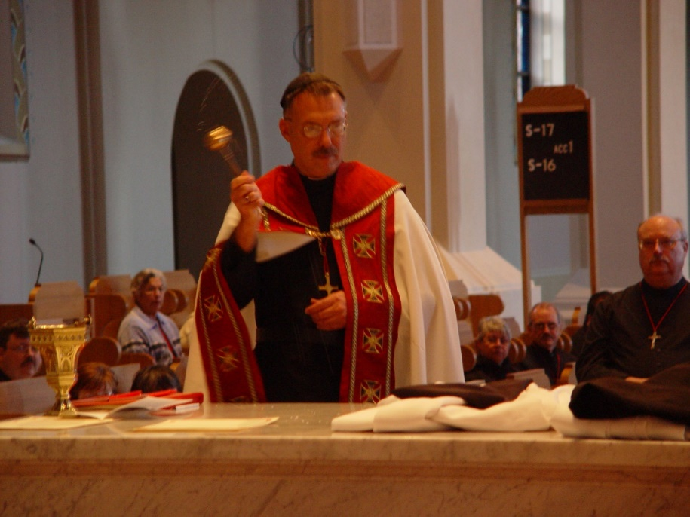
COSL 232 Br. Paul Howard; Jeanetta Doan; Prior Michael John Austin; Sr. Clare Benedicta Meyers; Br. Daniel Joseph Schroeder; Br. Raymond Owens

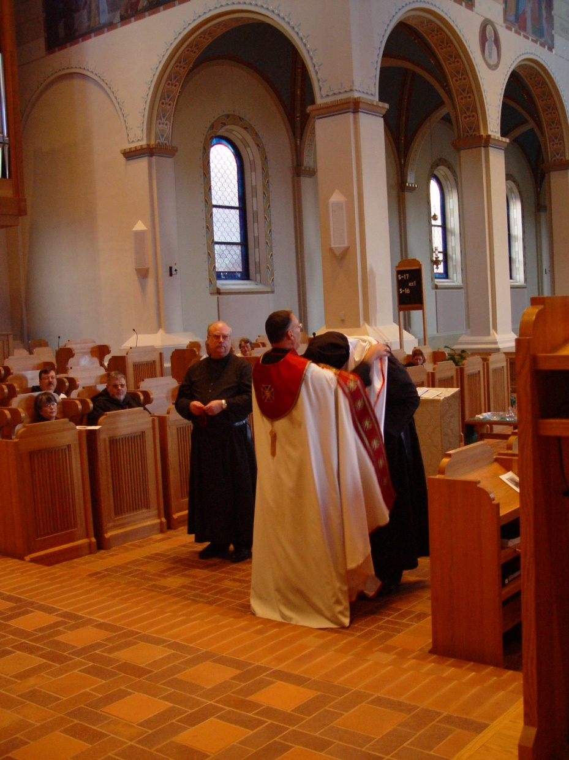
COSL 233 Sr. Anna Grace Madden; Br. Paul Howard; Becky Rittenhouse; Br. Nathan Gregory Miller; Br. Raymond Owens; Prior Michael John Austin; Br. Chad Anselm Gerns (later Br. David); Sr. Monica Ruth Mullen
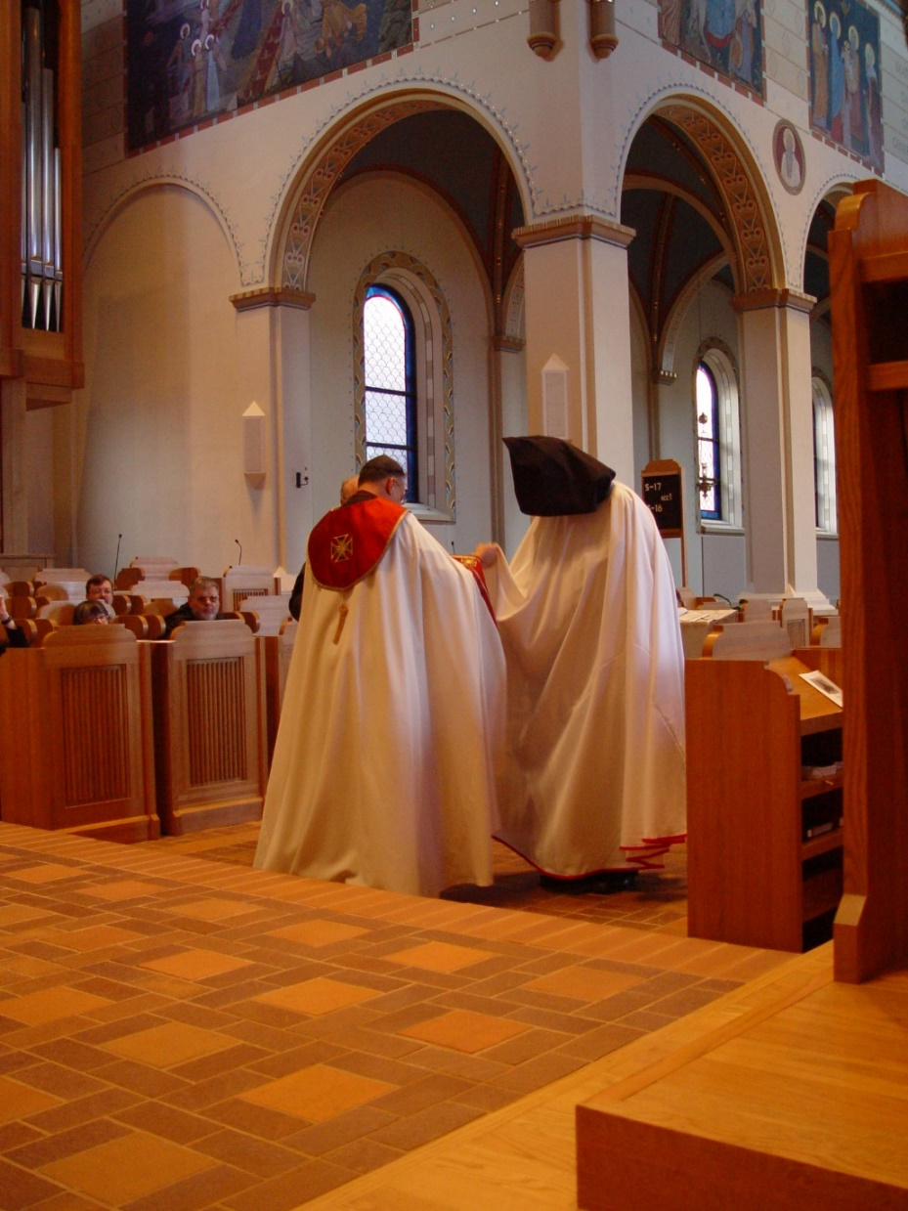
COSL 234 Sr. Anna Grace Madden; Br. Paul Howard; Br. Nathan Gregory Miller; Br. Raymond Owens; Prior Michael John Austin; Br. Chad Anselm Gerns (later Br. David)
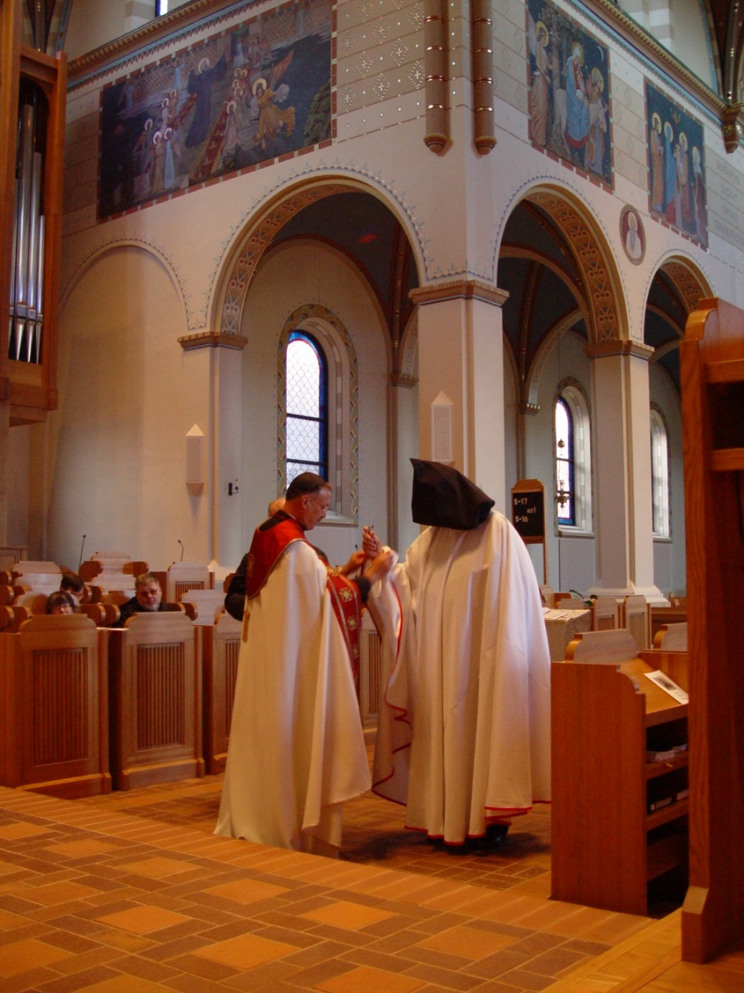
COSL 235 Sr. Anna Grace Madden; Br. Paul Howard; Br. Nathan Gregory Miller; Br. Raymond Owens; Prior Michael John Austin; Br. Chad Anselm Gerns (later Br. David)

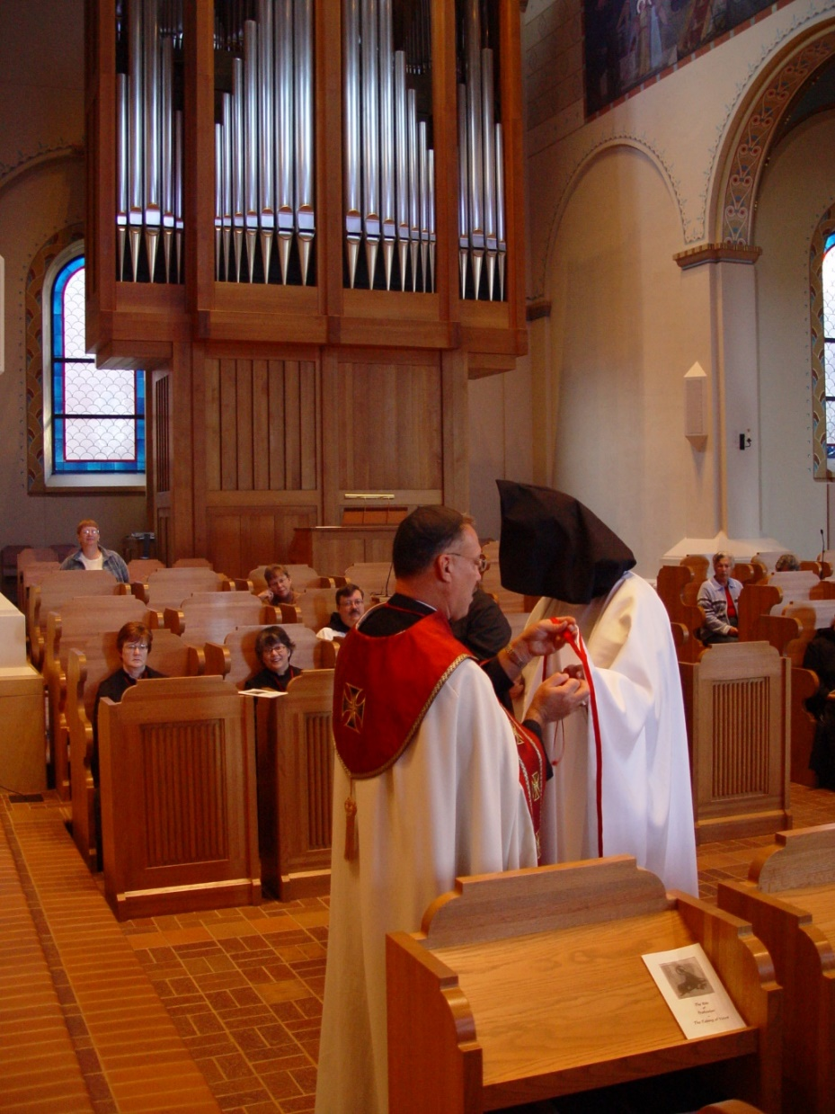
COSL 236 Lynn Owens; Sr. Ann Gerns; Lynn Owens; Sr. Anna Grace Madden; Becky Fredregill; Br. Paul Howard; Prior Michael John Austin; Br. Chad Anselm Gerns (later Br. David); Jeanetta Doan

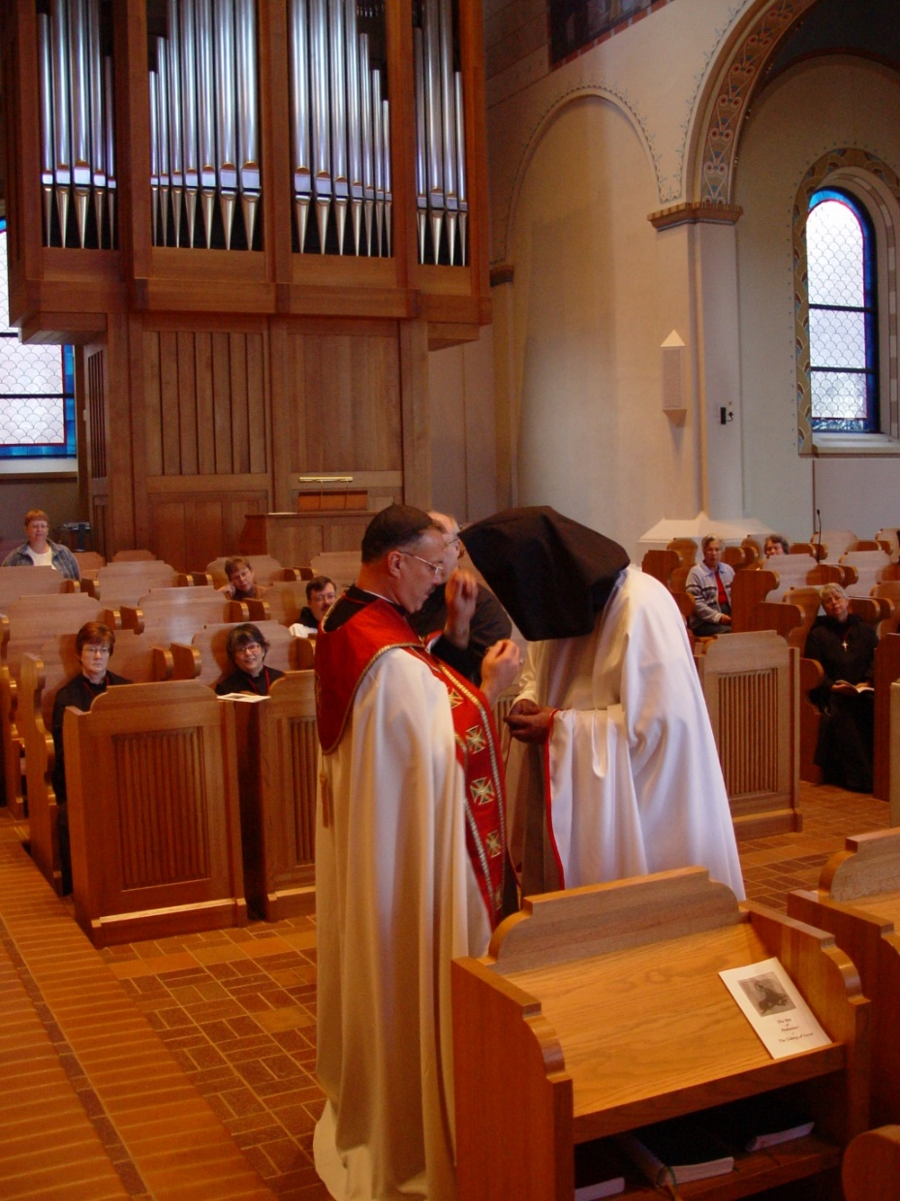
COSL 237 Sr. Ann Gerns; Lynn Owens; Sr. Anna Grace Madden; Becky Rittenhouse; Prior Michael John Austin; Becky Fredregill; Br. Paul Howard; Br. Raymond Owens; Br. Chad Anselm Gerns (later Br. David); Becky Rittenhouse; Sr. Clare Benedicta Meyers

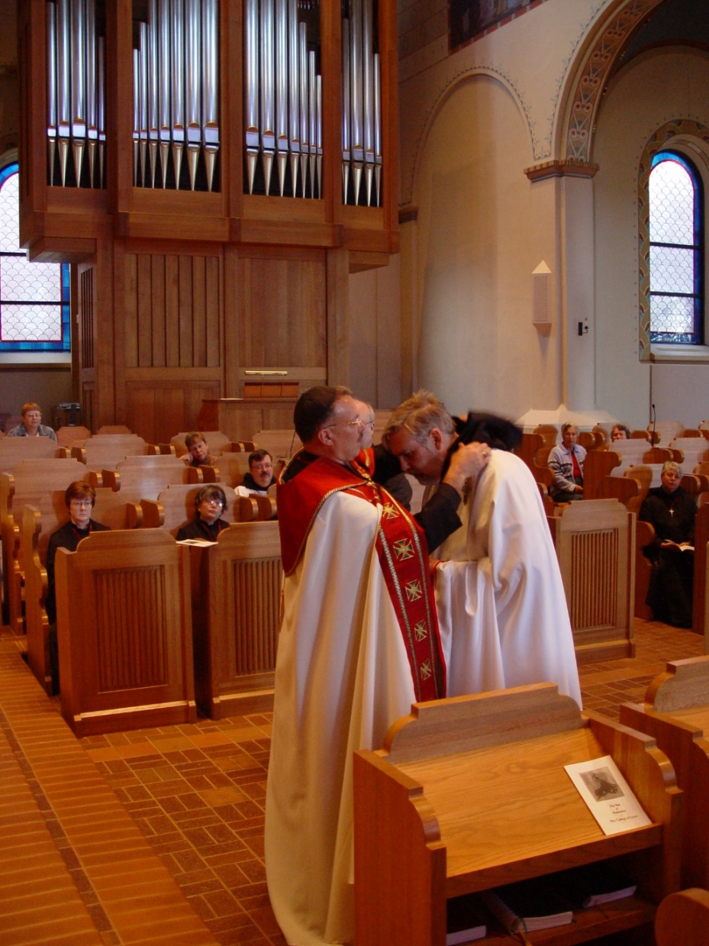
COSL 238 Sr. Ann Gerns; Lynn Owens; Sr. Anna Grace Madden; Becky Fredregill; Prior Michael John Austin; Br. Paul Howard; Br. Chad Anselm Gerns (later Br. David); Jeanetta Doan; Becky Rittenhouse; Sr. Clare Benedicta Meyers

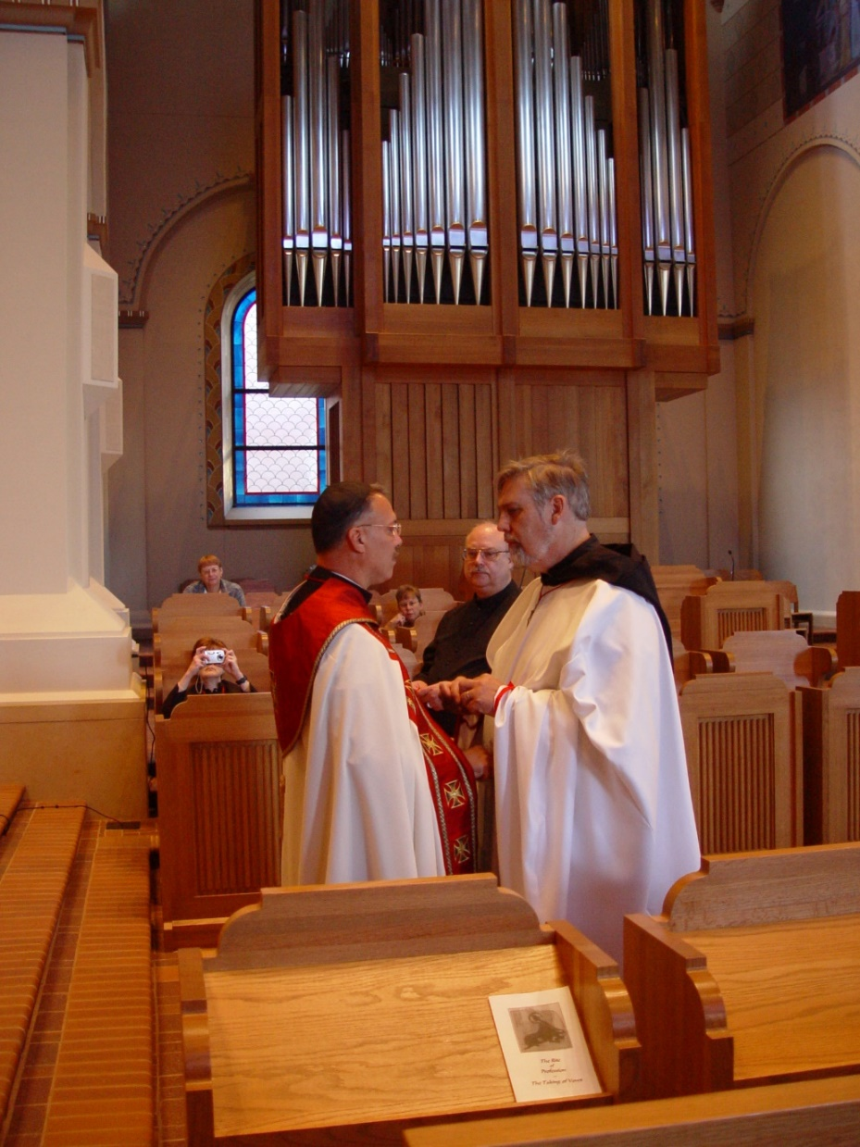
COSL 239 Sr. Ann Gerns; Lynn Owens; Prior Michael John Austin; Becky Fredregill; Br. Raymond Owens; Br. Chad Anselm Gerns (later Br. David)

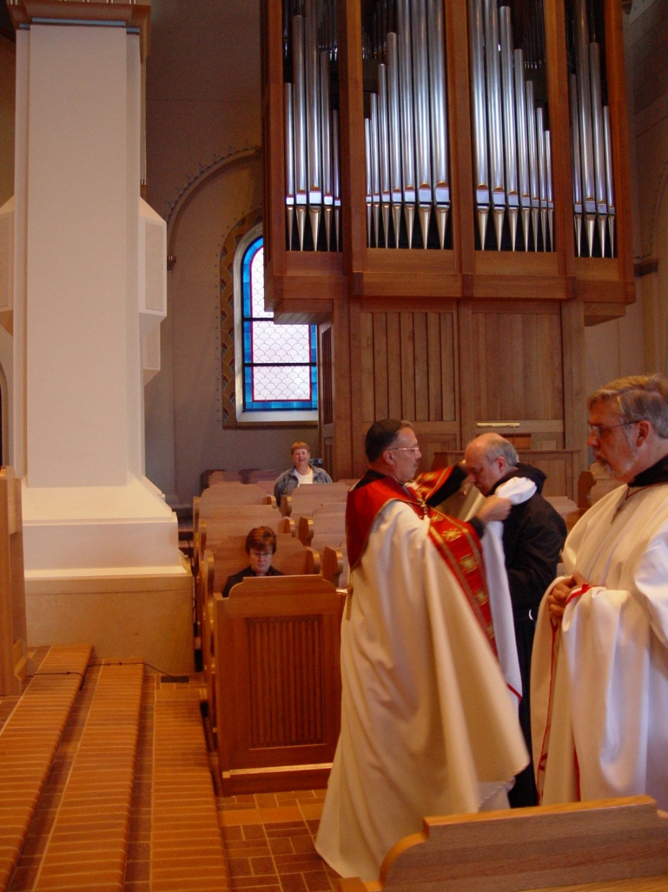
COSL 240 Sr. Ann Gerns; Lynn Owens; Prior Michael John Austin; Br. Raymond Owens; Br. Chad Anselm Gerns (later Br. David)

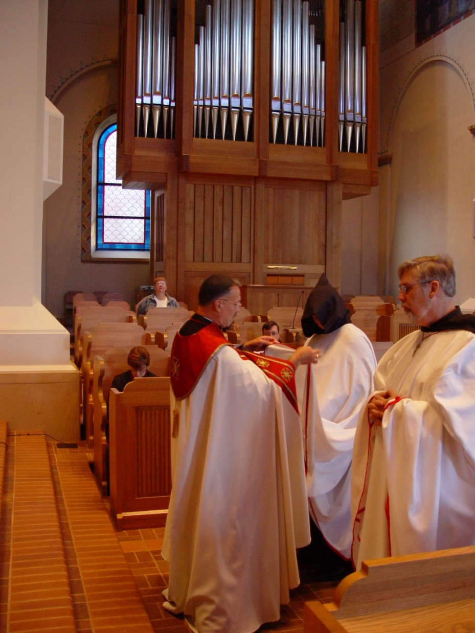
COSL 241 Sr. Ann Gerns; Lynn Owens; Prior Michael John Austin; Br. Paul Howard; Br. Raymond Owens; Br. Chad Anselm Gerns (later Br. David)

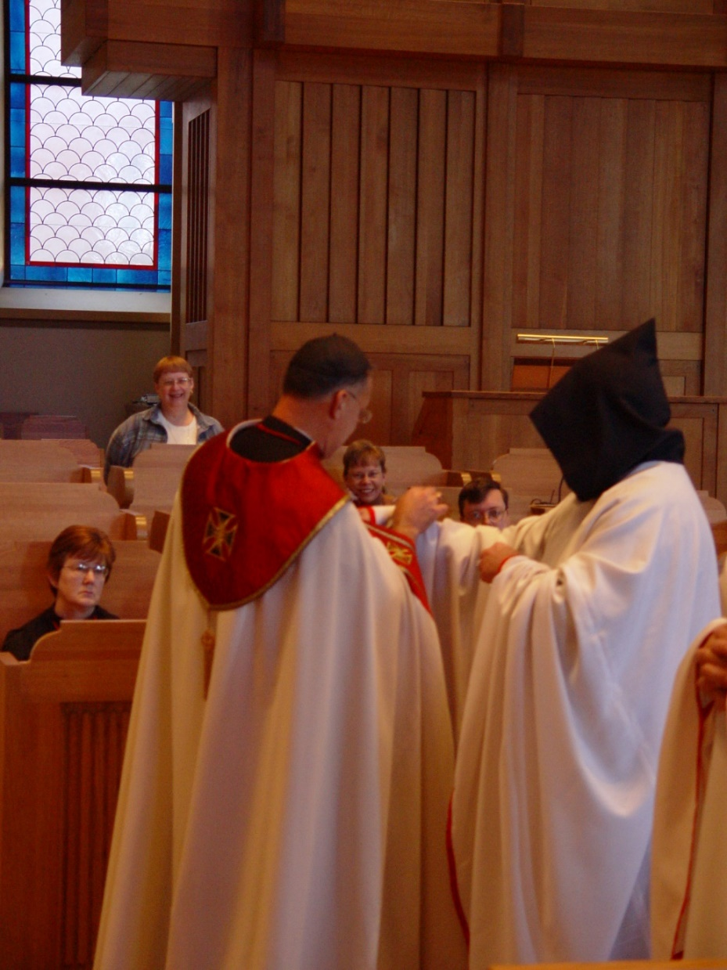
COSL 242 Sr. Ann Gerns; Lynn Owens; Prior Michael John Austin; Becky Fredregill; Br. Paul Howard; Br. Raymond Owens

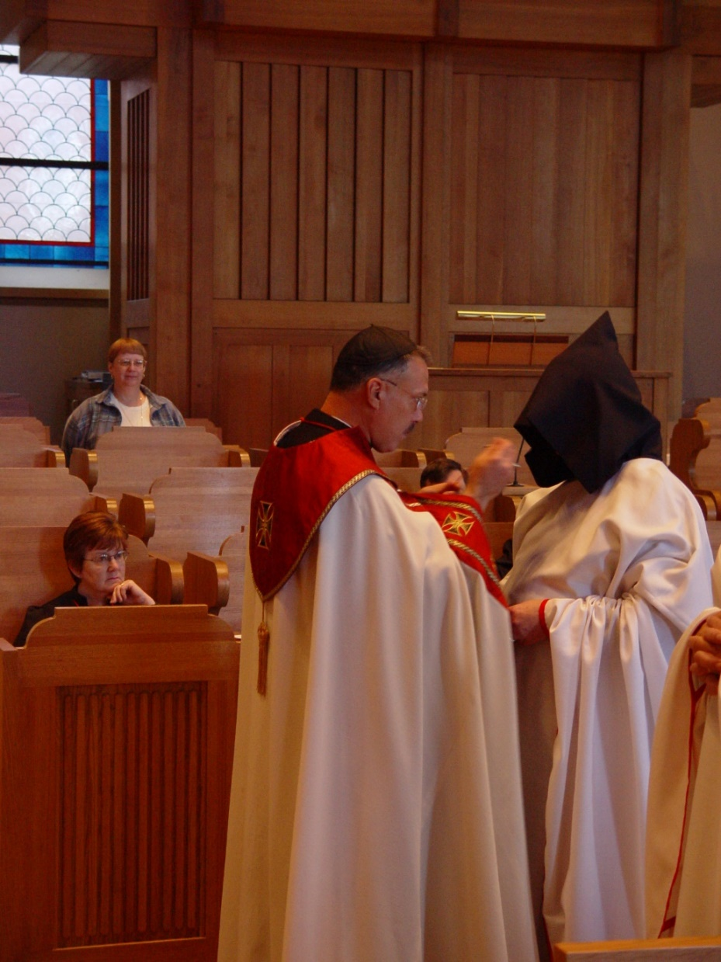
COSL 243 Sr. Ann Gerns; Lynn Owens; Prior Michael John Austin; Br. Paul Howard; Br. Raymond Owens

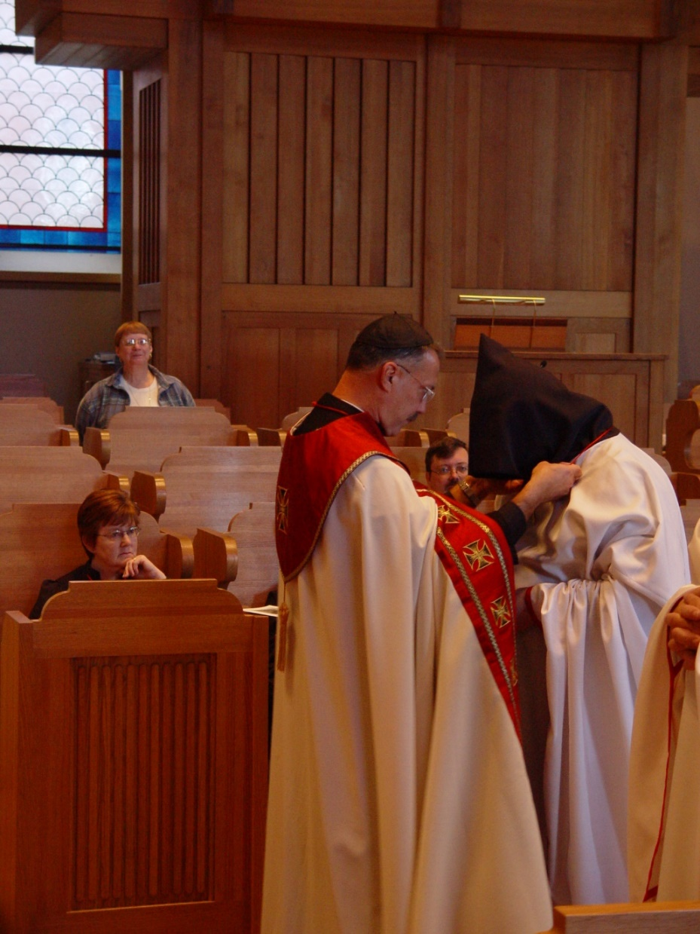
COSL 244 Sr. Ann Gerns; Lynn Owens; Prior Michael John Austin; Br. Paul Howard; Br. Raymond Owens

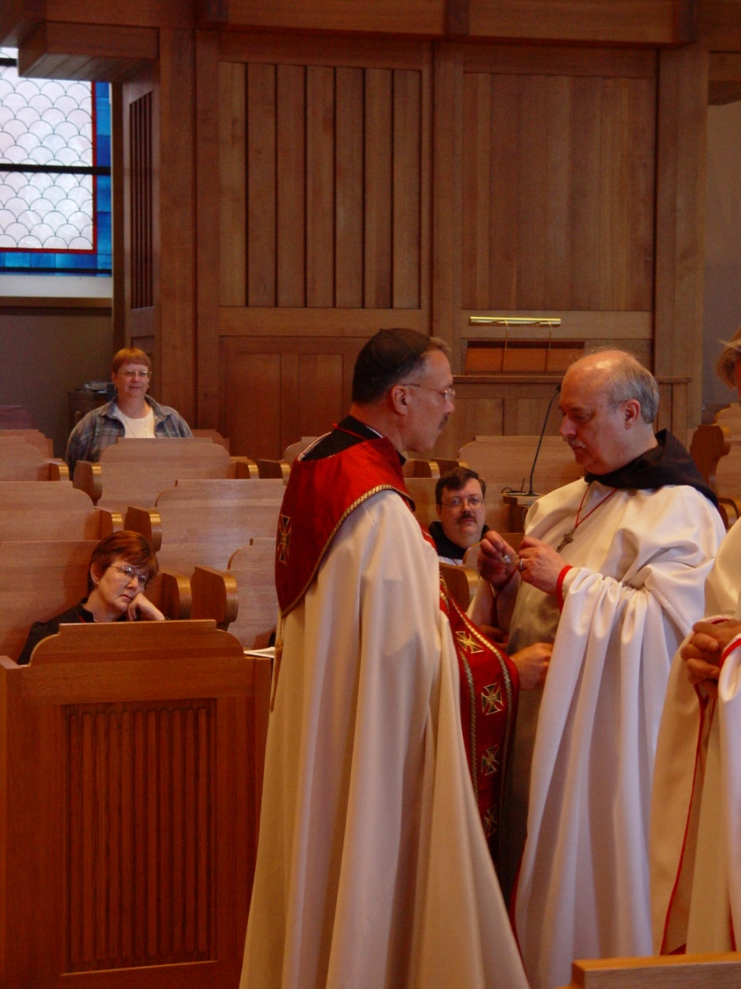
COSL 245 Sr. Ann Gerns; Lynn Owens; Prior Michael John Austin; Br. Paul Howard; Br. Raymond Owens

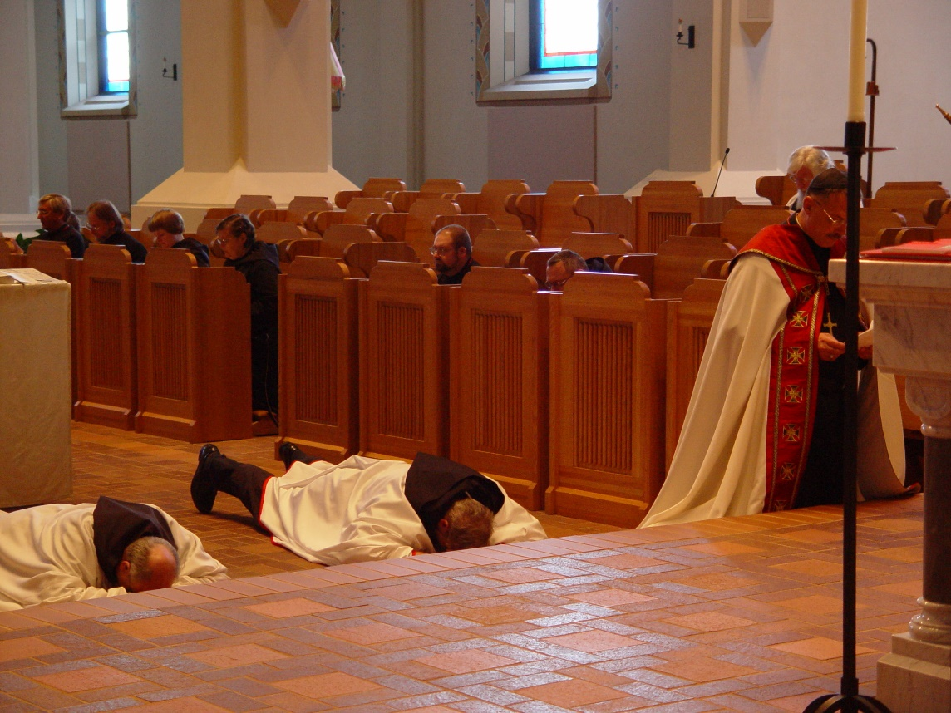
COSL 246 Br. Raymond Owens; Br. Chad Anselm Gerns (later Br. David); Prior Michael John Austin
In pew: Glen Converse (later Br. Camillus); Barry Mullen (later Br. Lawrence); Sr. Catherine Unterseher; Sr. Theodora of Jesus Perecca; Br. Willard Moore (later Br. Daniel); ; Br. Ambrose Heroux
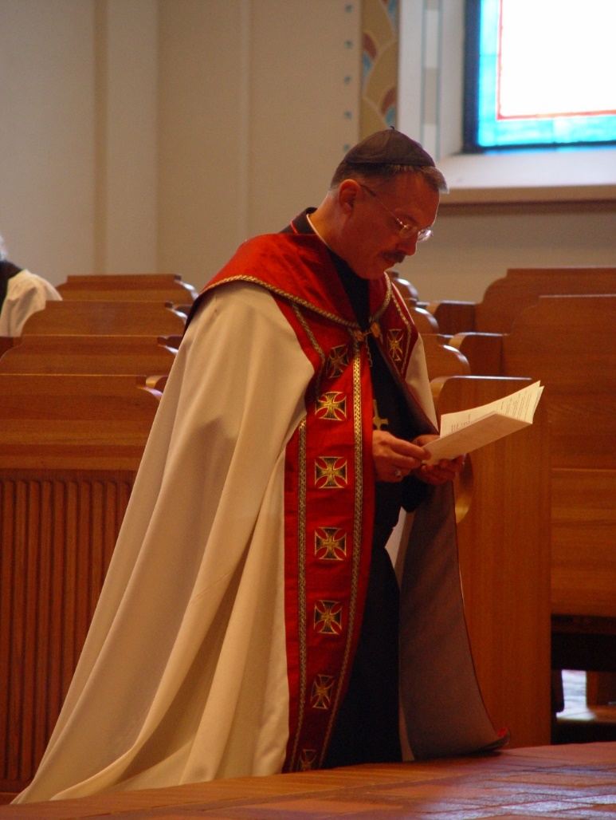
COSL 247 Prior Michael John Austin

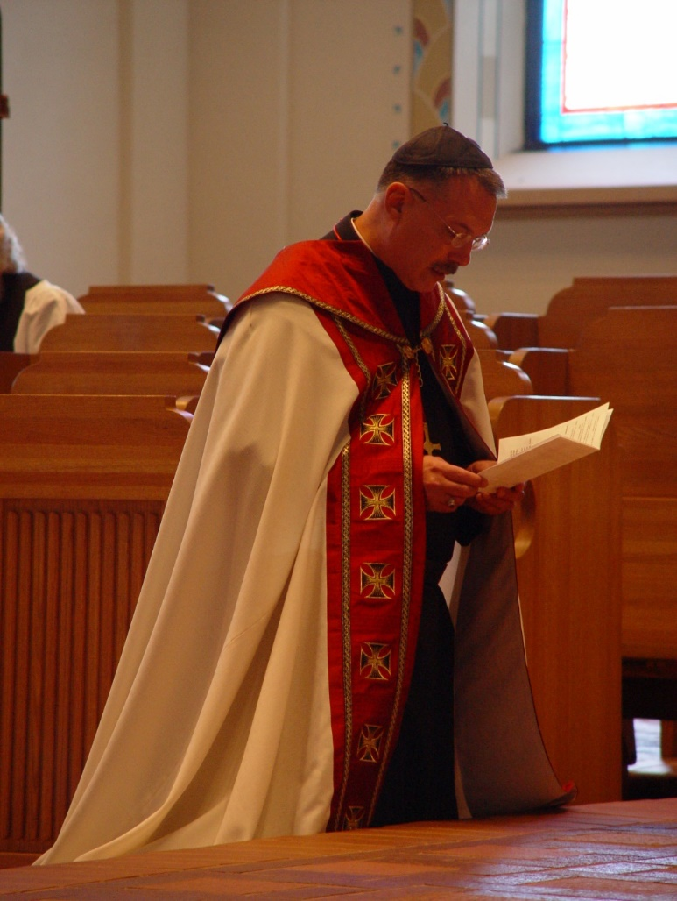
COSL 248 Prior Michael John Austin

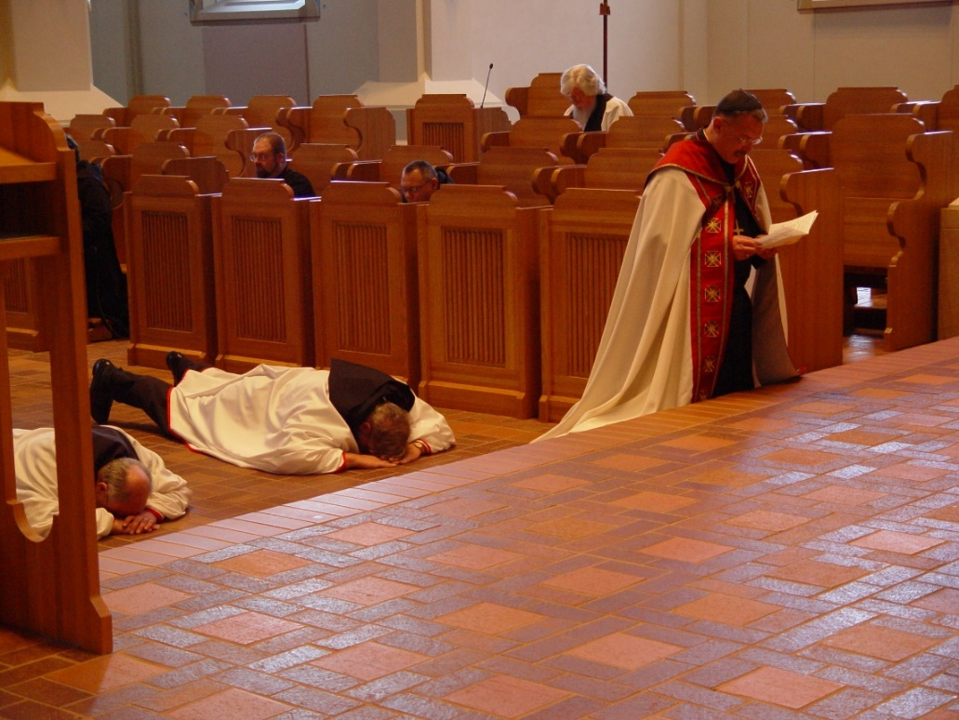
COSL 249 Br. Raymond Owens; Br. Chad Anselm Gerns (later Br. David); Prior Michael John Austin
In pews: Br. Willard Moore (later Br. Daniel); Br. Ambrose Heroux; Fr. Wayne Kamm

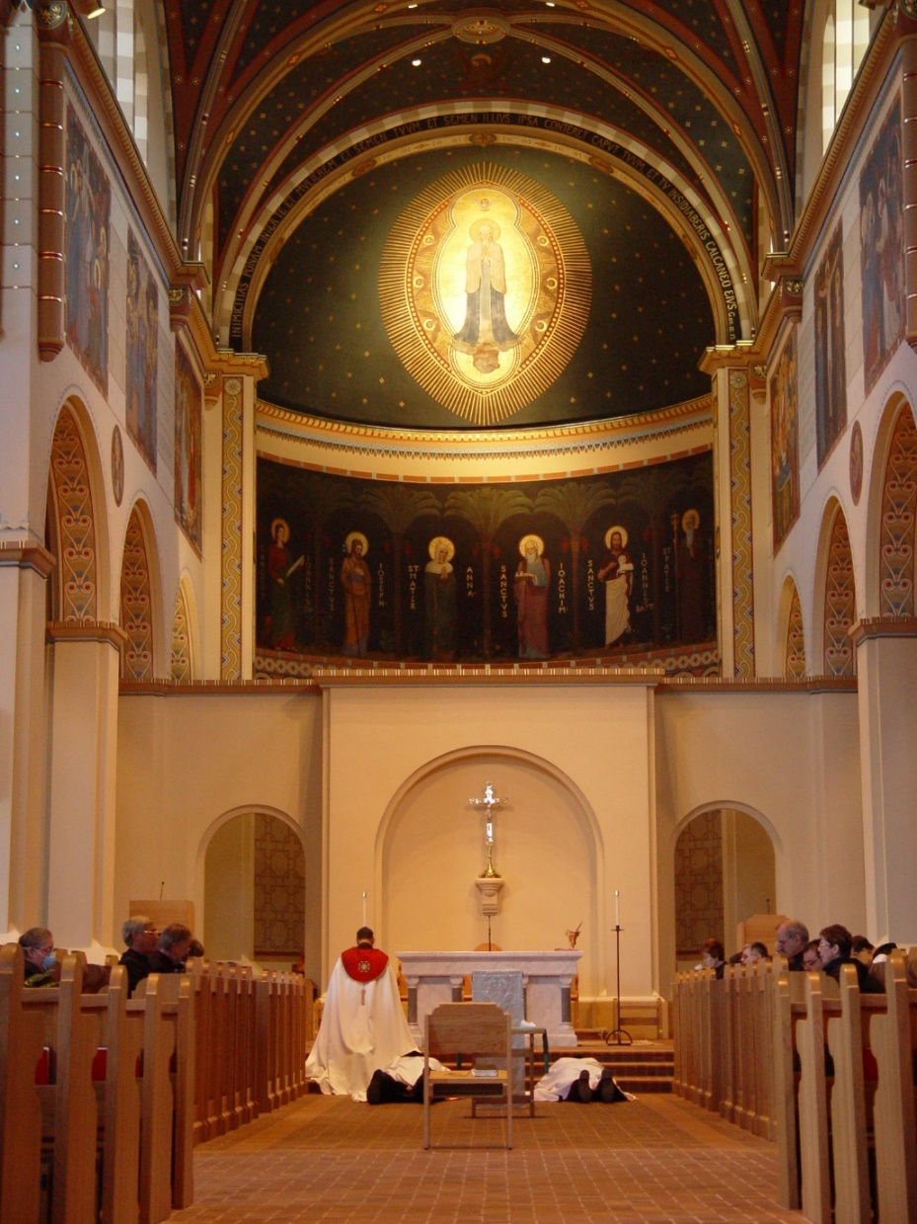
COSL 250 Prior Michael John Austin; Br. Chad Anselm Gerns (later Br. David); Br. Raymond Owens

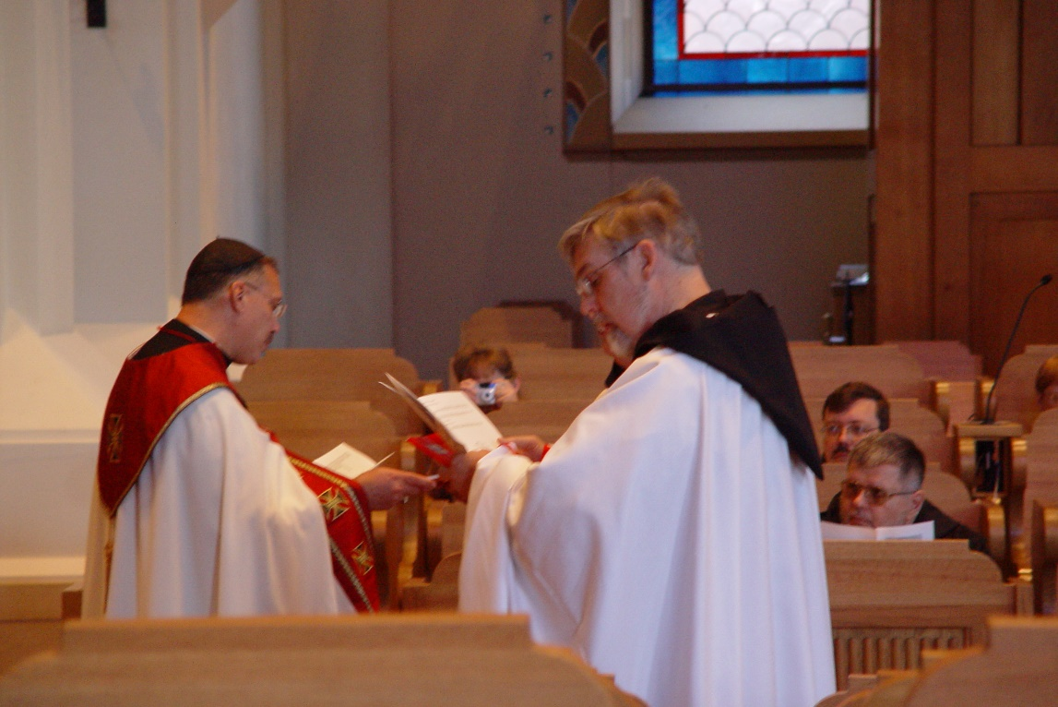
COSL 251 Prior Michael John Austin; Lynn Owens; Br. Chad Anselm Gerns (later Br. David); Br. Paul Howard; Br. Nathan Gregory Miller

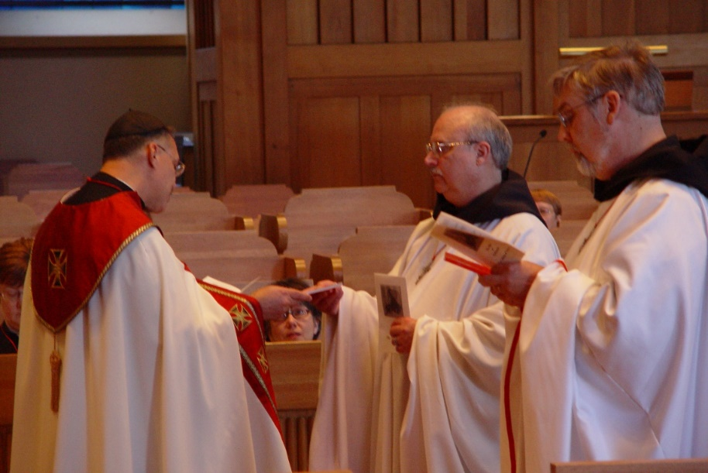
COSL 252 Prior Michael John Austin; Sr. Anna Grace Madden; Br. Raymond Owens; Br. Chad Anselm Gerns (later Br. David)

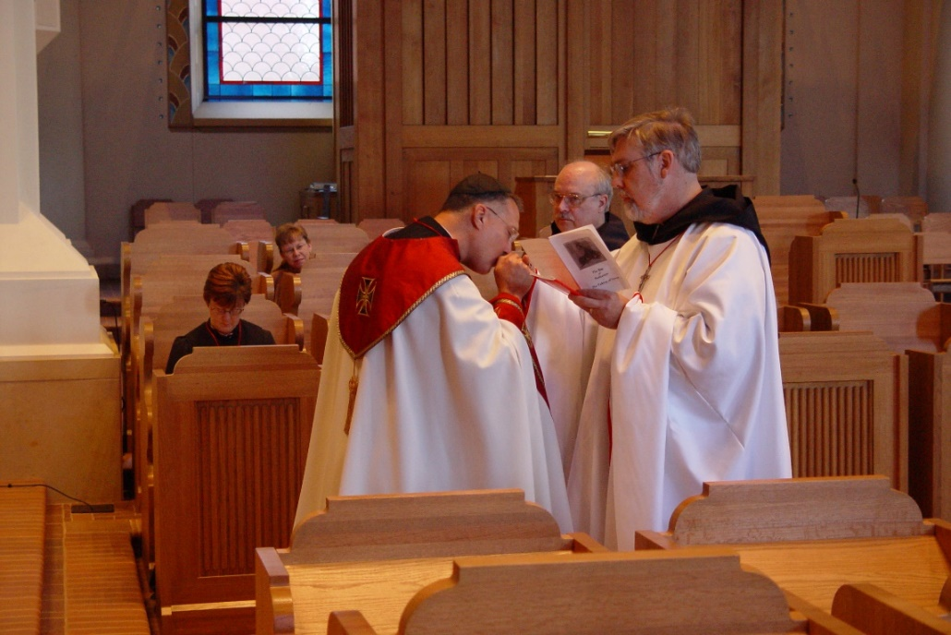
COSL 253 Sr. Ann Gerns; Becky Fredregill; Prior Michael John Austin; Br. Raymond Owens; Br. Chad Anselm Gerns (later Br. David)

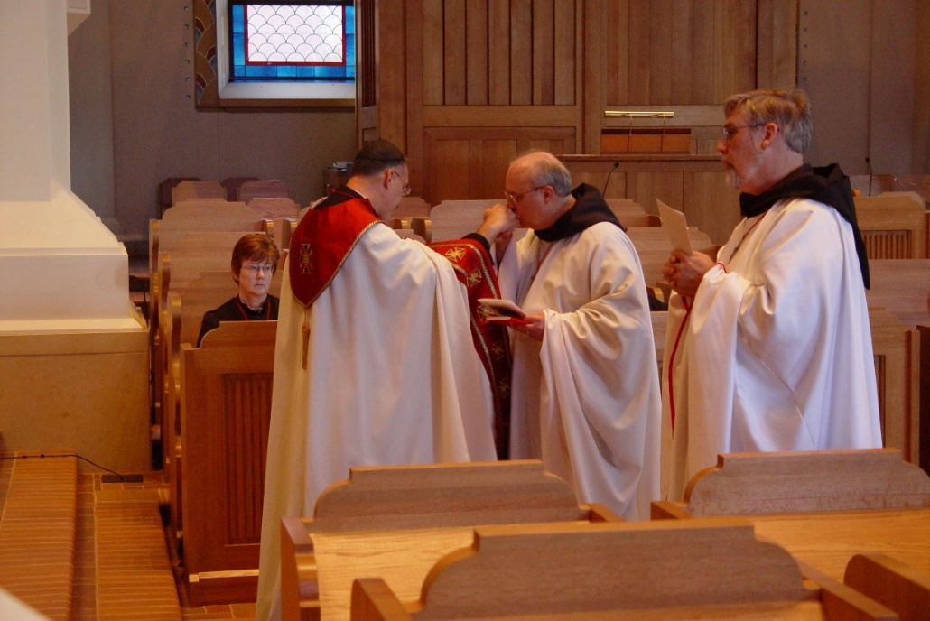
COSL 254 Sr. Ann Gerns; Prior Michael John Austin; Br. Raymond Owens; Br. Chad Anselm Gerns (later Br. David)

