Companions of St. Luke
Fall 2003 Convocation at Conception Abbey
Part 2 of 6

~Edited by Br. Steven Olderr, 14 May 2022 with the assistance of Br. Thomas Ferrell; if you find any errors or omissions, please notify Br. Steven at olderr@ameritech.net

People are identified from left to right.

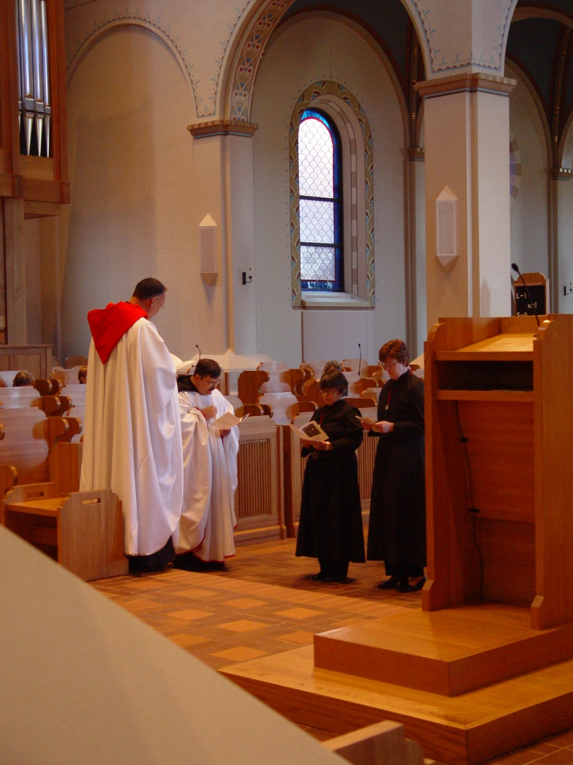
COSL 050 Prior Michael John Austin; Br. Paul Howard; Sr. Anna Grace Madden; Sr. Ann Gerns

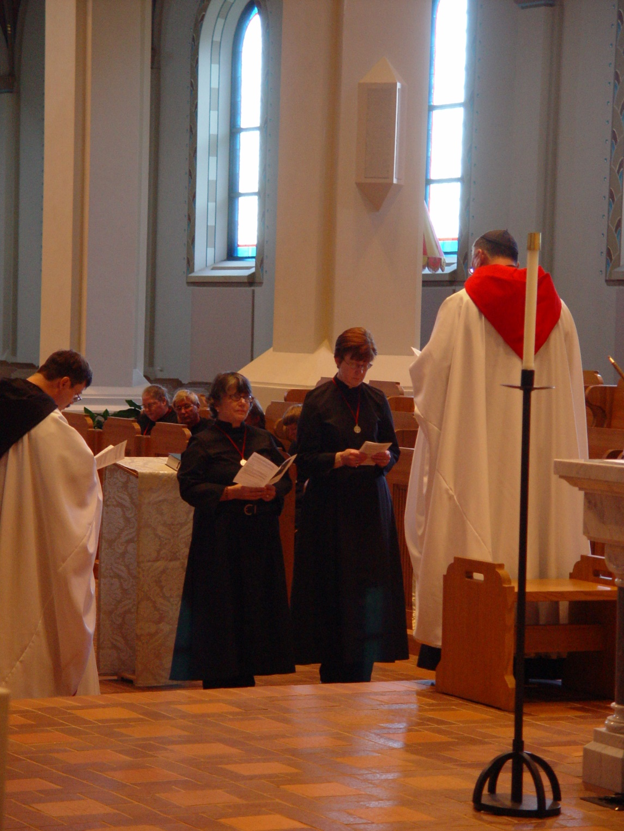
COSL 051 Br. Paul Howard; Sr. Margaret Moore; Be. Camillus Converse; Sr. Anna Grace Madden; Sr. Ann Gerns; Prior Michael John Austin
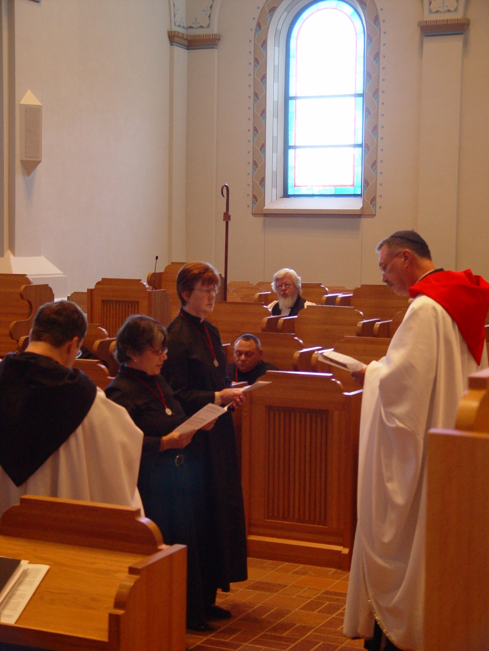
COSL 052 Br. Paul Howard; Sr. Anna Grace Madden; Sr. Ann Gerns; Br. Ambrose Heroux; Fr. Wayne Kamm; Prior Michael John Austin

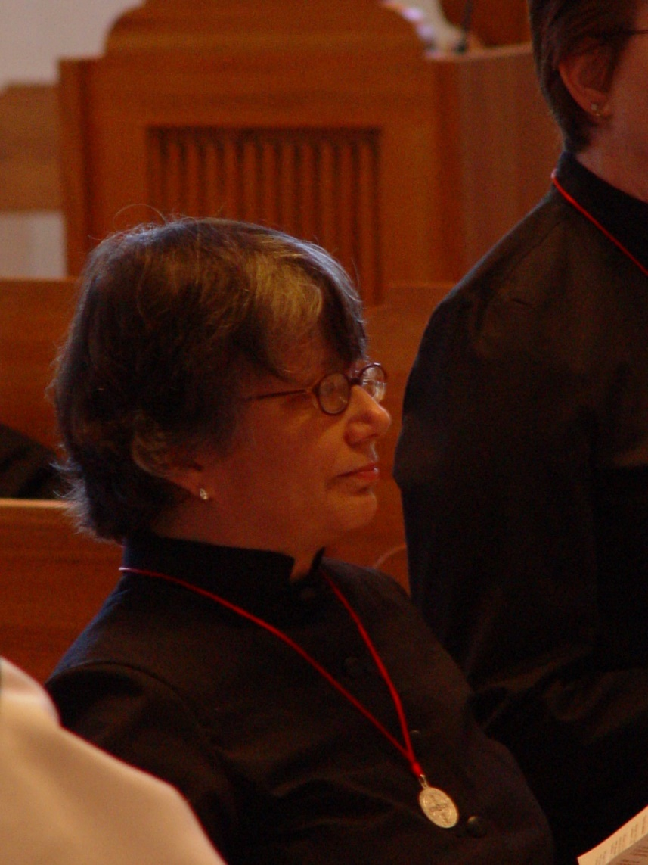
COSL 053 Sr. Anna Grace Madden
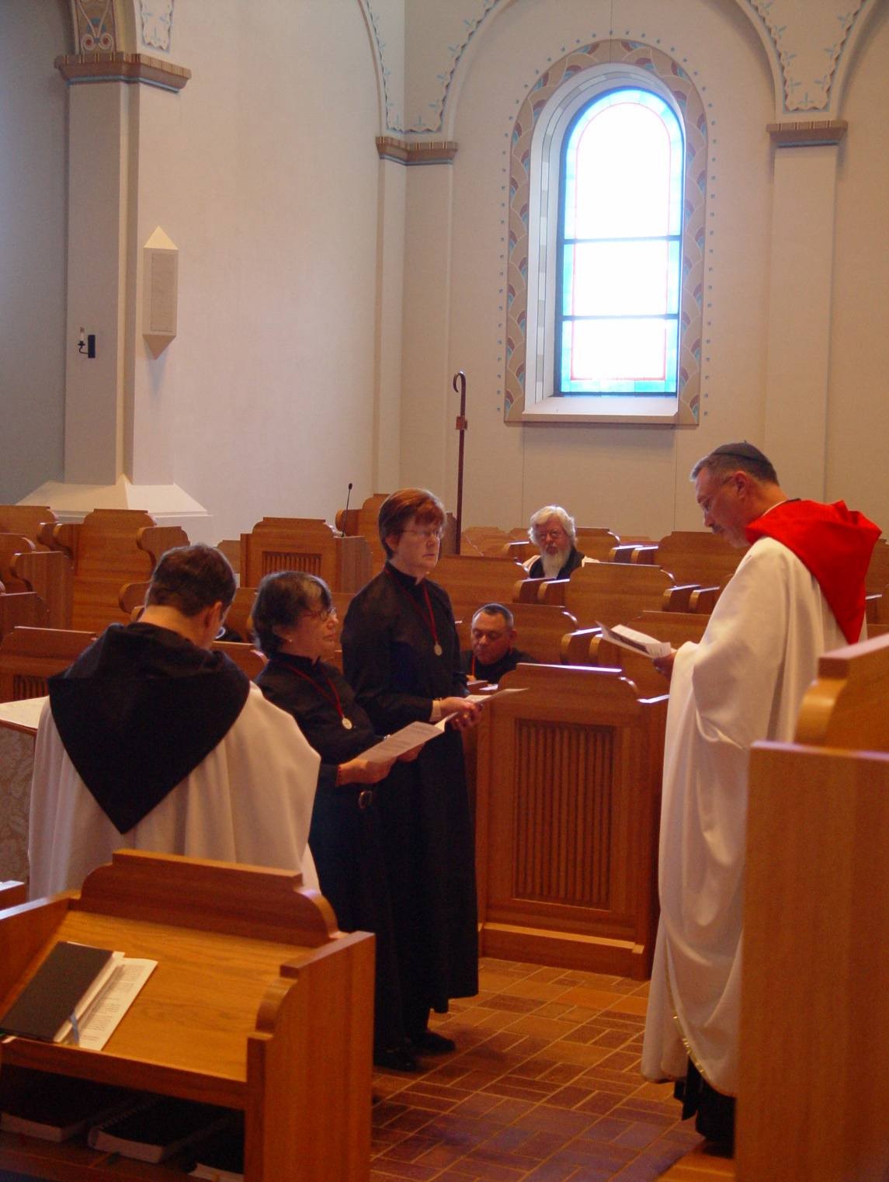
COSL 054 Br. Paul Howard; Sr. Anna Grace Madden; Sr. Ann Gerns; Br. Ambrose Heroux; Fr. Wayne Kamm; Prior Michael John Austin;
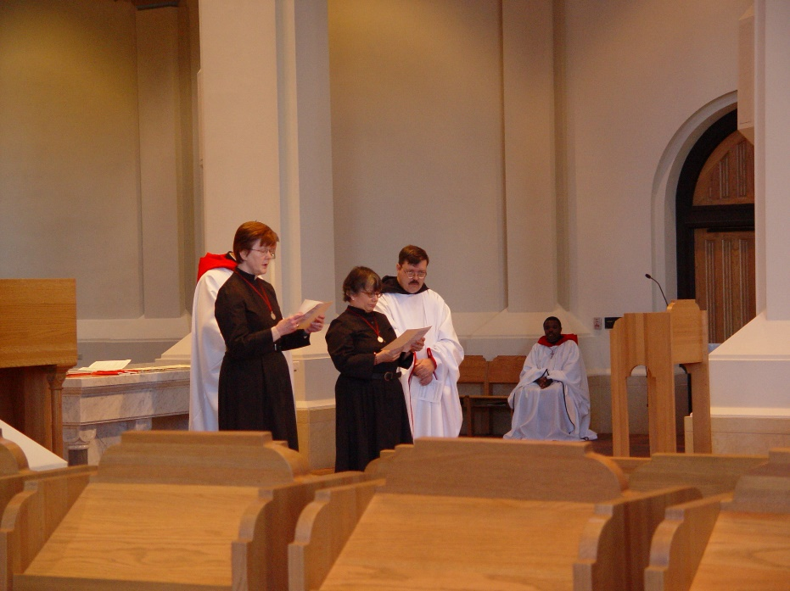
COSL 055 Prior Michael John Austin; Sr. Ann Gerns; Sr. Anna Grace Madden; Br. Paul Howard; Br. Thomas Ferrell

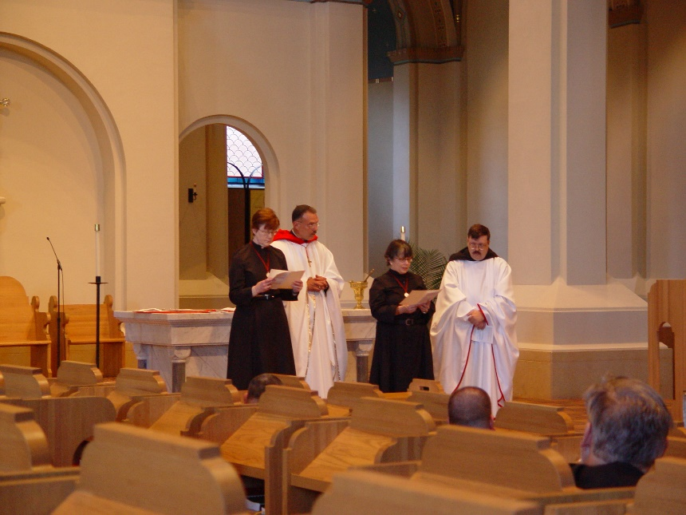
COSL 056 Sr. Ann Gerns; Prior Michael John Austin; Sr. Anna Grace Madden; Br. Paul Howard

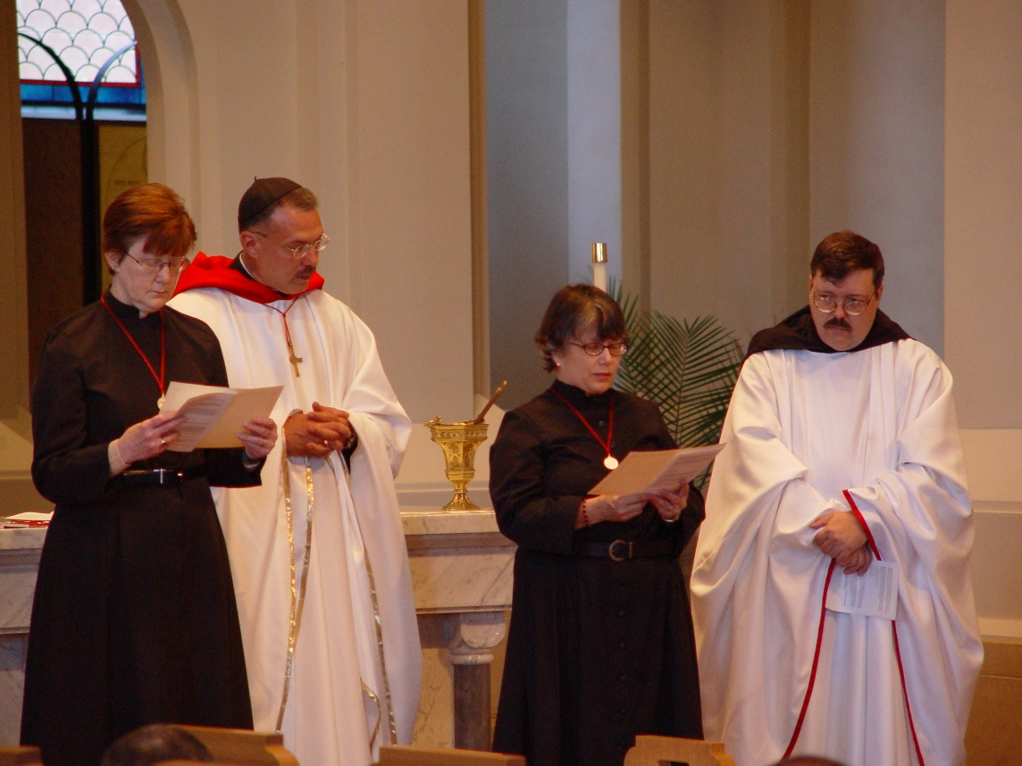
COSL 057 Sr. Ann Gerns; Prior Michael John Austin; Sr. Anna Grace Madden; Br. Paul Howard

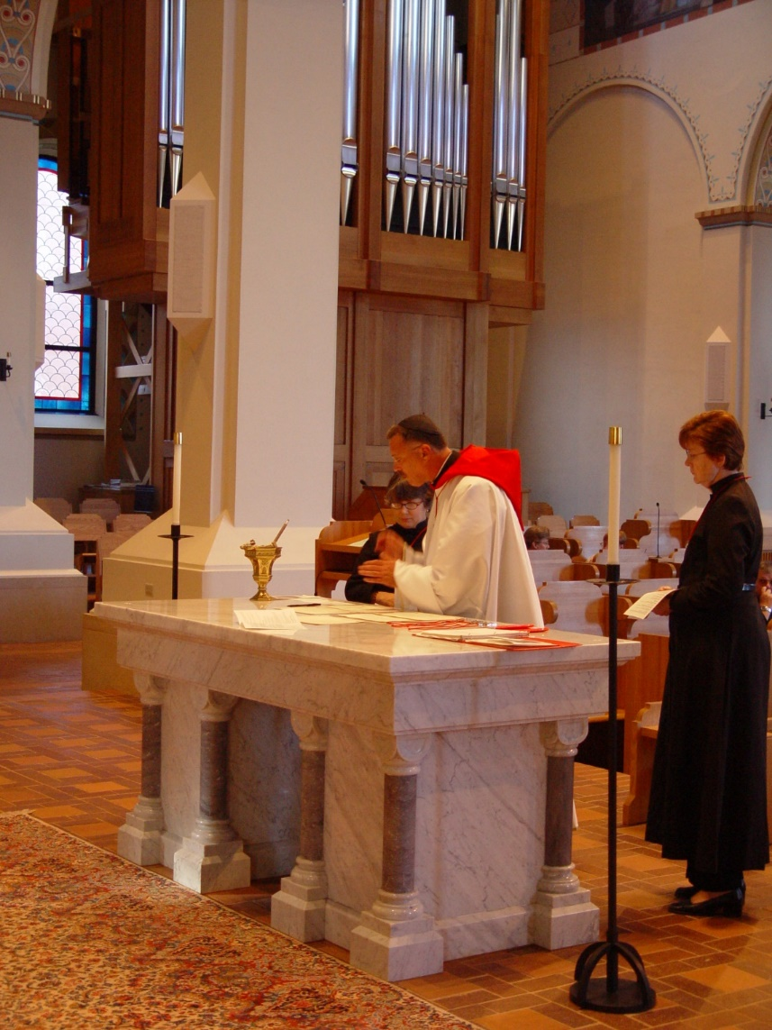
COSL 058 Sr. Anna Grace Madden; Prior Michael John Austin; Sr. Ann Gerns
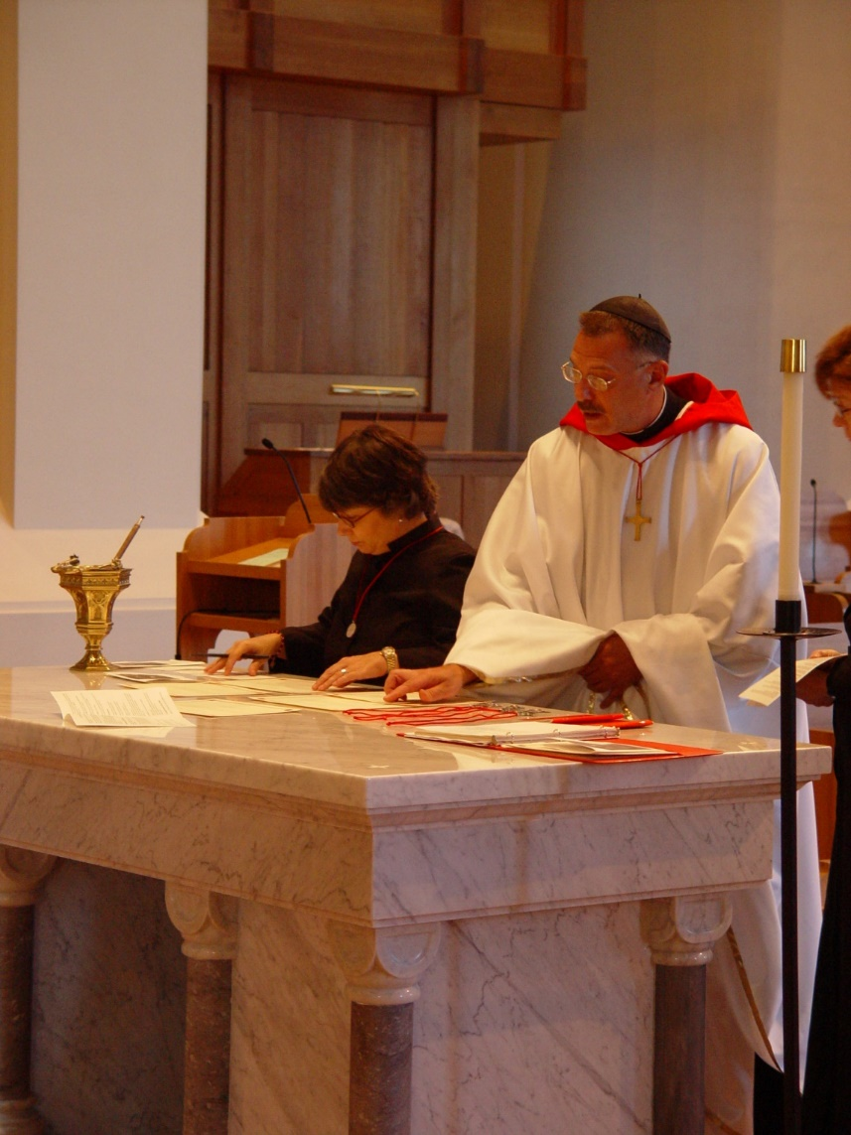
COSL 059 Sr. Anna Grace Madden; Prior Michael John Austin; Sr. Ann Gerns
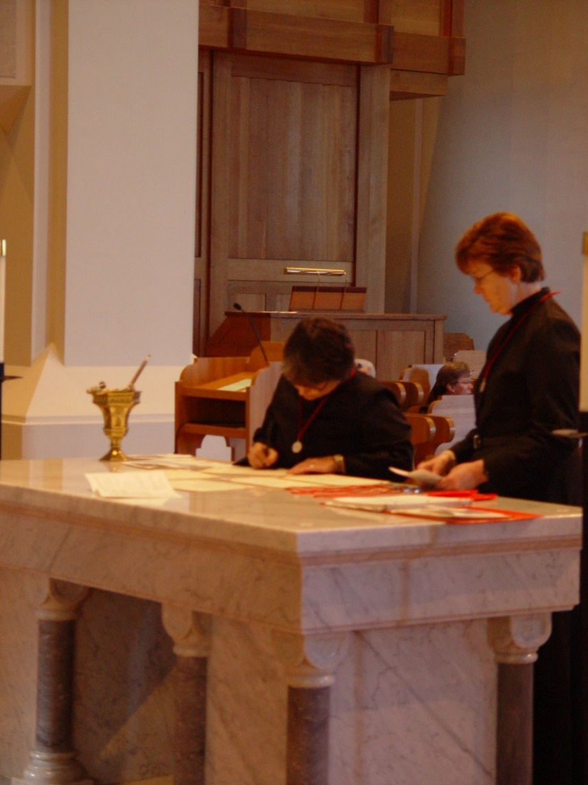
COSL 060 Sr. Anna Grace Madden; Sr. Ann Gerns
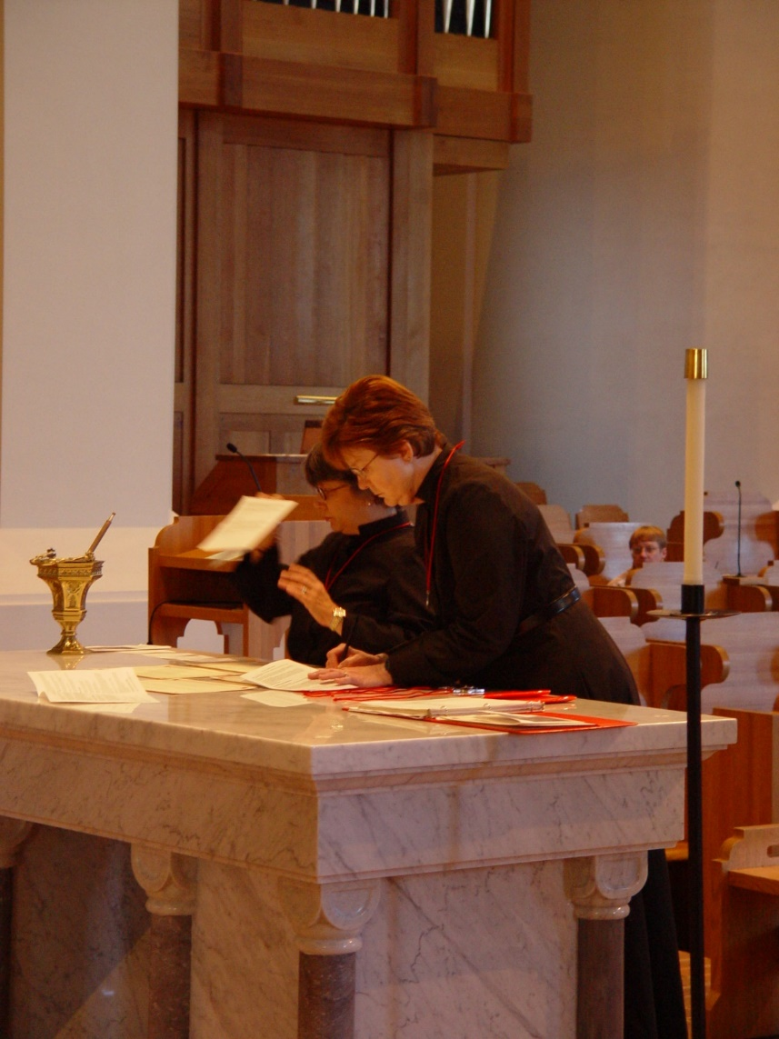
COSL 061 Sr. Anna Grace Madden; Sr. Ann Gerns
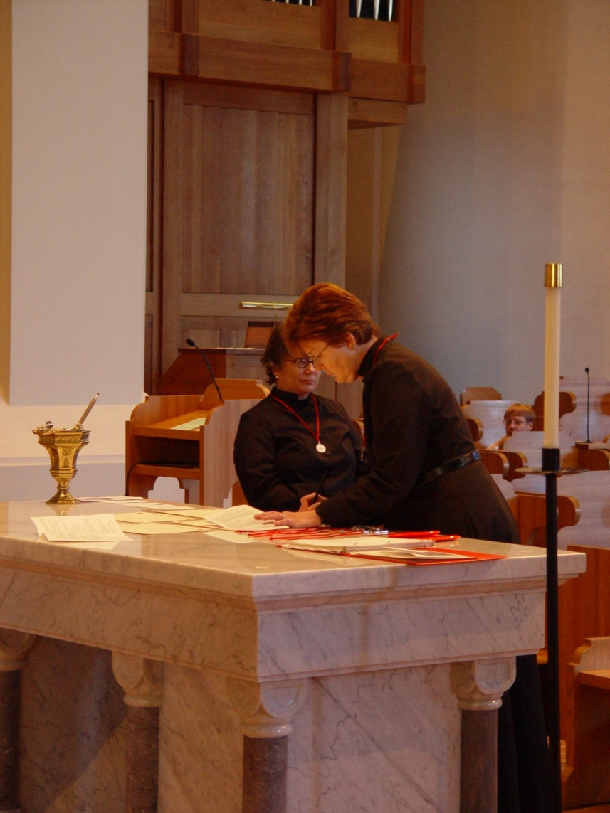
COSL 062 Sr. Anna Grace Madden; Sr. Ann Gerns
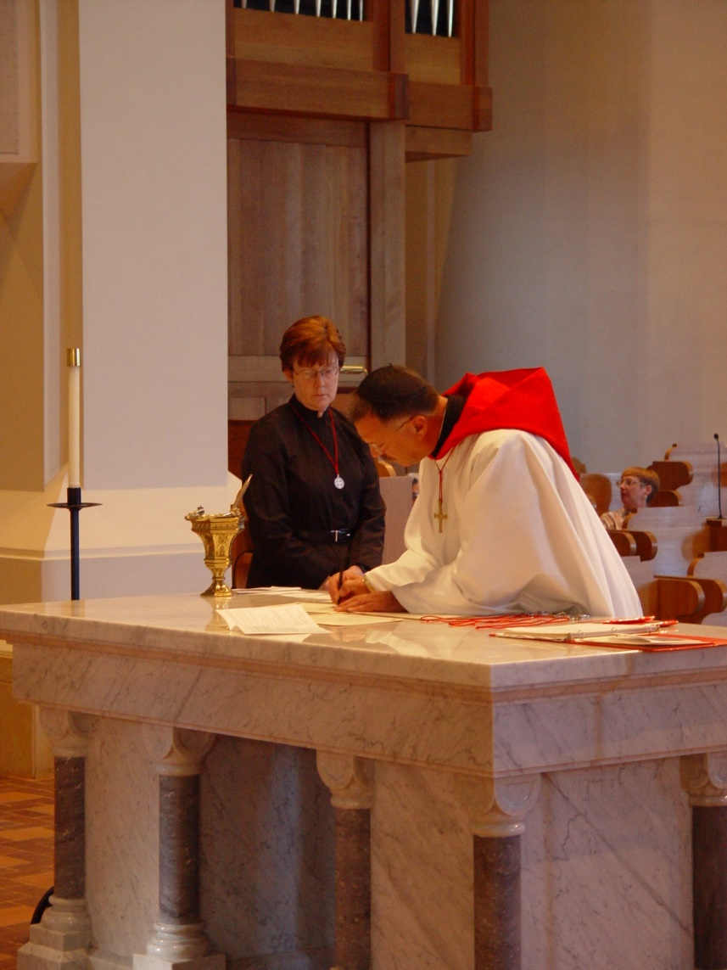
COSL 063 Sr. Ann Gerns; Prior Michael John Austin
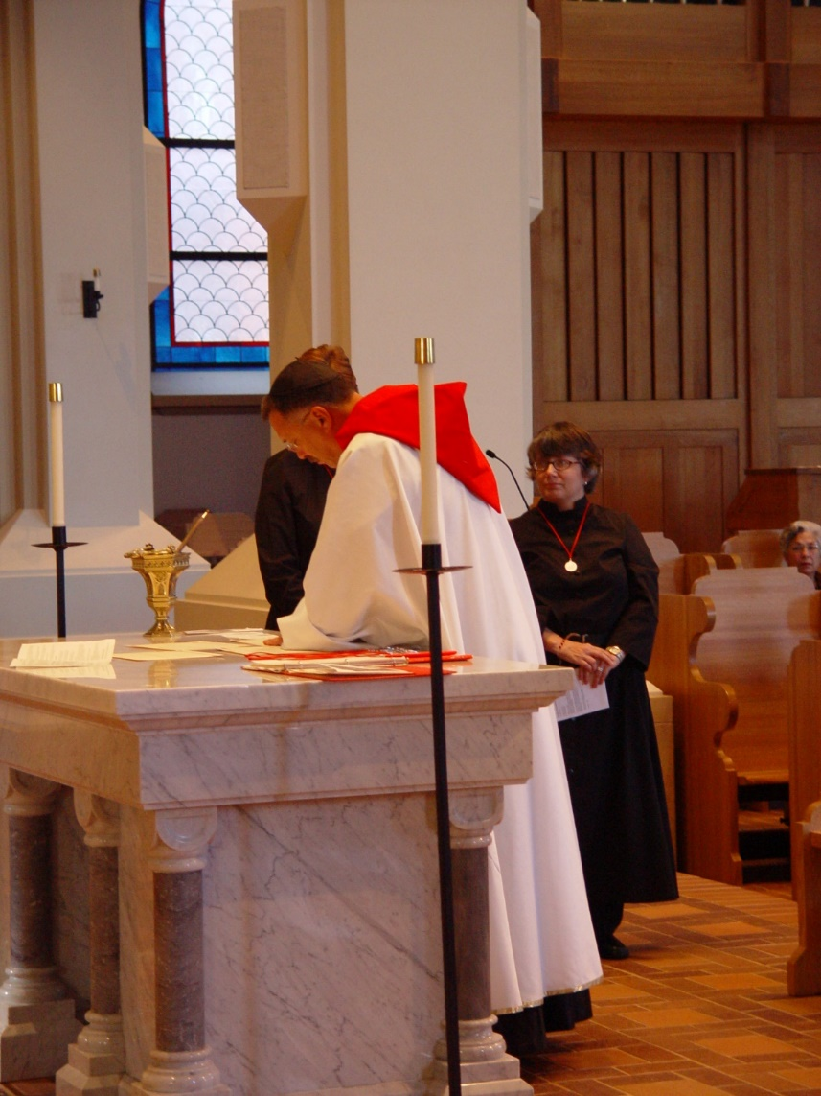
COSL 064 Sr. Ann Gerns; Prior Michael John Austin; Sr. Anna Grace Madden
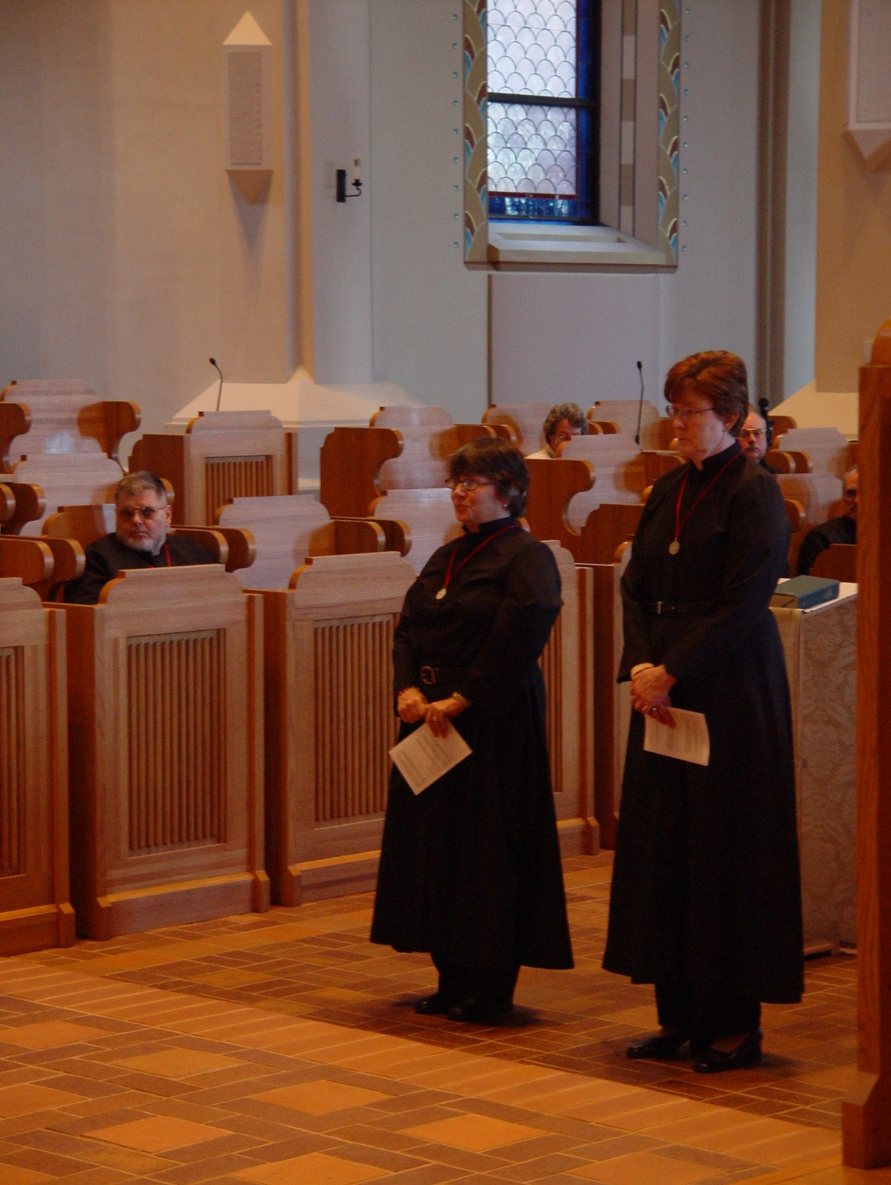
COSL 065 Br. Nathan Gregory Miller; Sr. Anna Grace Madden; Becky Rittenhouse; Sr. Ann Gerns; Br. Raymond Owens; Br. Daniel Joseph Schroeder
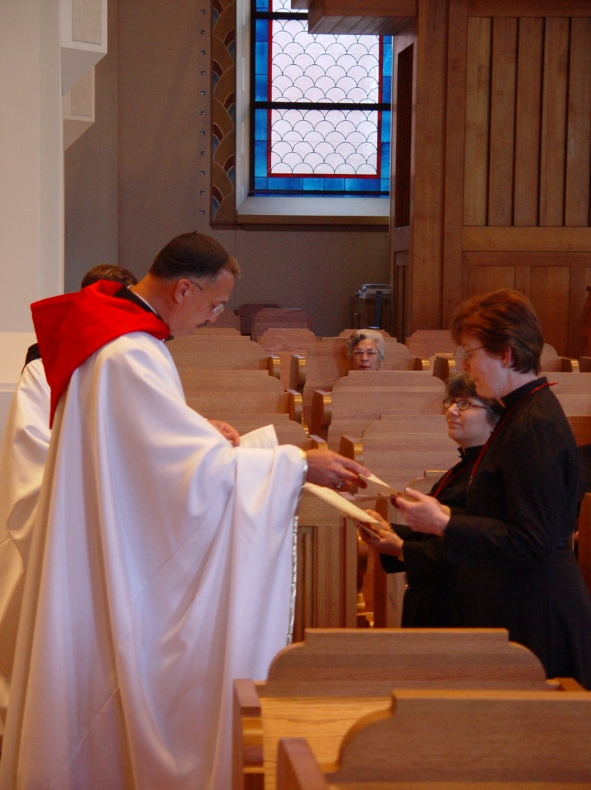
COSL 066 Br. Paul Howard; Prior Michael John Austin; Jeanetta Doan; Sr. Anna Grace Madden; Sr. Ann Gerns
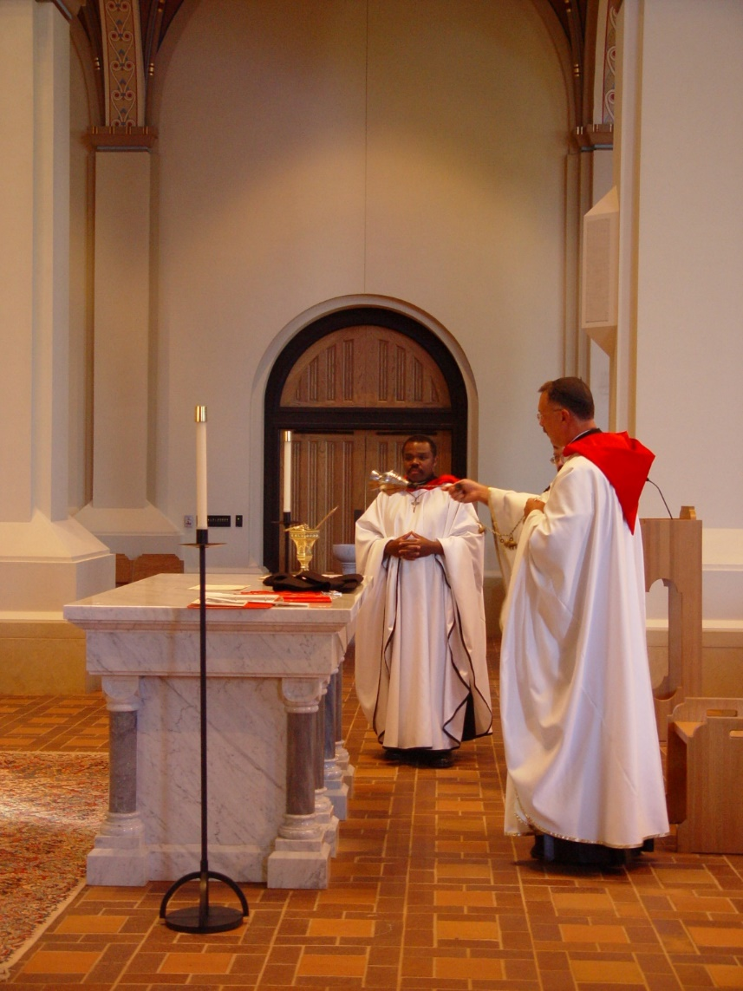
COSL 067 Br. Thomas Ferrell; Prior Michael John Austin
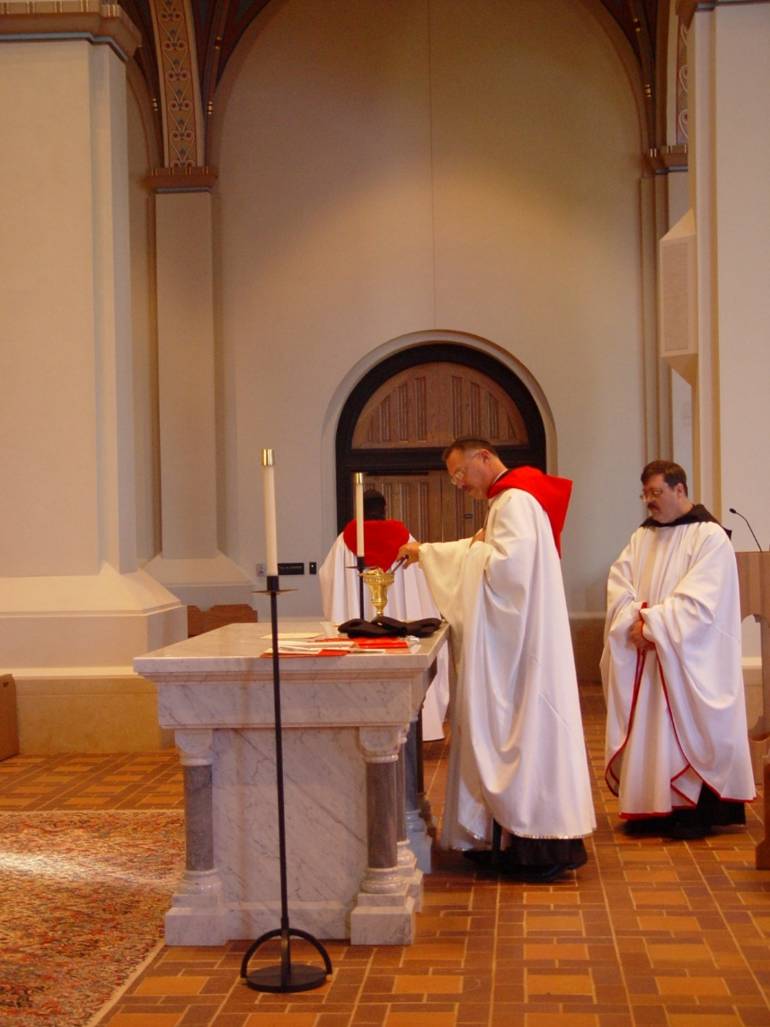
COSL 068 Br. Thomas Ferrell; Prior Michael John Austin; Br. Paul Howard
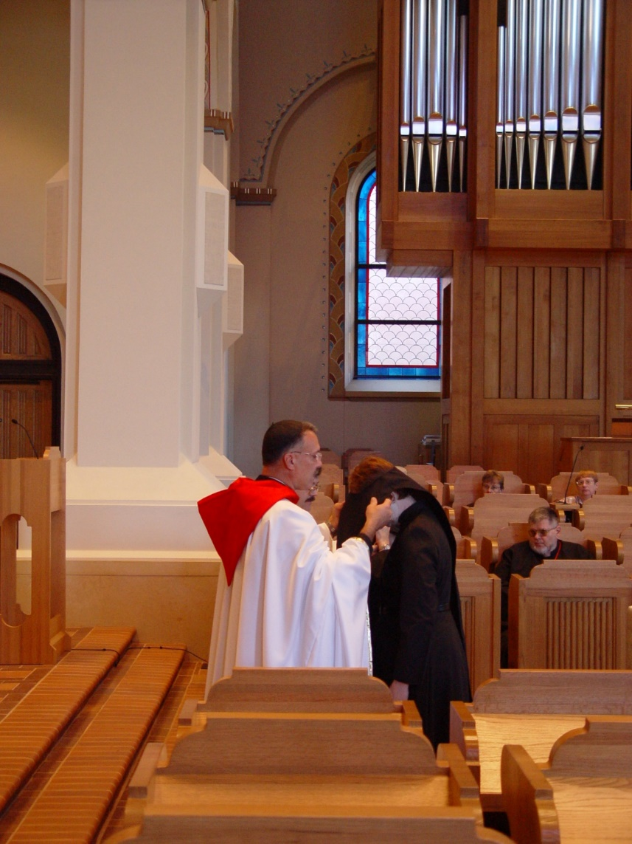
COSL 069 Prior Michael John Austin; Sr. Ann Gerns; Br. Nathan Gregory Miller; Becky Fredregill; Lynn Owens
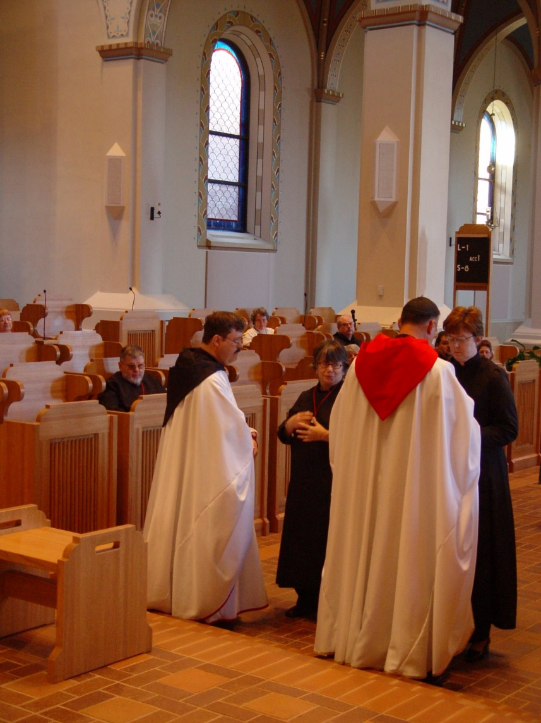
COSL 070 Br. Nathan Gregory Miller; Br. Paul Howard; Sr. Anna Grace Madden; Prior Michael John Austin; Sr. Ann Gerns; Becky Rittenhouse; Br. Raymond Owens; Regan Fox

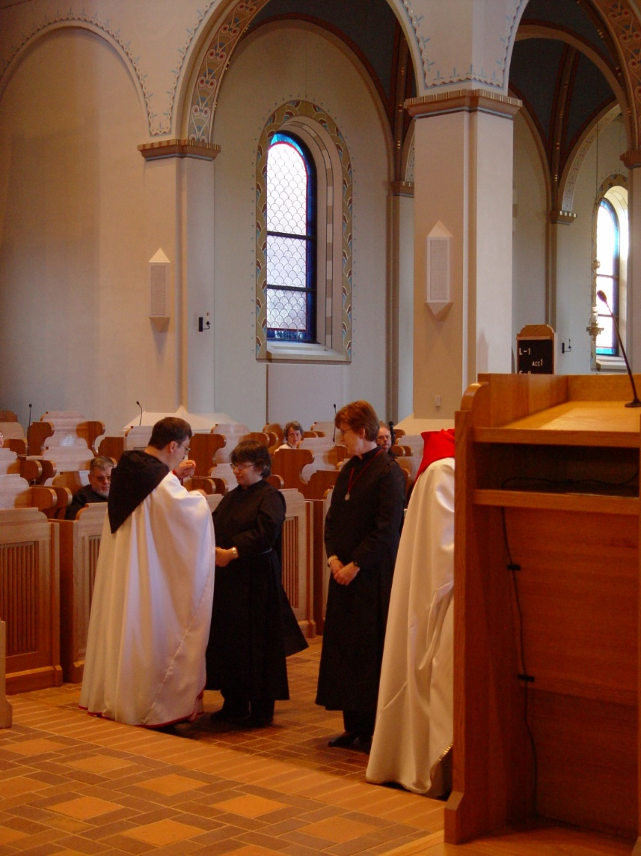
COSL 071 Br. Nathan Gregory Miller; Br. Paul Howard; Sr. Anna Grace Madden; Becky Rittenhouse; Br. Raymond Owens; Sr. Ann Gerns; Prior Michael John Austin
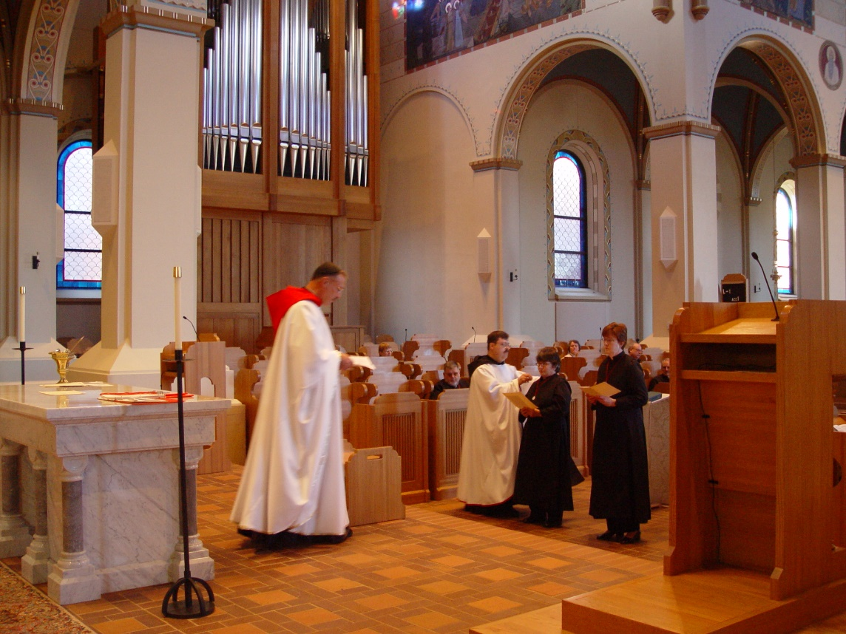
COSL 072 Prior Michael John Austin; Br. Paul Howard; Sr. Anna Grace Madden; Sr. Ann Gerns

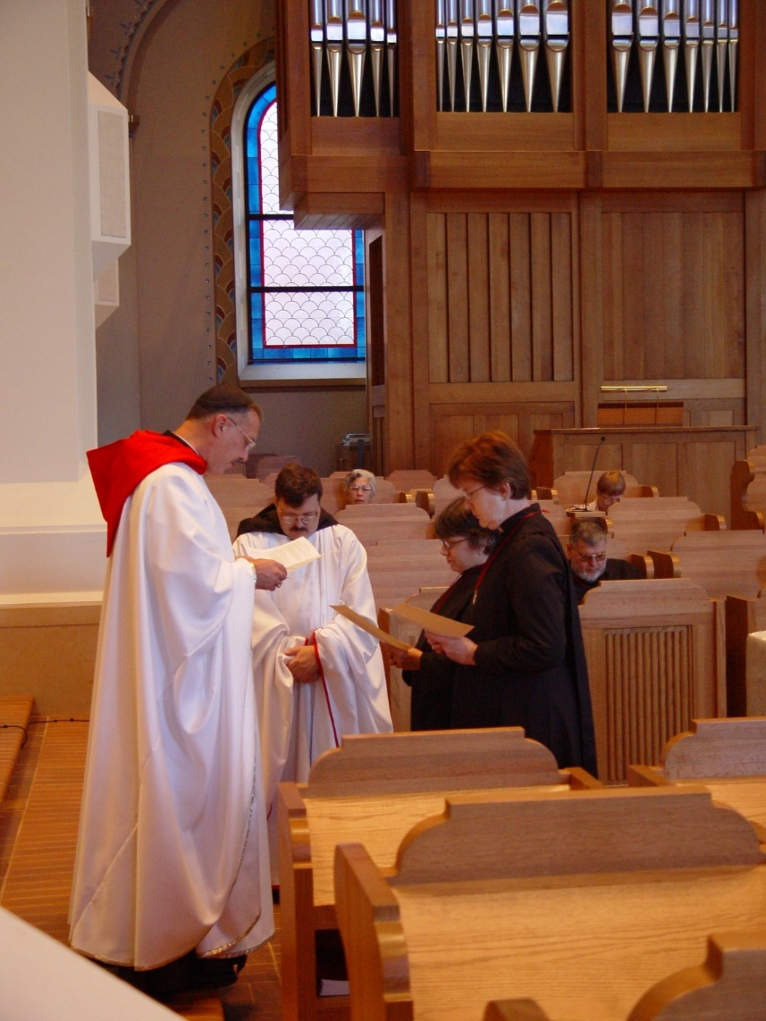
COSL 073 Prior Michael John Austin; Br. Paul Howard; Jeanetta Doan; Sr. Anna Grace Madden; Sr. Ann Gerns; Br. Nathan Gregory Miller; Lynn Owens
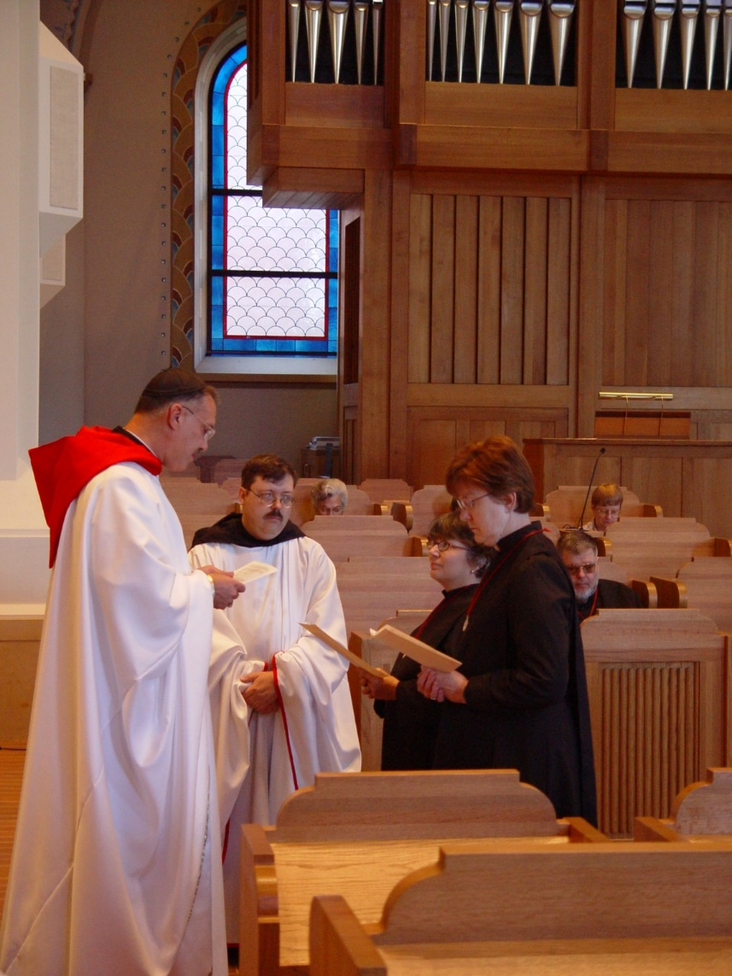
COSL 074 Prior Michael John Austin; Br. Paul Howard; Jeanetta Doan; Sr. Anna Grace Madden; Sr. Ann Gerns; Br. Nathan Gregory Miller; Lynn Owens
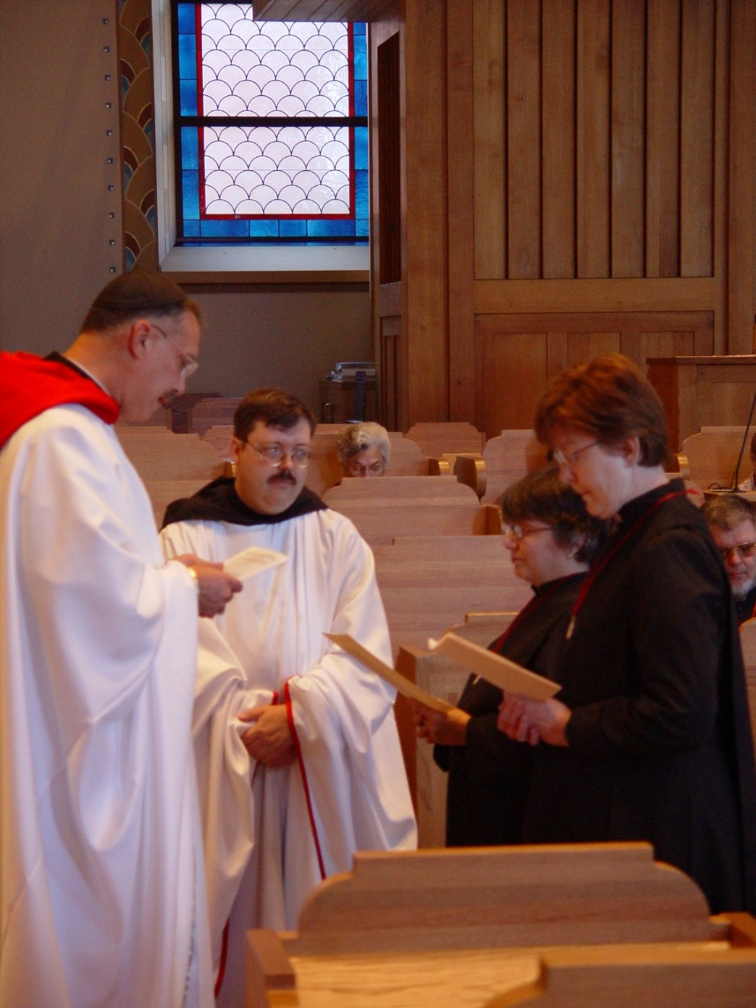
COSL 075 Prior Michael John Austin; Br. Paul Howard; Jeanetta Doan; Sr. Anna Grace Madden; Sr. Ann Gerns; Br. Nathan Gregory Miller
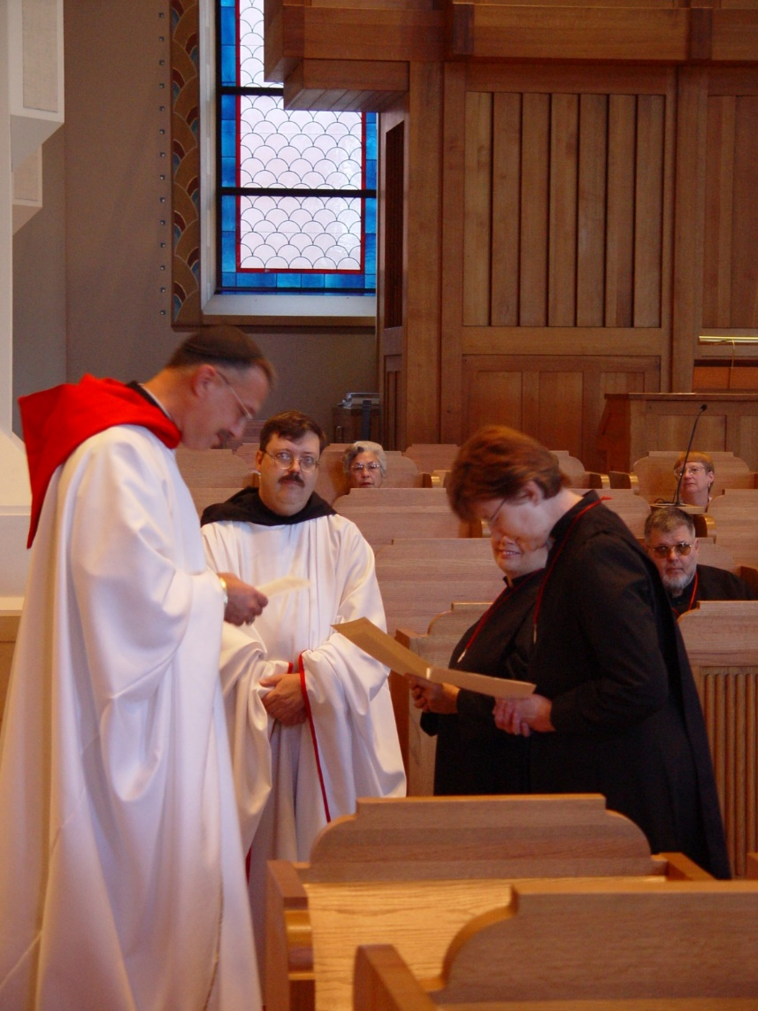
COSL 076 Prior Michael John Austin; Br. Paul Howard; Jeanetta Doan; Sr. Anna Grace Madden; Sr. Ann Gerns; Br. Nathan Gregory Miller; Lynn Owens
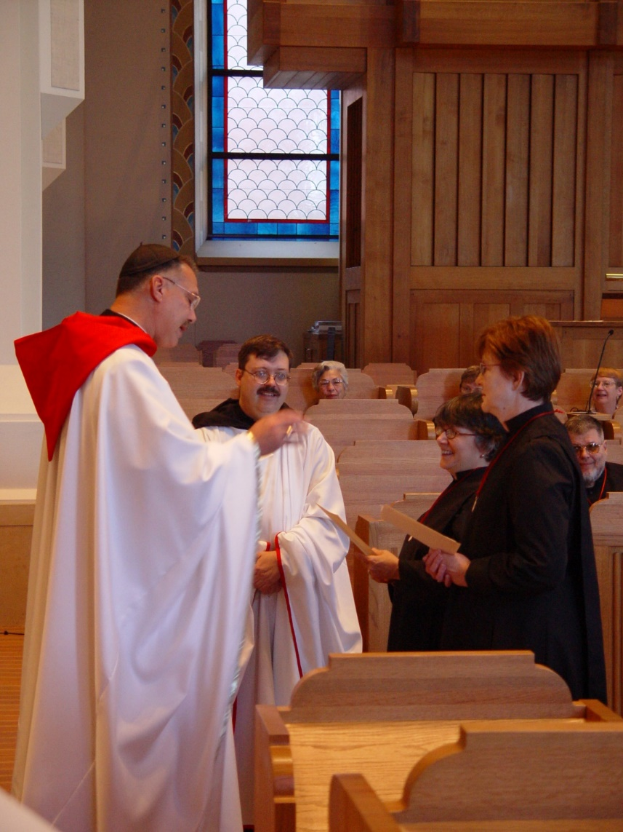
COSL 077 Prior Michael John Austin; Br. Paul Howard; Jeanetta Doan; Sr. Anna Grace Madden; Sr. Ann Gerns; Br. Nathan Gregory Miller; Lynn Owens
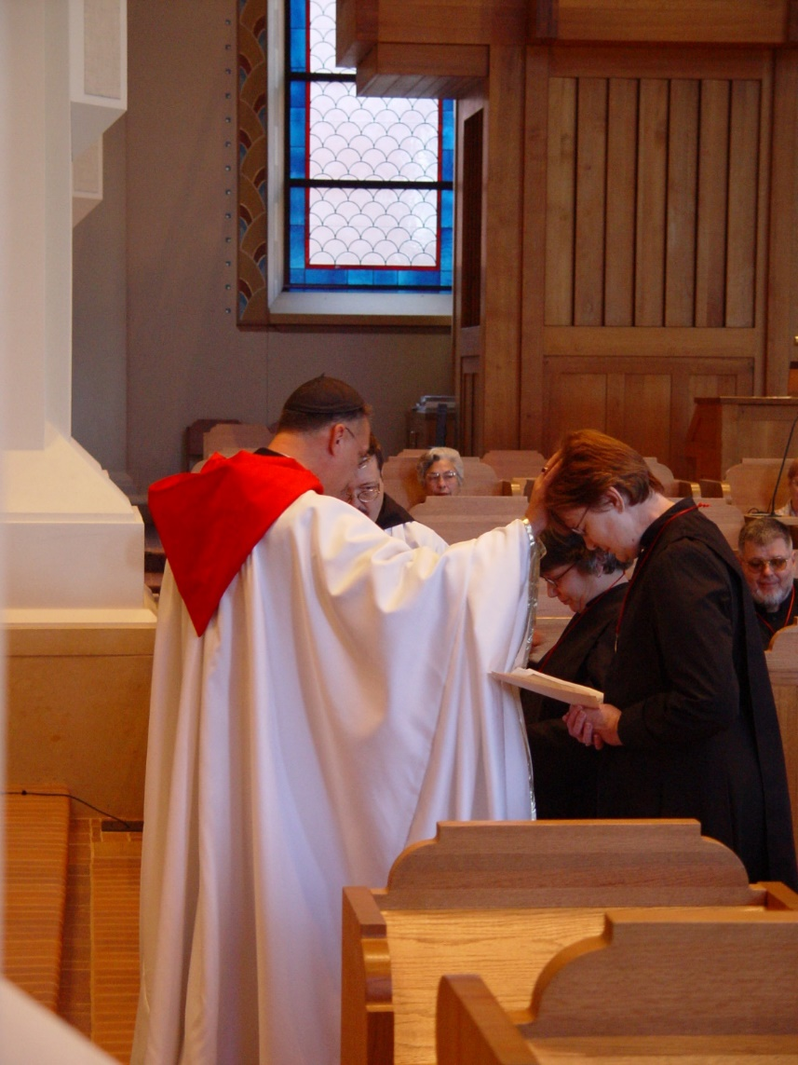
COSL 078 Prior Michael John Austin; Br. Paul Howard; Jeanetta Doan; Sr. Anna Grace Madden; Sr. Ann Gerns; Br. Nathan Gregory Miller
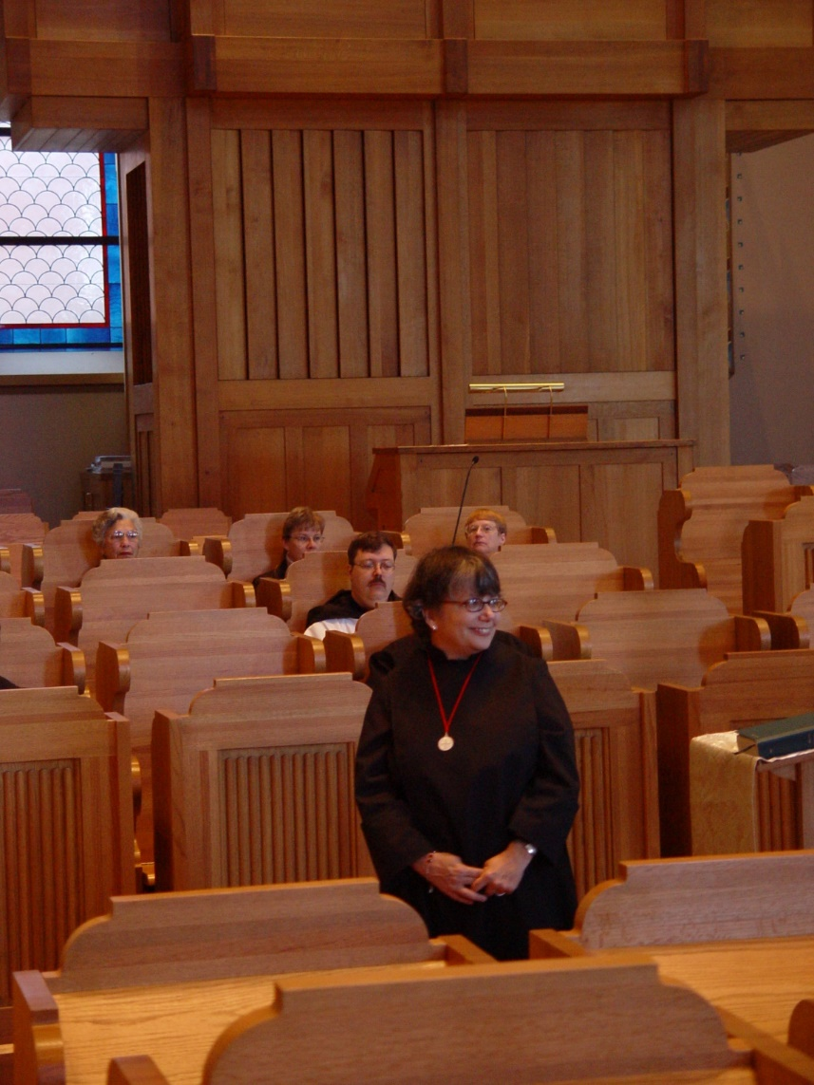
COSL 079 Jeanetta Doan; Becky Fredregill; Br. Paul Howard; Sr. Anna Grace Madden; Lynn Owens
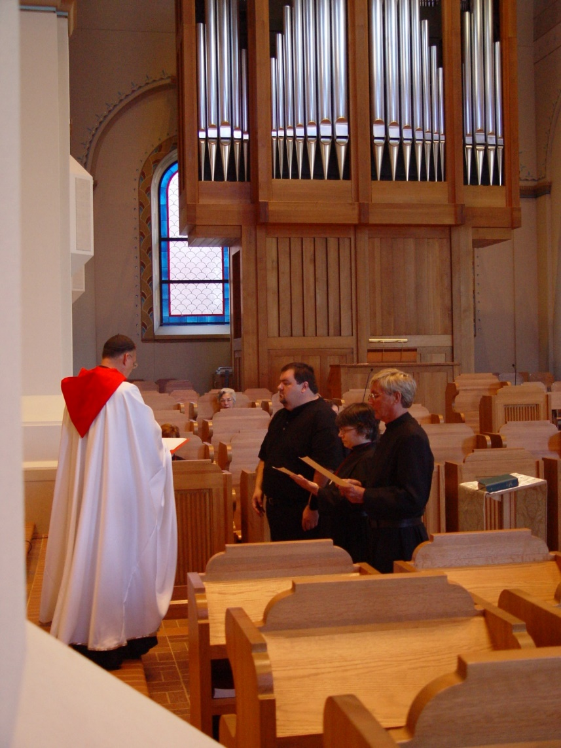
COSL 080 Prior Michael John Austin; Jeanetta Doan; Reagan Fox; Sr. Anna Grace Madden; Glen Converse (now Br. Camillus)
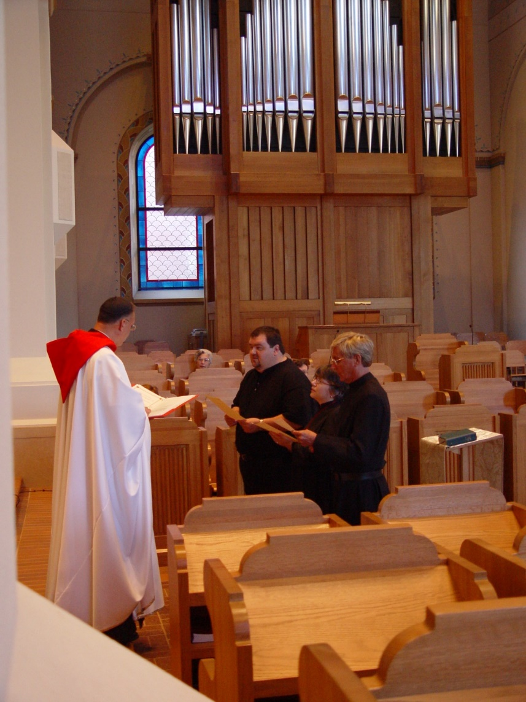
COSL 081 Prior Michael John Austin; Jeanetta Doan; Reagan Fox; Sr. Anna Grace Madden; Glen Converse (now Br. Camillus)

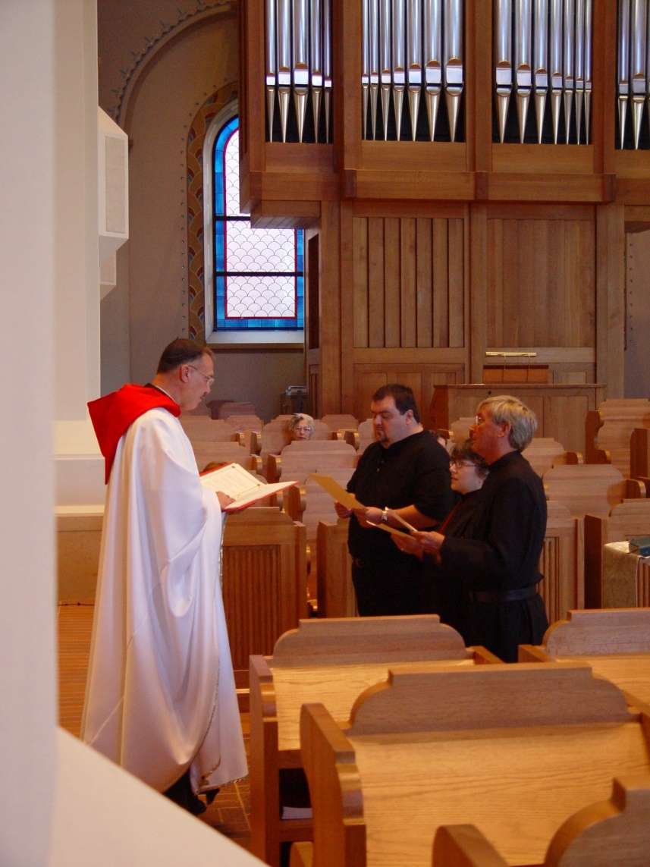
COSL 082 Prior Michael John Austin; Jeanetta Doan; Regan Fox; Sr. Anna Grace Madden; Glen Converse (now Br. Camillus)

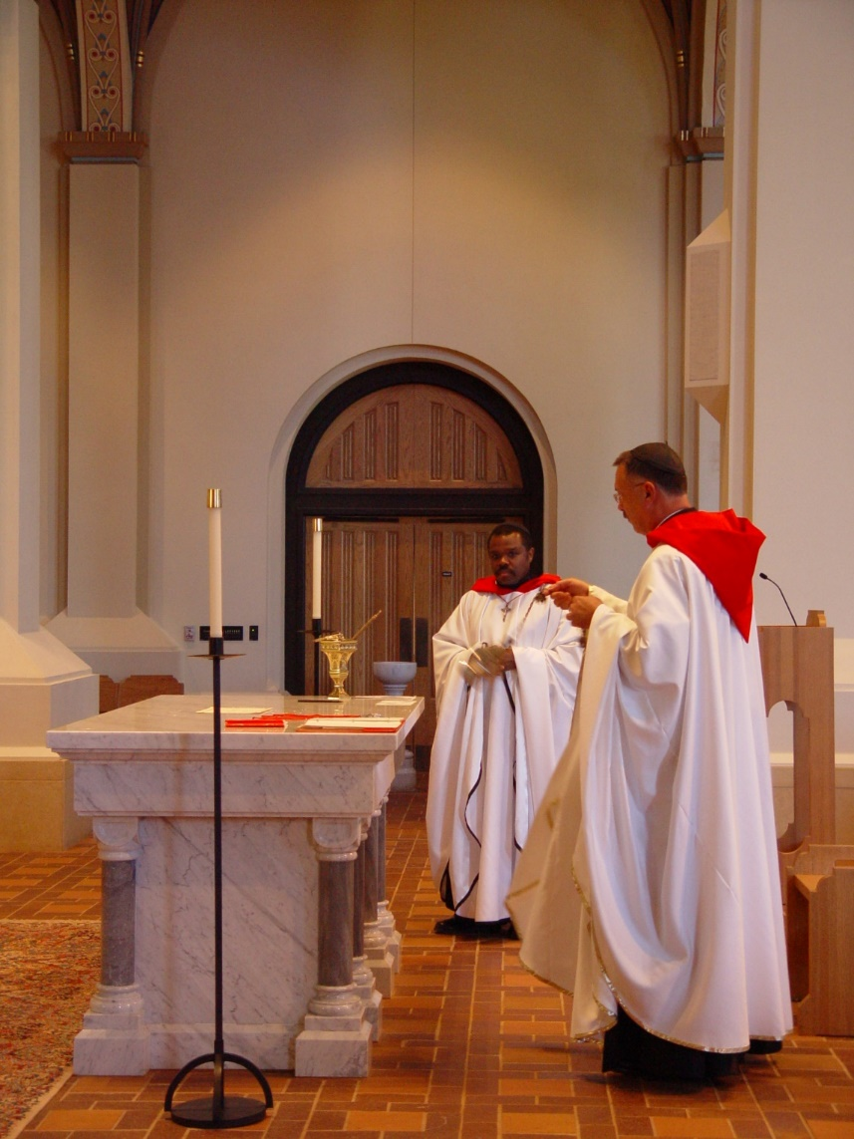
COSL 083 Br. Thomas Ferrell; Prior Michael John Austin
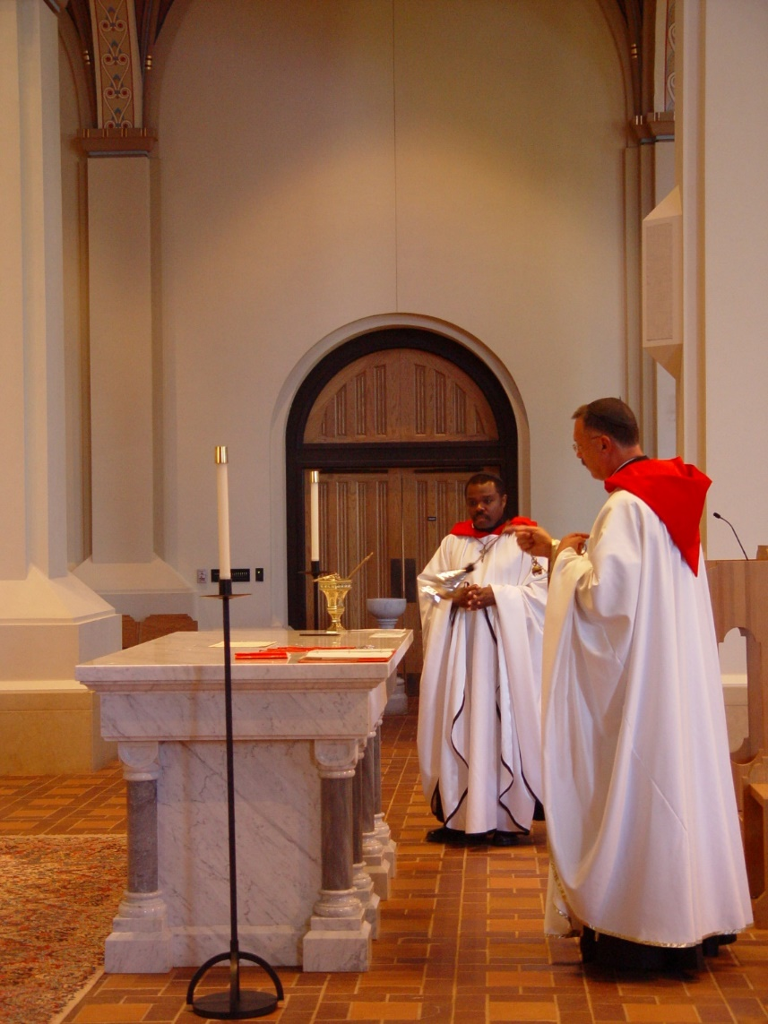
COSL 084 Br. Thomas Ferrell; Prior Michael John Austin

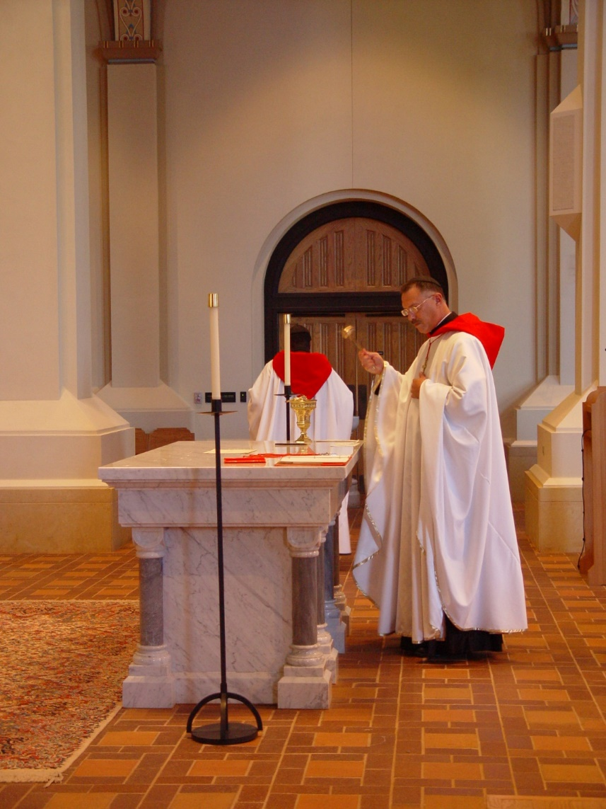
COSL 085 Br. Thomas Ferrell; Prior Michael John Austin

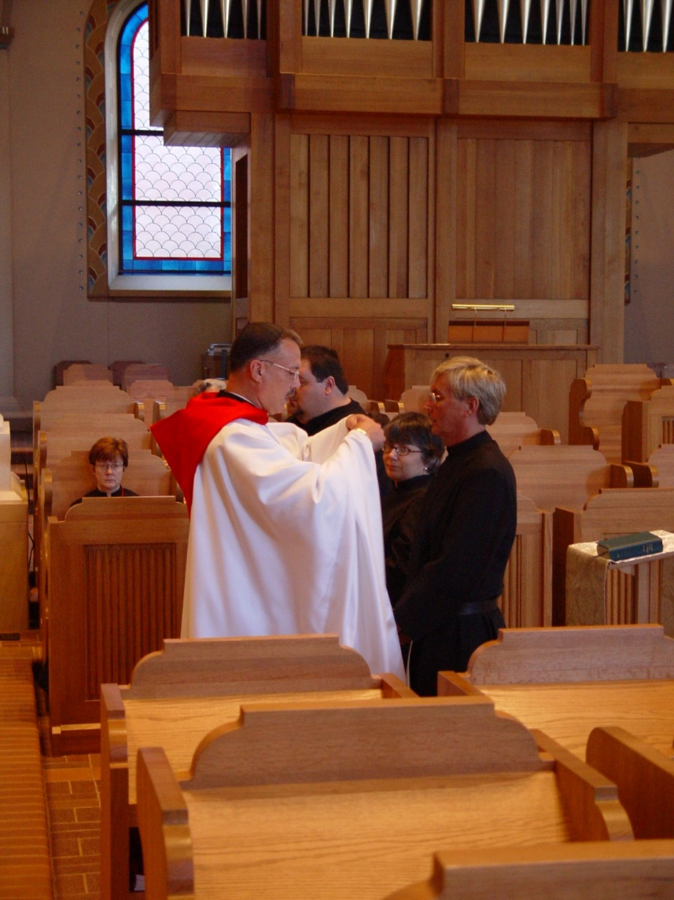
COSL 086 Sr. Ann Gerns; Prior Michael John Austin; Reagan Fox; Sr. Anna Grace Madden; Glen Converse (later Br. Camillus)

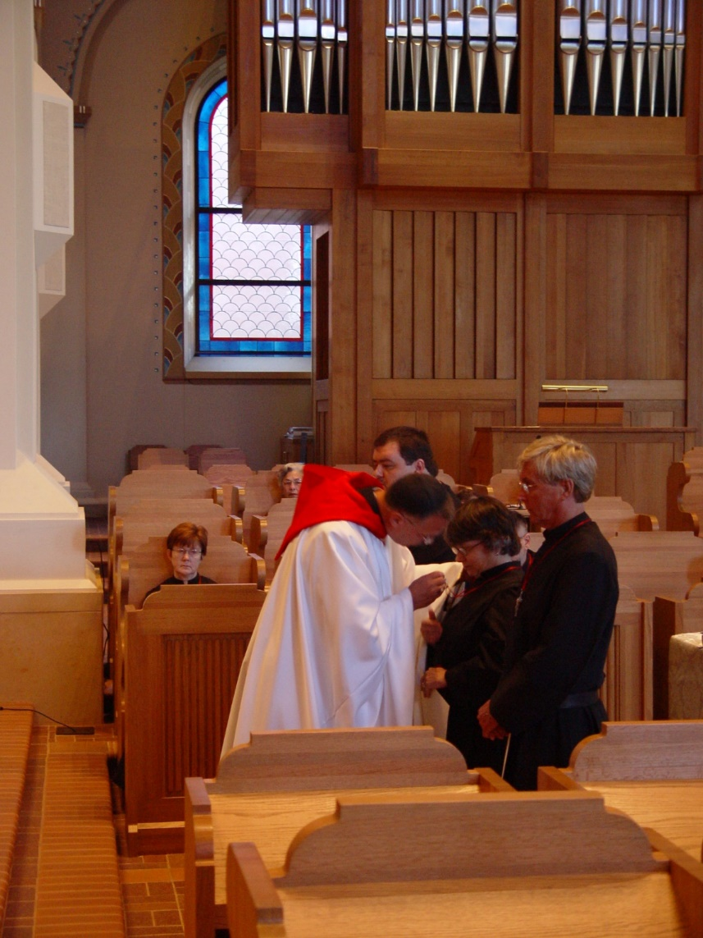
COSL 087 Sr. Ann Gerns; Prior Michael John Austin; Jeanetta Doan; Regan Fox; Sr. Anna Grace Madden; Glen Converse (later Br. Camillus)

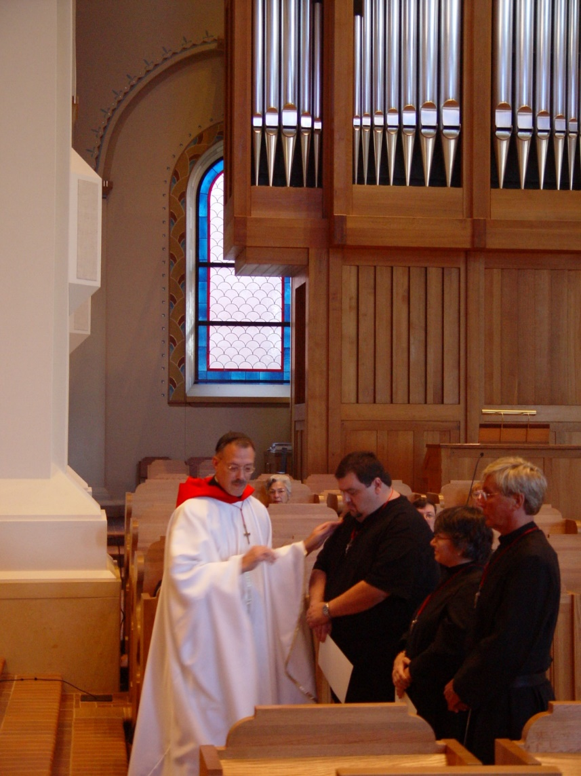
COSL 088 Prior Michael John Austin; Jeanetta Doan; Regan Fox; Br. Paul Howard; Sr. Anna Grace Madden; ; Glen Converse (later Br. Camillus)

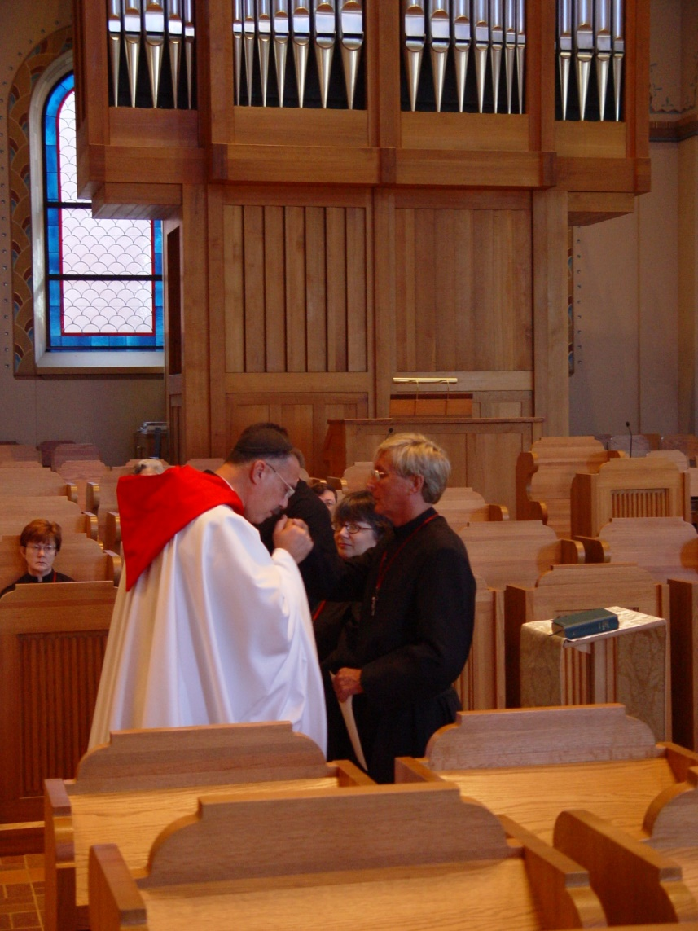
COSL 089 Sr. Ann Gerns; Prior Michael John Austin; Reagan Fox; Sr. Anna Grace Madden; Glen Converse (later Br. Camillus)

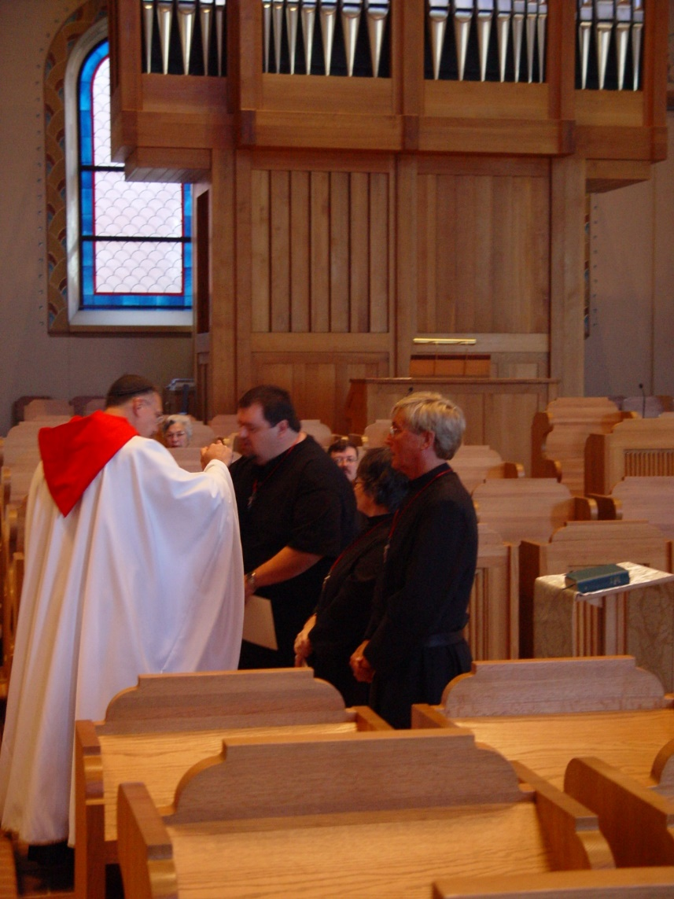
COSL 090 Prior Michael John Austin; Jeanetta Doan; Regan Fox; Br. Paul Howard; Sr. Anna Grace Madden; Glen Converse (later Br. Camillus)

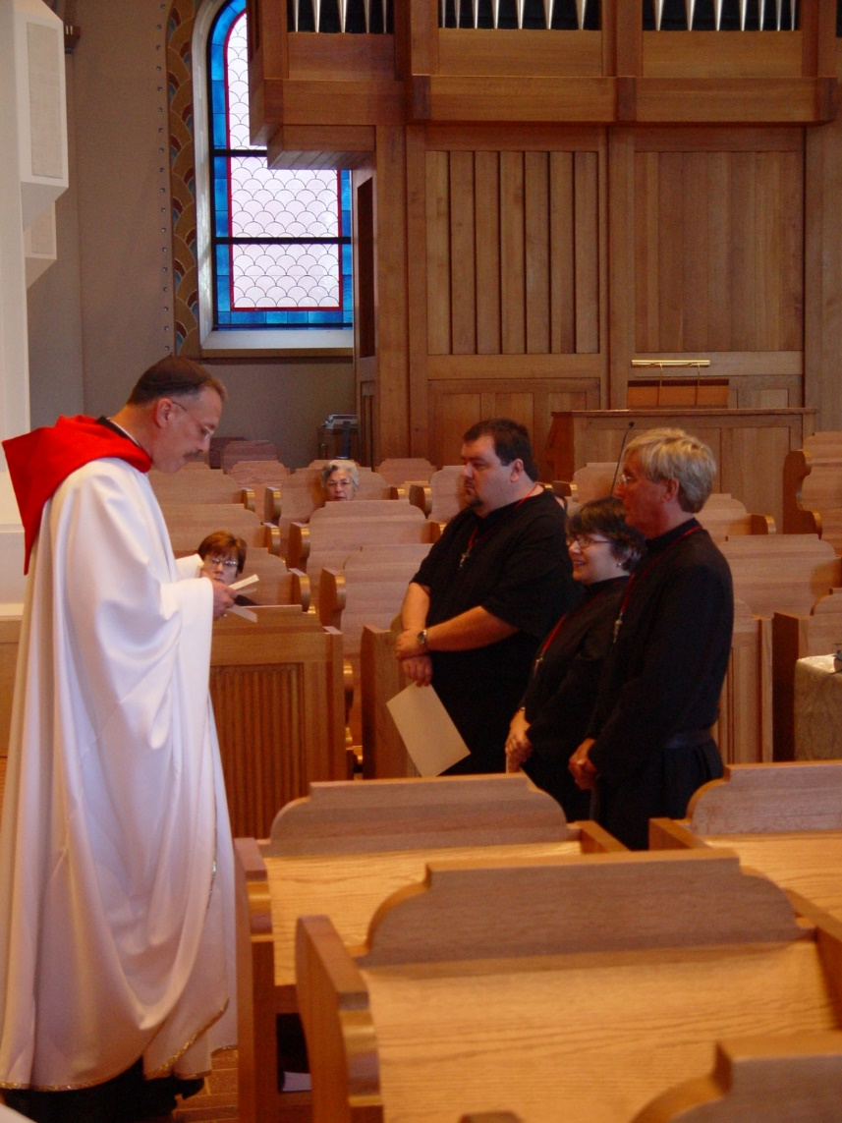
COSL 091 Prior Michael John Austin; Sr. Ann Gerns; Jeanetta Doan; Regan Fox; Sr. Anna Grace Madden; Glen Converse (later Br. Camillus)

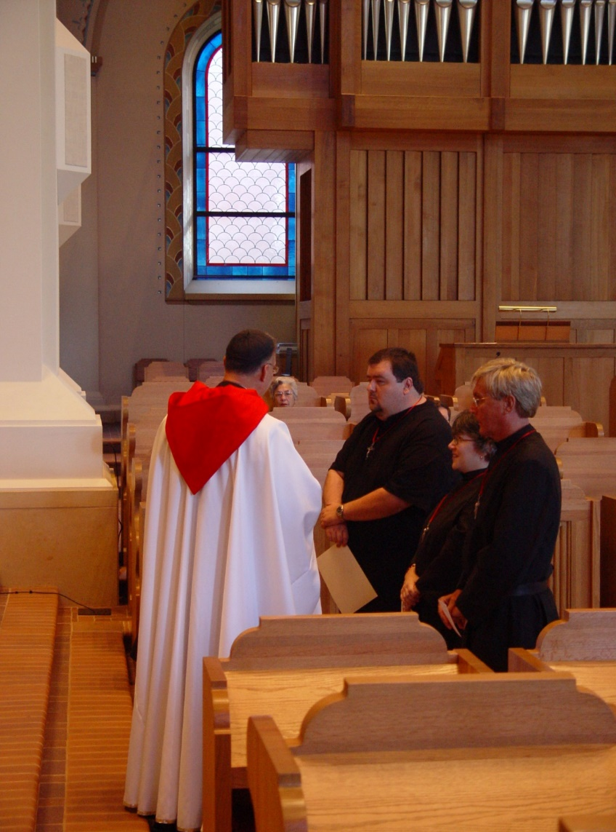
COSL 092 Prior Michael John Austin; Jeanetta Doan; Regan Fox; Sr. Anna Grace Madden; Glen Converse (later Br. Camillus)

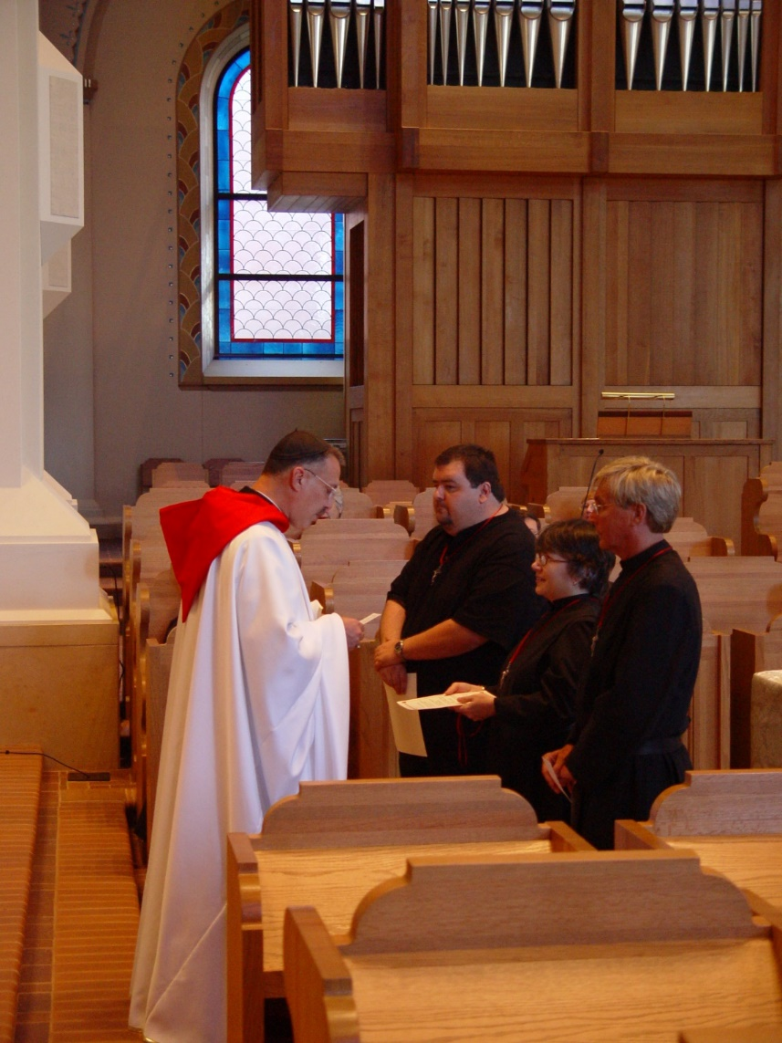
COSL 093 Prior Michael John Austin; Reagan Fox; Sr. Anna Grace Madden; Glen Converse (later Br. Camillus)
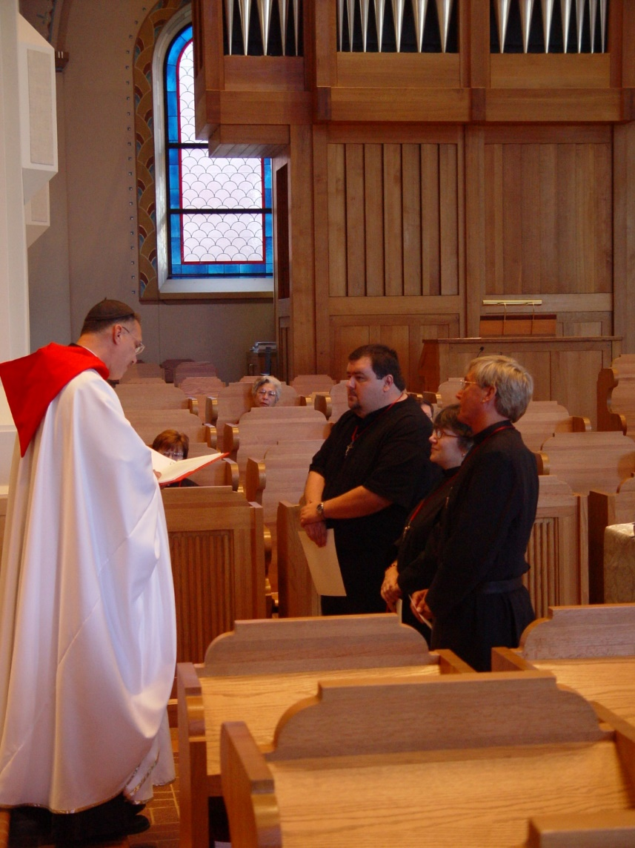
COSL 094 Prior Michael John Austin; Sr. Ann Gerns; Jeanetta Doan; Regan Fox; Sr,. Anna Grace Madden; Glen Converse (later Br. Camillus)
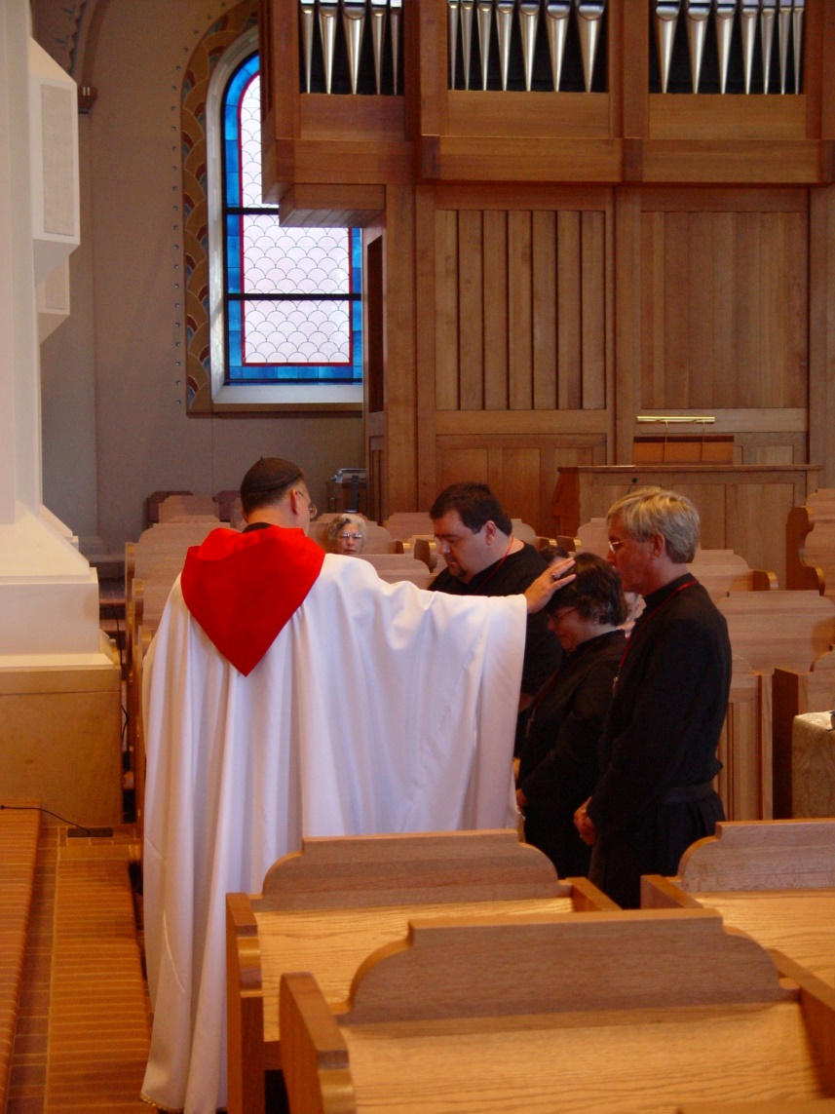
COSL 095 Prior Michael John Austin; Jeanetta Doan; Regan Fox; Sr. Anna Grace Madden; Glen Converse (later Br. Camillus)
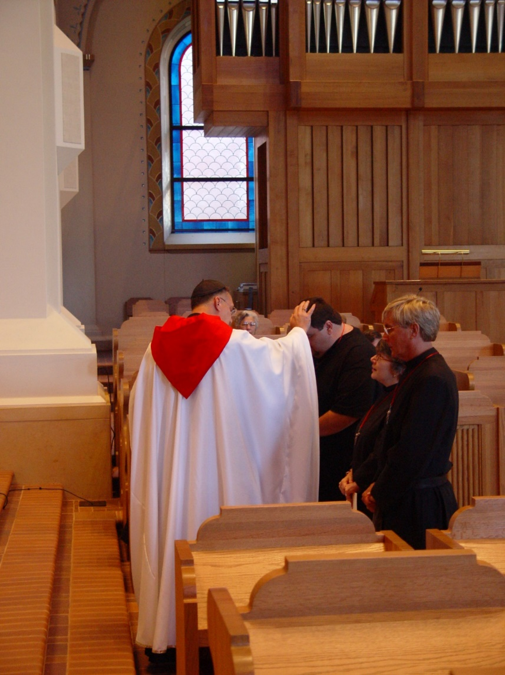
COSL 096 Prior Michael John Austin; Jeanetta Doan; Regan Fox; Sr. Anna Grace Madden; Glen Converse (later Br. Camillus)
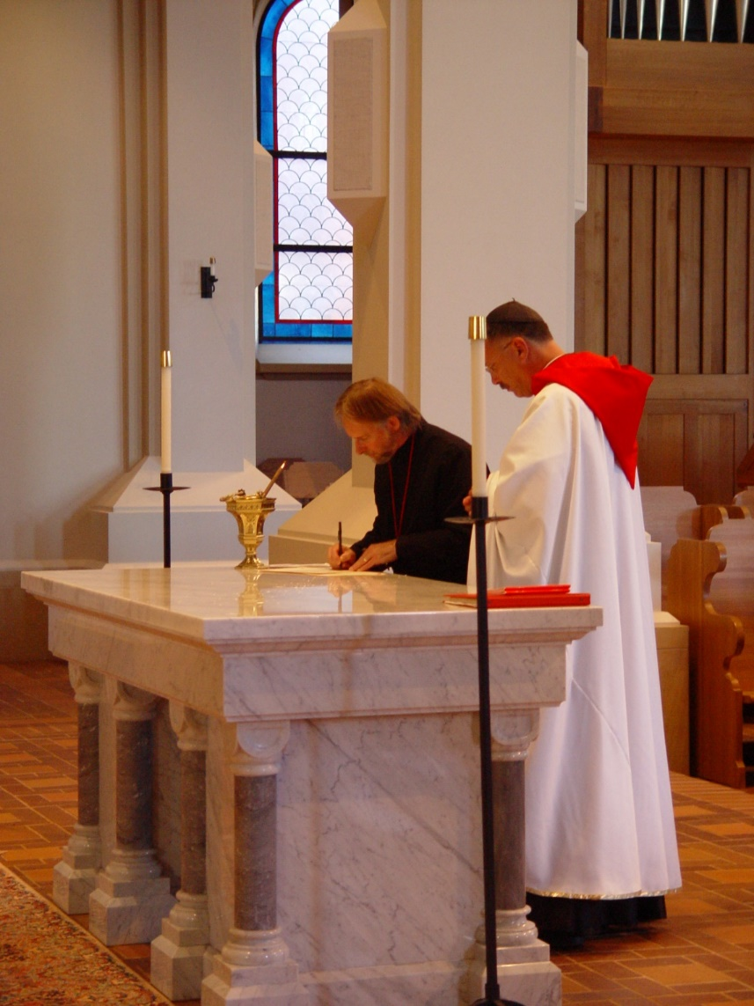
COSL 097 Barry Mullen (Br. Lawrence); Prior Michael John Austin

