Companions of St. Luke
Fall 2005 Convocation at Conception Abbey

~Edited by Br. Steven Olderr, 13 May 2022 with the assistance of Br. Thomas Ferrell; if you find any errors or omissions, please notify Br. Steven at olderr@ameritech.net

People are identified from left to right.

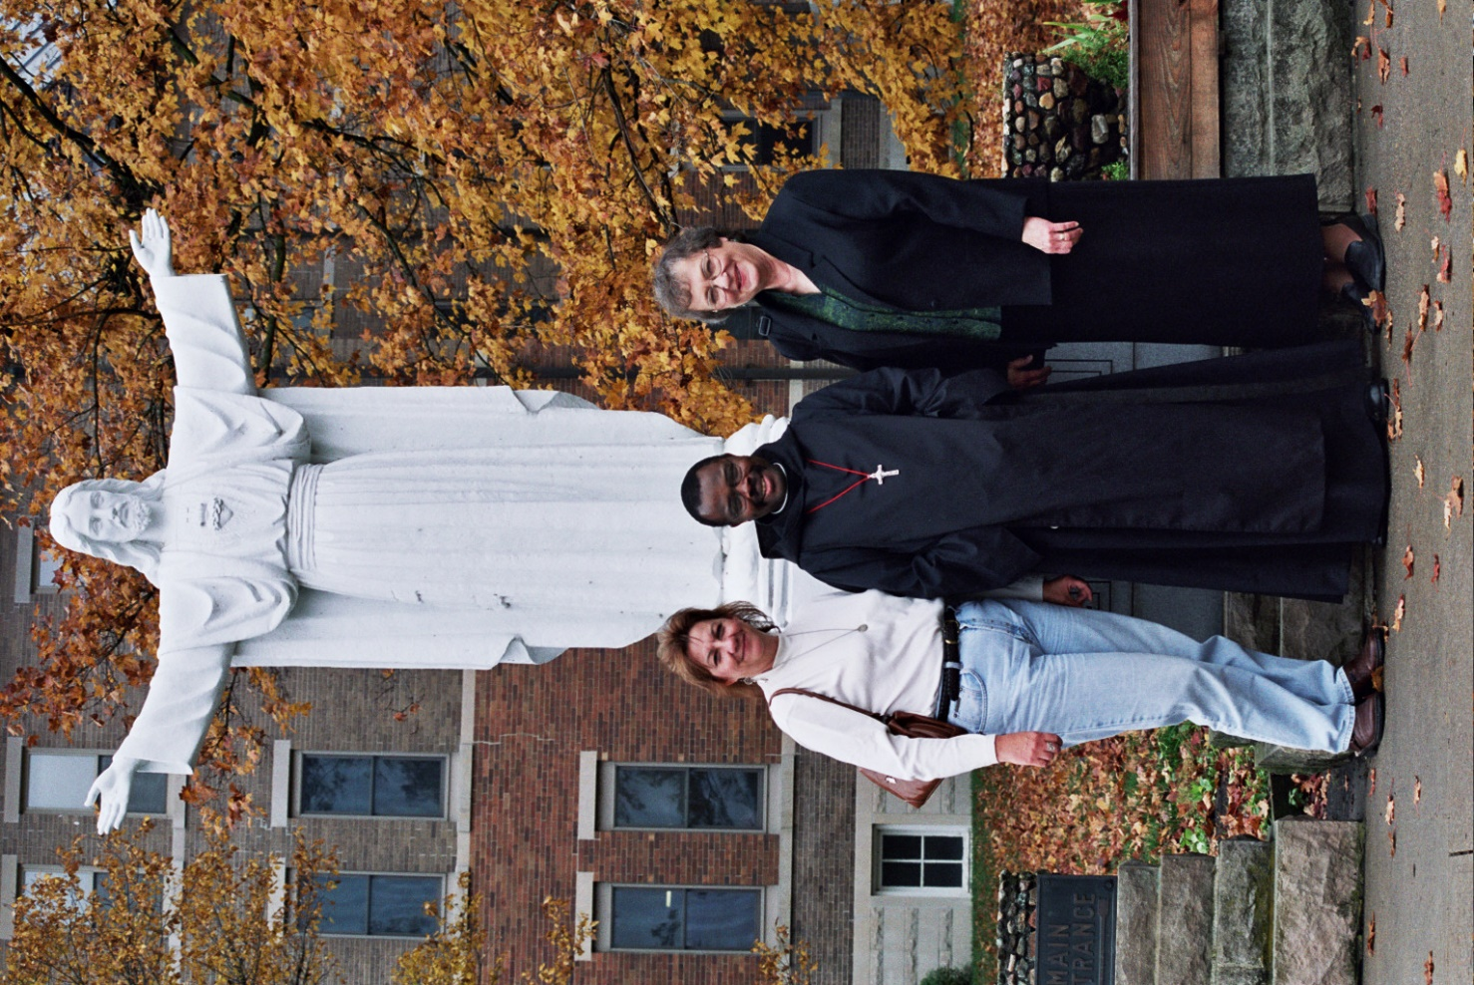
21-0079 Shelley McKeehan; Br. Thomas Ferrell; Mary Kamm

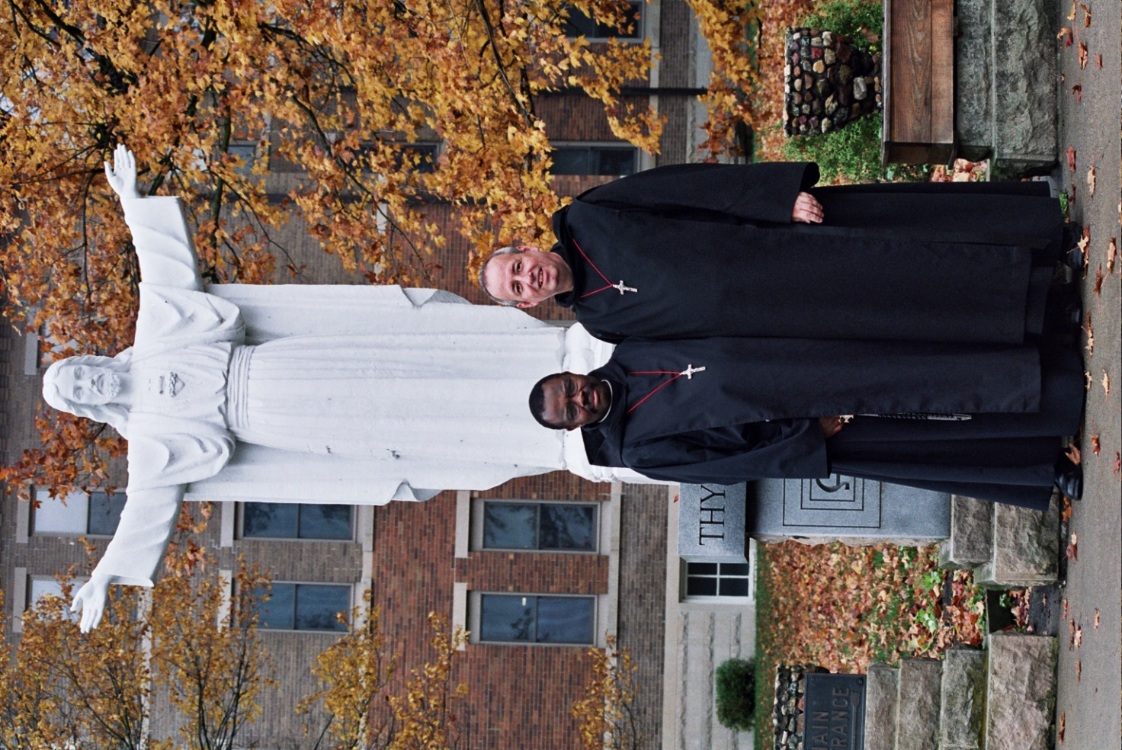
21-0080 Br. Thomas Ferrell; Br. Gabriel Hale

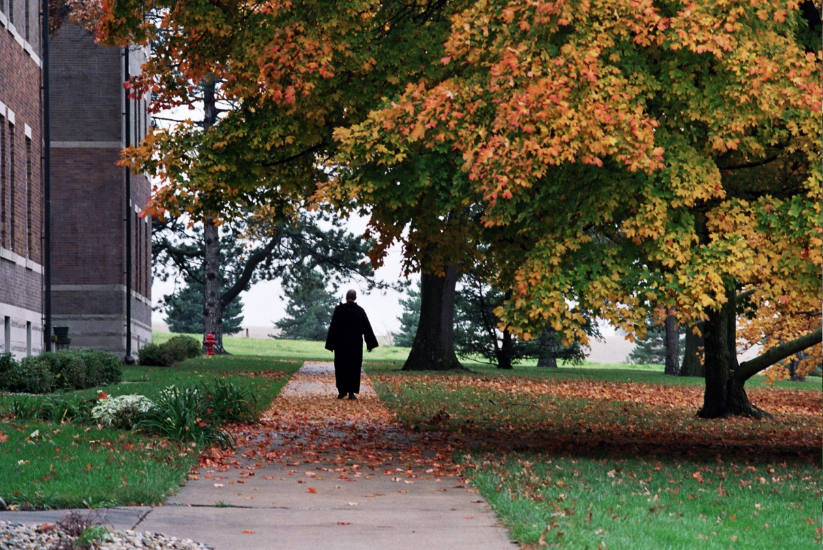
21-0081 Br. Gabriel Hale


21-0082 Br. Gabriel Hale

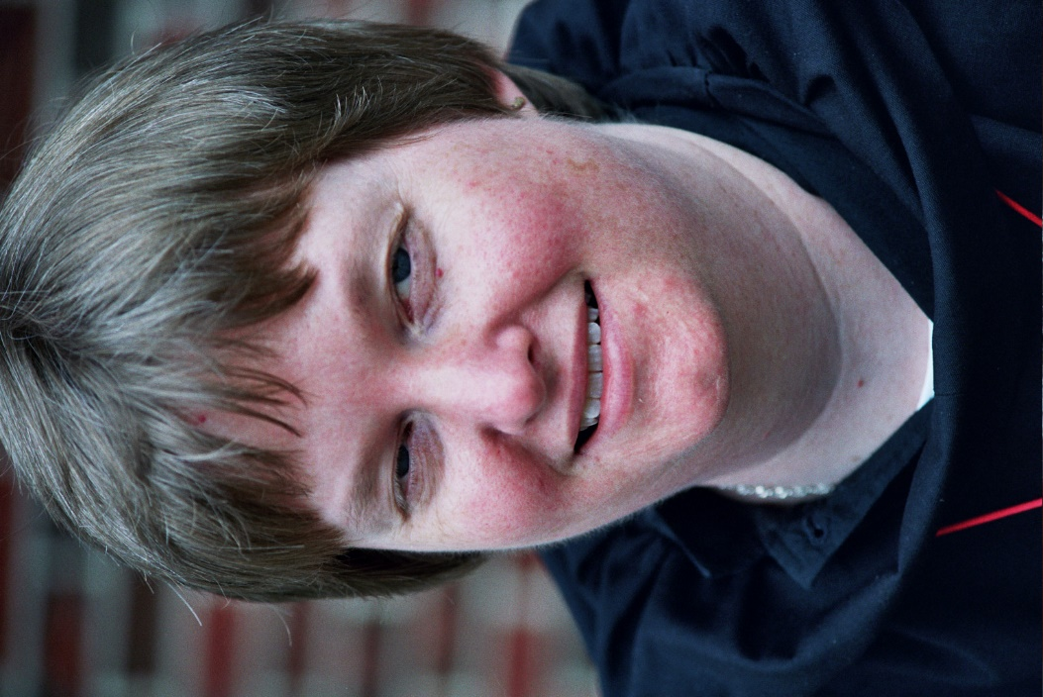
21-0083 Sr. Catherine Untermeyer

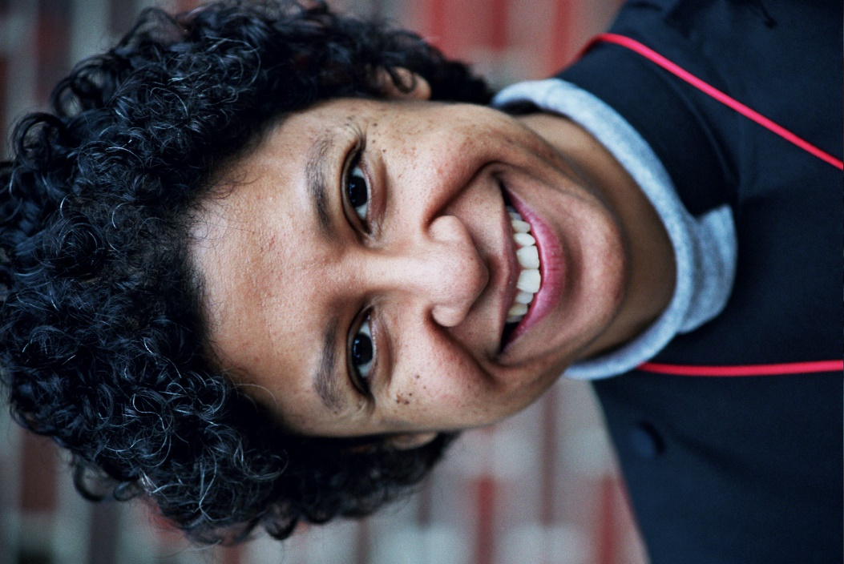
21-0084 Sr. Julian Baker

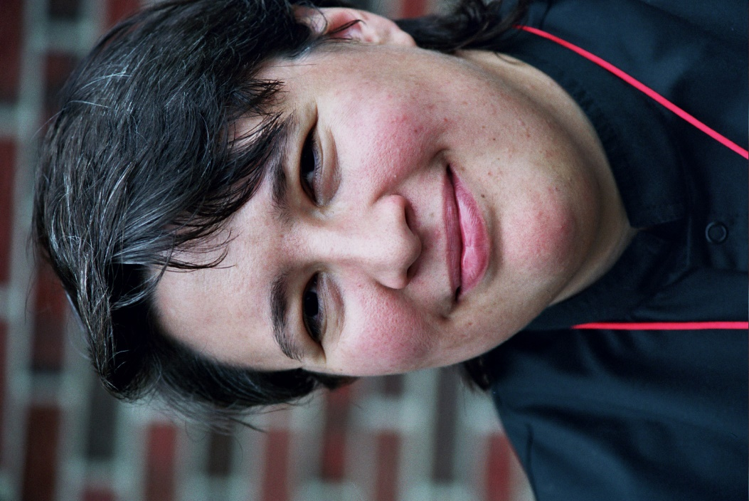
21-0085 Sr. Pauline Tysol (given name Jennifer)


21-0086 Sr. Johanna Kirkpatrick

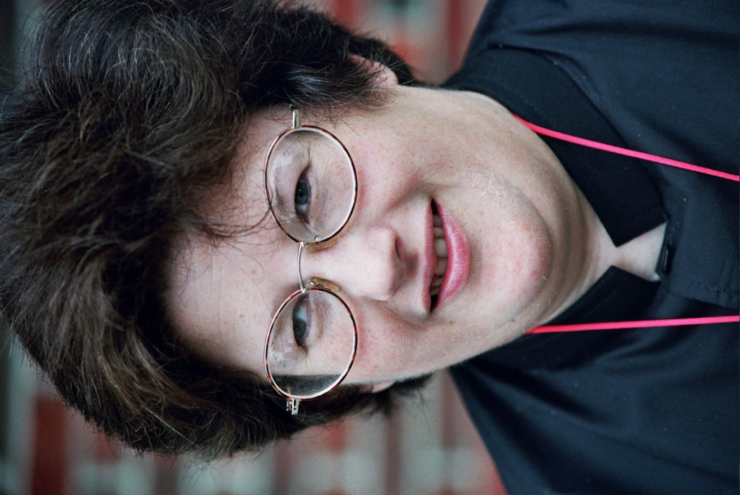
21-0087 Sr. Cecilia Lamoy (later Sr. Martha)

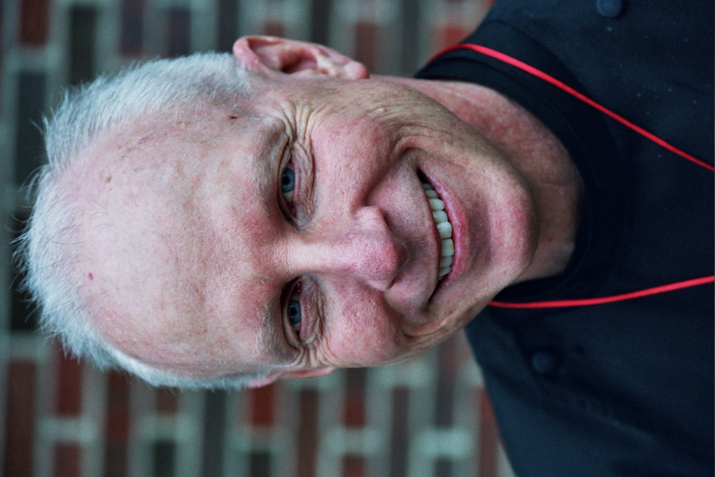
21-0088 Br. David Vincent Cotton (later Br. Robert)

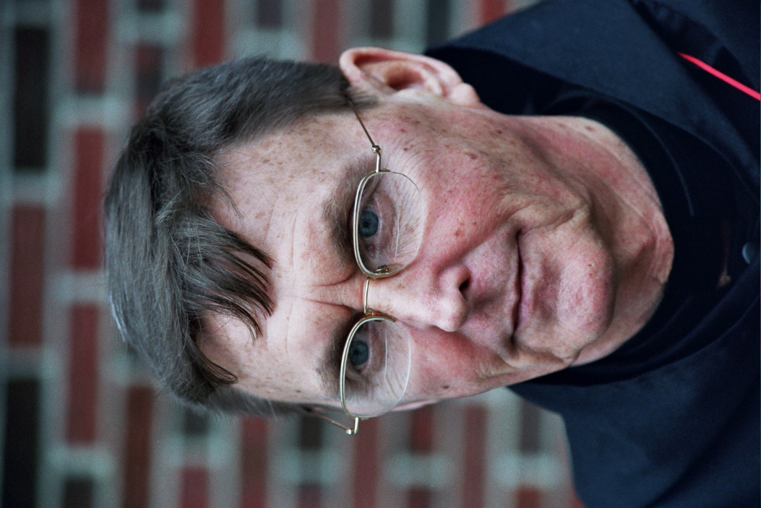
21-0089 Br. Camillus Converse

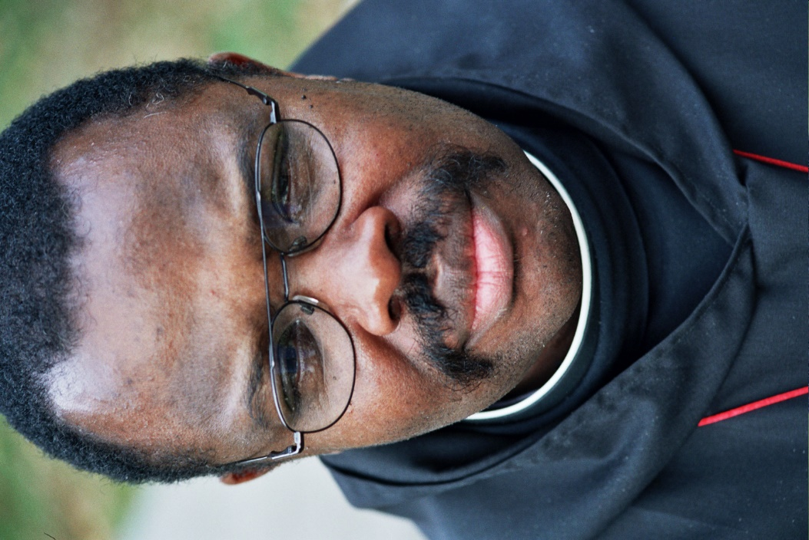
21-0090 Br. Thomas Ferrell

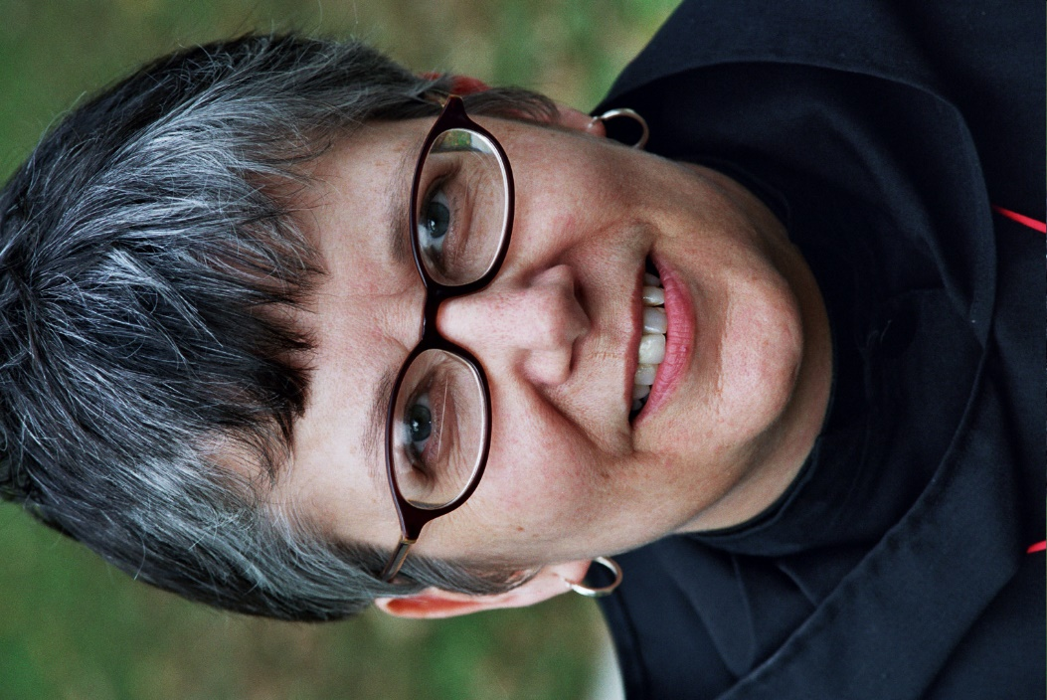
21-0091 Sr. Anna Grace Madden


21-0092 Fr. Wayne Kamm

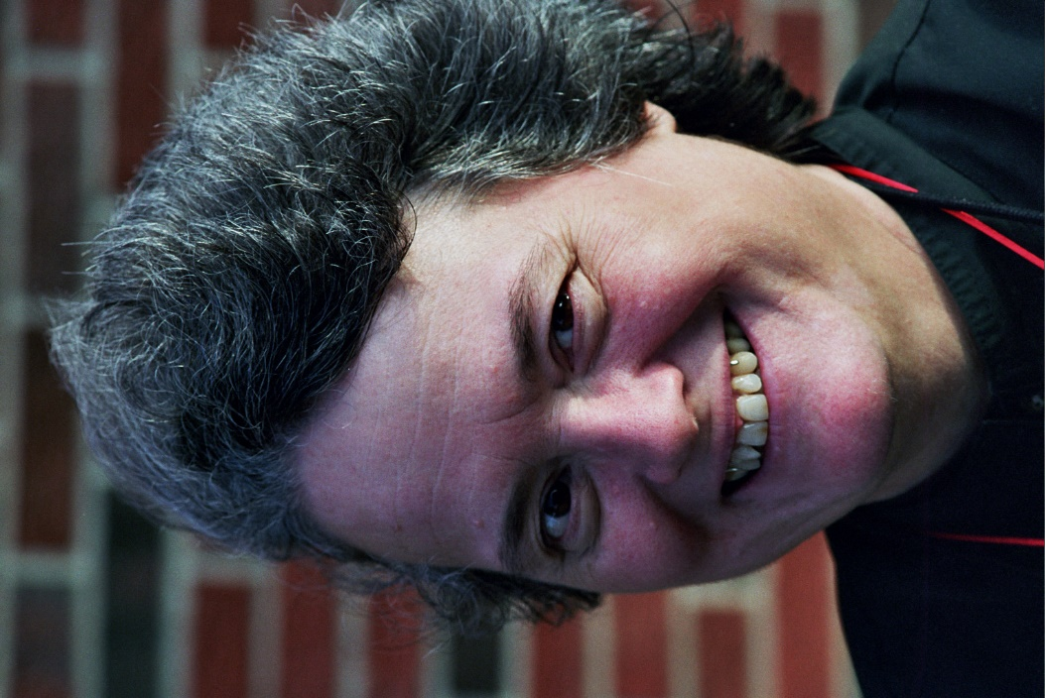
9-0102 Sr. Vincent Marie Rittenhouse (given name Becky)

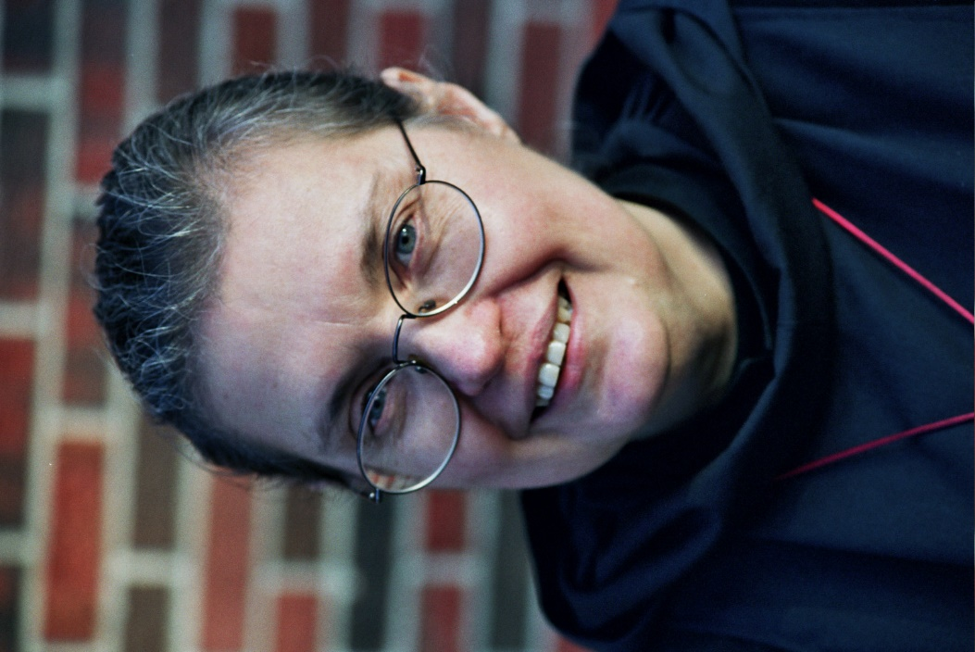
10-0103 Sr. Theodora of Jesus Perecca
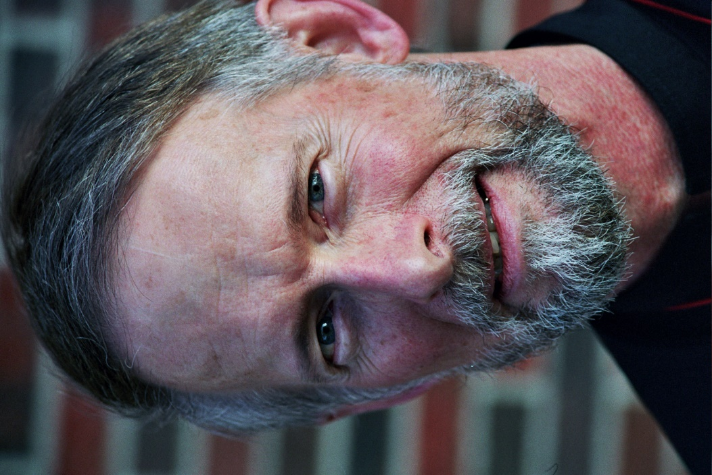
11-0104 Br. Lawrence Mullen

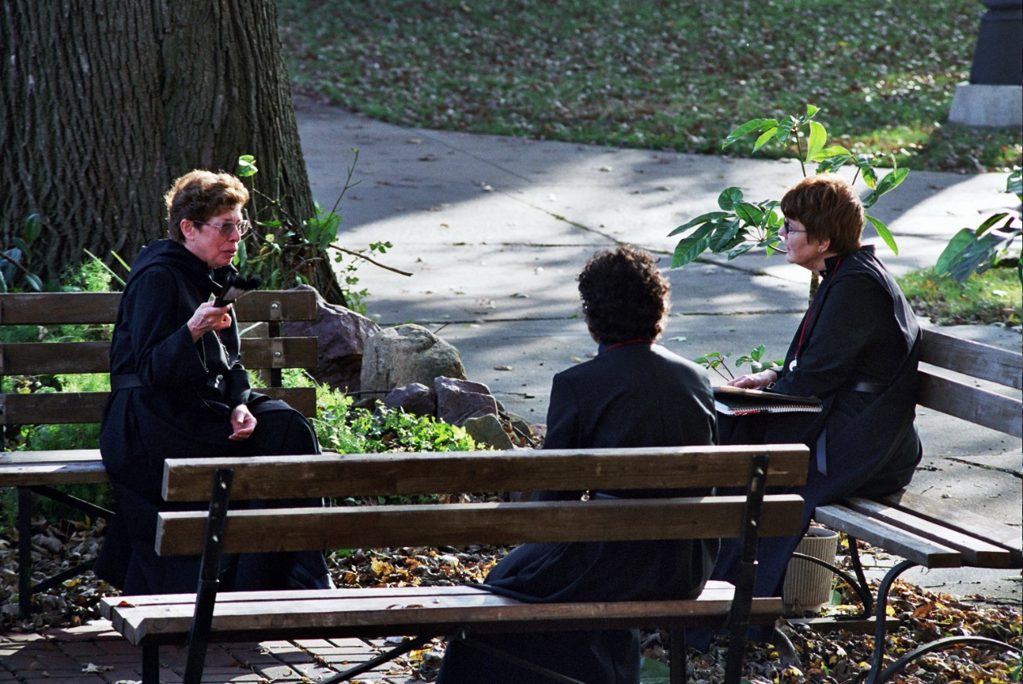
12-0105 Sr. Monica Ruth Mullen; Sr. Julian Baker; Sr. Brigid Gerns

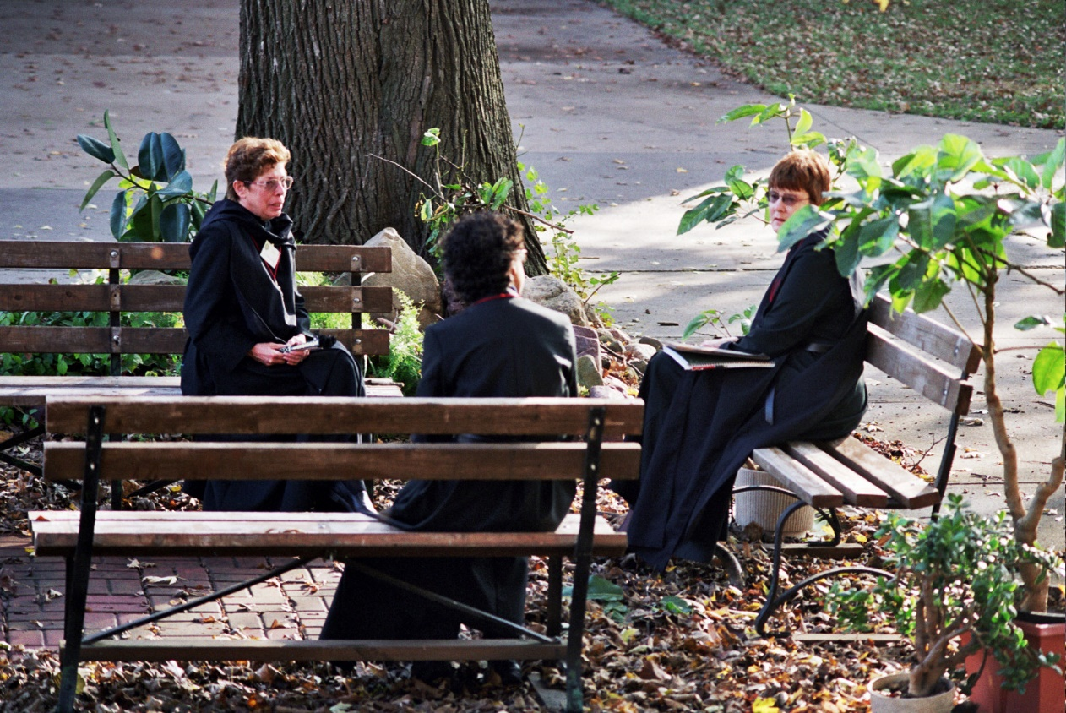
13-0106 Sr. Monica Ruth Mullen; Sr. Julian Baker; Sr. Brigid Gerns

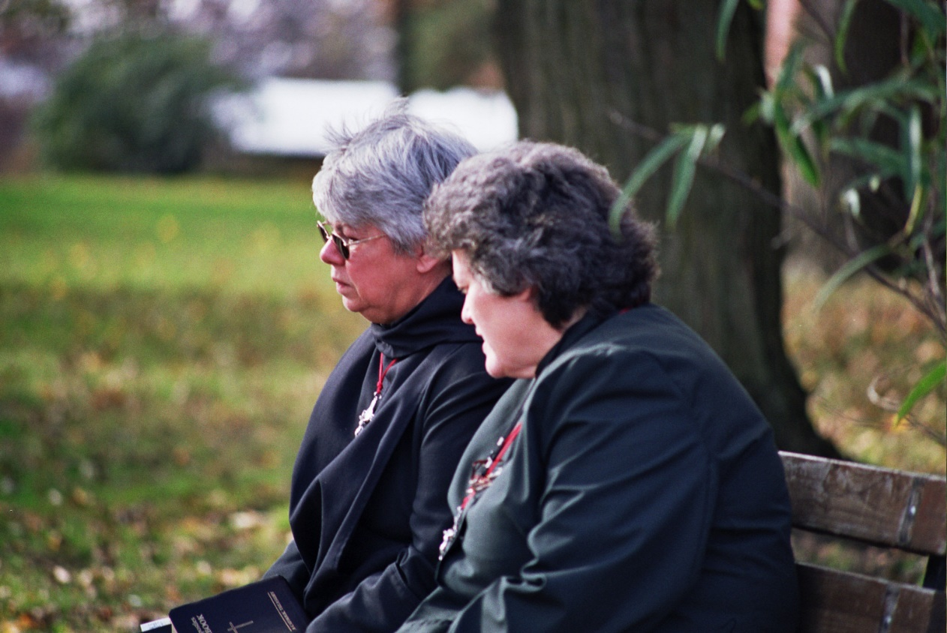
14-0107 Sr. Clare Benedicta Meyers; Sr. Vincent Marie

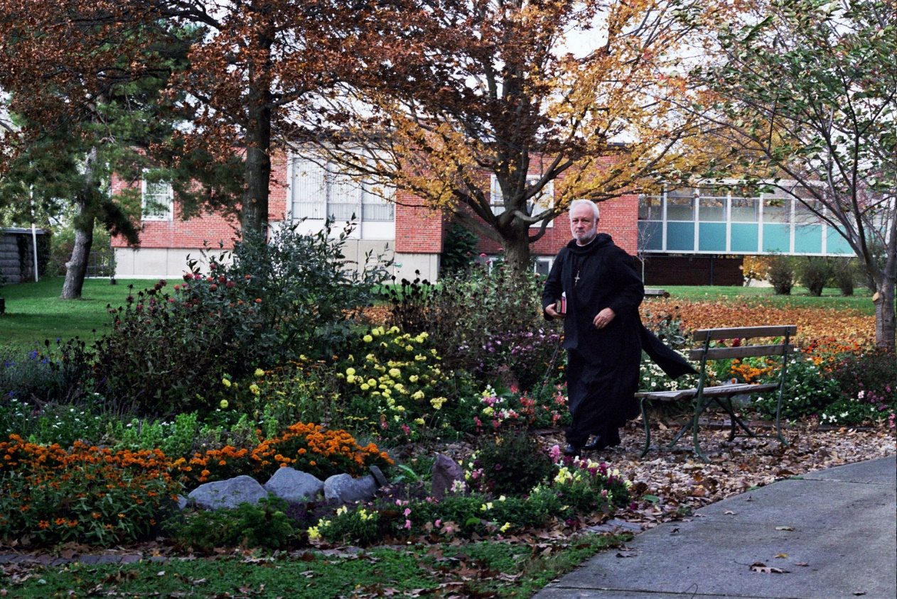
15-0108 Br. Christopher John Baumann

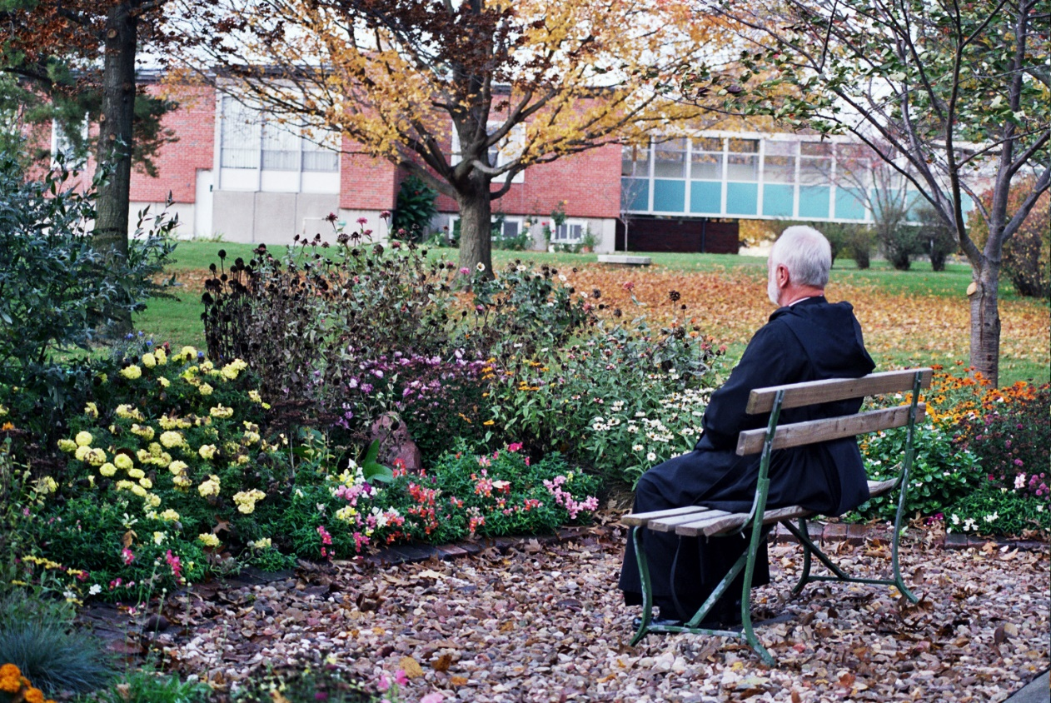
16-0109 Br. Christopher John Baumann


23-0116 Mary Kamm
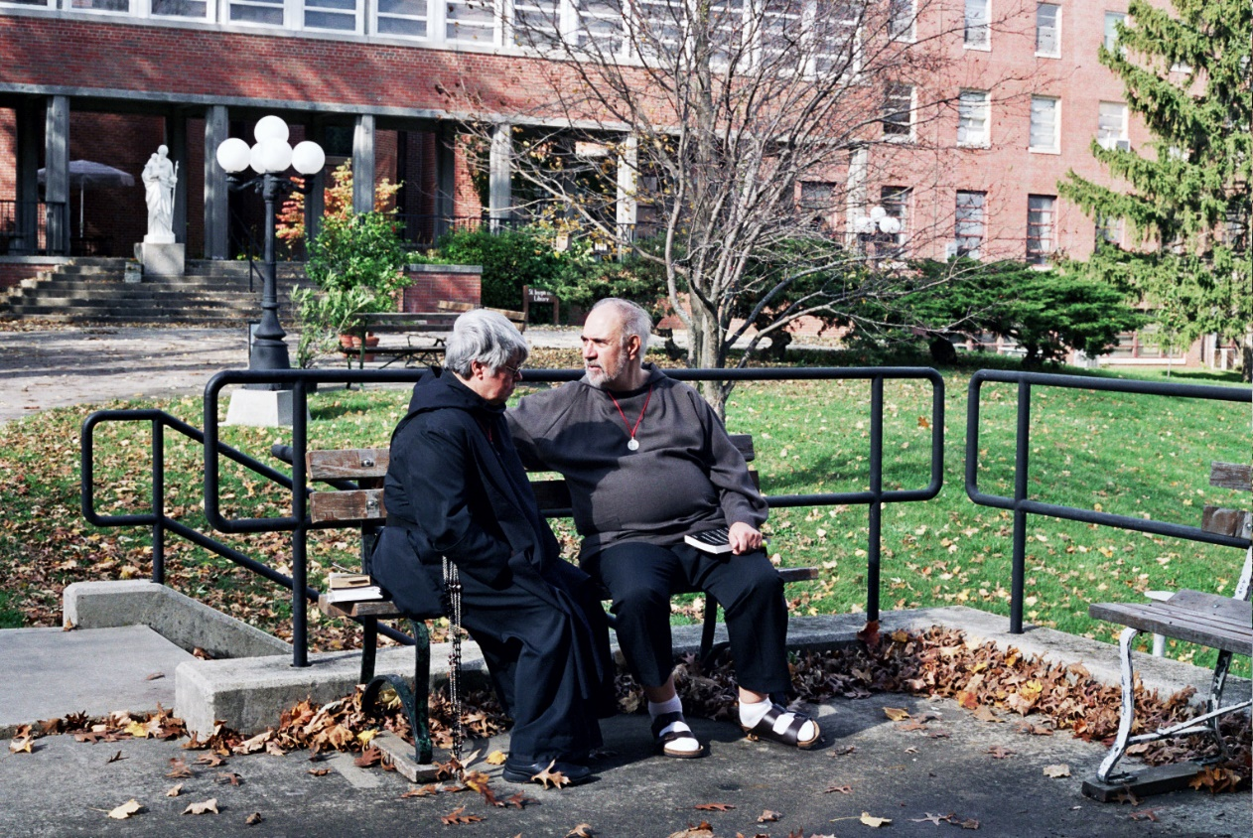
26-0019 Sr. Clare Benedicta Meyers; Br. Joseph Benedict DiMauro

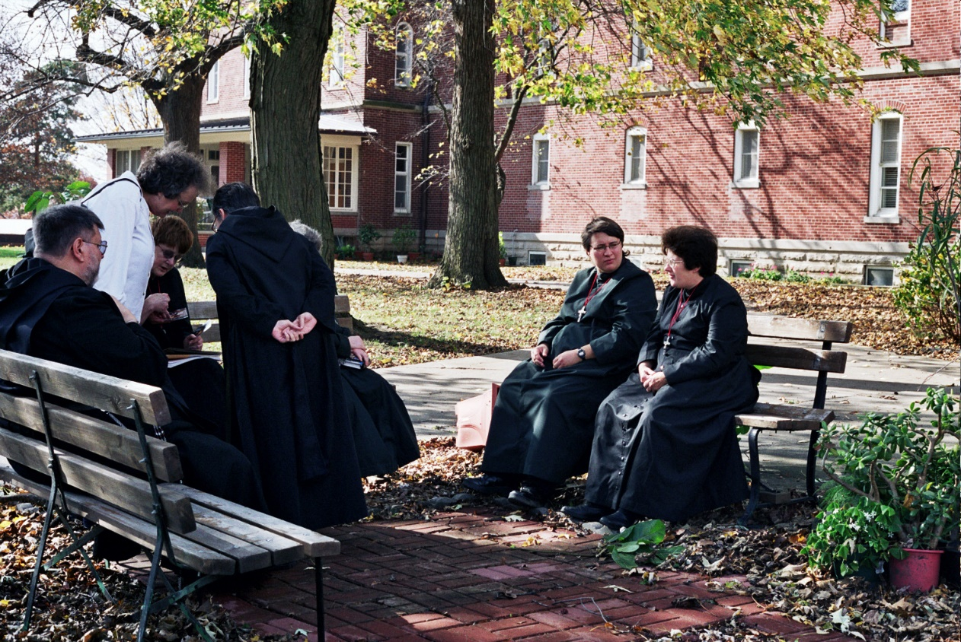
27-0120 Br. Nathan Gregory Miller; Becky Rittenhouse; Sr. Brigid Gerns; Sr. Vincent Marie Rittenhouse; Sr. Pauline Tysol; Sr. Cecelia Lamoy (later Sr. Martha)

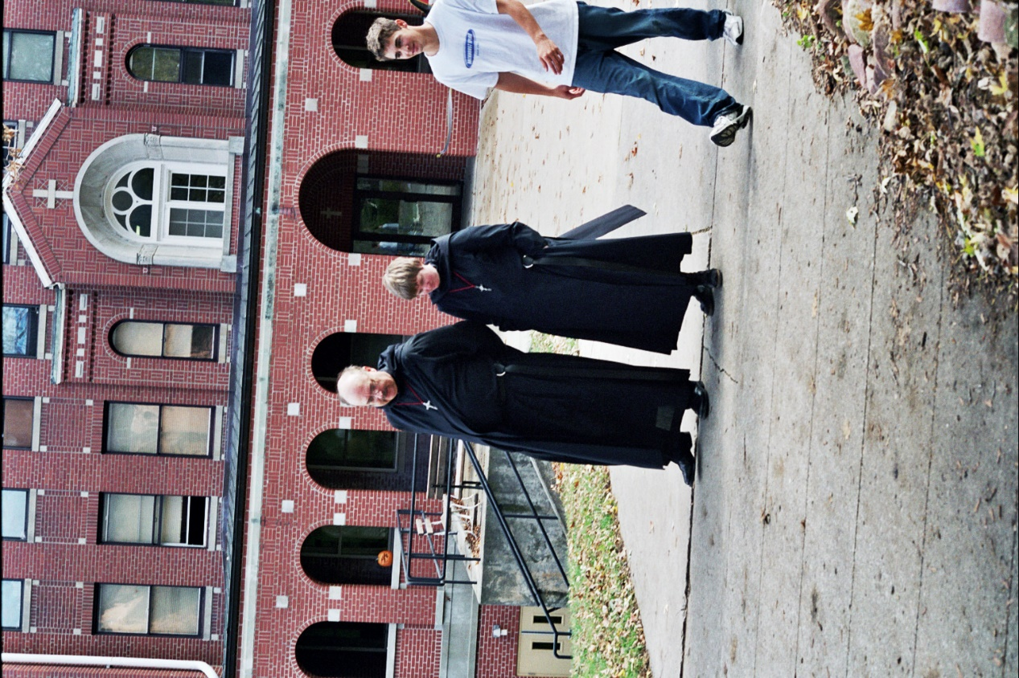
28-0121 Br. Raymond Owens; Sr. Catherine Unterseher; Conception Seminary student

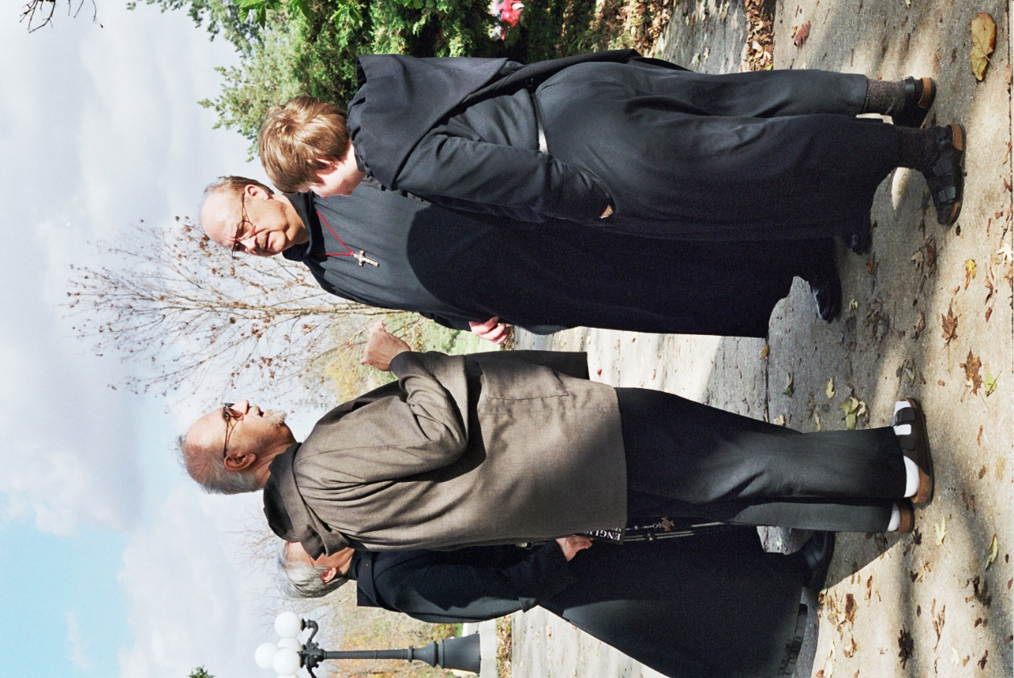
29-0122 Sr. Clare Benedicta; Br. Joseph Benedict DiMauro; Br. Raymond Owens; Sr. Catherine Unterseher

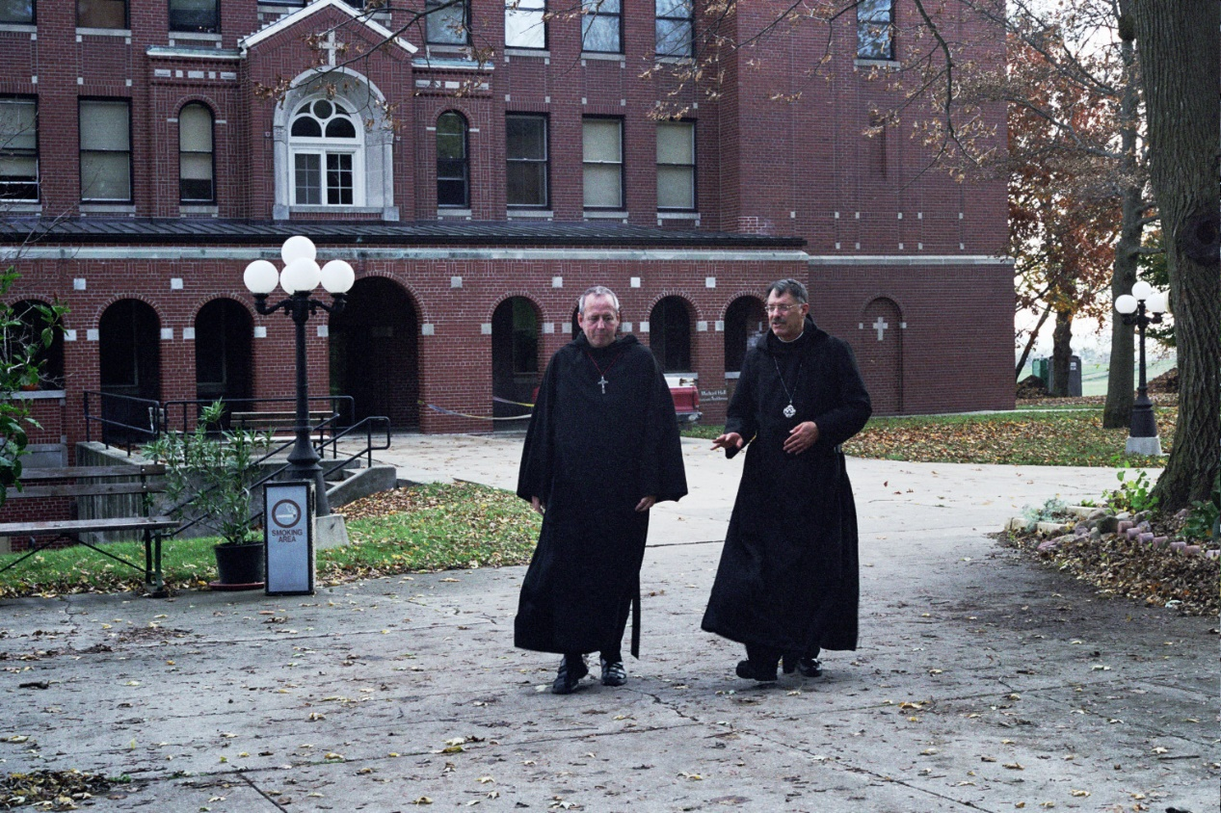
30-0123 Br. Gabriel Hale; Prior Michael John Austin

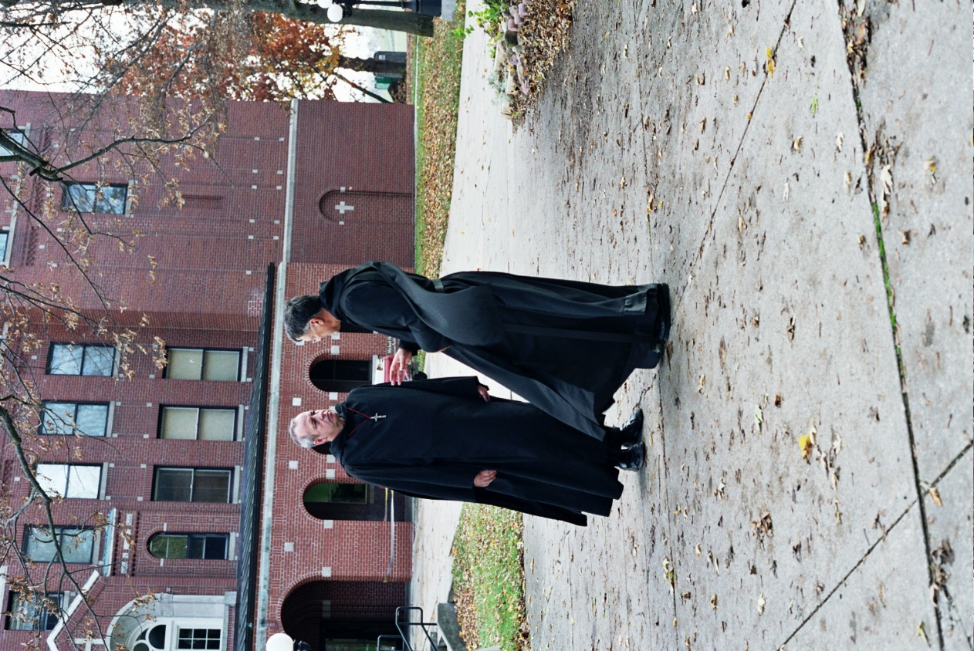
31-0124 Br. Gabriel Hale; Prior Michael John Austin

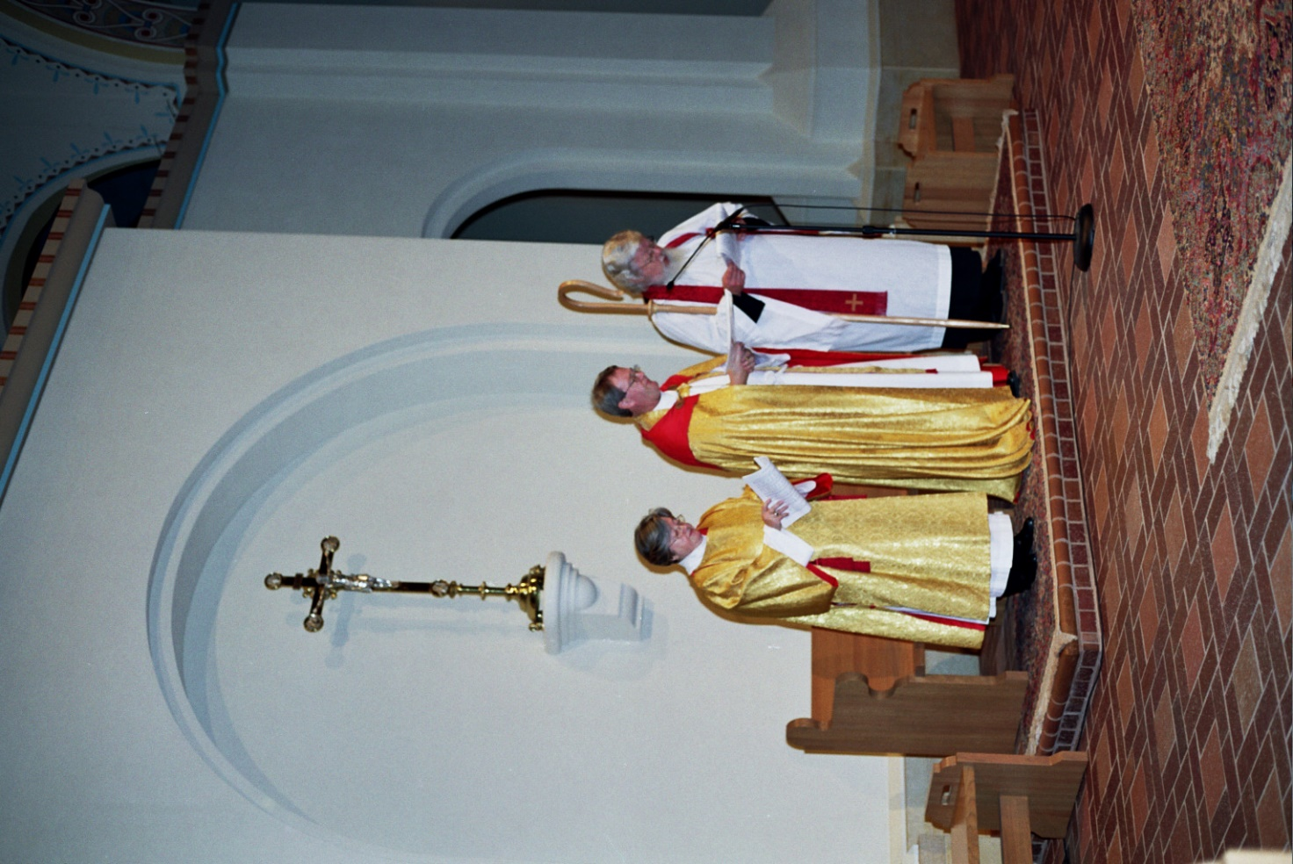
8-0134 Deacon Dian Ong; Bp. Alan Scarfe; Fr. Wayne Kamm
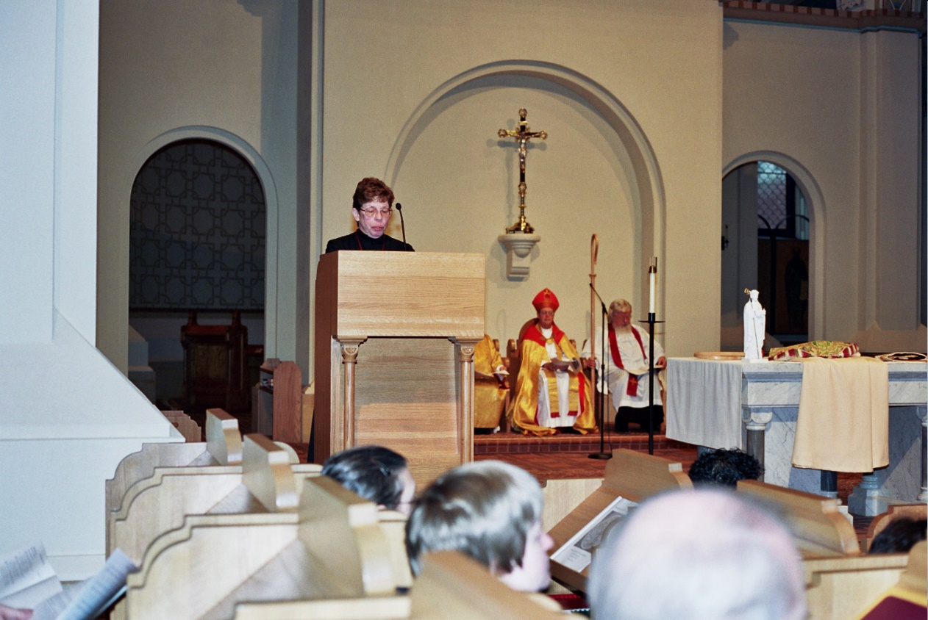
9-0135 Sr. Theodora of Jesus Perecca; Sr. Monica Ruth Mullen; Sr. Monica Ruth Mullen; Bp. Alan Scarfe; Fr. Wayne Kamm

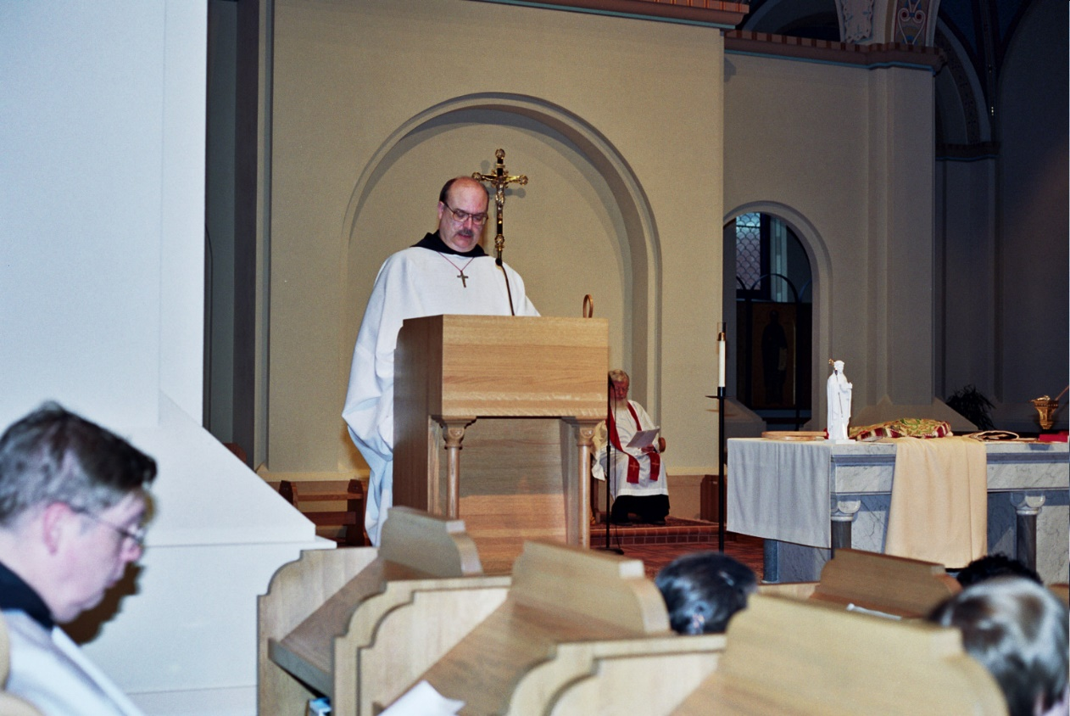
10-0136 Br. Chad Anselm Gerns; Br. Raymond Owens; Fr. Wayne Kamm

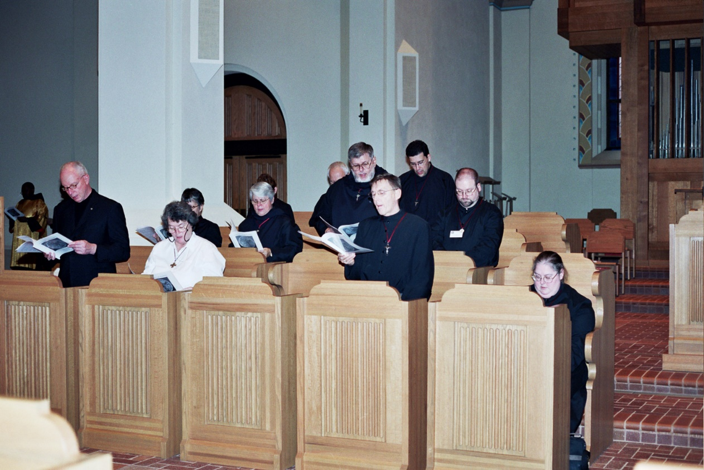
11-0137 Br. David Vincent Cotton; Becky Rittenhouse; Sr. Anna Grace Madden; Sr. Clare Benedicta Meyers; Br. Nathan Gregory Miller; Br. Camillus Converse; Br. Anthony Bernard Campos; Br. Willard Moore; Sr Margaret Moore

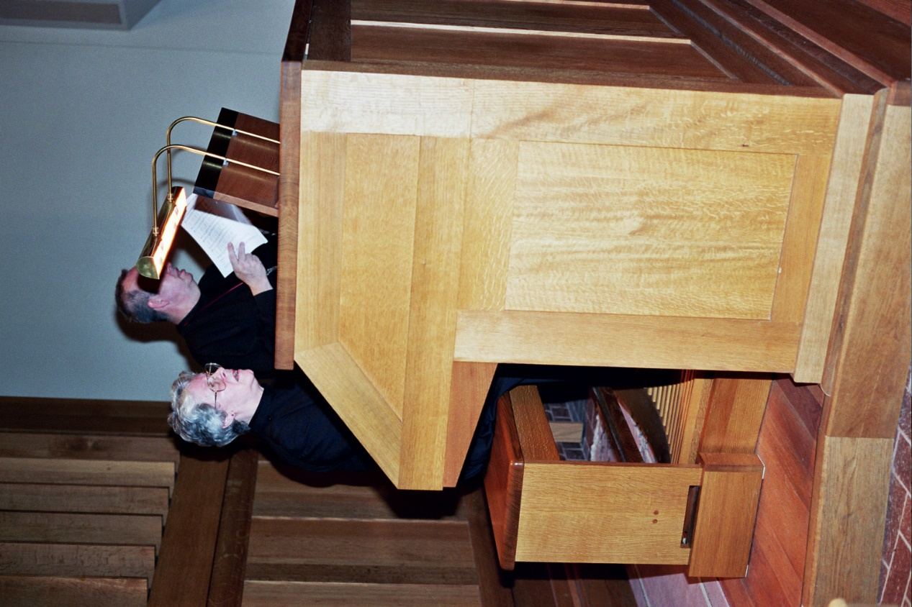
12-0138 Sr. Johanna Kirkpatrick; Br. Gabriel Hale

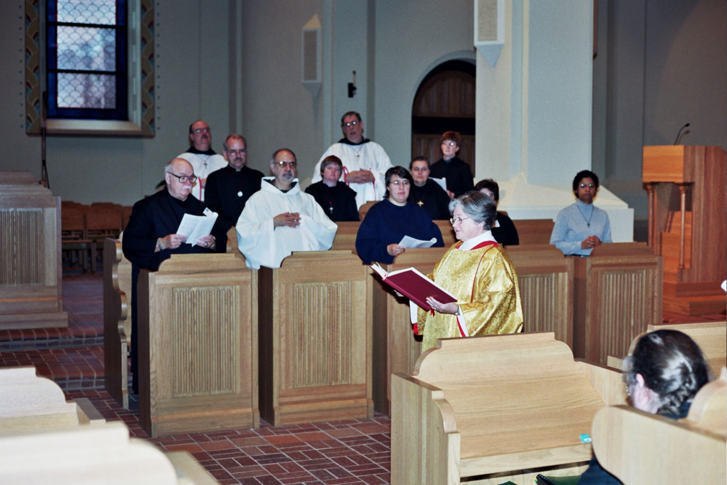
13-0139 Br. Benedict Truitt; Br. Raymond Owens; Br. Daniel Joseph Schroeder; Br. Joseph Benedict DiMauro; Sr. Catherine Unterseher; Br. Chad Anselm Gerns; Sr. Pauline Tysol; Sr. Theodora of Perecca; Sr. Brigid Gerns; Deacon Dian Ong; Sr. Cecelia Lamoy; Sr. Julian Baker; Sr. Denise Moore

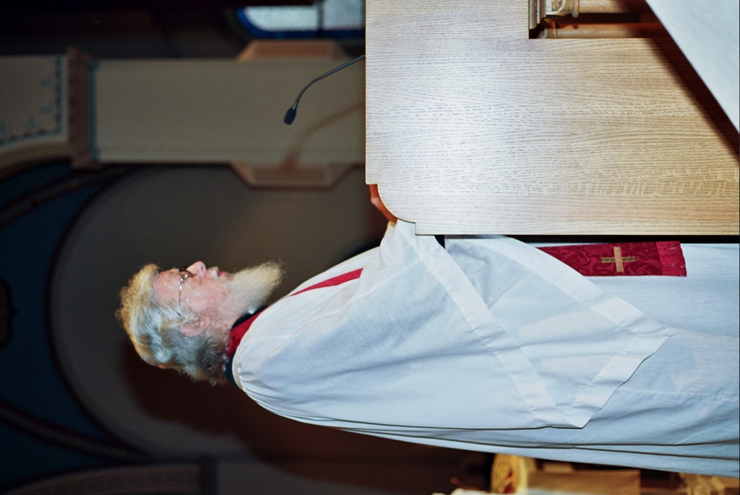
14-0140 Fr. Wayne Kamm
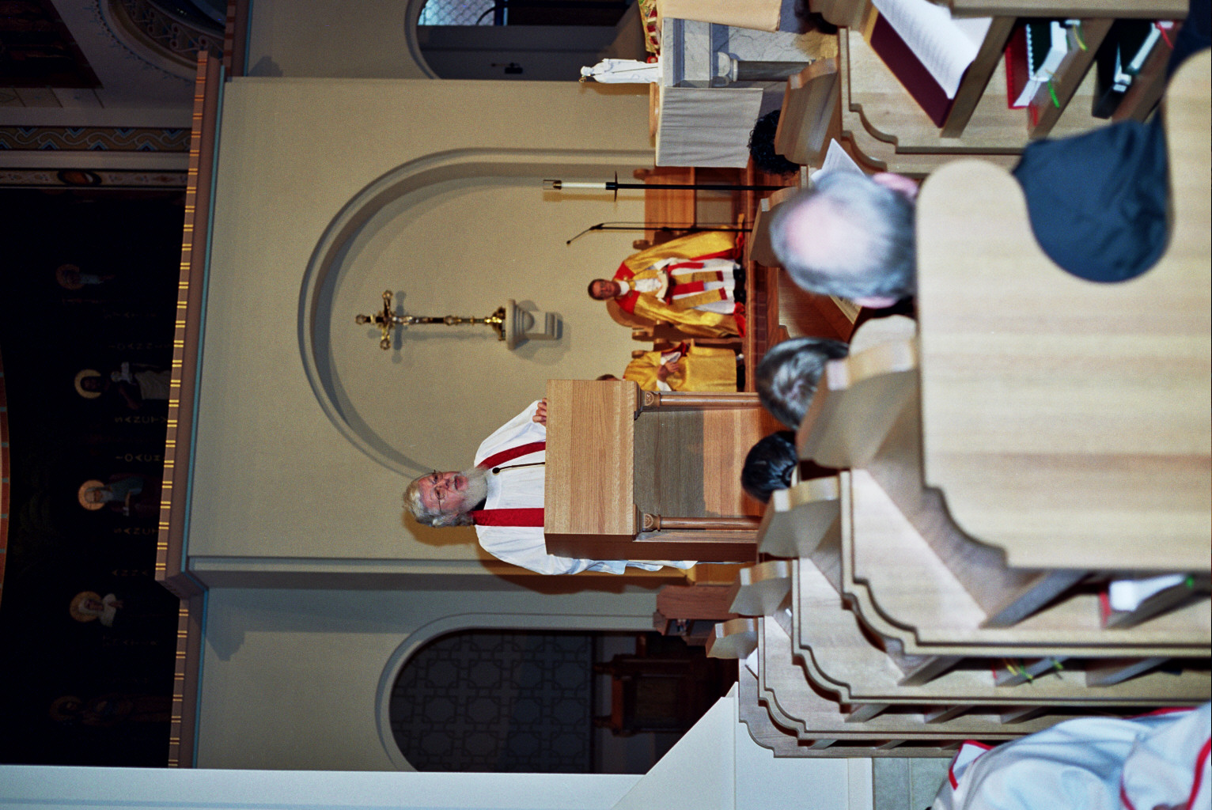
15-0141 Fr. Wayne Kamm; Bp. Alan Scarfe

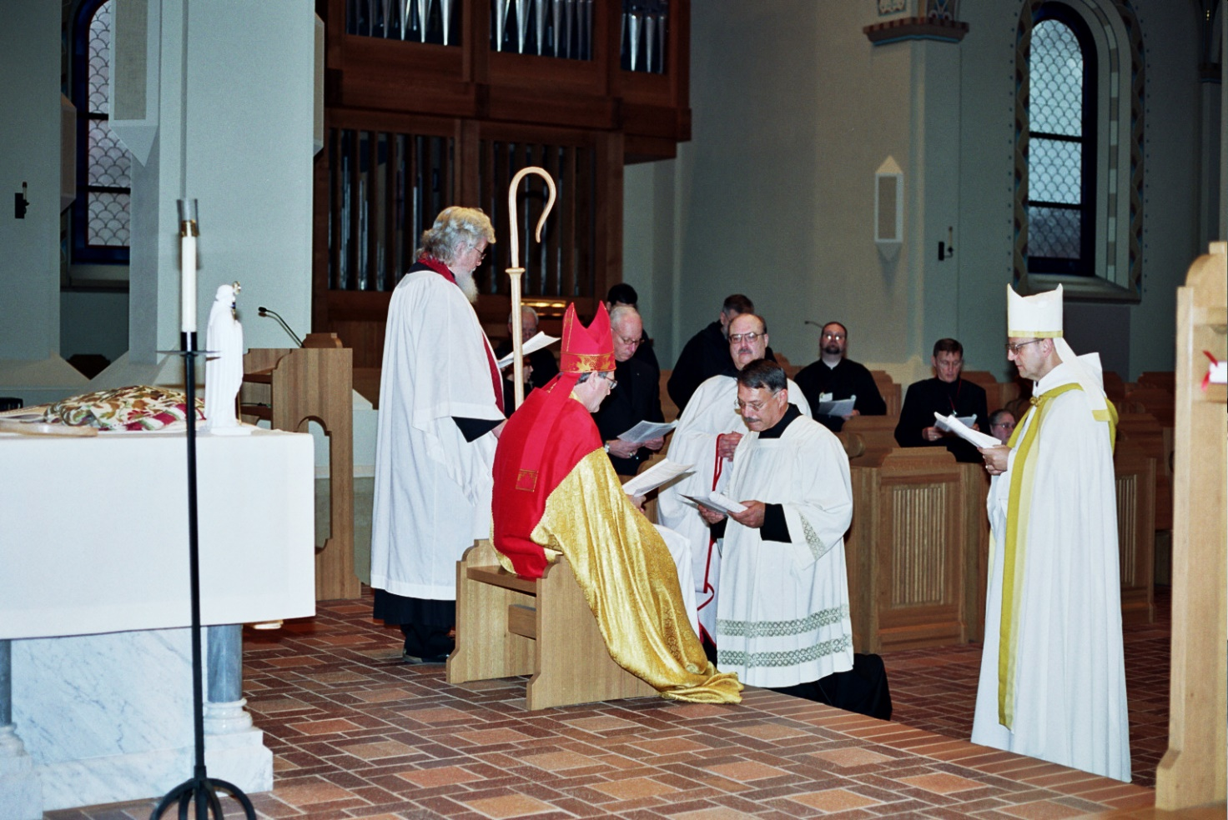
14-0142 Fr. Wayne Kamm; Bp. Alan Scarfe; Br. David Vincent Cotton; Br. Raymond Owens; Br. Prior Michael John Austin; Br. Willard Moore; Br. Camillus Converse; Sr. Margaret Moor; Abbot Gregory Polan

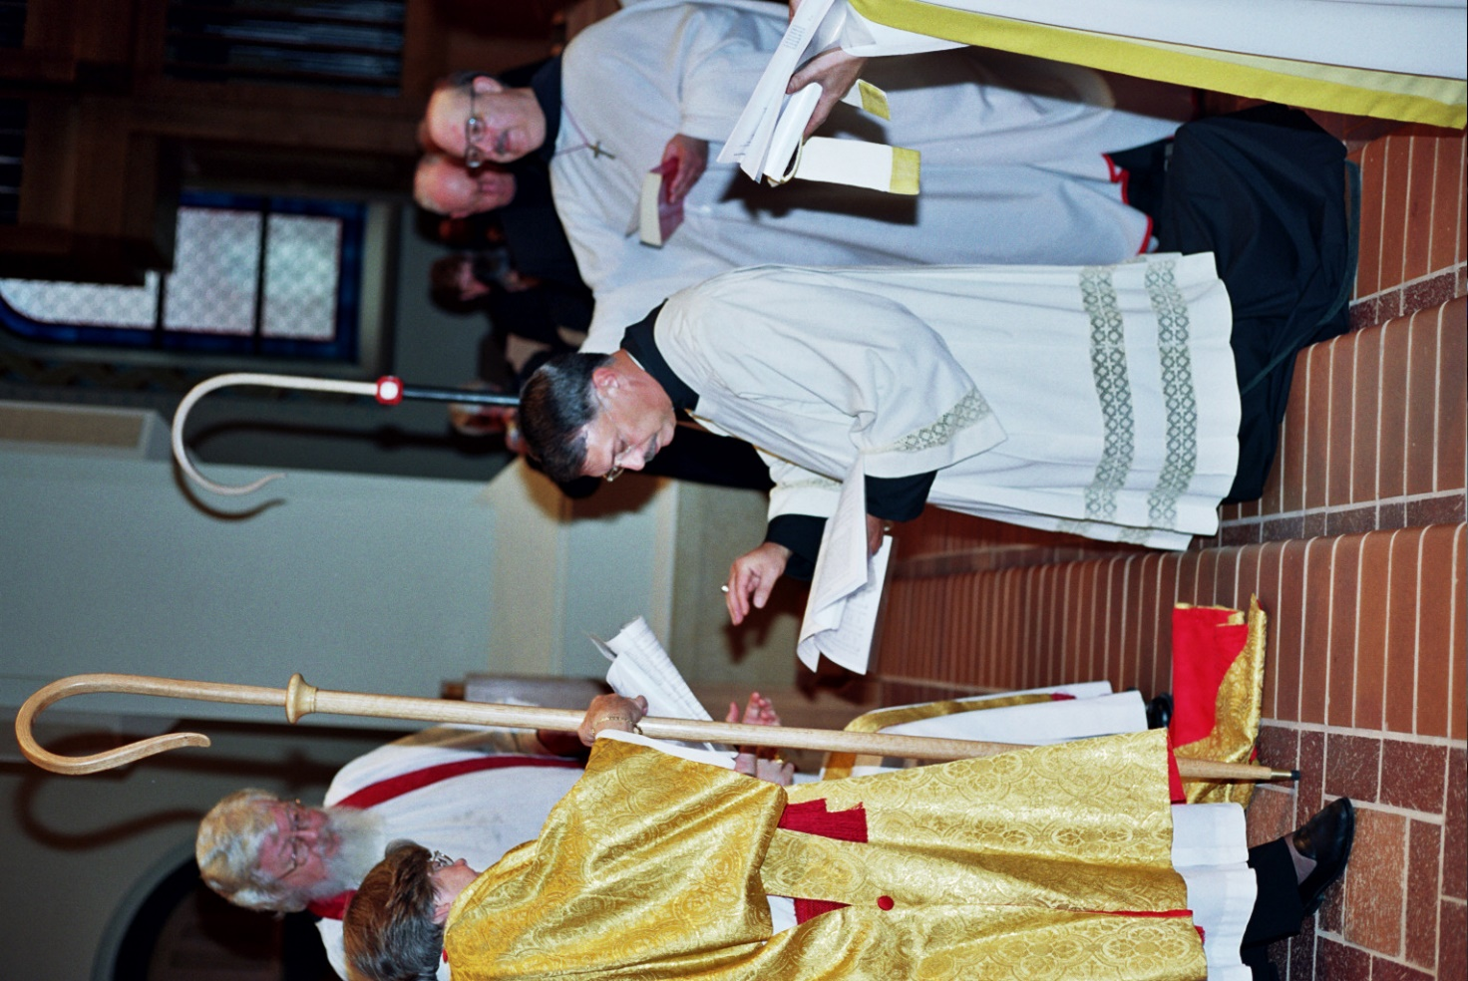
17-0143 Deacon Dian Ong; Fr. Wayne Kamm; Prior Michael John Austin; Br. David Vincent Cotton; Br. Raymond Owens

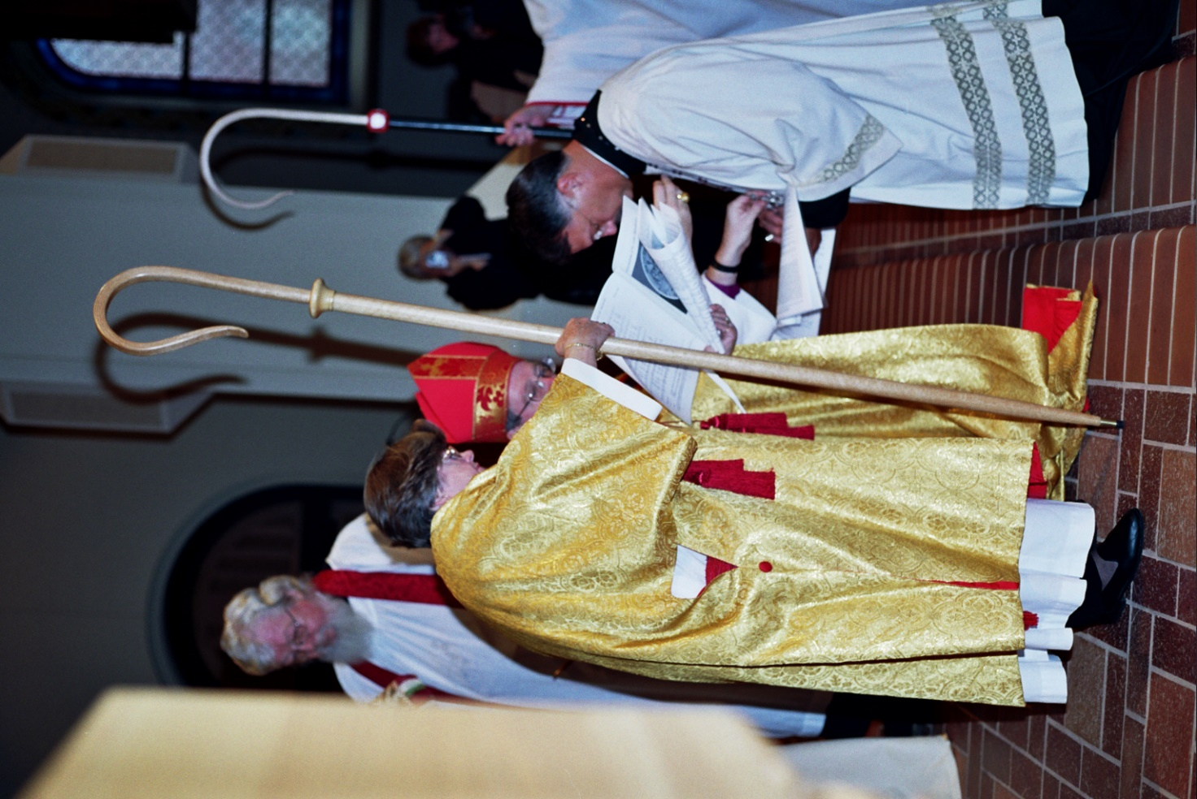
18-0144 Fr. Wayne Kamm; Deacon Dian Ong; Bp. Alan Scarfe; Prior Michael John Austin

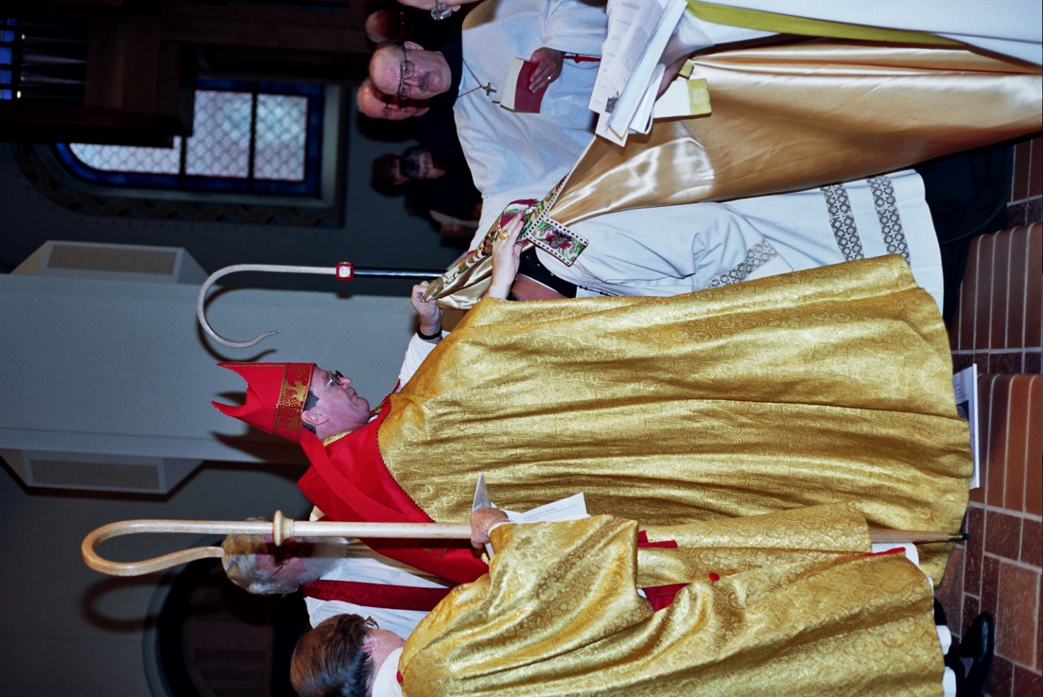
19-0145 Deacon Dian Ong Fr. Wayne Kamm; Bp. Alan Scarfe; Prior Michael John Austin; Br. David Vincent Cotton; Br. Raymond Owens

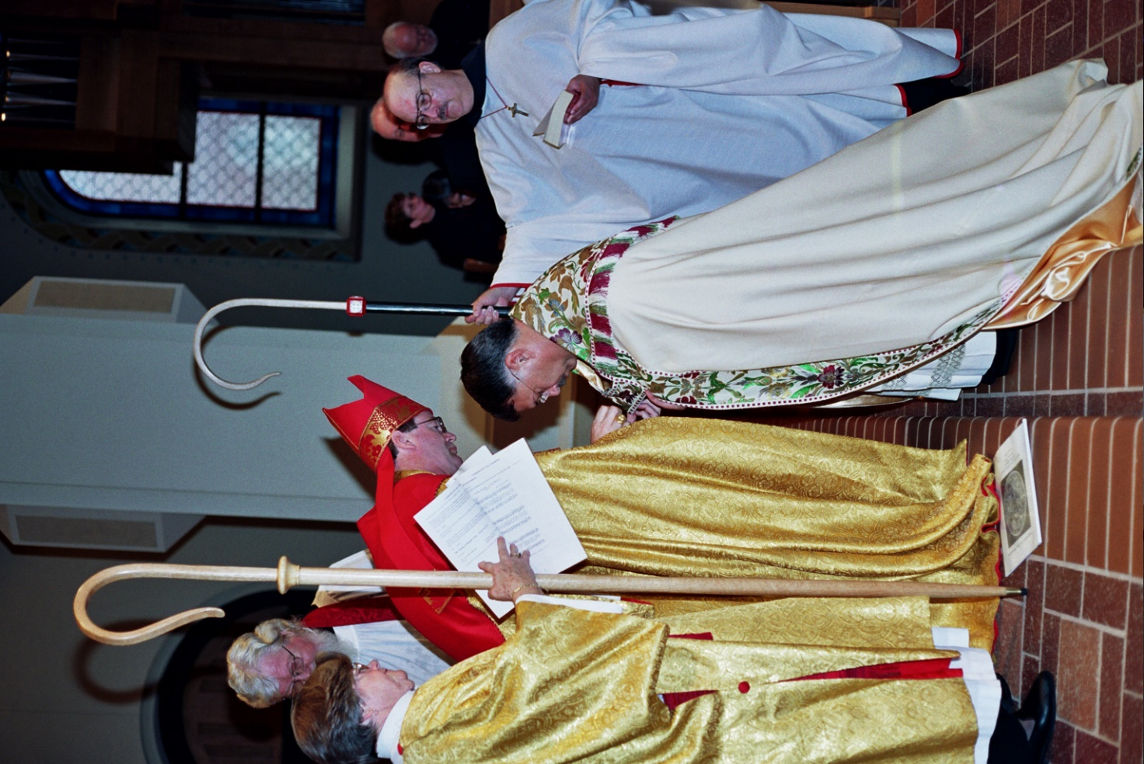
20-0146 Deacon Dian Ong; Fr. Wayne Kamm; Bp. Alan Scarfe; Abbot Michael John Austin; Sr. Monica Ruth Mullen; Br. Raymond Owens

