Companions of St. Luke
Fall 2003 Convocation at Conception Abbey
Part 3 of 6

~Edited by Br. Steven Olderr, 16 May 2022 with the assistance of Br. Thomas Ferrell; if you find any errors or omissions, please notify Br. Steven at olderr@ameritech.net

People are identified from left to right.

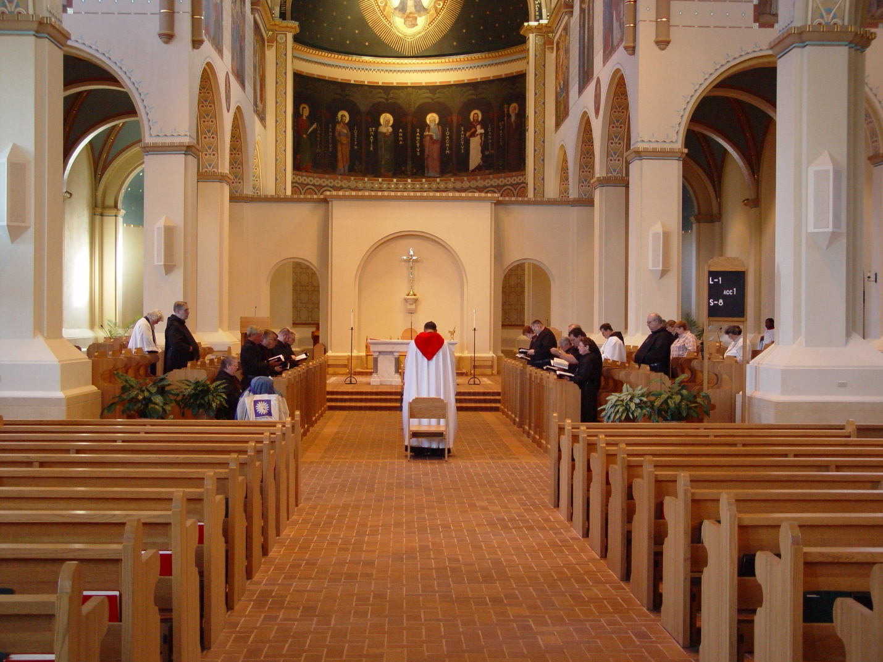
COSL 098

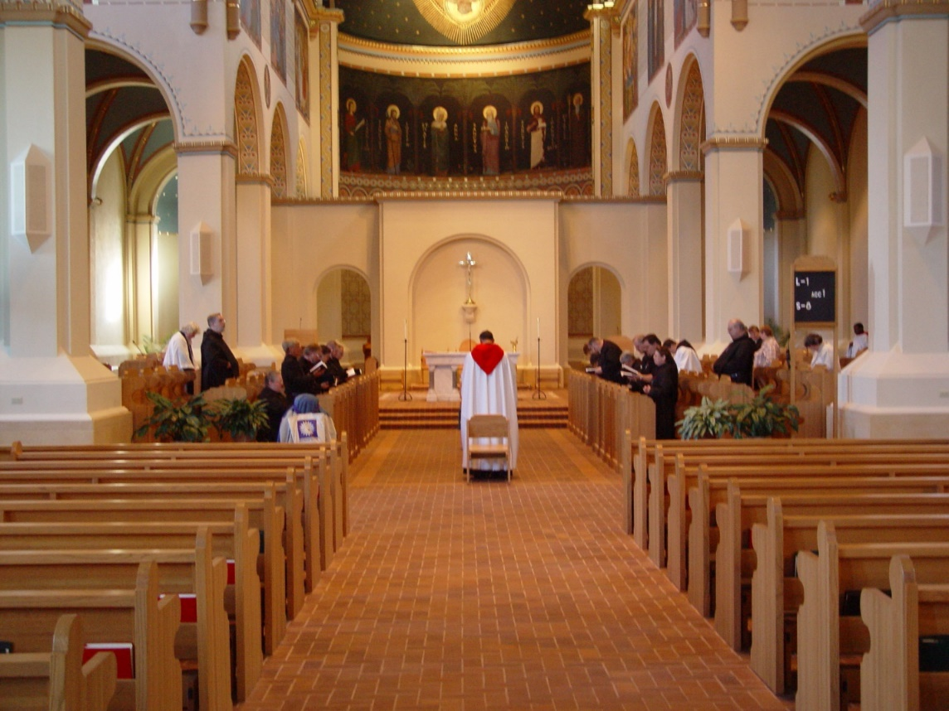
COSL 099

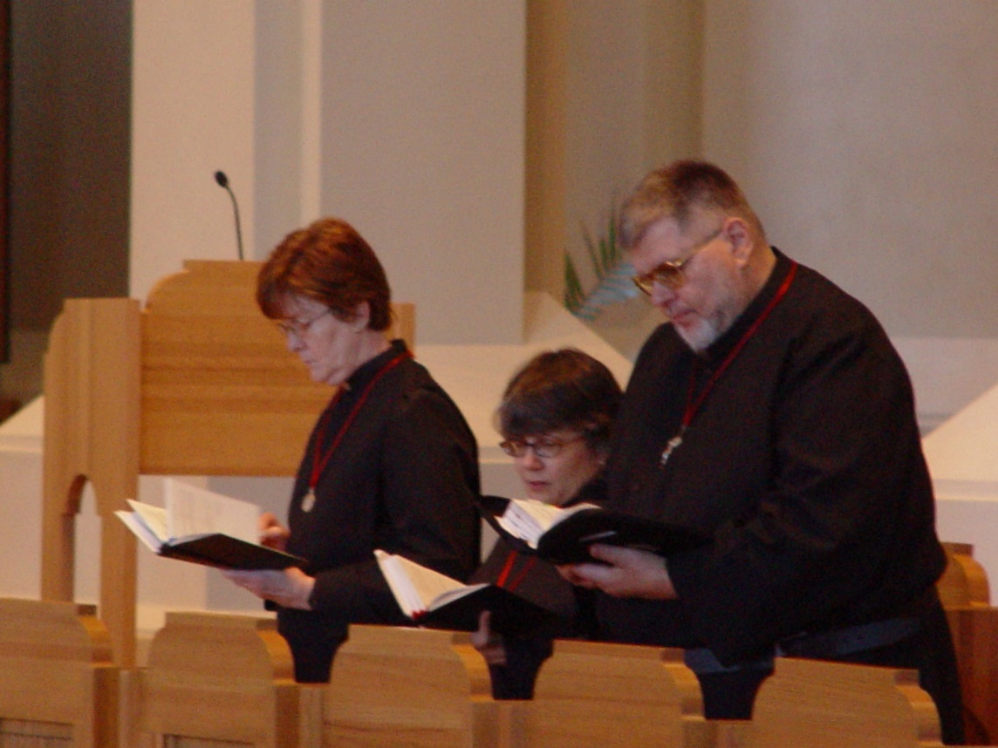
COSL 100 Sr. Ann Gerns; Sr. Anna Grace Madden; Br. Nathan Gregory Miller

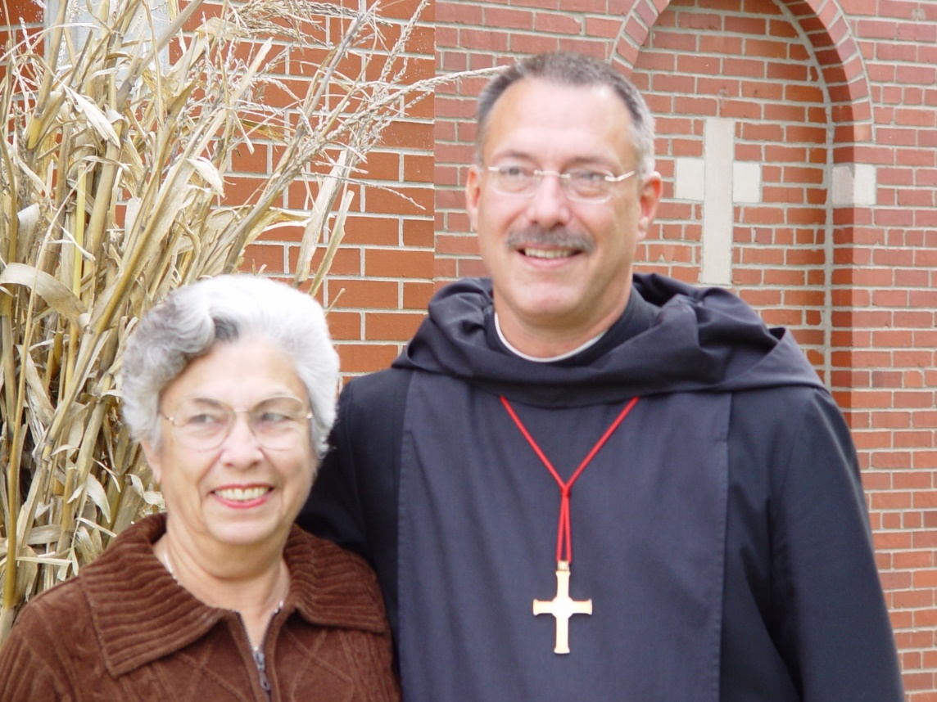
COSL 101 Jeanetta Doan (Prior Michael John’s mother); Prior Michael John Austin
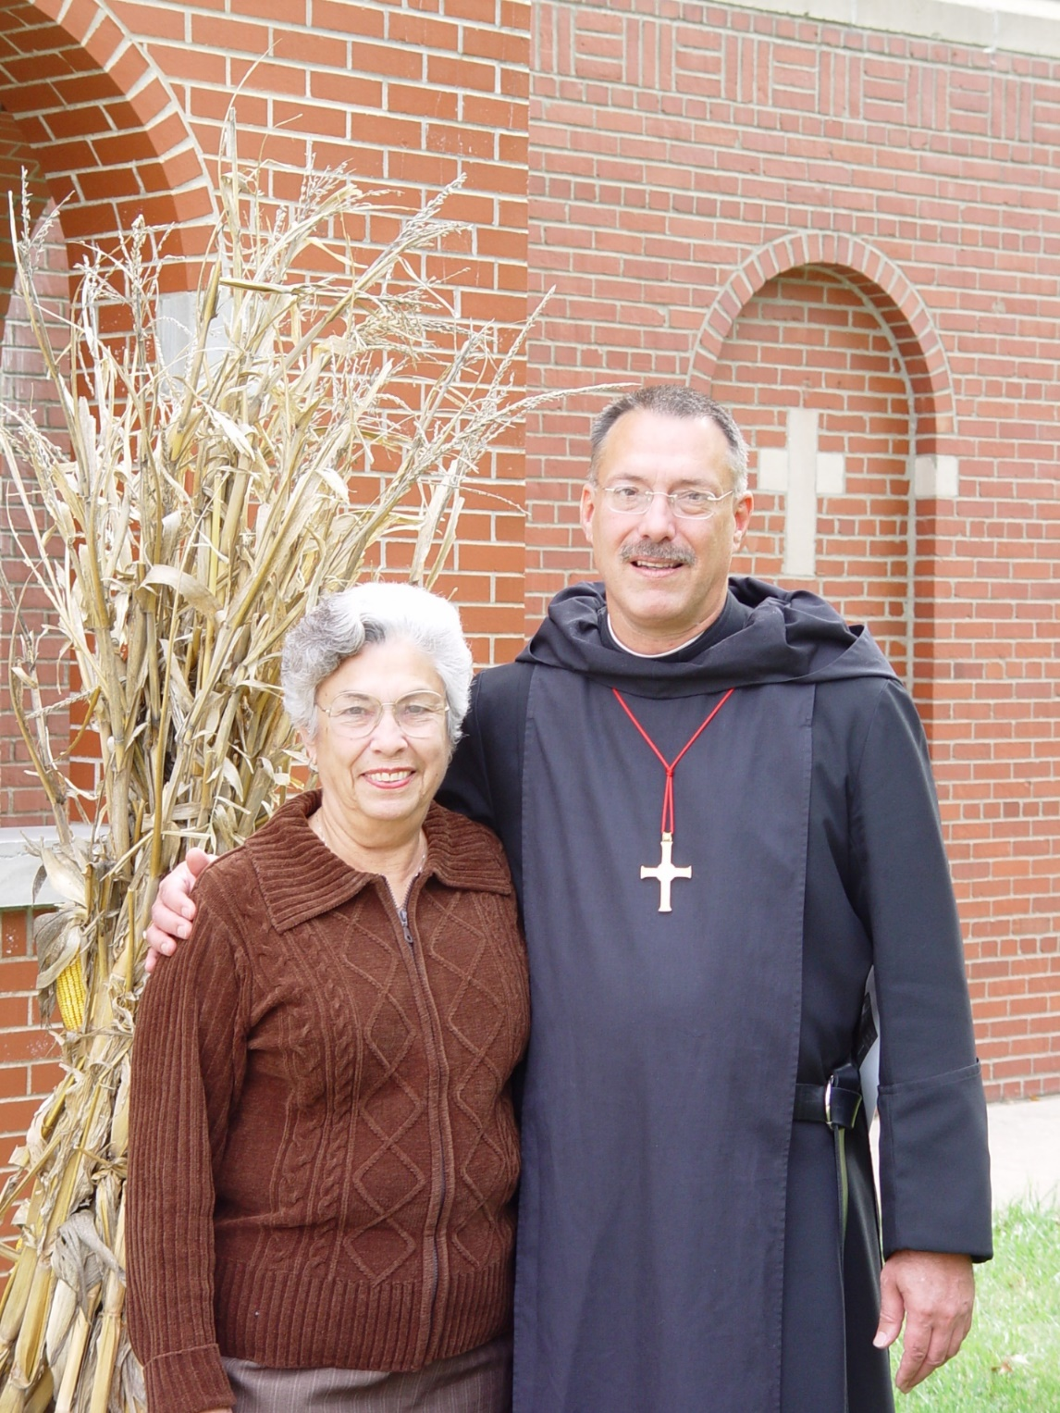
COSL 102 Jeanetta Doan; Prior Michael John Austin

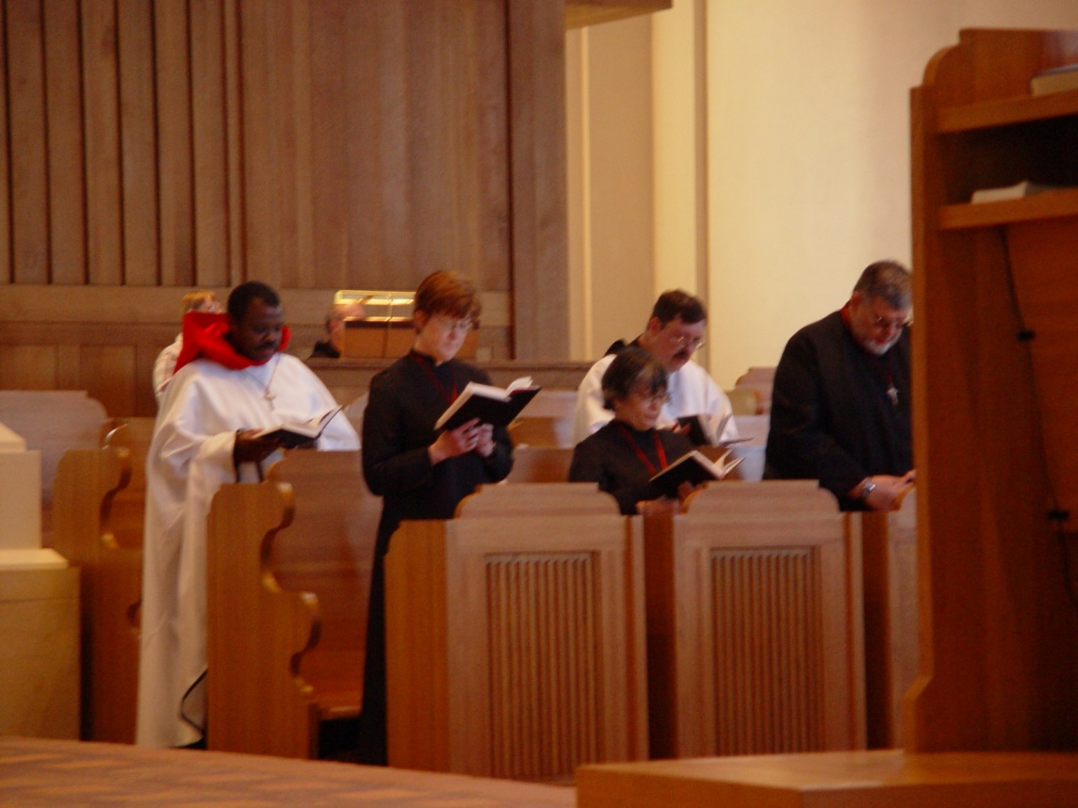
COSL 103 Br. Thomas Ferrell; Sr. Ann Gerns; Sr. Anna Grace Madden; Br. Paul Howard; Br. Nathan Gregory Miller
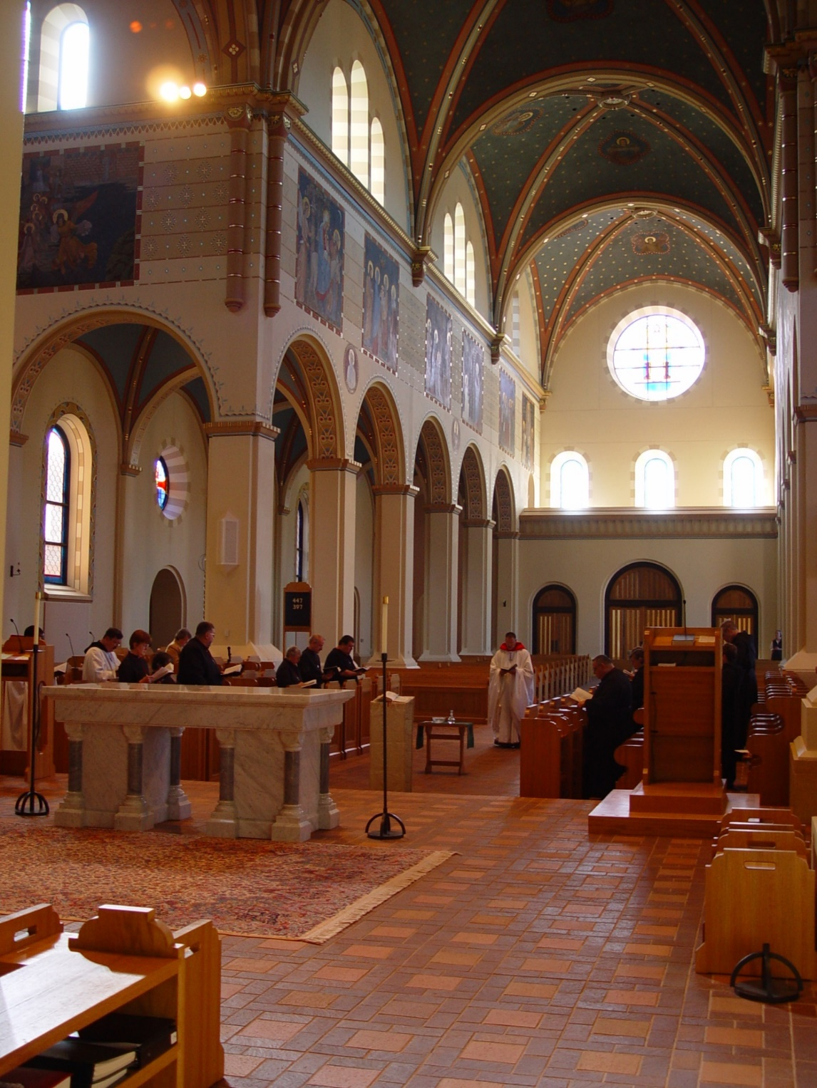
COSL 104
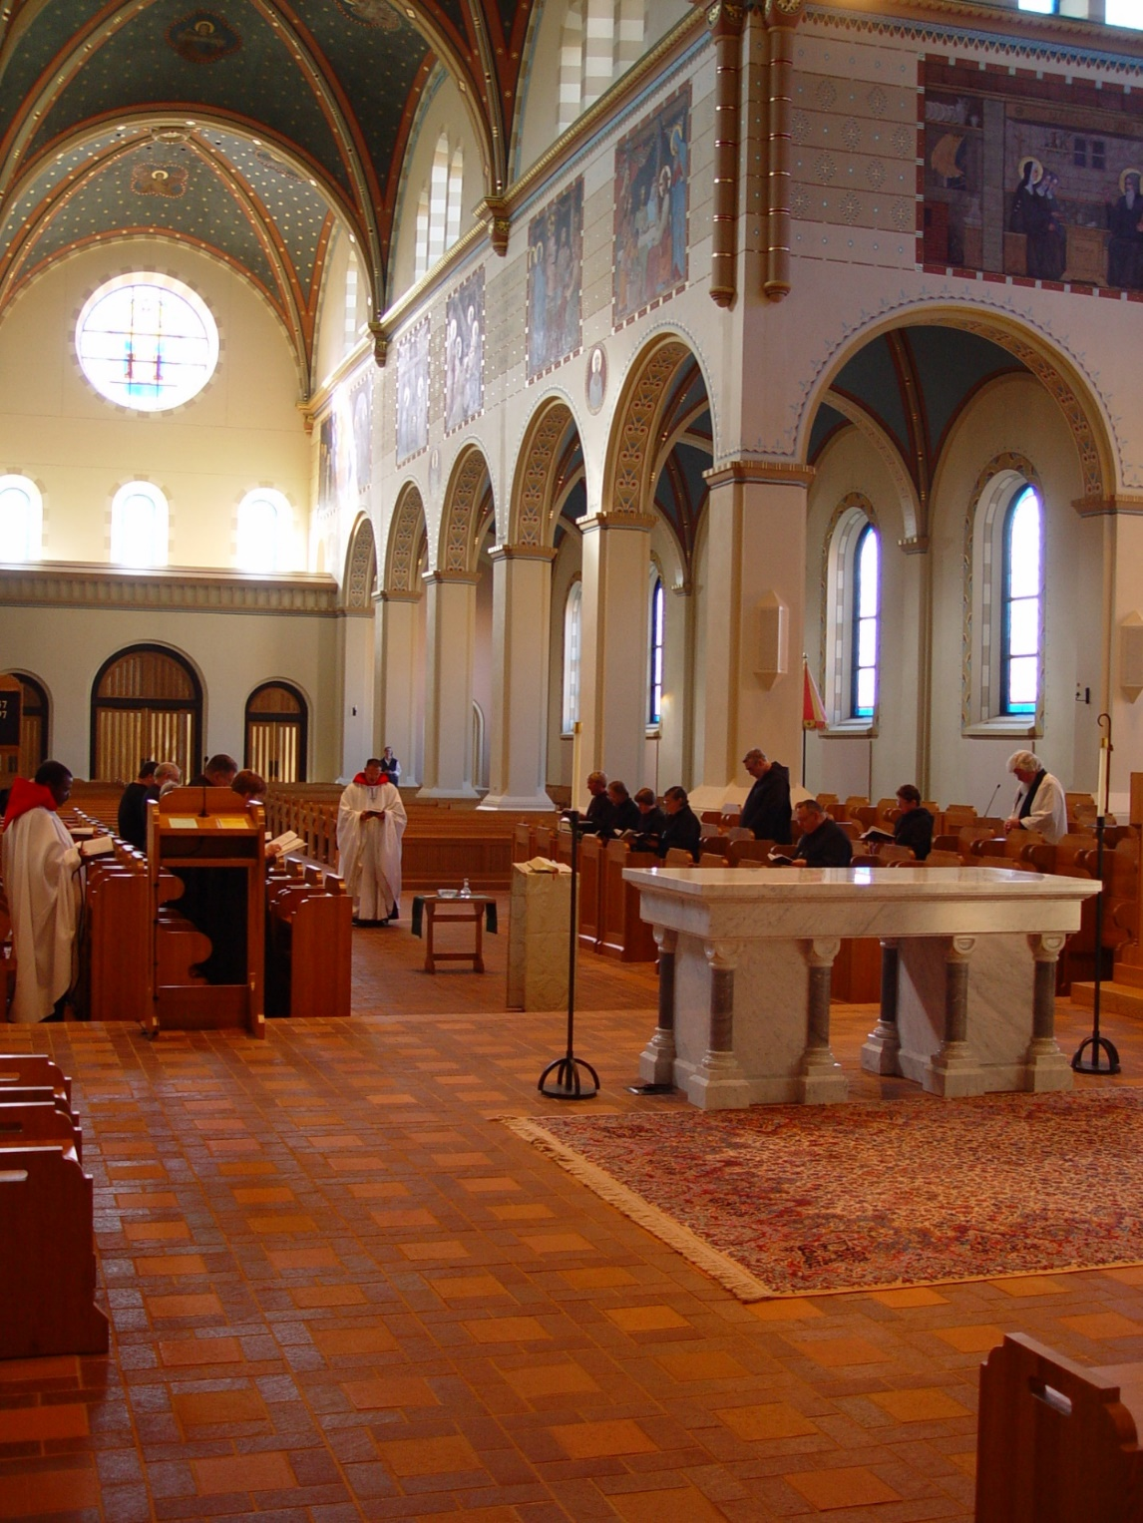
COSL 105
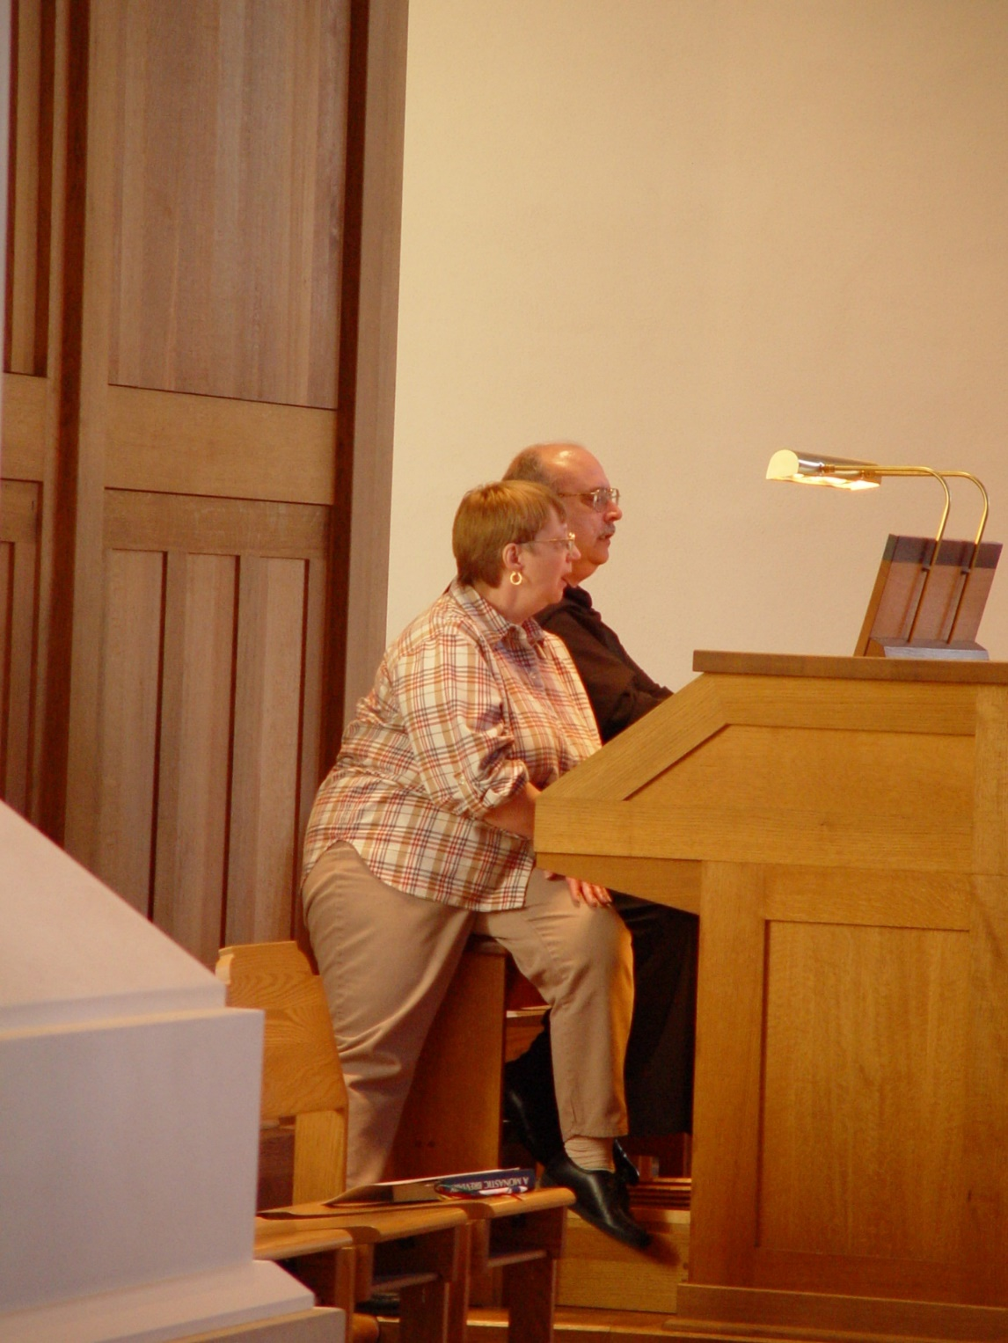
COSL 106 Lynn Owens; Br. Raymond Owens
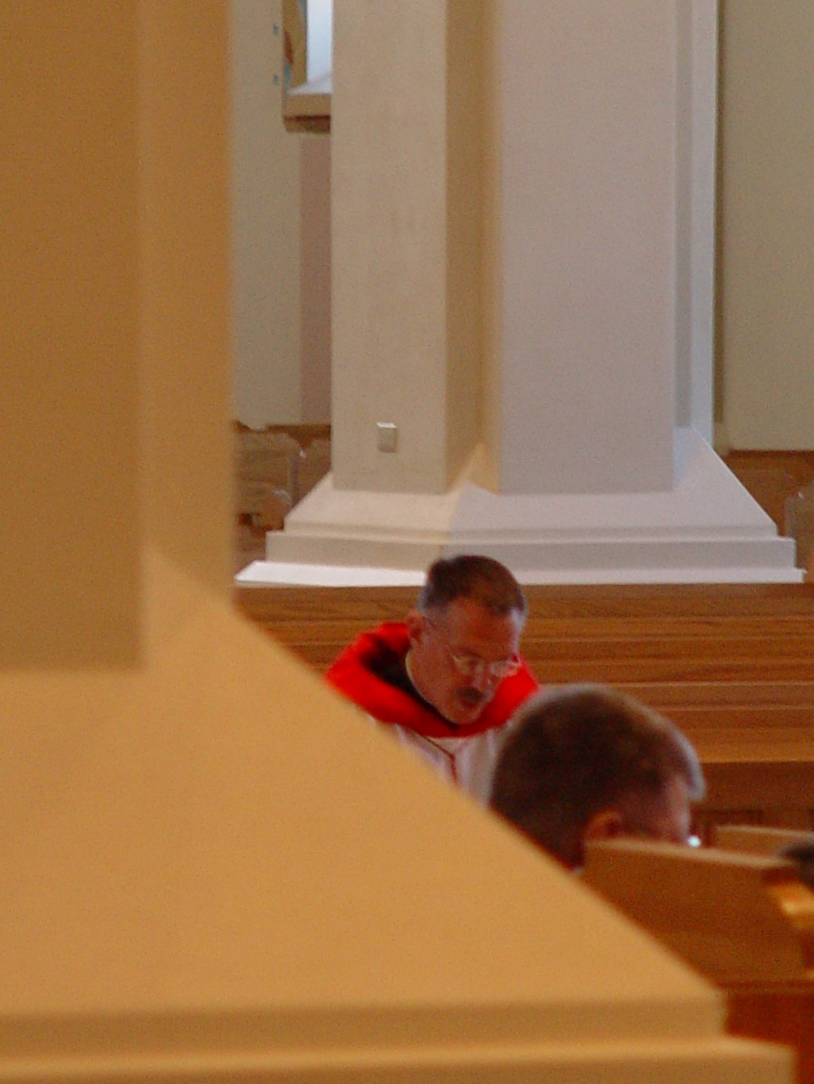
COSL 107 Prior Michael John Austin; Br. Nathan Gregory Miller
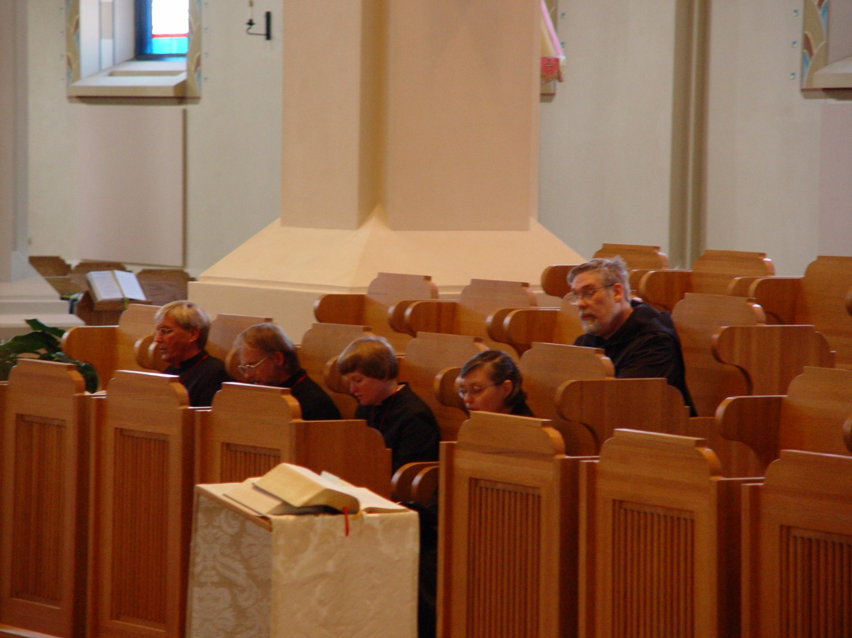
COSL 108 Glen Converse (later Br. Camillus); Barry Mullen; Sr. Catherine Unterseher; Sr. Theodora of Jesus Perecca; Br. Chad Anselm Gerns (later Br. David)
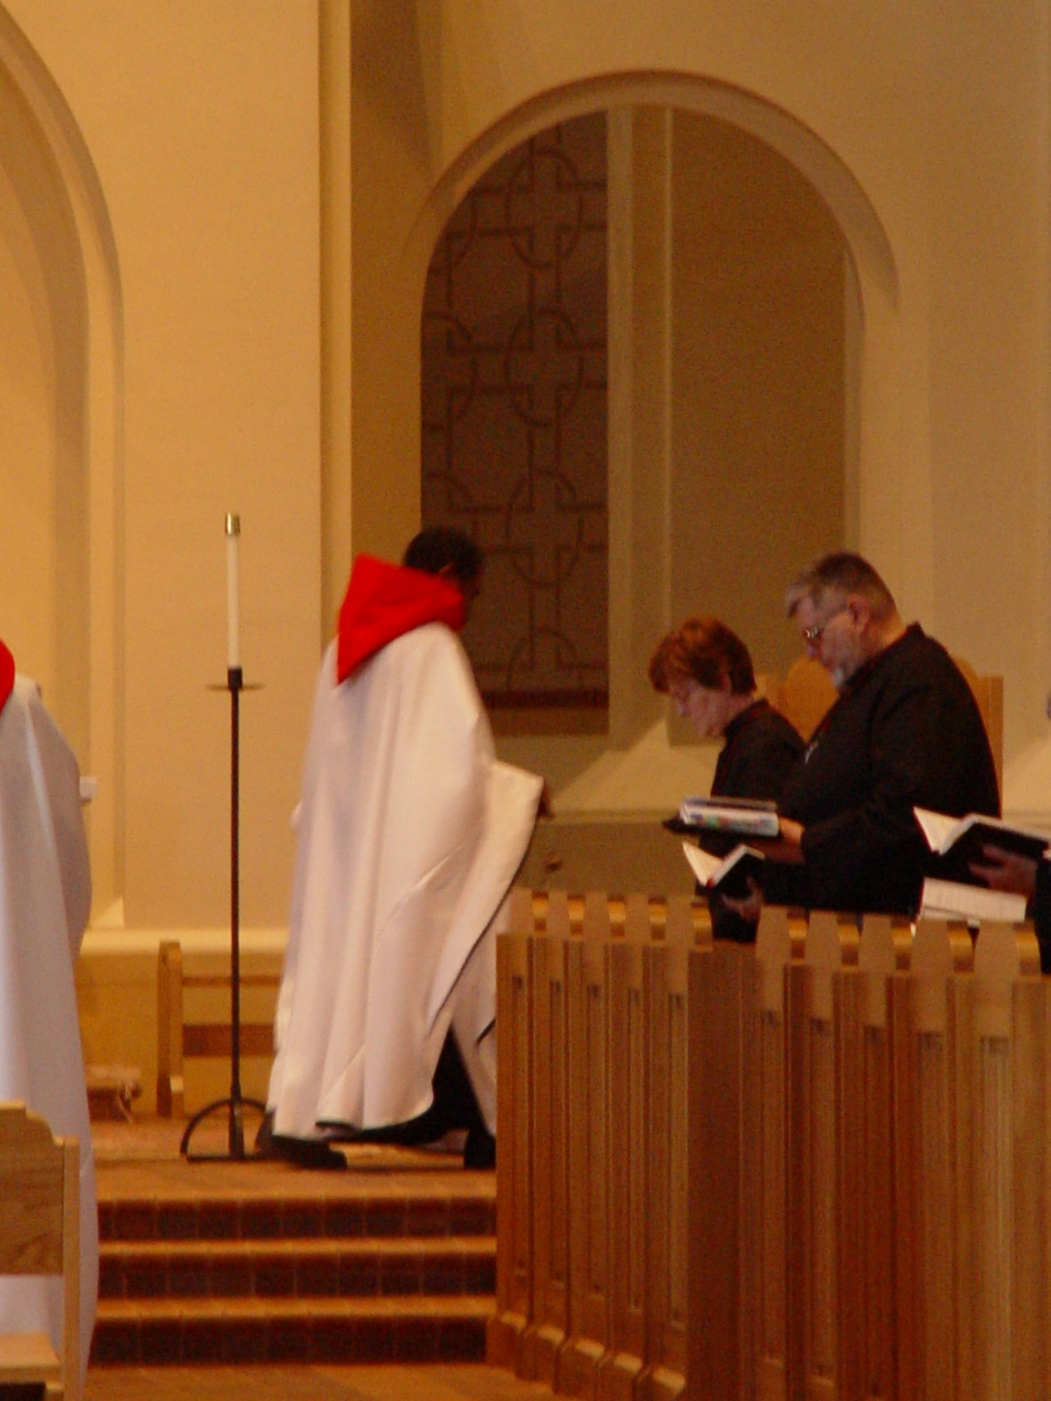
COSL 109 Br. Thomas Ferrell; Sr. Ann Gerns; Br. Nathan Gregory Miller
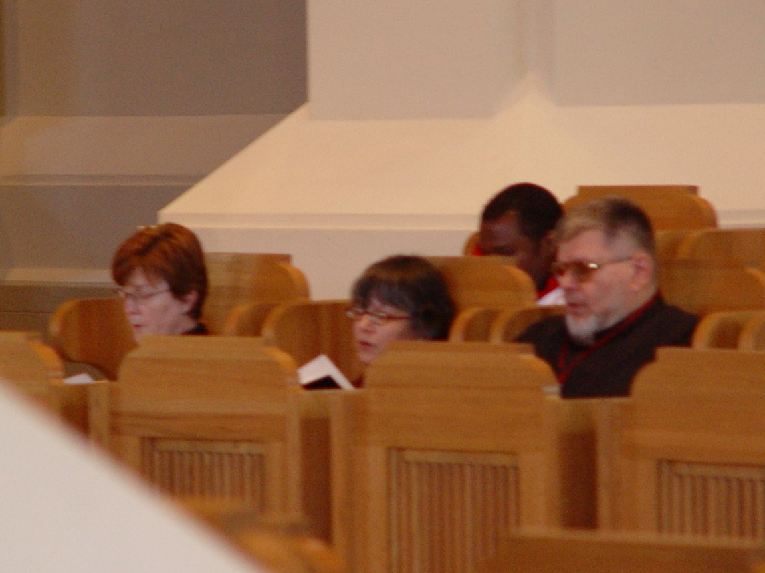
COSL 110 Sr. Ann Gerns; Sr. Anna Grace Madden; Br. Thomas Ferrell; Br. Nathan Gregory Miller
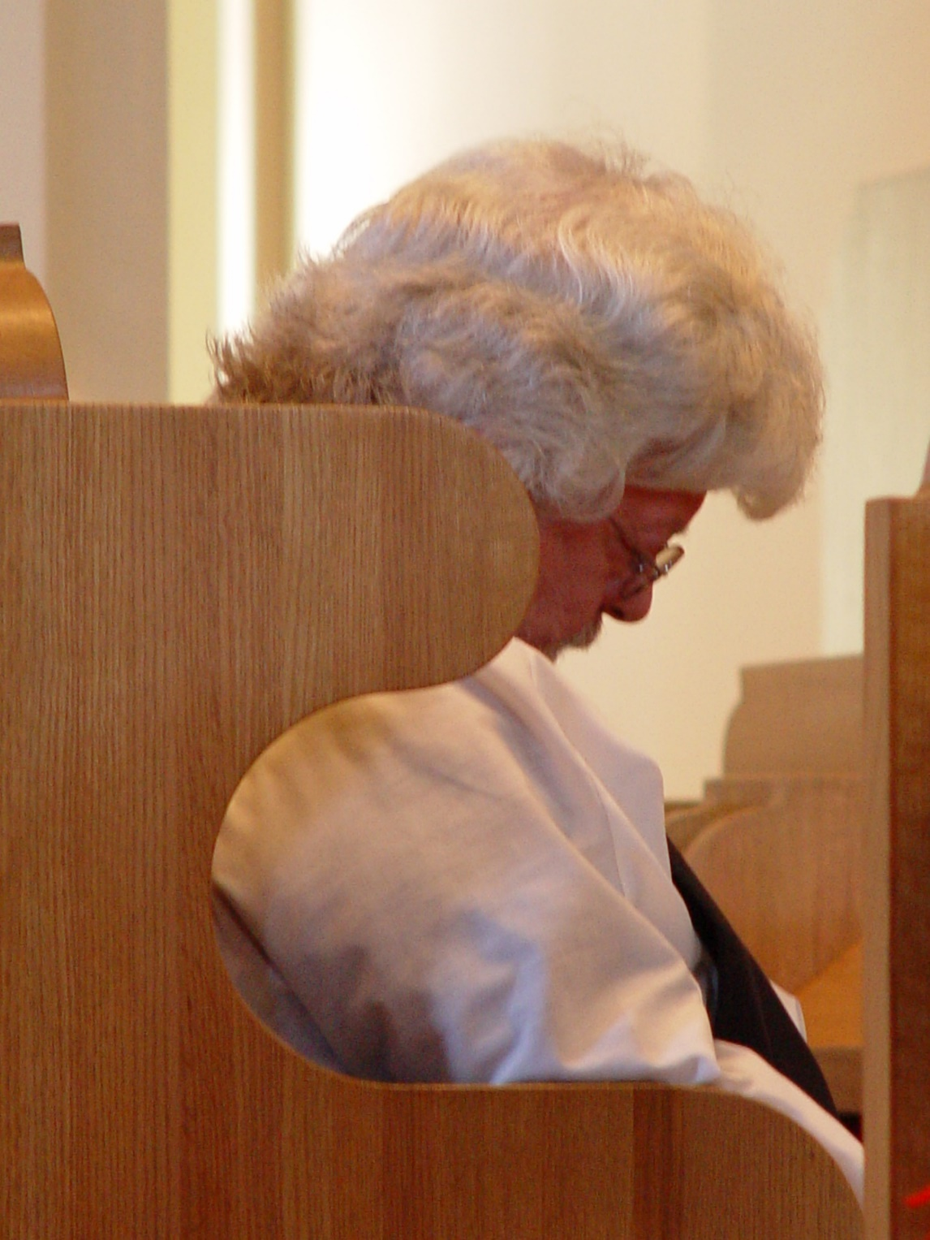
COSL 111 Fr. Wayne Kamm
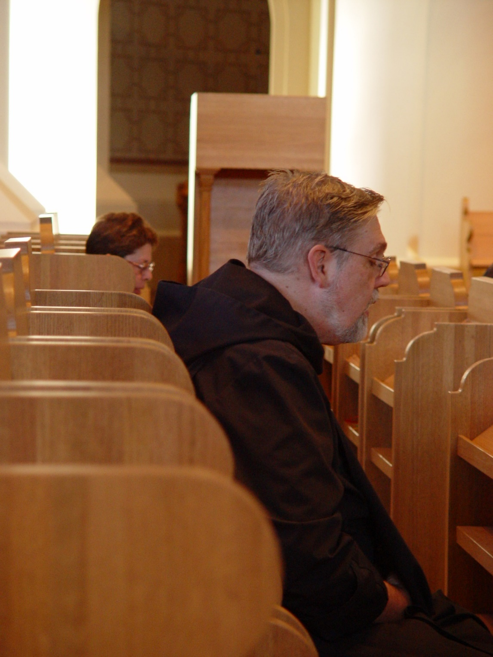
COSL 112 Sr. Monica Ruth Mullen; Br. Chad Anselm Gerns (later Br. David)
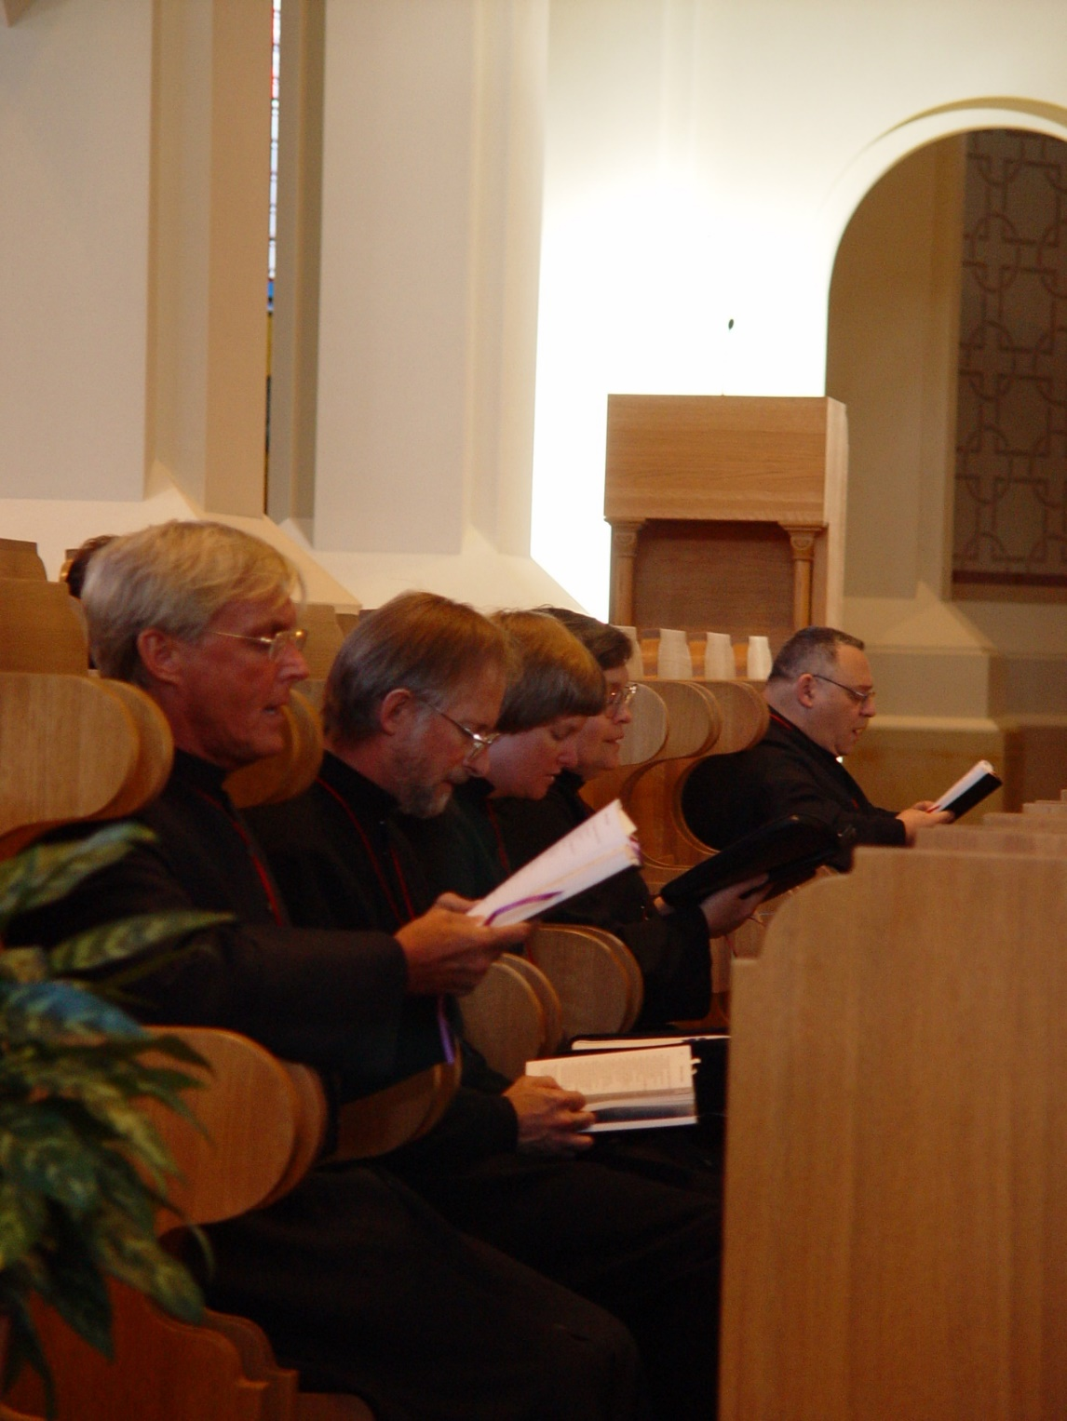
COSL 113 Glen Converse (later Br. Camillus); Barry Mullen (later Br. Lawrence); Sr. Catherine Unterseher; Sr. Theodora of Jesus Perecca; Br. Ambrose Heroux
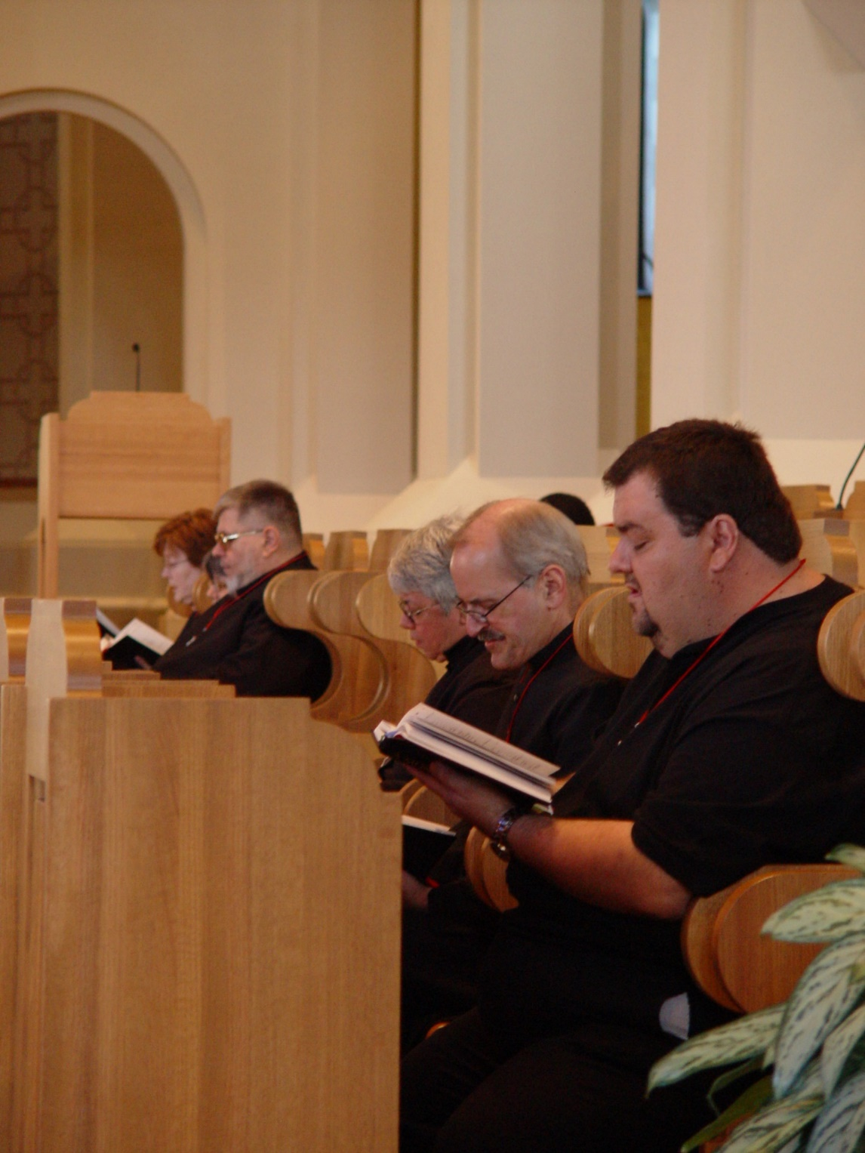
COSL114 Sr. Ann Gerns; Br. Nathan Gregory Miller; Sr. Clare Benedicta Meyers; Br. Paul Schroeder; Regan Fox
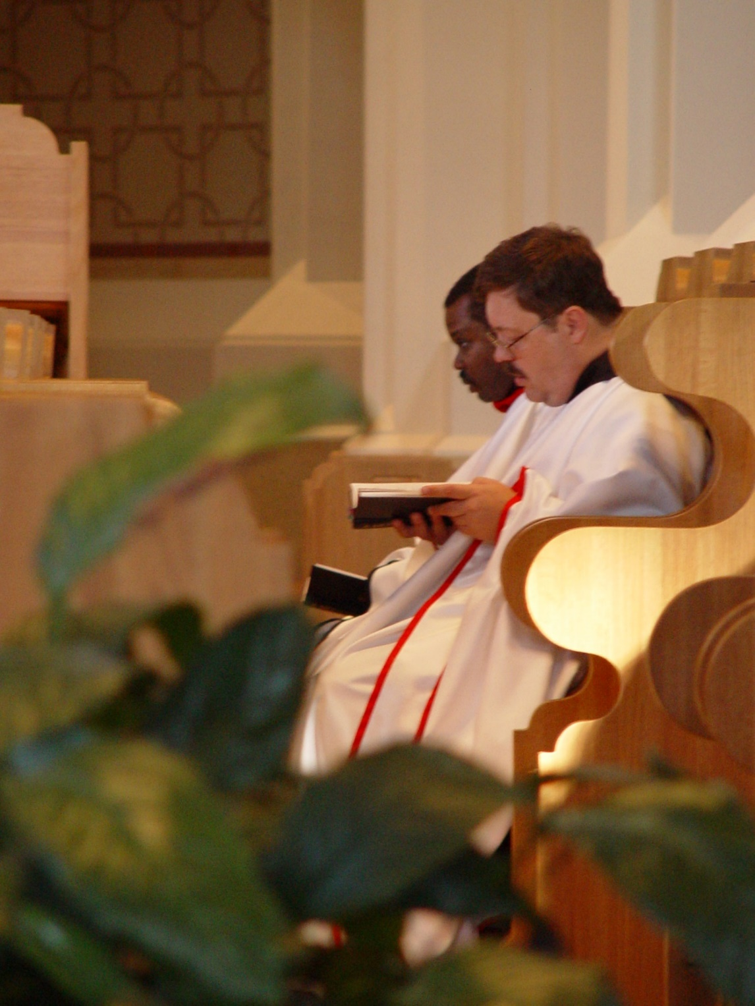
COSL 115 Br. Thomas Ferrell; Br. Paul Howard
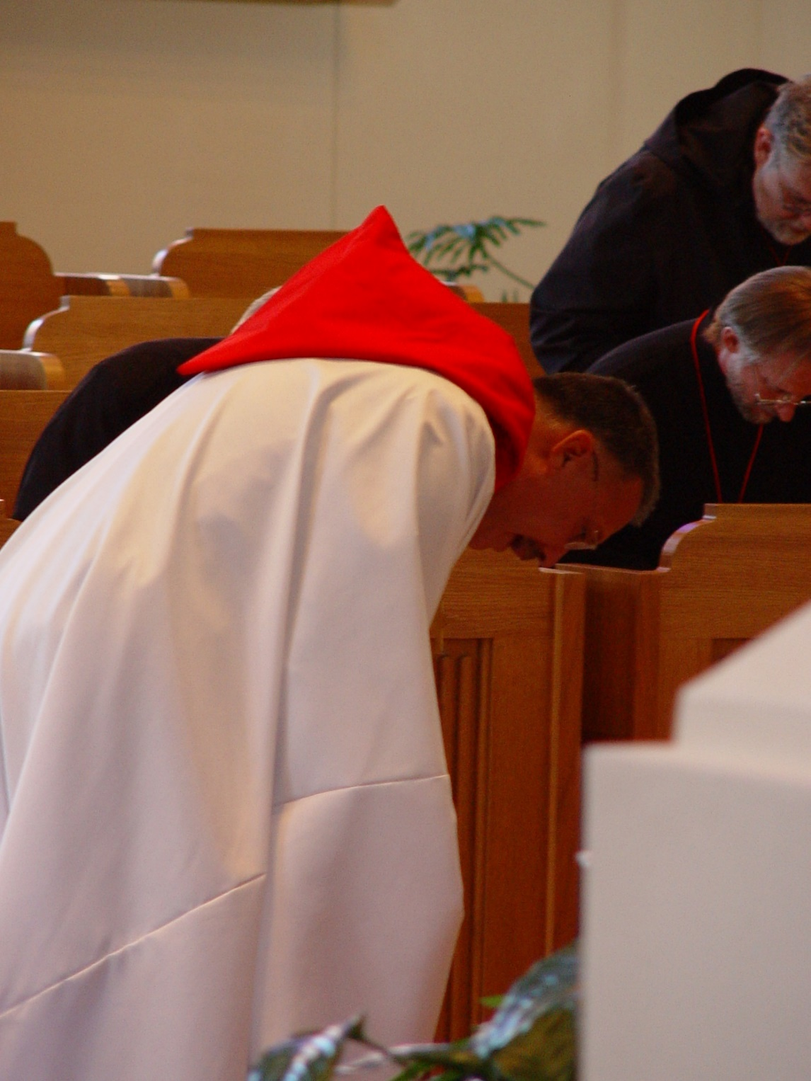
COSL 116 Prior Michael John Austin; Barry Mullen (Br. Lawrence); Br. Nathan Gregory Miller
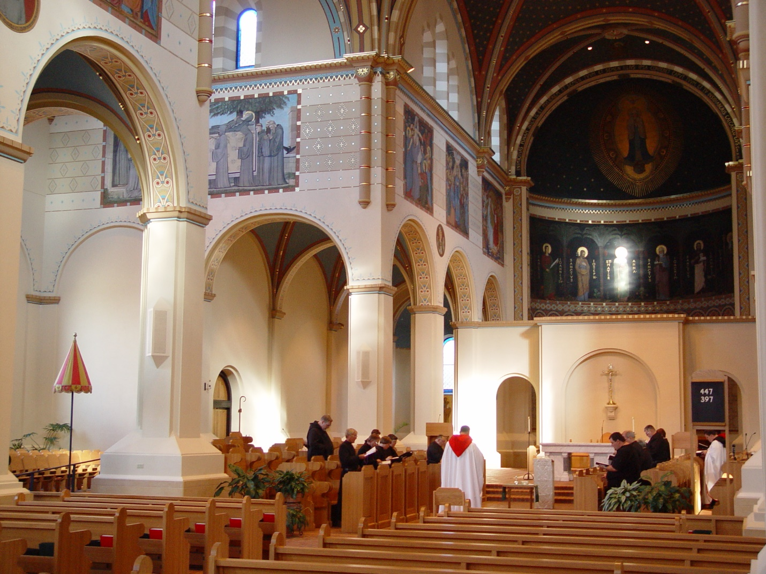
COSL 117
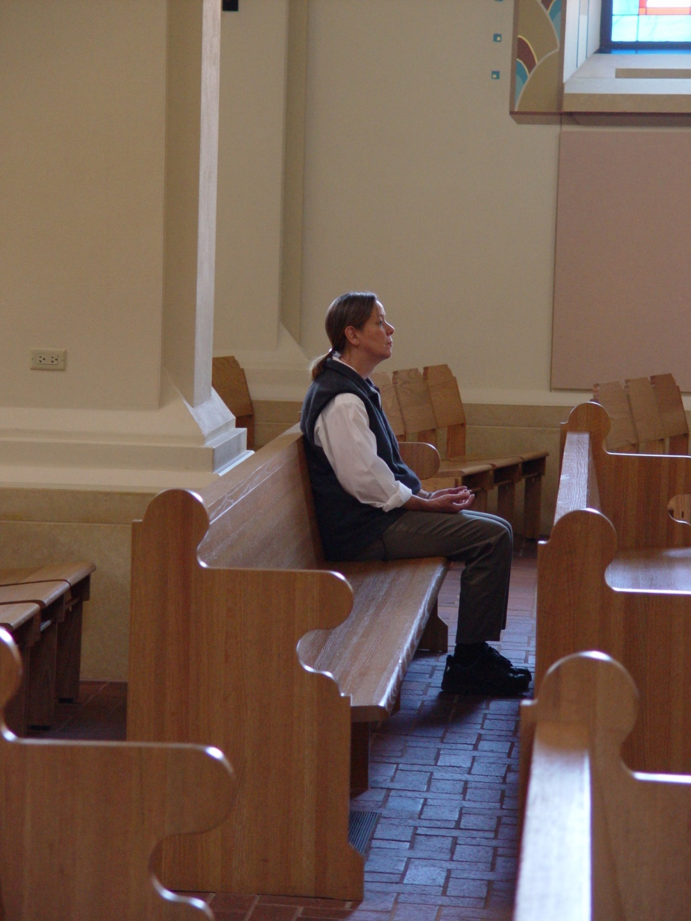
COSL 118 Mary Schroeder (wife of Br, Daniel Joseph Schroeder)
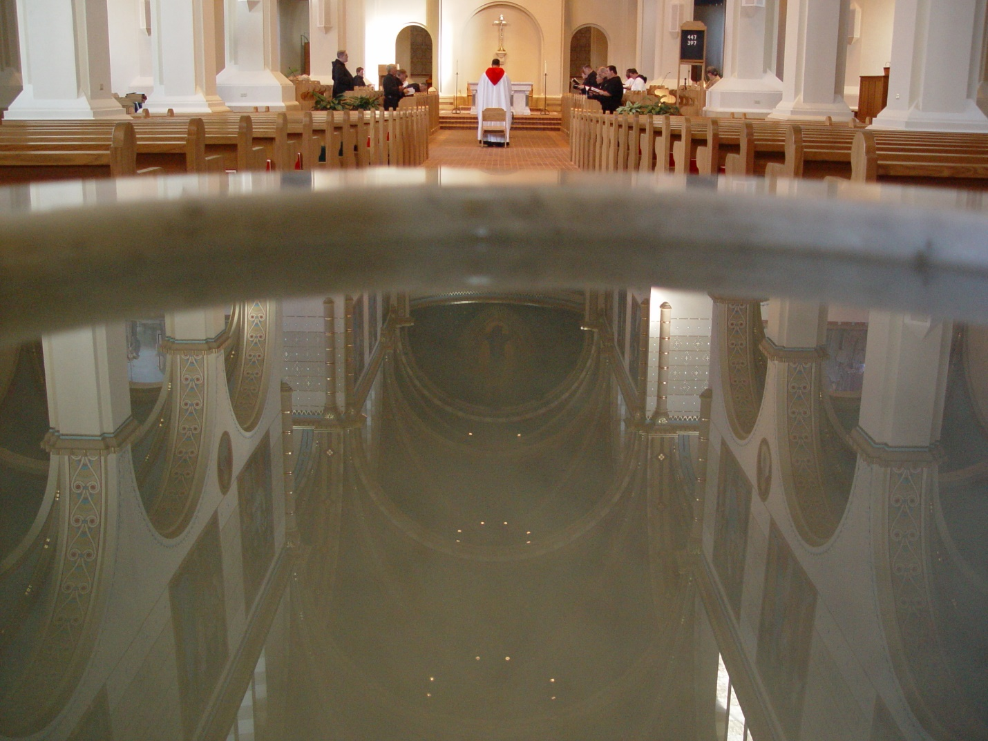
COSL 119
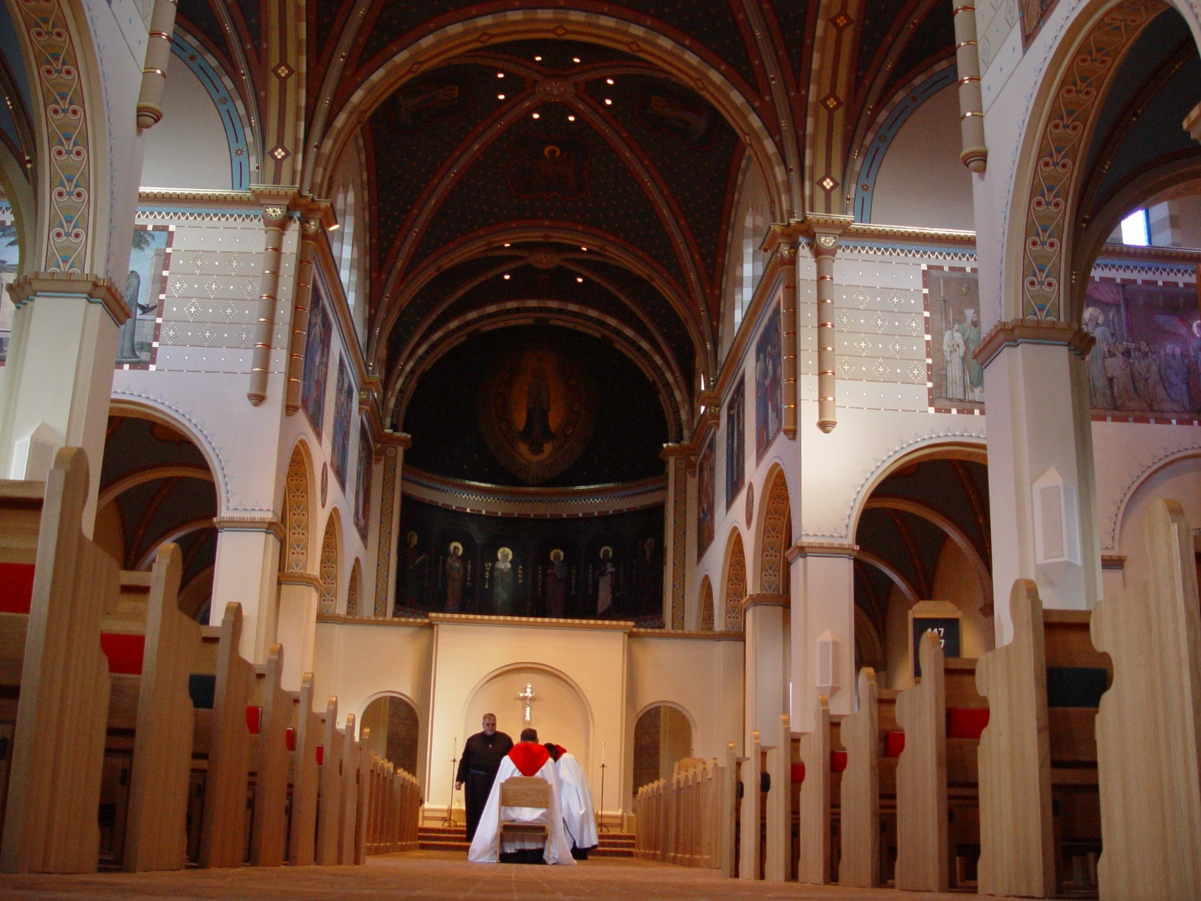
COSL 120
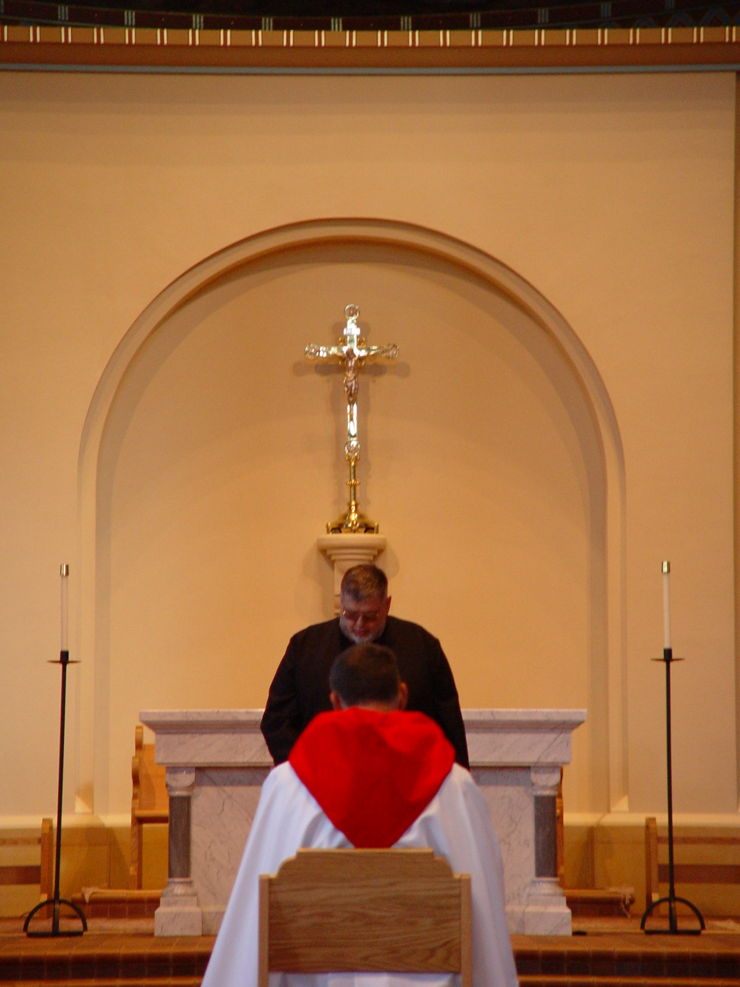
COSL 121 Prior Michael John Austin; Br. Nathan Gregory Miller
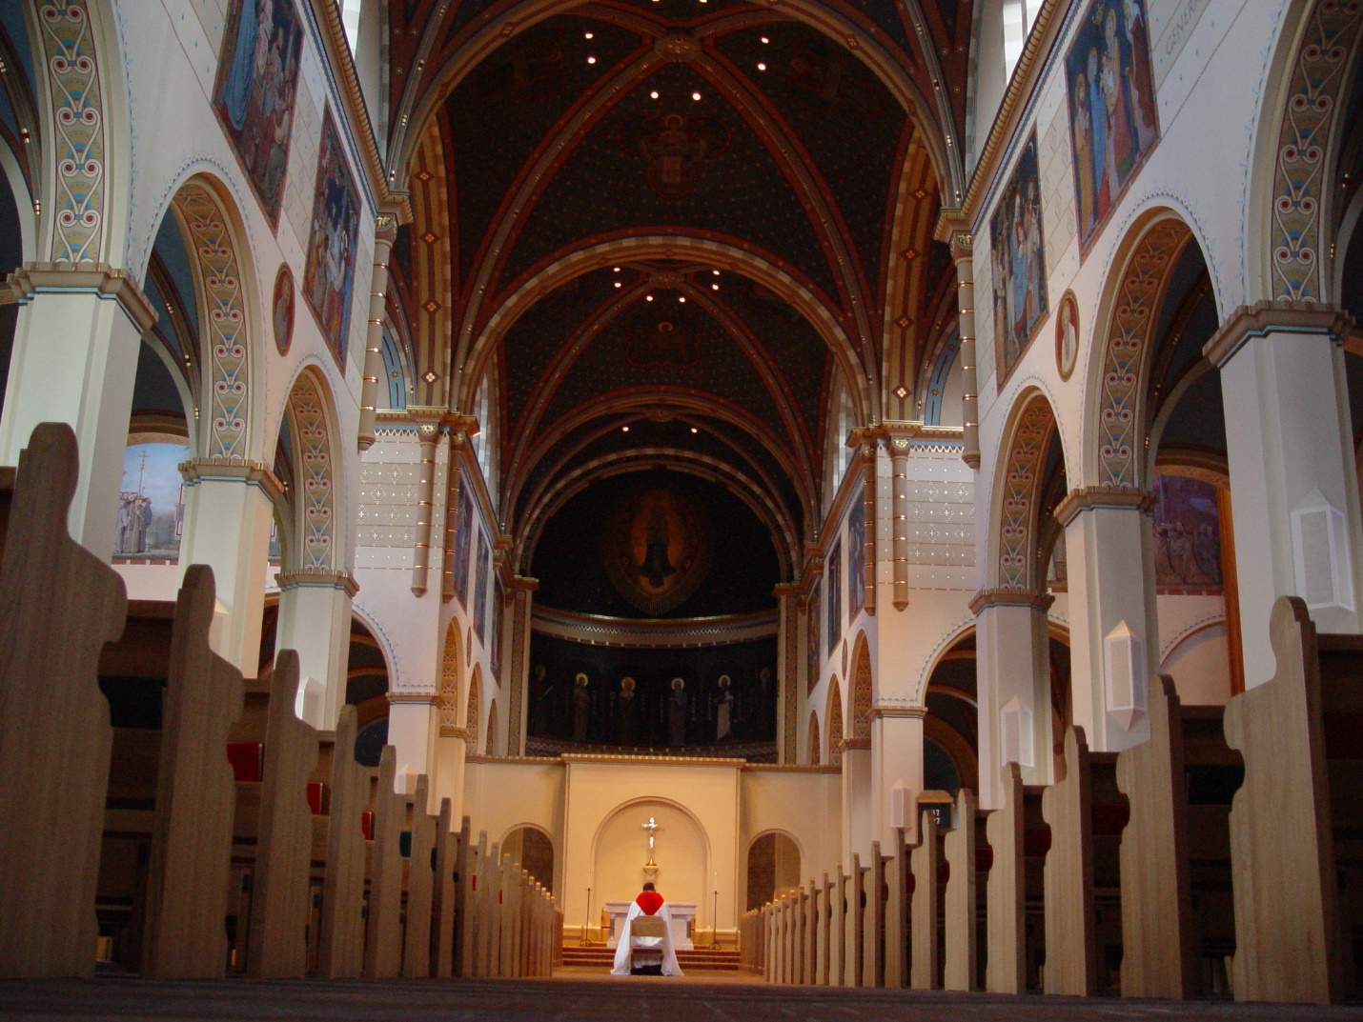
COSL 122
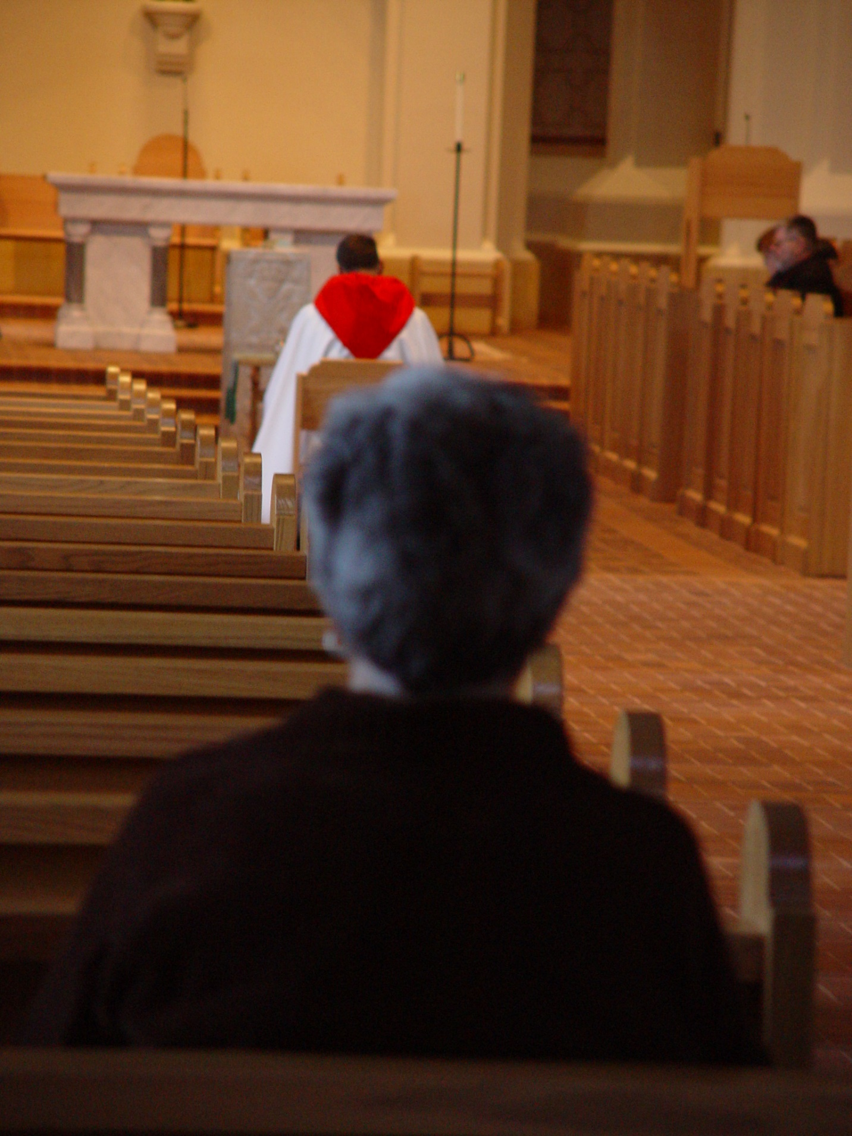
COSL 123 Prior Michael John Austin; Jeanetta Doan
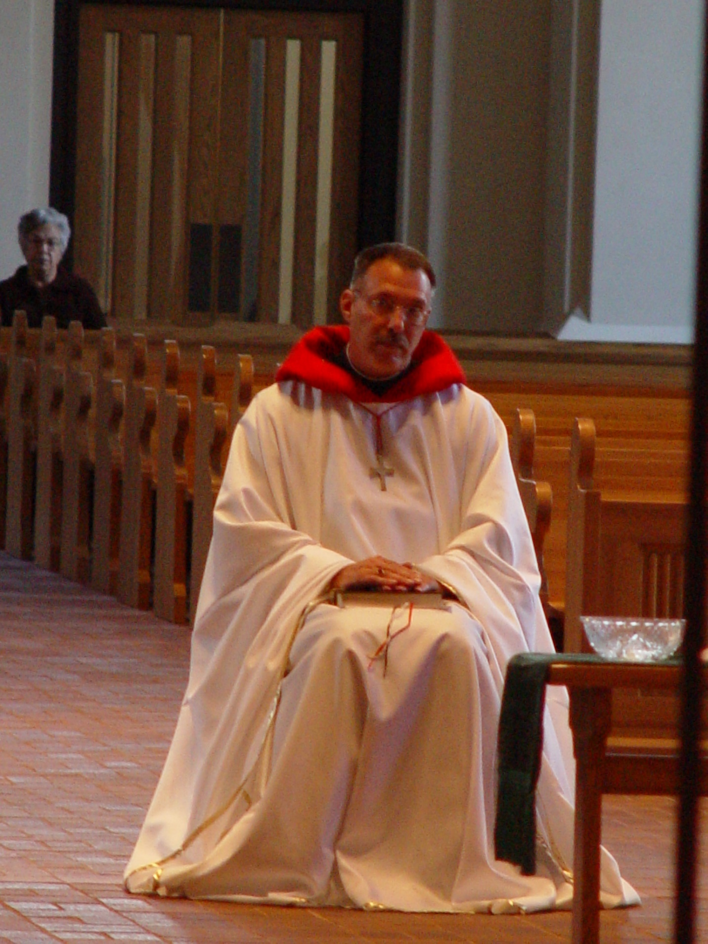
COSL 124 Jeanetta Doan; Prior Michael John Austin
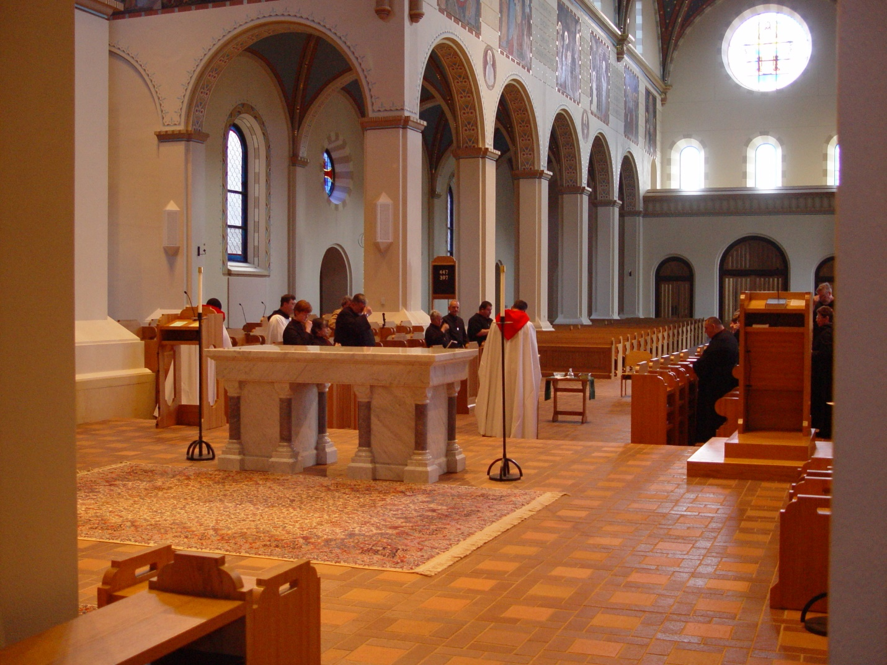
COSL125
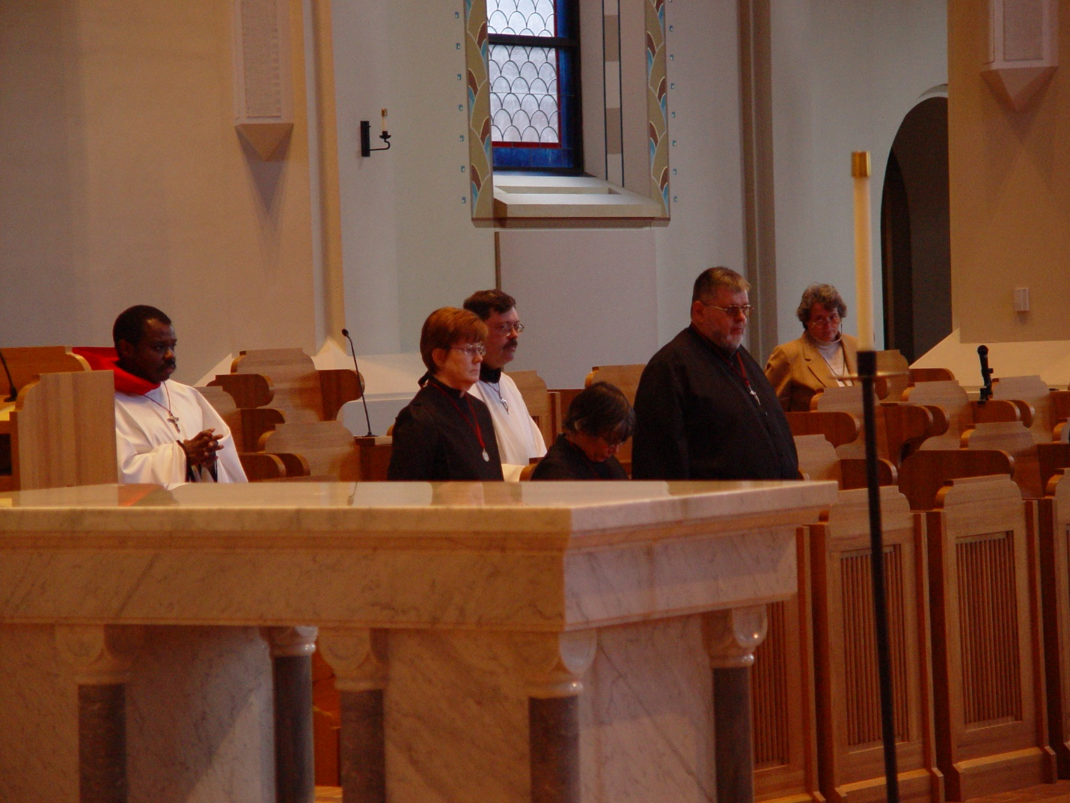
COSL 125 Br. Thomas Ferrell; Sr. Ann Gerns; Br. Paul Howard; Sr. Anna Grace Madden; Br. Nathan Gregory Miller; Becky Rittenhouse
COSL 126 Br. Thomas Ferrell; Sr. Ann Gerns; Br. Paul Howard; Sr. Anna Grace Madden; Br. Nathan Gregory Miller; Becky Rittenhouse

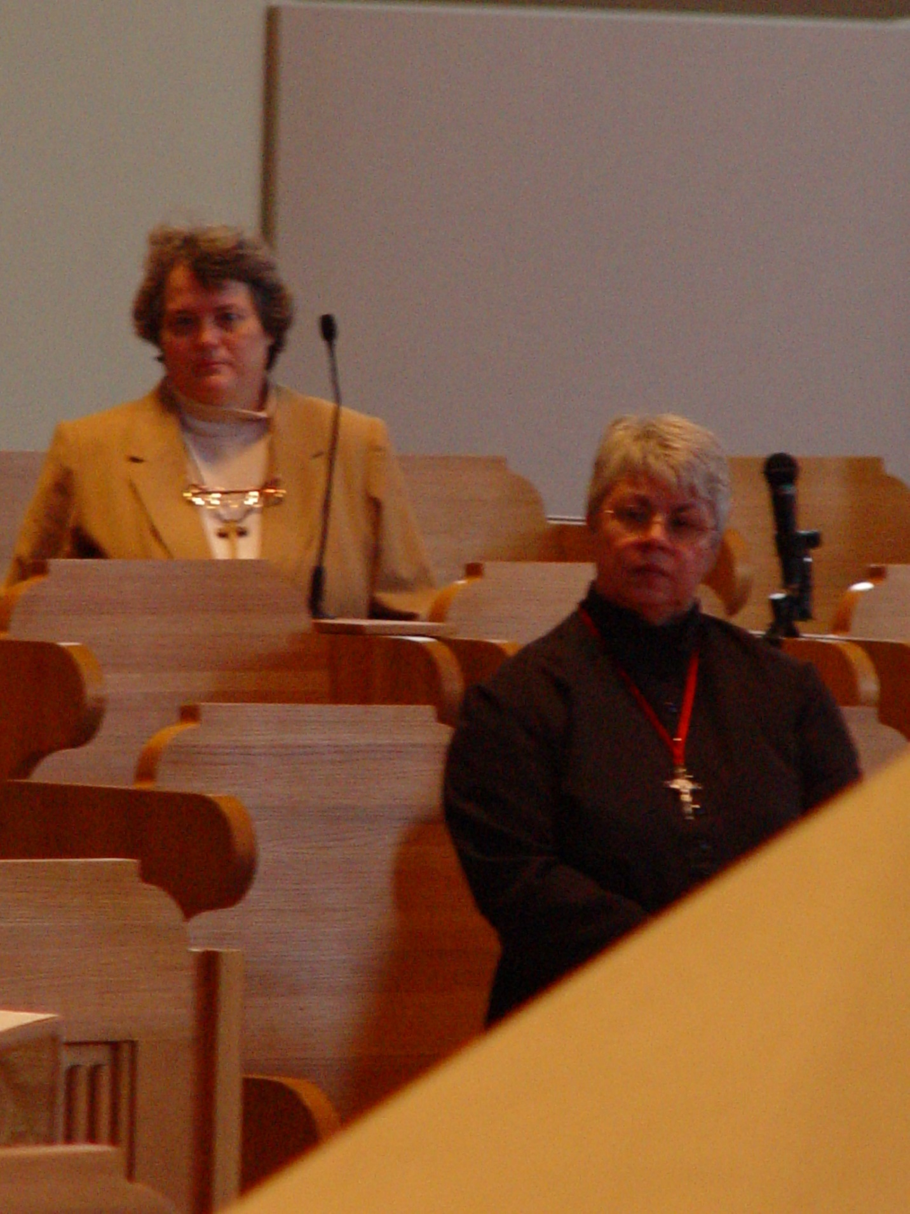
COSL 127 Becky Rittenhouse; Sr. Clare Benedicta Meyers
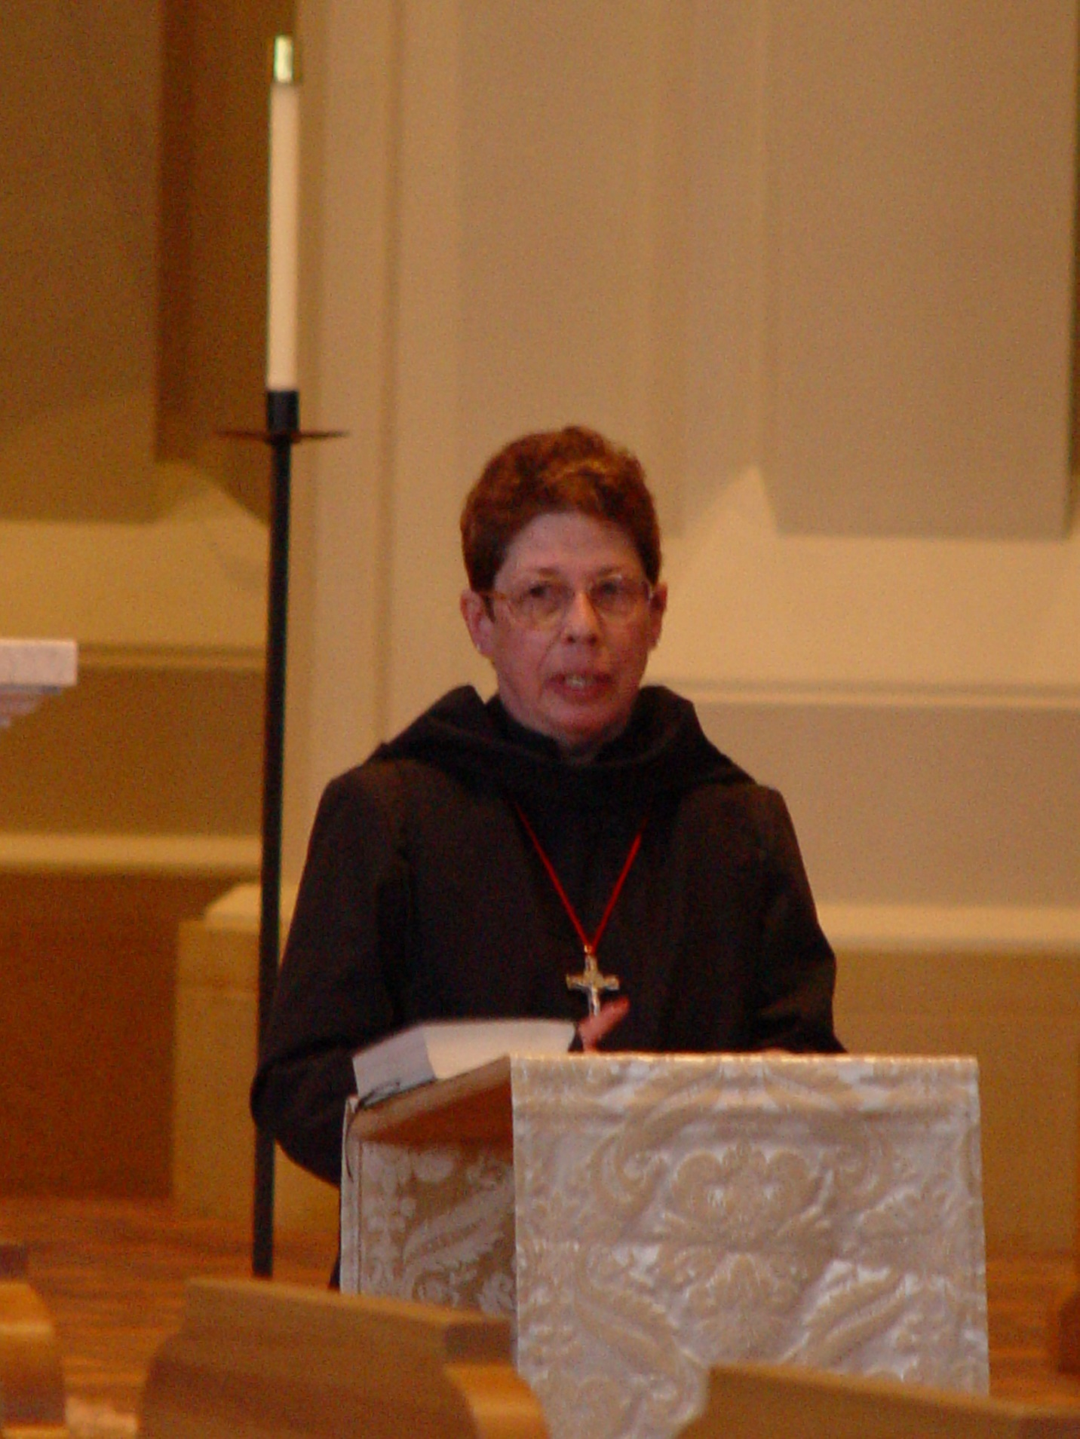
COSL 128 Sr. Monica Ruth Mullen
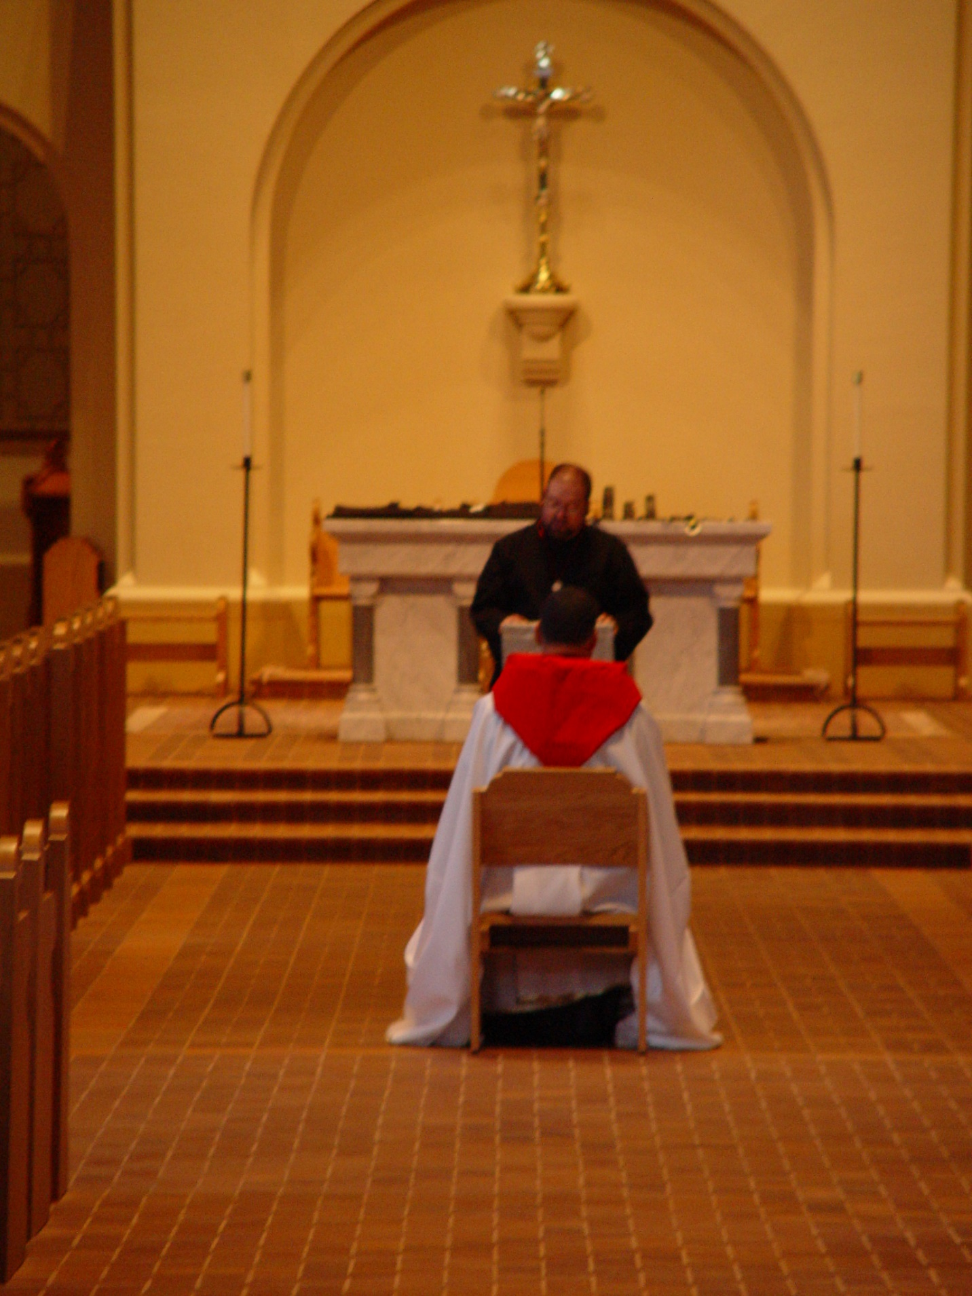
COSL 129 Prior Michael John Austin; Br. Willard Moore
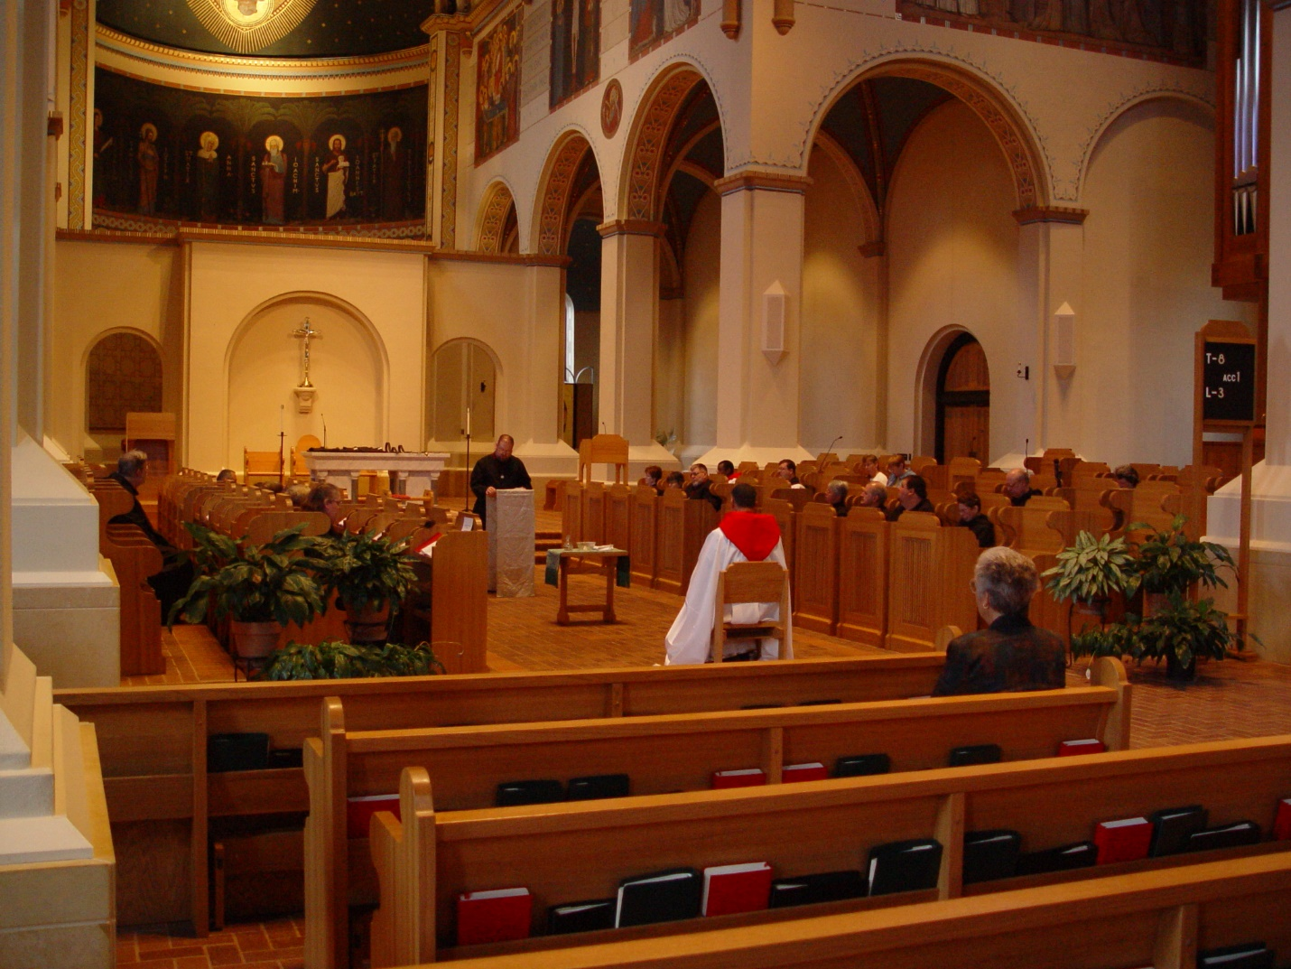
COSL 130
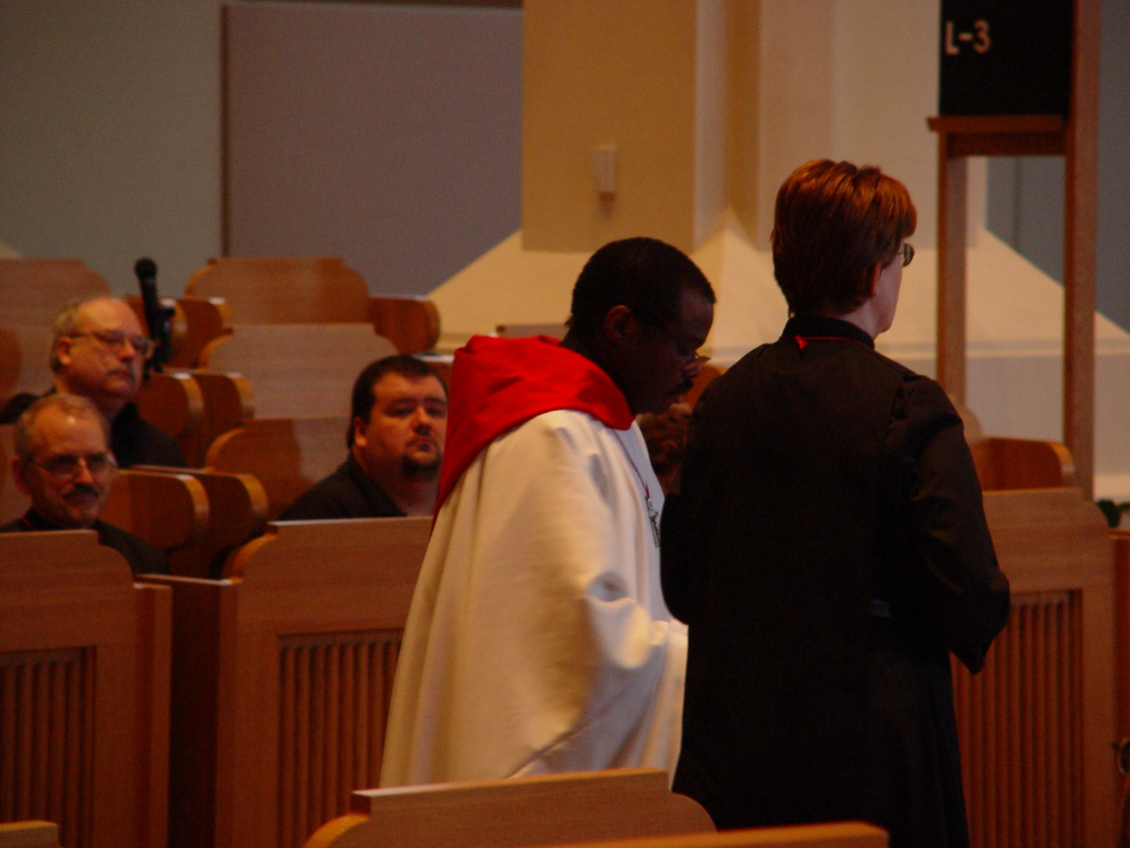
COSL 131 Br. Daniel Joseph Schroeder; Regan Fox Br. Thomas Ferrell; Sr. Ann Gerns
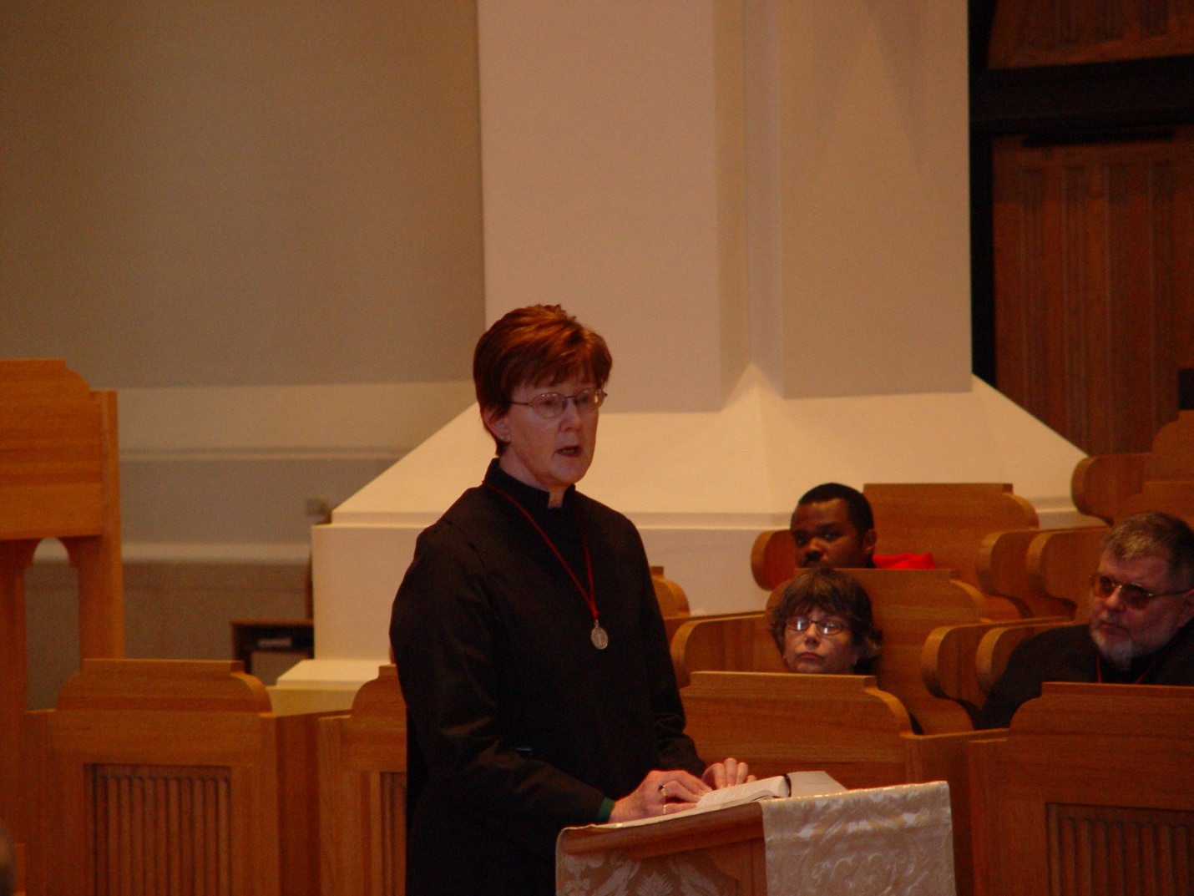
COSL 132 Sr. Ann Gerns; Sr. Anna Grace Madden; Br. Thomas Ferrell; Br. Nathan Gregory Miller
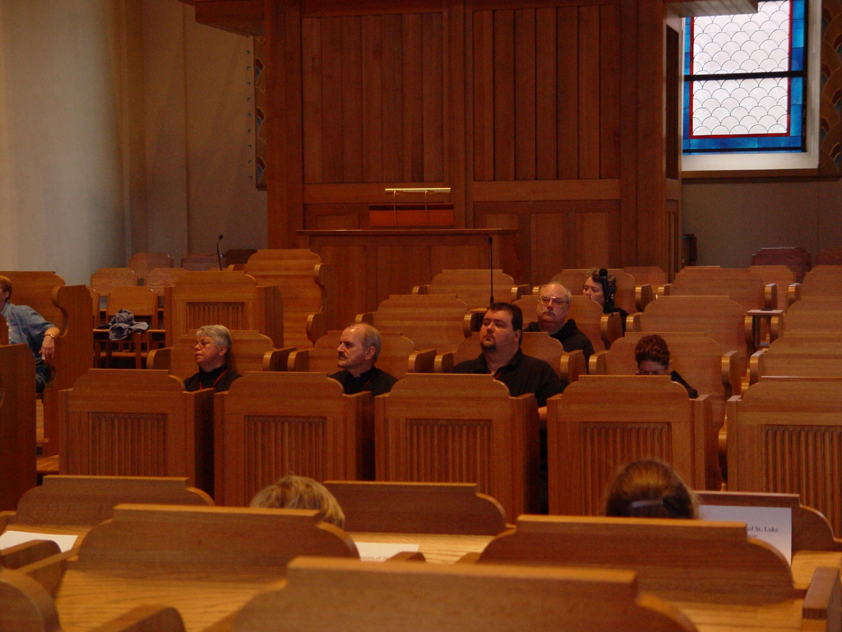
COSL 133 Sr. Clare Benedicta Meyers; Br. Daniel Joseph Schroeder; Regan Fox; Br. Raymond Owens; Becky Rittenhouse; Sr. Monica Ruth Mullen
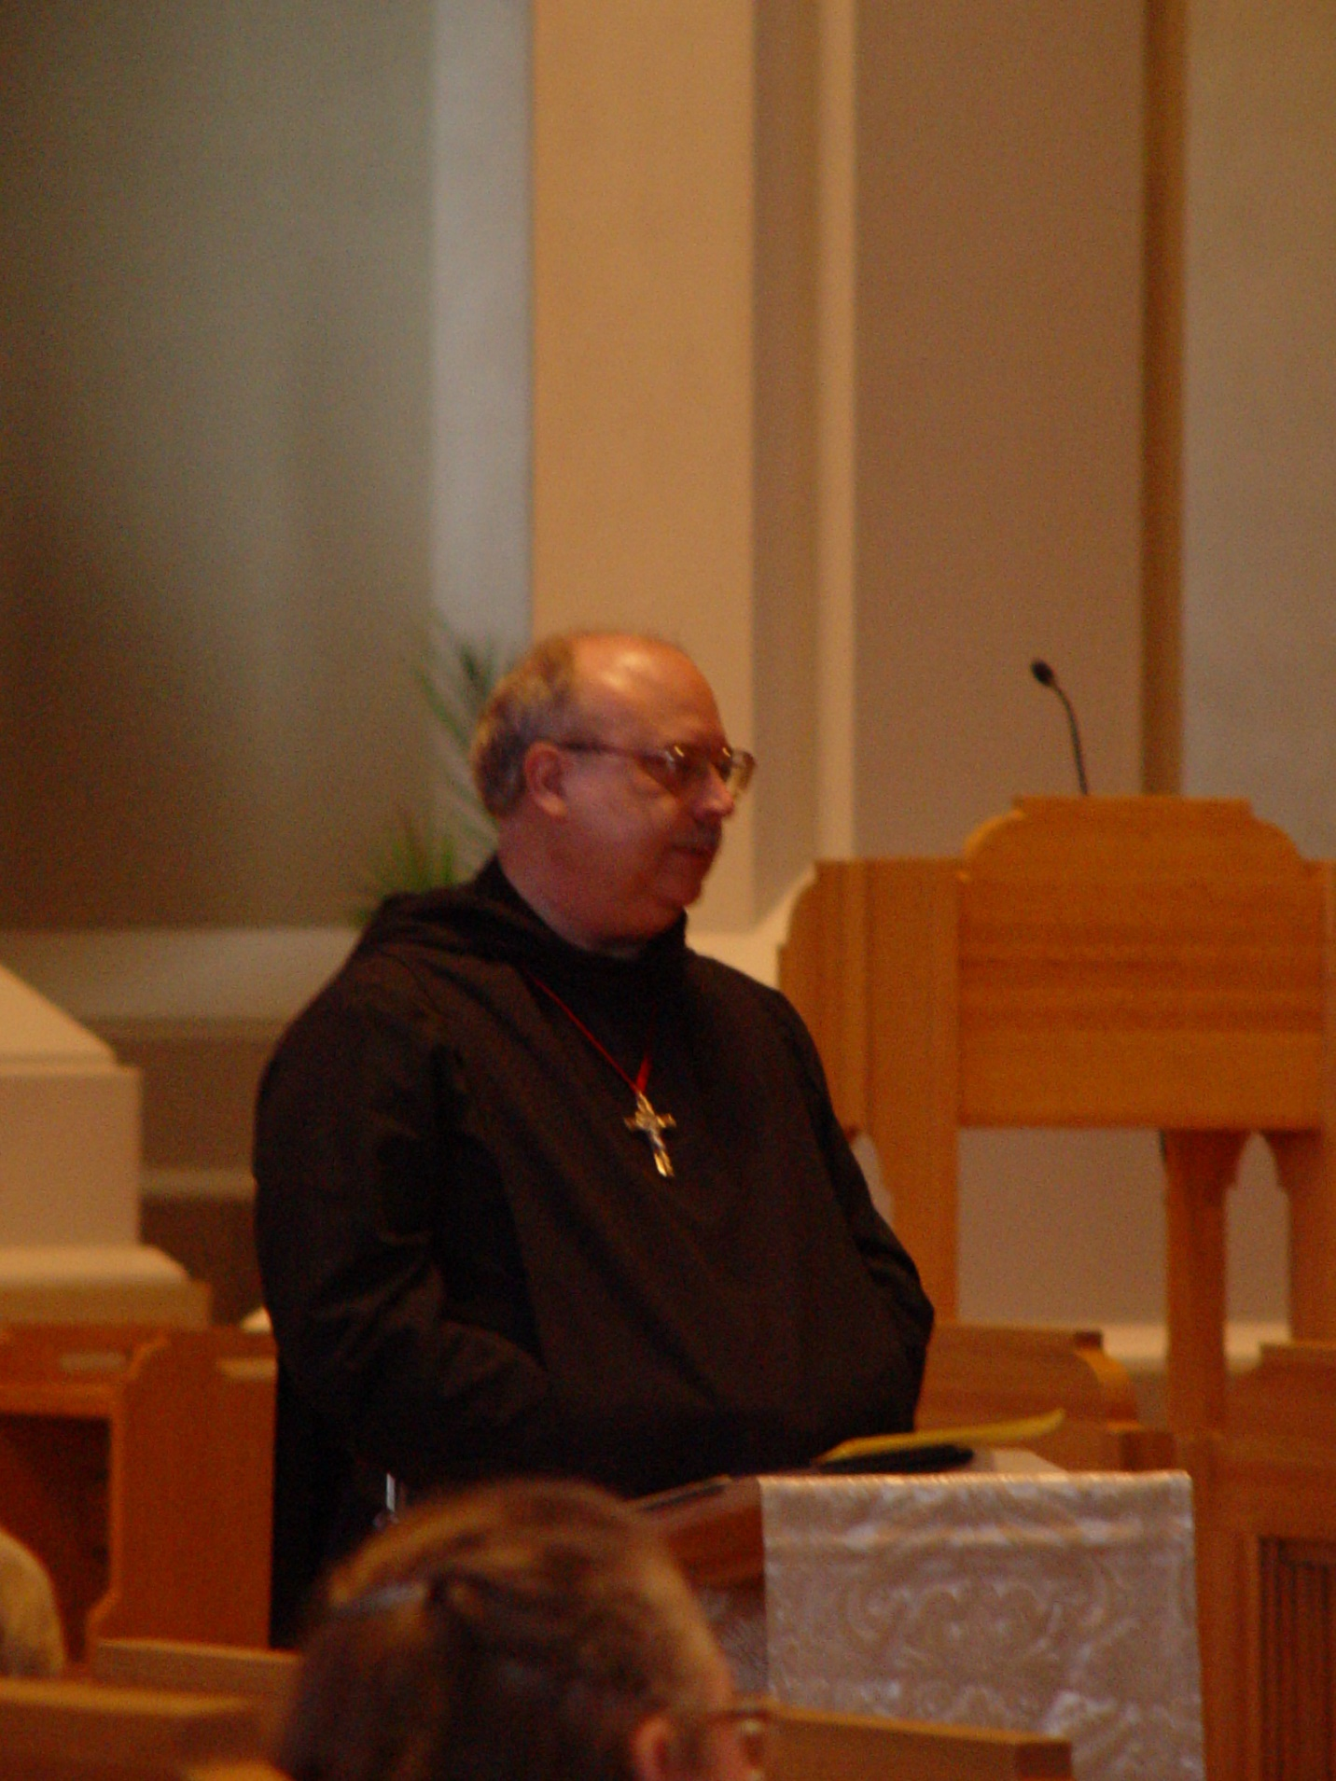
COSL 134 Br. Raymond Owens
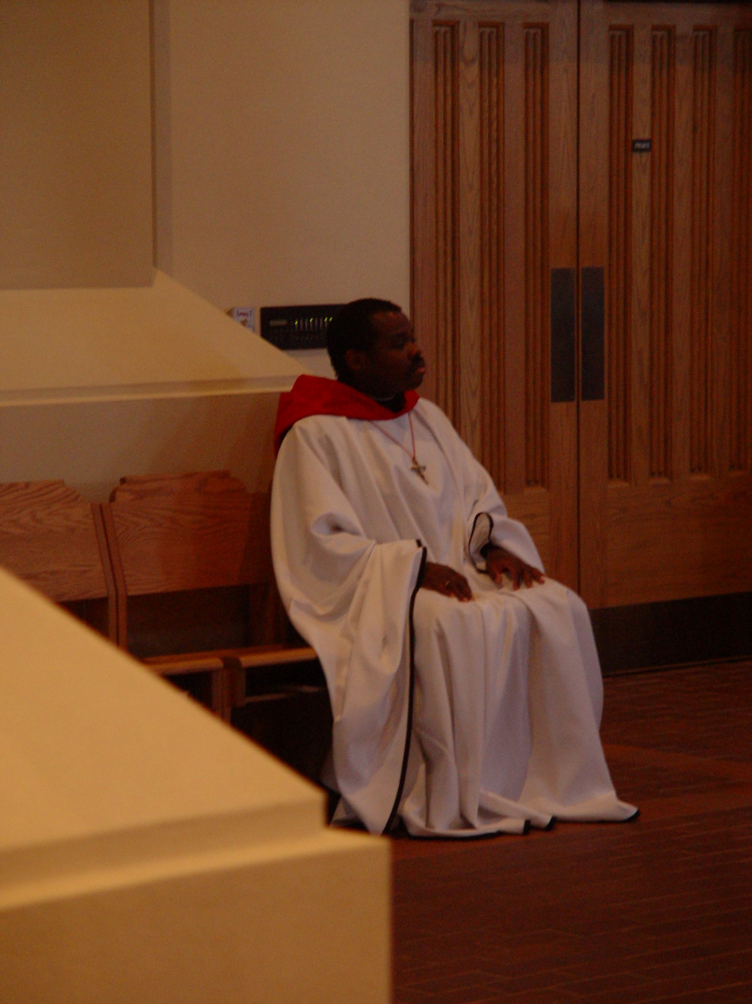
COSL 135 Br. Thomas Ferrell
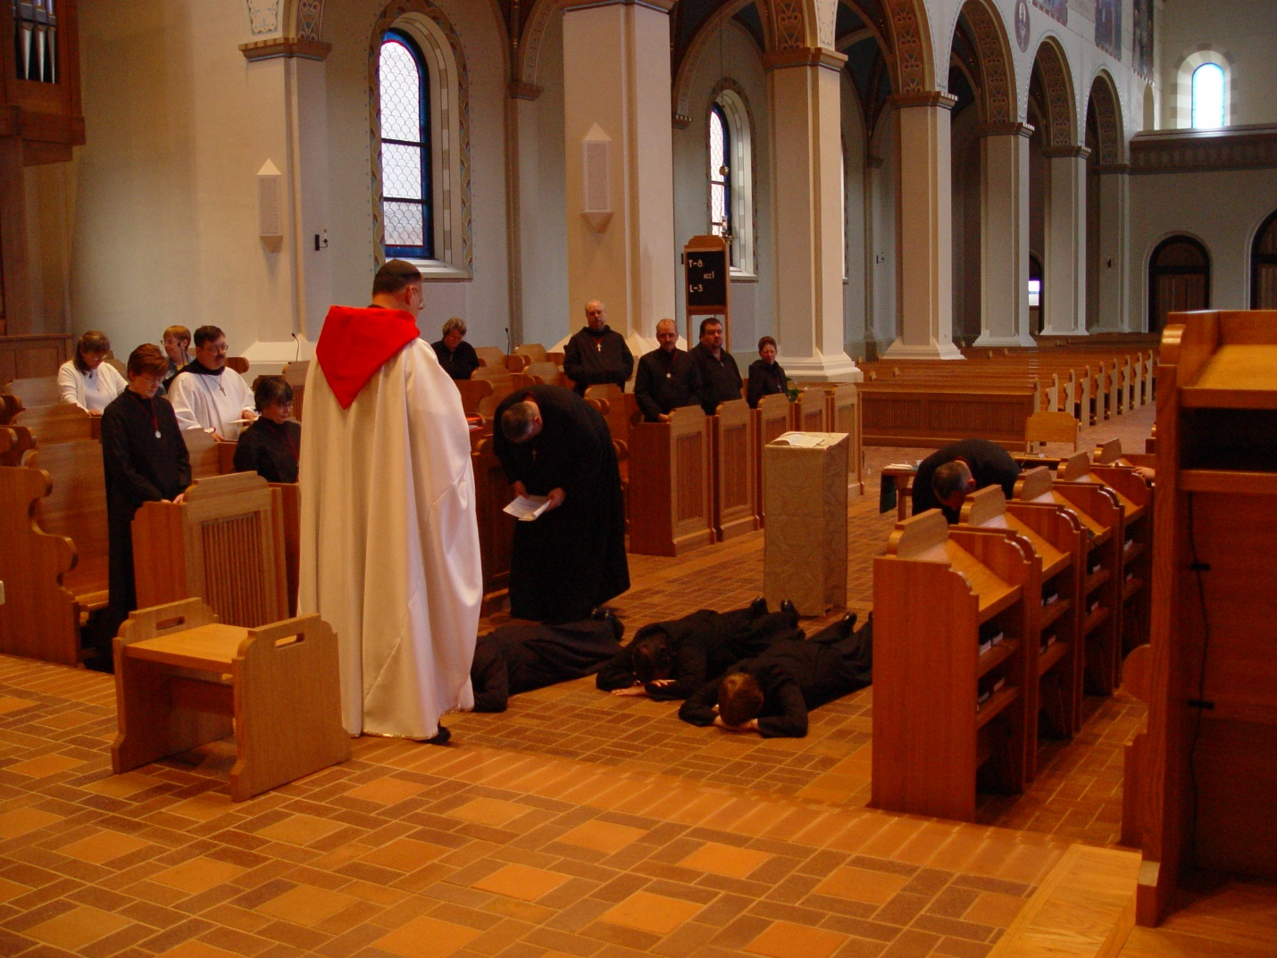
COSL 136 Fredregill; Sr. Ann Gerns; Lynn Owens; Br. Paul Howard; Sr. Anna Grace Madden; Prior Michael John Austin; Br. Nathan Gregory Miller; Becky Rittenhouse; Br. Raymond Owens; Sr. Clare Benedicta; Br. Daniel Joseph Schroeder; Regan Fox; Sr. Theodora of Jesus Perecca; Sr. Catherine Unterseher; Br. Ambrose Heroux
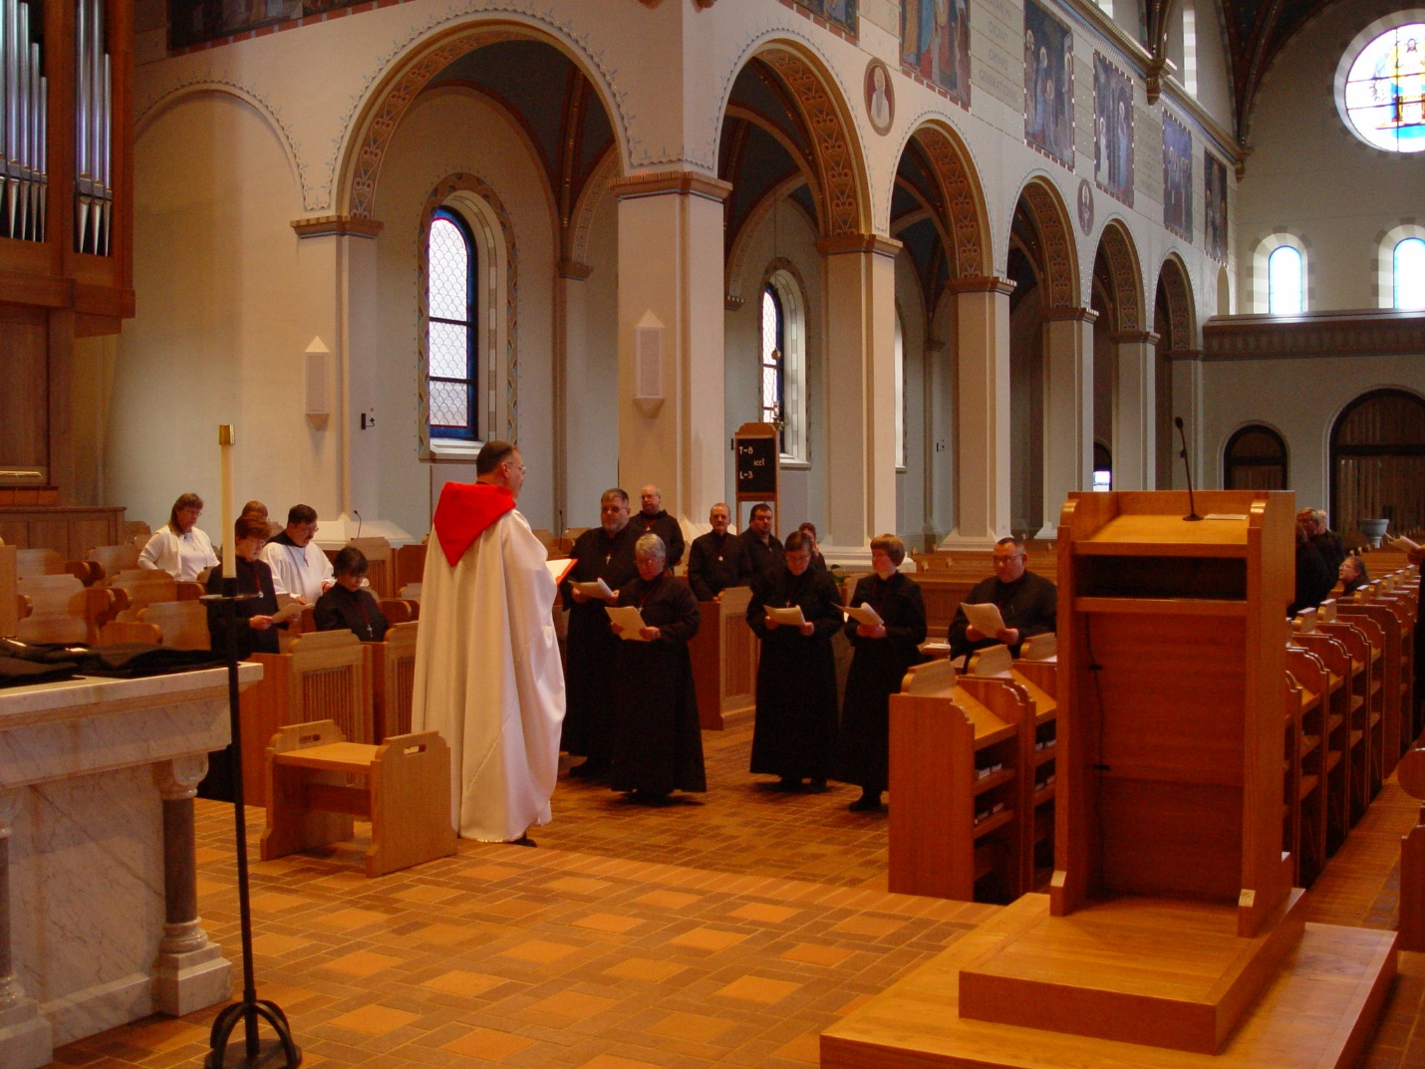
COSL 137 Becky Fredregill; Sr. Ann Gerns; Br. Paul Howard; Sr. Anna Grace Madden; Prior Michael John Austin; Br. Nathan Gregory Miller; Br. Raymond Owens; Sr. Clare Benedicta; Br. Daniel Joseph Schroeder; Regan Fox; Sr. Theodora of Jesus Perecca; Sr. Catherine Unterseher; Br. Ambrose Heroux
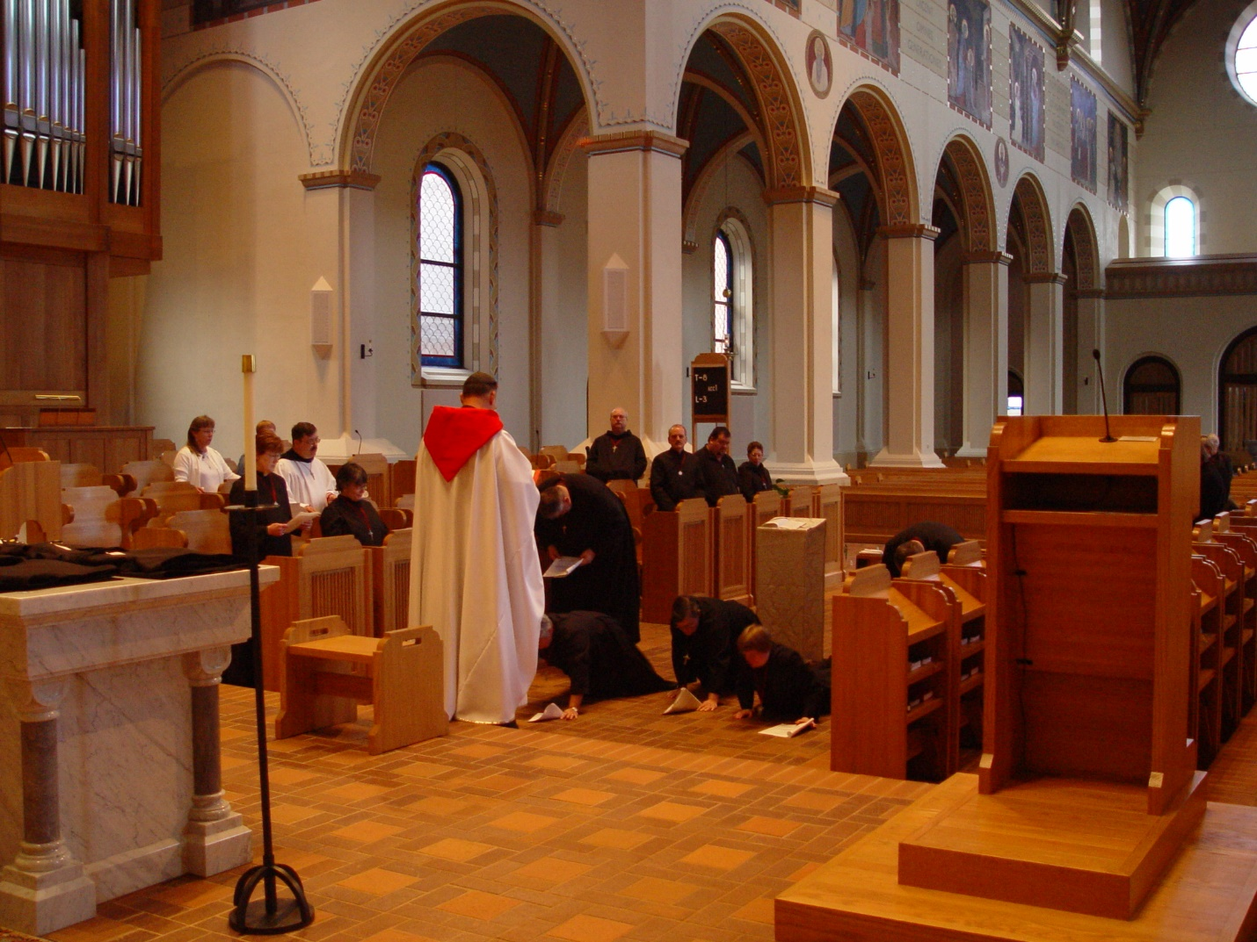
COSL 138 Becky Fredregill; Sr. Ann Gerns; Br. Paul Howard; Sr. Anna Grace Madden; Prior Michael John Austin; Sr. Clare Benedicta; Br. Nathan Gregory Miller; Br. Raymond Owens; Br. Daniel Joseph Schroeder; Sr. Theodora of Jesus Perecca; Regan Fox; Sr. Monica Ruth Mullen; Sr. Catherine Unterseher; Br. Ambrose Heroux
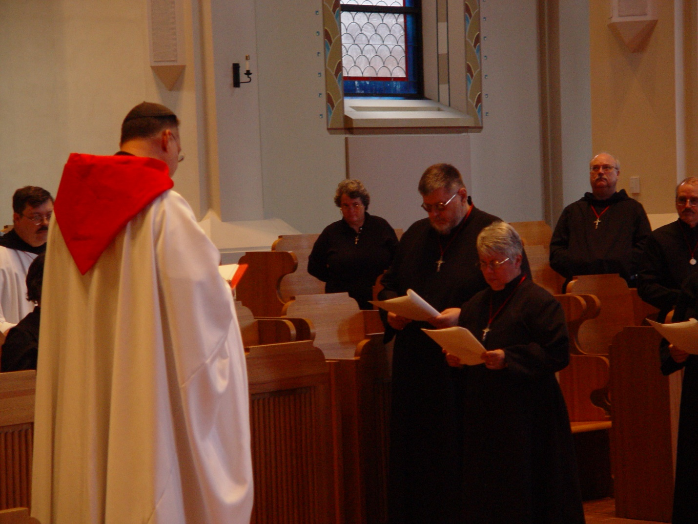
COSL 139 Br. Paul Howard; Prior Michael John Austin; Becky Rittenhouse; Br. Nathan Gregory Miller; Sr. Clare Benedicta Meyers; Br. Raymond Owens; Br. Daniel Joseph Schroeder
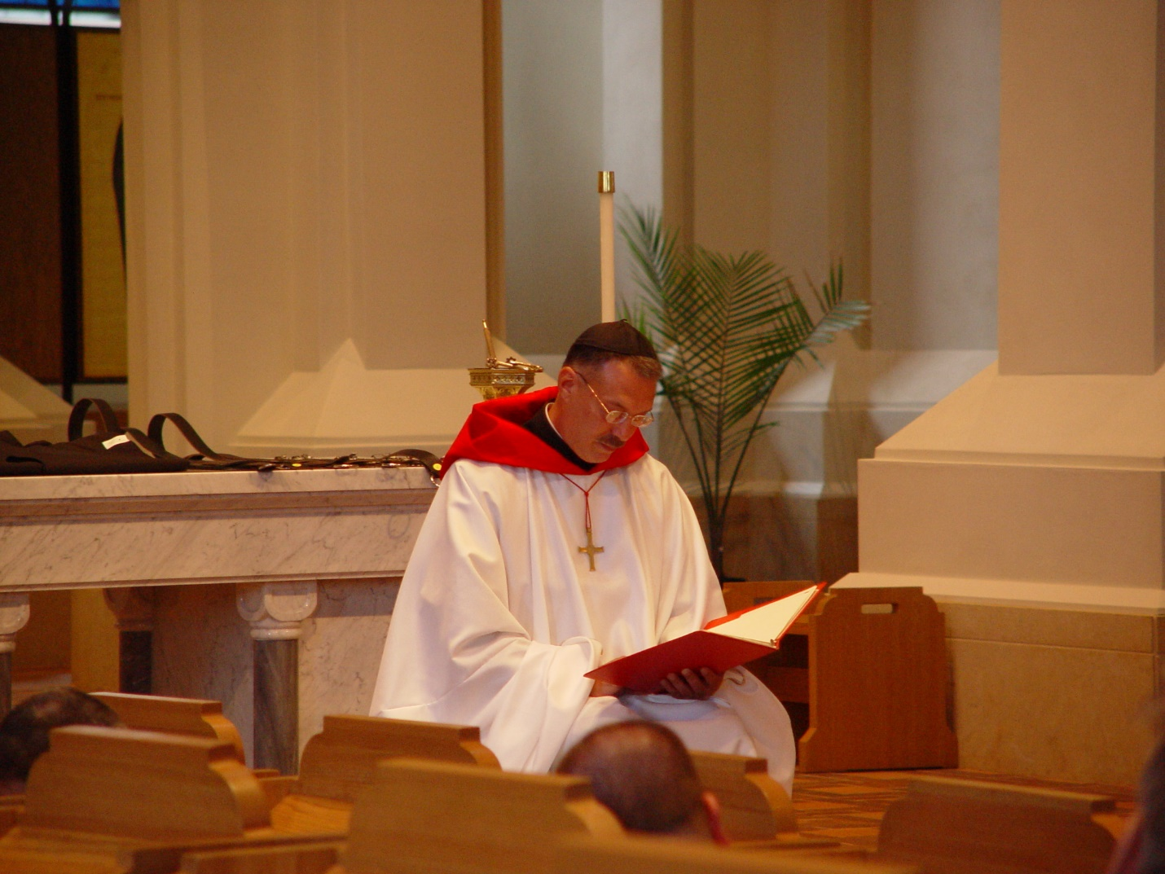
COSL 140 Prior Michael John Austin
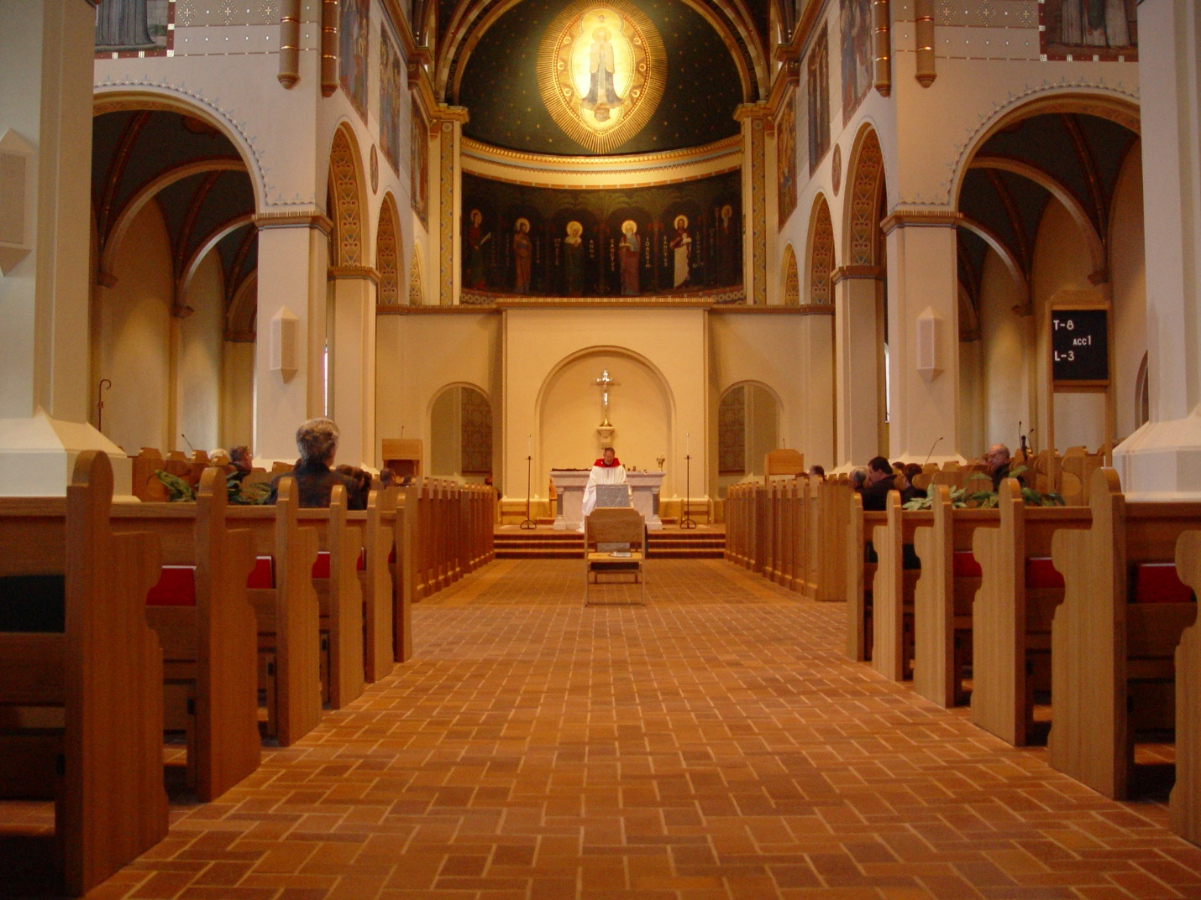
COSL 141
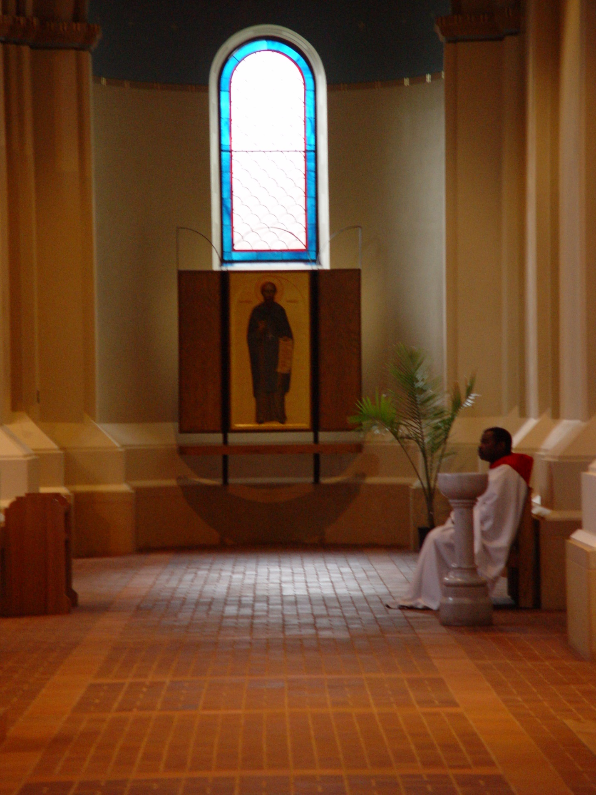
COSL 142 Br. Thomas Ferrell
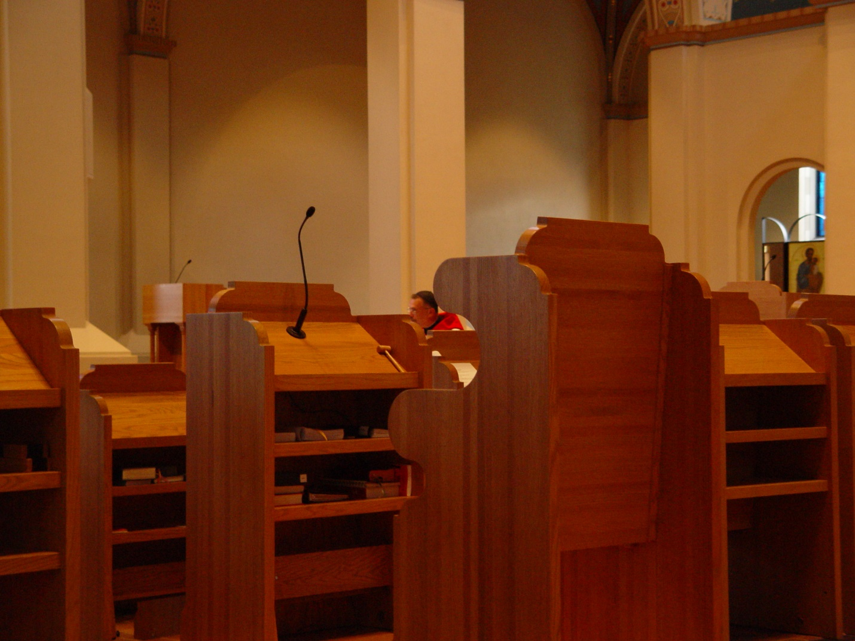
COSL 143

