Companions of St. Luke
Fall 2003 Convocation at Conception Abbey
Part 1 of 6

~Edited by Br. Steven Olderr, 13 May 2022 with the assistance of Br. Thomas Ferrell; if you find any errors or omissions, please notify Br. Steven at olderr@ameritech.net

People are identified from left to right.

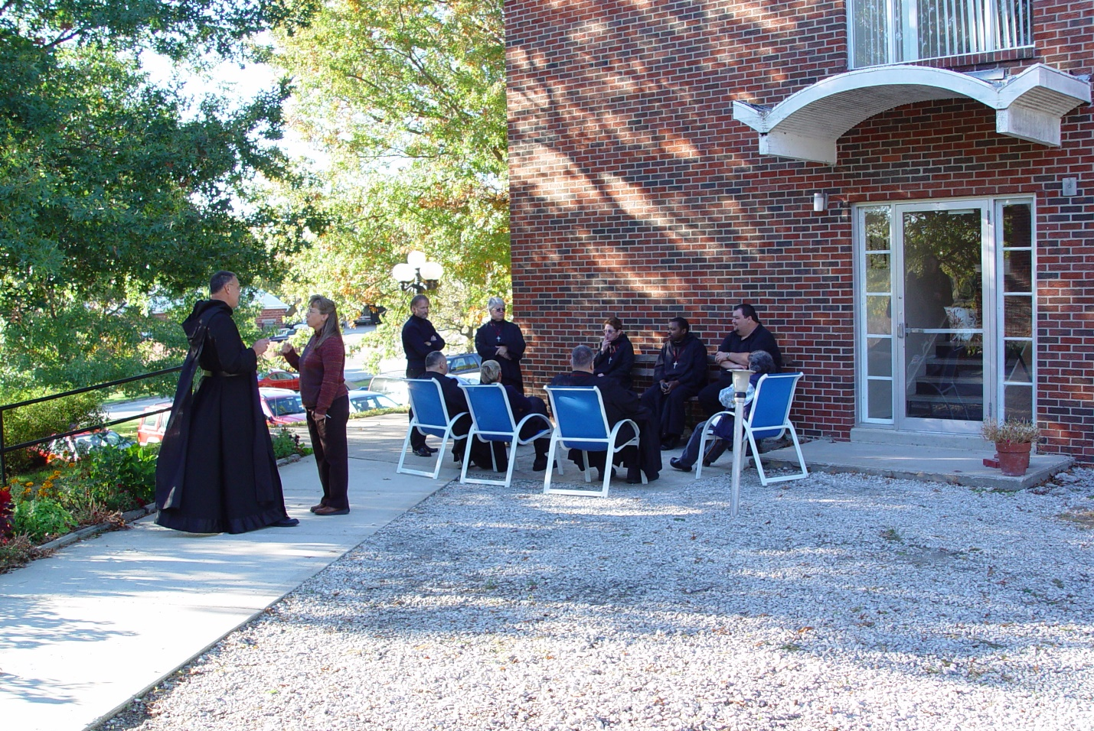
COSL 001 Prior Michael John Austin; Becky Fredregill; Br. Nathan Gregory Miller; Glen Converse (later Br. Camillus), Lawrence (Barry Mullen (later Br. Lawrence); Sr. Clare Benedicta Meyers; Sr. Monica Ruth Mullen; Br. Thomas Ferrell; Regan Fox; Becky Rittenhouse
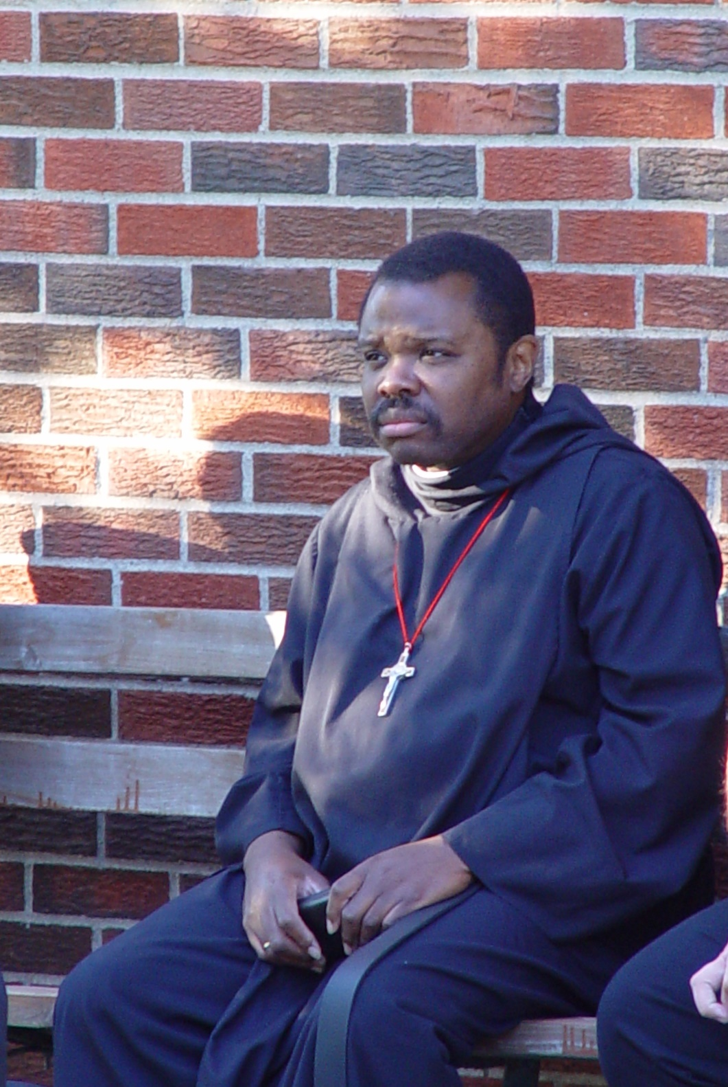
COSL 002 Br. Thomas Ferrell

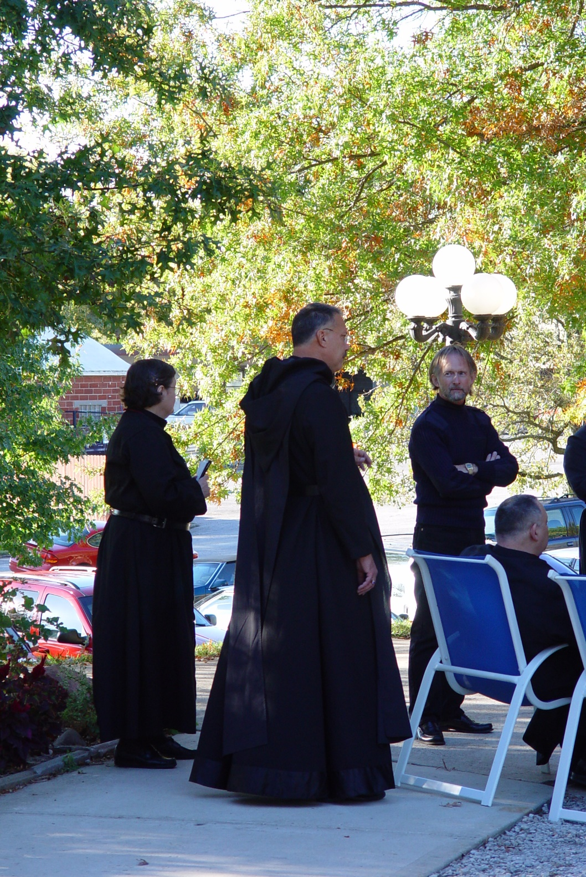
COSL 003 Sr. Theodora of Jesus Preecca; Prior Michael John Austin; Barry Mullen (later Br. Lawrence)

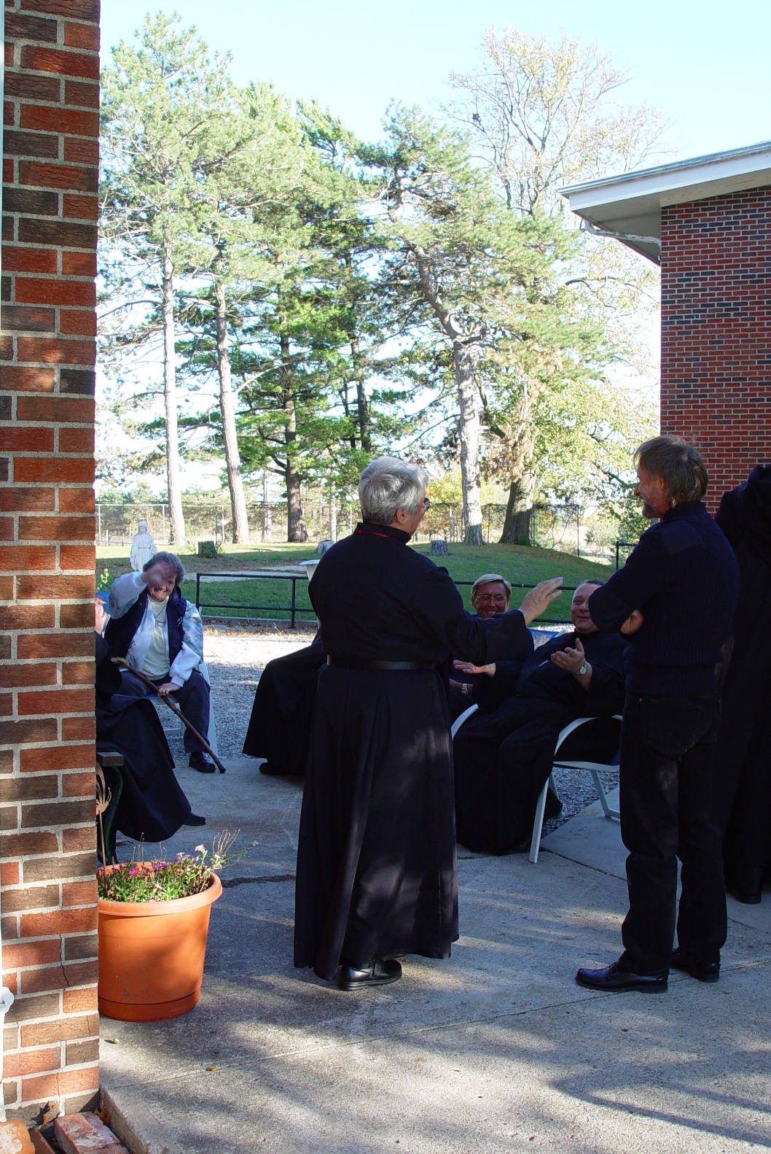
COSL 004 Becky Rittenhouse; Sr. Clare Benedicta Meyers; Glen Converse (later Br. Camillus); Br. Ambrose Heroux; Barry Mullen (later Br. Lawrence)

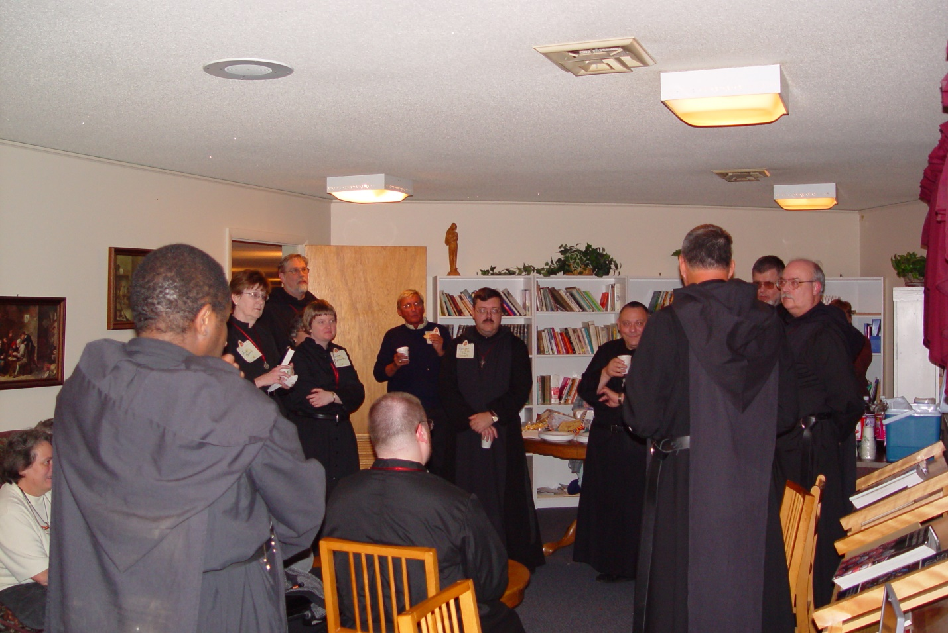
COSL 005 Becky Rittehouse; Br. Thomas Ferrell; Sr. Ann Gerns; Br. Chad Anselm Gerns (now Br. David); Sr. Catherine Unterseher; Br. Daniel Moore; Glen Converse (later Br. Camillus); Br. Paul Howard; Br. Ambrose Heroux; Prior Michael John Austin; Br. Nathan Gregory Miller; Br. Raymond Owens

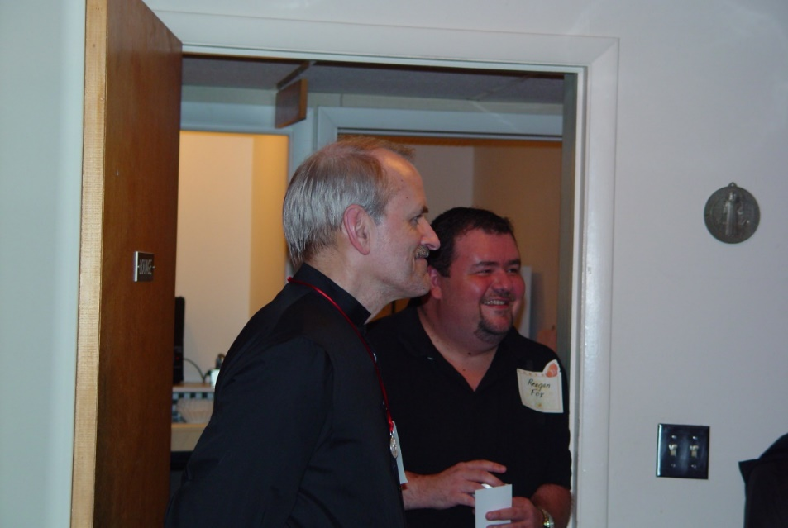
COSL 006 Br. Daniel Joseph Schroeder; Regan Fox

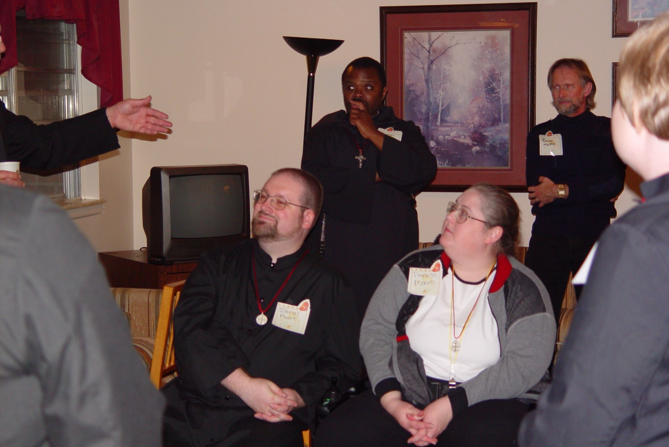
COSL 007 Br. Daniel Moore; Br. Thomas Ferrell; Denise Moore; Barry Mullen (later Br. Lawrence); Sr. Catherine Unterseher

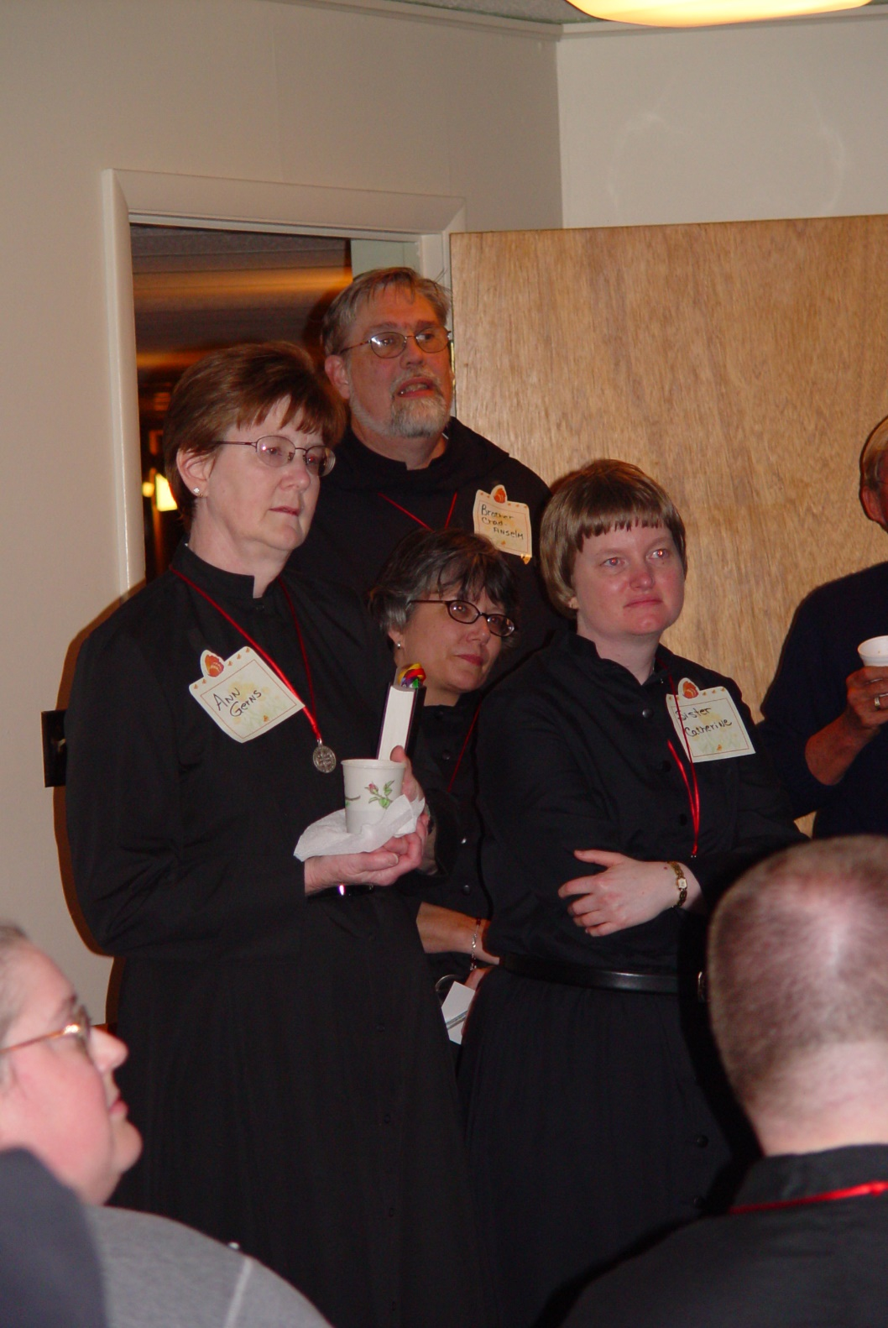
COSL 008 Denise Moore; Sr. Ann Gerns; Br. Chad Anselm Gerns (now Br. David);
Sr. Anna Grace Madden; Sr. Catherine Unterseher; Br. Daniel Moore

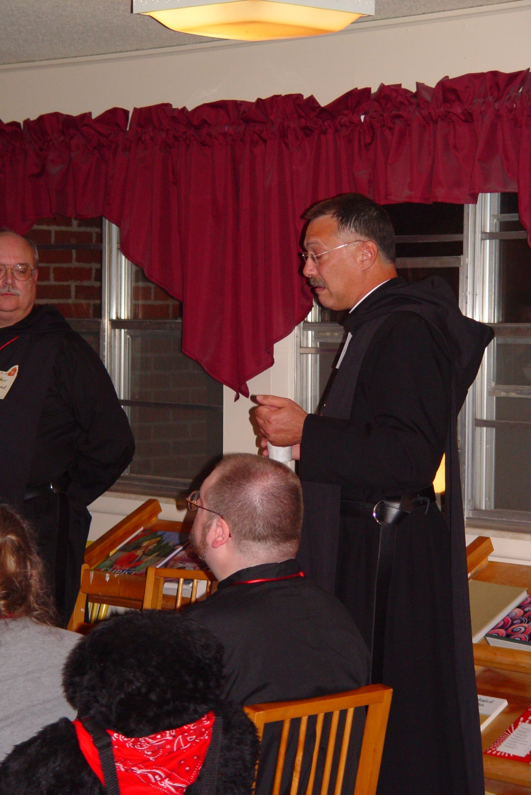
COSL 009 Br. Raymond Owens; Br. Daniel Moore; Prior Michael John Austin

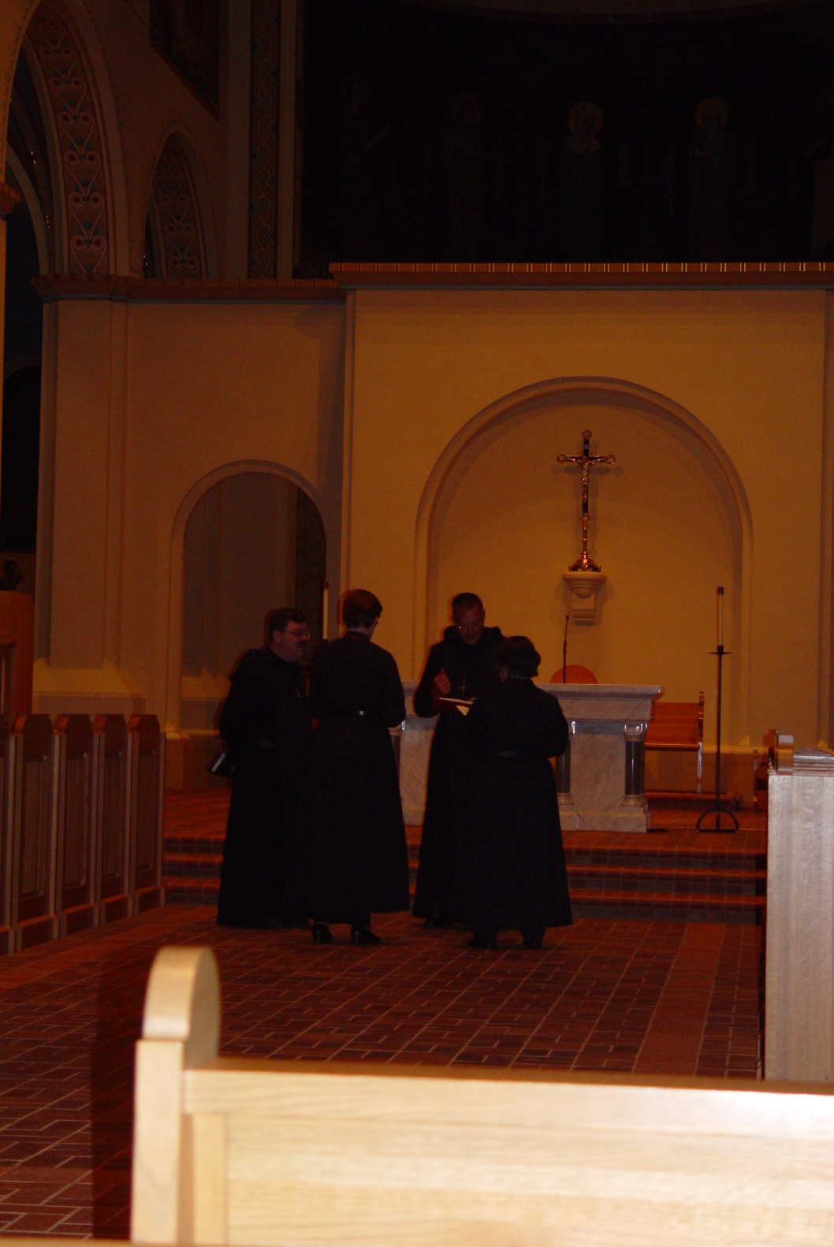
COSL 010 Br. Paul Howard; Sr. Ann Gerns; Prior Michael John Austin; Sr. Anna Grace Madden

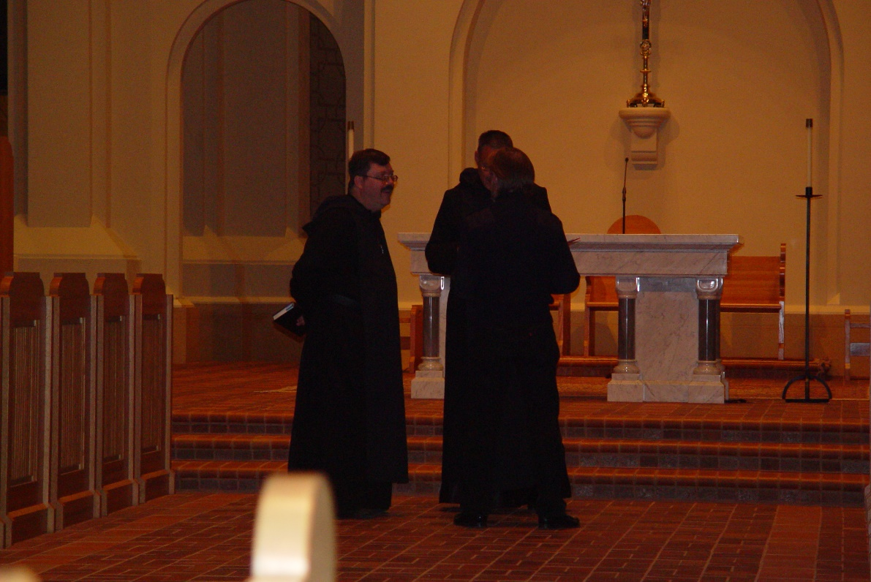
COSL 011 Br. Paul Howard; Prior Michael John Austin; ?

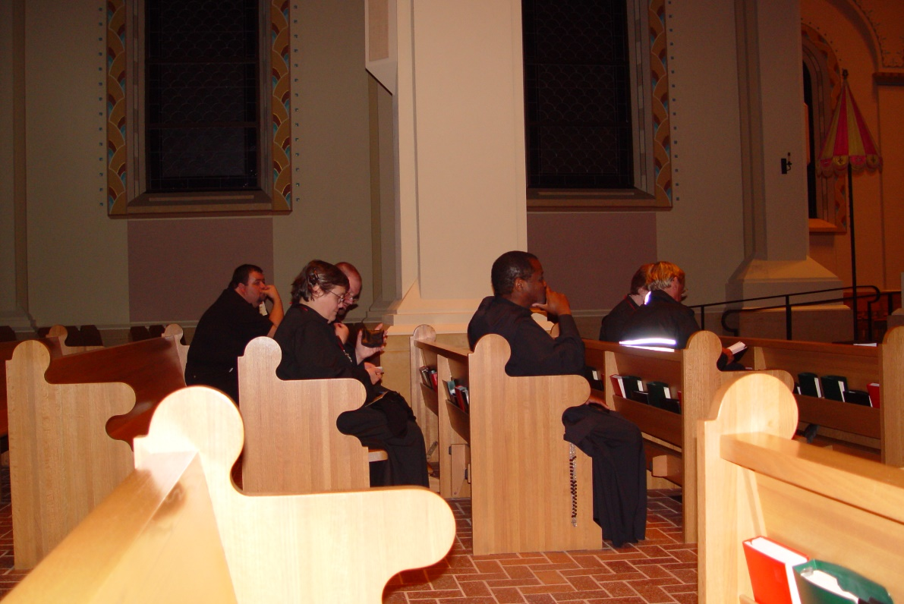
COSL 012 Regan Fox ; Sr. Theodora of Jesus Perecca; Br. Thomas Ferrell; Glen Converse (later Br. Camillus)

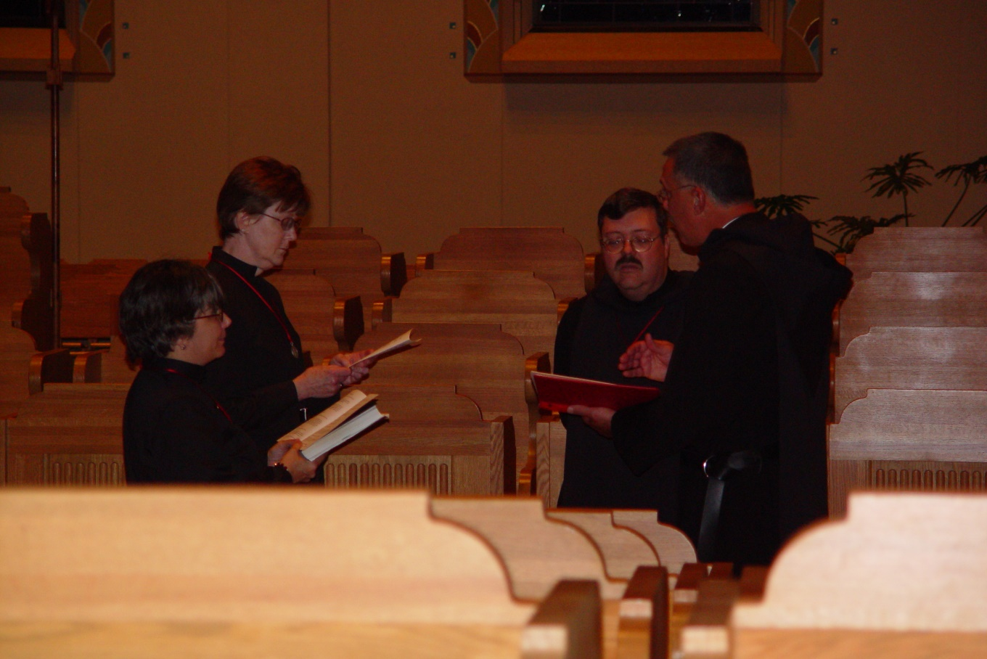
COSL 013 Sr. Anna Grace Madden; Sr. Ann Gerns; Br. Paul Howard; Prior Michael John Austin

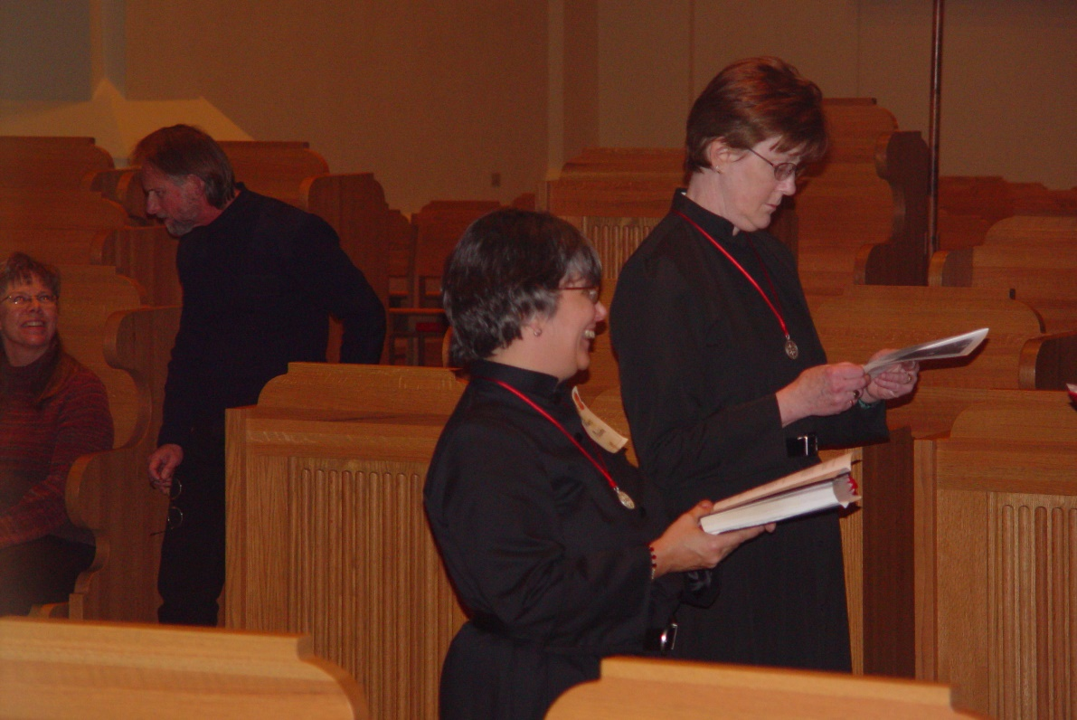
COSL 014 Beck Fredregill; Barry Mullen; (later Br. Lawrence); Sr. Anna Grace Madden; Sr. Ann Gerns
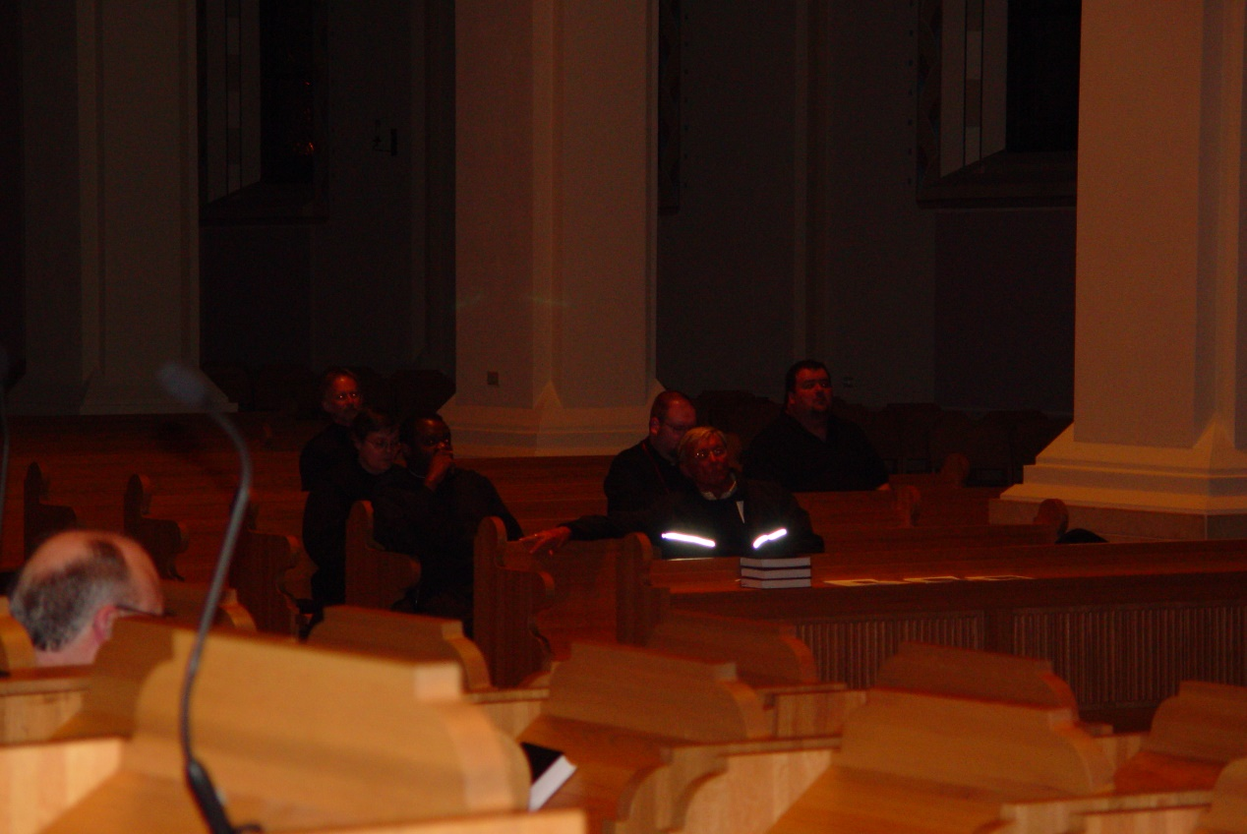
COSL 015

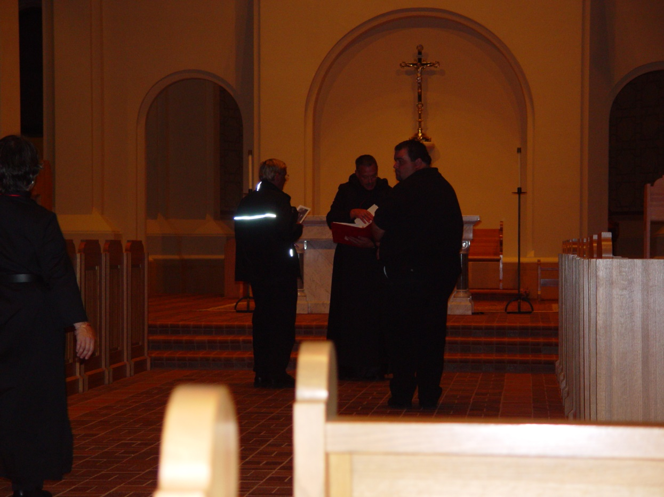
COSL 016 Glen Converse (later Br. Camillus); Prior Michael John Austin; Regan Fox

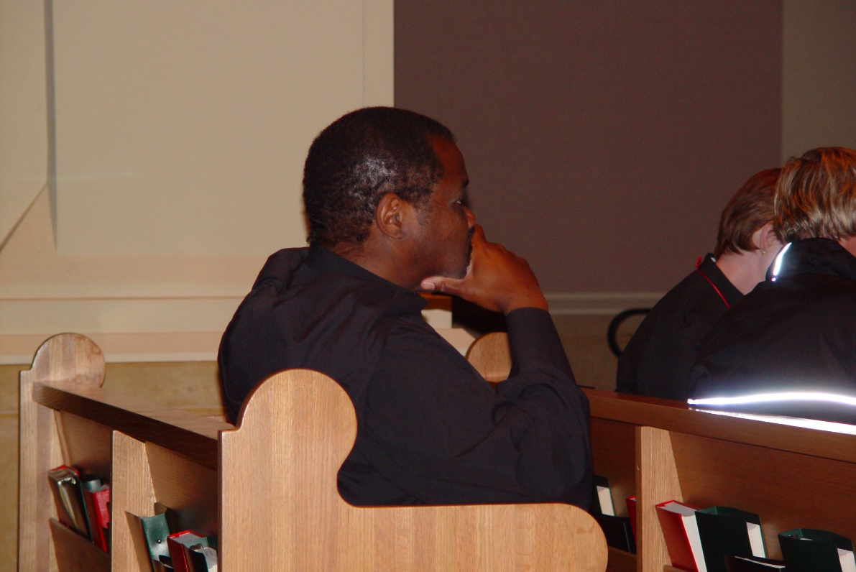
COSL 017 Br. Thomas Ferrell

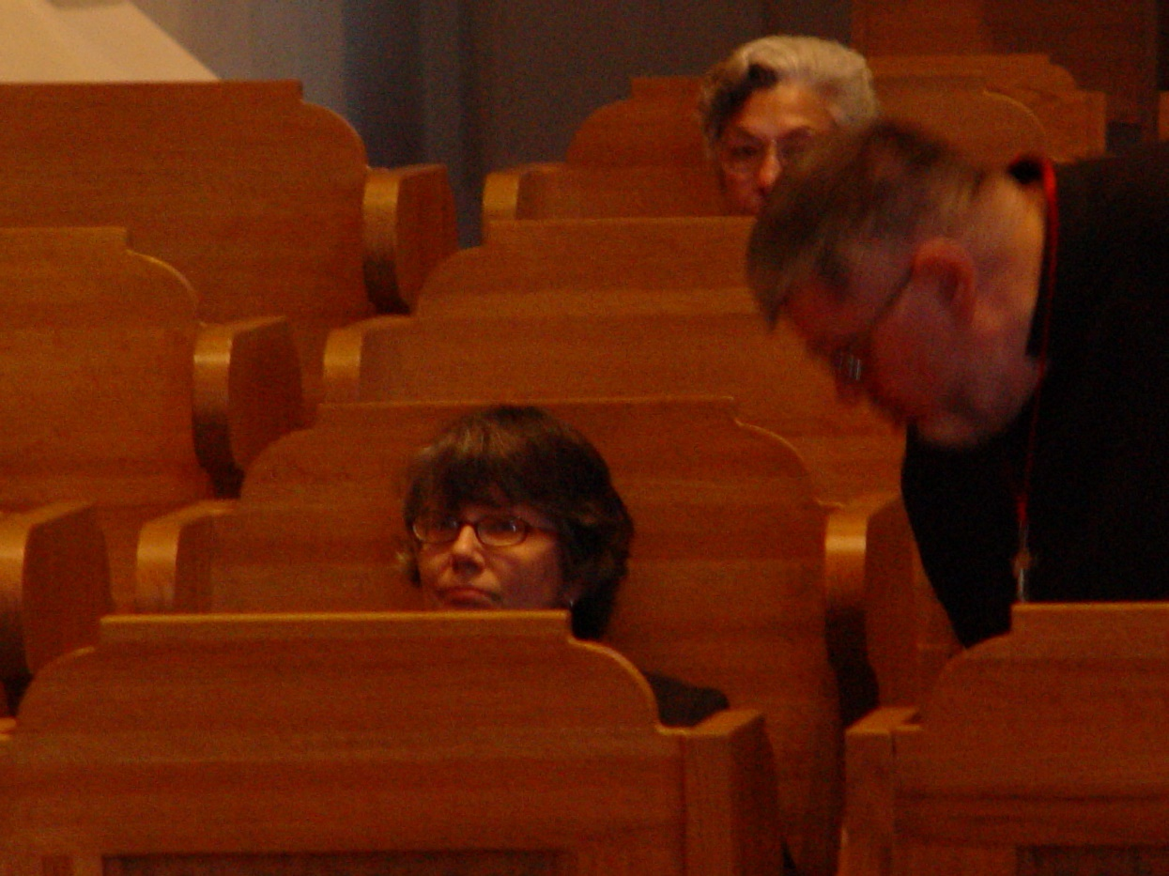
COSL 018 Sr. Anna Grace Madden; Jeanetta Doan (Prior Michael John’s mother); Br. Nathan Gregory Miller

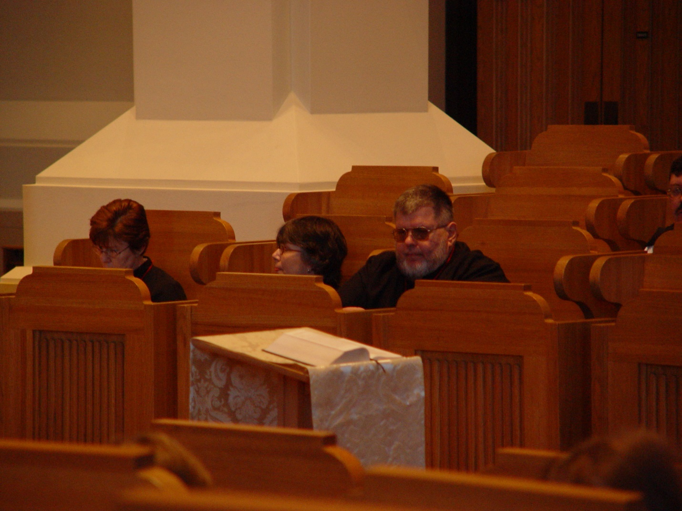
COSL 019 Sr. Ann Gerns; Sr. Anna Grace Madden; Br. Nathan Gregory Miller

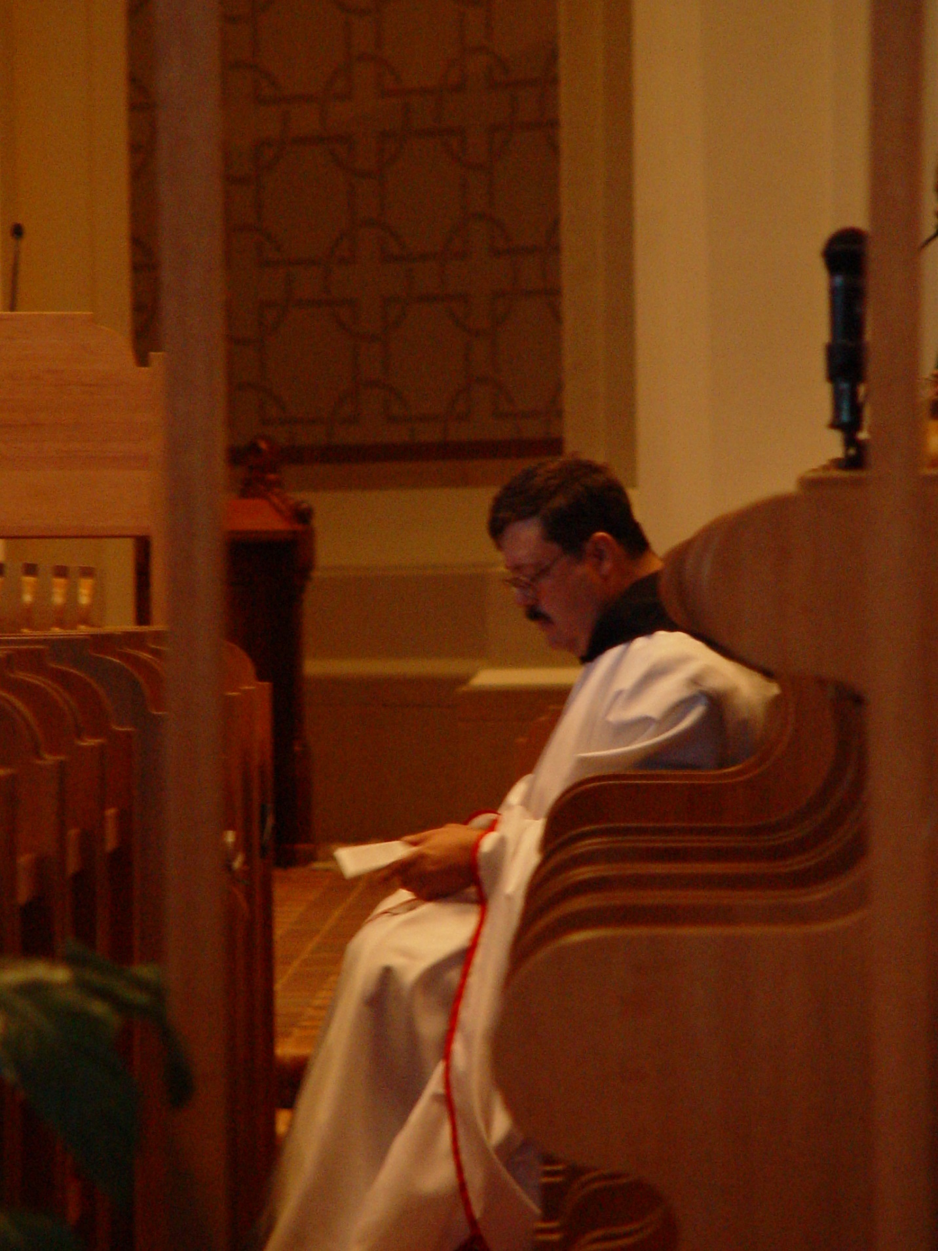
COSL 020 Br. Paul Howard
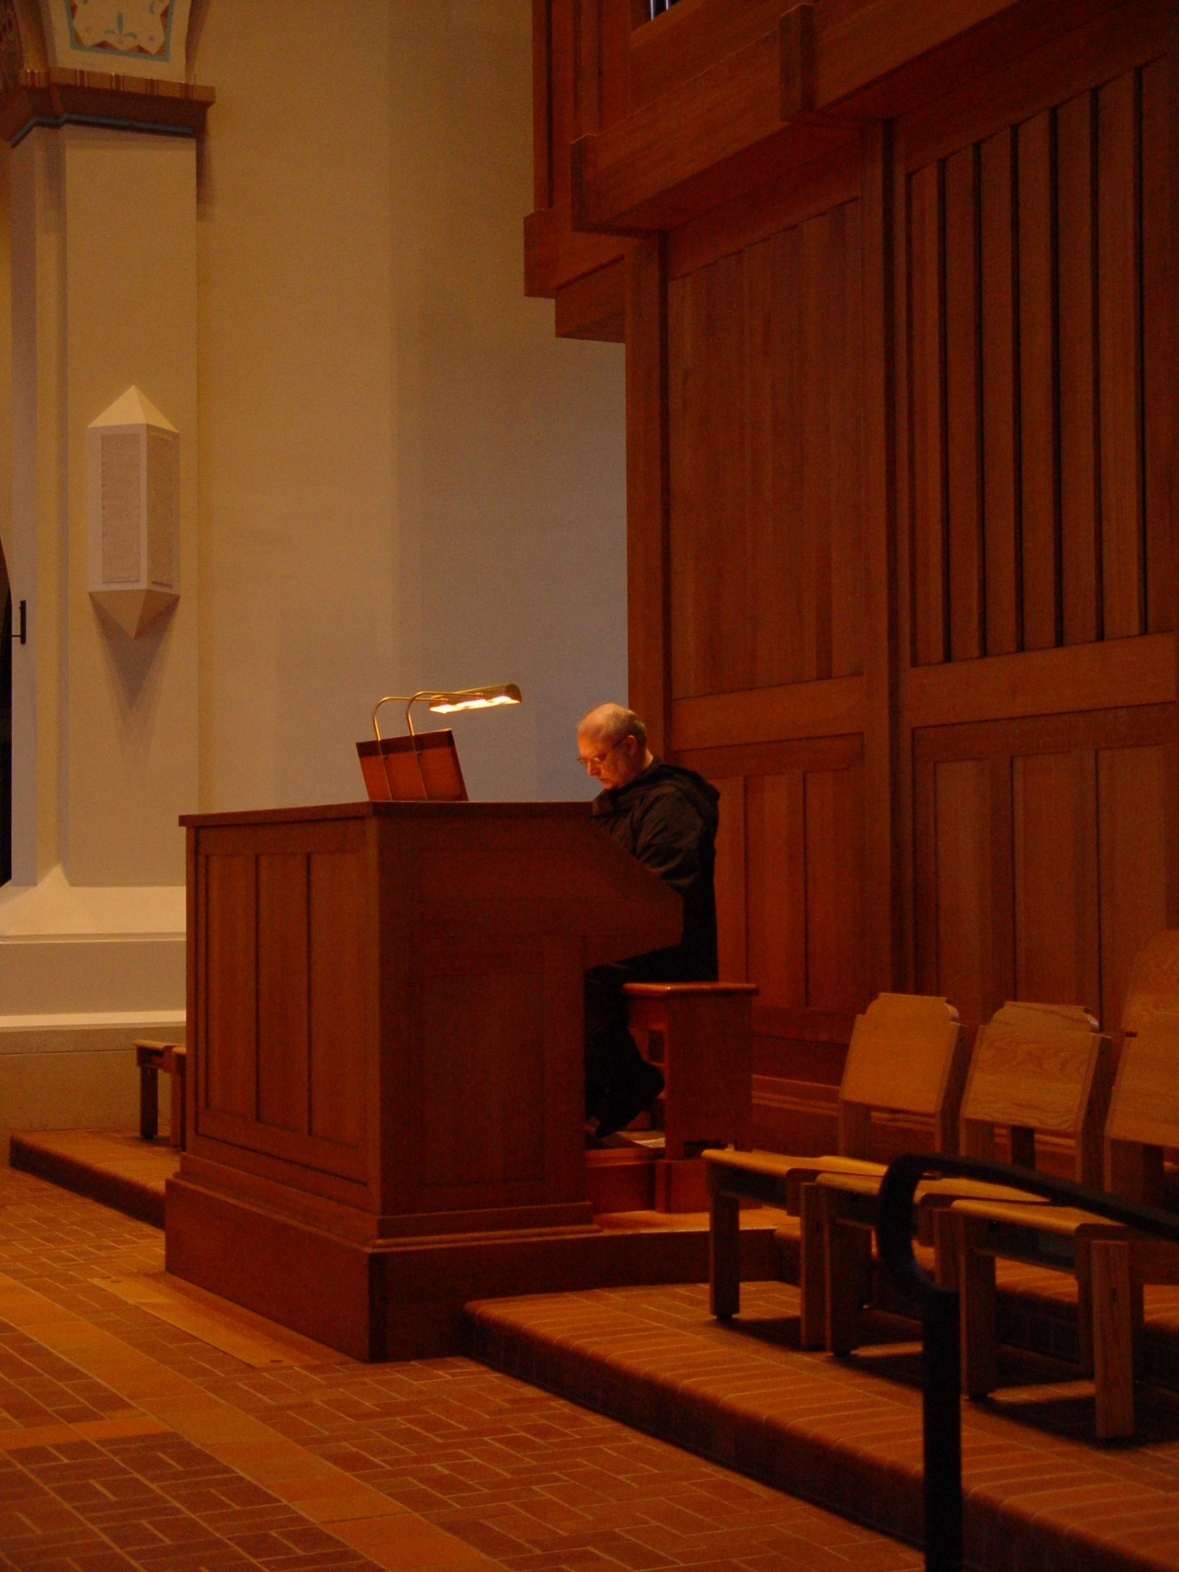
COSL 021 Br. Raymond Owens
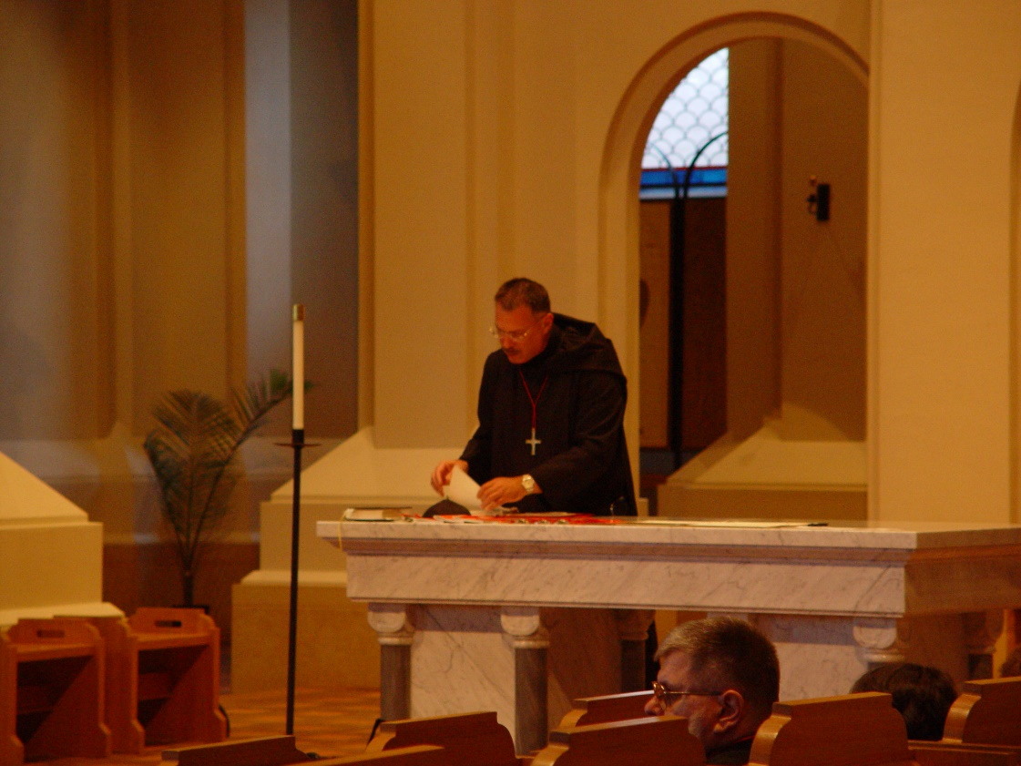
COSL 022 Prior Michael John Austin

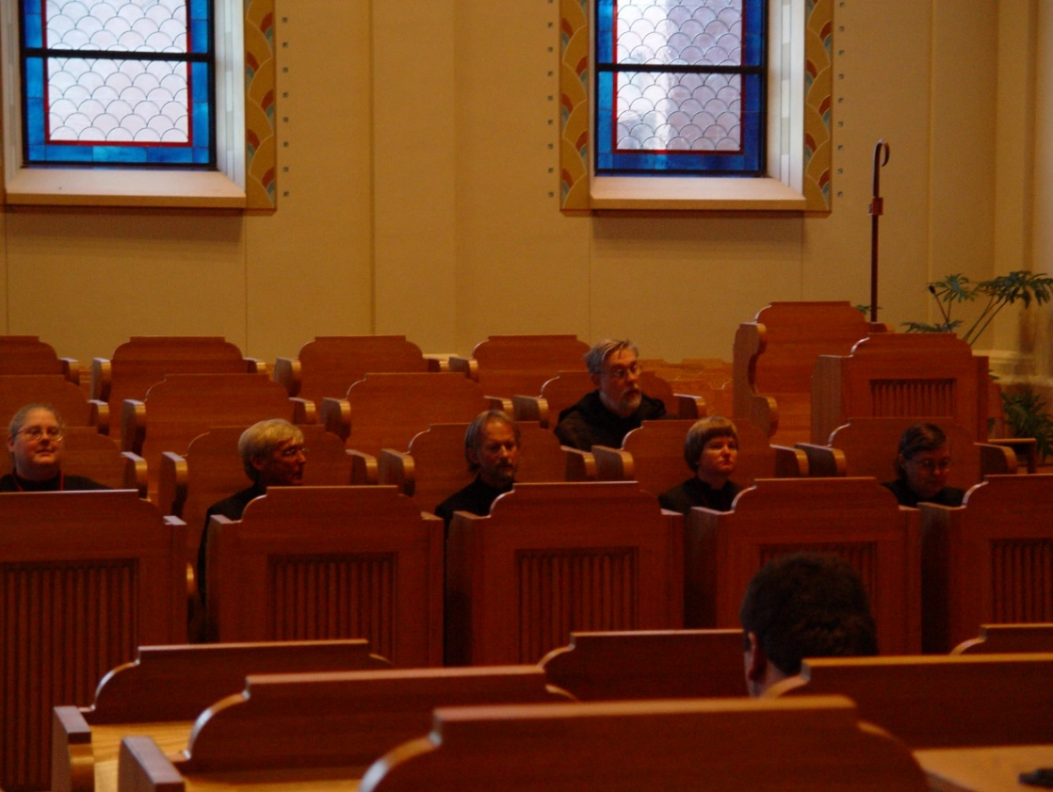
COSL 023 Denise Moore; Glen Converse (later Br. Camillus); Barry Mullen (later Br. Lawrence); Br. Chad Anselm Gerns (now Br. David); Sr. Catherine Unterseyer; Sr. Theodora of Jesus Perecca

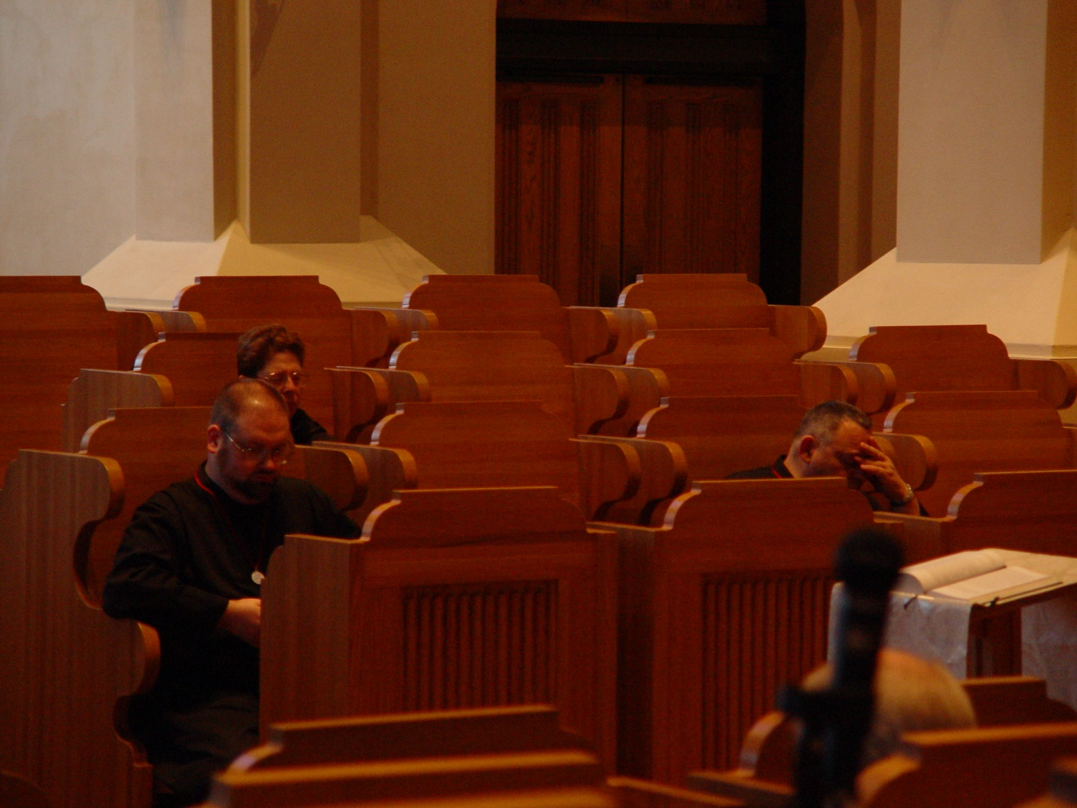
COSL 024 Br. Daniel Moore; Sr. Monica Ruth Mullen; Br. Ambrose Heroux

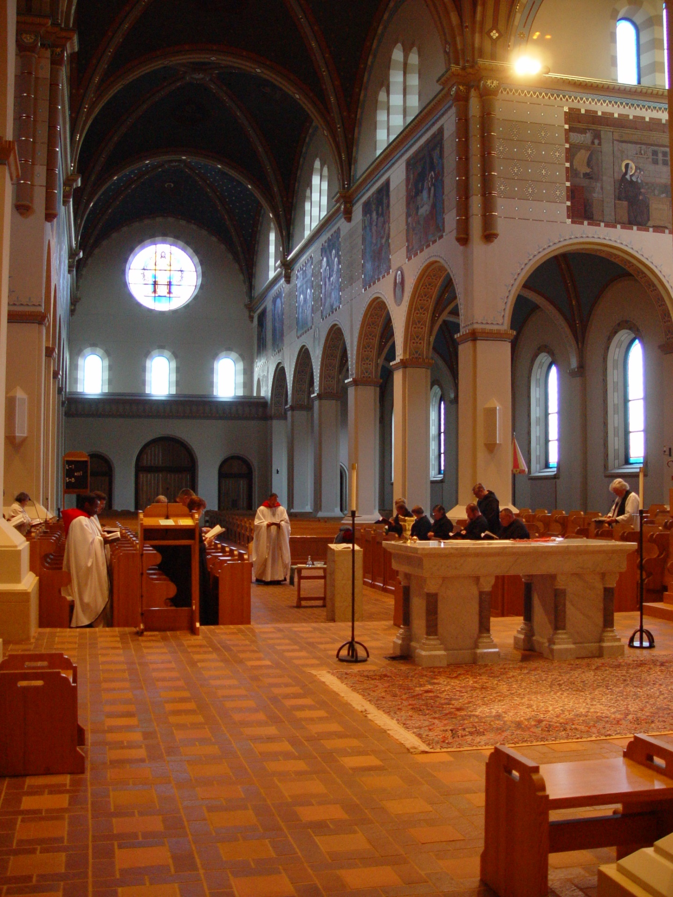
COSL 025
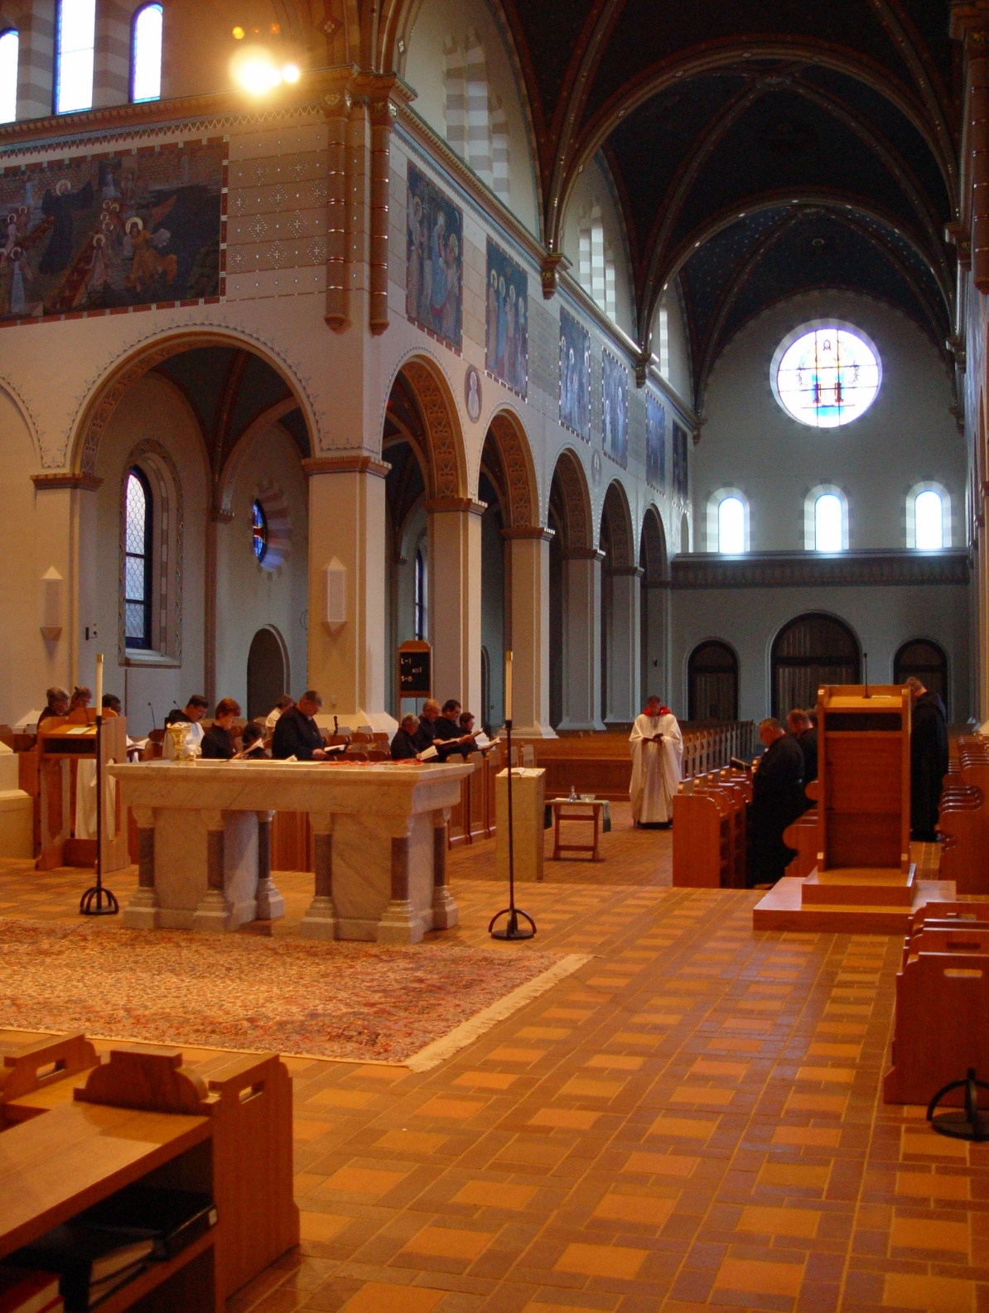

COSL 026

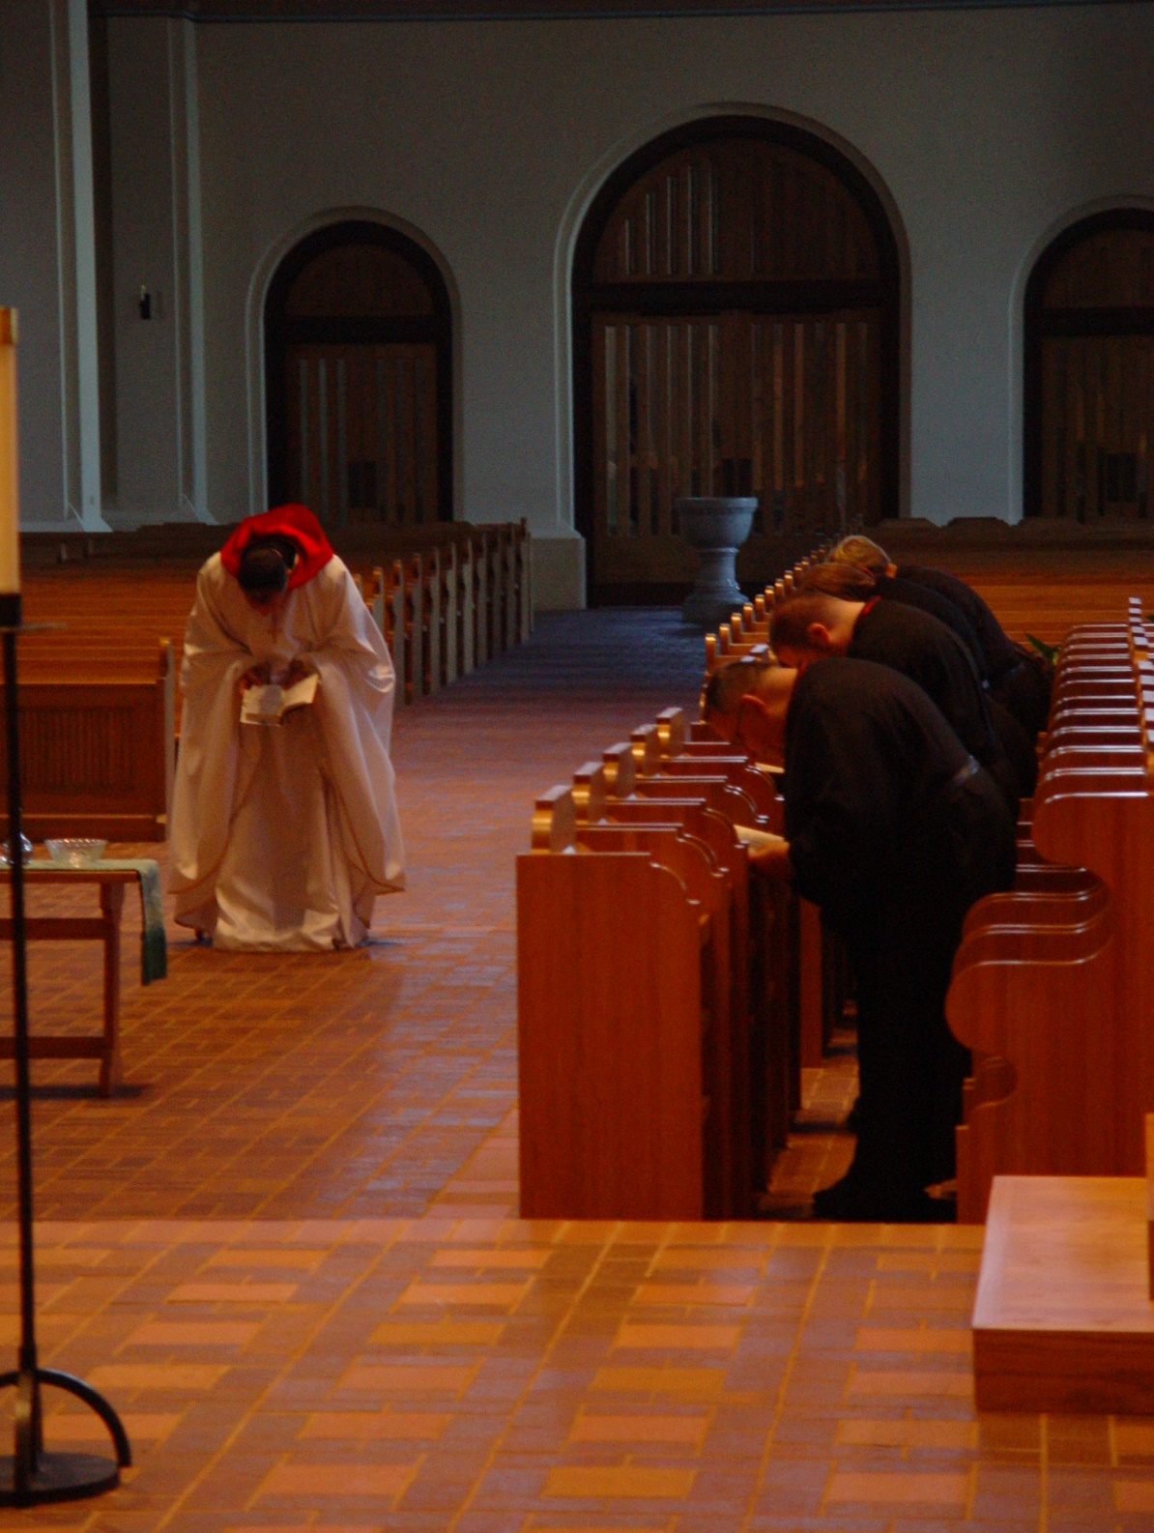
COSL 027 Prior Michael John Austin; Br. Ambrose Heroux; Br. Daniel Moore; Sr. Ann Gerns; Barry Mullen (later Br. Lawrence)

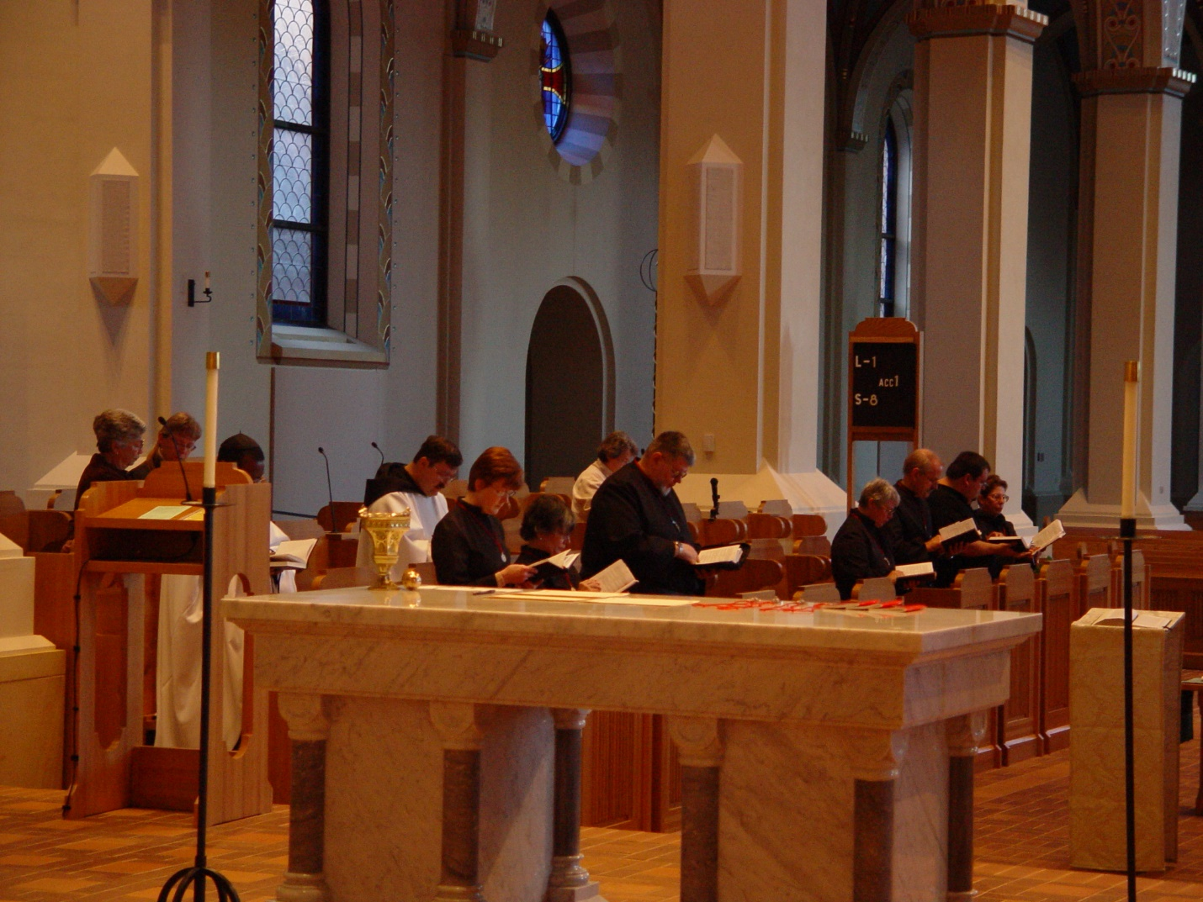
COSL 028 Jeanetta Doan; Becky Fredregill. Br. Thomas Ferrell; Br. Paul Howard; Sr. Ann Gerns; Br. Thomas Ferrell; Sr. Anna Grace Madden; Becky Rittenhouse; Br. Nathan Gregory Miller; Sr. Clare Benedicta Meyers; Br. Daniel Joseph Schroeder; Regan Fox; Sr. Monica Ruth Mullen
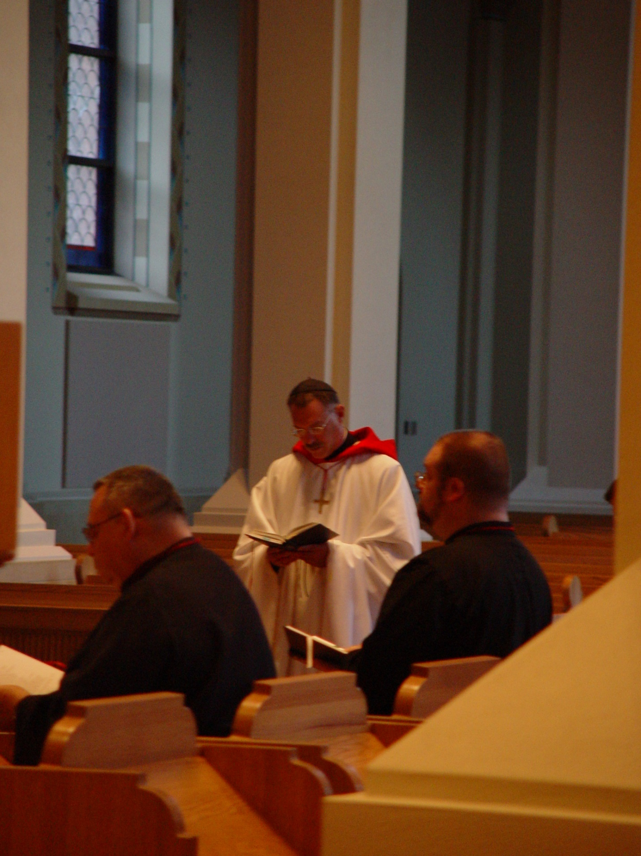
COSL 029 Br. Ambrose Heroux; Prior Michael John Austin; Br. Daniel Moore
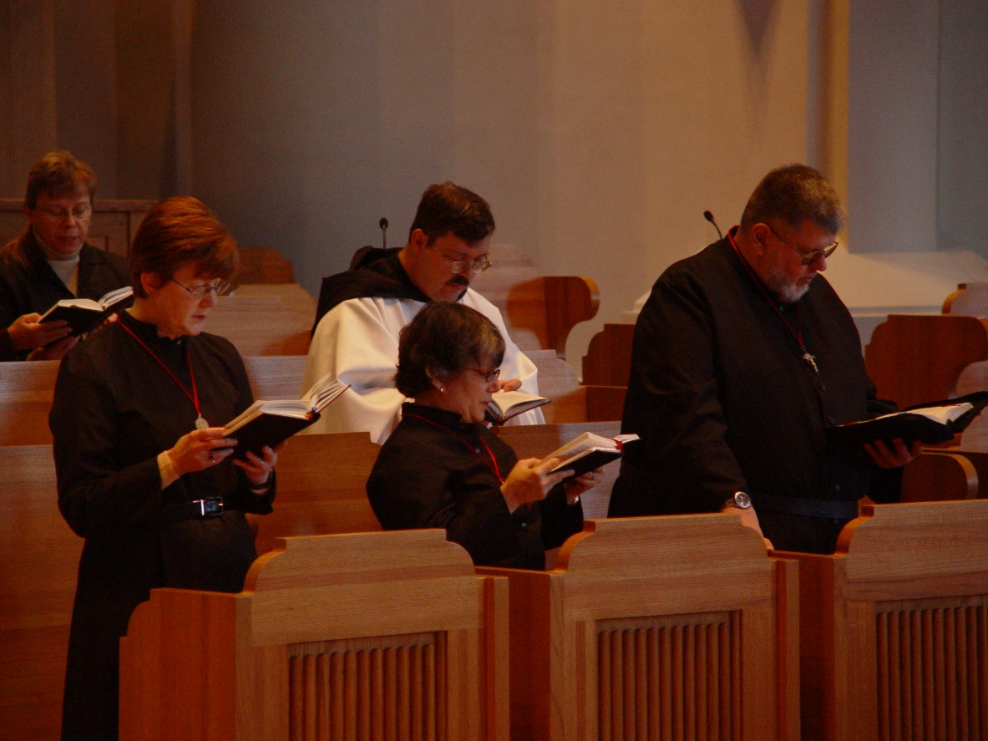
COSL 030 Becky Fredregill; Sr. Ann Gerns; Sr. Anna Grace Madden; Br. Paul Howard; Br. Nathan Gregory Miller

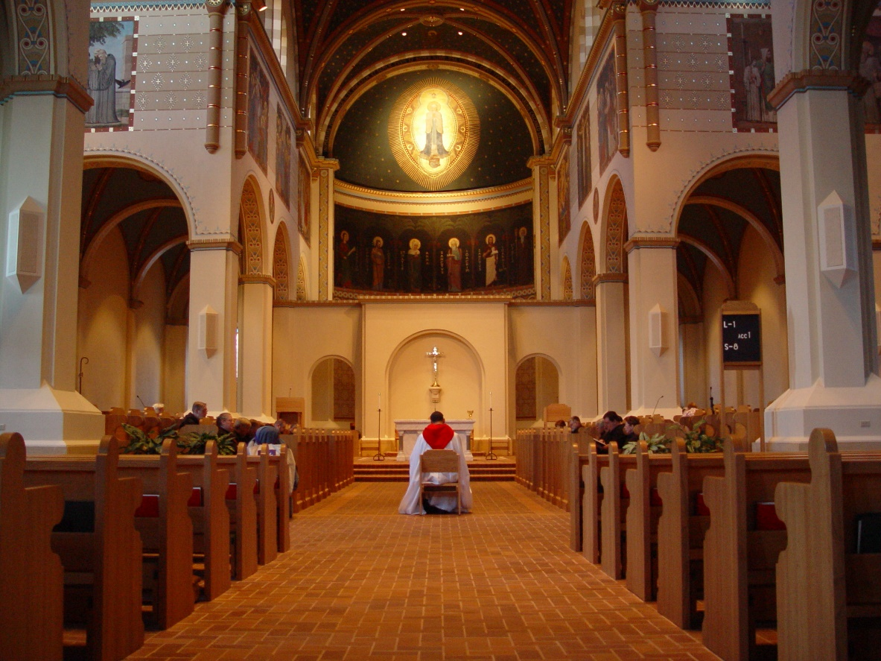
COSL 031

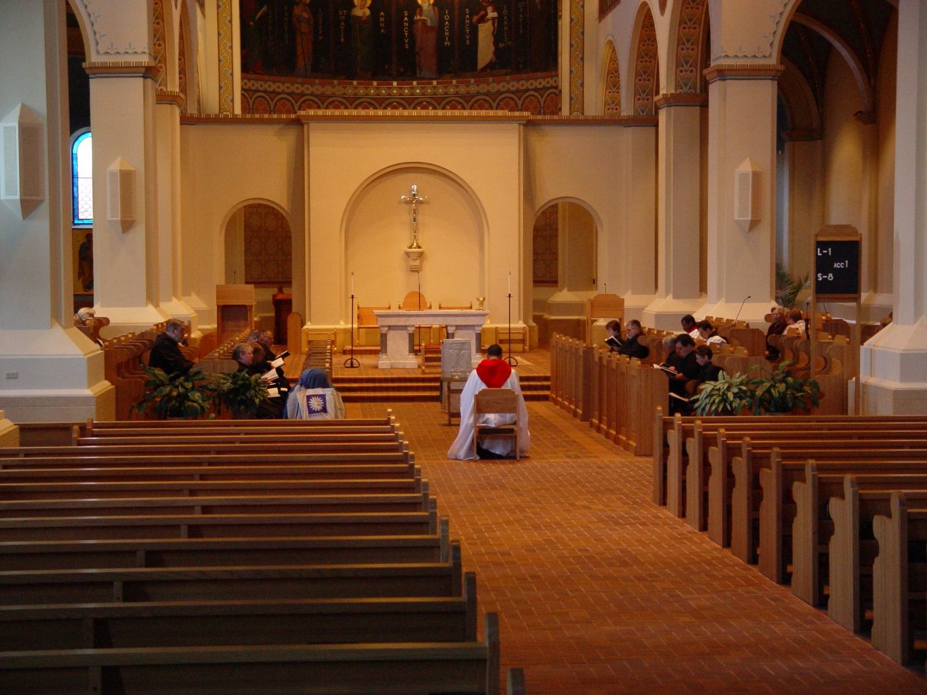
COSL 032

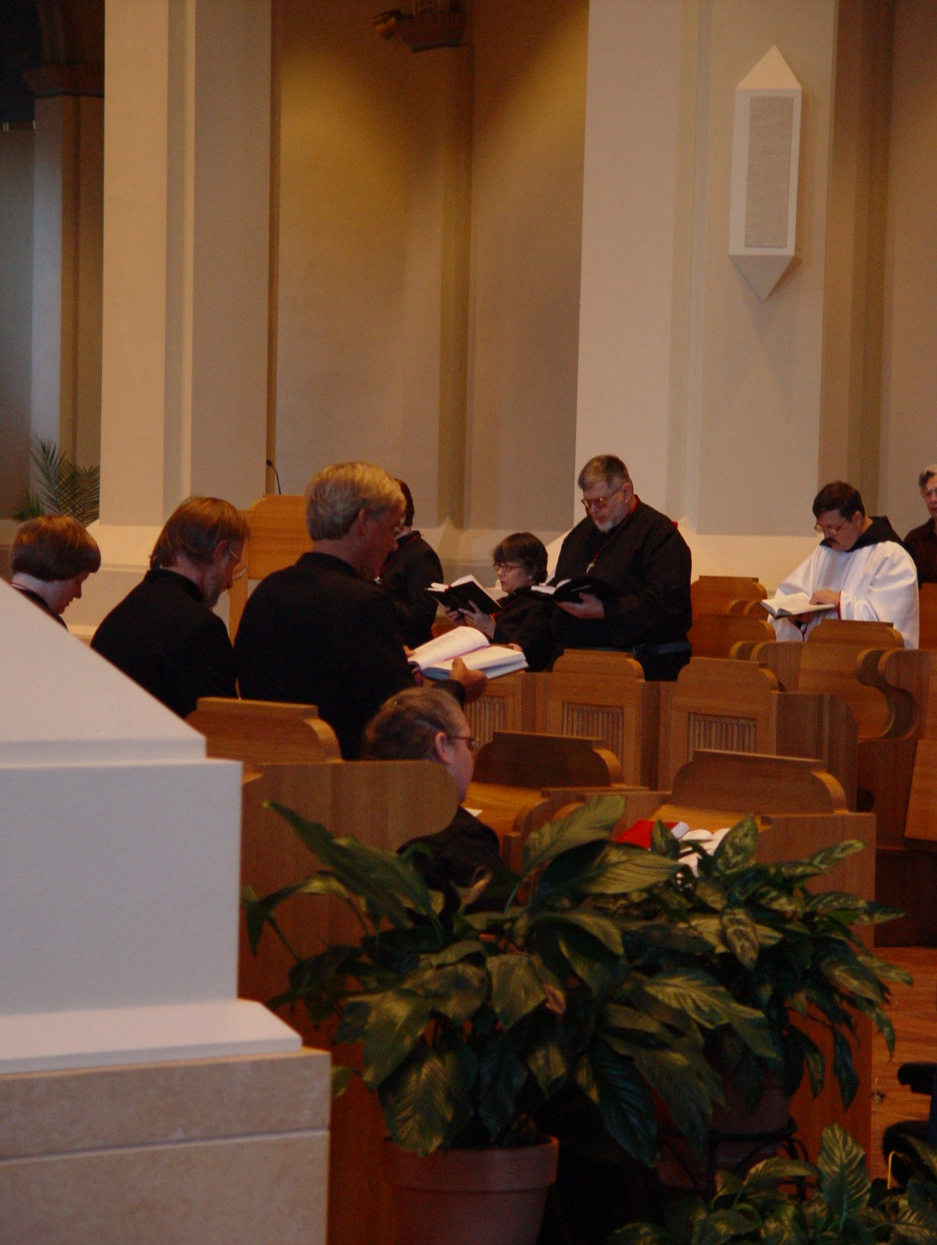
COSL 033 Foreground: Sr. Catherine Unterseyer; Barry Mullen; Glen Converse (now Br. Camillus); Sr. Denise Moore
Backround: Sr. Ann Gerns; ; Sr. Anna Grace Madden; Br. Nathan Gregory Miller; Br. Paul Howard; Jeanetta Doan

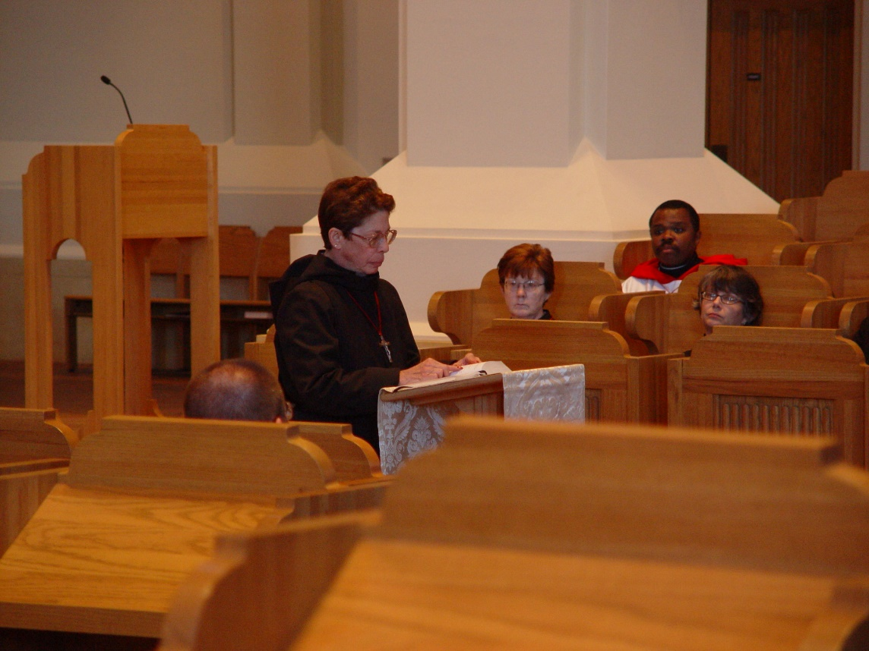
COSL 034 Br. Daniel Moore; Sr. Monica Ruth Mullen; Sr. Ann Gerns; Br. Thomas Ferrell; Sr. Anna Grace Madden

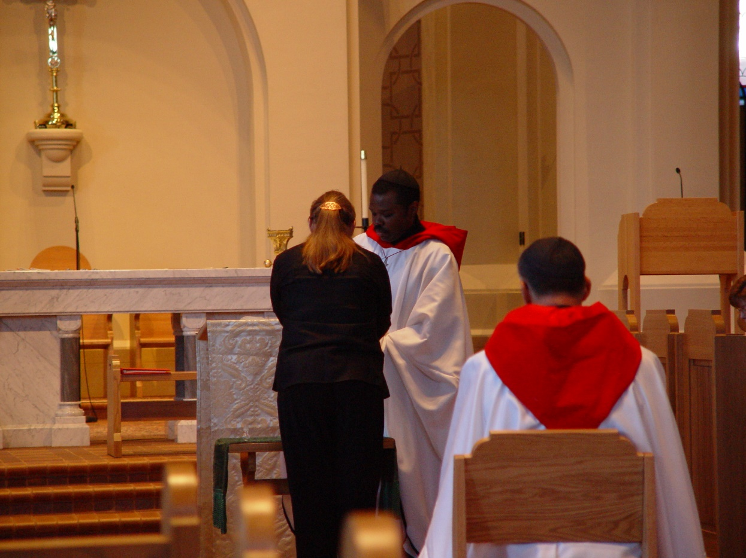
COSL 035 Becky Fredregill; Br. Thomas Ferrell; Prior Michael John Austin

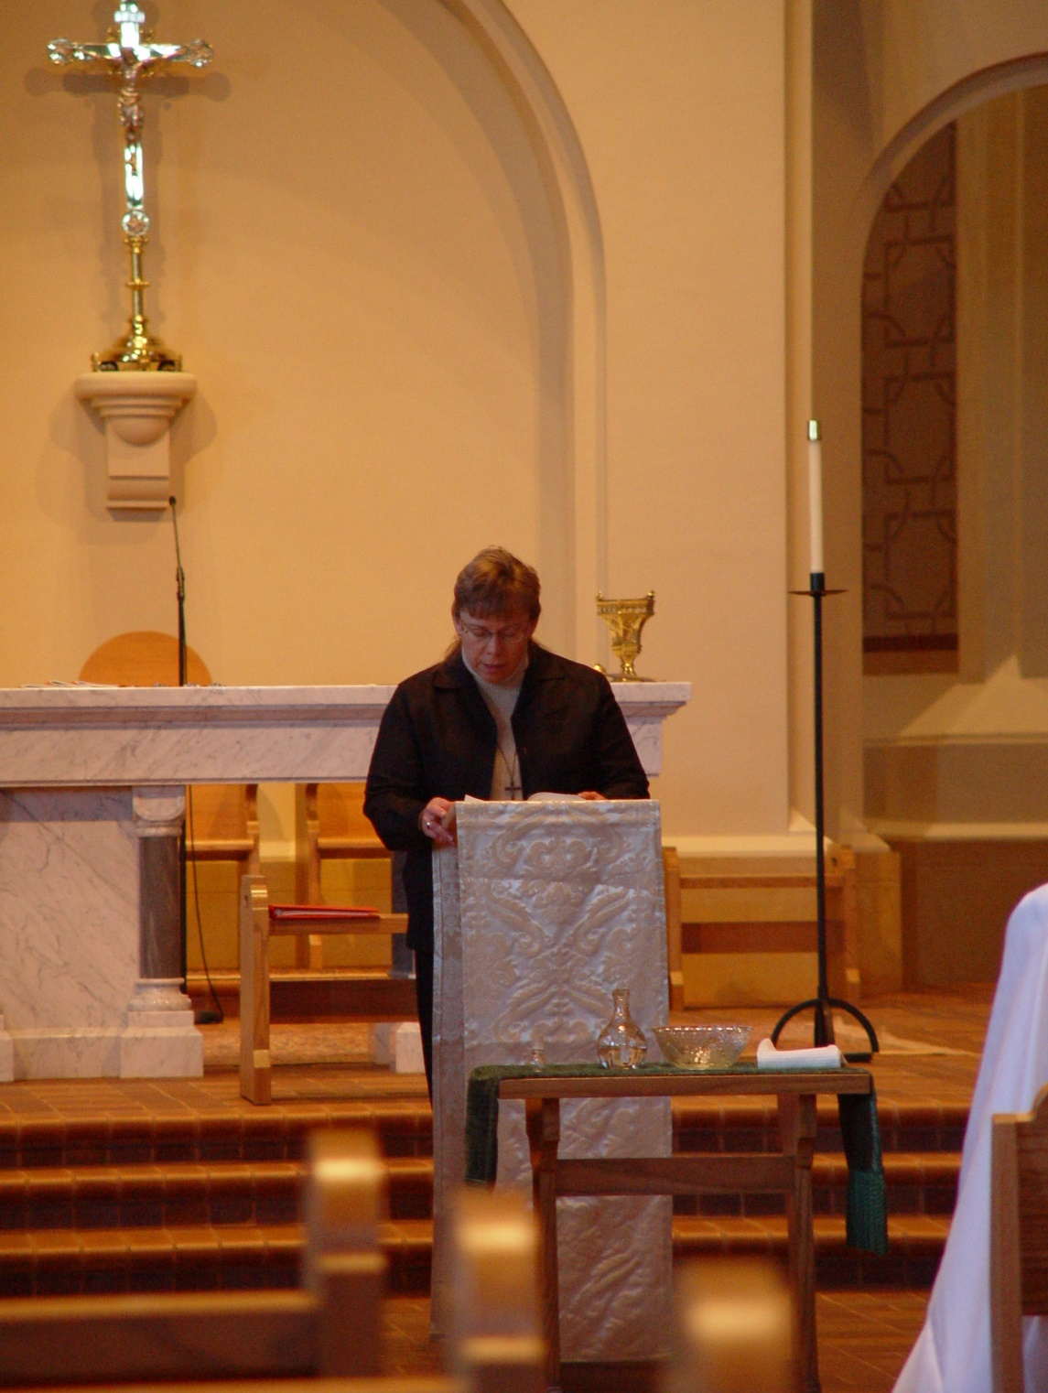
COSL 036 Becky Fredregill
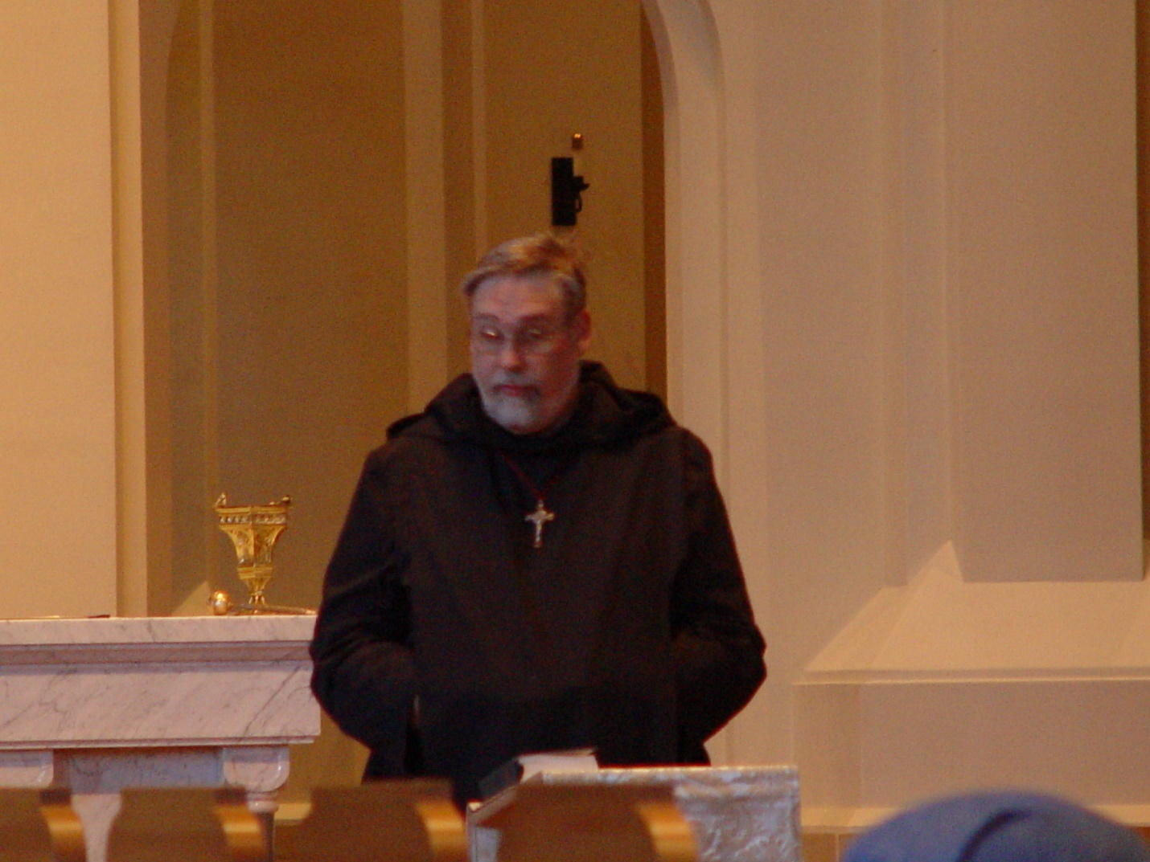
COSL 037 Br. Chad Anselm Gerns (now Br. David)

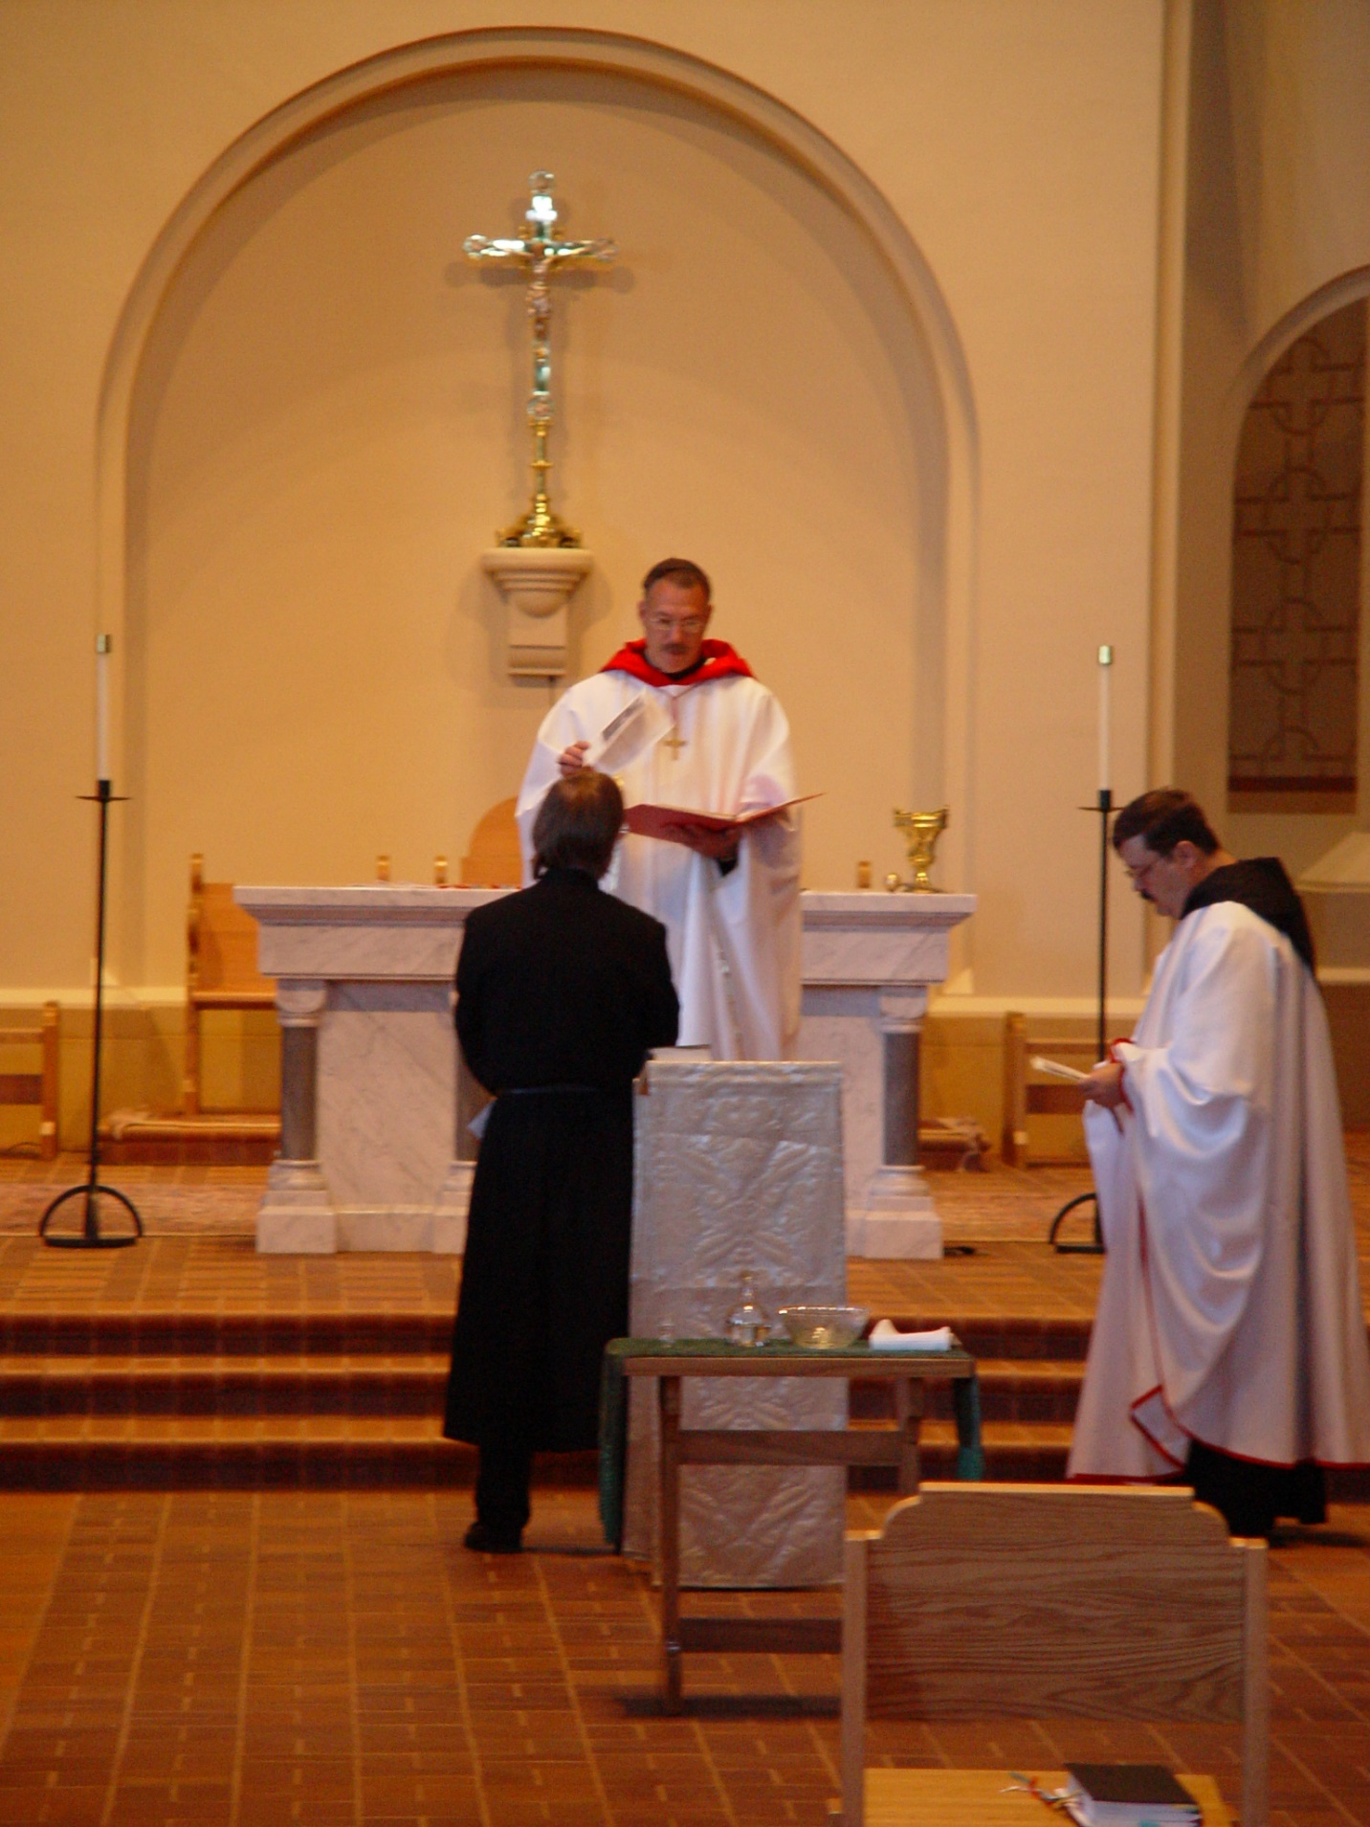
COSL 038 Barry Mullen; Prior Michael John Austin; Br. Paul Howard
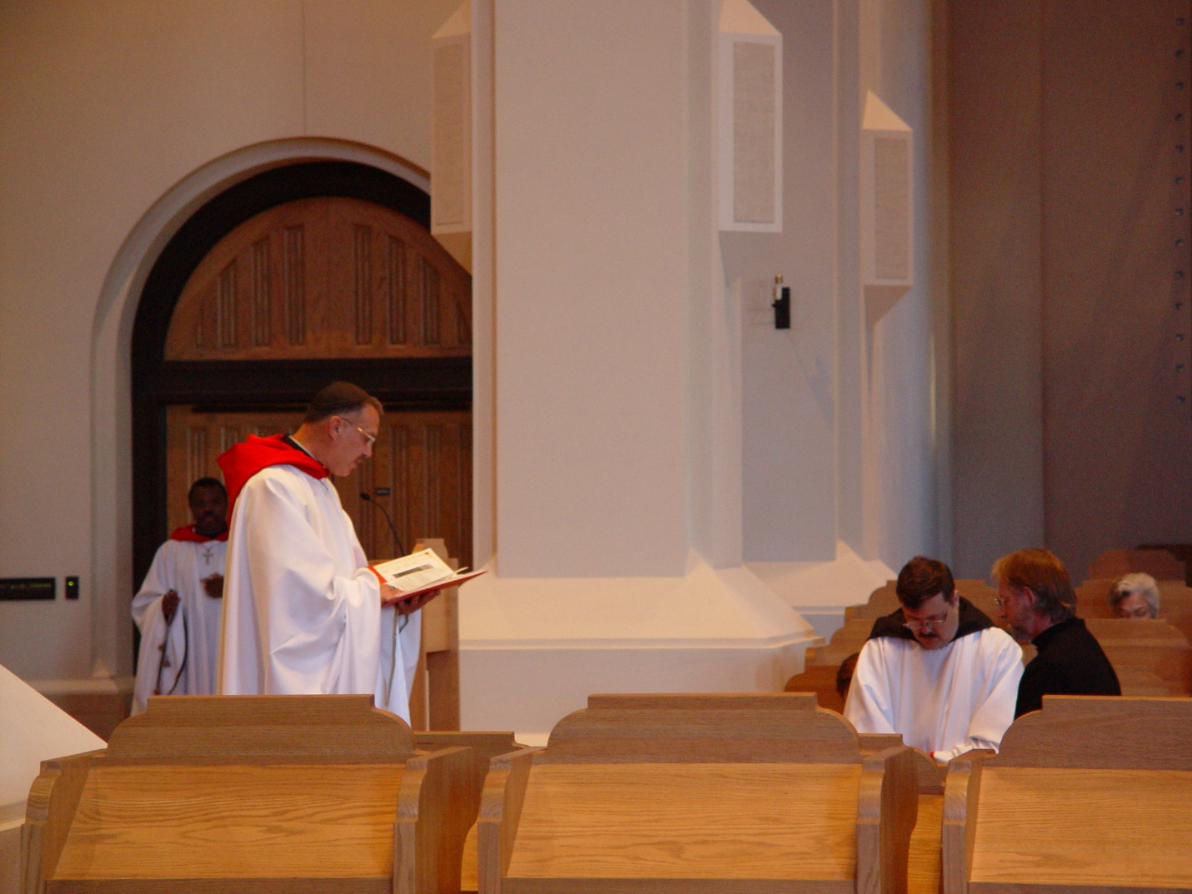
COSL 039 Br. Thomas Ferrell; Prior Michael John Austin; Br. Paul Howard; Barry Mullen; Jeanetta Doan

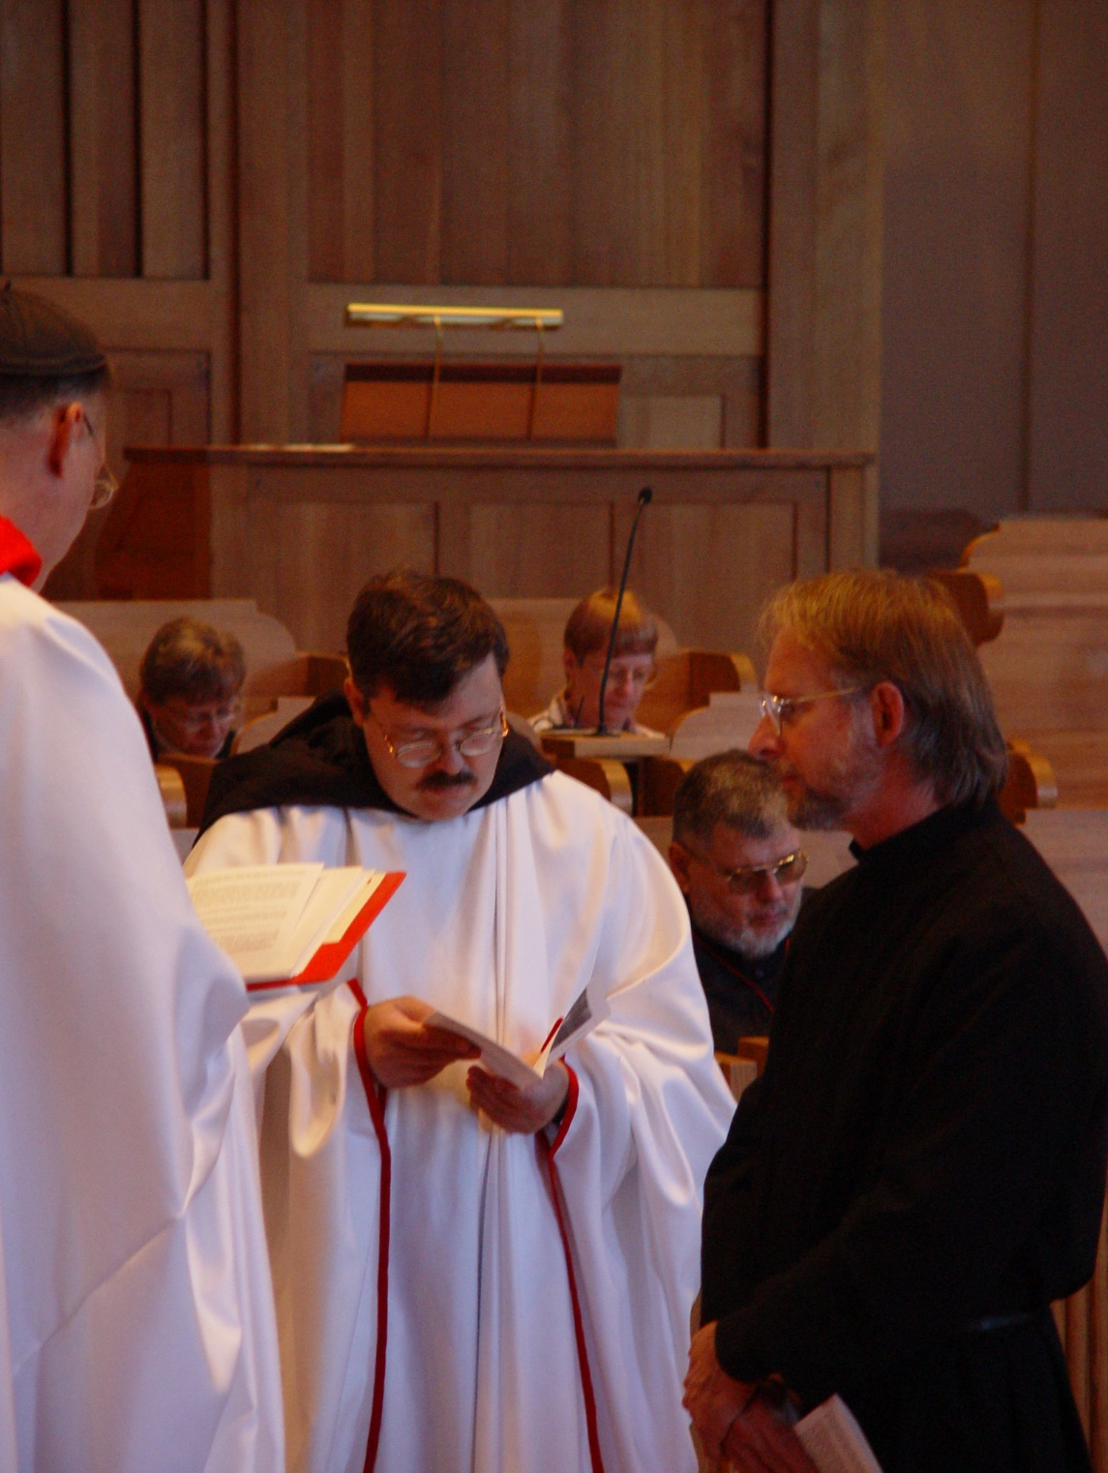
COSL 040 Prior Michael John Austin; Jeanetta Doan; Br. Paul Howard; Lynn Owens; Br. Nathan Gregory Miller; Barry Mullen
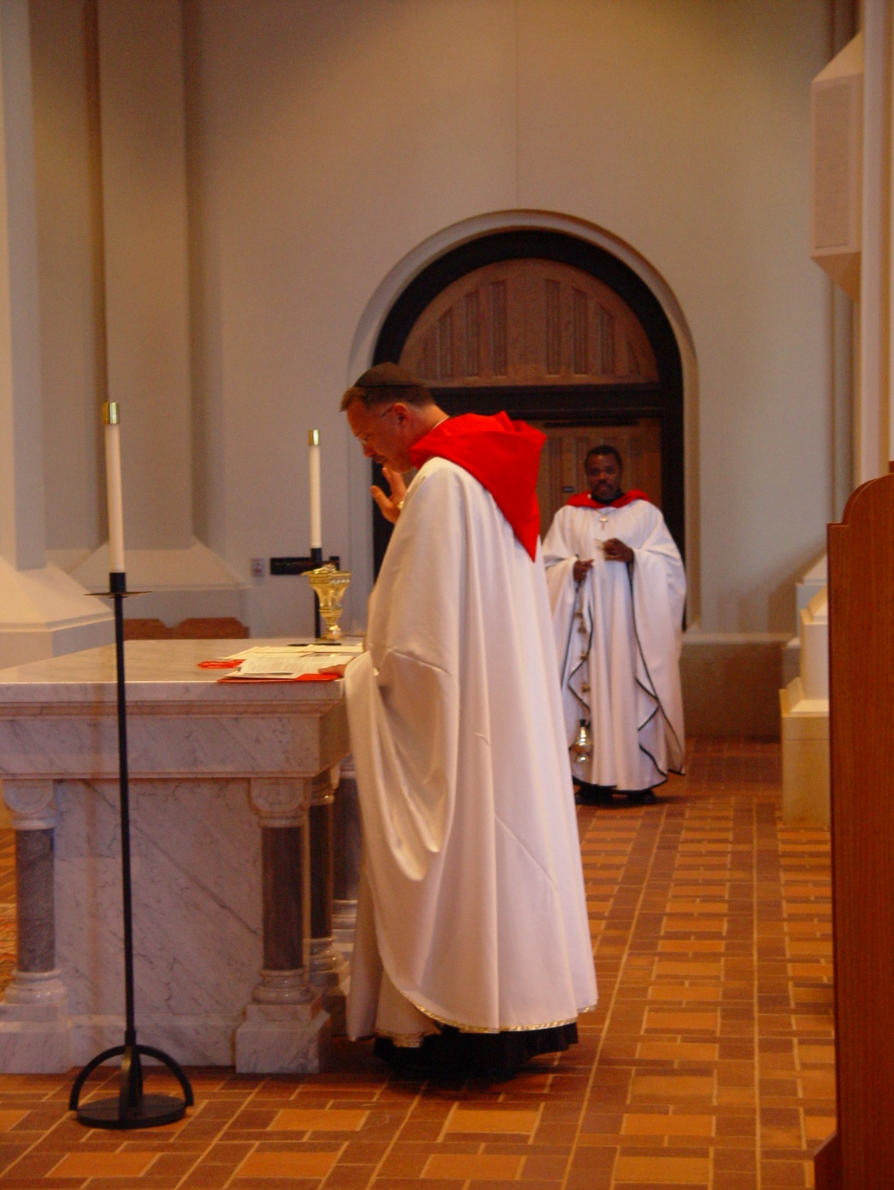
COSL 041 Prior Michael John Austin; Br. Thomas Ferrell
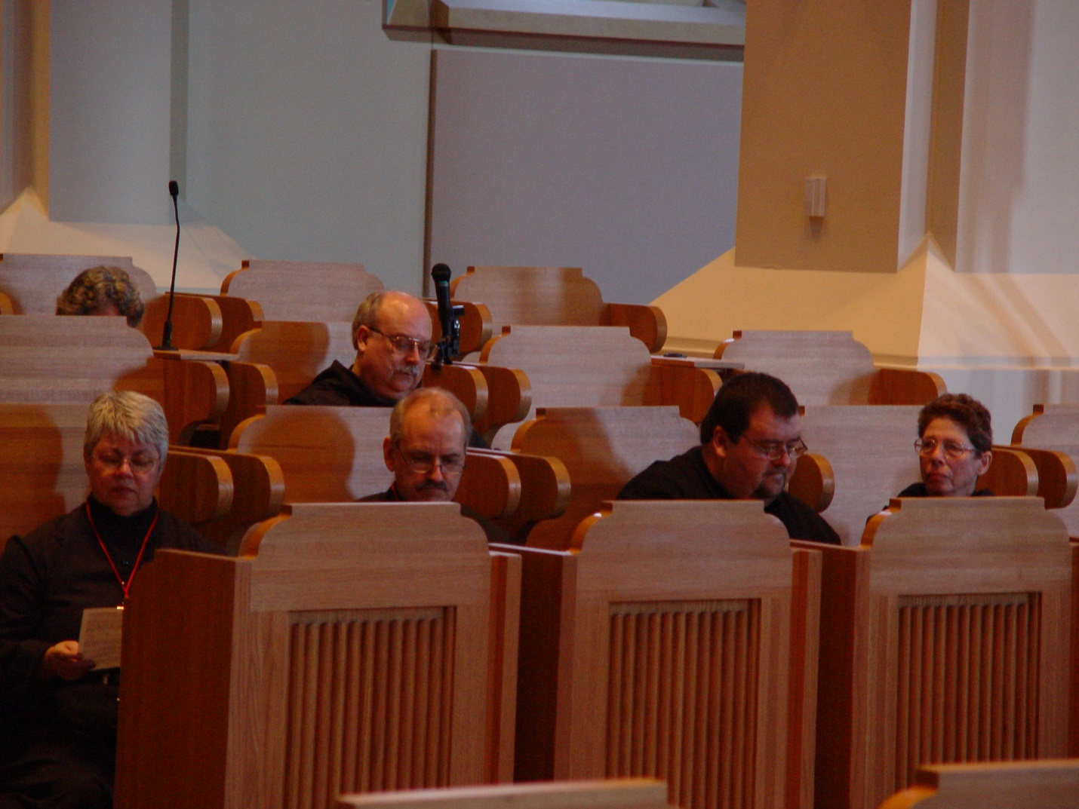
COSL 042 Sr. Clare Benedicta Meyers; Becky Ritttenhouse; Br. Raymond Owens; Br. Daniel Joseph Schroeder; Regan Fox; Sr. Monica Ruth Mullen

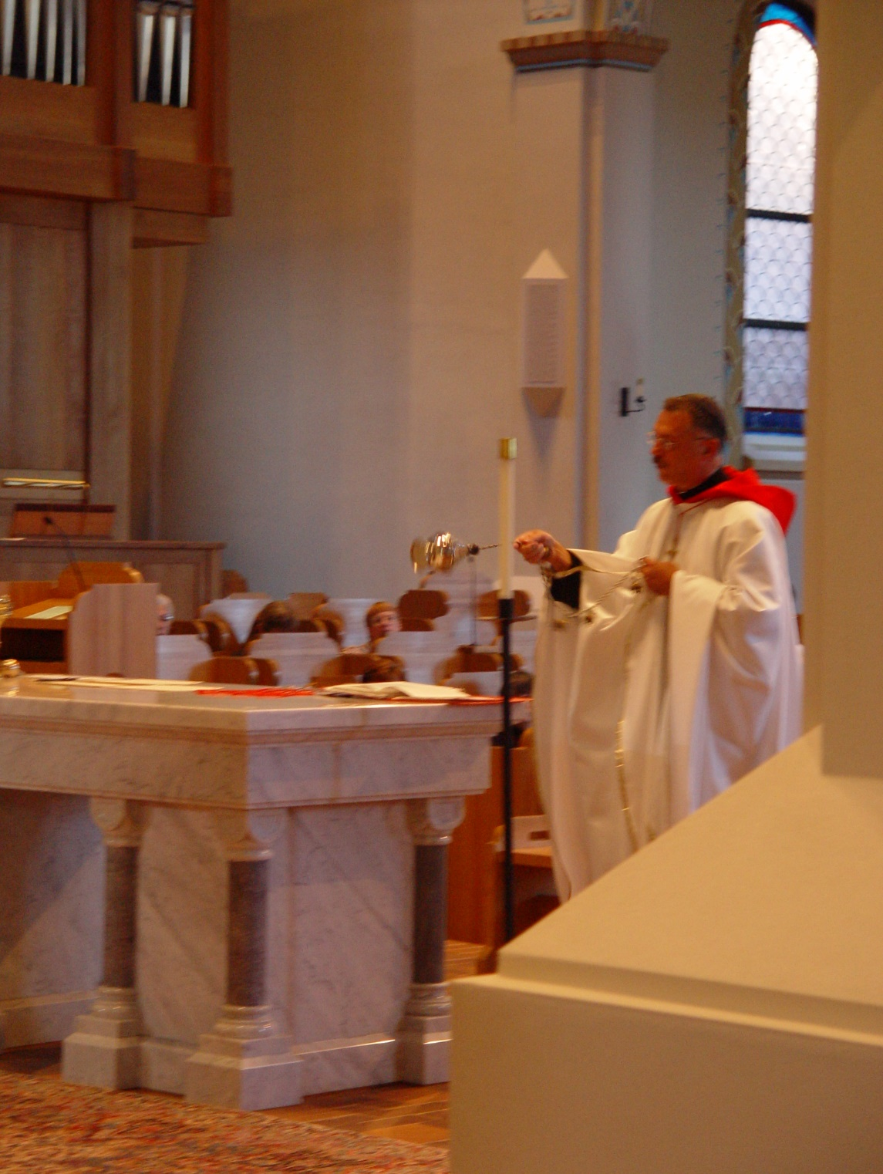
COSL 043 Prior Michael John Austin
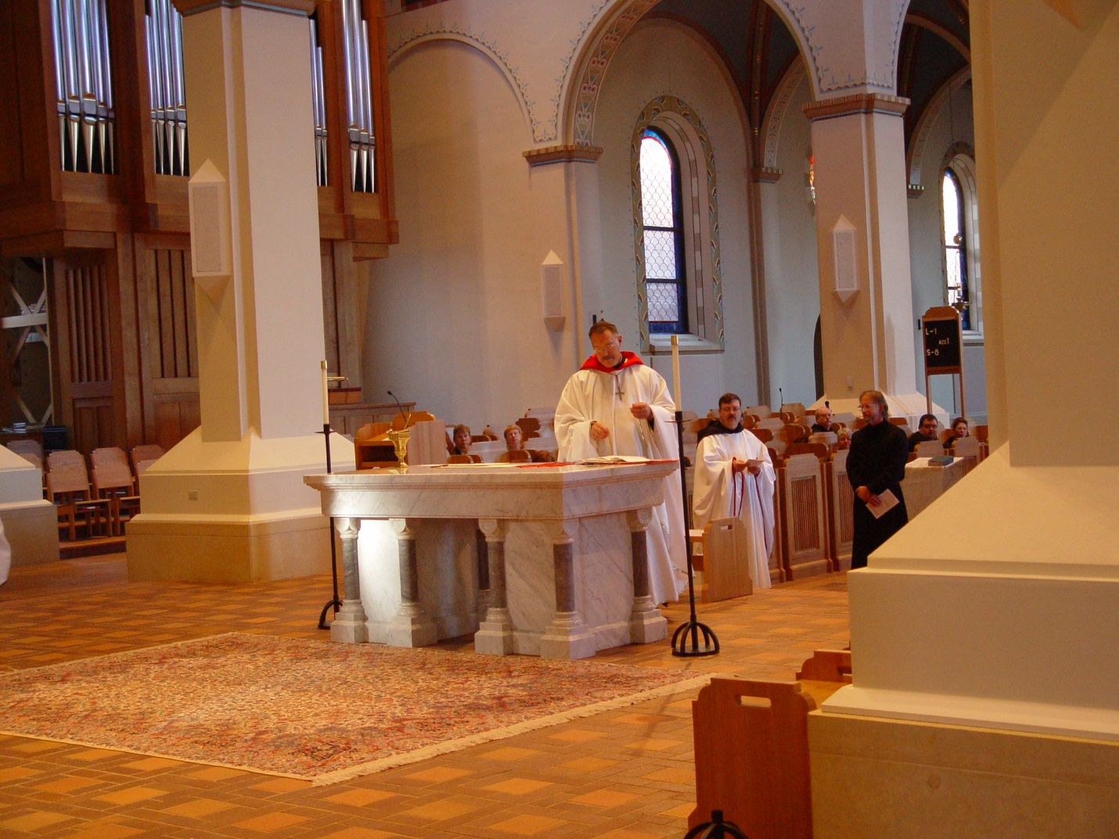
COSL 044 Prior Michael John Austin; Br. Paul Howard; Barry Mullen

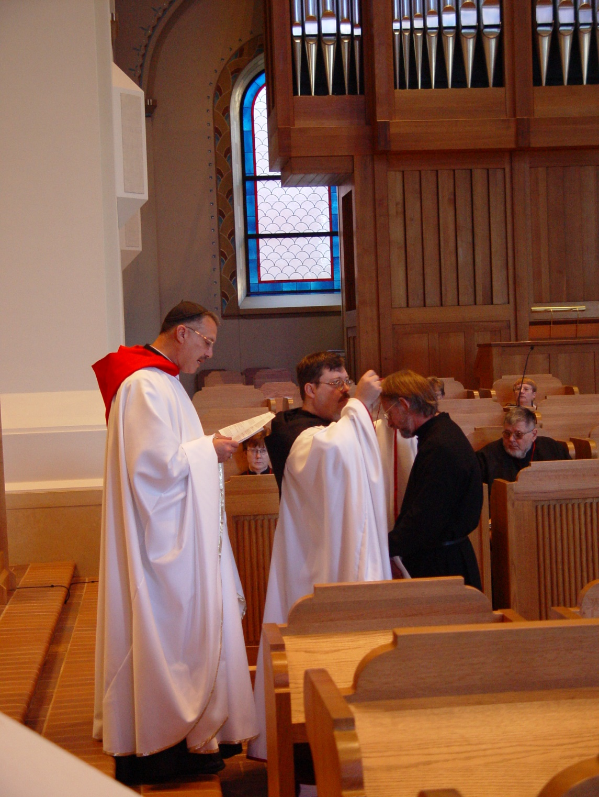
COSL 045 Prior Michael John Austin; Sr. Ann Gerns; Br. Paul Howard; Barry Mullen; Br. Nathan Gregory Miller; Lynn Owens
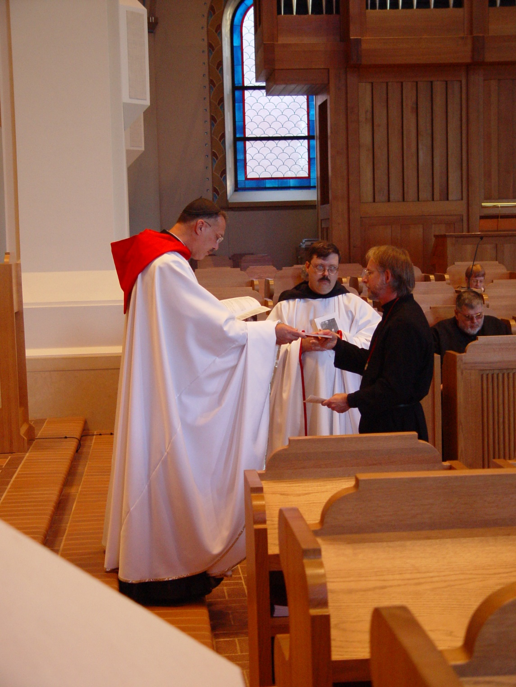
COSL 046 Prior Michael John Austin; Br. Paul Howard; Barry Mullen; Br. Nathan Gregory Miller; Lynn Owens
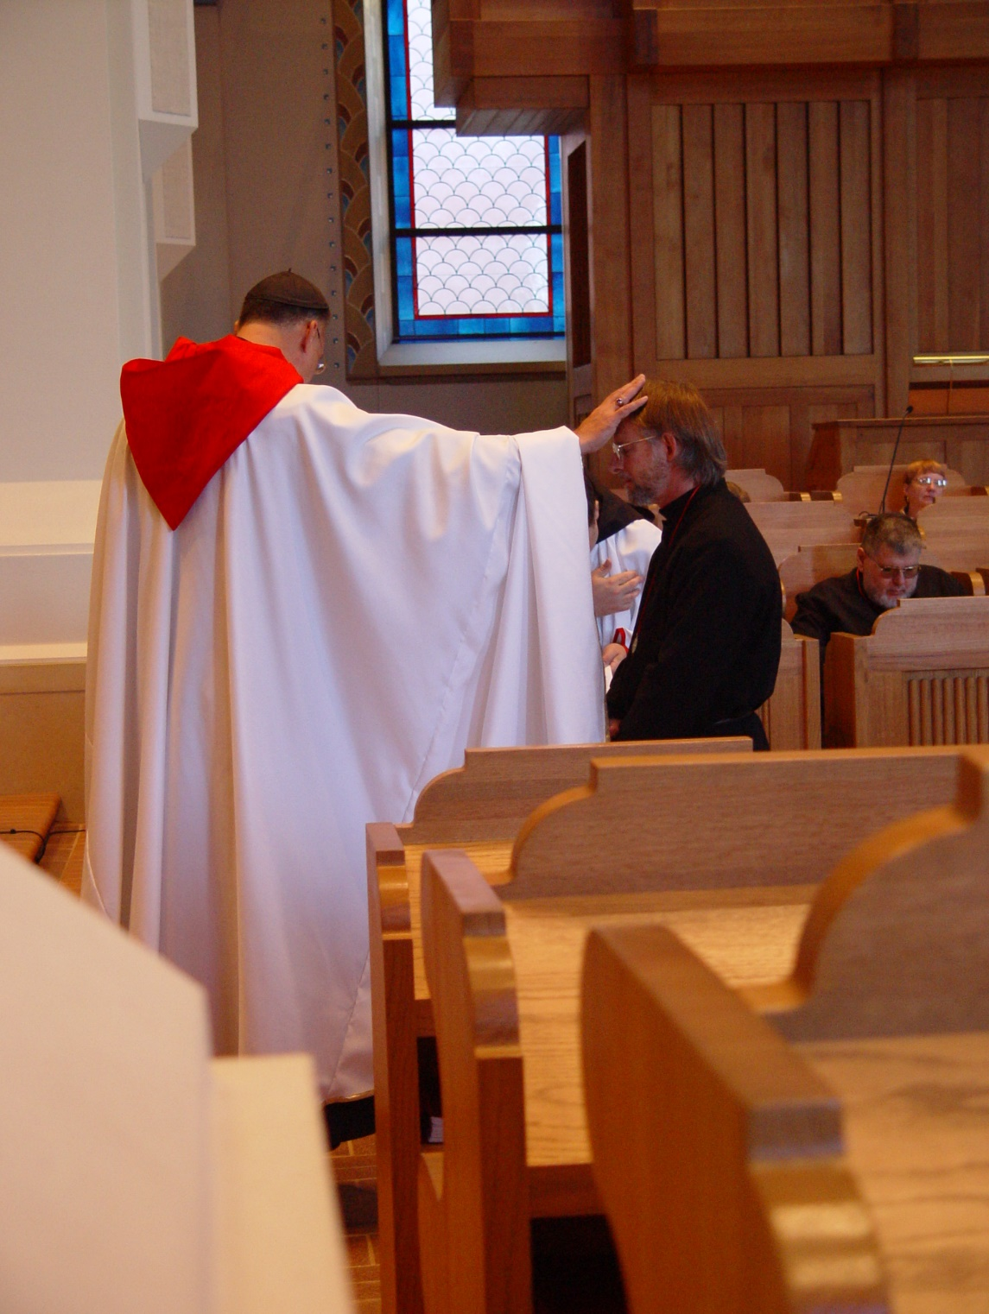
COSL 047 Prior Michael John Austin; Br. Paul Howard; Barry Mullen; Br. Nathan Gregory Miller; Lynn Owens

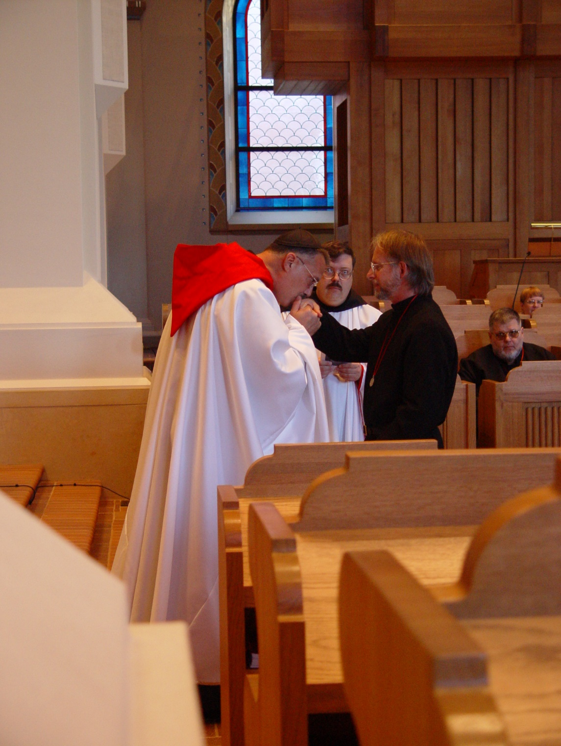
COSL 048 Prior Michael John Austin; Br. Paul Howard; Barry Mullen; Br. Nathan Gregory Miller; Lynn Owens

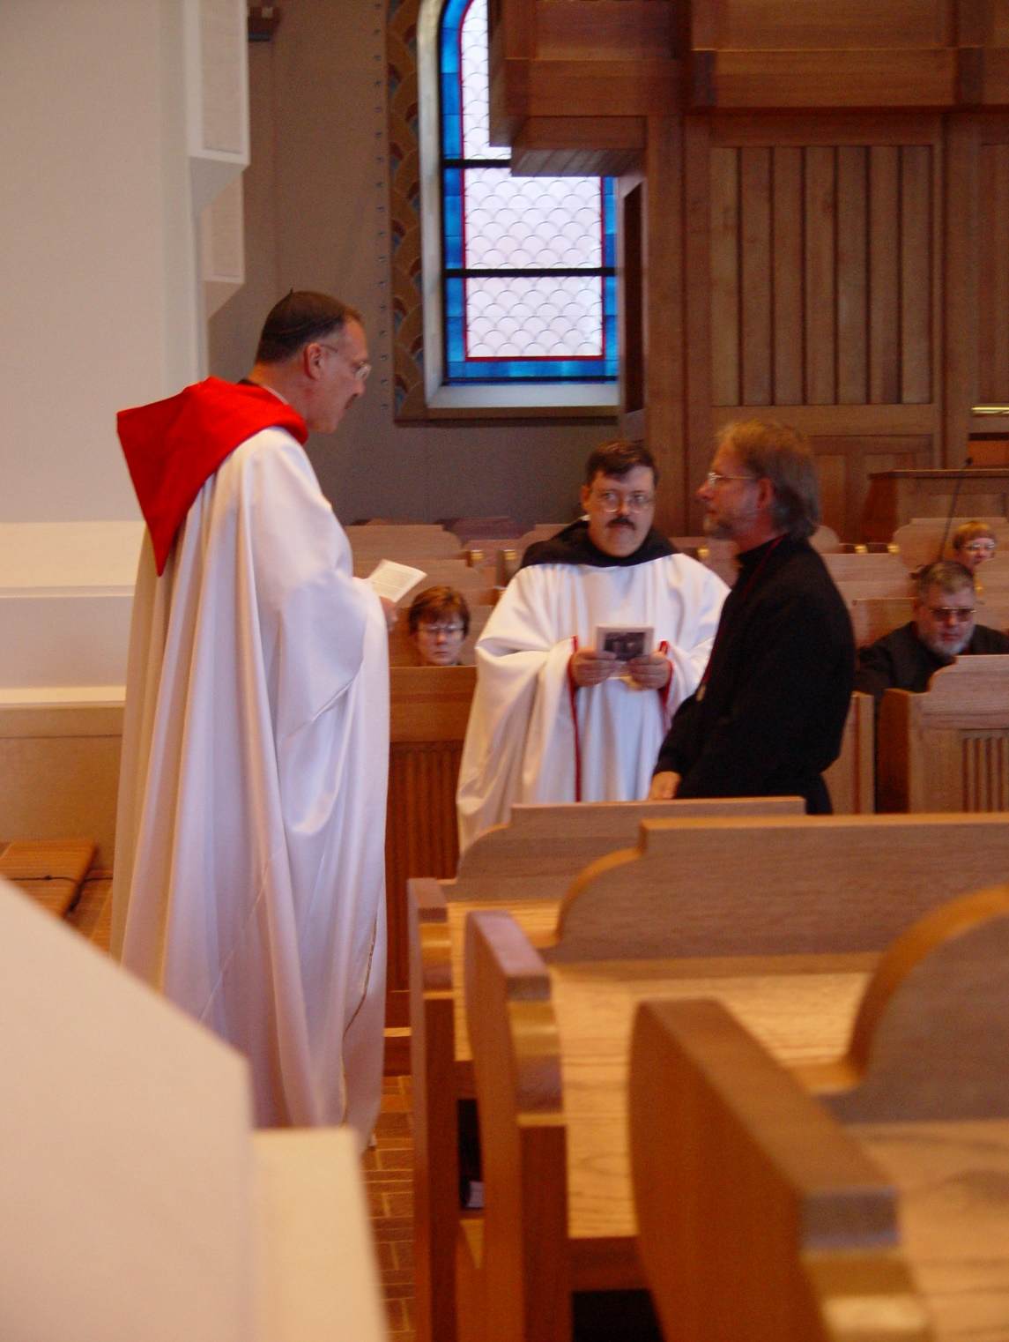
COSL 049 Prior Michael John Austin; Sr. Ann Gerns; Br. Paul Howard; Barry Mullen; Br. Nathan Gregory Miller; Lynn Owens

