Companions of St. Luke
Spring 2003 Convocation at Conception Abbey
Day 4 PM

~Edited by Br. Steven Olderr, 12 May 2022 with the assistance of Br. Thomas Ferrell; if you find any errors or omissions, please notify Br. Steven at olderr@ameritech.net

People are identified from left to right.

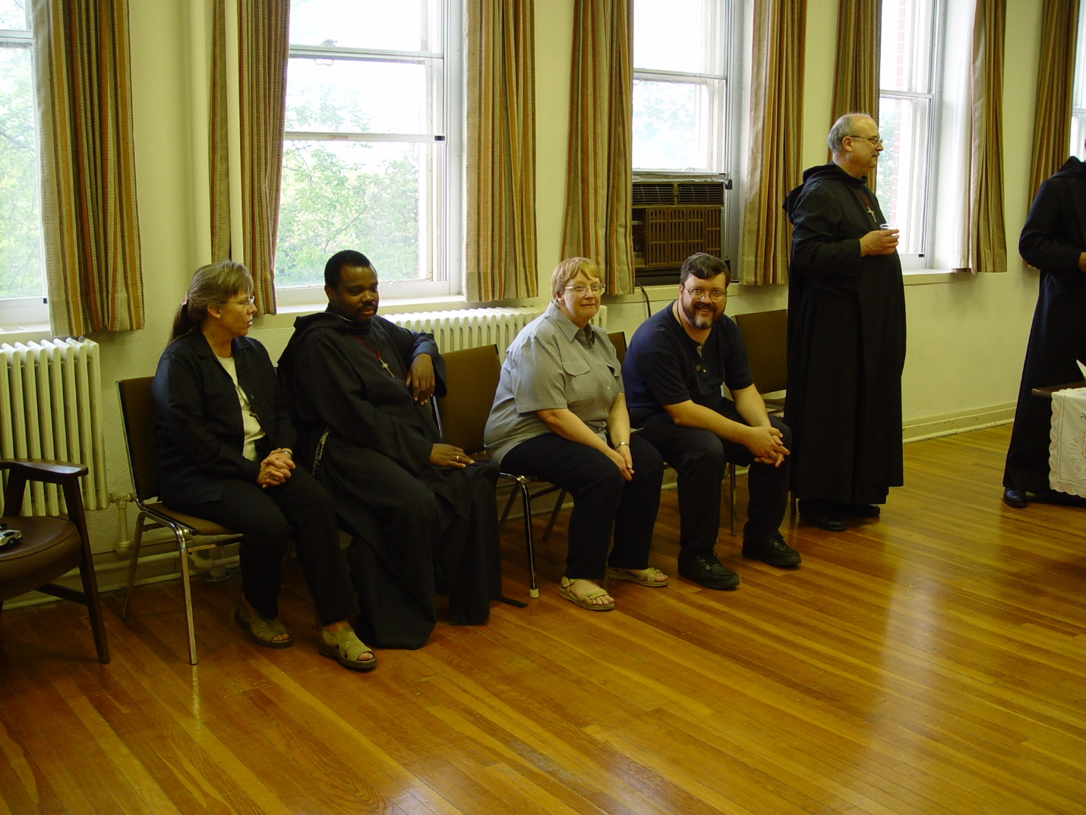
Day 4 PM 001
Becky Rittenhouse; Br. Thomas Ferrell; Lynn Owens; Br. Paul Howard; Br. Raymond Owens

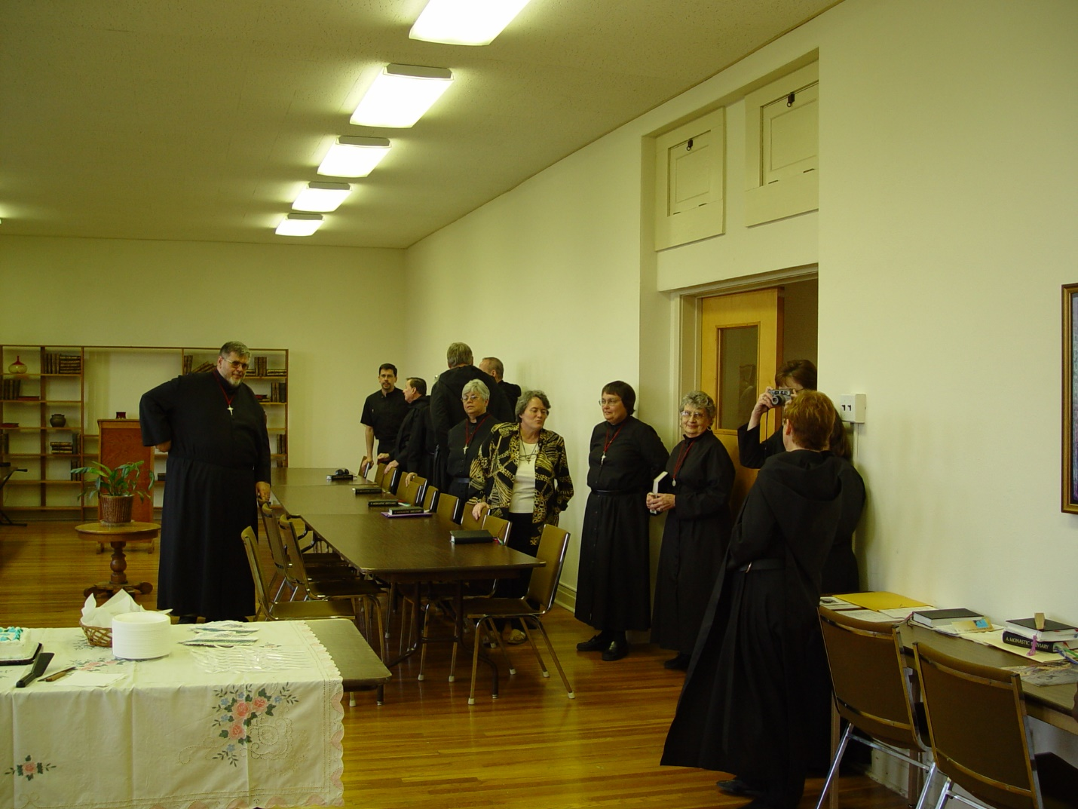
Day 4 PM 002
Br. Nathan Gregory Miller
Sr. Ann Gerns with camera

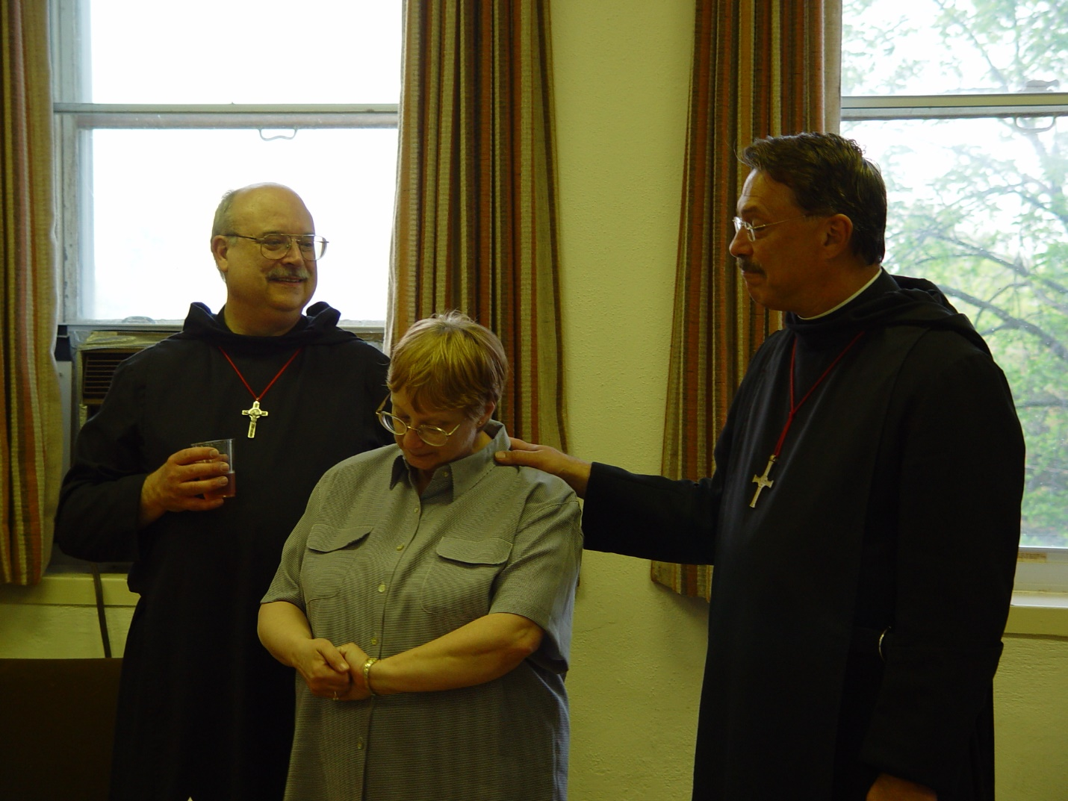
Day 4 PM 003
Br. Raymond Owens; Lynn Owens; Prior Michael John Austin

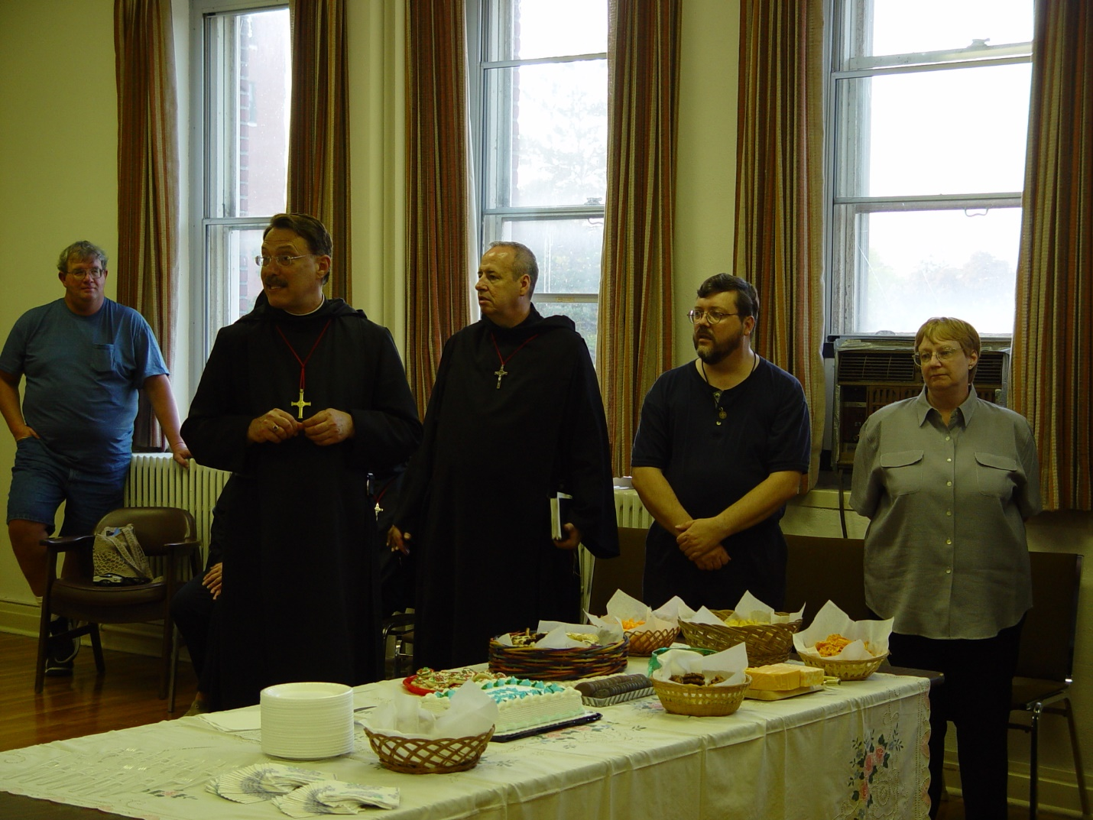
Day 4 PM 004
?; Prior Michael John Austin; Br. Gabriel Hale; Br. Paul Howard; Lynn Owens

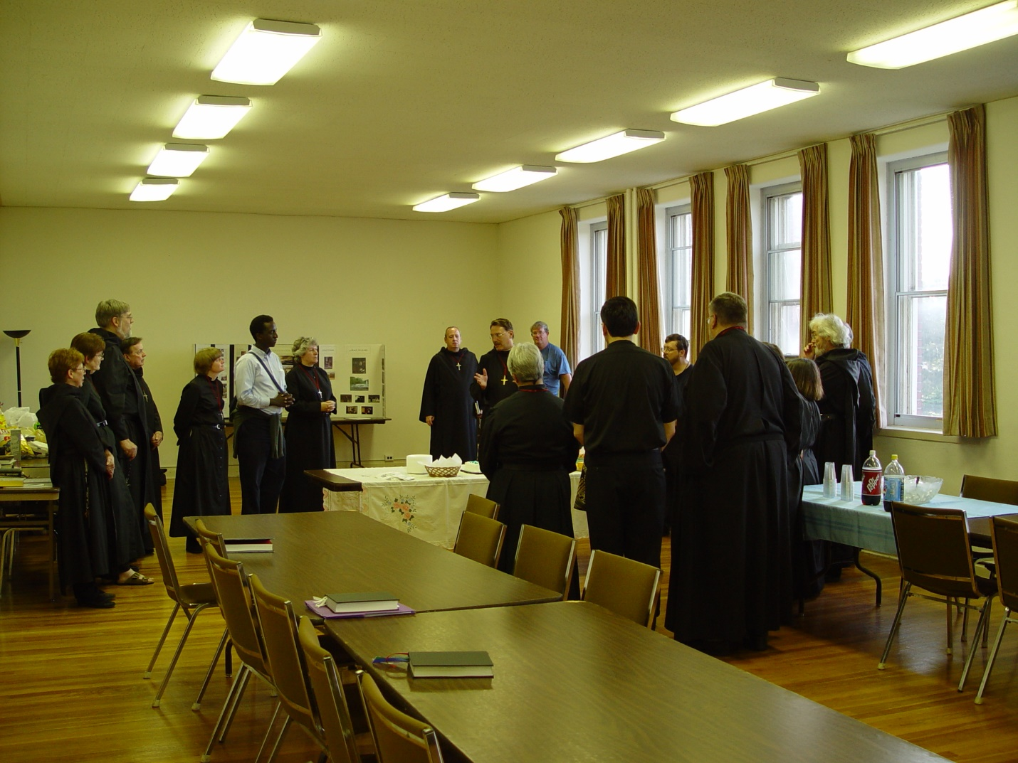
Day 4 PM 005

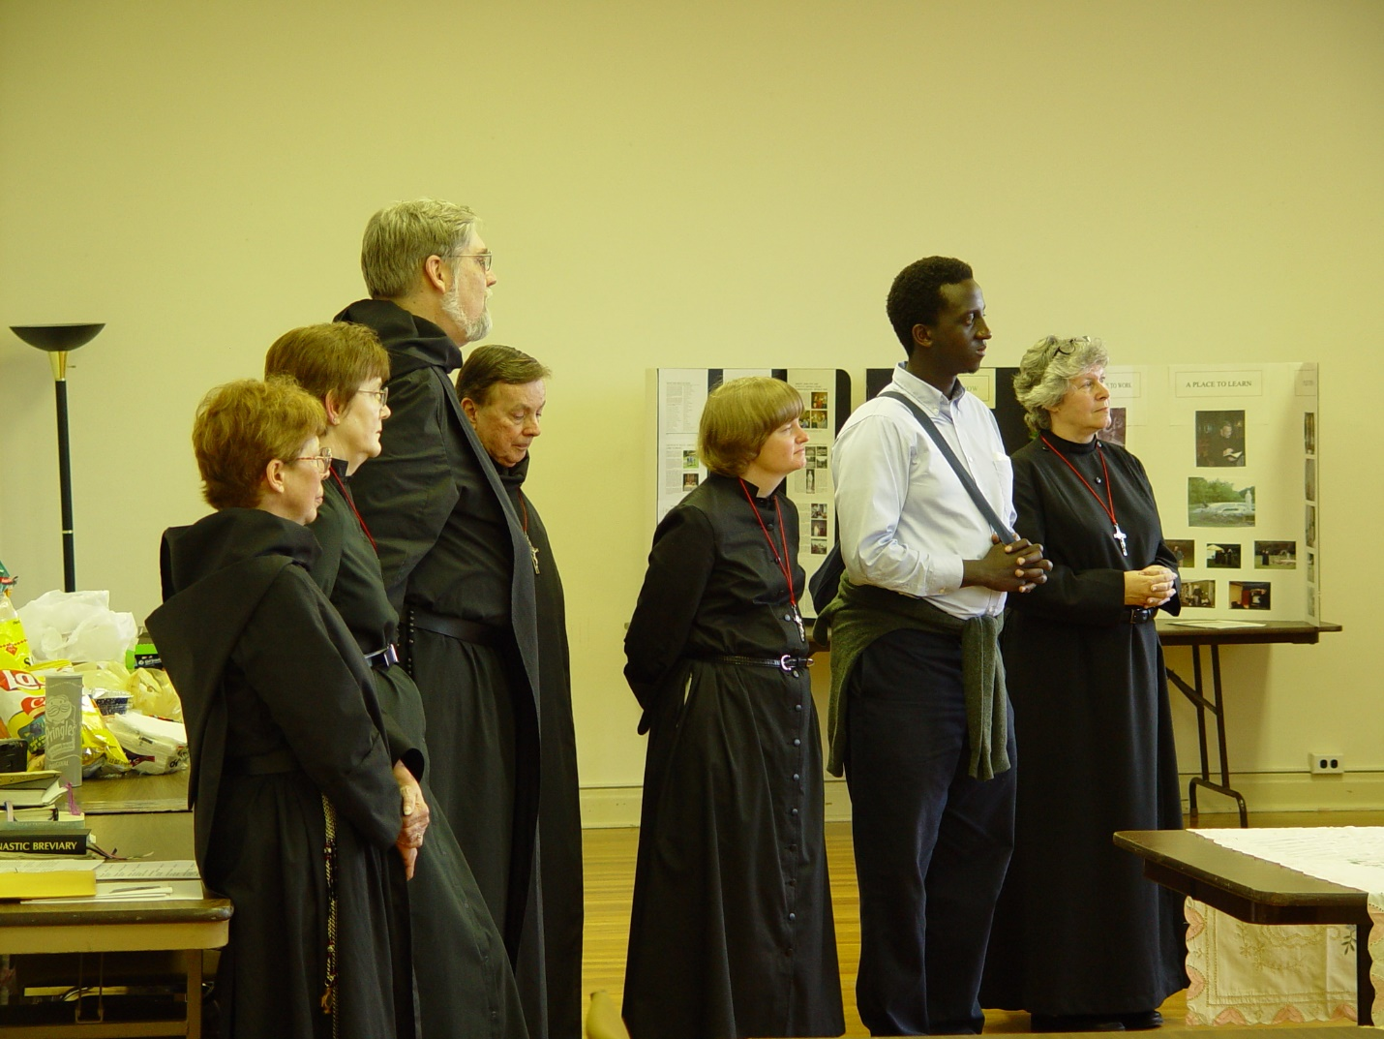
Day 4 PM 006
Sr. Monica Ruth Mullen; Sr. Ann Gerns; Br. Chad Anselm Gerns (now Br. David); Sr. Catherine Unterseher; unidentified guest; Sr. Johanna Kirkpatrick

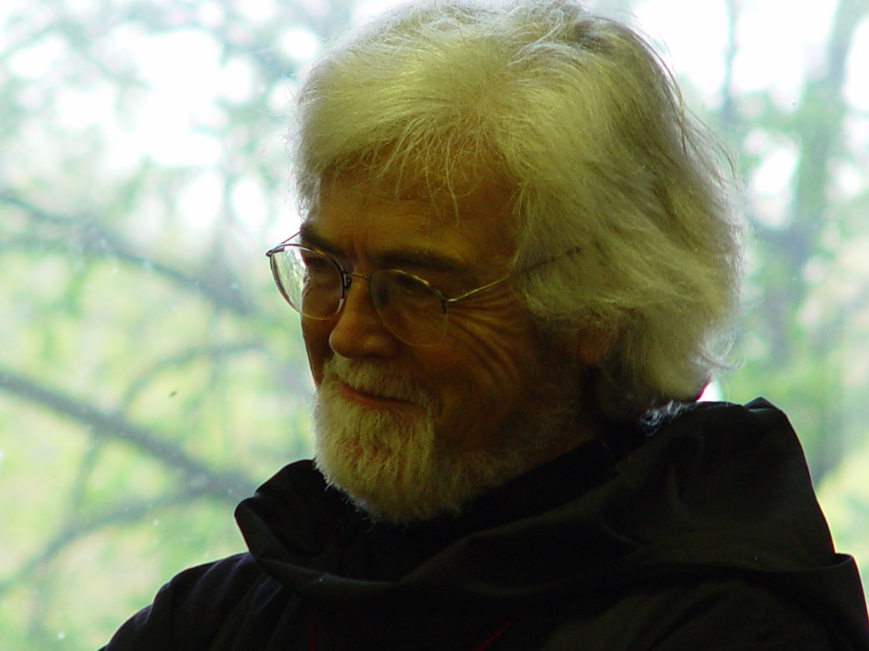
Day 4 PM 007
Br. Martin Sheridan

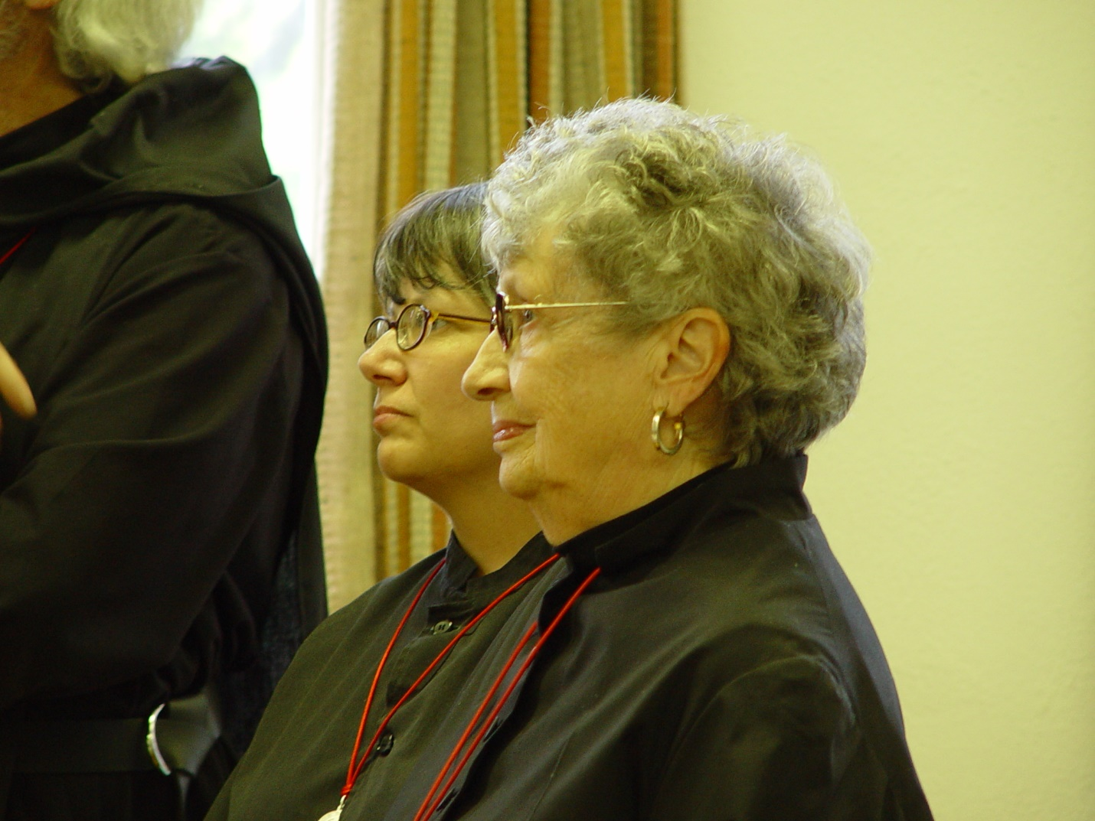
Day 4 PM 008
Br. Martin Sheridan; Sr. Anna Grace Madden; Sr. Joseph Kateri Ettleson

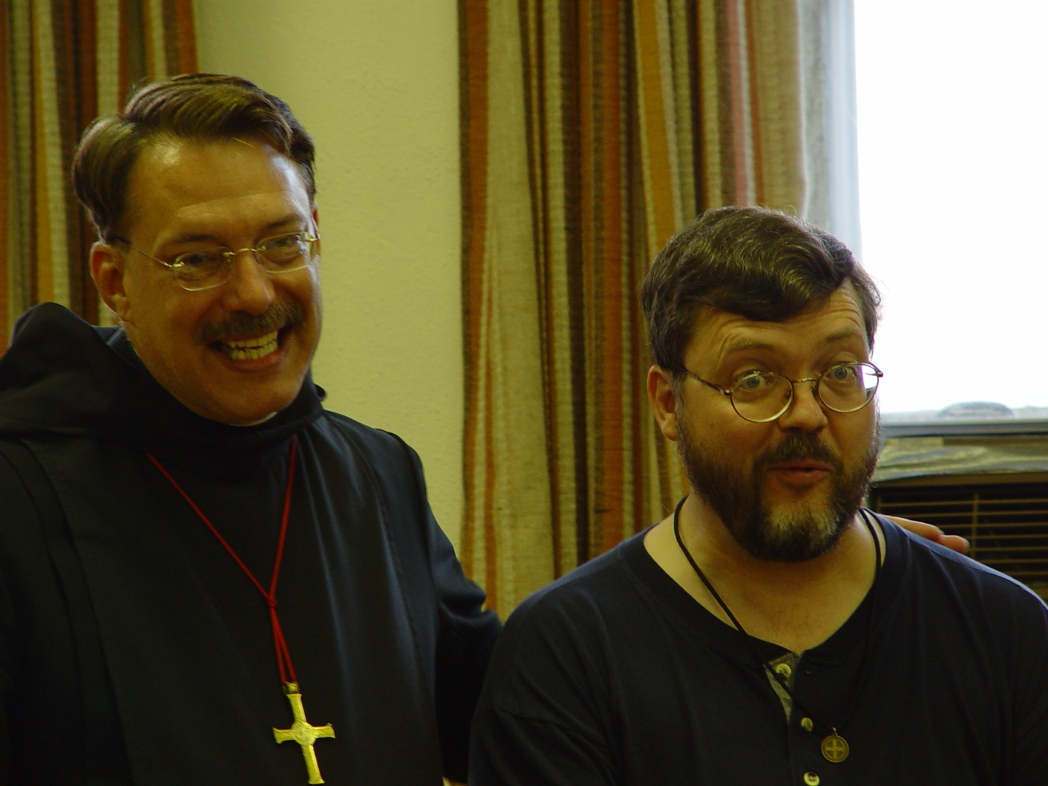
Day 4 PM 009
Prior Michael John Austin; Br. Paul Howard

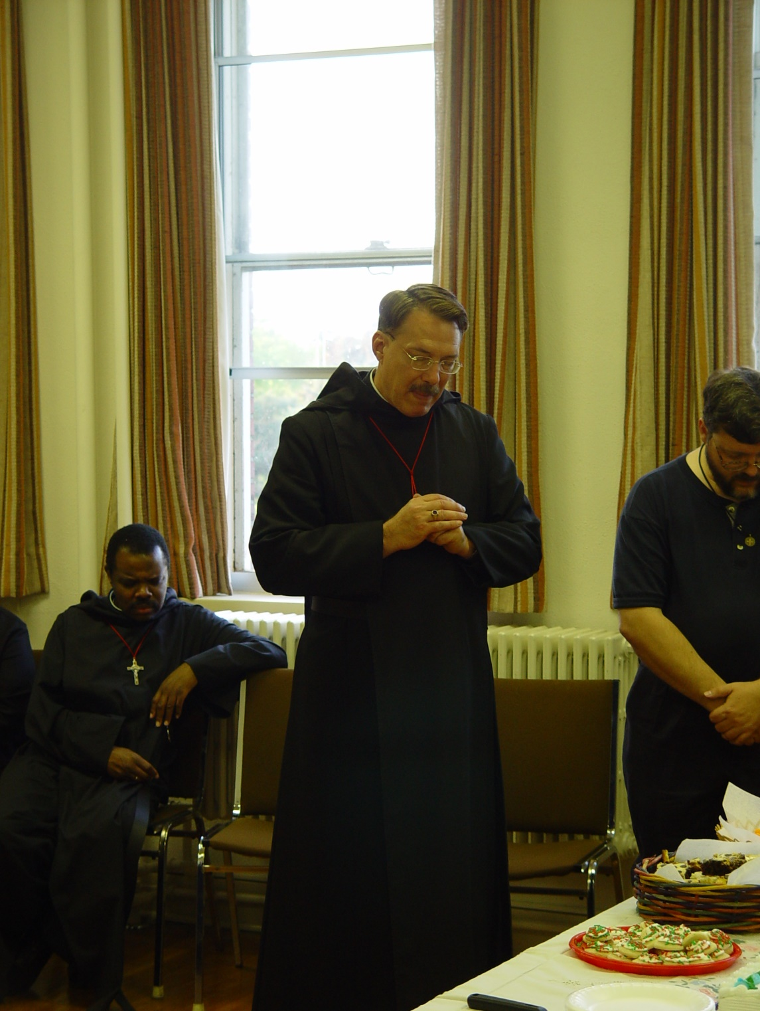
Day 4 PM 010
Br. Thomas Ferrell; Prior Michael John Austin; Br. Paul Howard

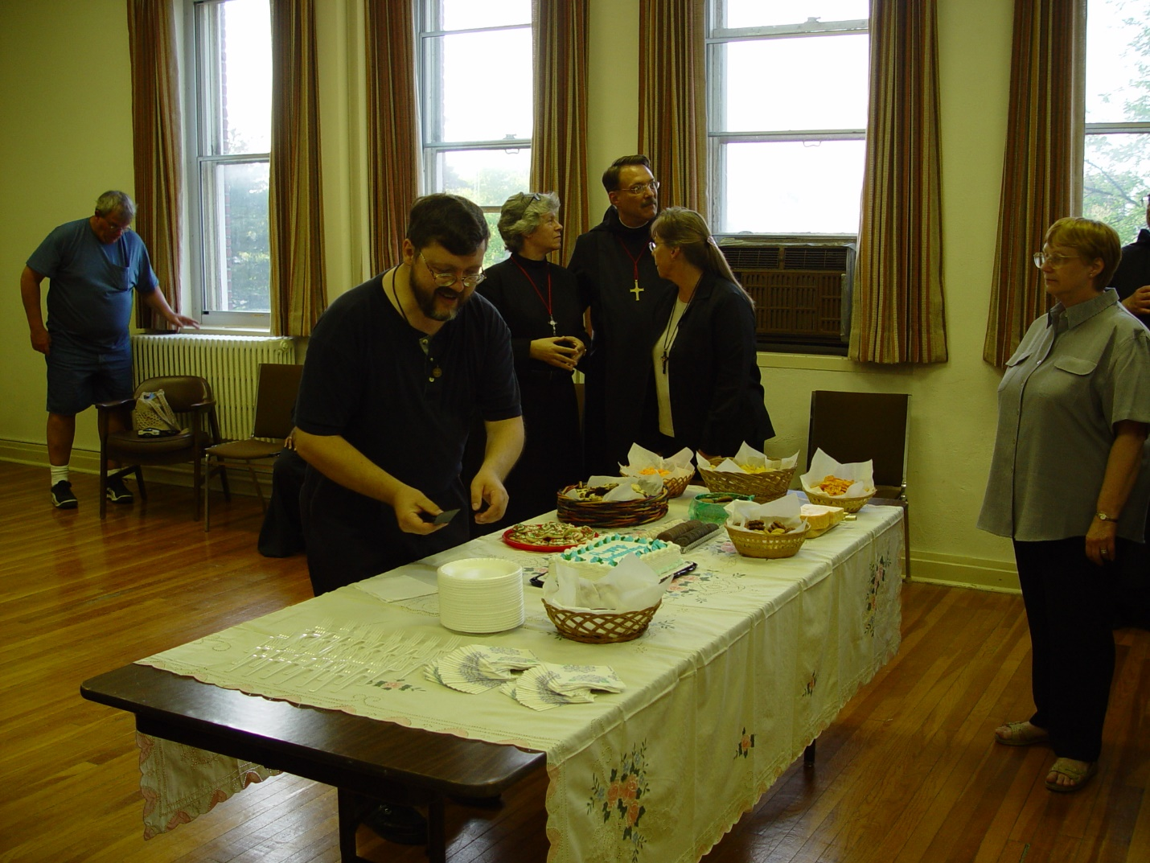
Day 4 PM 011 ?; Br. Paul Howard; Sr. Johanna Kirkpatrick; Prior Michael John Austin; Becky Fredregill; Lynn Owens

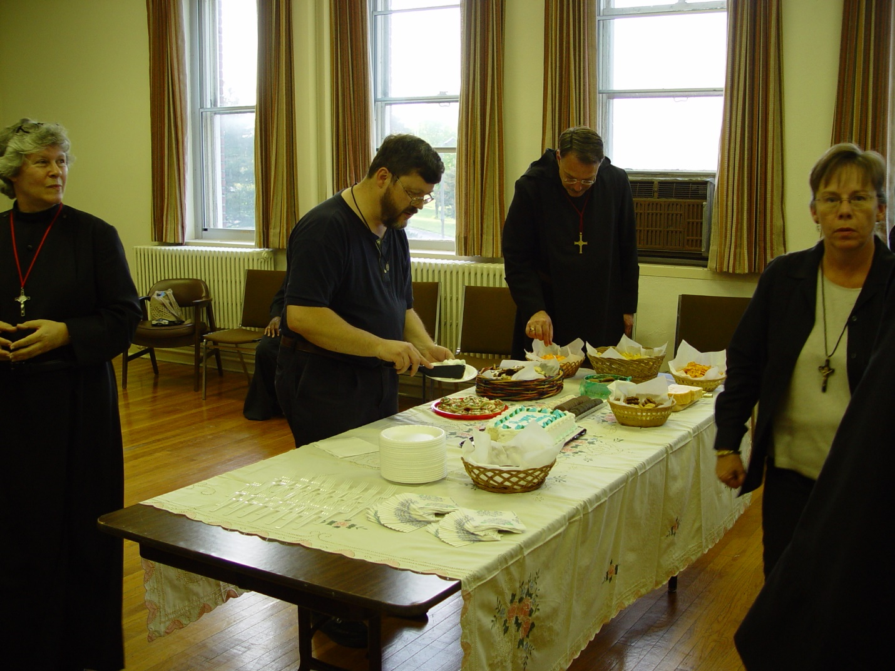
Day 4 PM 012
Sr. Johanna Kirkpatrick; Br. Paul Howard; Prior Michael John Austin; Becky Fredregill

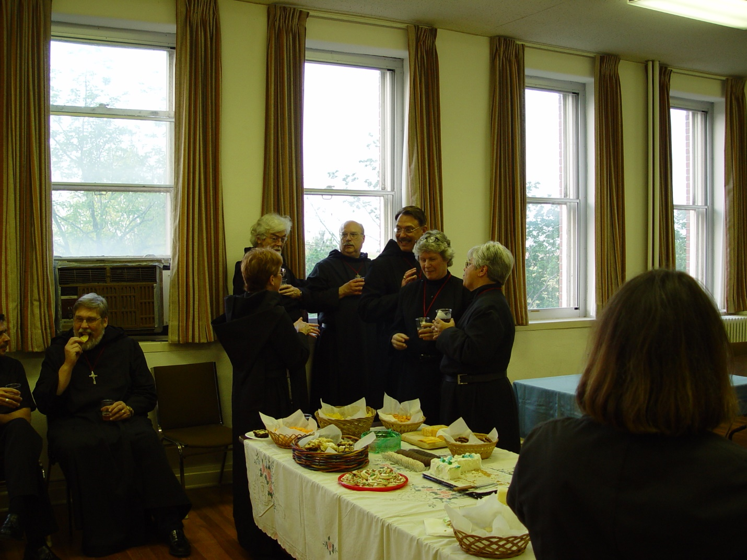
Day 4 PM 013
Br. Chad Anselm Gerns (now Br. David); Sr. Monica Ruth Mullen; Br. Martin Sheridan; Br. Raymond Owens; Sr. Johanna Kirkpatrick; Sr. Clare Benedicta Meyers; Sr. Anna Grace Madden

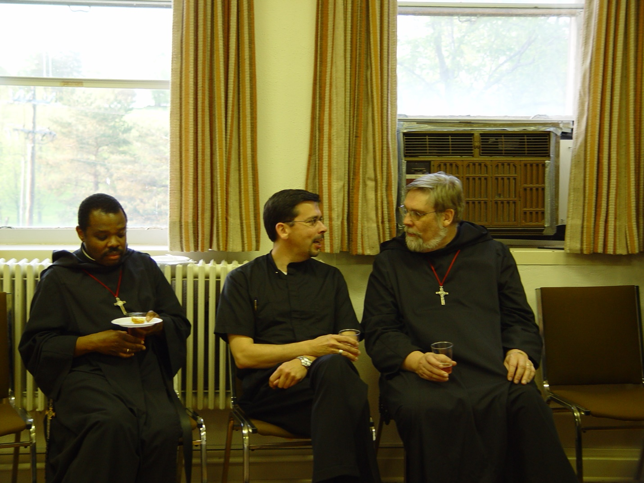
Day 4 PM 014
Br. Thomas Ferrell; Br. Augustine Colvert; Br. Chand Anselm Gerns (now Br. David)

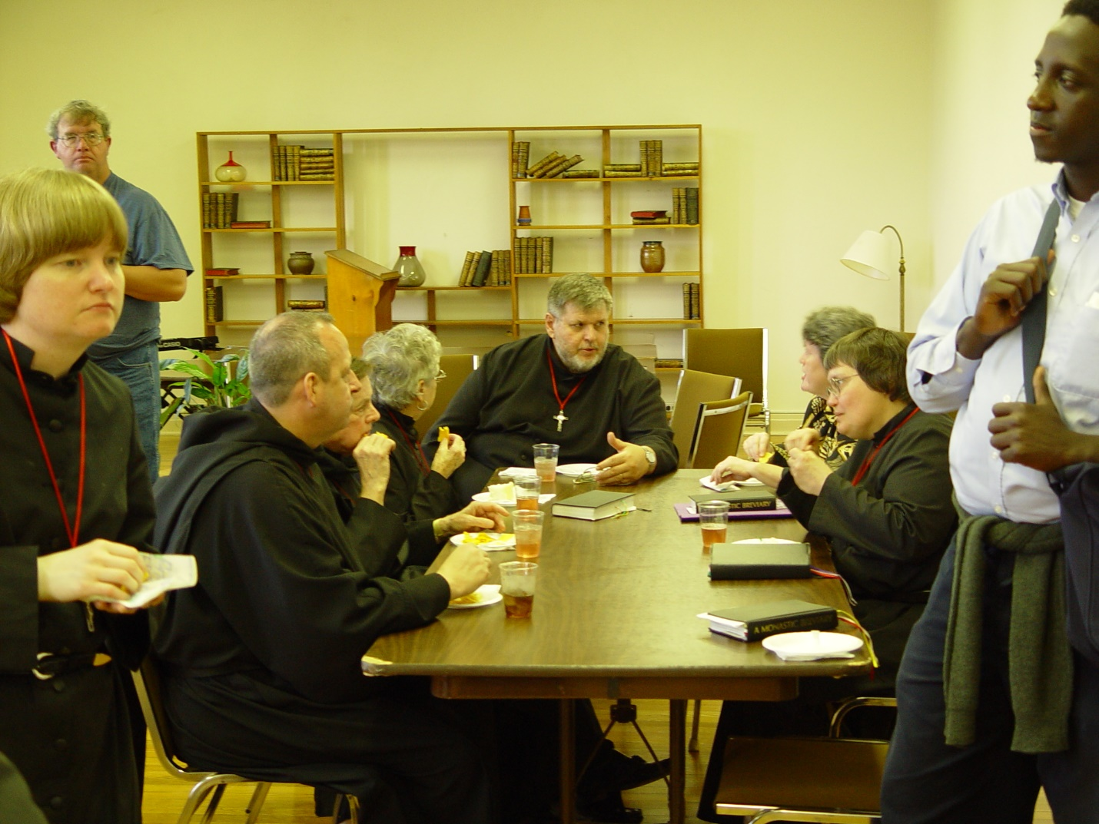
Day 4 PM 015
Sr. Catherine Unterseher; ?; Br. Gabriel Hale; Sr. ?; Br. Nathan Gregory Miller; Sr. ?; Sr. Theodora of Jesus Perecca; unidentified guest

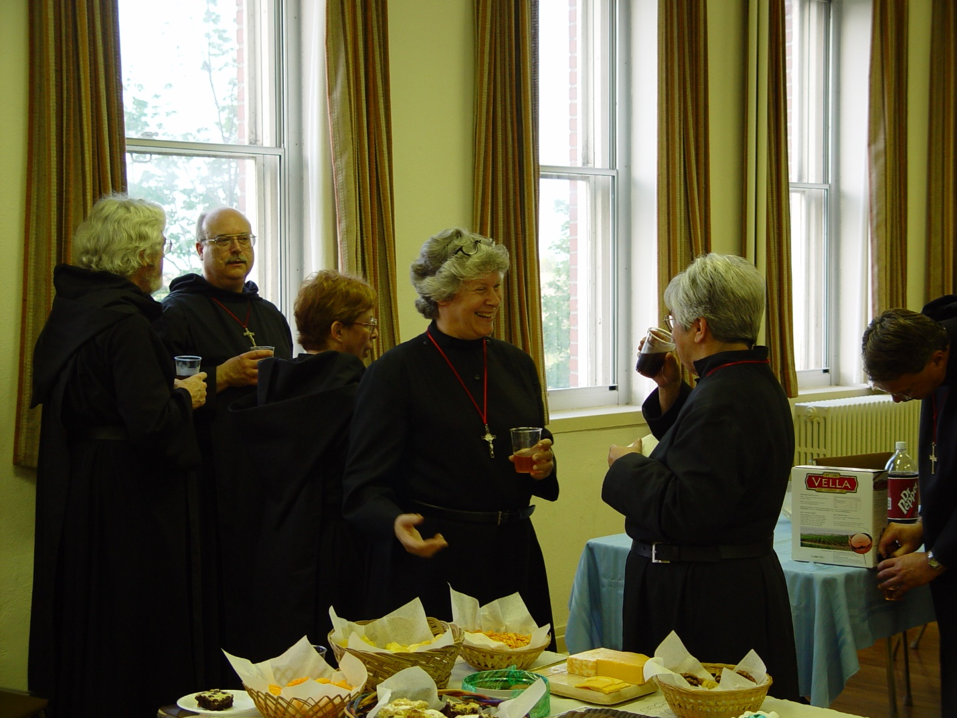
Day 4 PM 016
Br. Martin Sheridan; Br. Raymond Owens; Sr. Monica Ruth Madden; Sr. Johanna Kirkpatrick; Sr. Clare Benedicta Meyers; Prior Michael John Austin
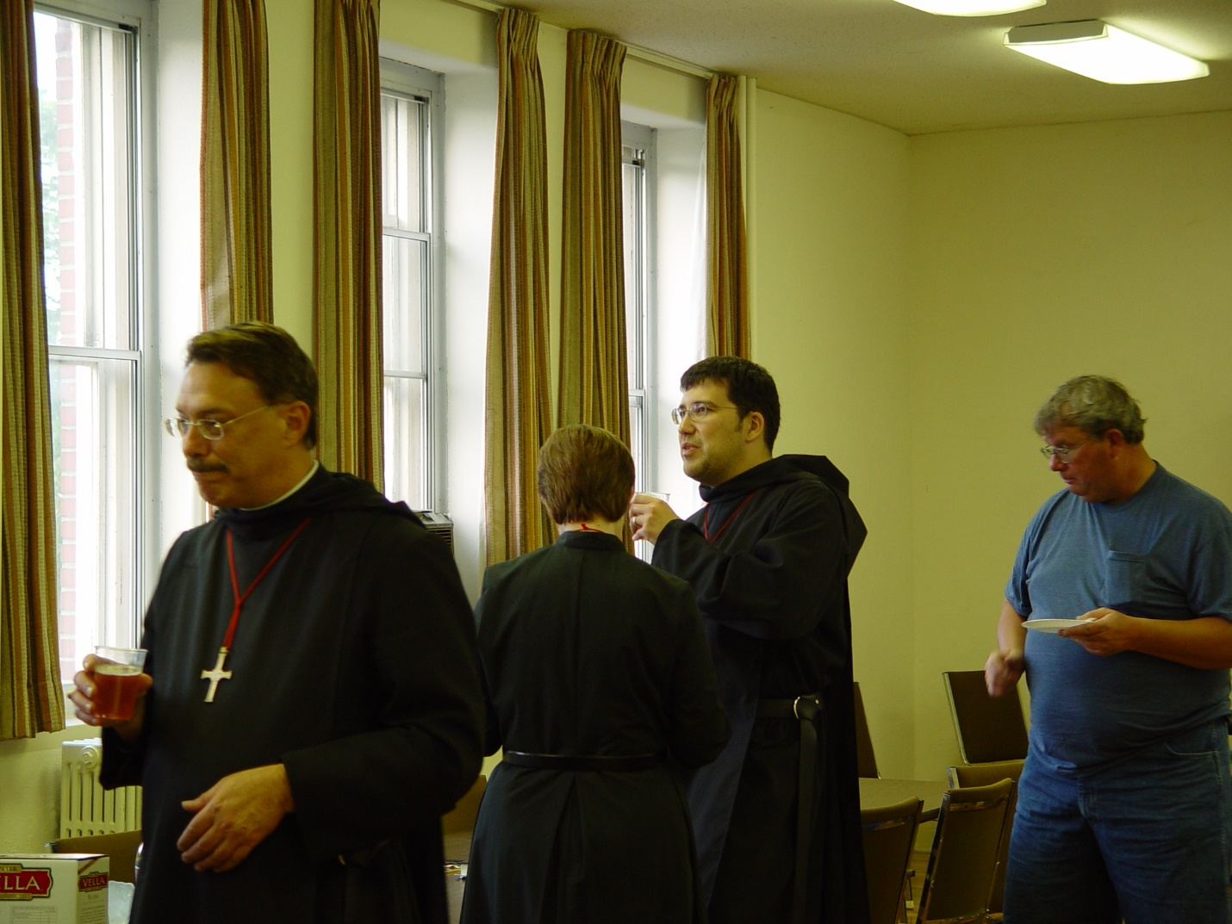
Day 4 PM 017
Prior Michael John Austin; Sr. Ann Gerns; Br. Anthony Bernard Campos; ?

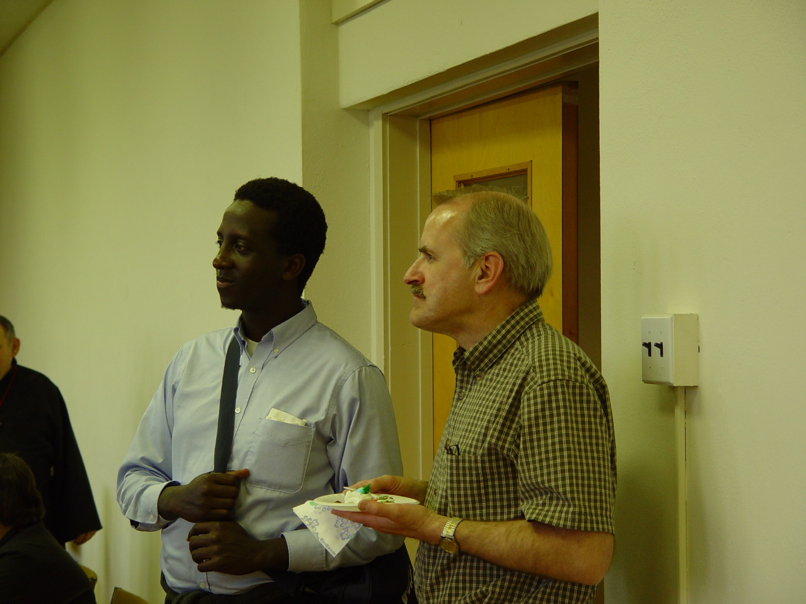
Day 4 PM 018
Unidentified guest; Br. Daniel Joseph Schroeder

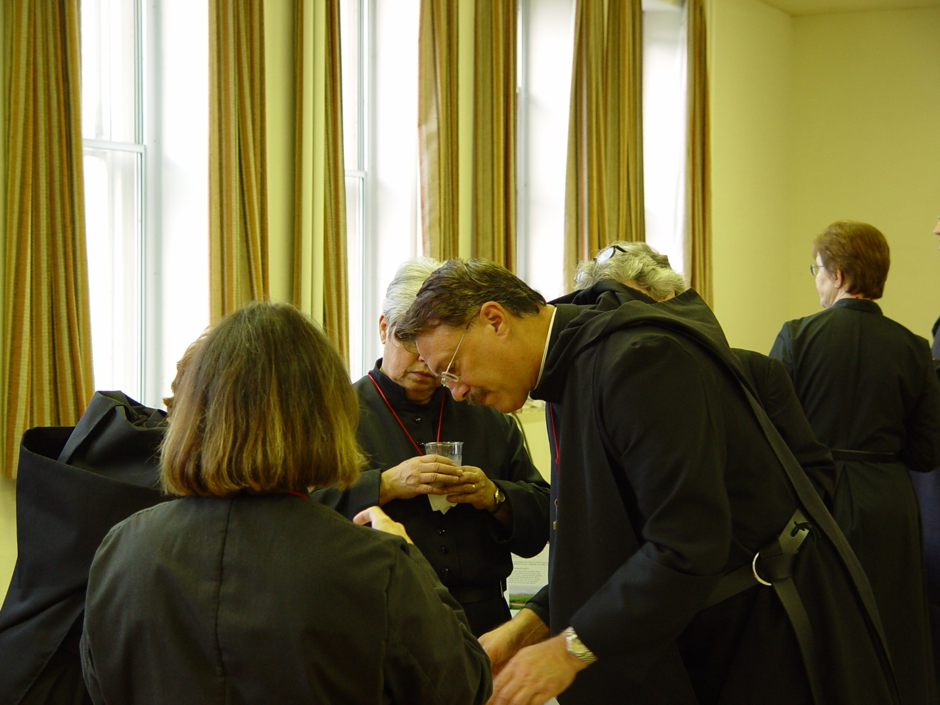
Day 4 PM 019
Sr. Anna Grace Madden; Sr. Clare Benedicta; Prior Michael John Austin; Sr. Ann Gerns

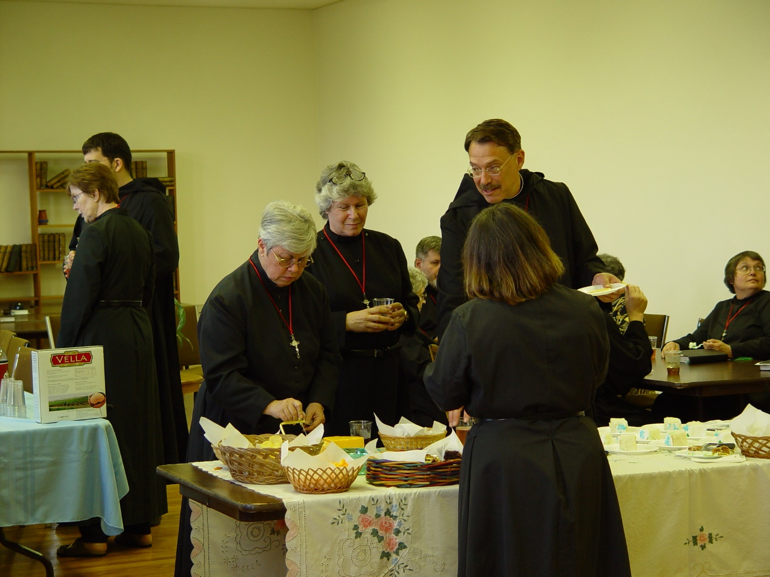
Day 4 PM 020
Sr. Ann Gerns; Br. Anthony Bernard Campos; Sr. Clare Benedicta; Sr. Johanna Kirkpatrick; Prior Michael John Austin; Sr. Anna Grace Madden; Sr. Theodora of Jesus Perecca

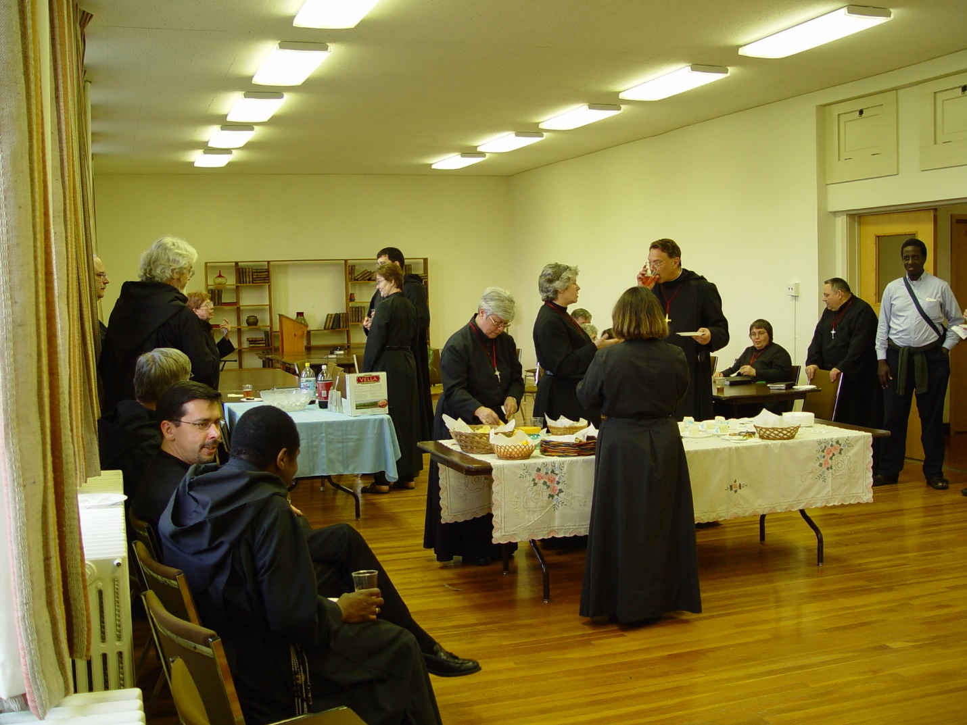
Day 4 PM 021
Br. Thomas Ferrell; Br. Augustine Campos; Br. Chad Anselm Gerns (now Br. David); Br. Martin Sheridan; Br. ?; Sr. Ann Gerns; Br. Anthony Bernard Campos; Sr. Clare Benedicta Meyers; Sr. Johanna Kirkpatrick; Sr. Anna Grace Madden; Prior Michael John Austin; Sr. Theodora of Jesus Perecca; Br. Ambrose Heroux; unidentified guest
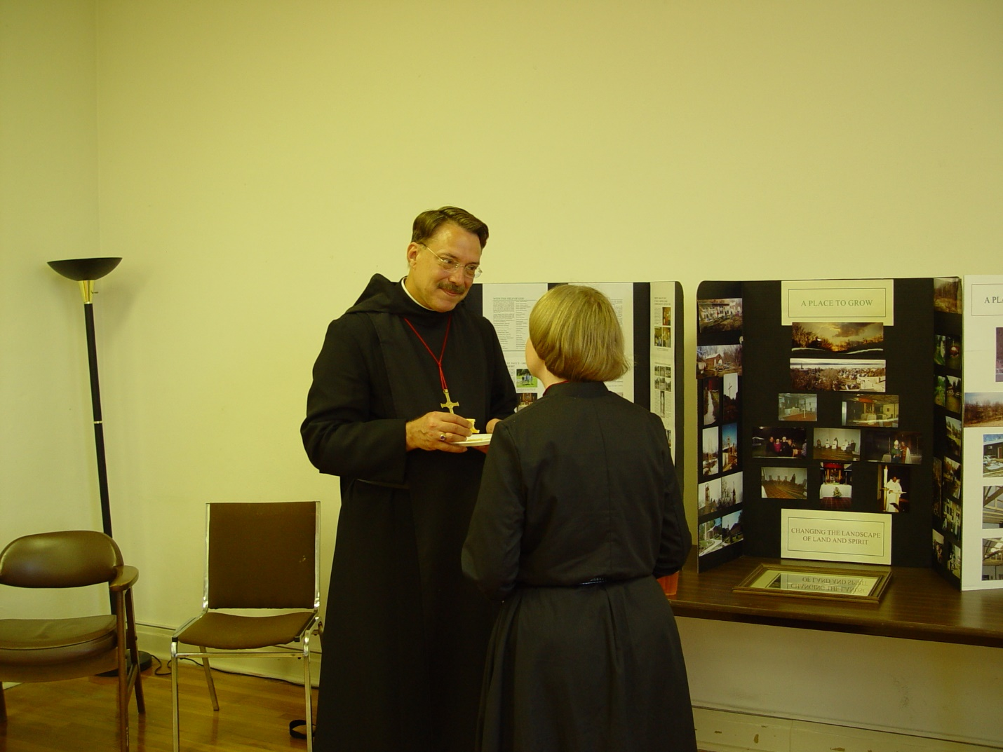
Day 4 PM 022
Prior Michael John Austin; Sr. Catherine Unterseher

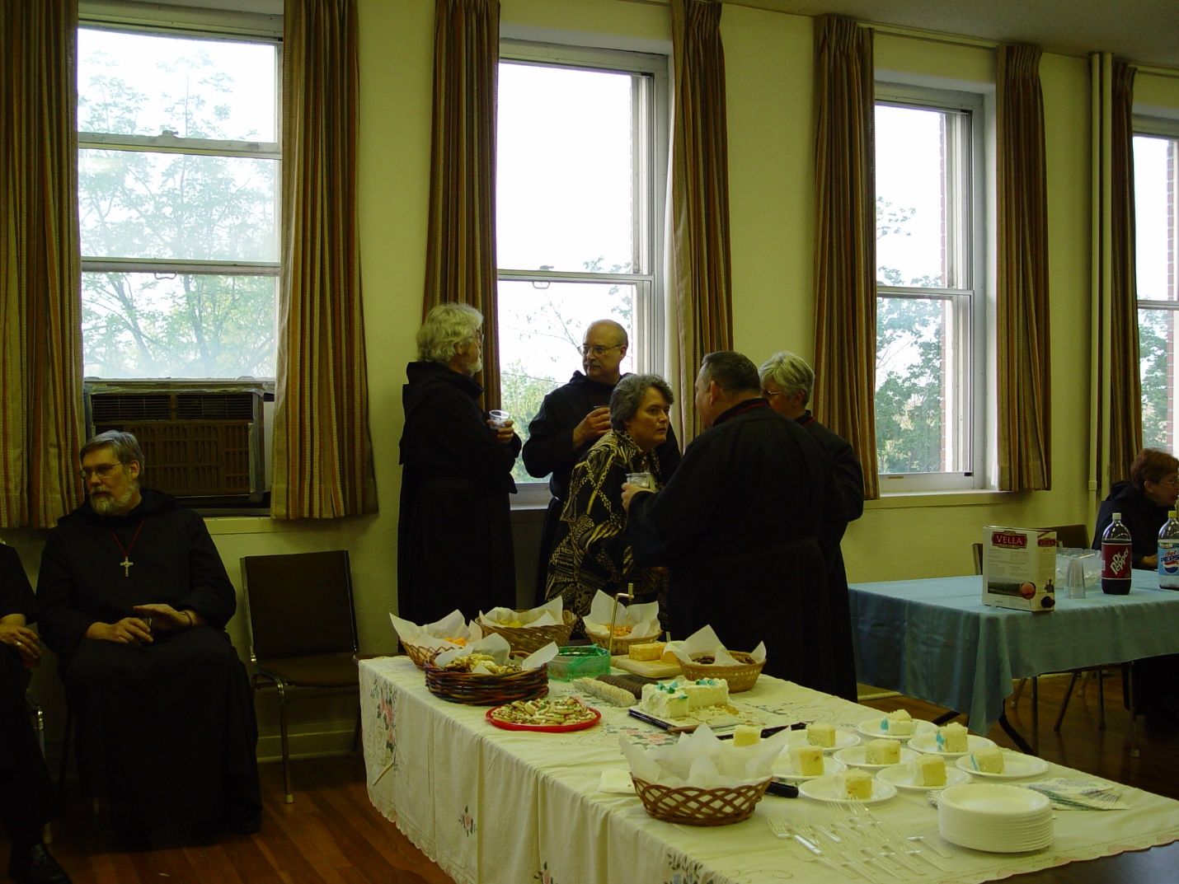
Day 4 PM 023
Br. Chad Anselm Gerns (now Br. David); Br. Martin Sheridan; Br. Raymond Owens; ?; Br. Ambrose Heroux; Sr. Clare Benedicta Meyers

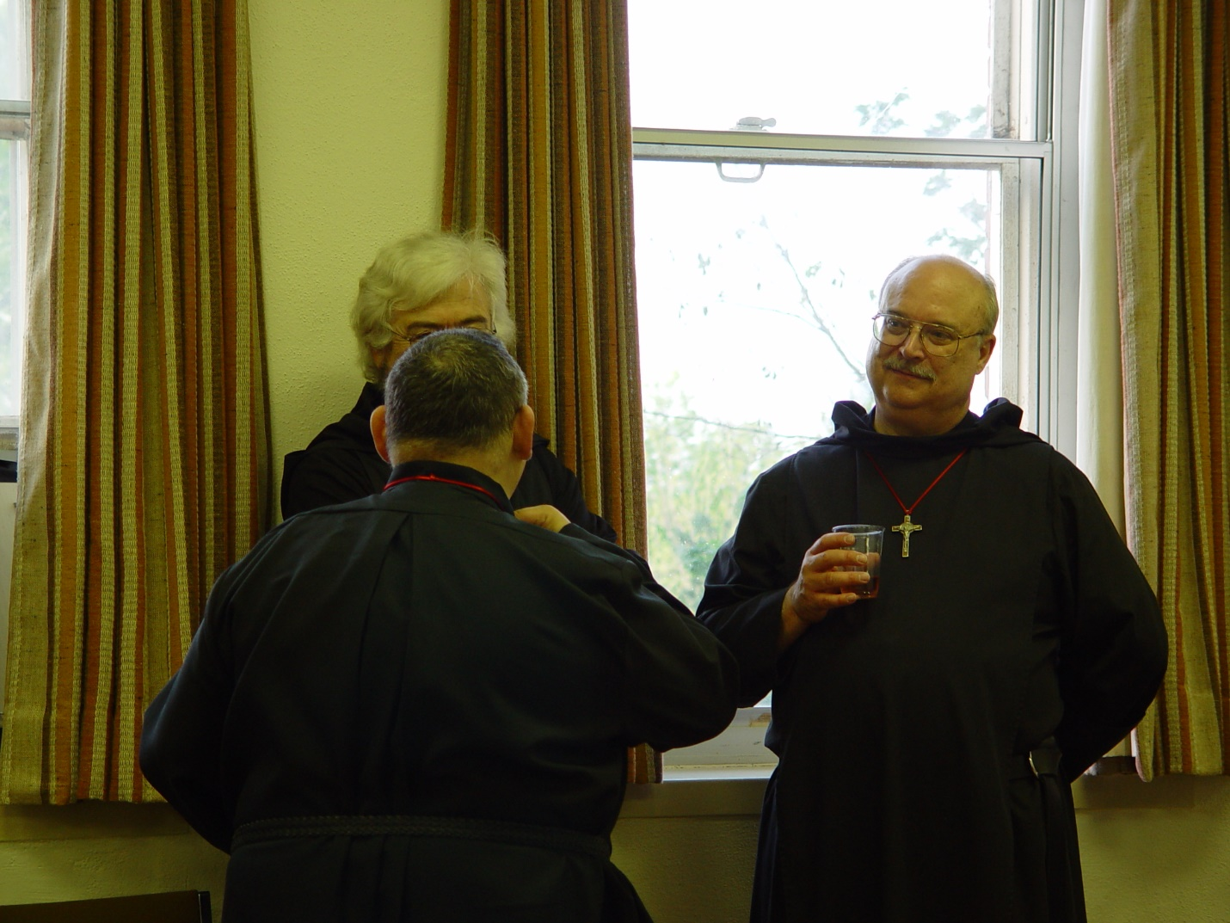
Day 4 PM 024
Br. Ambrose Heroux; Br. Martin Sheridan; Br. Raymond Owens

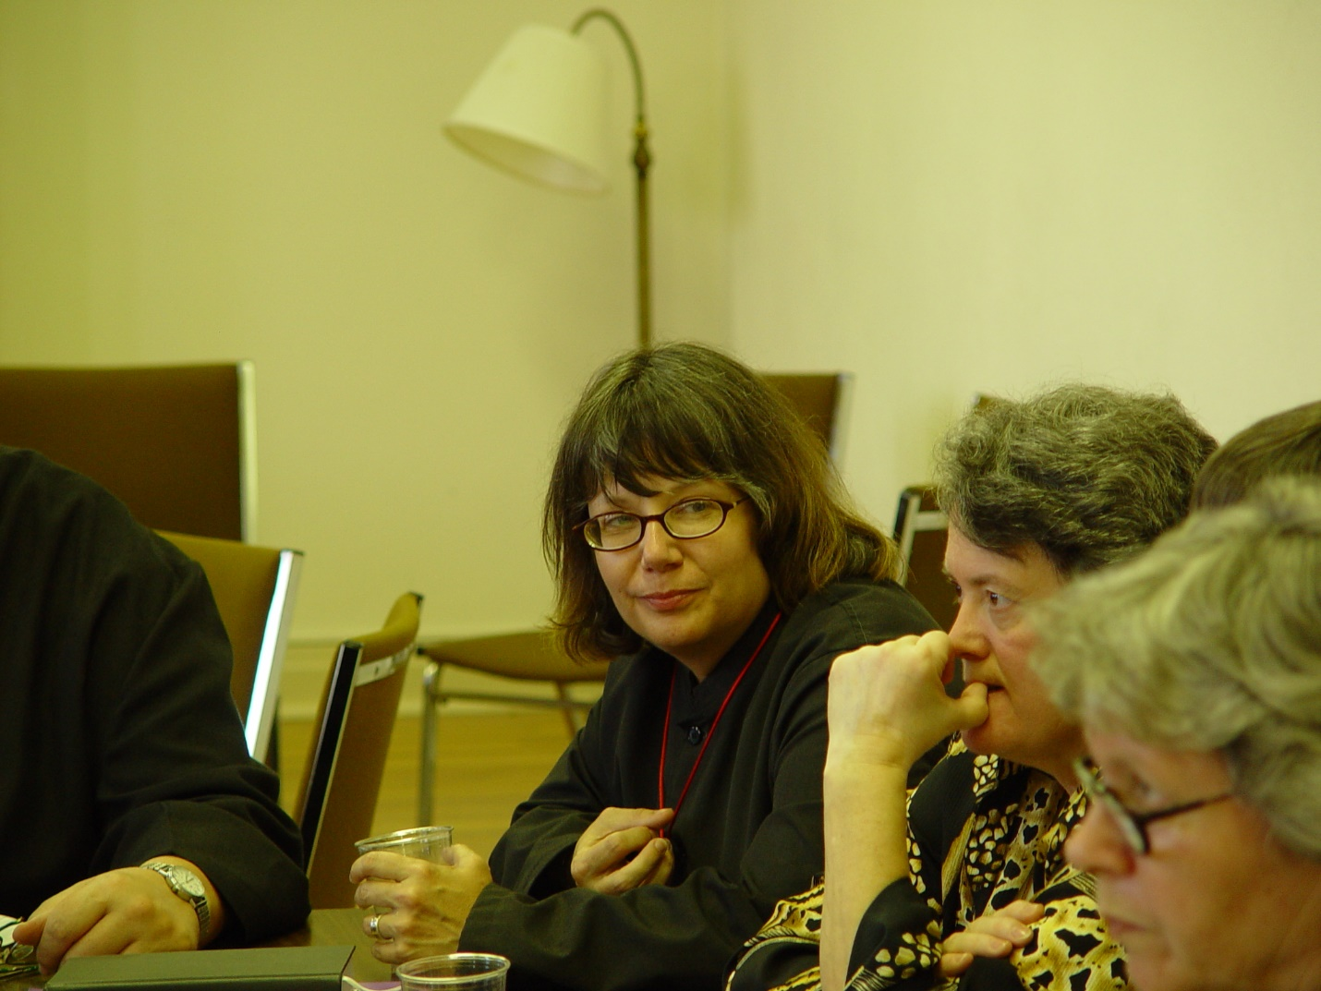
Day 4 PM 025
Sr. Anna Grace Madden; ?; ?

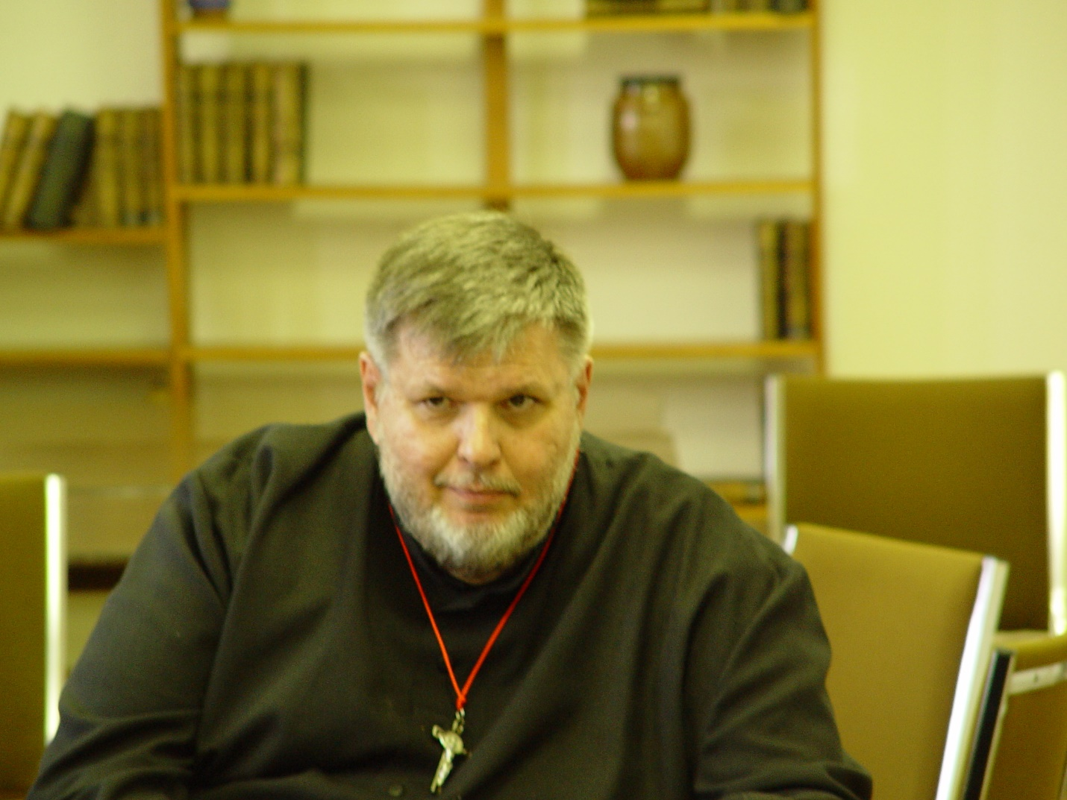
Day 4 PM 026
Br. Nathan Gregory Miller

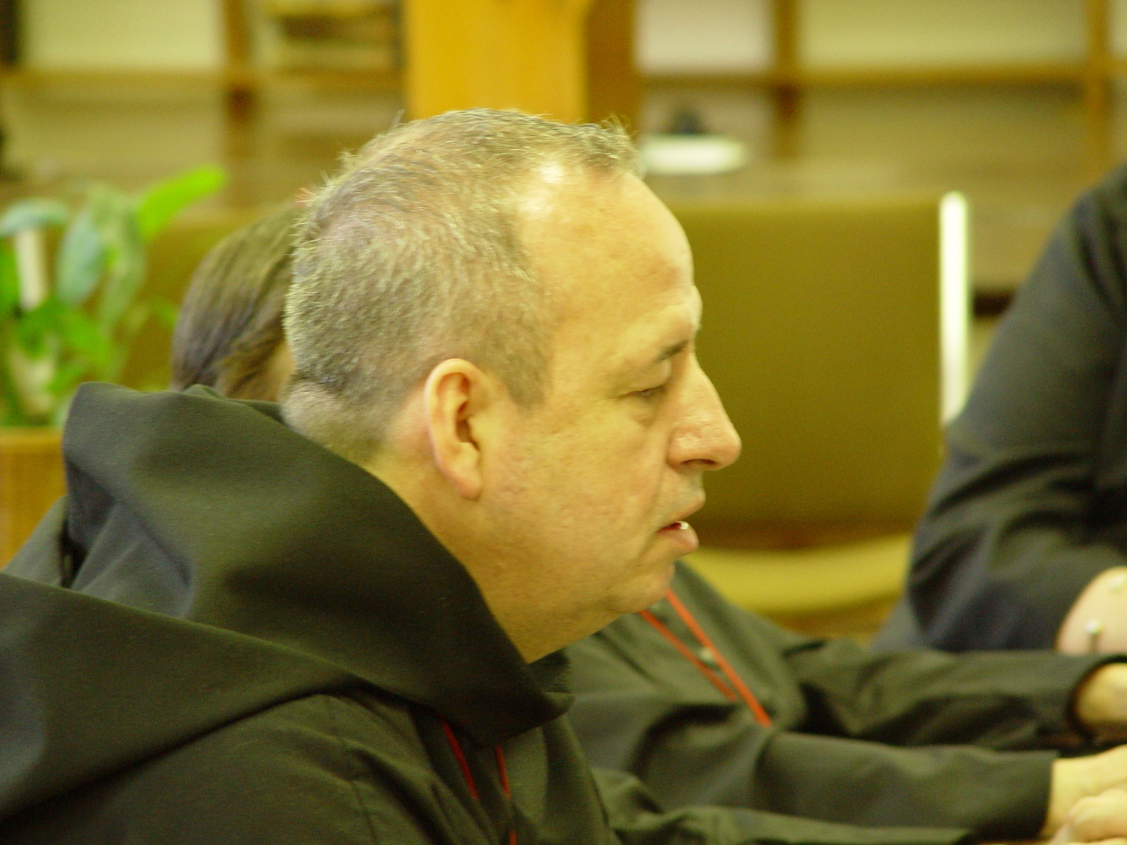
Day 4 PM 027
Br. Gabriel Hale

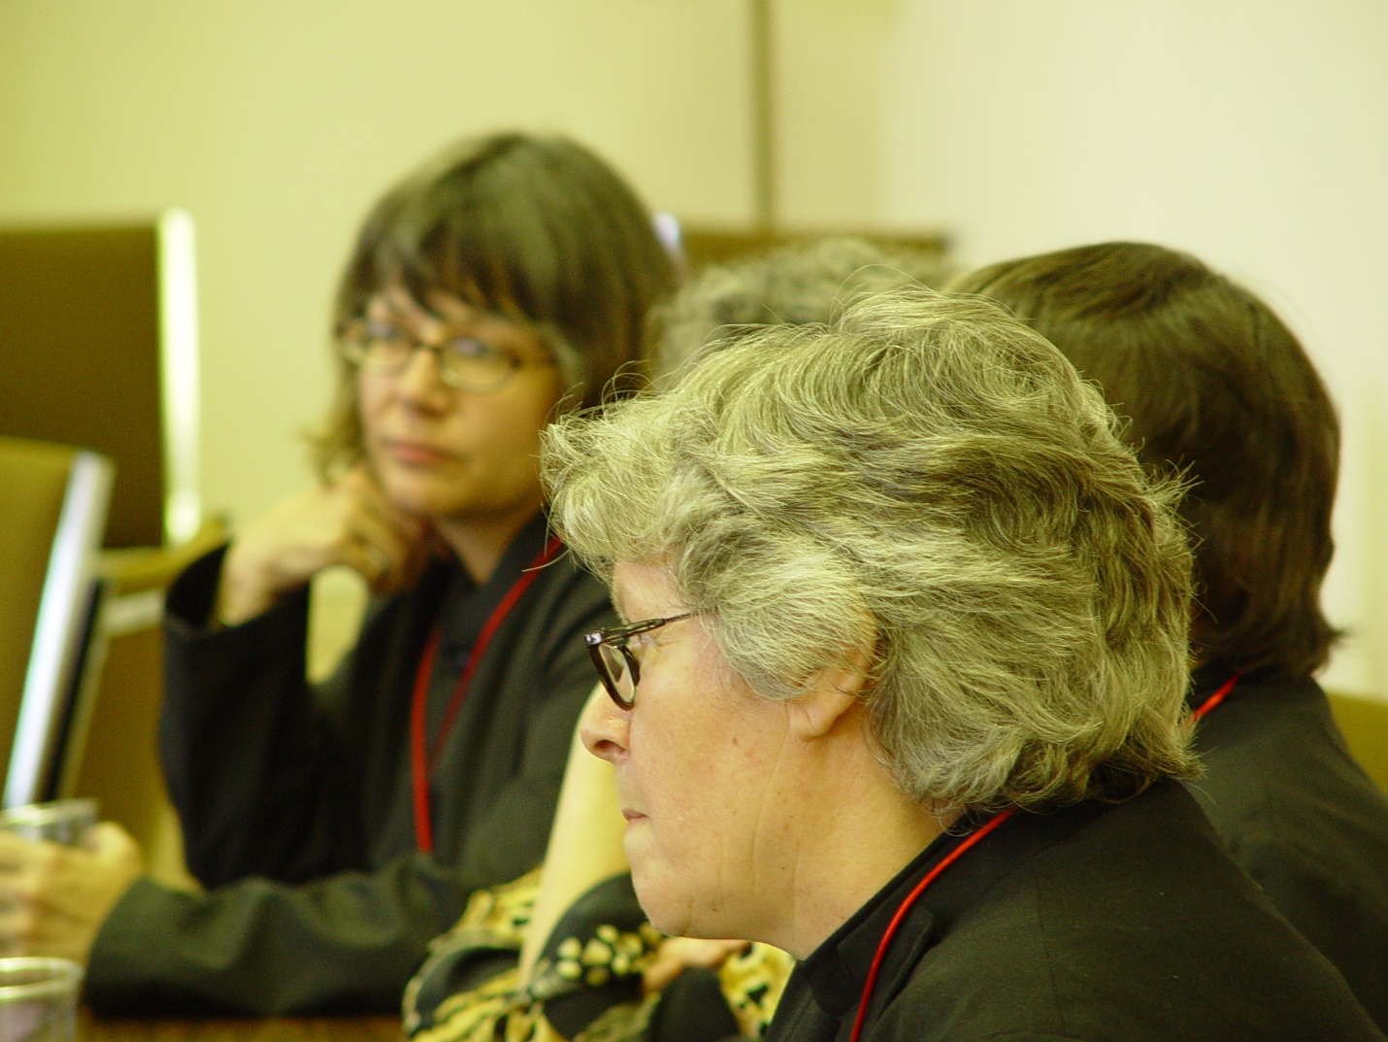
Day 4 PM 028
Sr. Anna Grace Madden; Sr. ?

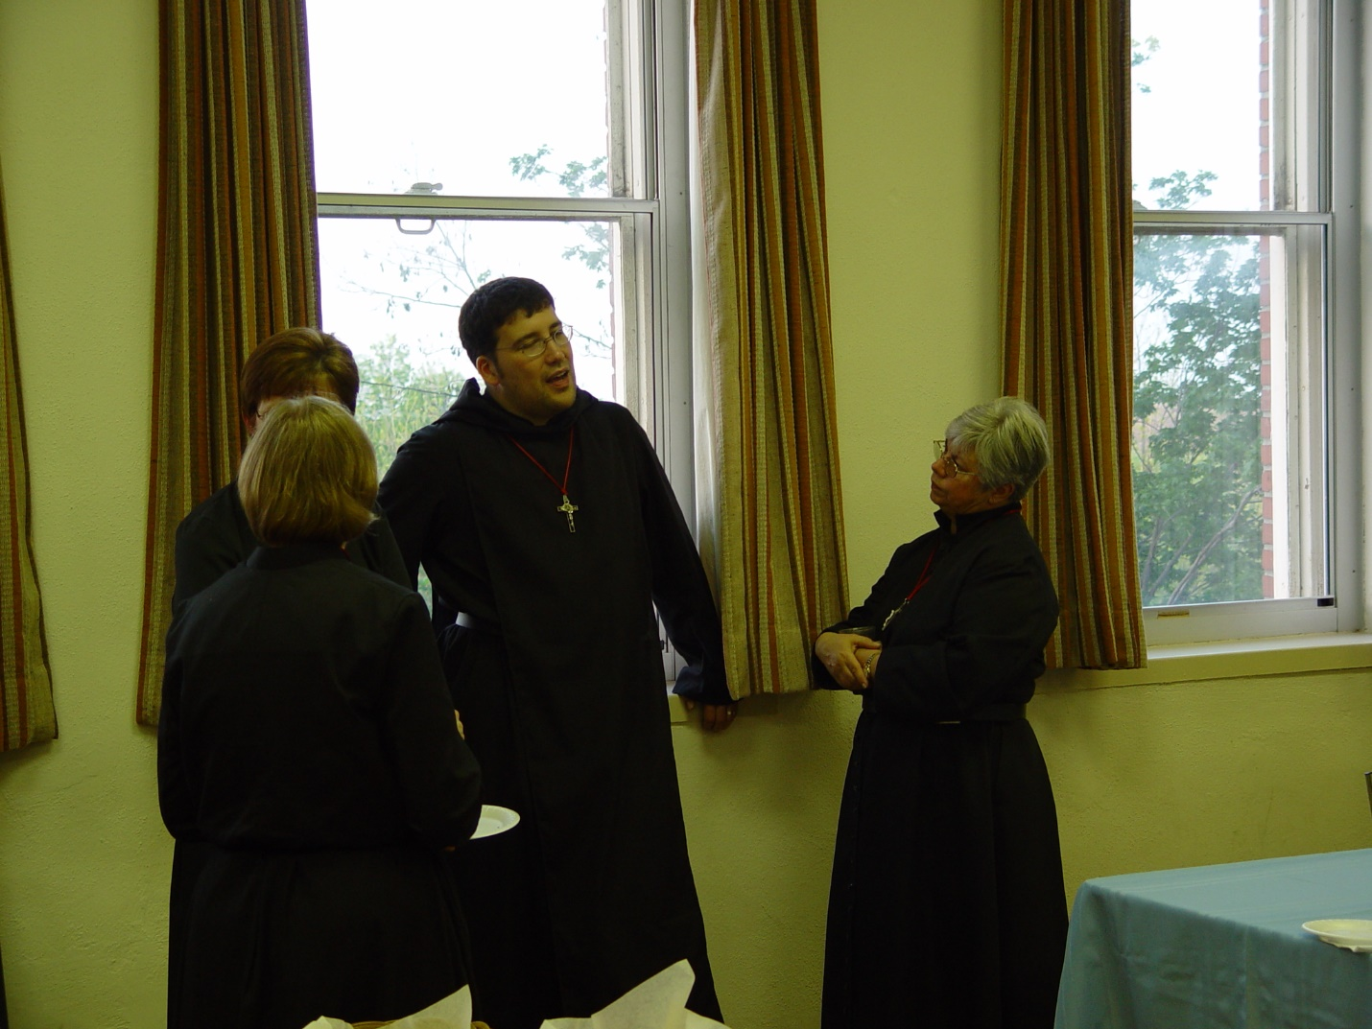
Day 4 PM 029
Sr. Anna Grace Madden?; Sr. Ann Gerns; Br. Anthony Bernard Campos; Sr. Clare Benedicta Meyers

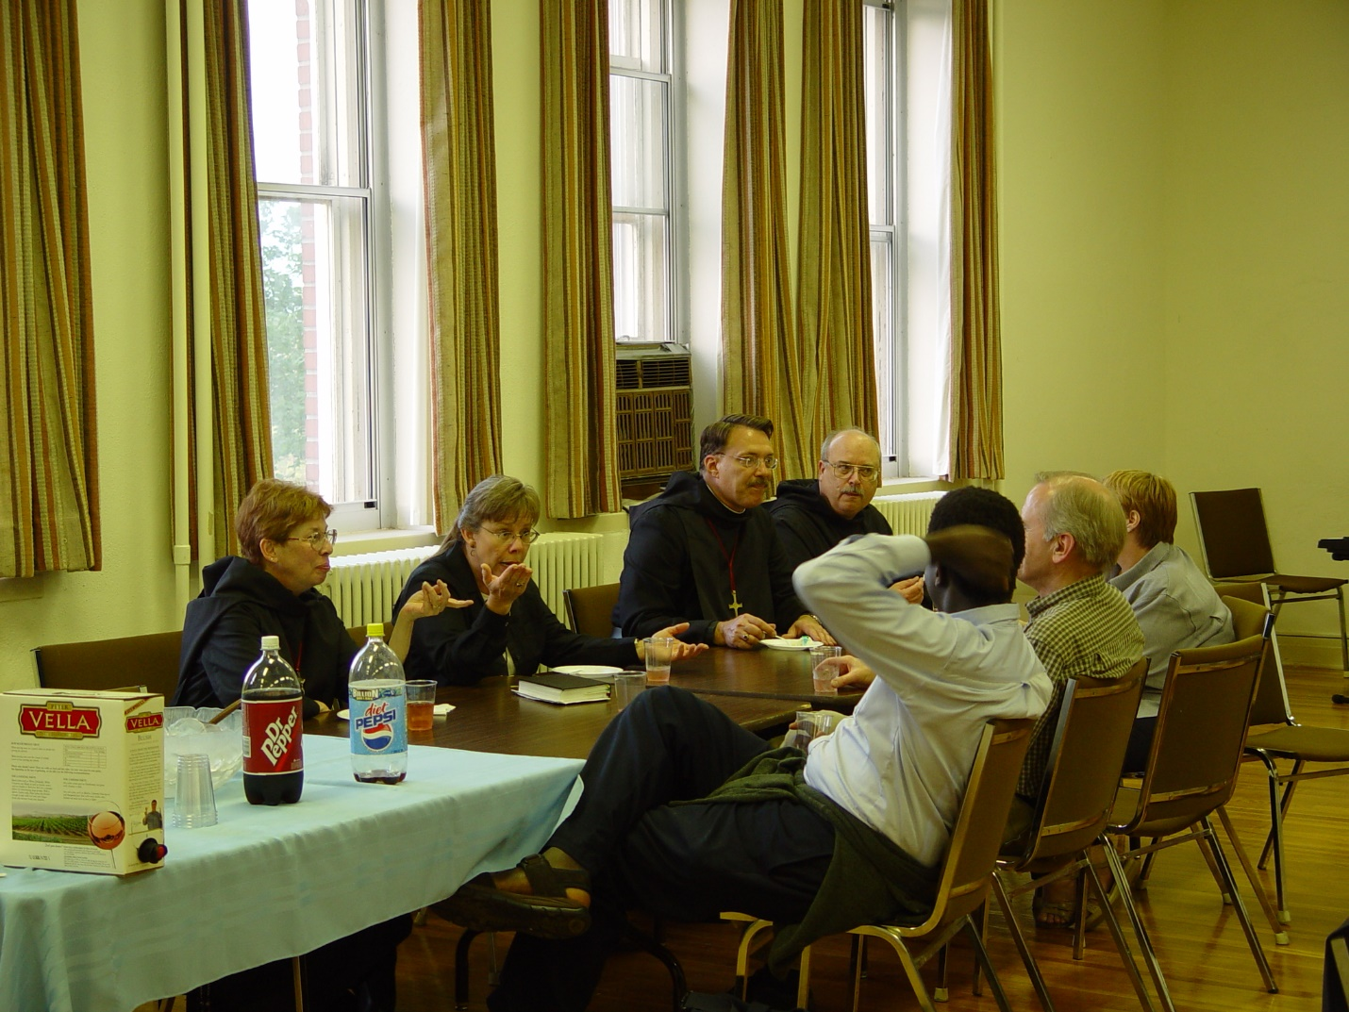
Day 4 PM 030
Sr. Monica Ruth Mullen; Sr.?; Prior Michael John Austin; Br. Raymond Owens; unidentified guest; Br. Daniel Joseph Schroeder; Becky Fredregill

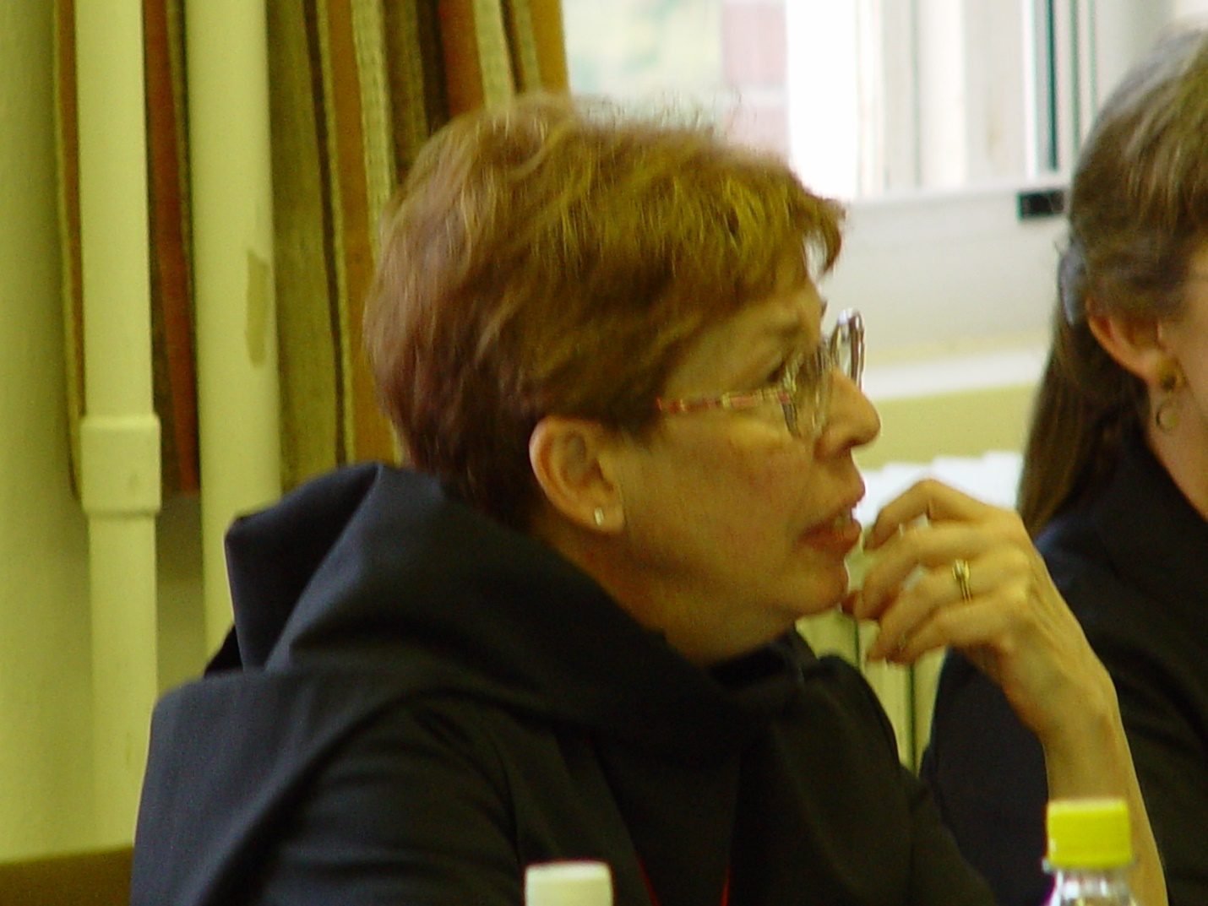
Day 4 PM 031
Sr. Monica Ruth Mullen

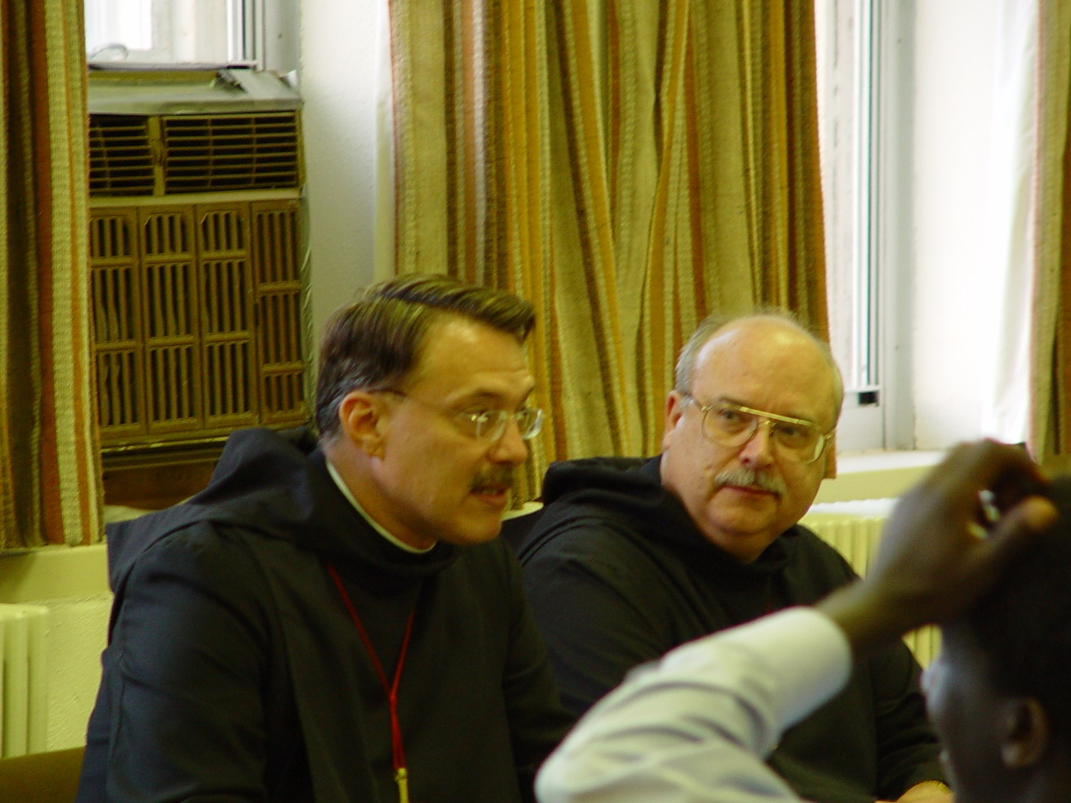
Day 4 PM 032
Prior Michael John Austin; Br. Raymond Owens; unidentified guest

