Companions of St. Luke
Spring 2003 Convocation at Conception Abbey
Day 2 Morning, Part 2

~Edited by Br. Steven Olderr, 7 May 2022; most identifications by Br. Thomas Ferrell

Note: People are named from left to right.

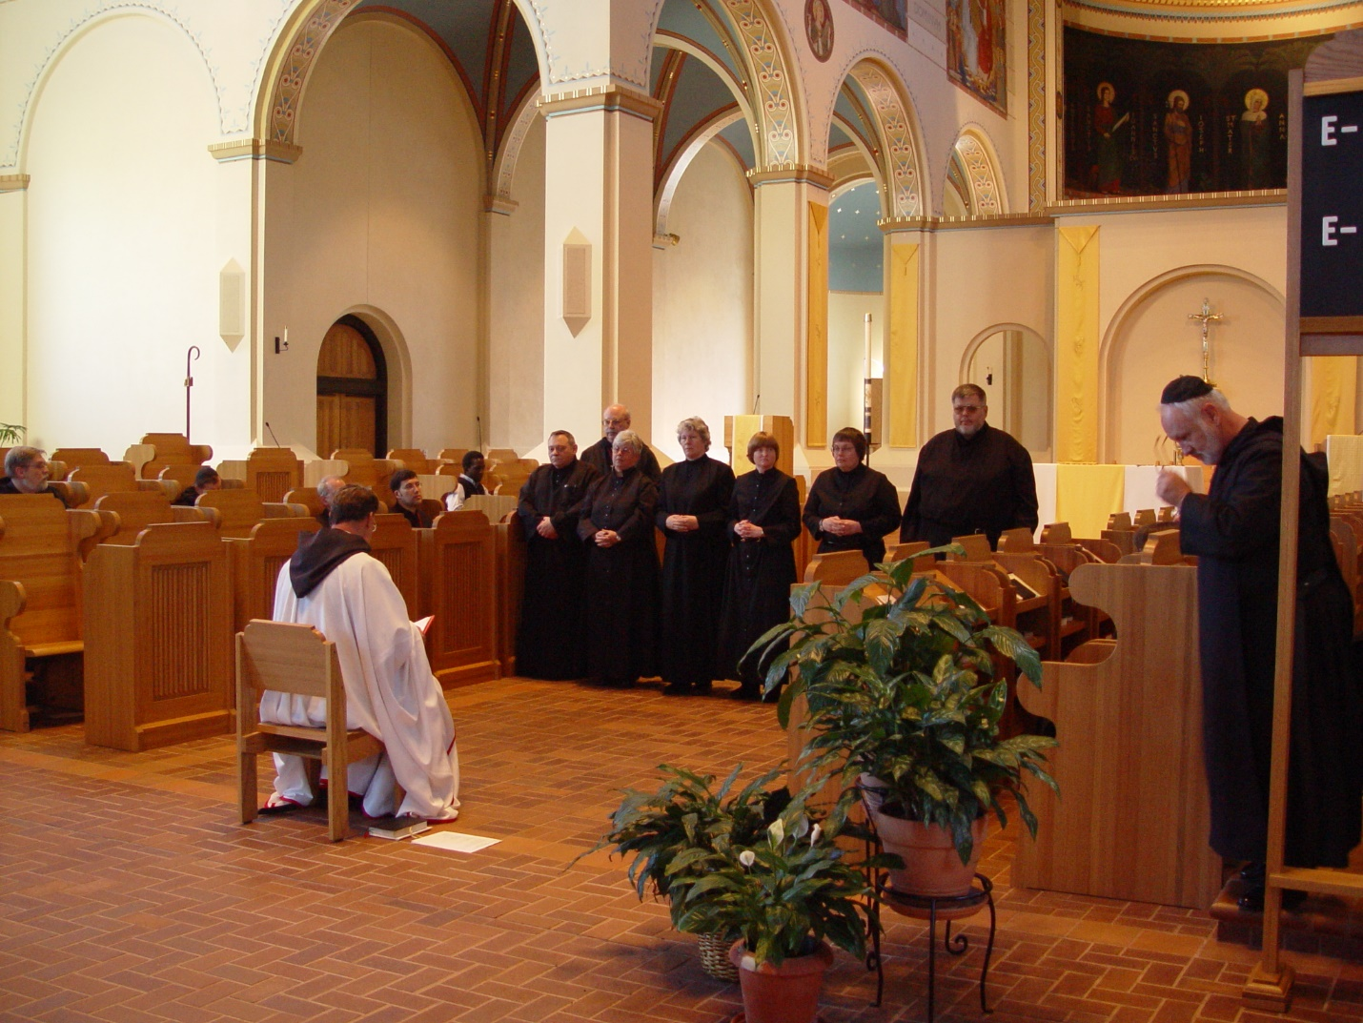

Day 2 Morning 038
Prior Michael John Austin officiating

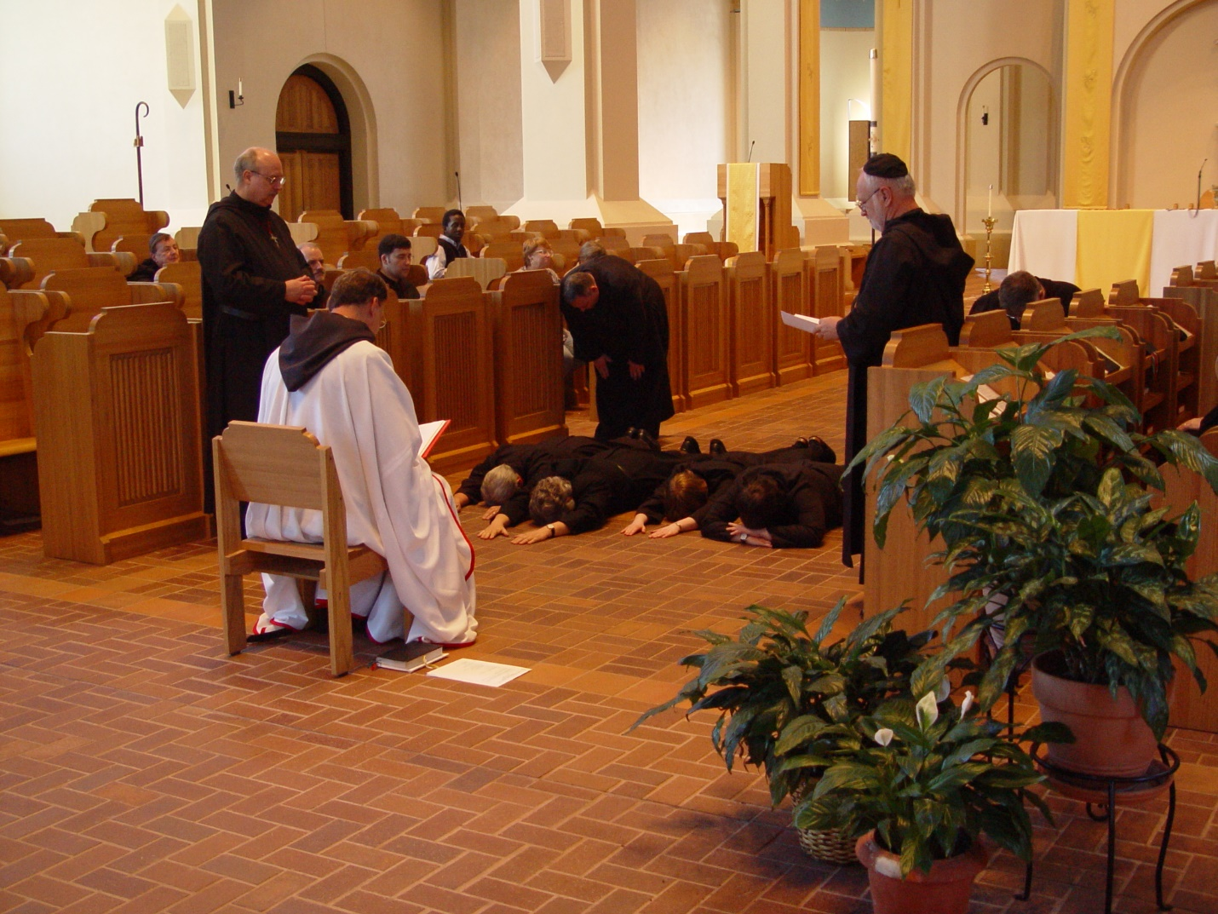

Day 2 Morning 039

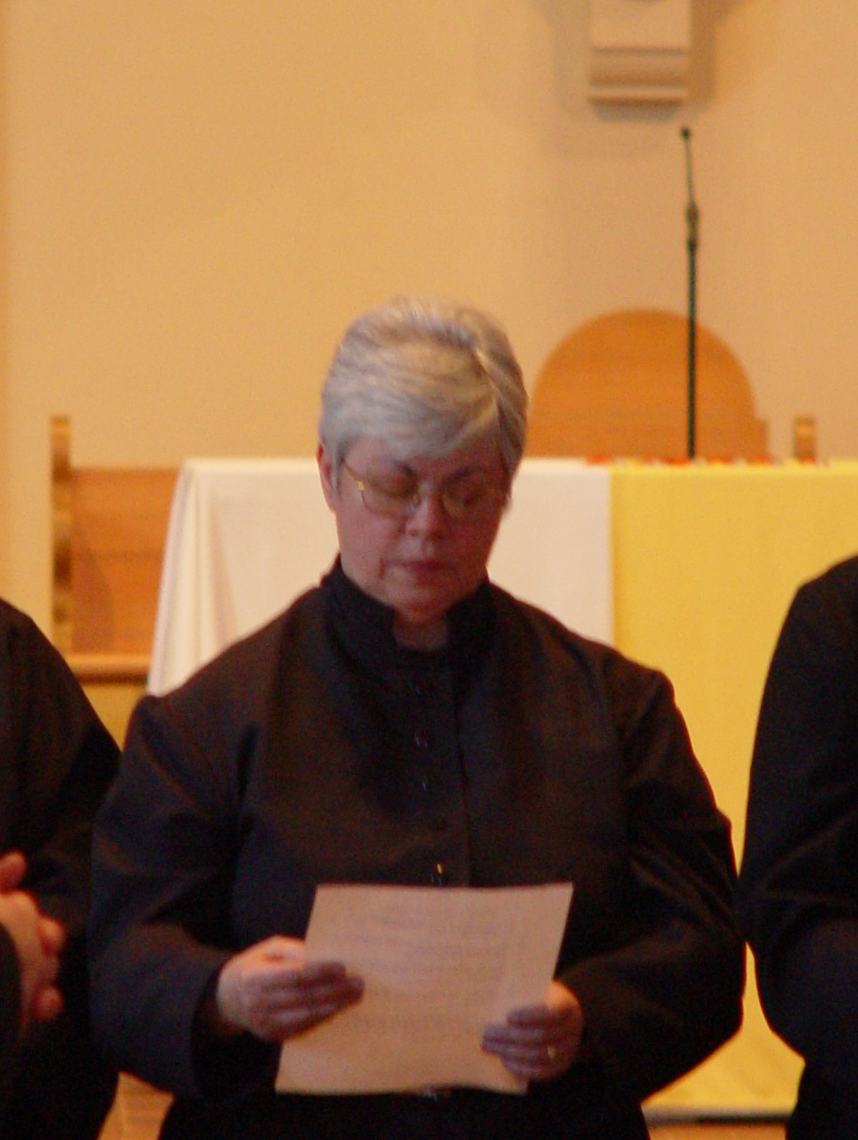

Day 2 Morning 040

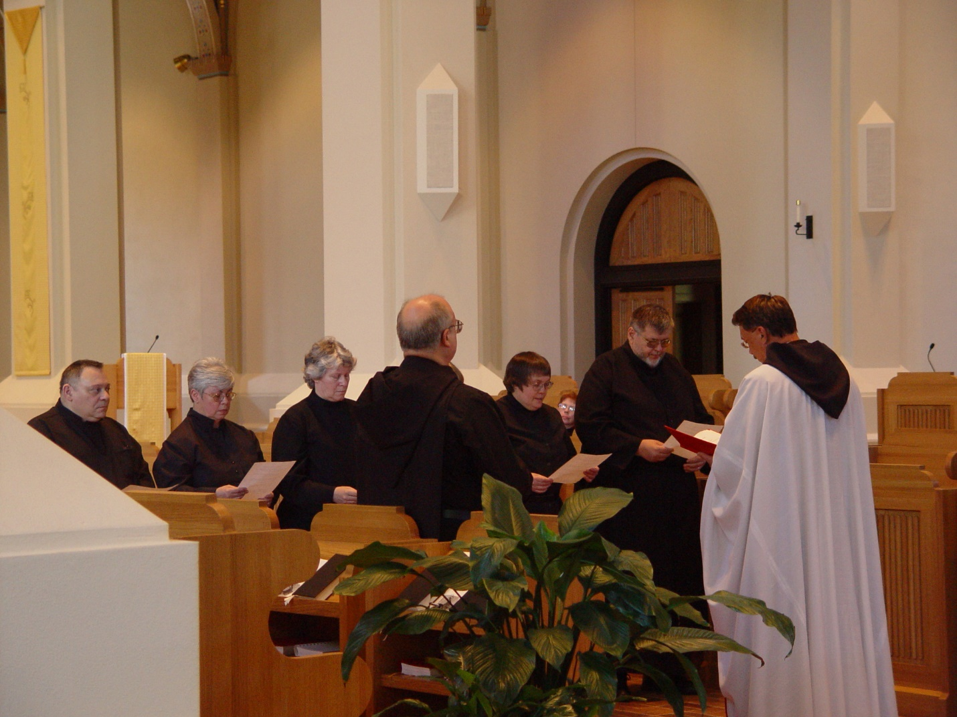

Day 2 Morning 041
Br. Ambrose Heroux;
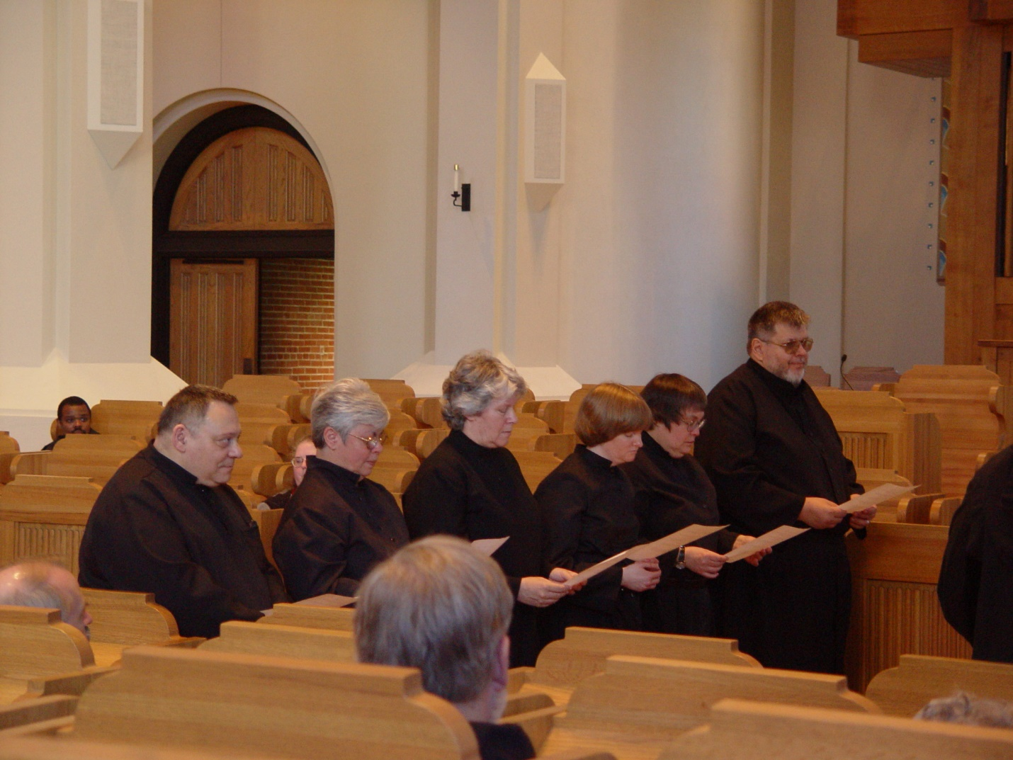

Day 2 Morning 042
Br. Ambrose Heroux; ?? Sr. Catherine Unterseher; ?; Br. Nathan Gregory Miller
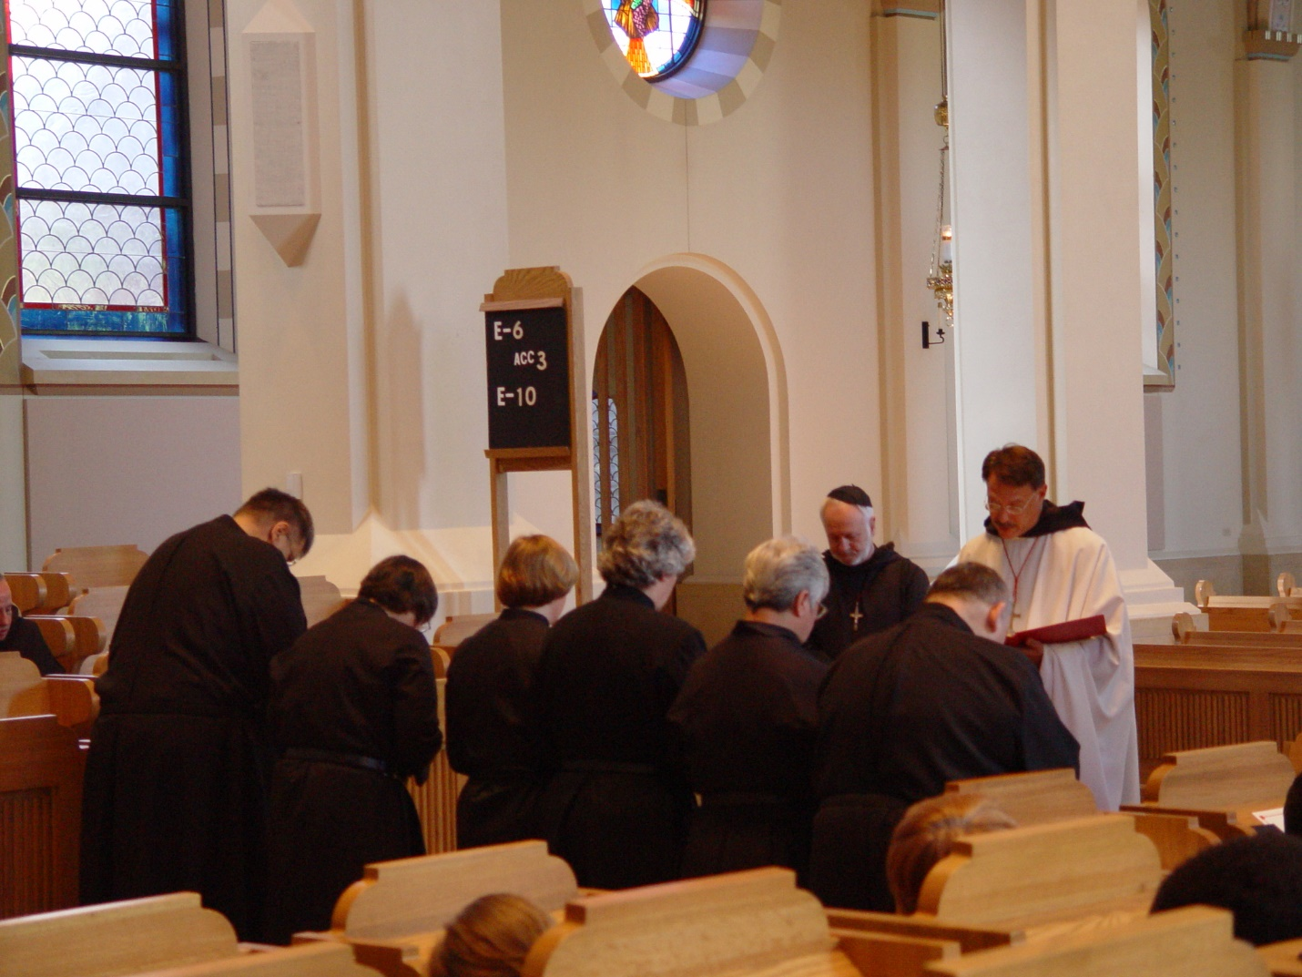

Day 2 Morning 043
Backs to camera: Br, Nathan Gregory Miller; ?; Sr. Catherine Unterseher; ?; ? ; Br. Ambrose Heroux
Facing camera: ?; Prior Michael John Austin
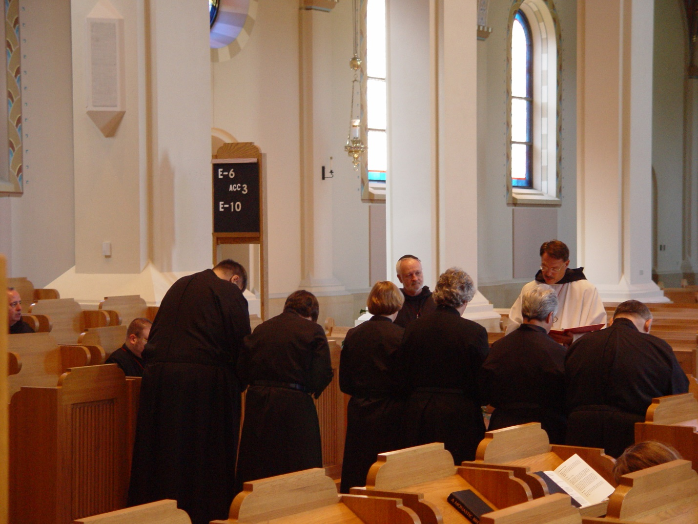

Day 2 Morning 044
Backs to camera: Br, Nathan Gregory Miller; ?; Sr. Catherine Unterseher; ?; ? ; Br. Ambrose Heroux
Facing camera: ?; Prior Michael John Austin
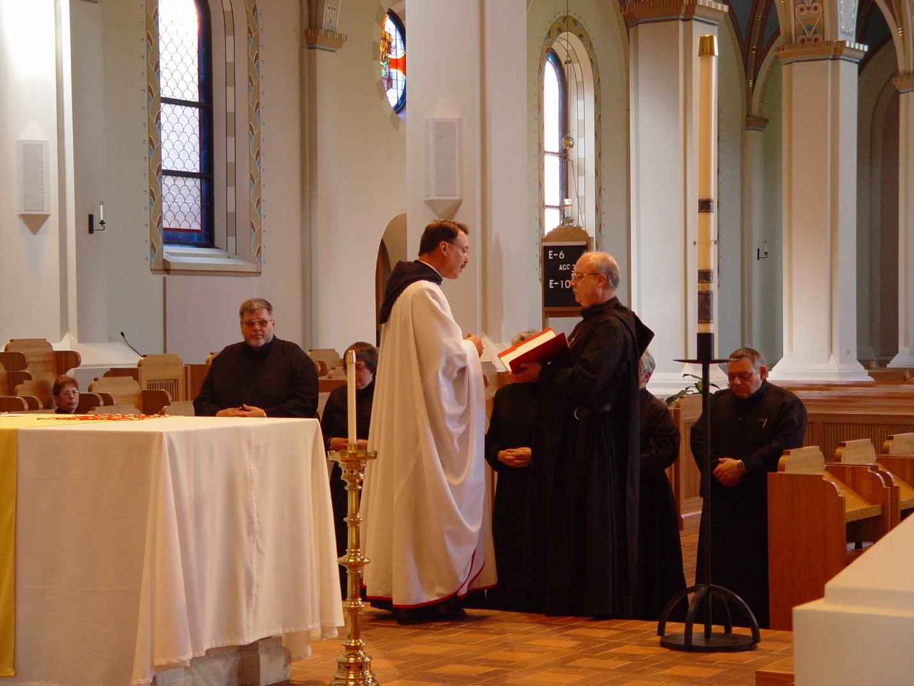

Day 2 Morning 045
Prior Michael John Austin officiating
Facing camera: Br. Nathan Gregory Miller; ? ????; Br. Ambrose Heroux
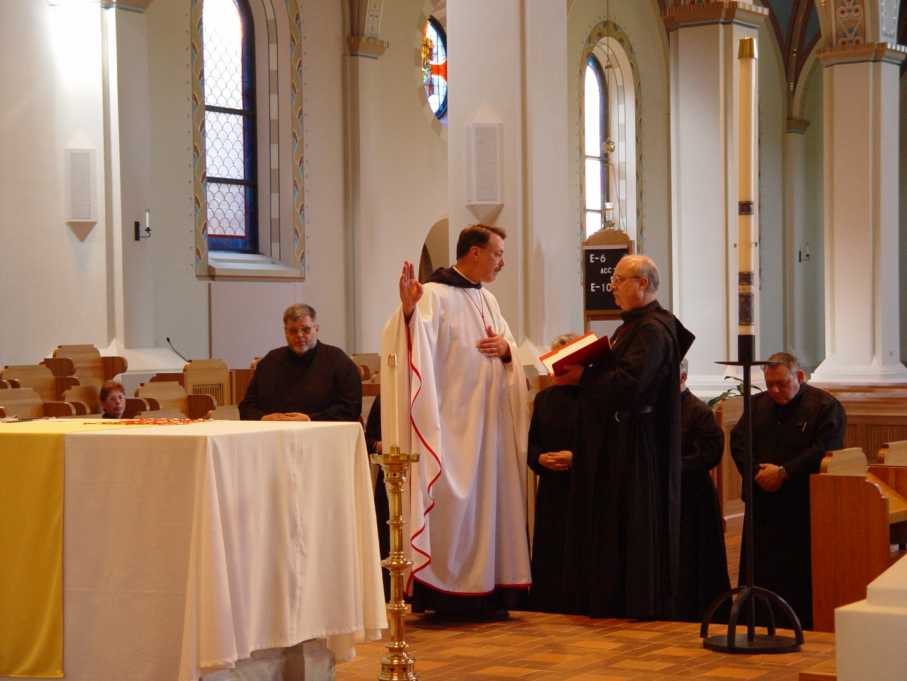Day 2 Morning 046 Prior Michael John Austin officiating
Facing camera: Br. Nathan Gregory Miller; ? ????; Br. Ambrose Heroux
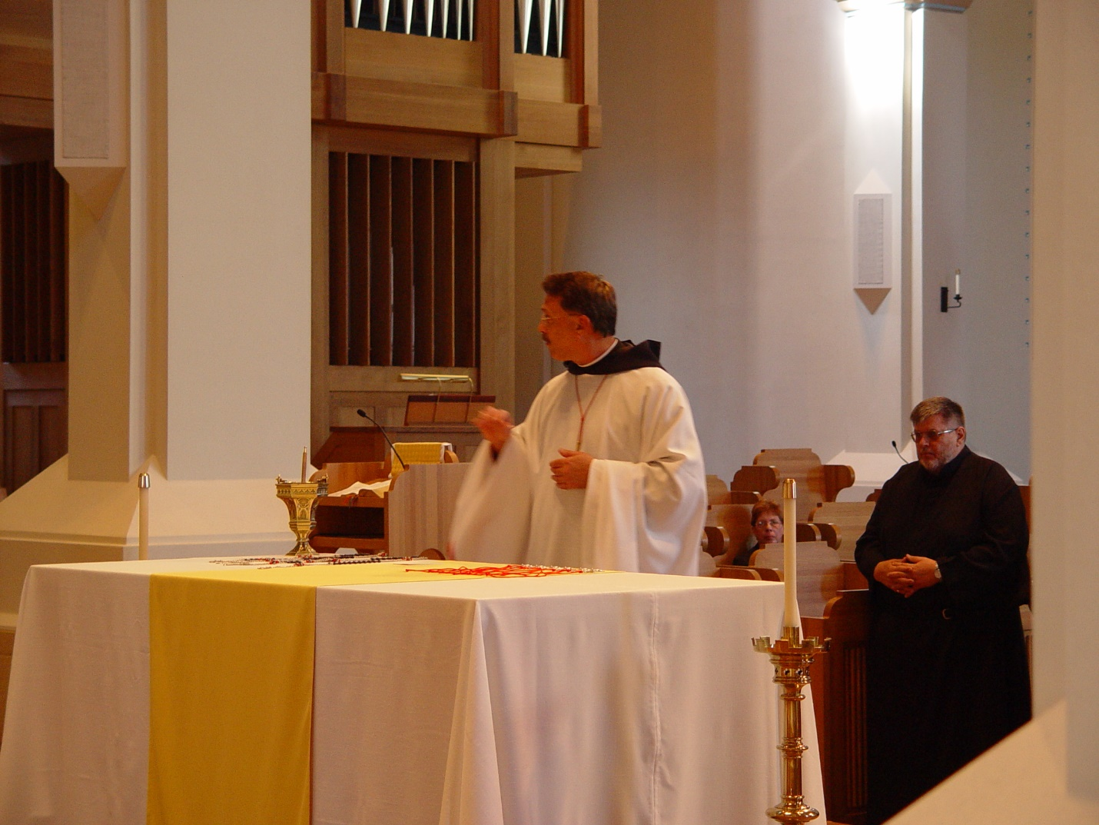

Day 2 Morning 047
Prior Michael John Austin; Sr. Monica Ruth Mullen; Br. Nathan Gregory Miller
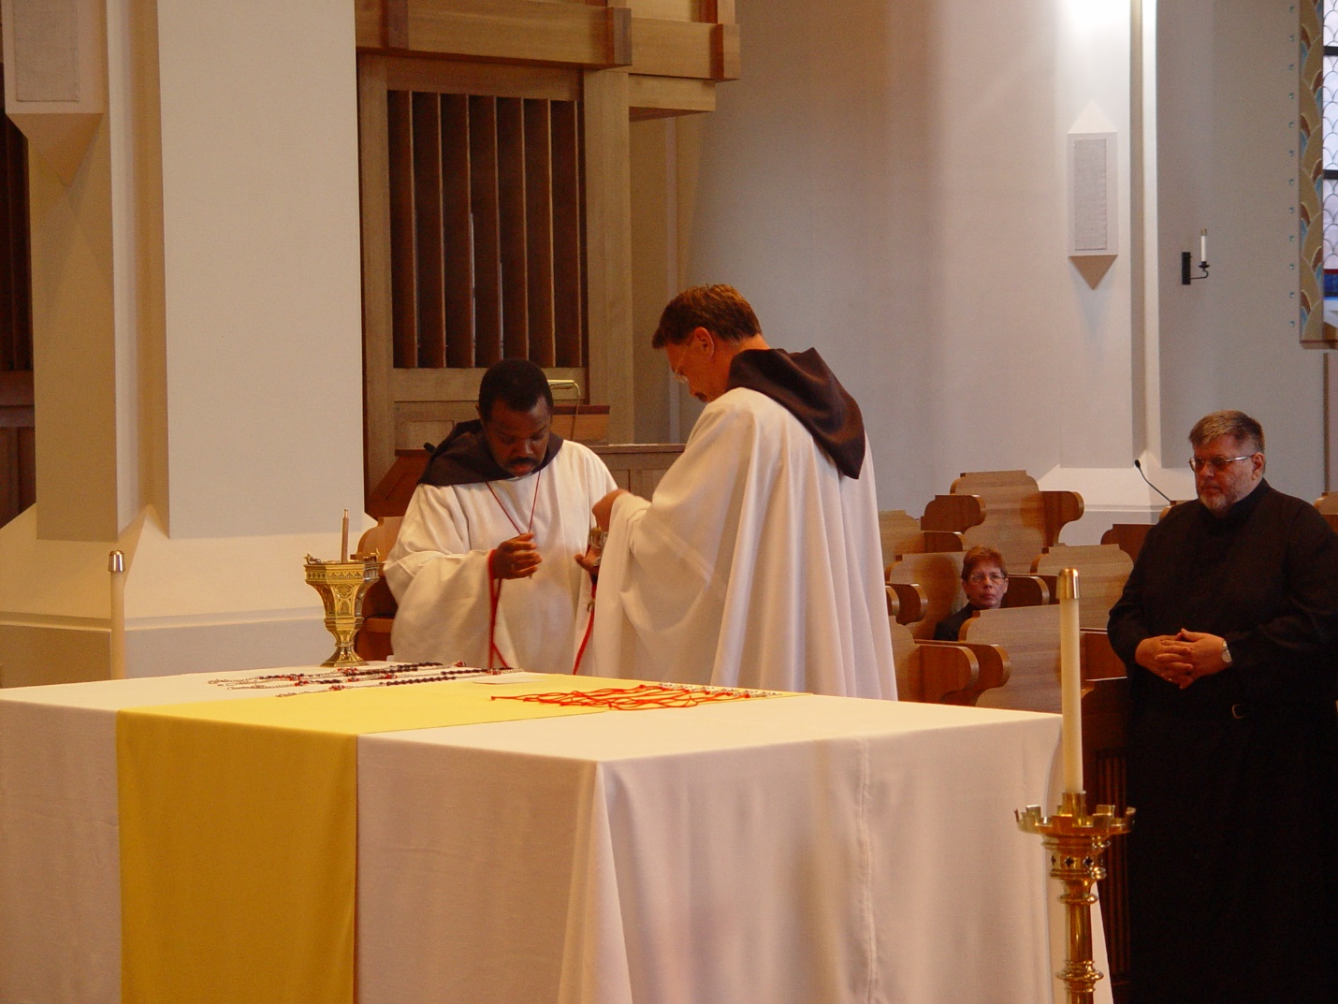

Day 2 Morning 048
Br. Tomas Ferrell; Prior Michael John Austin; Sr. Monica Ruth Mullen; Br. Nathan Gregory Miller
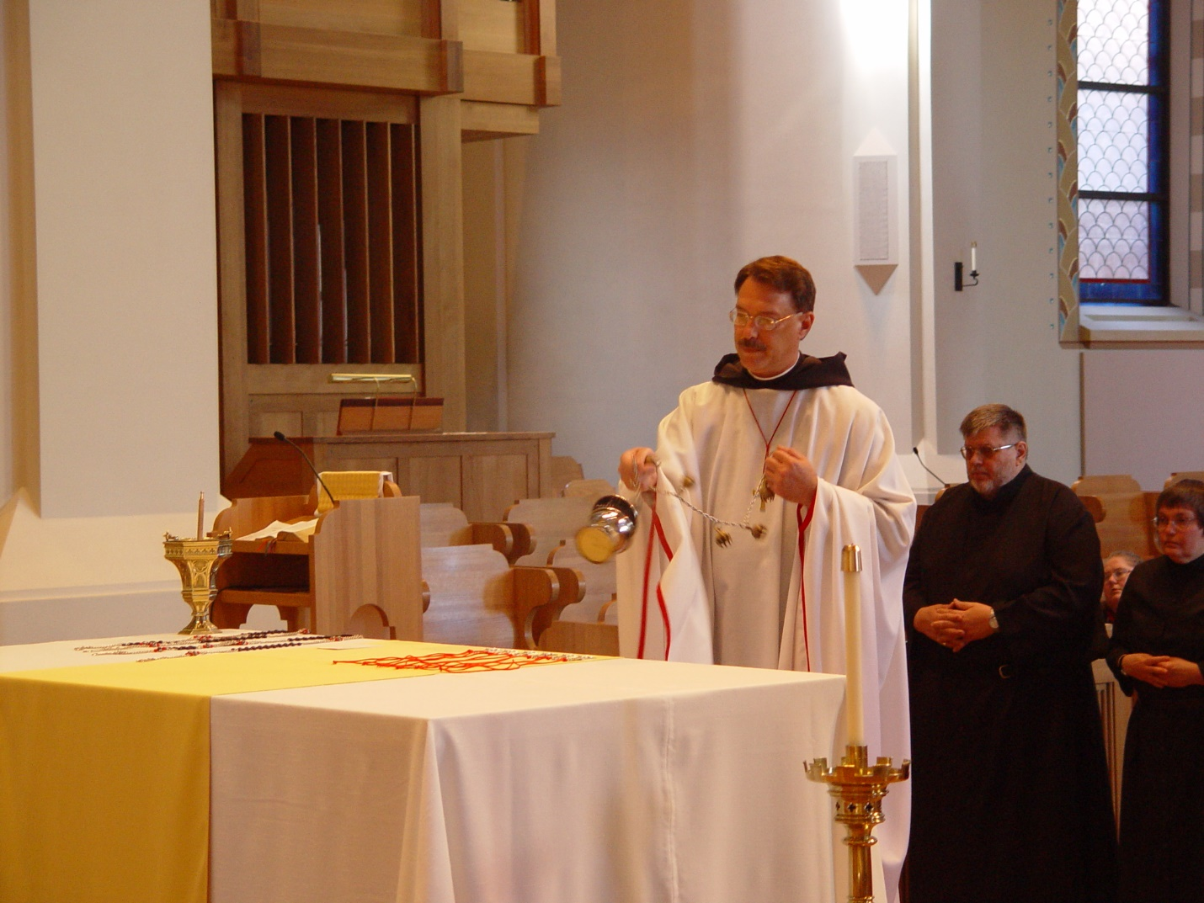

Day 2 Morning 049
Prior Michael John Austin; Br. Nathan Gregory Miller; Sr. ?
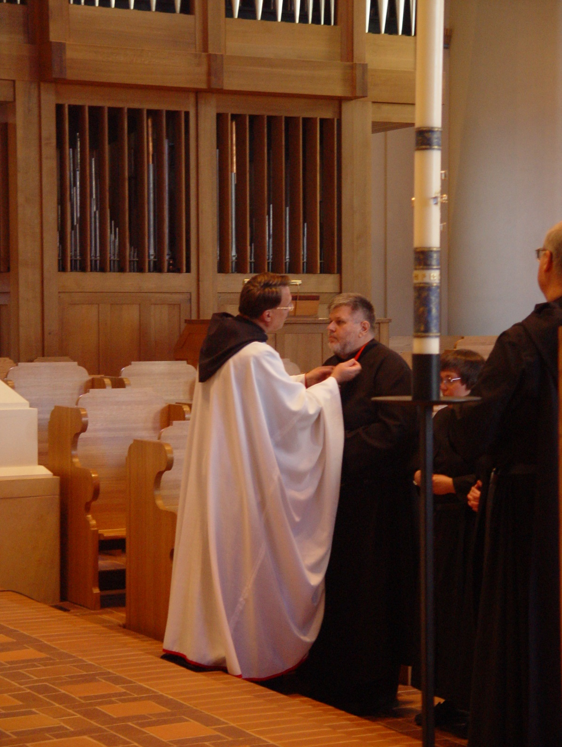

Day 2 Morning 050
Prior Michael John Austin; Br. Nathan Gregory Miller; Sr. ?; Br. ?
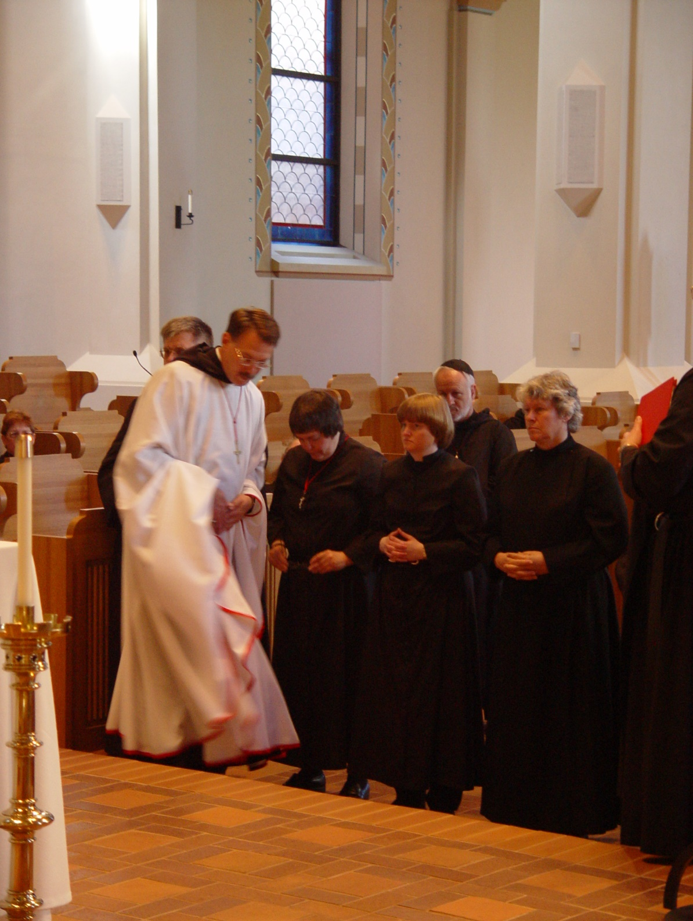

Day 2 Morning 051
Br. Nathan Gregory Miller; Prior Michael John Austin; Sr. ?; Sr. Catherine Unterseher; Sr. ?
who’s the guy in the skullcap?
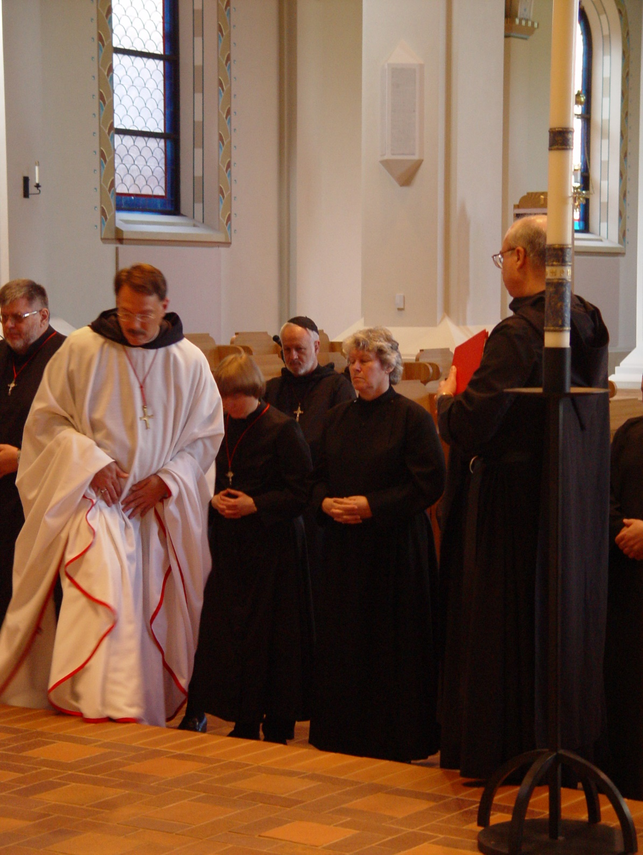

Day 2 Morning 052
Br. Nathan Gregory Miller; Prior Michael John Austin; Sr. Catherine Unterseher; Sr. ?; Br. ?
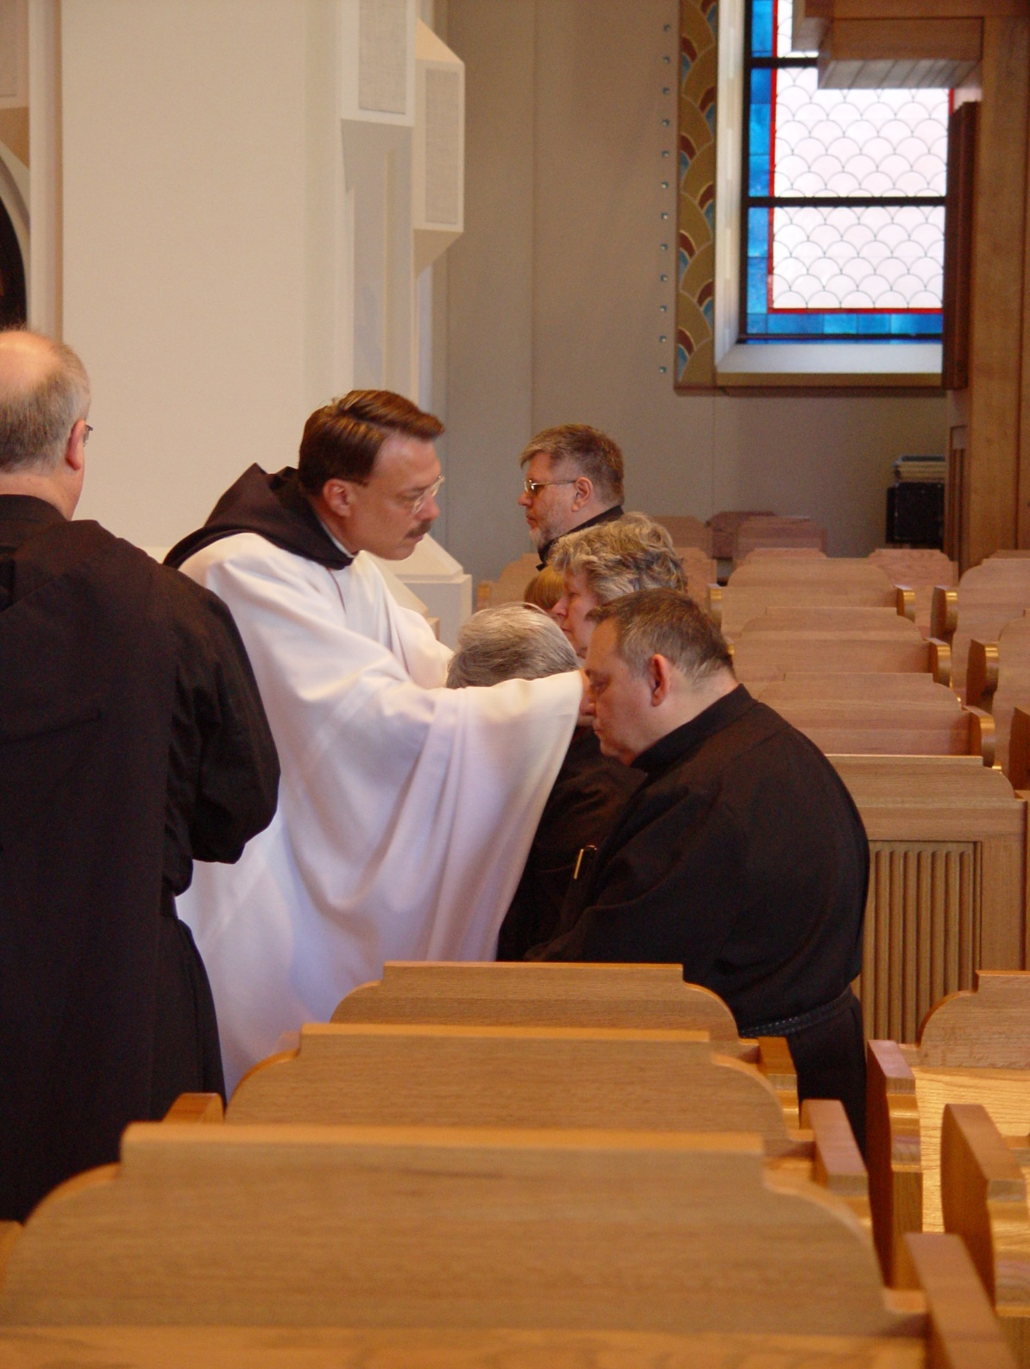

Day 2 Morning 053
Prior Michael John Austin; Br. Ambrose Heroux in front end of line; Br. Nathan Gregory Miller at far end of line

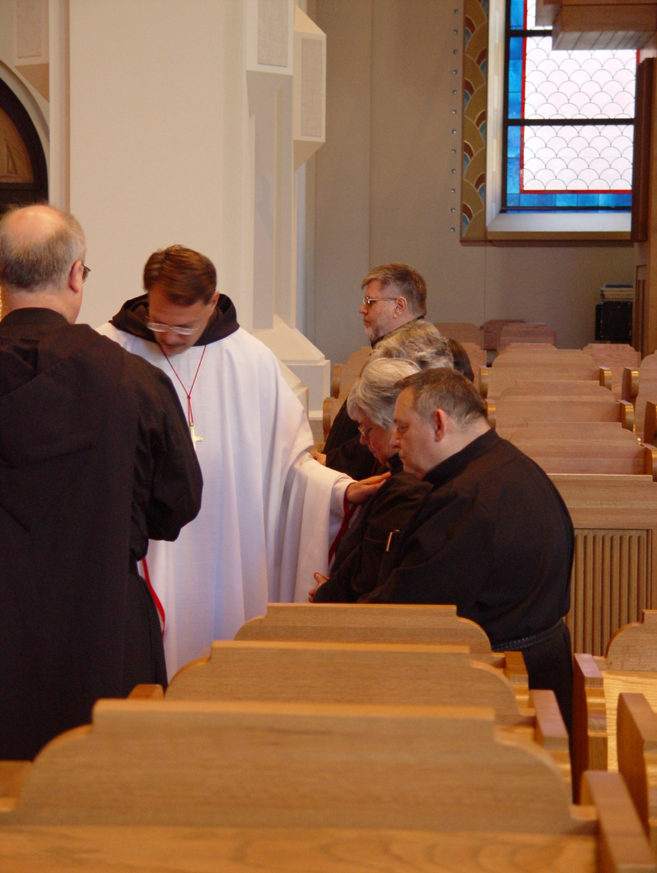

Day 2 Morning 054 Prior Michael John Austin officiating; Br. Ambrose Heroux in front end of line; Br. Nathan Gregory Miller at far end of line
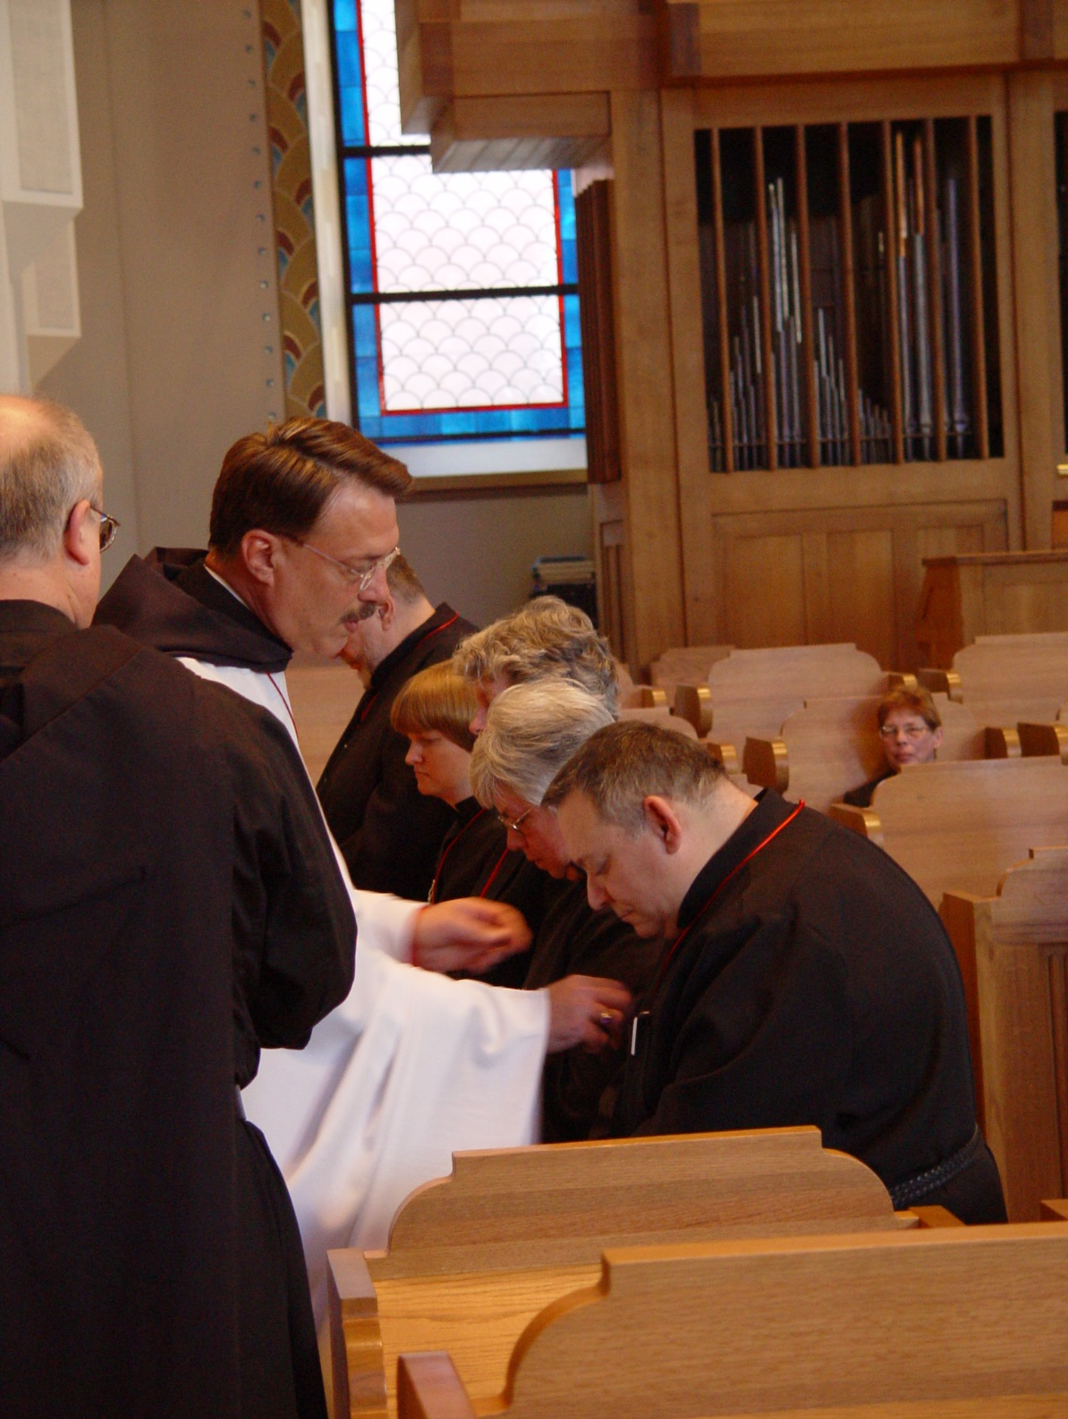

Day 2 Morning 055
Prior Michael John Austin officiating; Br. ? facing away from camera; Br. Ambrose Heroux in front end of line; Br. Nathan Gregory Miller at far end of line; Sr. Catherine Unterseher next to him;
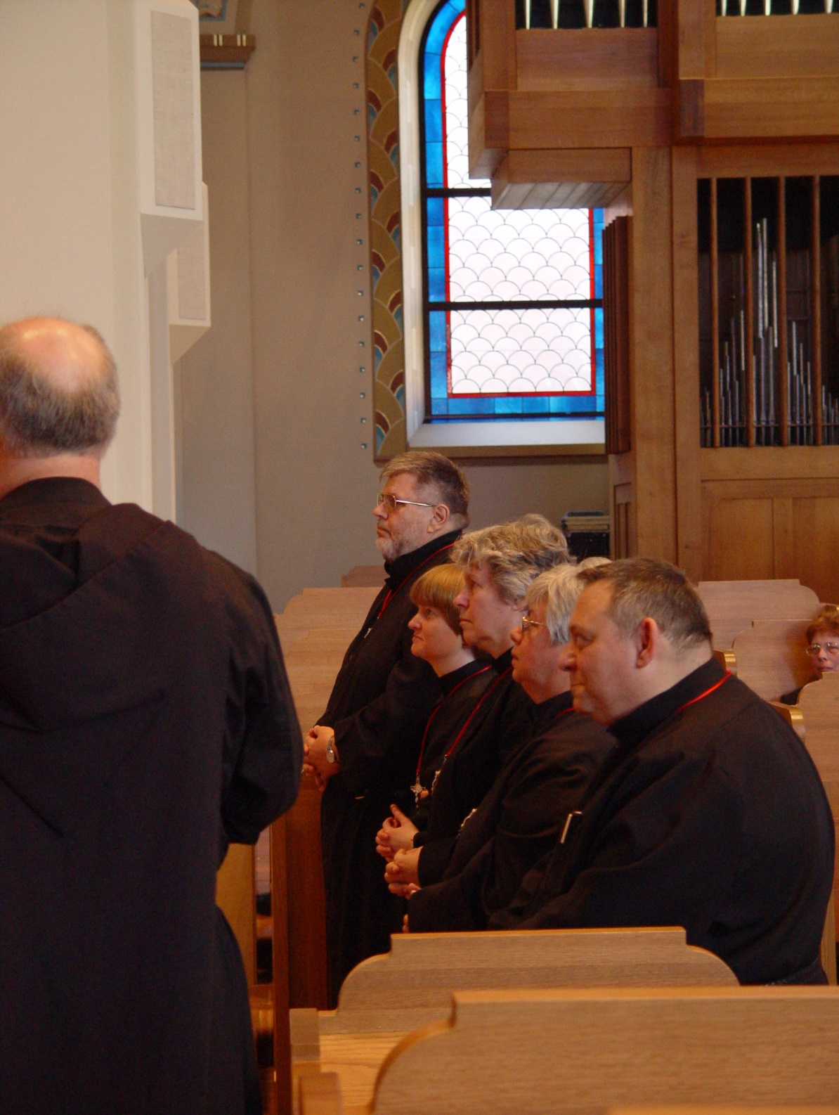

Day 2 Morning 056
Back to camera ?; Br. Nathan Gregory Mille; Sr. Catherine Unterseher; Sr. ?; Sr. ?; Br. Ambrose Heroux

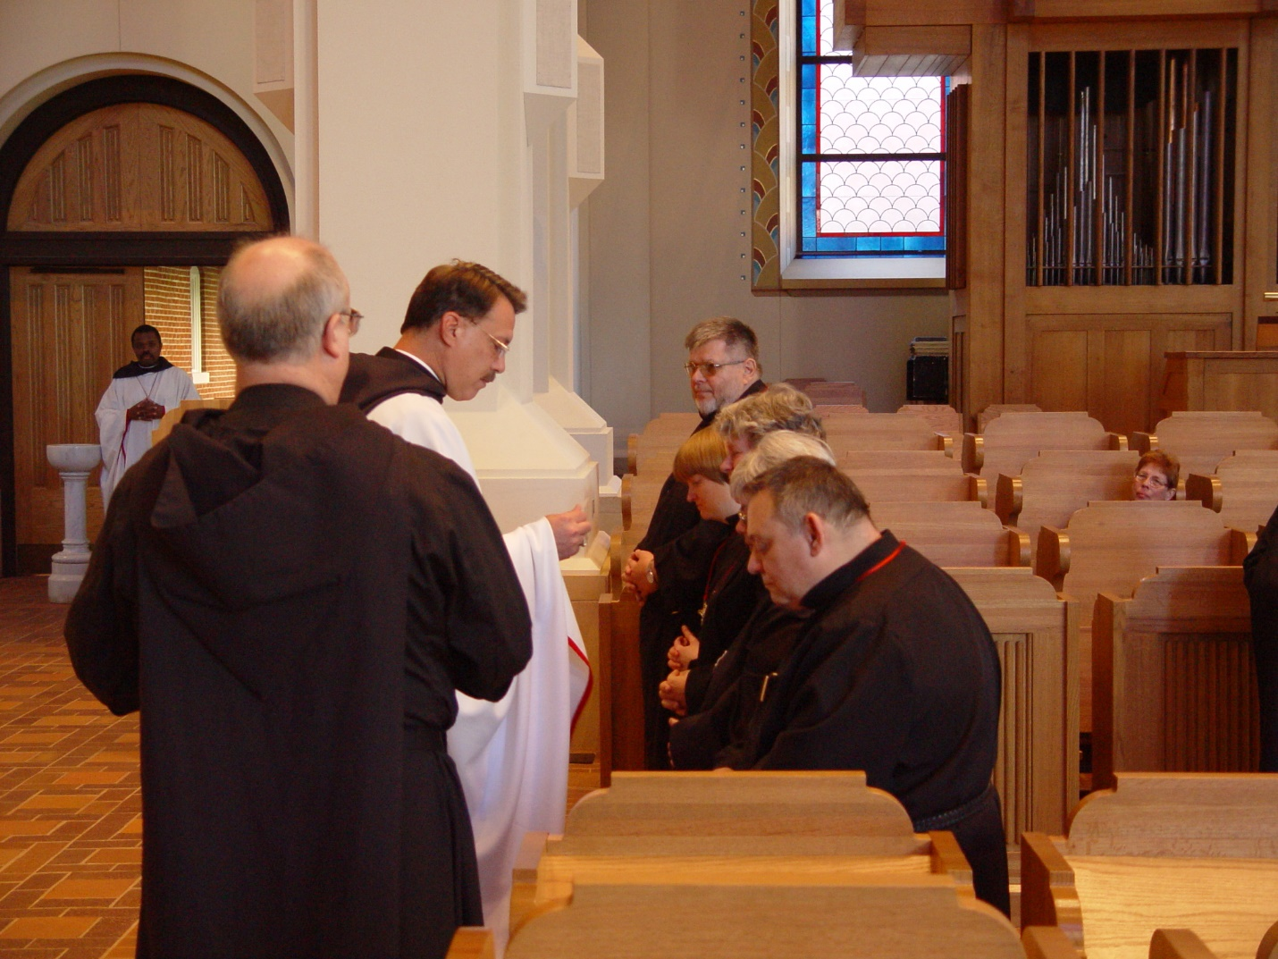

Day 2 Morning 057
Br. Thomas Ferrell; Back to camera: Br. ?; Prior Michael John Ausitn ; Br. Nathan Gregory Miller; Sr. Catherine Unterseher; Sr. ?; Sr. ?; Br. Ambrose Heroux
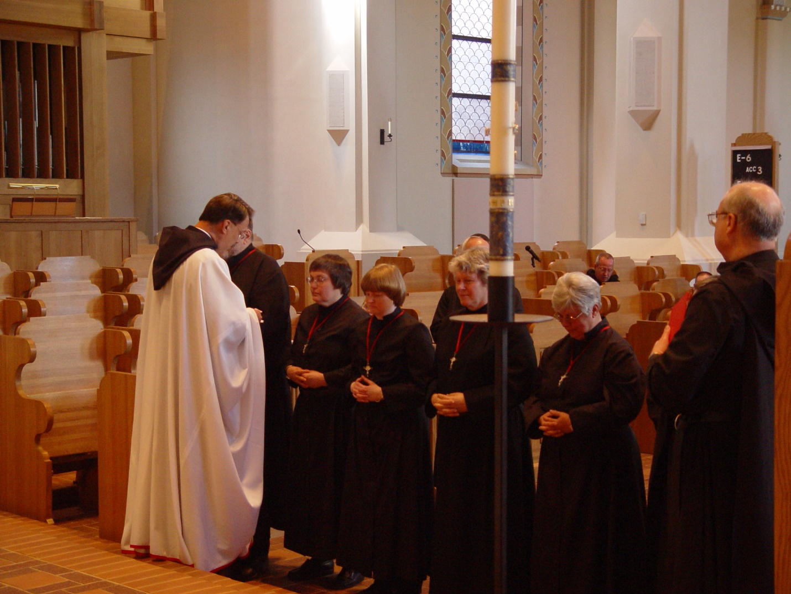

Day 2 Morning 058
Prior Michael John Ausitn; Br. Nathan Gregory Miller; Sr. ?; Sr. Catherine Unterseher; Sr. ?; Sr. ?; Br. Ambrose Heroux; Br. ?

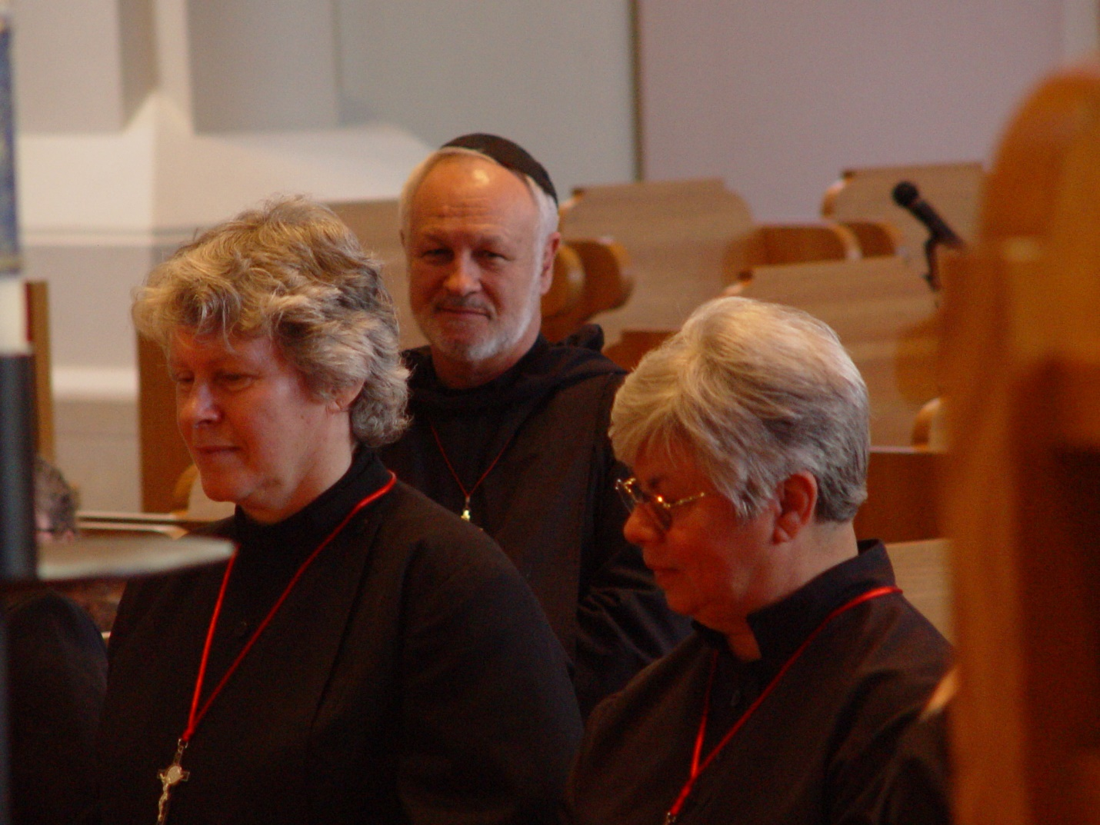

Day 2 Morning 059

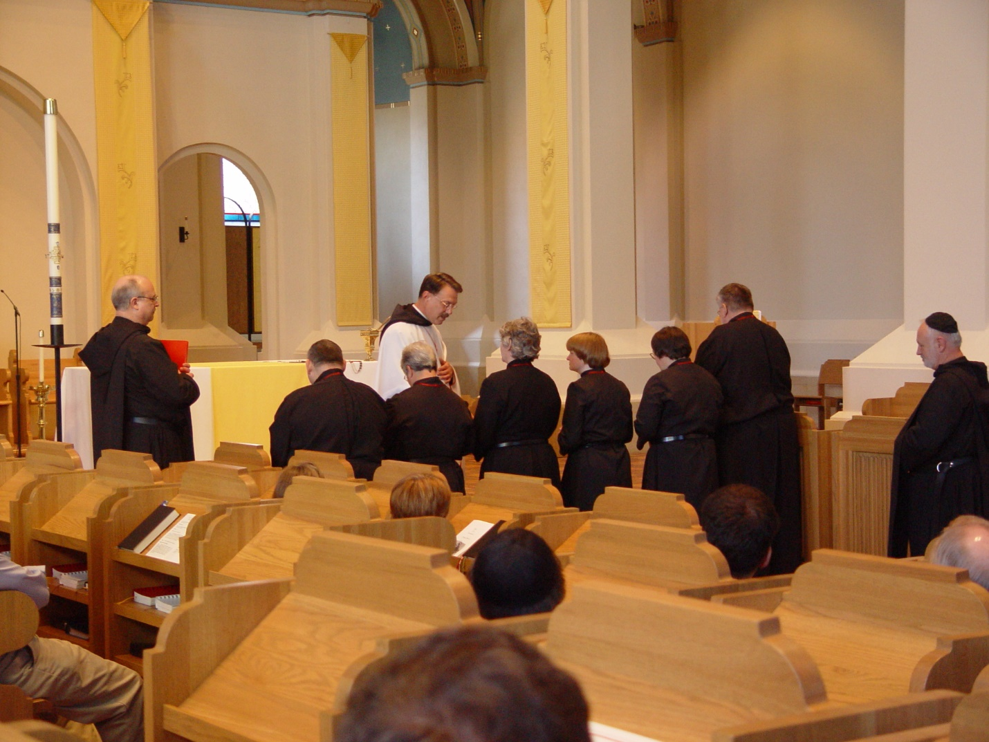

Day 2 Morning 060
Br. ?; Br. Ambrose Heroux; Sr. ?; Prior Michael John Austin; Sr. ?; Sr. ?; Sr. Catherine Unterseher; Sr. ?; Br. Nathan Gregory Miller; guy in skullcap?
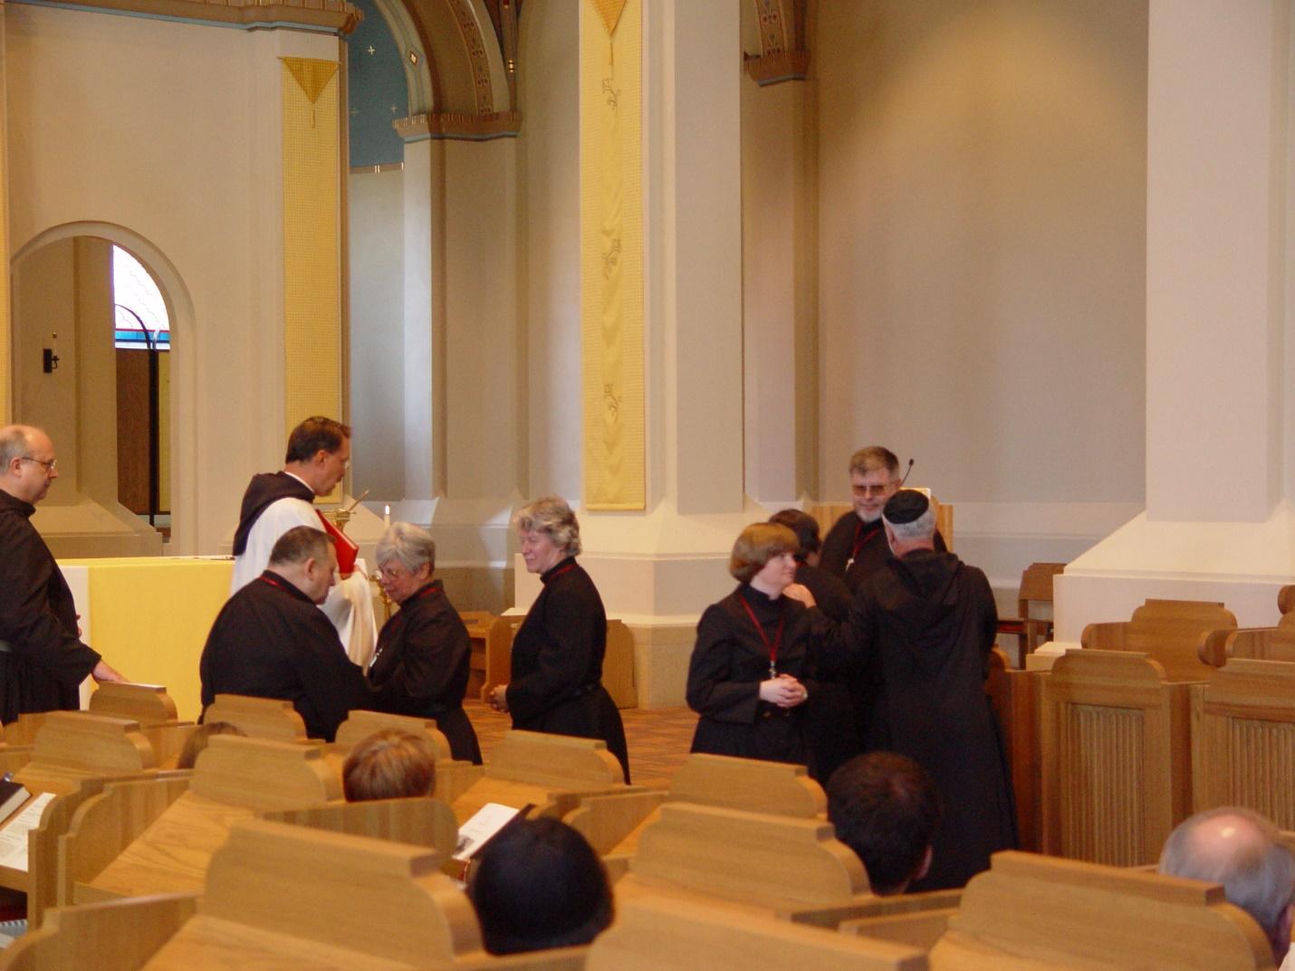

Day 2 Morning 061
Br. ?; Br. Ambrose Heroux; Sr. ?; Prior Michael John Austin; Sr. ?; Sr. ?; Sr. Catherine Unterseher; Sr. ?; Br. Nathan Gregory Miller; guy in skullcap?
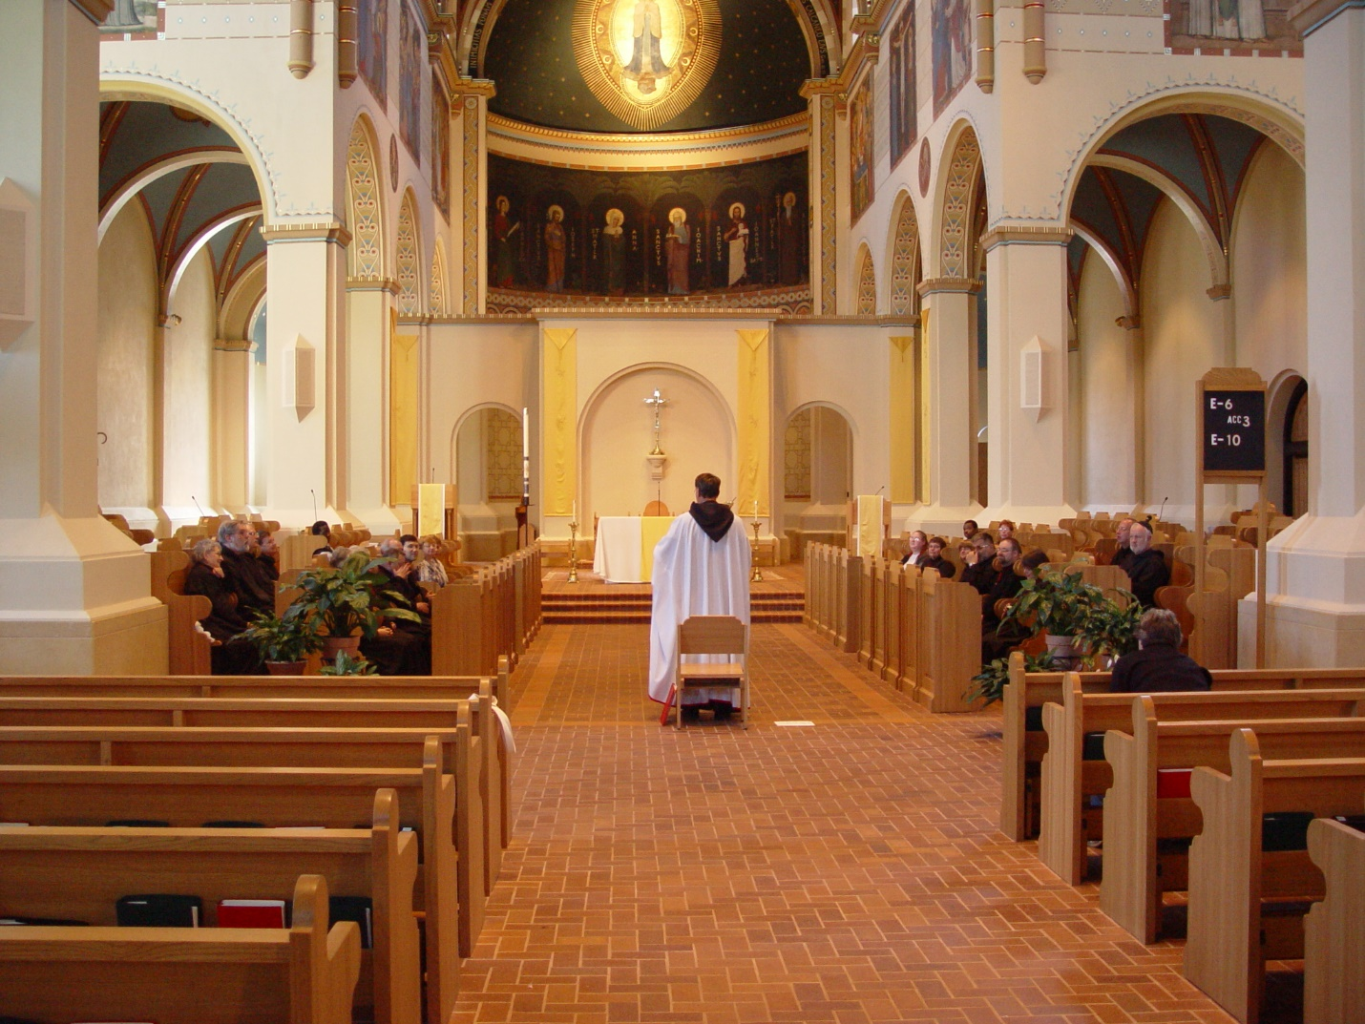

Day 2 Morning 062

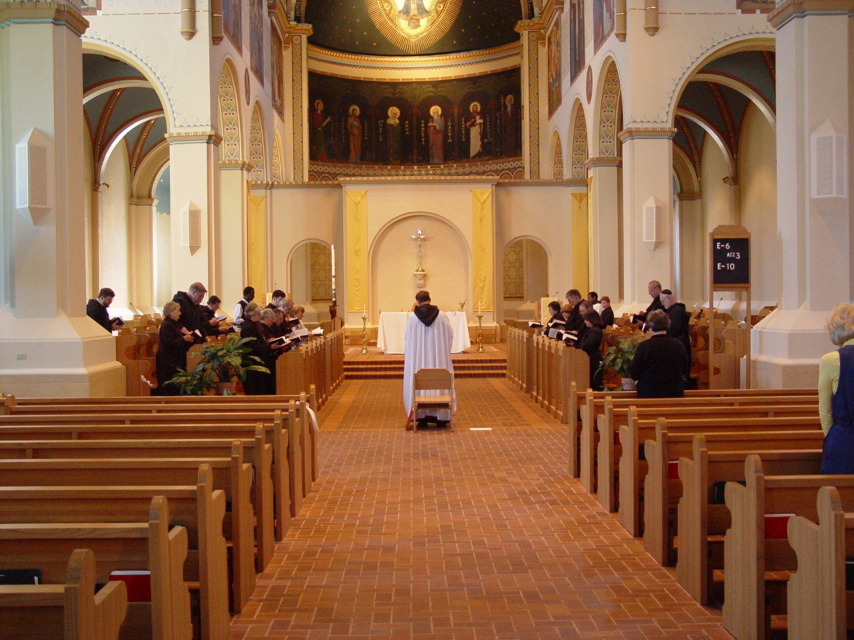

Day 2 Morning 063

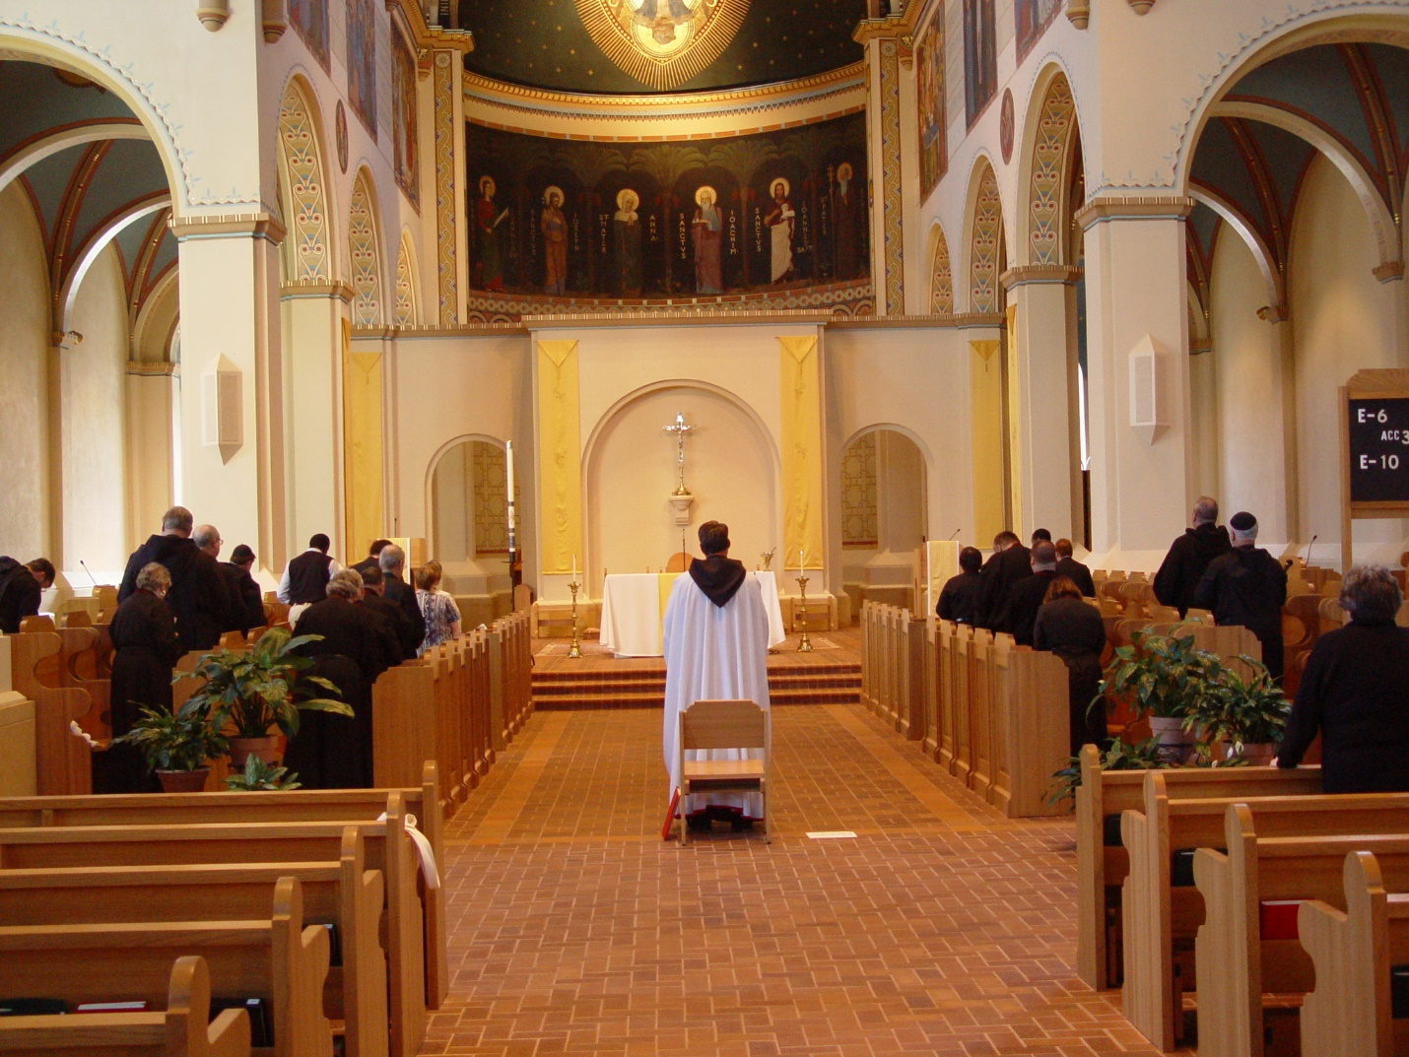

Day 2 Morning 064

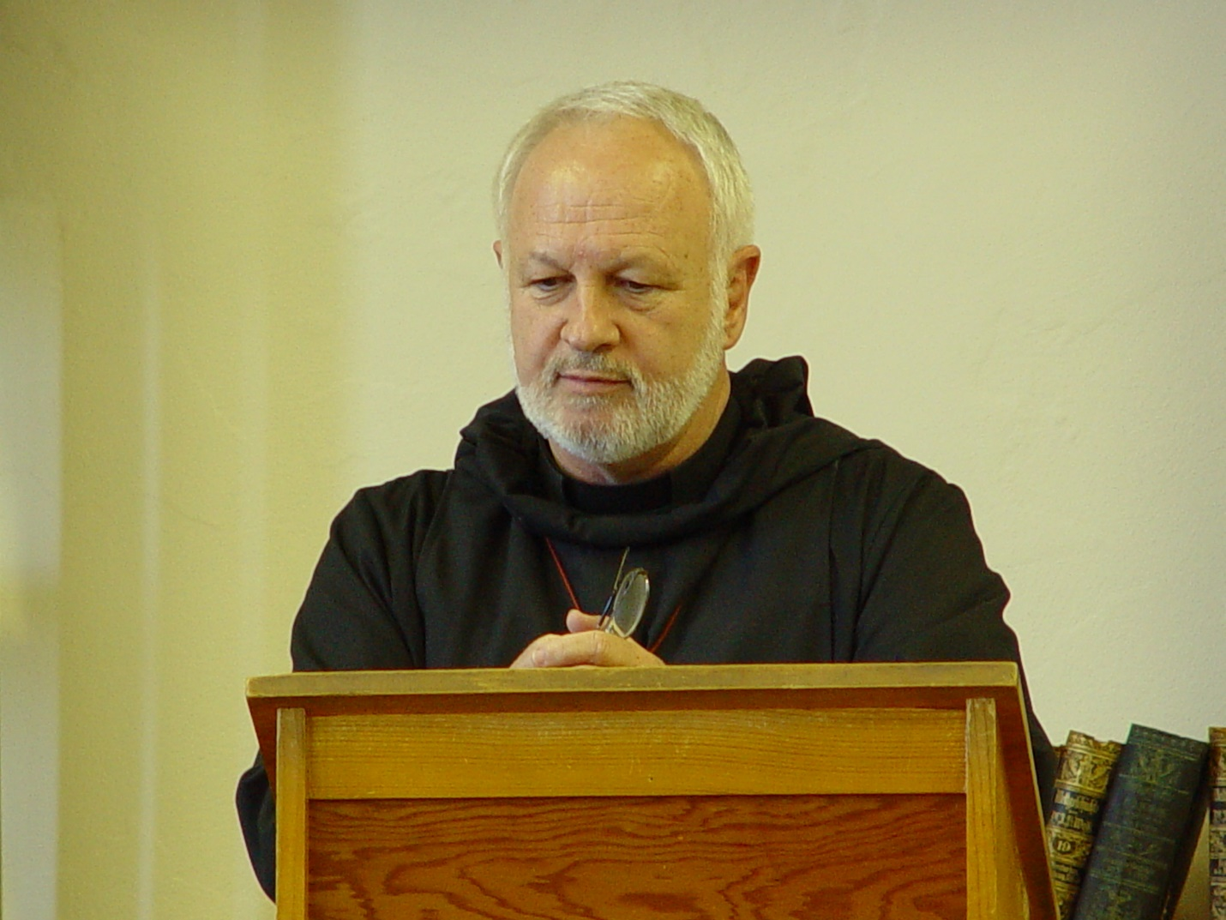

Day 2 Morning 065

