Companions of St. Luke
Spring 2003 Convocation at Conception Abbey
Day 2 PM

~Edited by Br. Steven Olderr, 7 May 2022; most identifications by Br. Thomas Ferrell

Note: People are named from left to right.

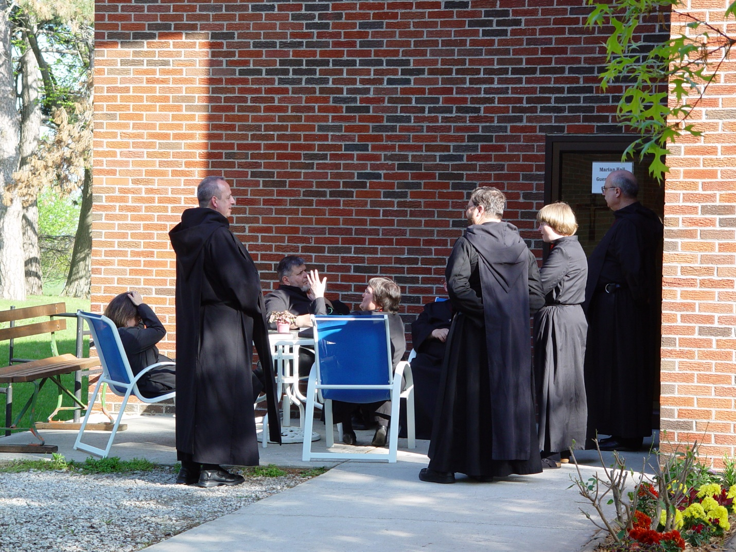

Day 2 PM 001
Sr. Anna Grace Madden; Br. Gabriel Hale, Br. Nathan Gregory Miller, Sr. Theodora of Jesus Perecca; Br. Ambrose Heroux partially obscured); Br. Paul Howard; Sr. Catherine Unterseher; Br. Raymond Owens

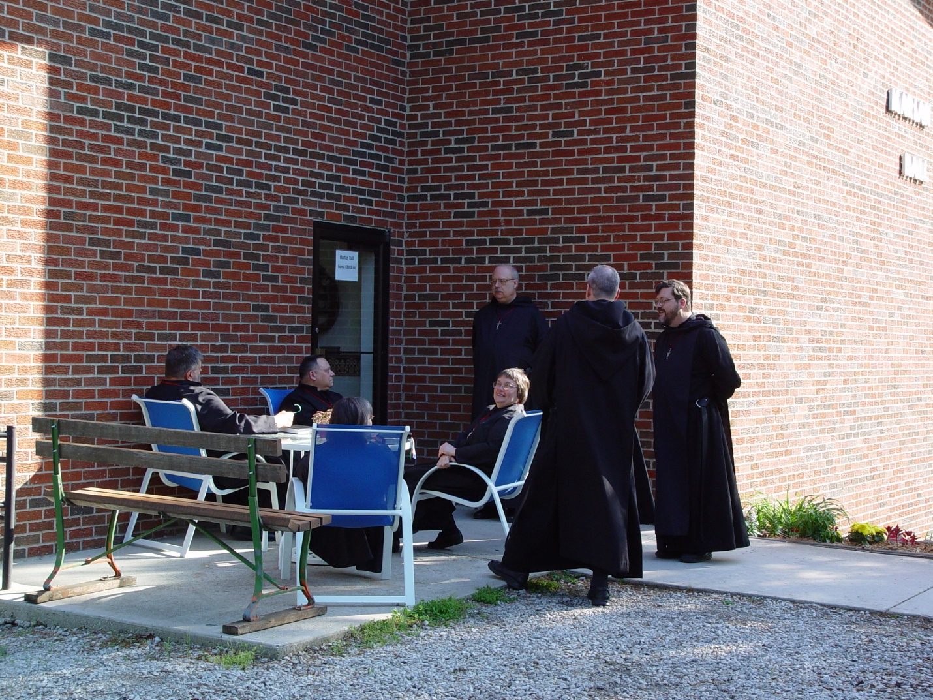

Day 2 PM 002 Br. Nathan Gregory Miller; Br. Ambrose Heroux; Sr. Anna Grace Madden; Sr. Theodora of Jesus Perecca; Br. Raymond Owens; Br. Gabriel Hale; Br. Paul Howard

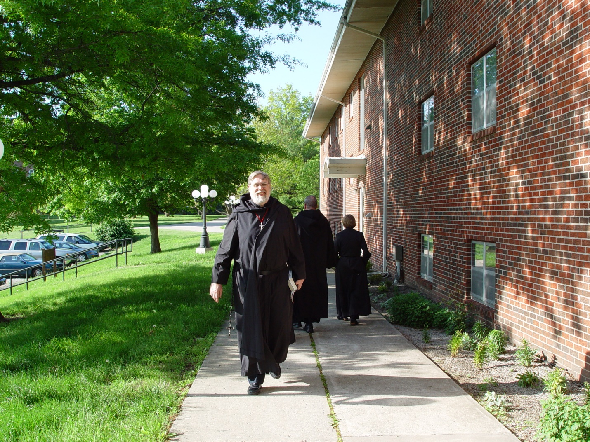

Day 2 PM 003
Br. Chad Anselm Gerns (now Br. David); Br. Gabriel Hale & Sr. Christine Unterseher in the background

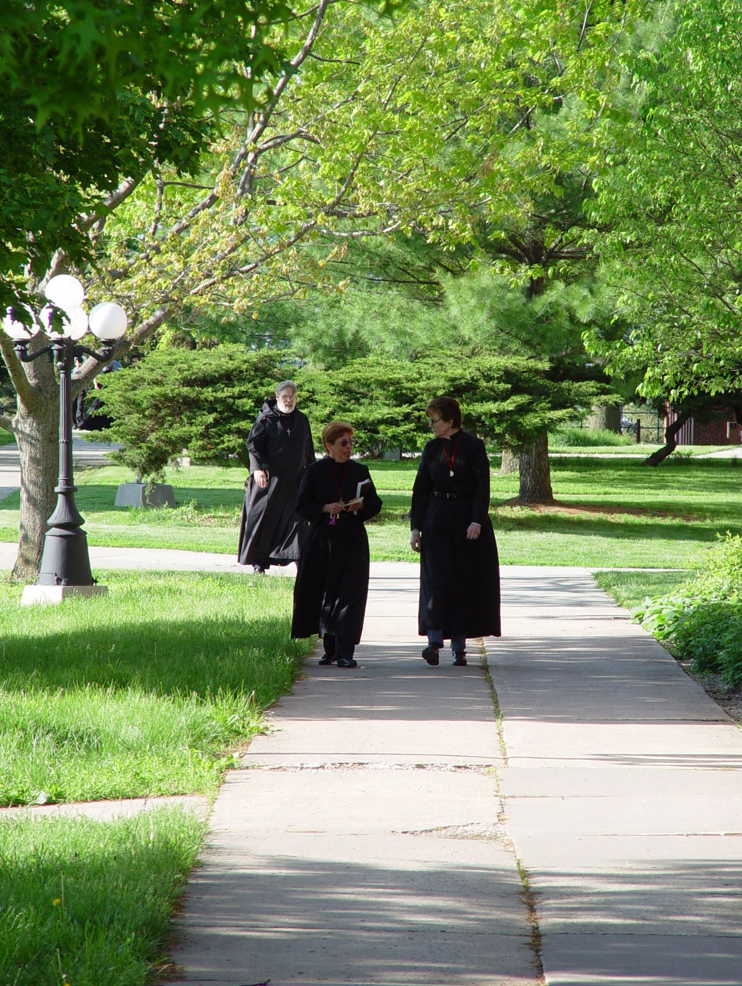

Day 2 PM 004
Foreground: Sr. Monica Ruth Mullen; Sr. Ann Gerns
Background: Br. Chad Anselm Gerns (now Br. David)

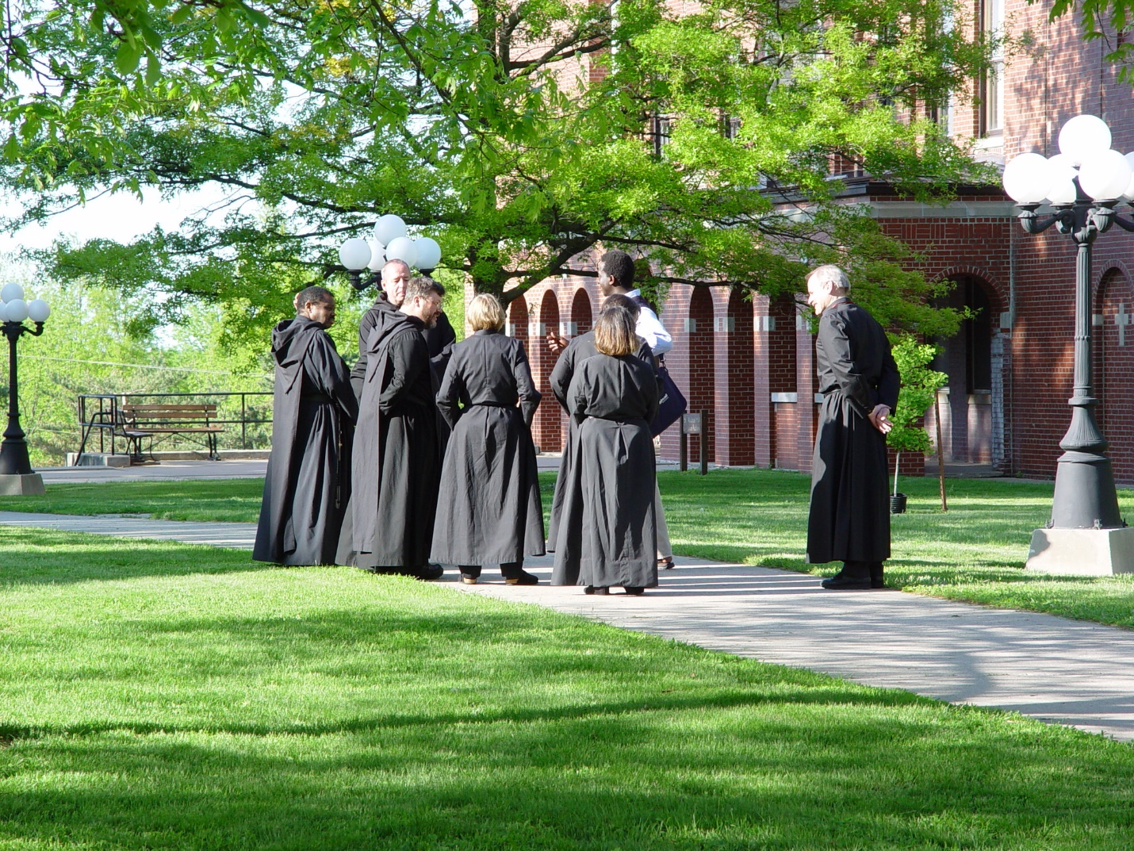

Day 2 PM 005
Br. Thomas Ferrell; Br. Gabriel Hale; Br. Paul Howard; Sr. Catherine Unterseher; Sr. Anna Grace Madden; guest (in civvies); Br. Daniel Joseph Schroeder

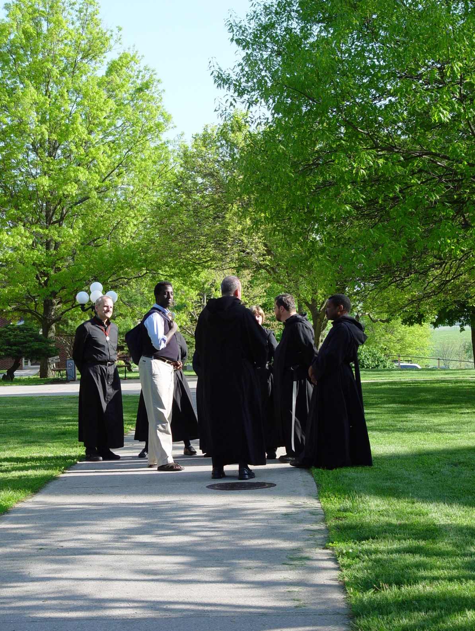

Day 2 PM 006
Br Daniel Joseph Schroeder; guest (in civvies); Br. Gabriel Hale (back to camera); Sr. Catherine Unterseher (partially hidden); Br. Thomas Ferrell
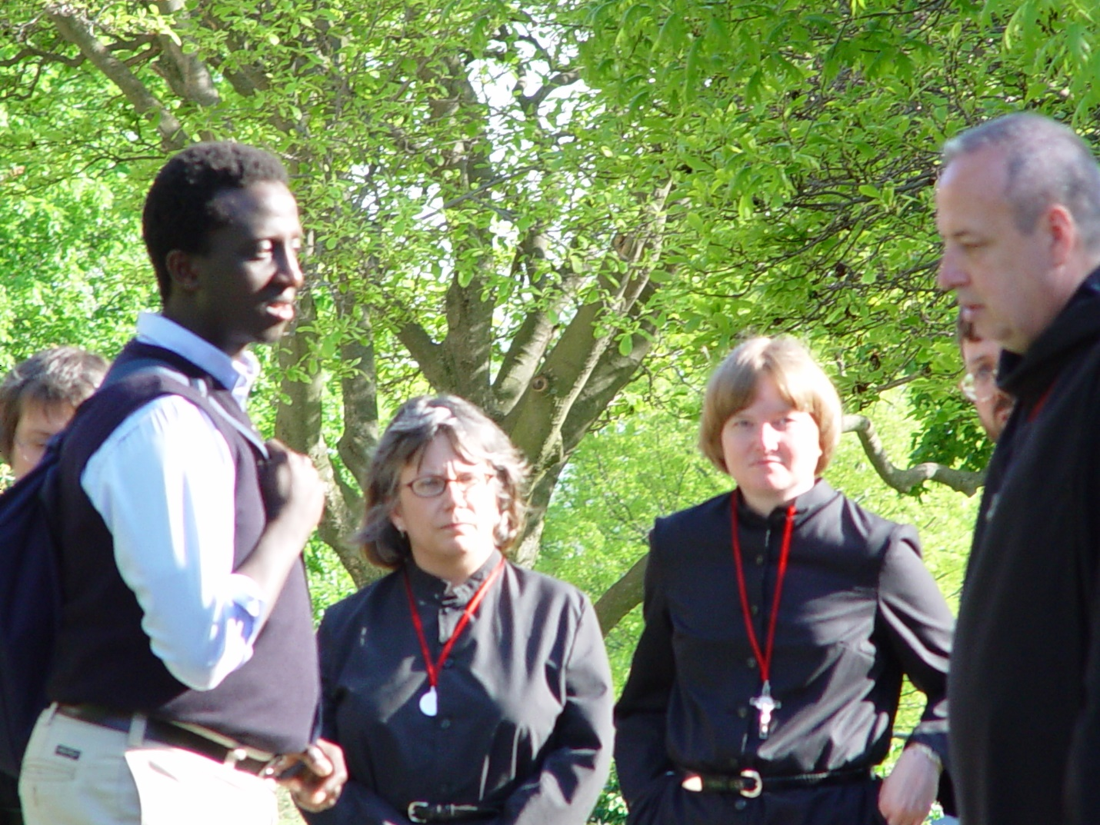

Day 2 PM 007
Sr. Theodora of Jesus Perecca; guest; Sr. Anna Grace Madden; Sr. Catherine Unterseher; Br. Paul Howard(partially hidden); Br. Gabriel Hale

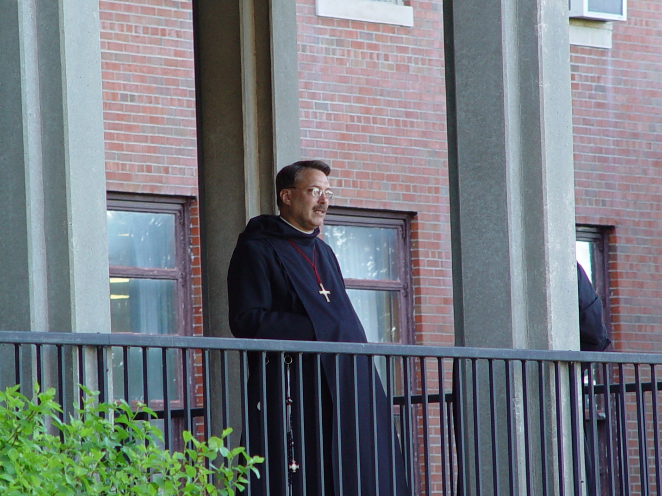

Day 2 PM 008 Prior Michael John Austin

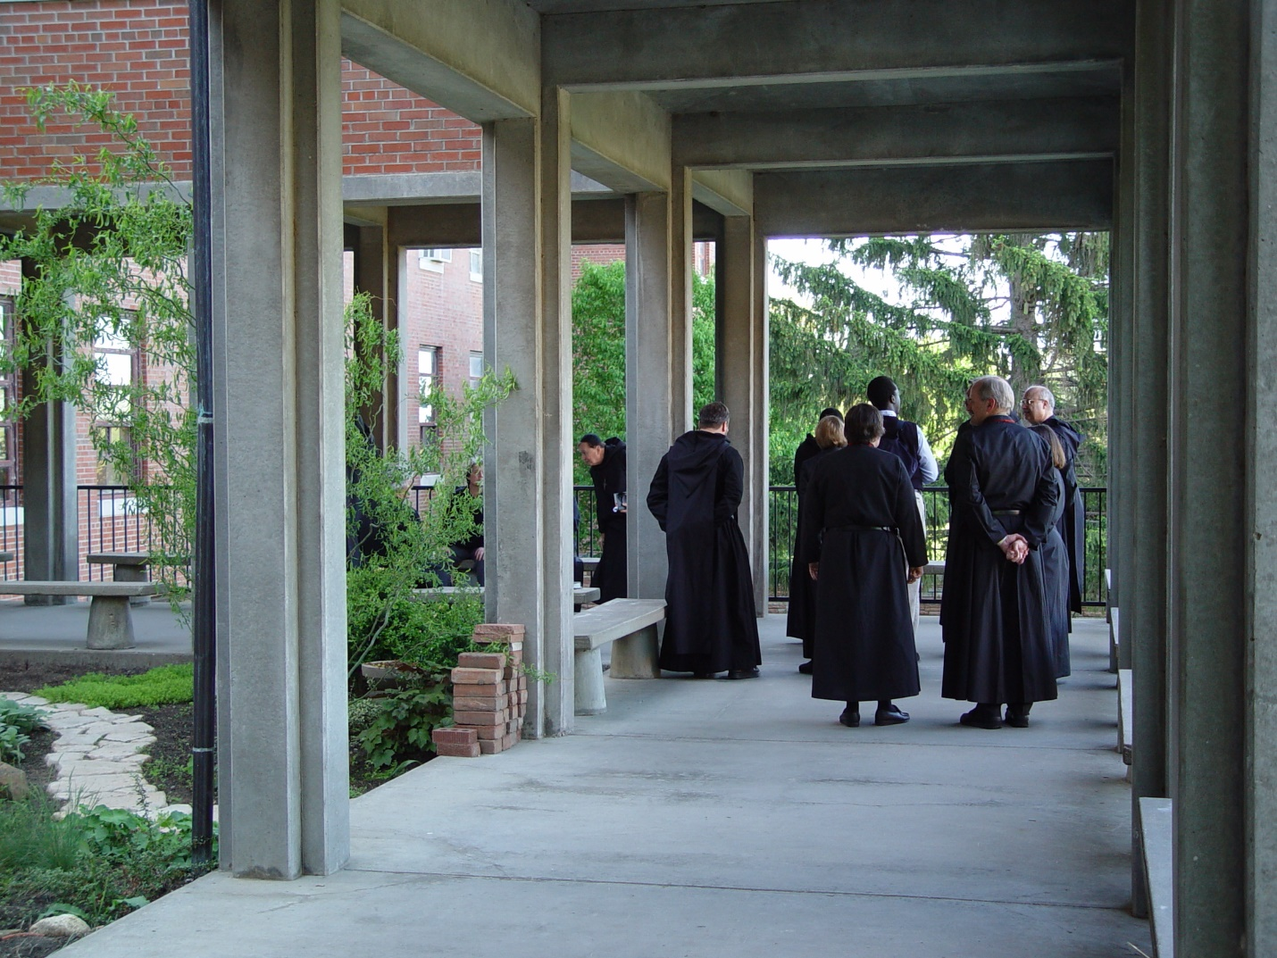

Day 2 PM 009

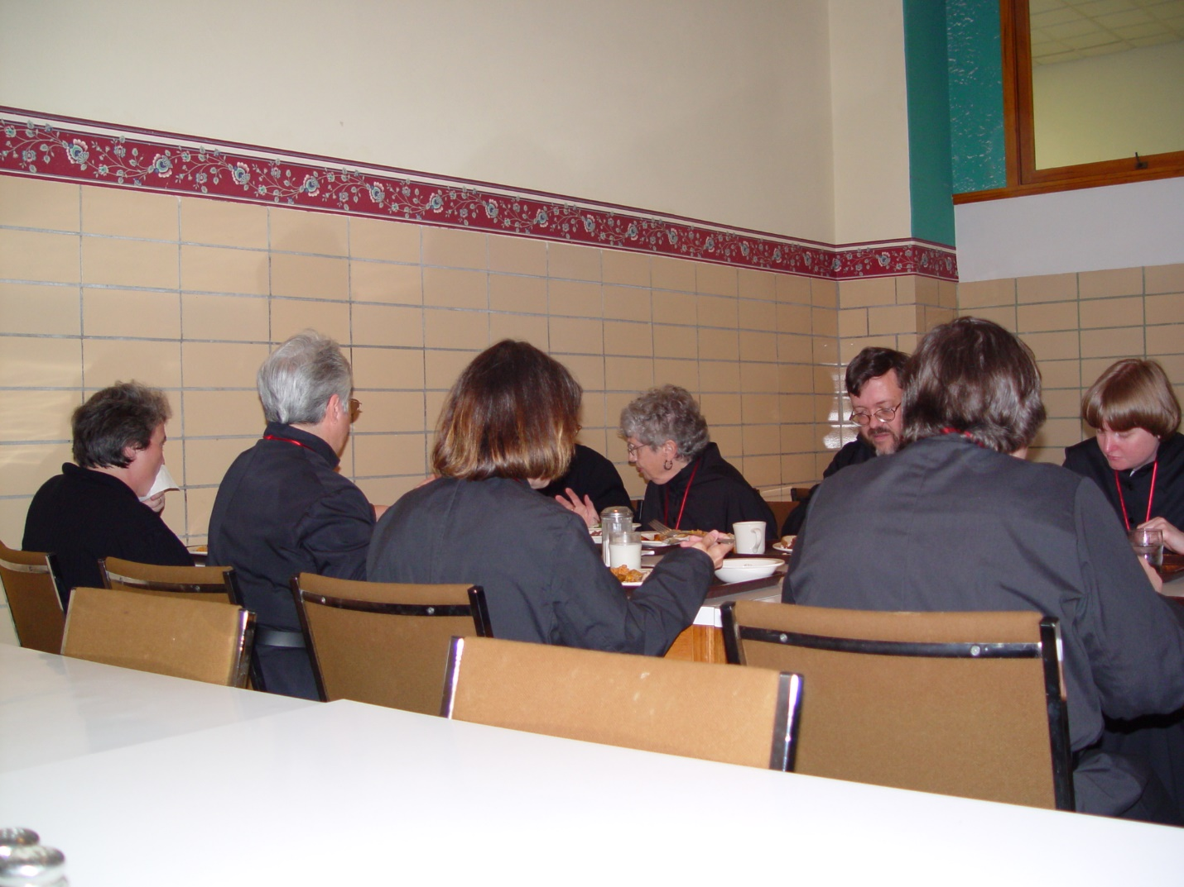

Day 2 PM 010
Back to camera: Sr. Vincent Marie; Sr. Clare Benedicta Meyers; Sr. Ann Gerns; Sr. Pauline
Facing camera: Sr. Joseph Kateri; Br. Paul Howard; Sr. Catherine Unterseher
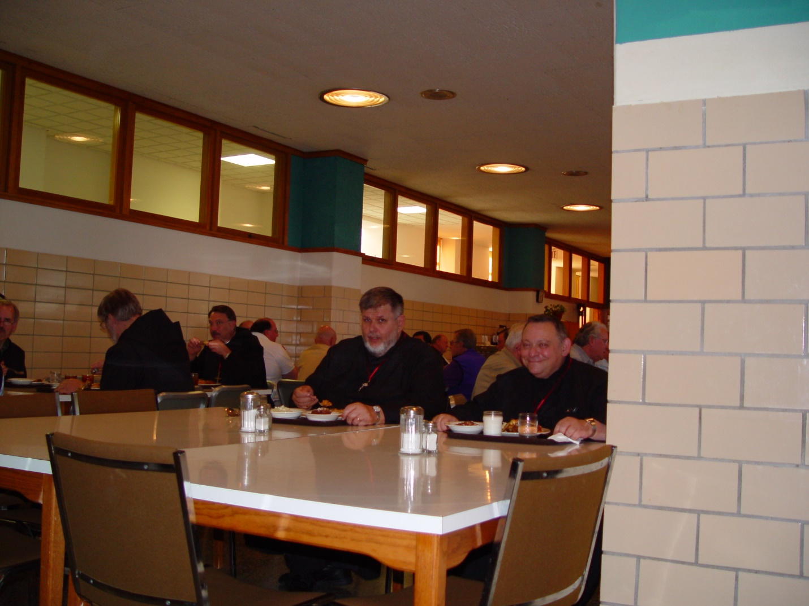

Day 2 PM 011
Foreground: Br. Nathan Gregory Miller; Br. Ambrose Heroux
Background: Br. Chad Anselm Gerns (now Br. David); Prior Michael John Austin

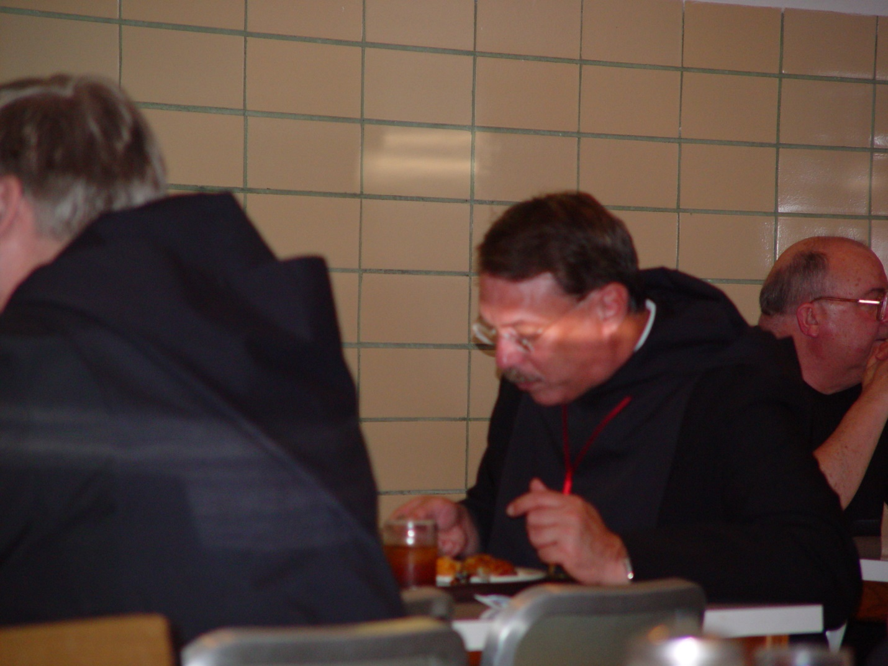

Day 2 PM 012
Br. Chad Anselm Gerns (now Br. David); Prior Michael John Austin

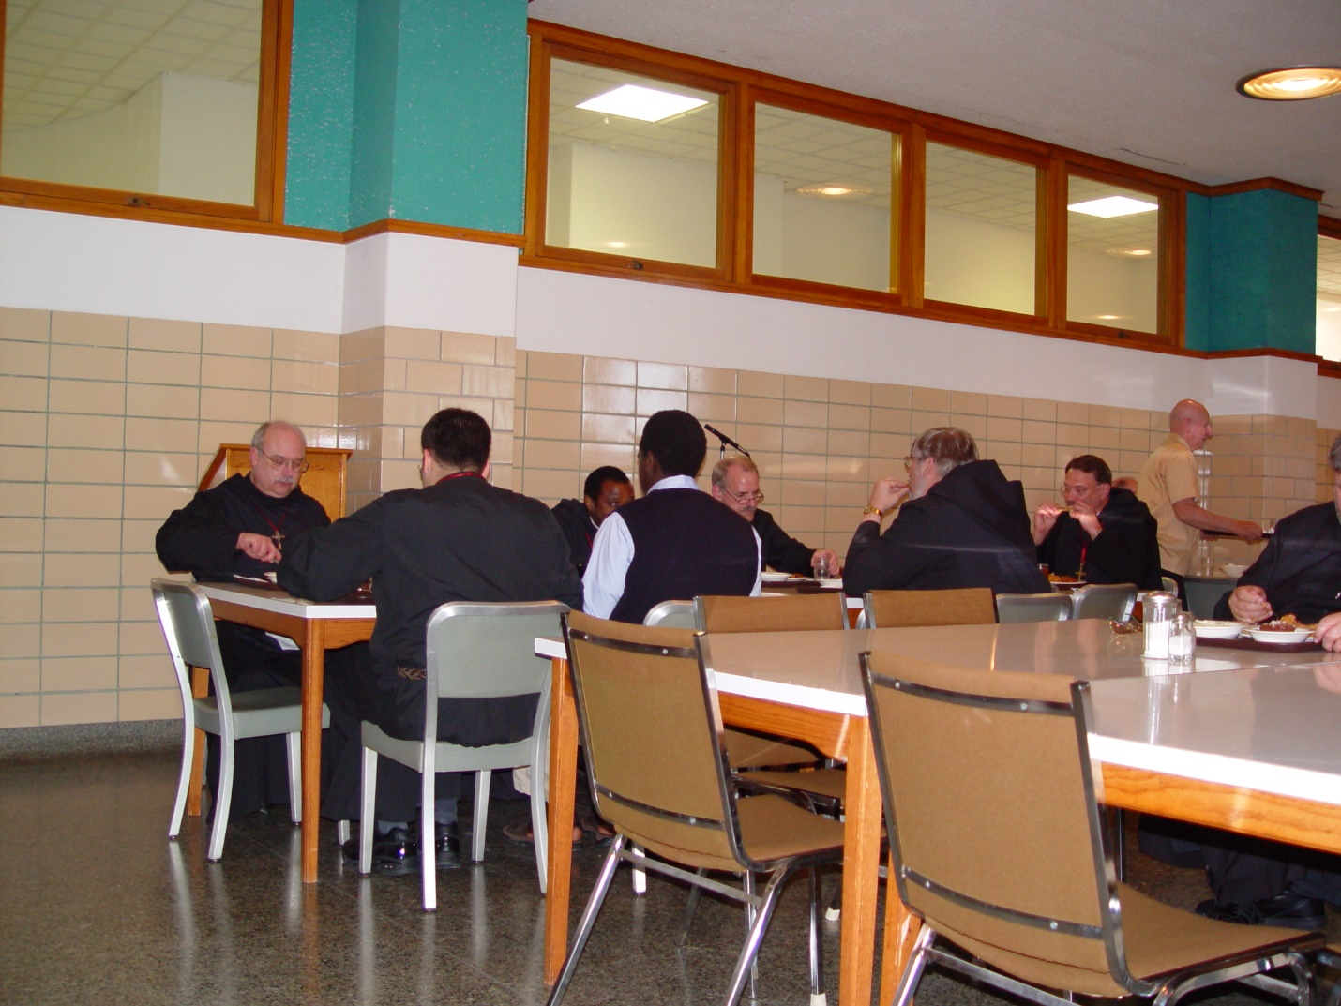

Day 2 PM 013
Backs to camera: Br. Anthony Bernard Campos; guest (in civvies); Br. Chad Anselm Gerns (now Br. David)
Facing camera: Br. Raymond Owens; Br. Thomas Ferrell; Br. Daniel Joseph Schroeder; Prior Michael John Austin
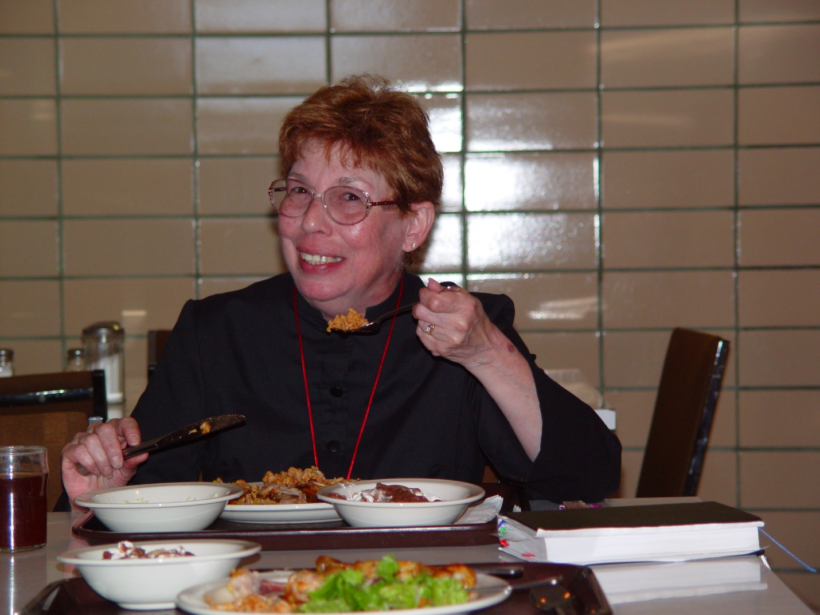

Day 2 PM 014
Sr. Monica Ruth Mullen

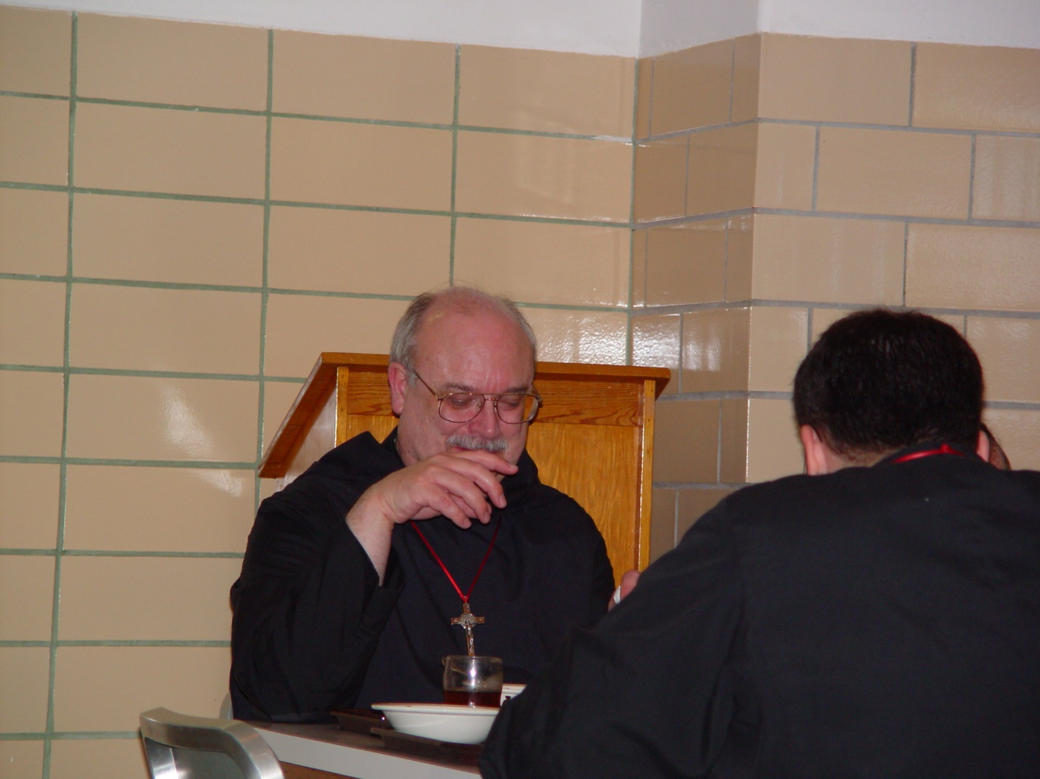

Day 2 PM 015
Br Raymond Owens; Br. Anthony Bernard Campos

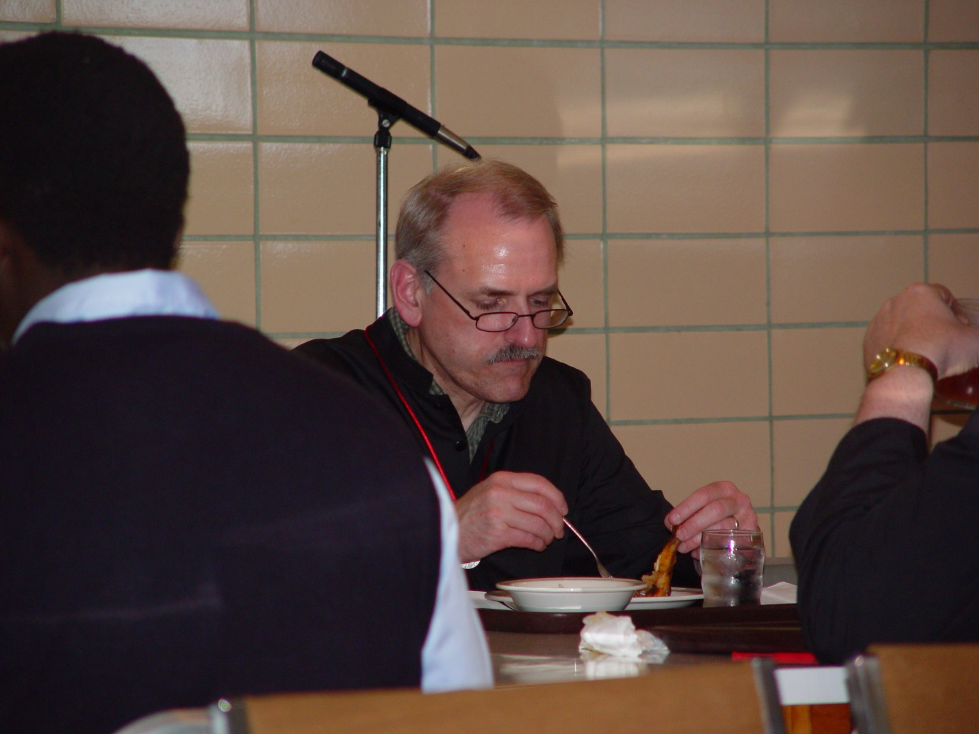

Day 2 PM 016
Br. Daniel Joseph Schroeder

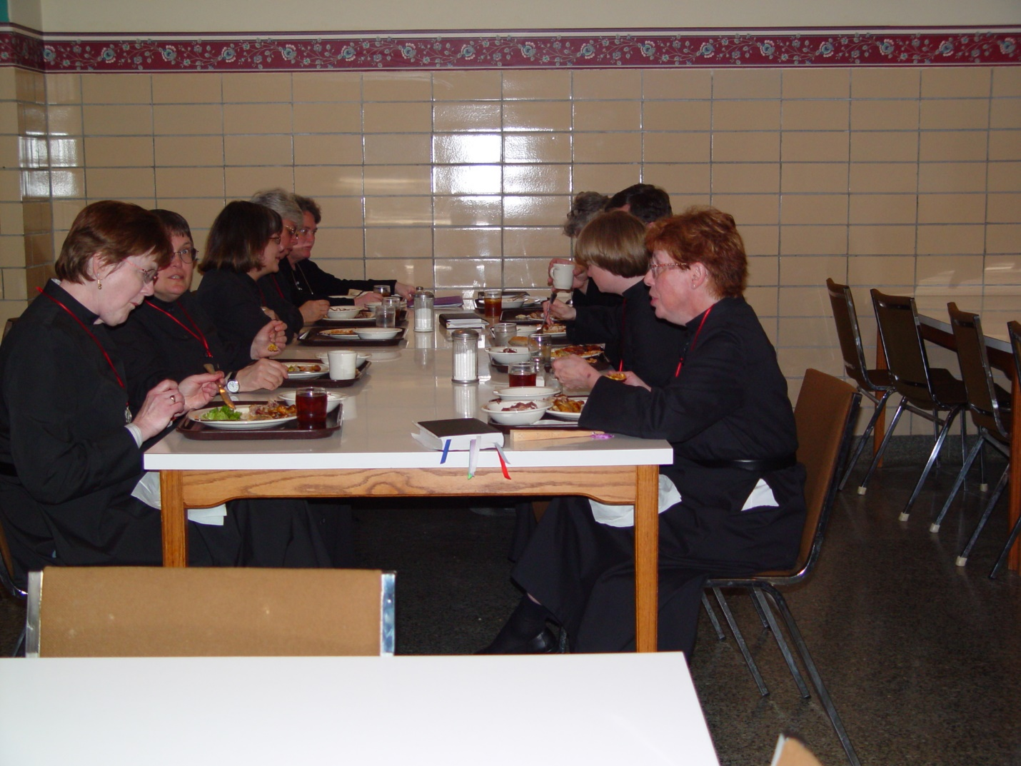

Day 2 PM 017
Left side: Sr. Ann Gerns; Sr. Theodora of Jesus Perecca; Sr. Anna Grace Madden; Sr. Clare Benedicta Meyers; Sr. Vincent Marie
Right side: Sr. Monica Ruth Mullen; Sr. Catherine Unterseher; Br. Anthony Bernard Campos; Sr. Johanna Kirkpatrick
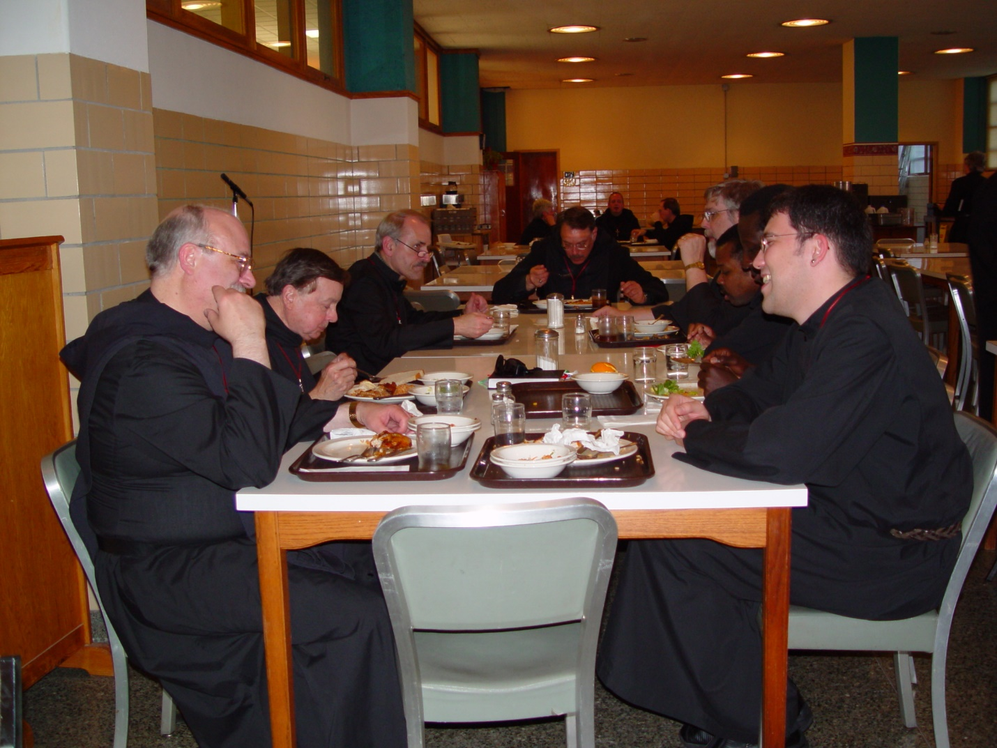

Day 2 PM 018
Left side: Br. Raymond Owens; Br. Matthias Smith; Br. Daniel Joseph Schroeder
Head of table: Prior Michael John Austin
Right side: Br. Anthony Bernard Campos; Br. Thomas Ferrell; Br. Chan Anselm Gerns (now Br. David)

