Companions of St. Luke
Spring 2003 Convocation at Conception Abbey
Day 1

~Edited by Br. Steven Olderr, 8 May 2022; if you find any errors or omissions, please notify Br. Steven at olderr@ameritech.net

Most identifications by Br. Thomas Ferrell. People are named from left to right.


Day 1 001 Br. Nathan Gregory Miller & Sr. Anna Grace Madden

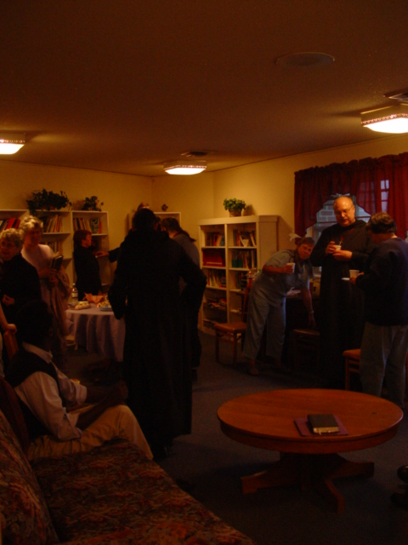
Day 1 002 Too dark for identifications

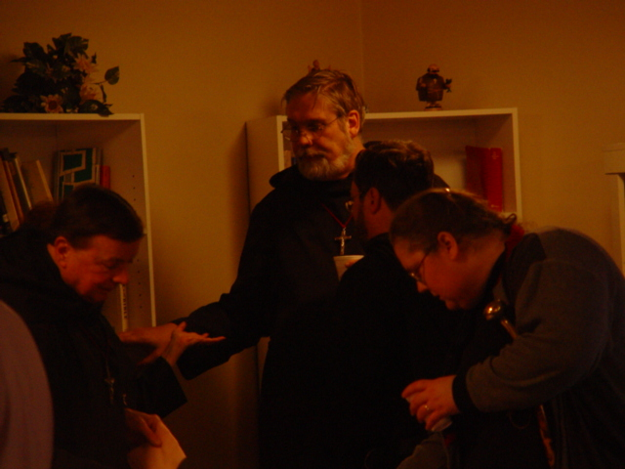
Day 1 003 Br. Matthias Smith; Br. Chad Anselm Gerns (now Br. David); Br. Paul Howard; Sr. Margaret Moore (now Sr. Denise)


Day 1 004
Becky Fredrigill (friend of Lynn and Br. Raymond Owens); Br. Raymond Owens; Sr. Theodora of Jesus Perecca

Day 1 005 Sr. Vincent Marie; Sr. Clare Benedicta Meyers

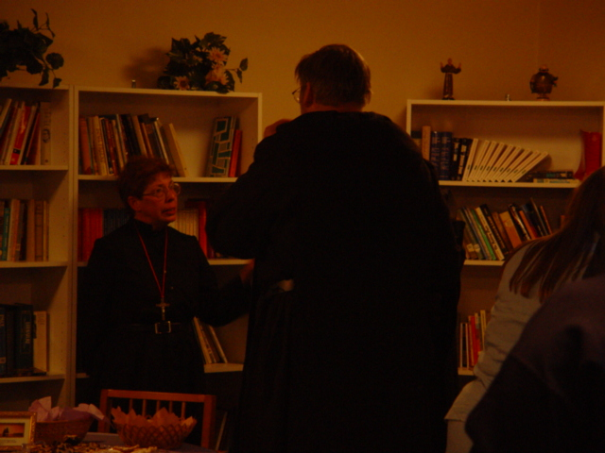

Day 1 006 Sr. Monica Ruth Mullen (given name Judy) and Br. Chad Anselm Gerns (now Br. David)

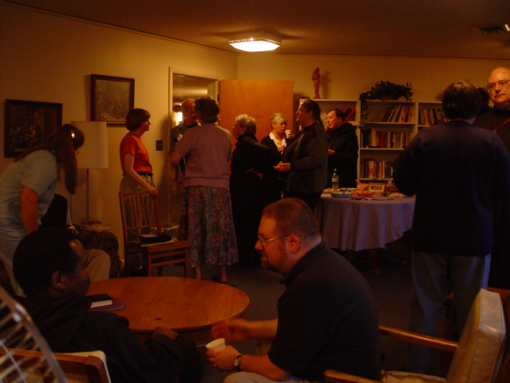
Day 1 007 Foreground: Br. Thomas Ferrell & Willard Moore

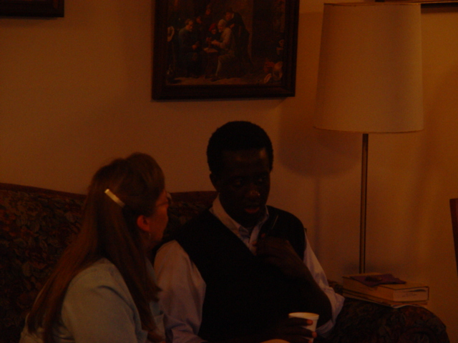
Day 1 008

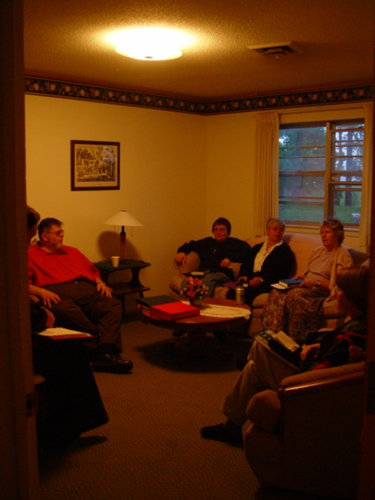

Day 1 009 Br. Nathan Gregory Miller; Sr. Theodora of Jesus Perecca; Sr. Clare Benedicta Meyers; Sr. Johanna Kirkpatrick; Sr. Catherine Unterseher
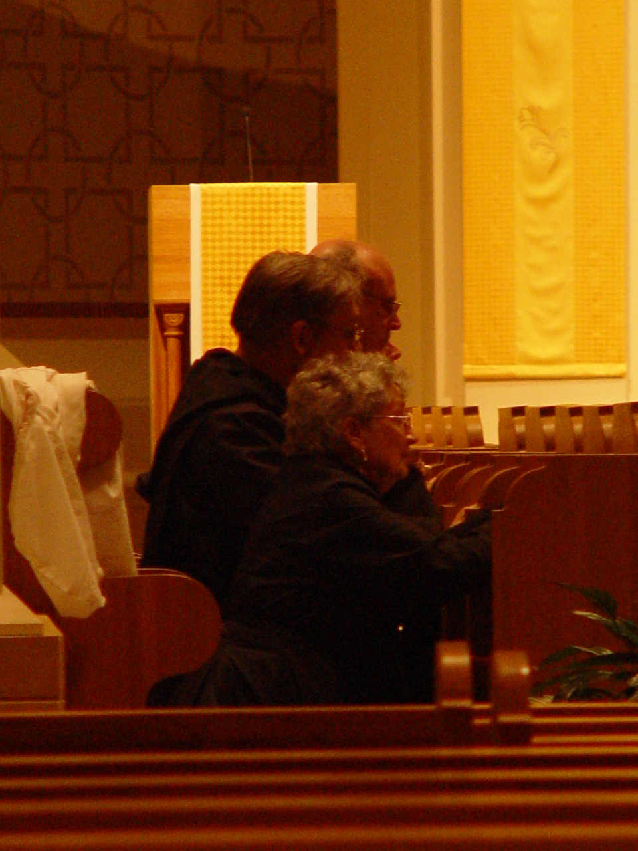
Day 1 010 Sr. Joseph Kateri (Doris Garretson); Br. Chad Anselm Gerns (now Br. David); Br. Raymond Owens

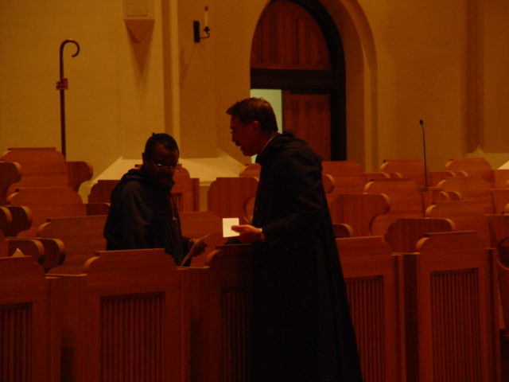

Day 1 011 Br. Thomas Ferrell & Prior Michael John Austin

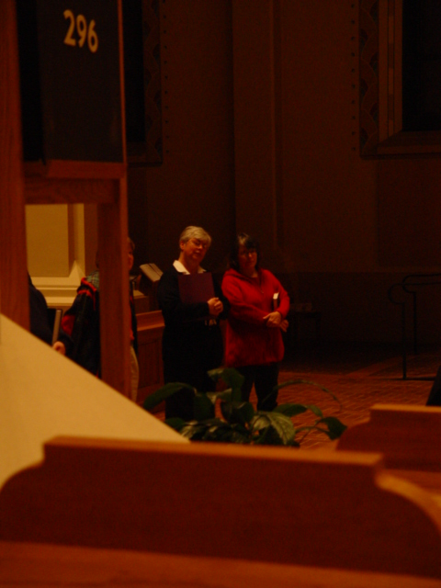

Day 1 012 Sr, Clare Benedicta Meyers & Sr. Anna Grace Madden
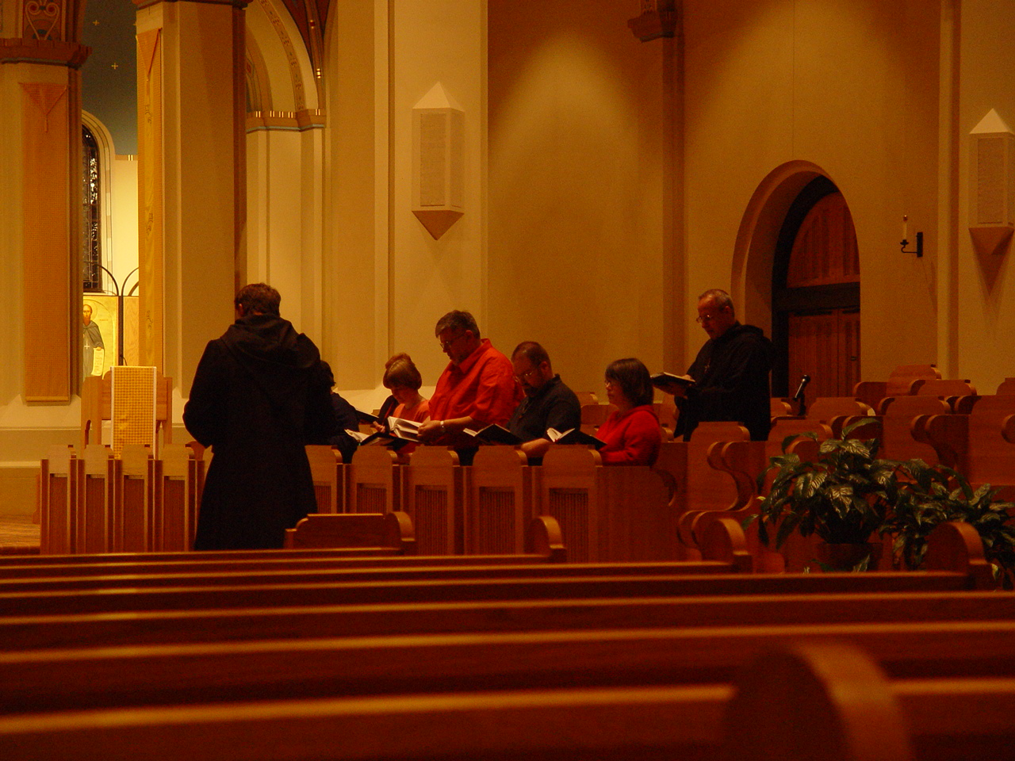

Day 1 013 Prior Michael John Austen with back to camera;
Kneeling: Sr. Theodora of Jesus Perecca; Sr. Catherine Unterseher; Br. Nathan Gregory Miller;
Br. Daniel Moore (now Br. Willard); Sr. Anna Grace Madden

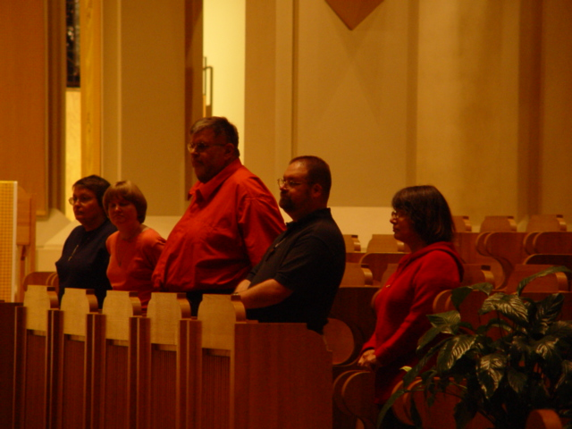

Day 1 014 Sr. Theodora of Jesus Perecca; Sr. Catherine Unterseher; Br. Nathan Gregory Miller;
Br. Daniel Moore (now Br. Willard); Sr. Anna Grace Madden

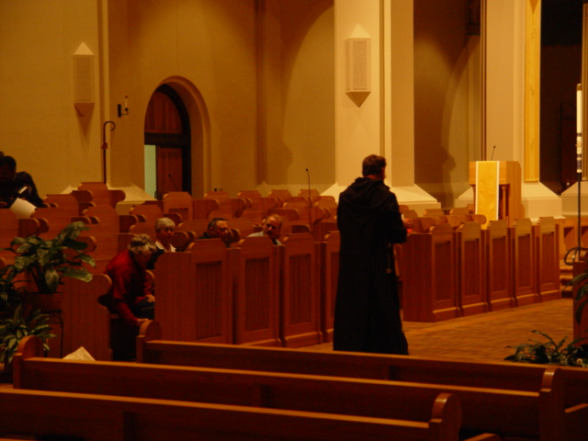

Day 1 015 Prior Michael John Austin

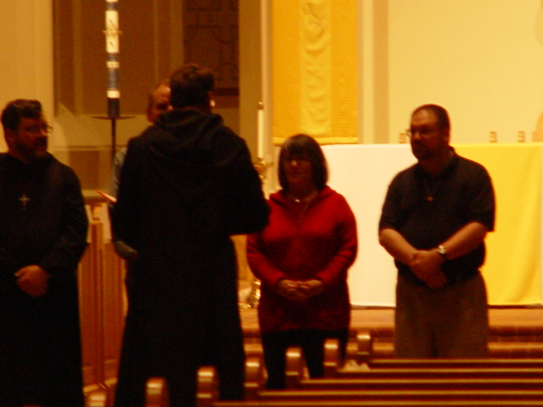

Day 1 016 Prior Michael John Austin with back to camera; Facing camera Br. Paul Howard; Br. Daniel Joseph Schroeder; Sr. Anna Grace Madden; Br. Daniel Moore (now Br. Willard)

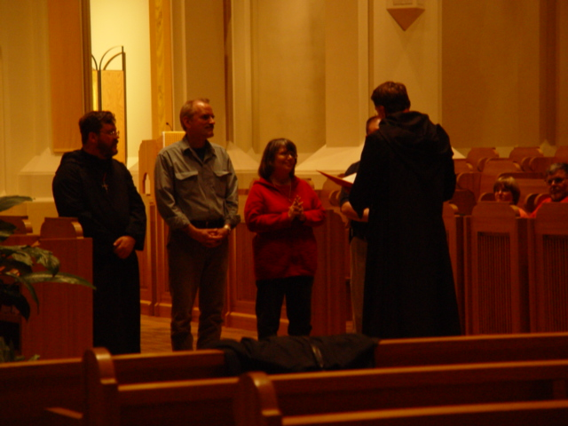

Day 1 017 Back to camera: Prior Michael John Austin; Facing camera: Br. Paul Howard; Br. Daniel Joseph Schroeder; Sr. Anna Grace Madden; Br. Daniel Moore (now Br. Willard)

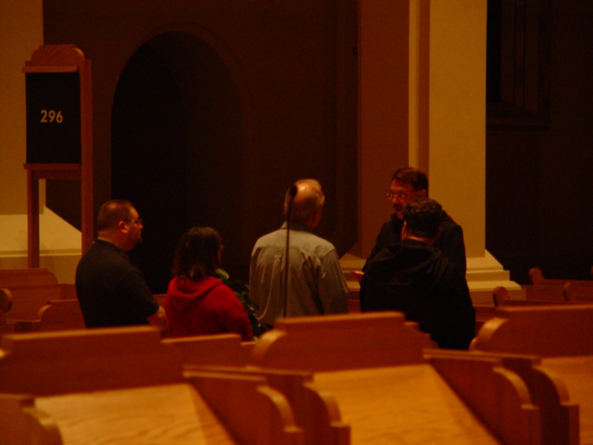

Day 1 018 Facing camera: Prior Michael John Austin; Backs to camera: Br. Daniel Moore (now Br. Willard); Sr. Anna Grace Madden; Br. Daniel Joseph Schroeder; Br. Paul Howard
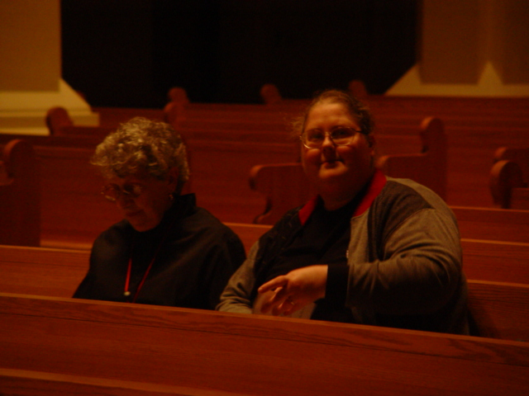

Day 1 019 Sr. Joseph Kateri (Doris Garretson); Sr. Margaret Moore (now Sr. Denise)

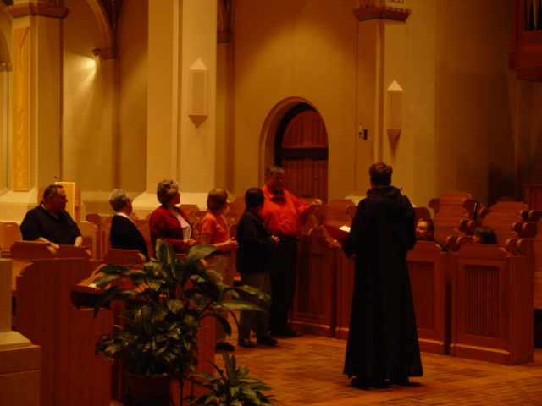

Day 1 020 Back to camera: Prior Michael John Austin;
Facing camera: Br. Ambrose Heroux; Sr. Clare Benedicta Meyers; Sr. Johanna Kirkpatrick; Sr. Theodora of Jesus Perecca; Br. Nathan Gregory Miller; Br. Daniel Moore (now Br. Willard)

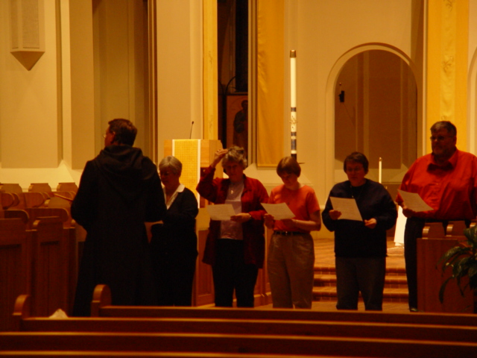

Day 1 021 Back to camera: Prior Michael John Austin; Facing camera: Sr. Clare Benedicta Meyers; Sr. Johanna Kirkpatrick; Sr. Catherine Unterseher; Sr. Theodora of Jesus Perecca; Br. Nathan Gregory Miller

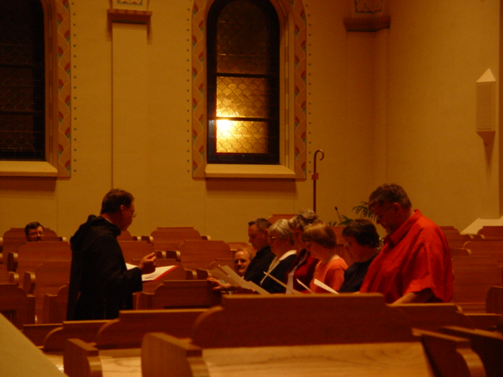

Day 1 022 Prior Michael John Austin; Br. Paul Howard; Br. Daniel Joseph; Br. Ambrose Heroux; Sr. Clare Benedicta Meyers; Sr. Johanna Kirkpatrick; Sr. Catherine Unterseher; Sr. Theodora Perecca; Br. Nathan Gregory Miller

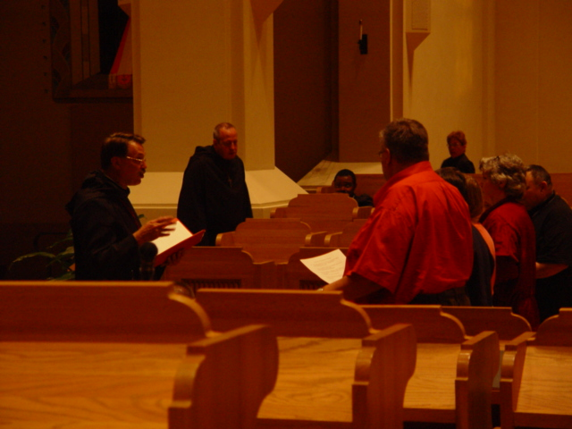

Day 1 023 Prior Michael John Austin; Br. Gabriel Hale; Br. Thomas Ferrell; Sr. Monica Ruth Mullen; Br. Ambrose Heroux; Sr. Johanna Kirkpatrick; Sr. Catherine Unterseher; Sr. Theodora of Jesus Perecca; Br. Nathan Gregory Miller

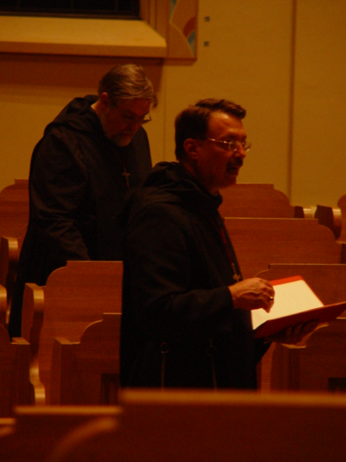

Day 1 024 Foreground: Prior Michael John Austin; Background: Br. Chad Anselm Gerns (now Br. David)

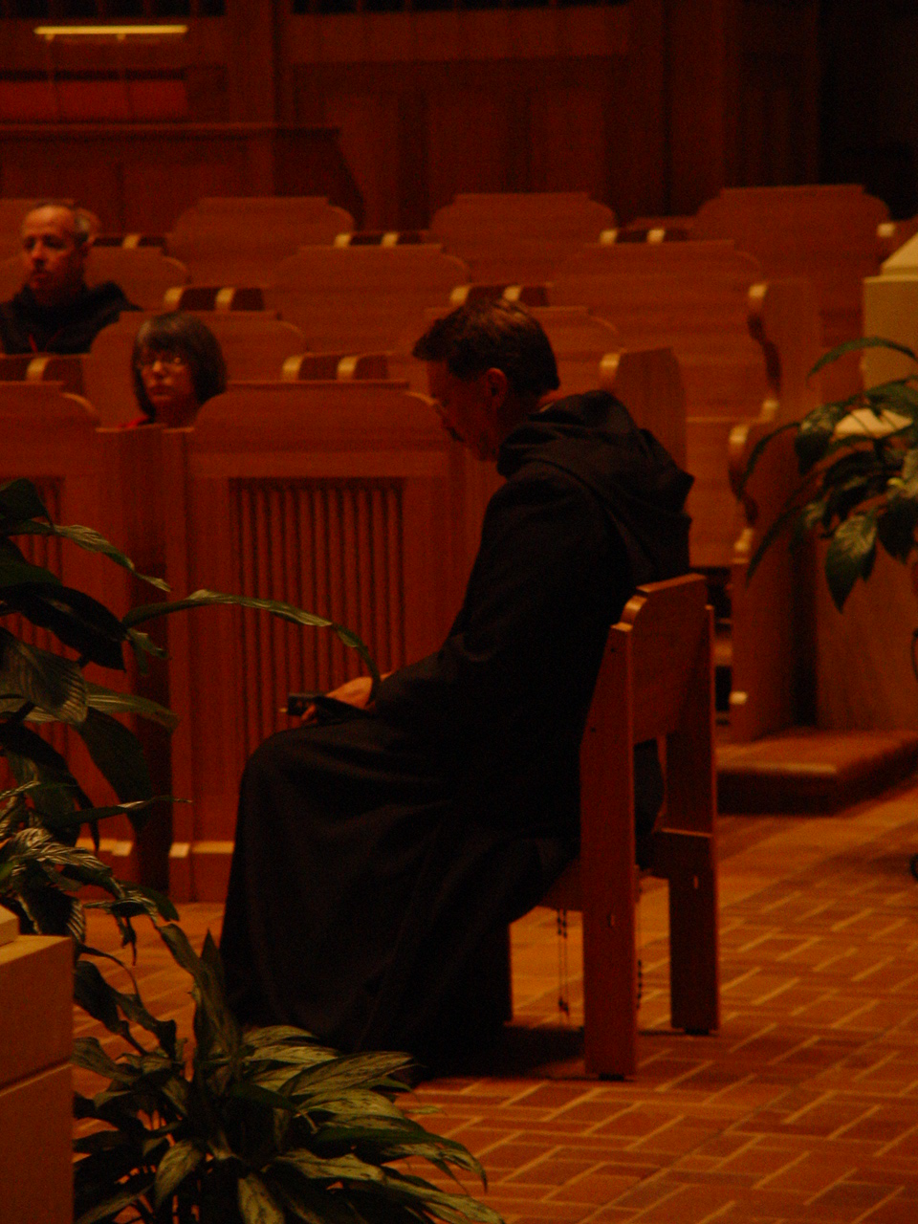

Day 1 025 Br. Gabriel Hale; Sr. Anna Grace Madden; Prior Michael John Austin

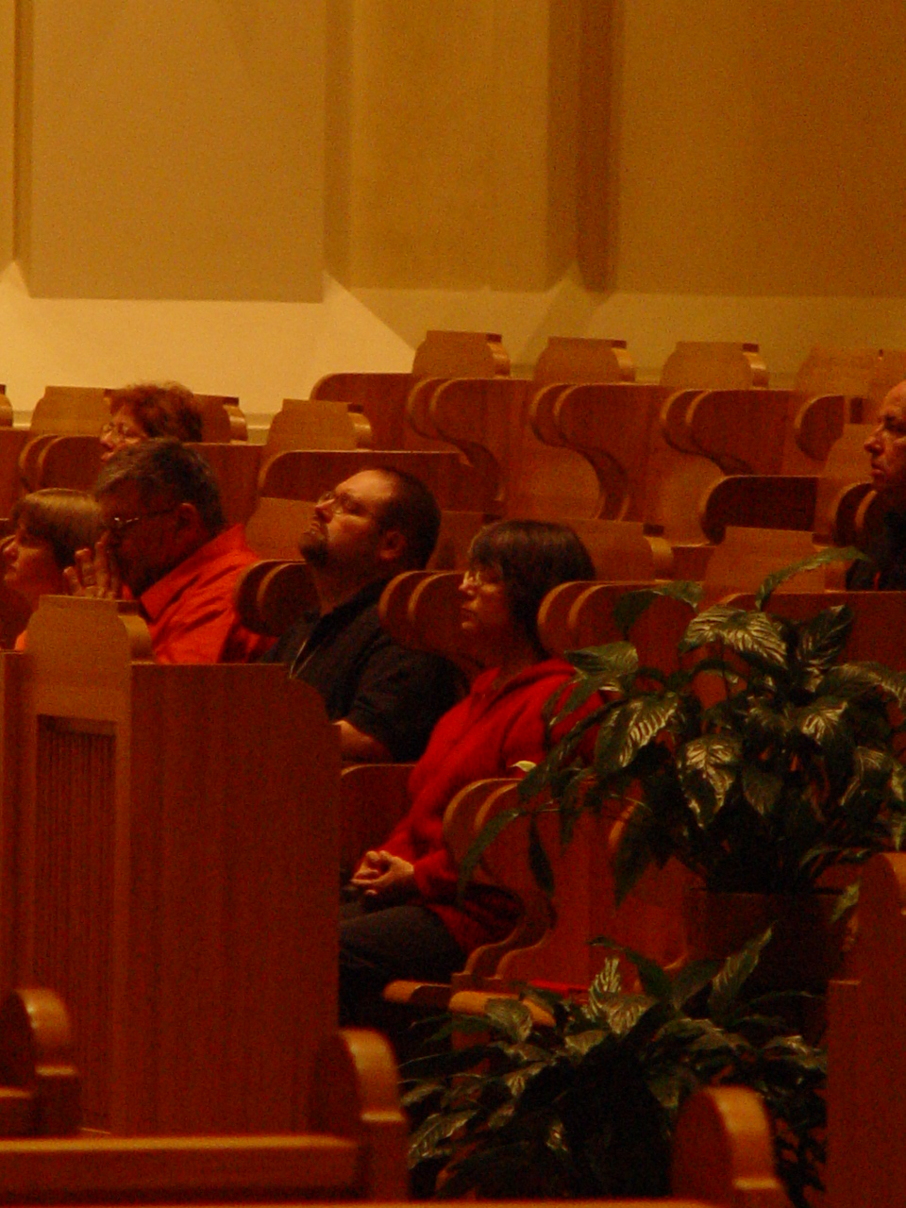

Day 1 026 Front row: Sr. Catherine Unterseher; Br. Nathan Gregory Miller; Br. Daniel Moore (now Br. Willard); Sr. Anna Grace Madden
Back row: St. Monica Ruth Mullen
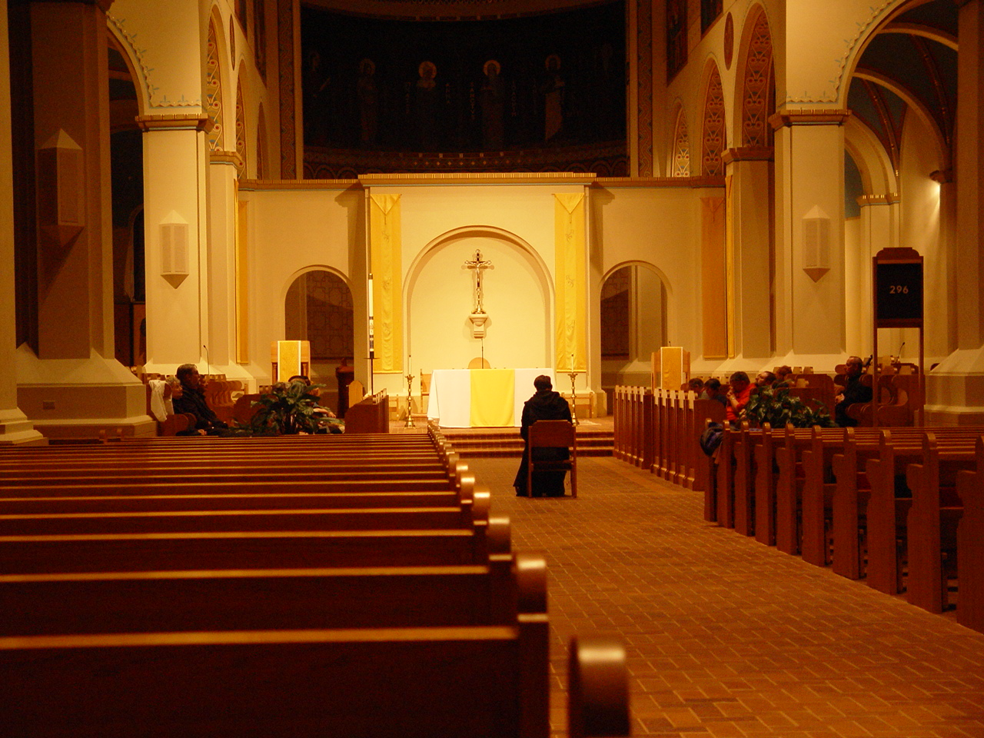

Day 1 027

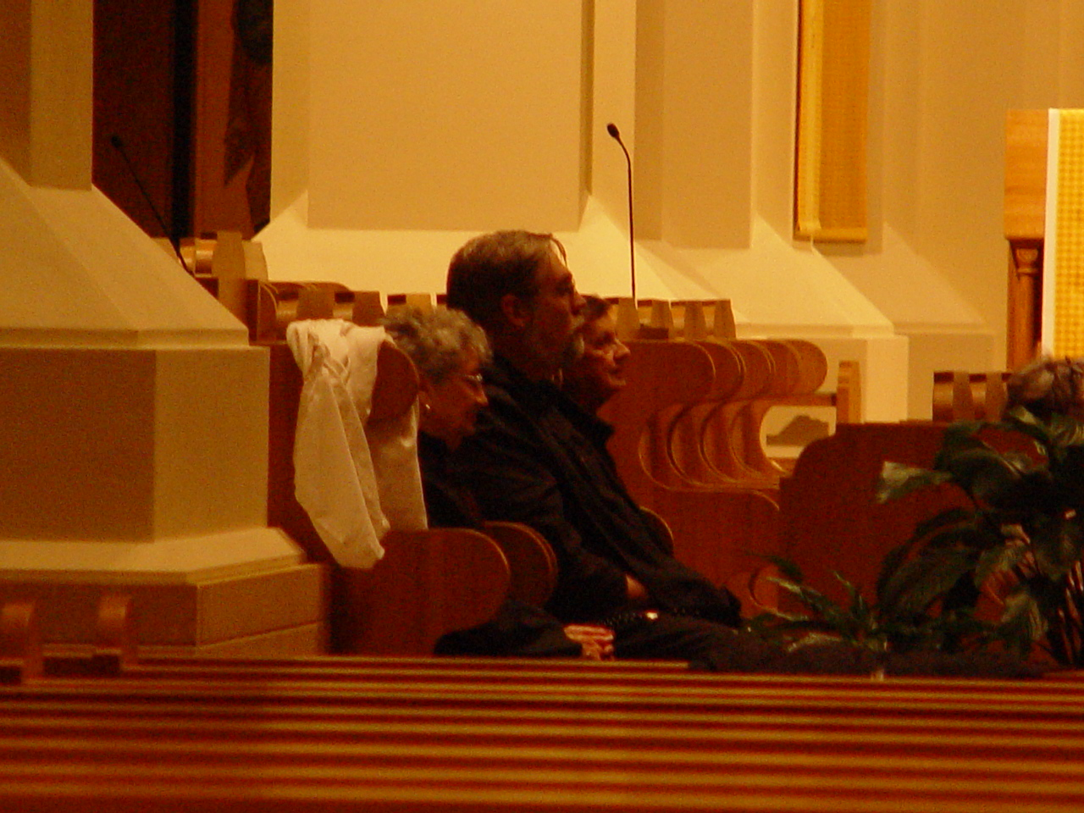

Day 1 028 Sr. Joseph Kateri (Doris Garretson); Br. Chad Anselm Gerns (now Br. David); Br. Matthias Smith

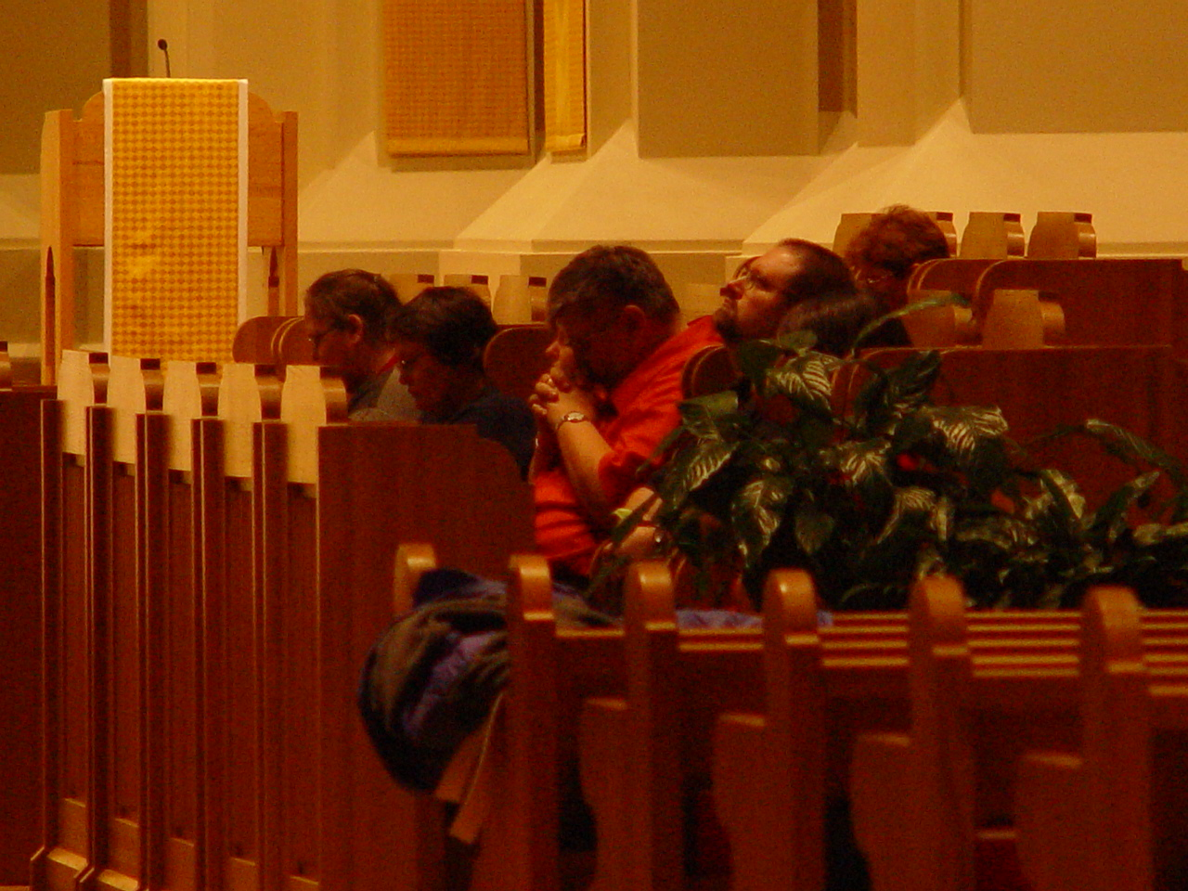

Day 1 029 Front row: Sr. Margaret Moore (now Sr. Denise); Sr Theodora of Jesus Perecca; Br. Nathan Gregory Miller; Br. Daniel Moore (now Br. Willard); Sr. Anna Grace Madden (only the top of her head is showing)
Back row: Sr. Monica Ruth Mullen

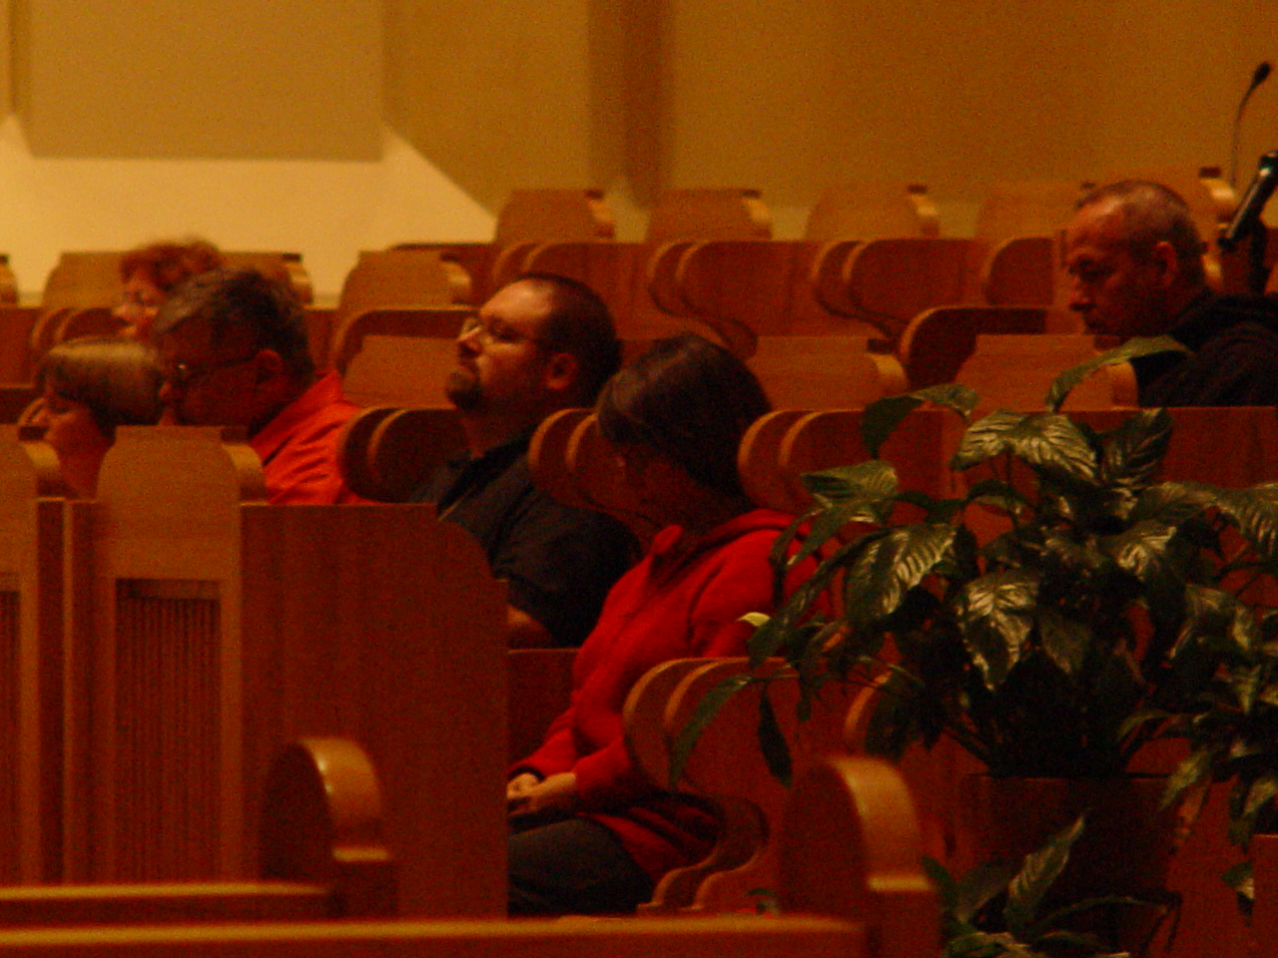

Day 1 030 Front row: Sr. Margaret Moore (now Sr. Denise); Sr Theodora of Jesus Perecca; Br. Nathan Gregory Miller; Br. Daniel Moore (now Br. Willard); Sr. Anna Grace Madden (
Back row: Sr. Monica Ruth Mullen; Br. Gabriel Hale
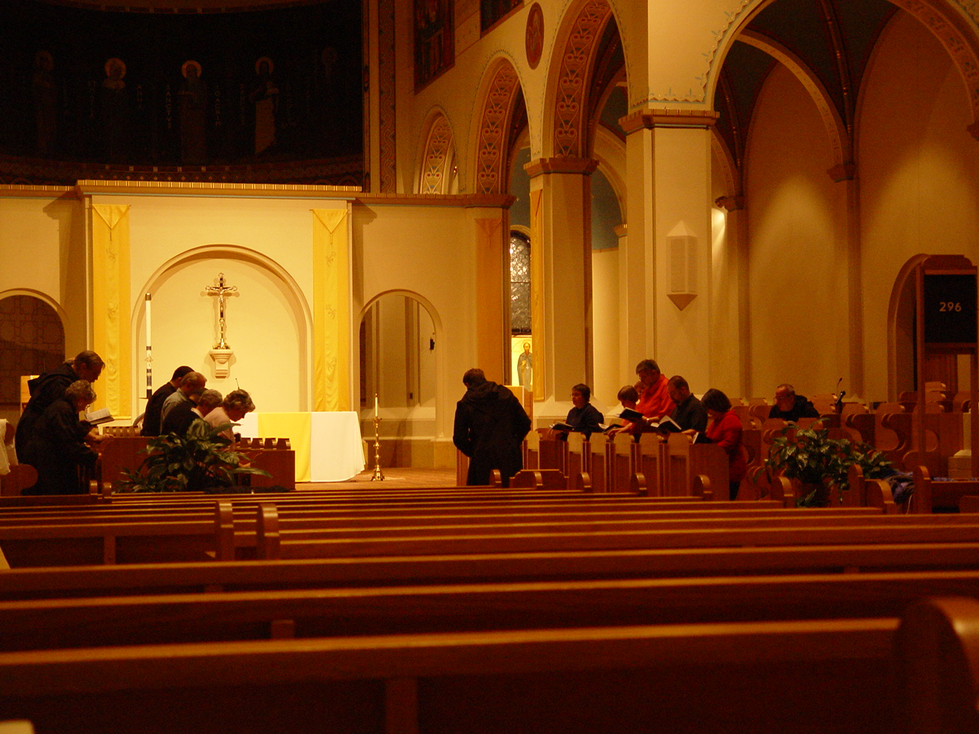

Day 1 031

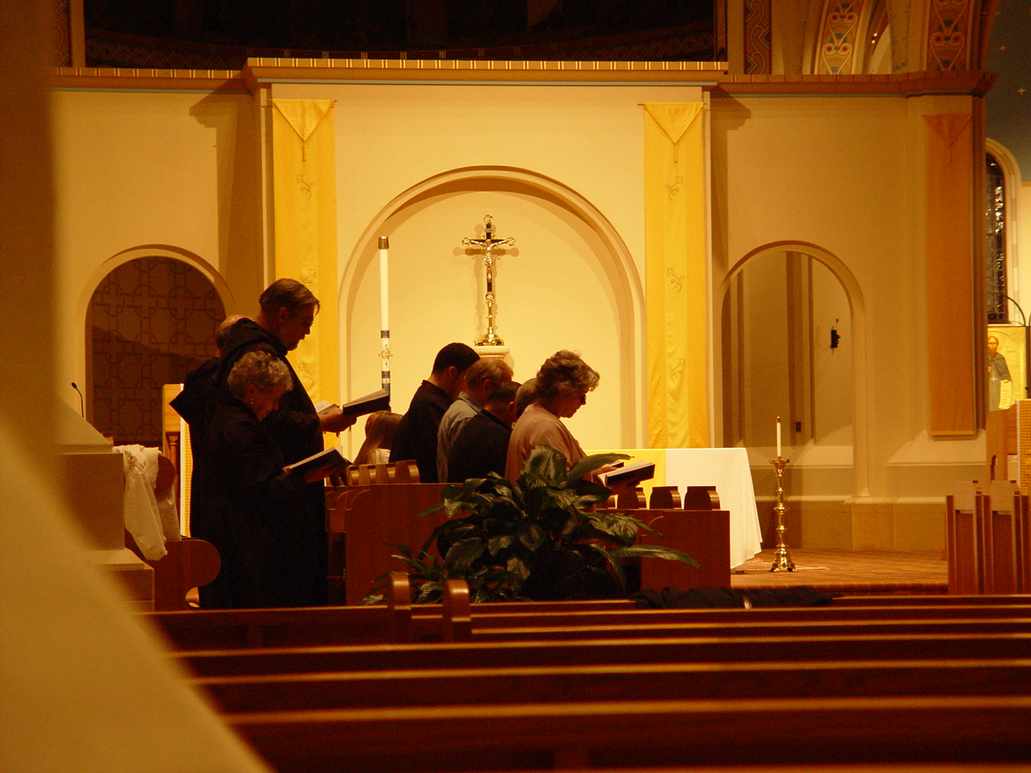

Day 1 032 Back row Sr. Joseph Kateri (Doris Garretson); Br. Chad Anselm Gerns (now Br. David); Br. Raymond Owens
Front row: Sr. Johanna Kirkpatrick; Br. Daniel Moore (now Br. Willard); Br. Daniel Joseph; Br. Anthony Gerard Campos

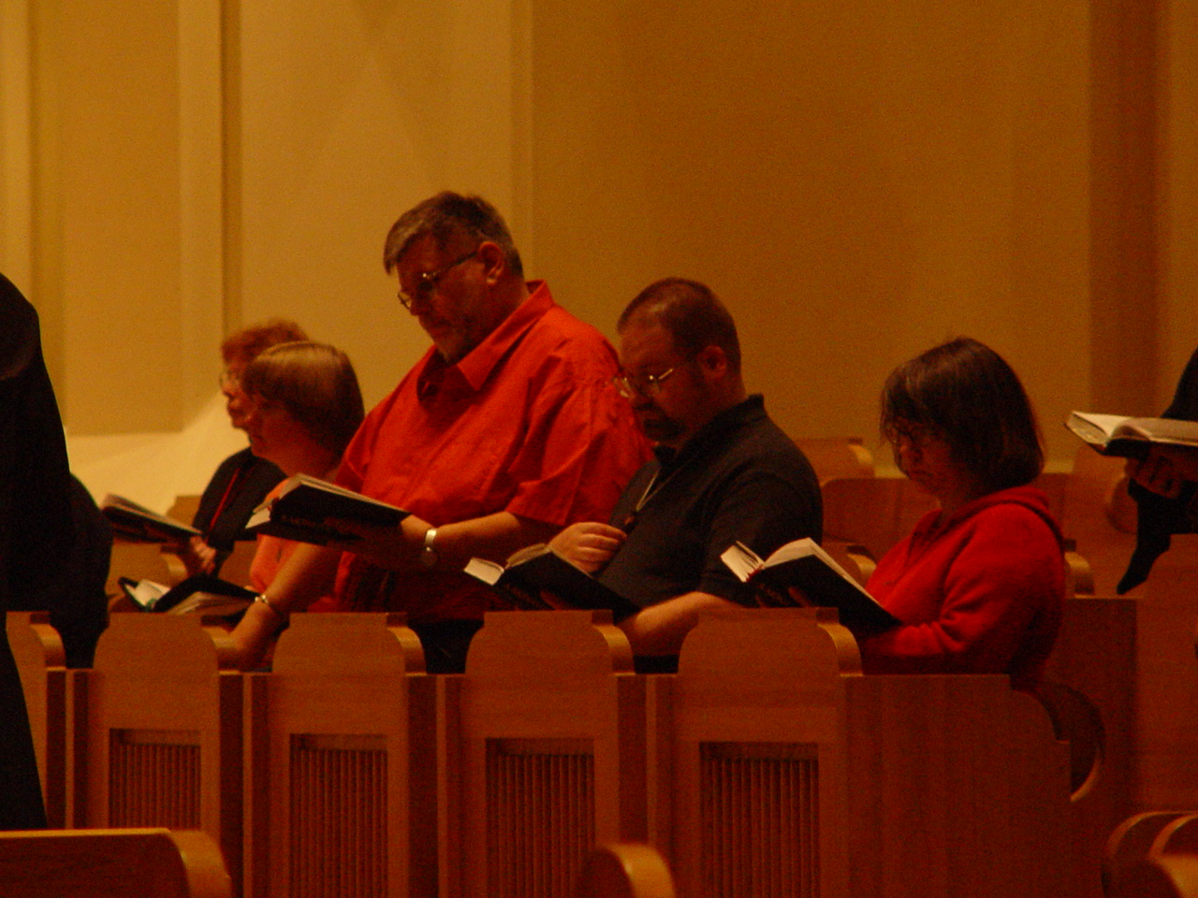

Day 1 033
Sr. Monica Ruth Mullen; Sr. Catherine Unterseher; Br. Nathan Gregory Miller; Br. Daniel Moore (now Br. Willard); Sr. Anna Grace Madden
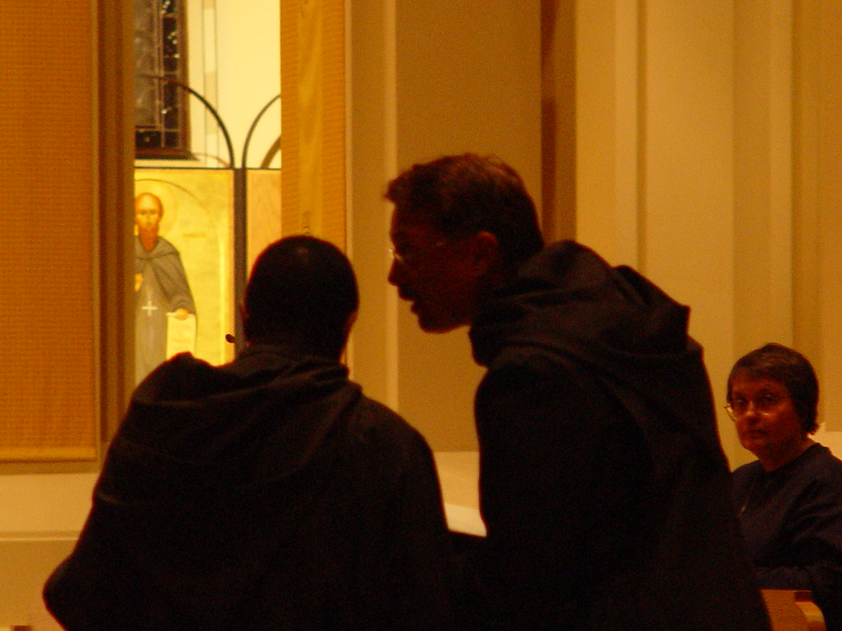

Day 1 034 Br. Thomas Ferrell; Prior Michael John Austin; Sr. Theodora of Jesus Perecca

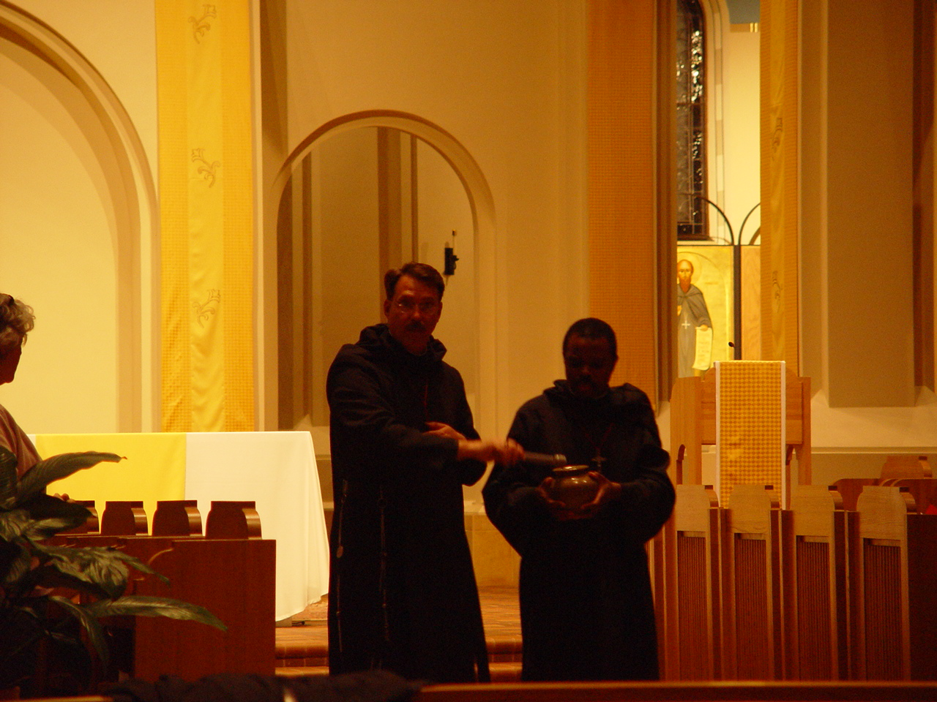

Day 1 035 Sr. Johanna Kirkpatrick; Prior Michael John Austin & Br. Thomas Ferrell

