Companions of St. Luke
Spring 2003 Convocation at Conception Abbey
Portraits

~Edited by Br. Steven Olderr, 8 May 2022; if you find any errors or omissions, please notify Br. Steven at olderr@ameritech.net

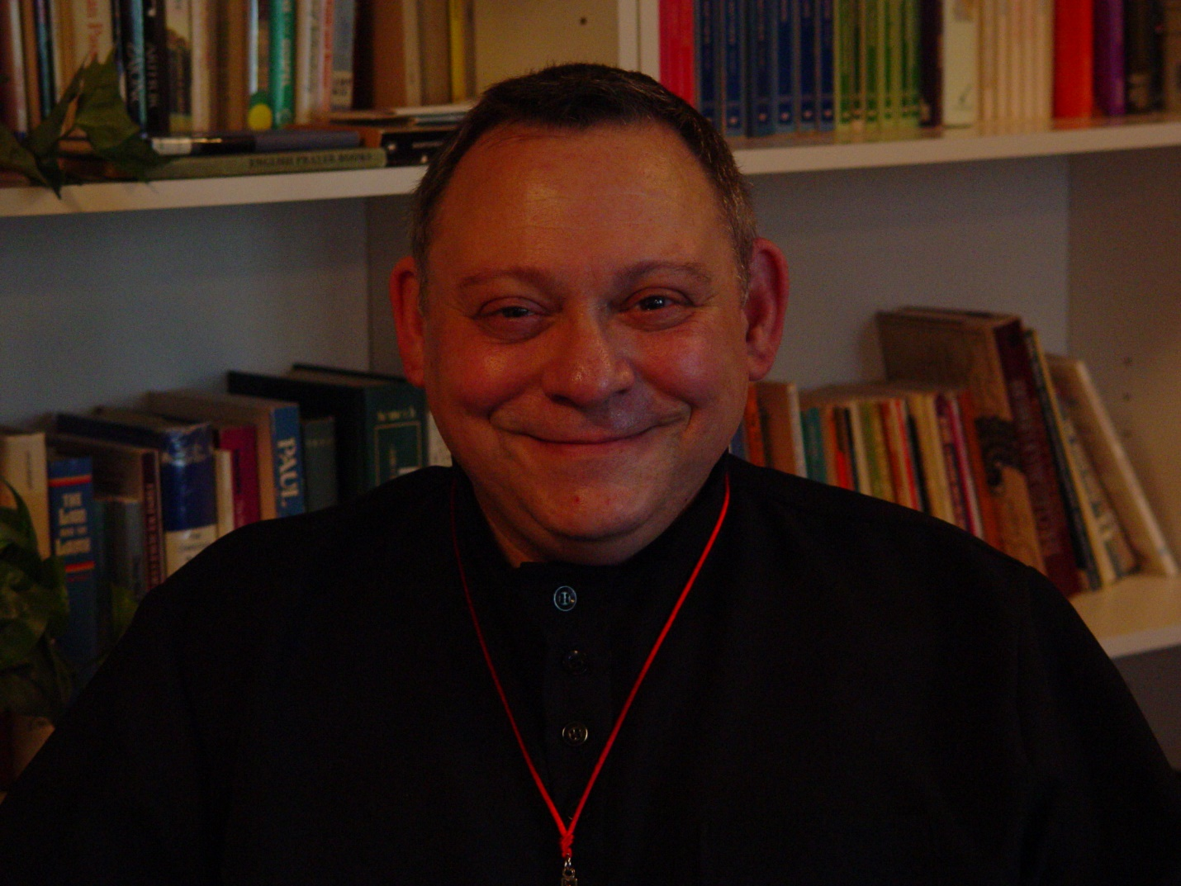

Portrait Pictures 001 Br. Ambrose Heroux (given name Steven)

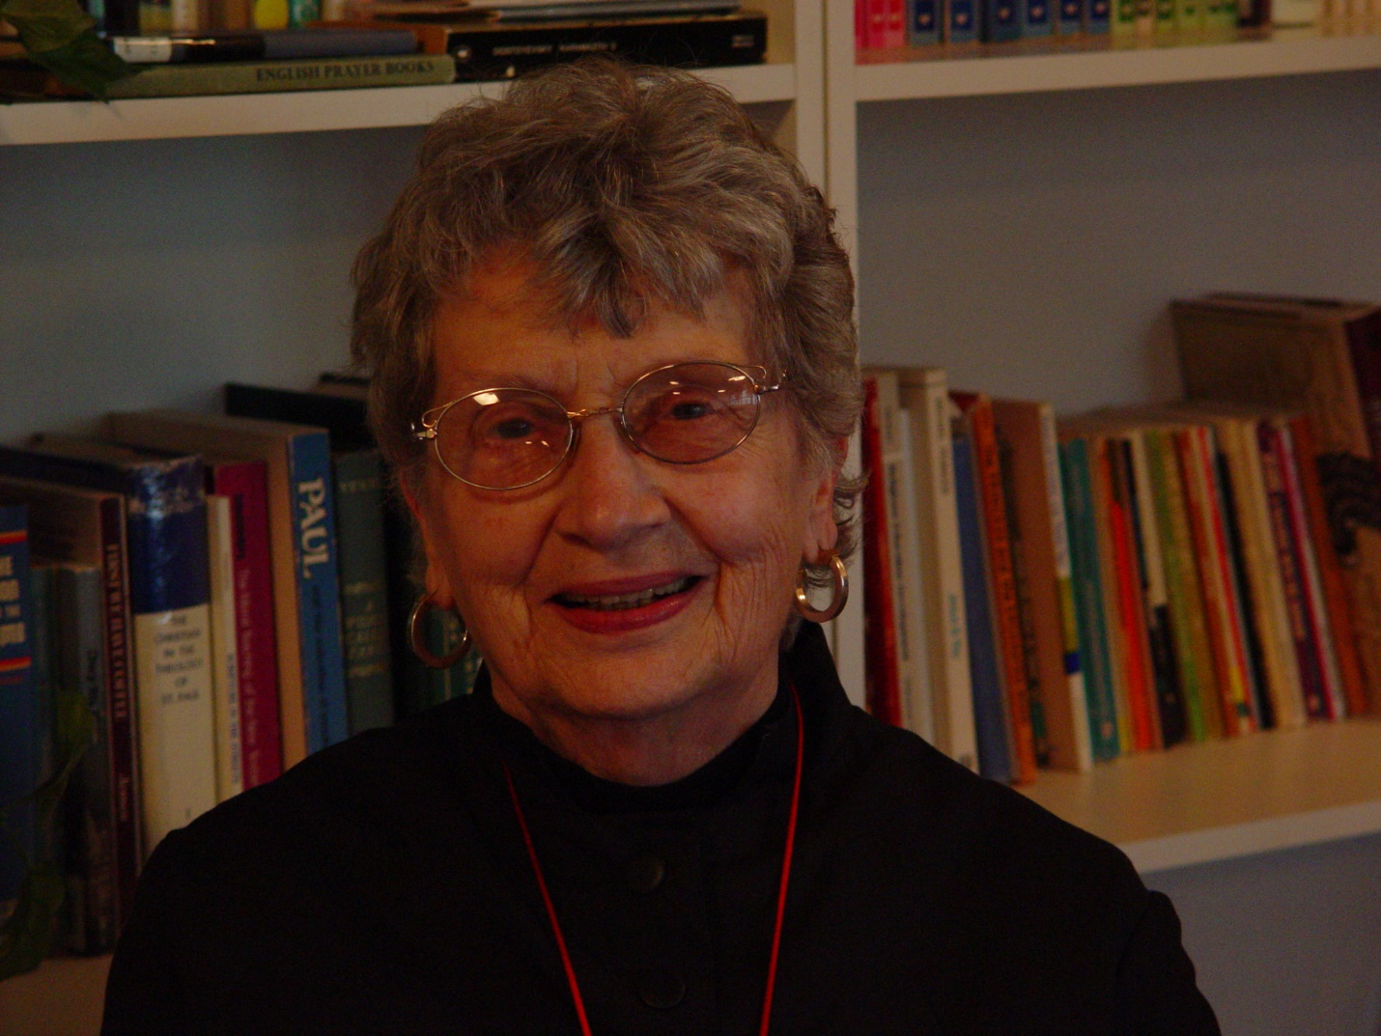

Portrait Pictures 003 Sr. Joseph Kateri (Doris Garretson)

[There is no Portrait Picture 002 on the original CD]

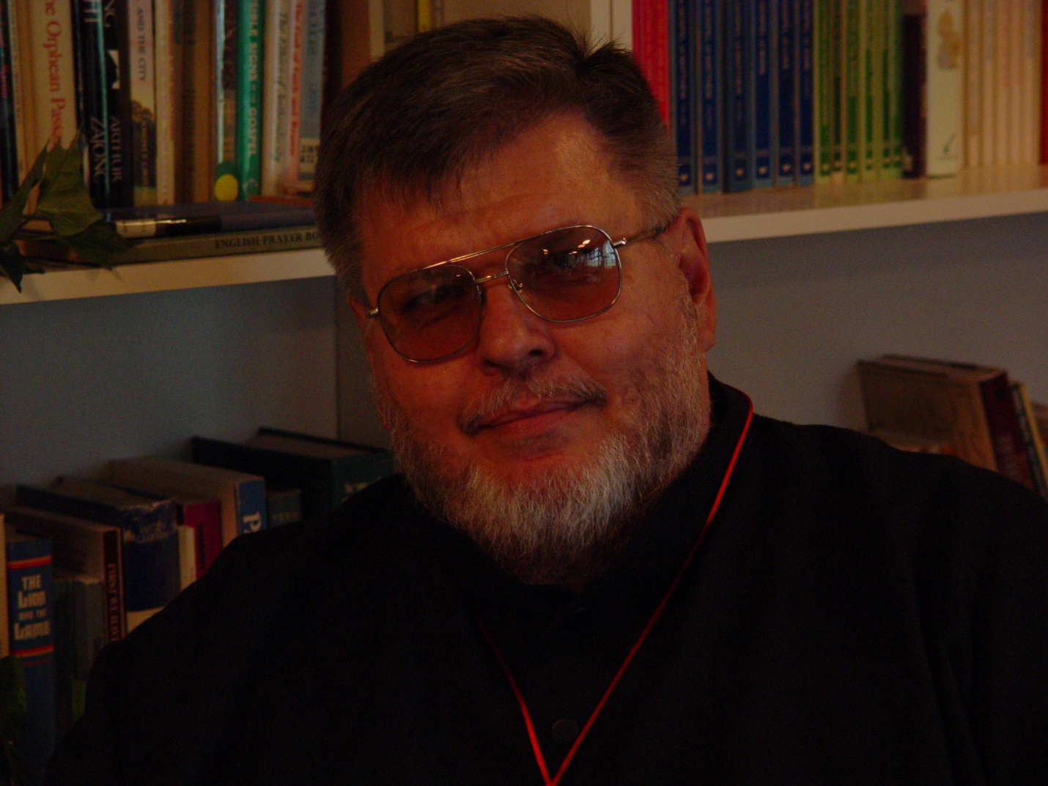

Portrait Pictures 004 Br. Nathan Gregory Miller (given name Wayne)

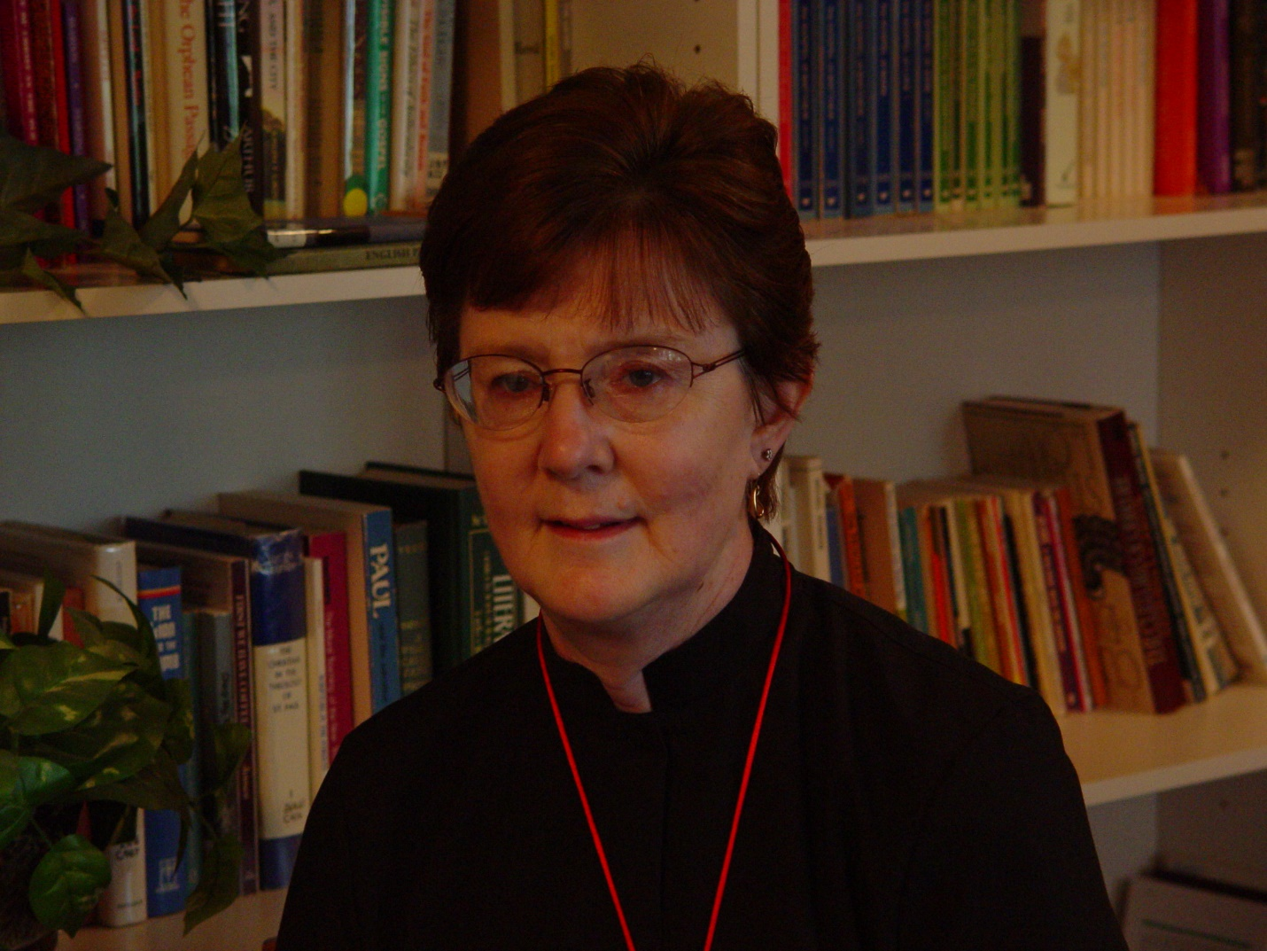

Portrait Pictures 005 Sr. Brigid Gerns (given name Ann)

 Portrait Pictures 006 Sr. Anna Grace Madden (given name Nancy)

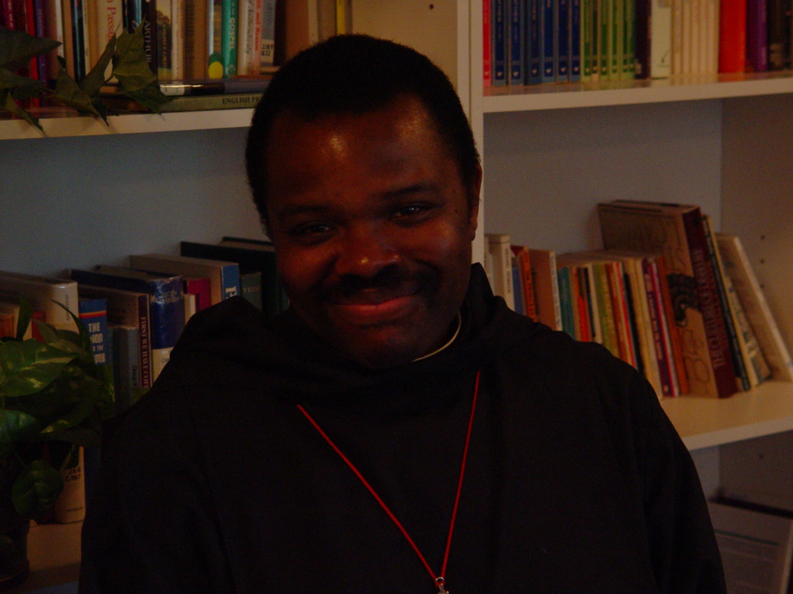

Portrait Pictures 007 Br. Thomas Ferrell [Photo mislabeled on original CD as Br. Thomas Perecca]

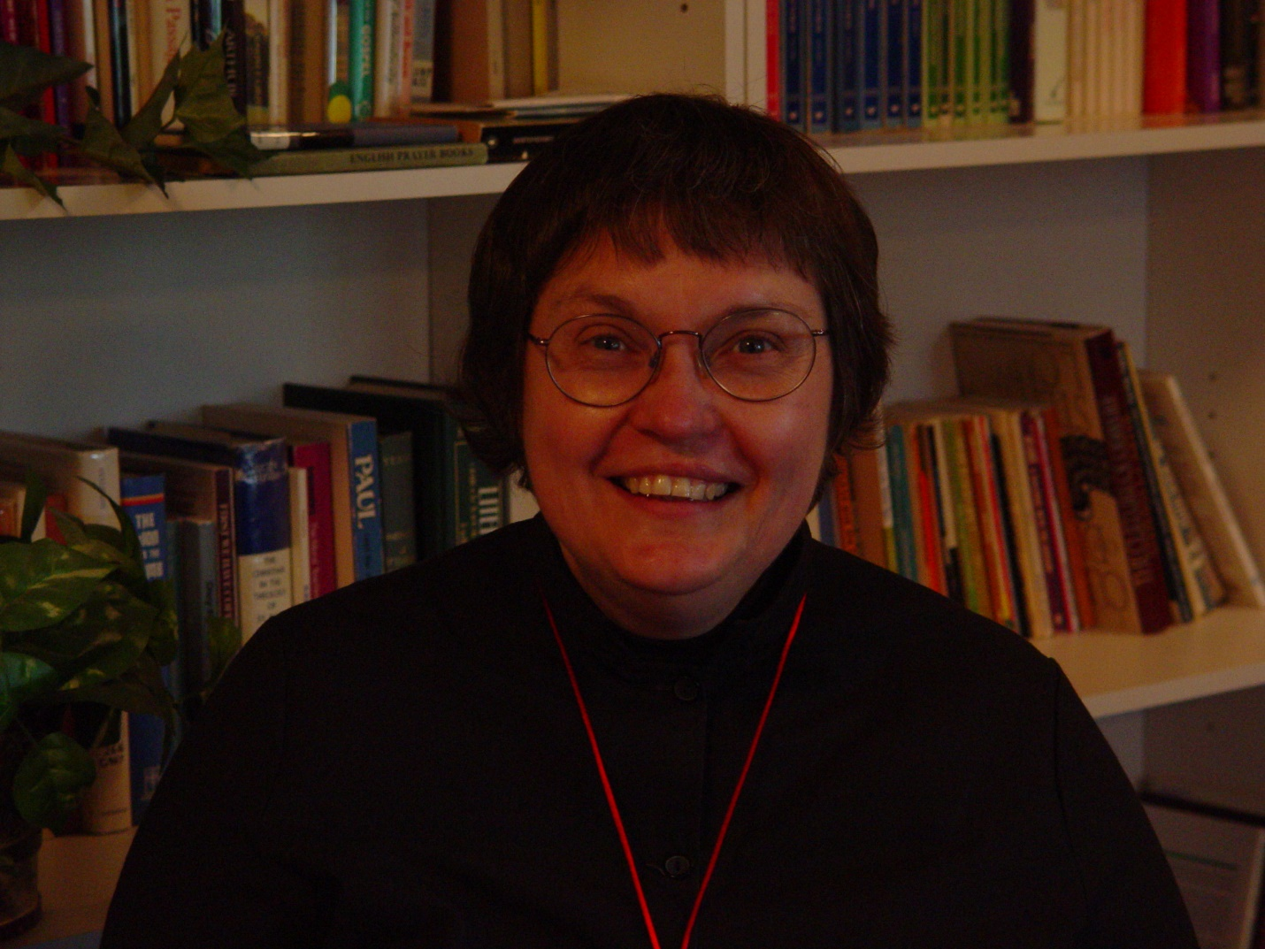
Portrait Pictures 008 Sr. Theodora of Jesus Perecca (given name Adona)

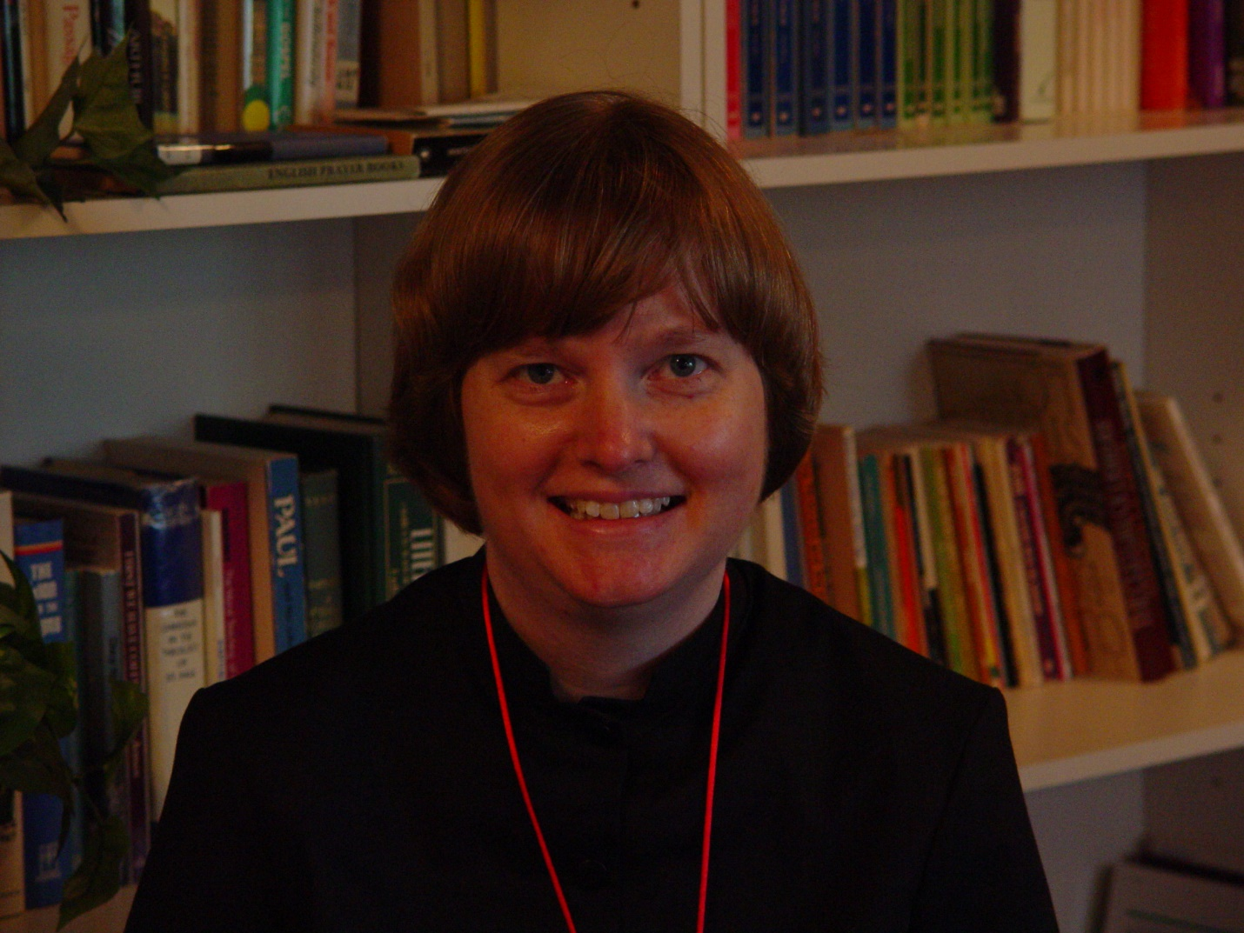

Portrait Pictures 009 Sr. Catherine Unterseher (given name Lisa)

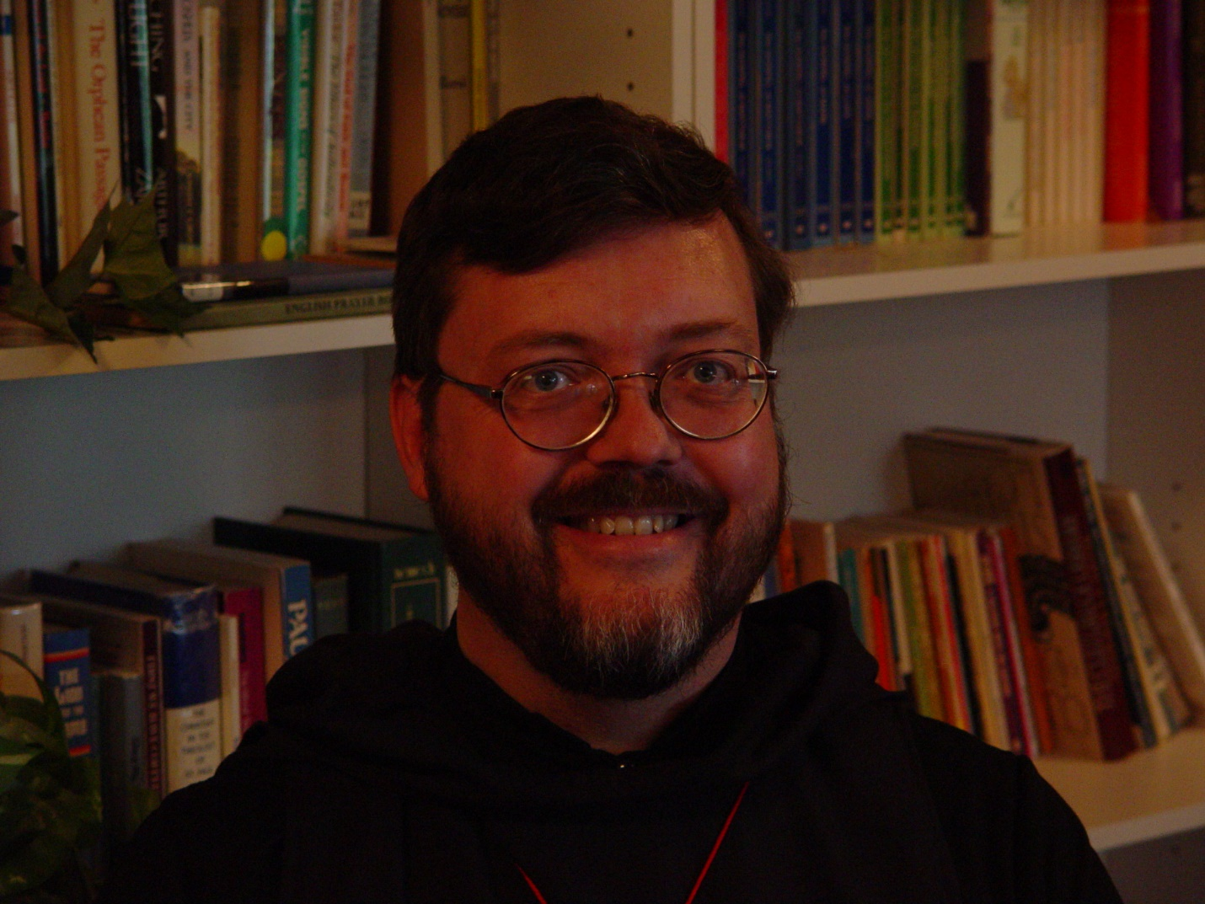

Portrait Pictures 010 Br. Paul Howard

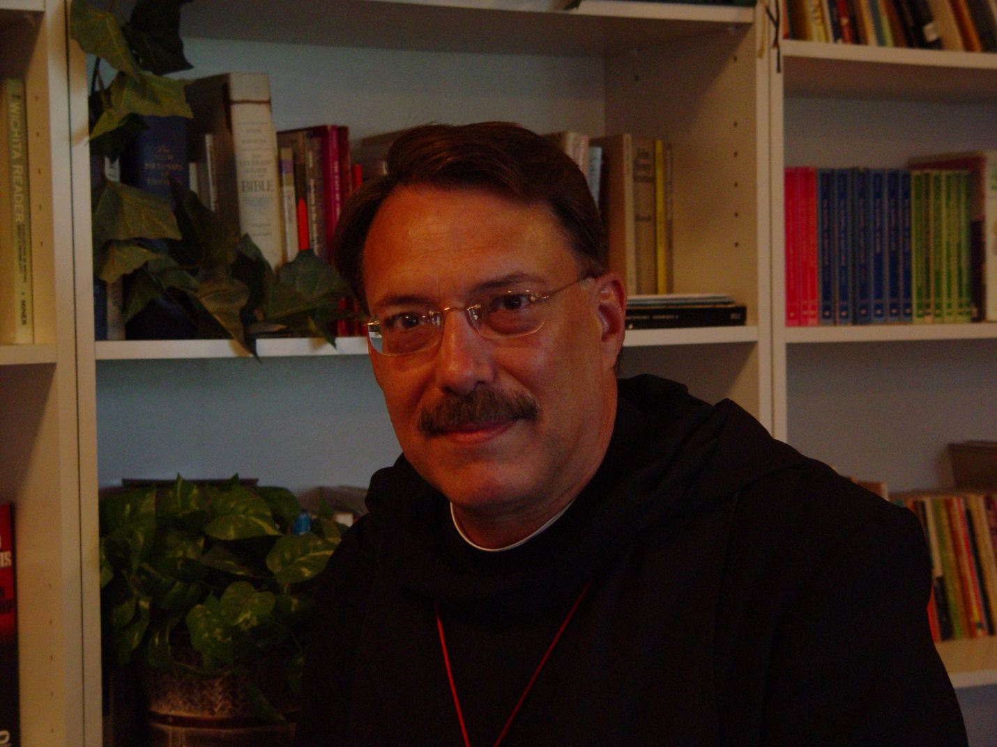

Portrait Pictures 011 Prior Michael John

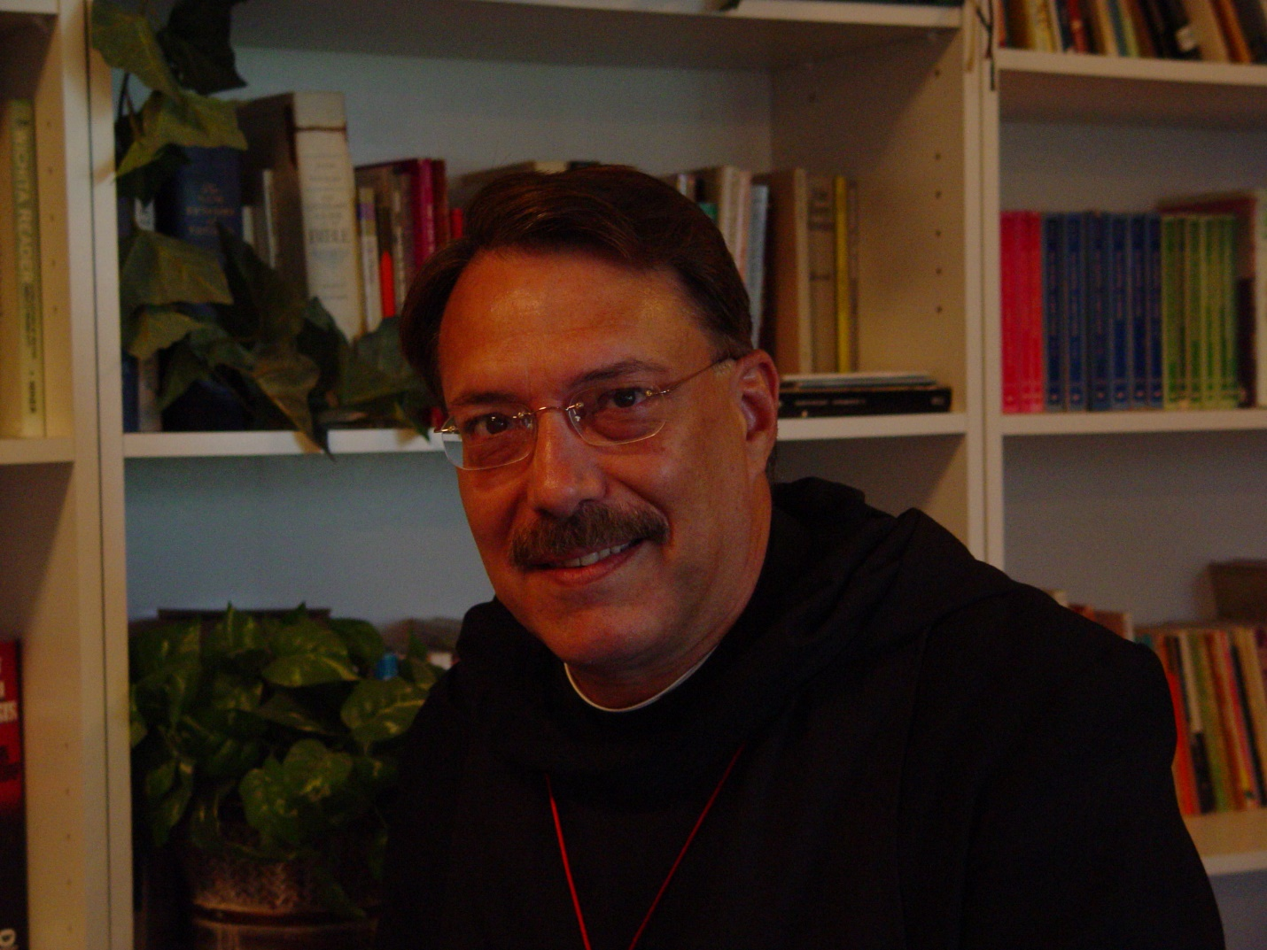

Portrait Pictures 012 Prior Michael John

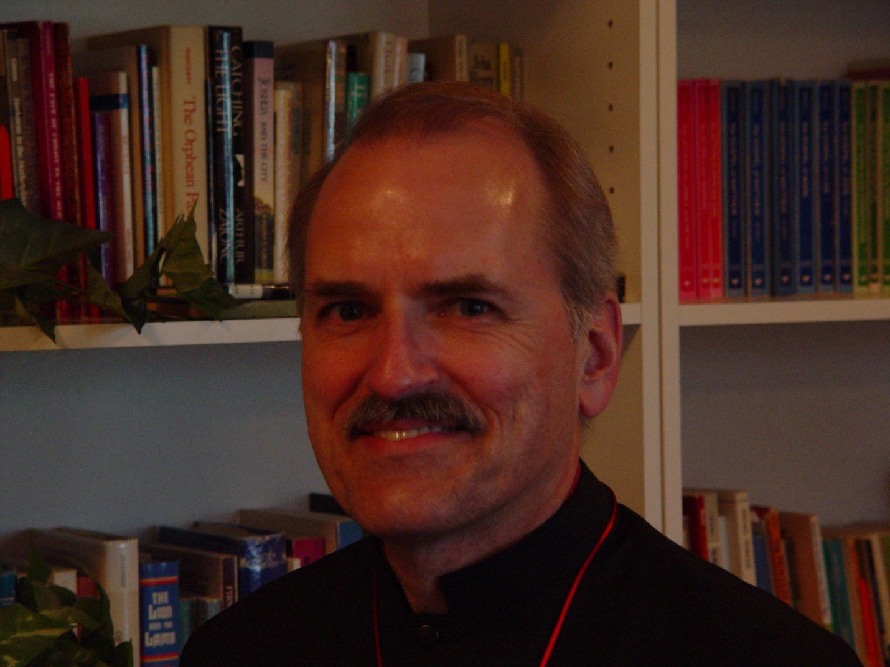

Portrait Pictures 013 Br. Daniel Joseph Schroeder

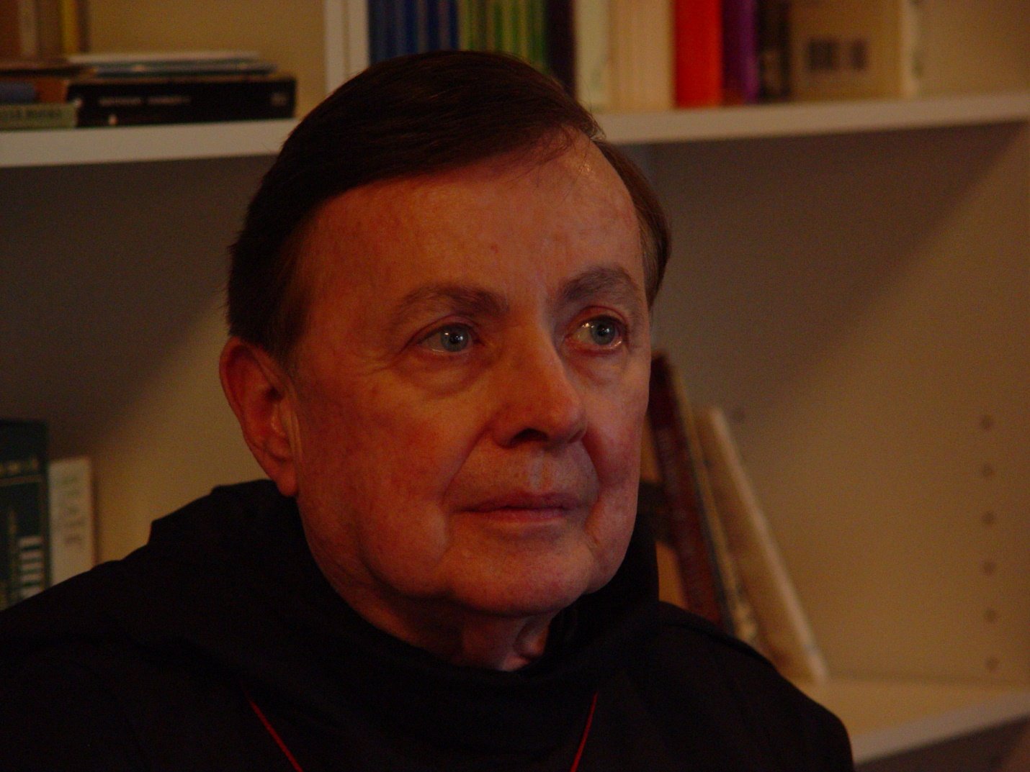

Portrait Pictures 014 Br. Matthias Smith

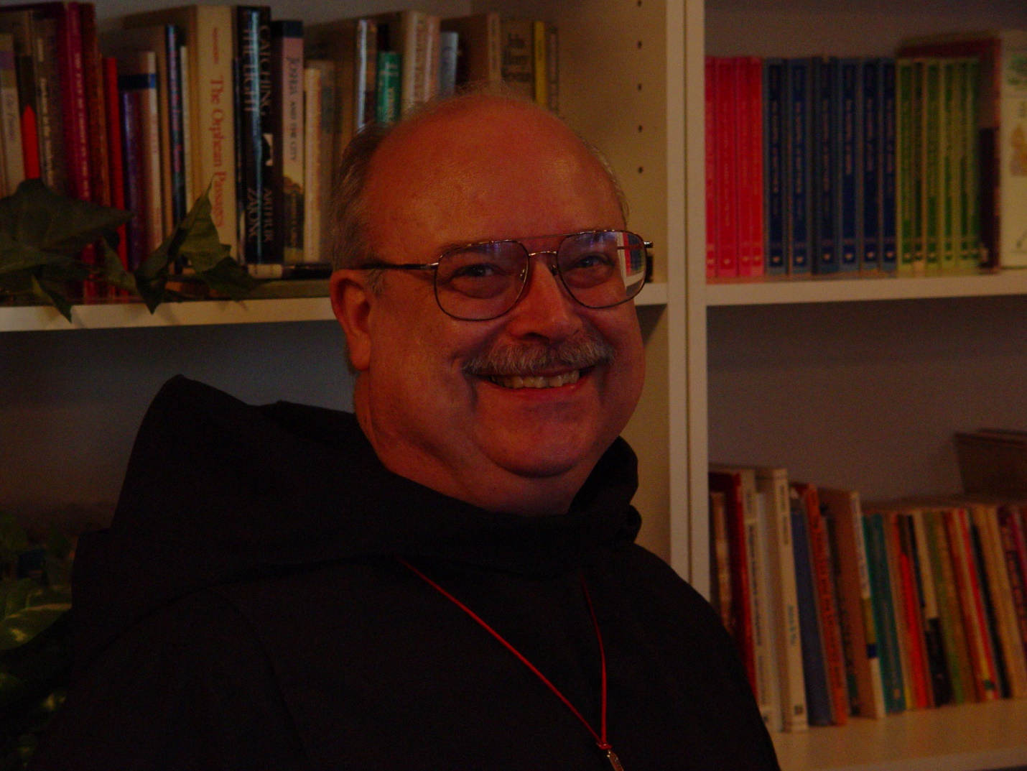

Portrait Pictures 015 Br. Raymond Owens

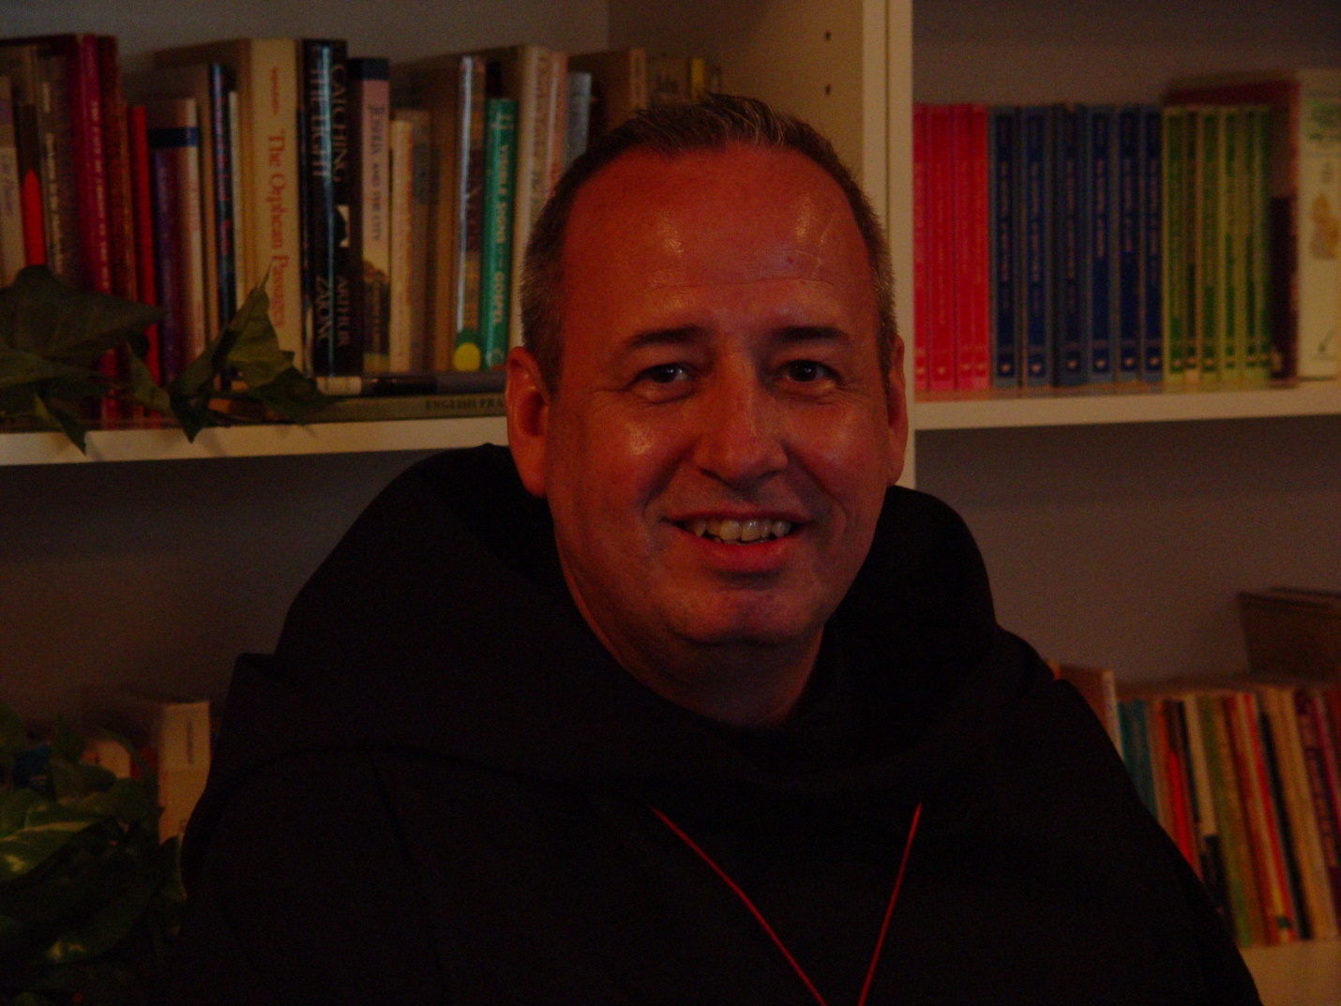

Portrait Pictures 016 Br. Gabriel Hale

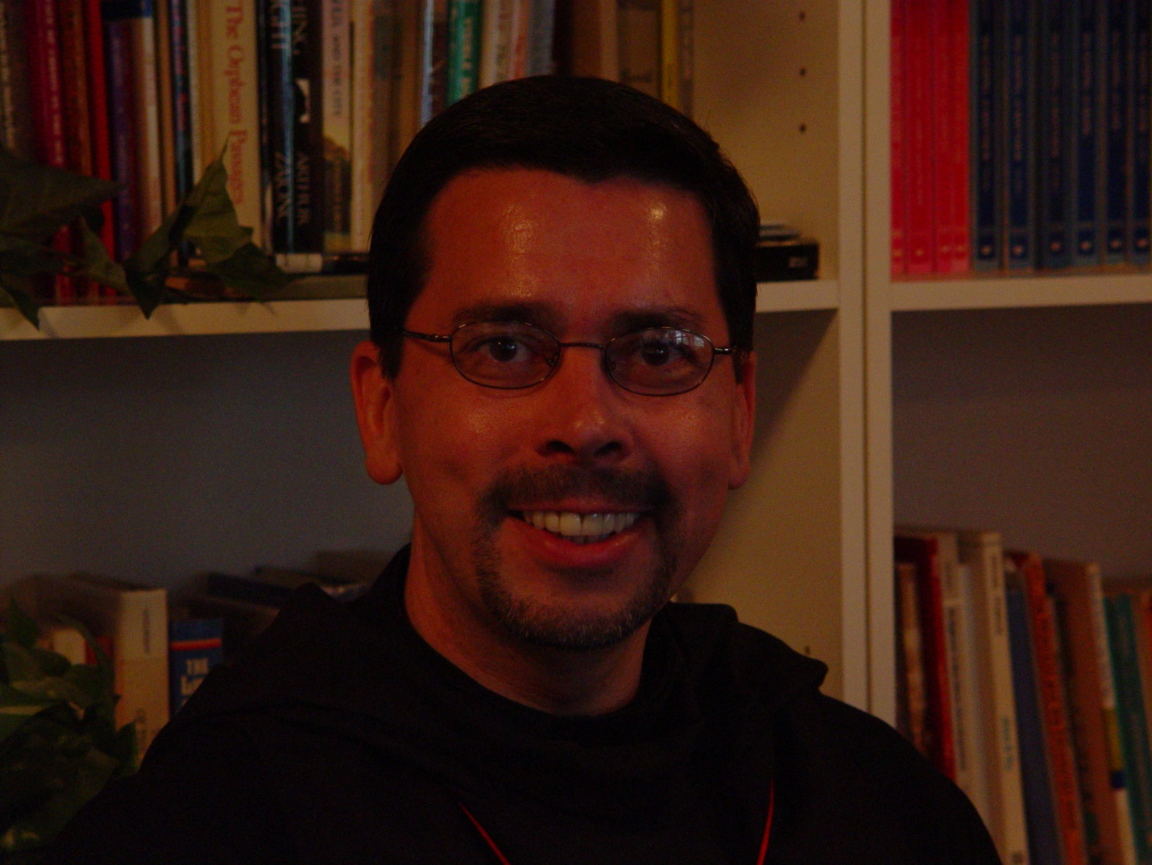

Portrait Pictures 017 Br. Augustine Colvert

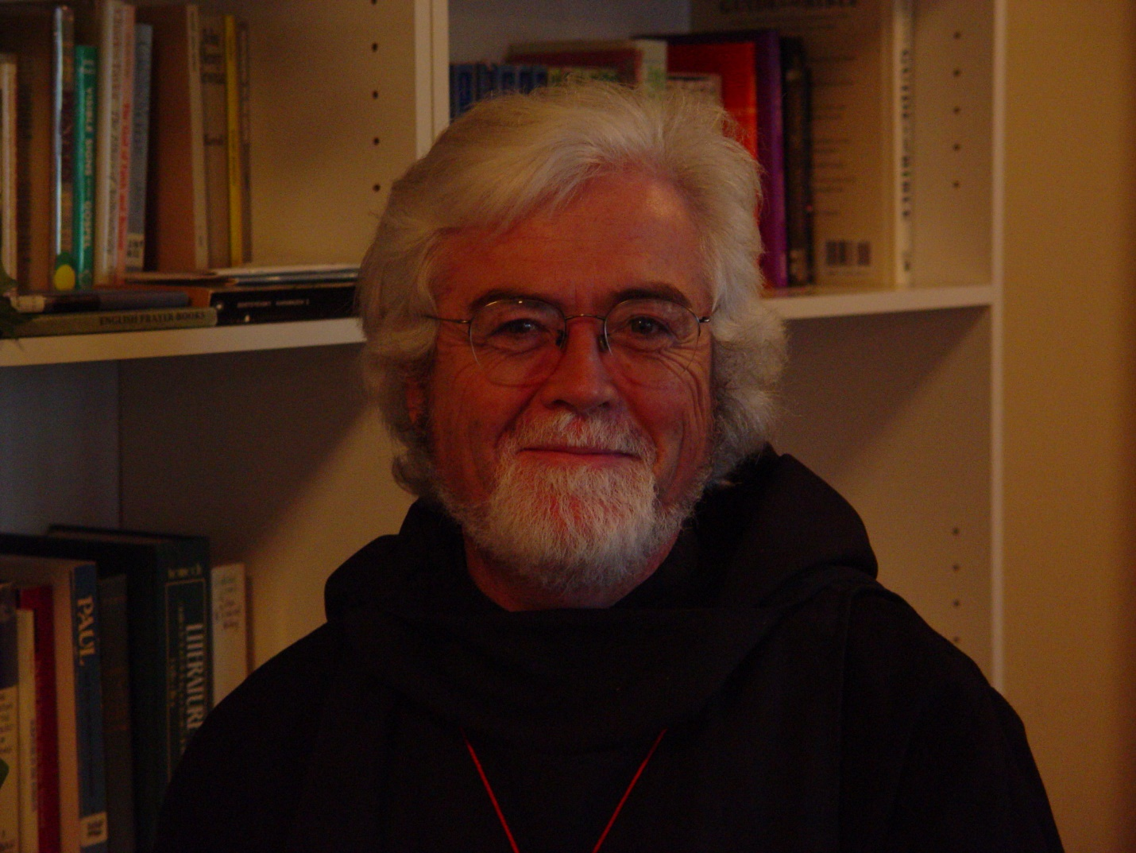

Portrait Pictures 018 Br. Martin Sheridan

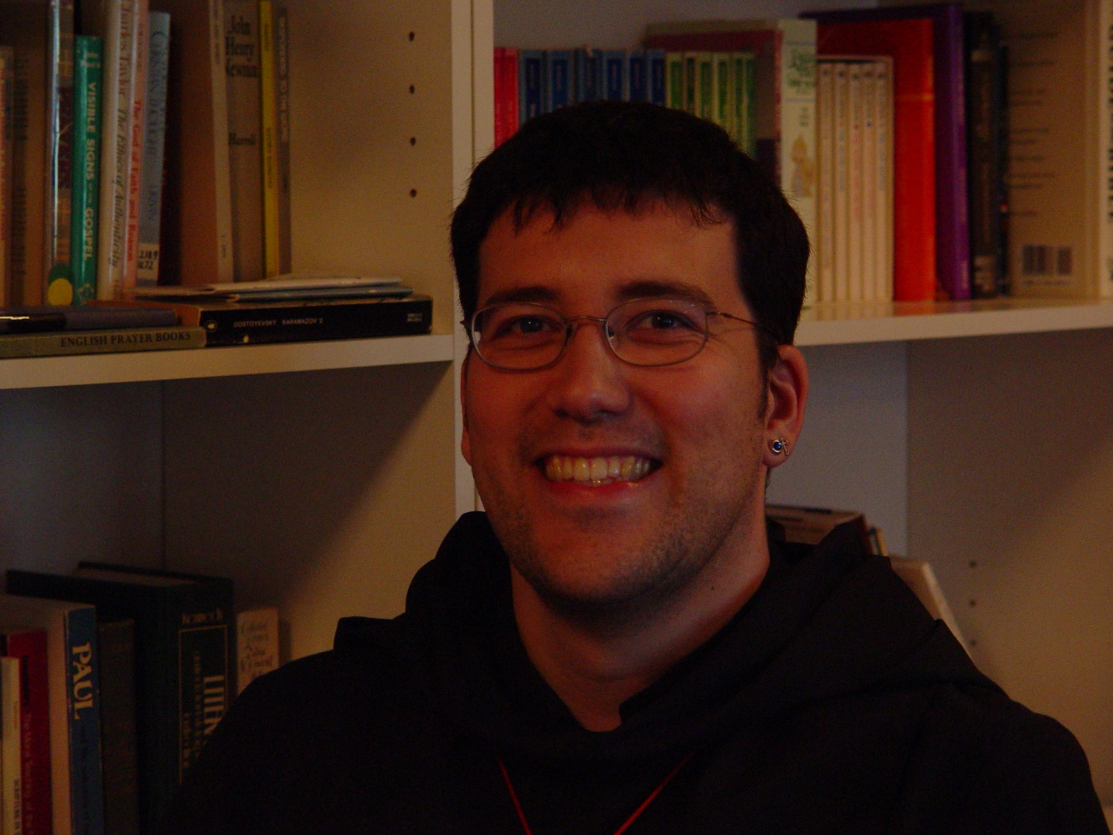

Portrait Pictures 019 Br. Anthony Bernard Campos

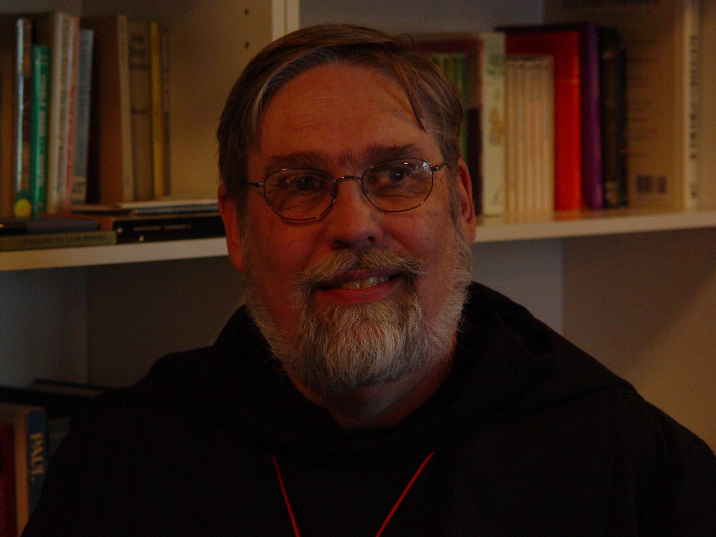Portrait Pictures 020 Br. Chad Anselm Gerns [now Br. David]

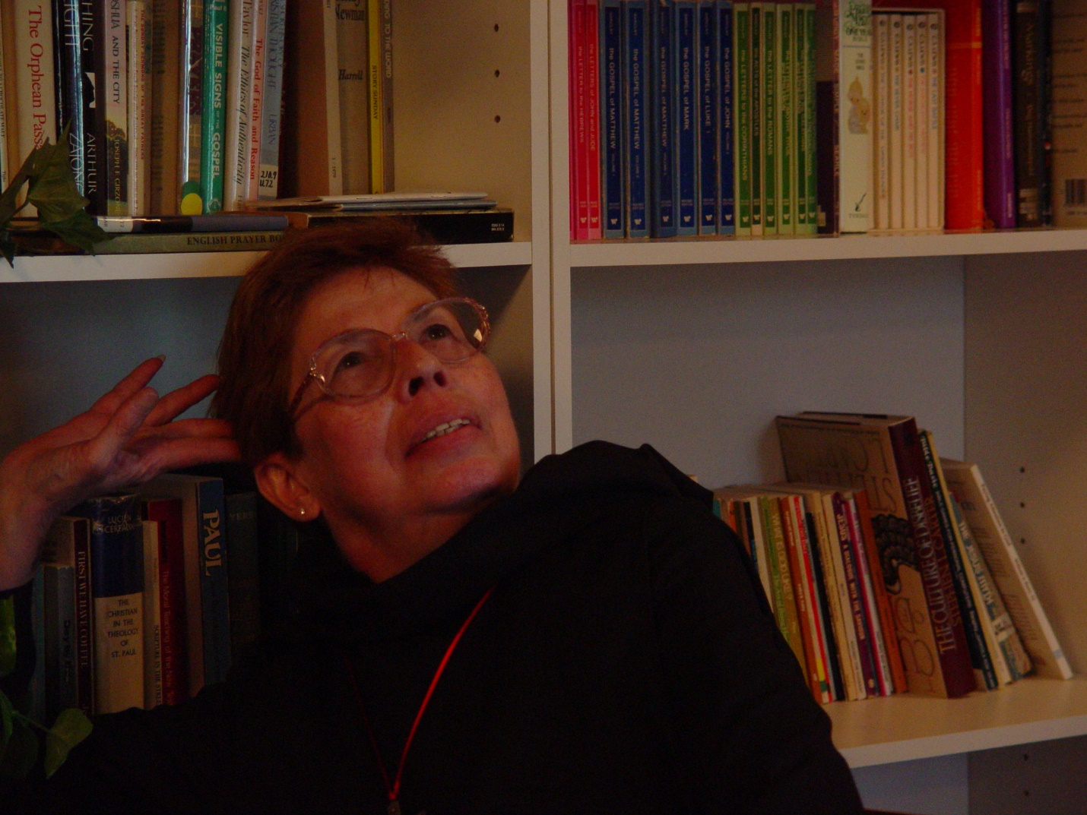

Portrait Pictures 021 Sr. Monica Ruth Mullen
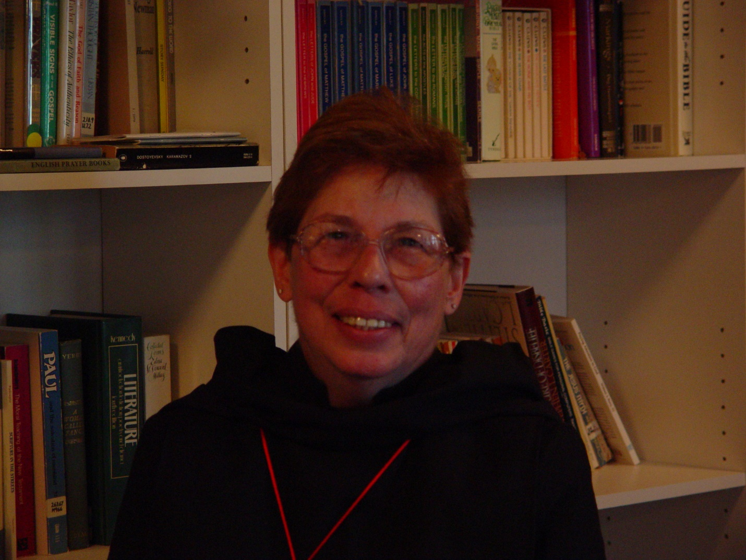

Portrait Pictures 021 Sr. Monica Ruth Mullen

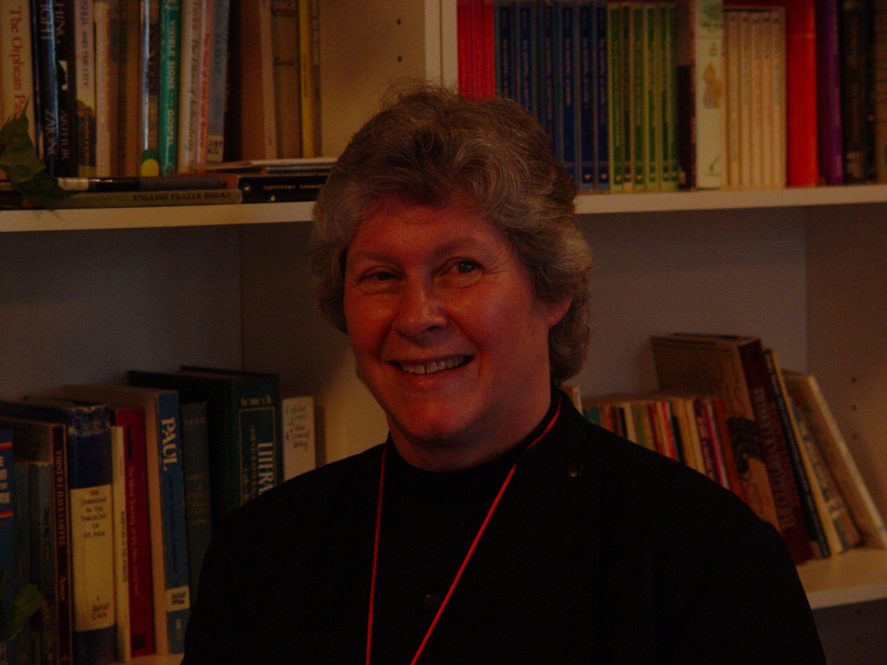

Portrait Pictures 022 Sr. Johanna Kirkpatrick

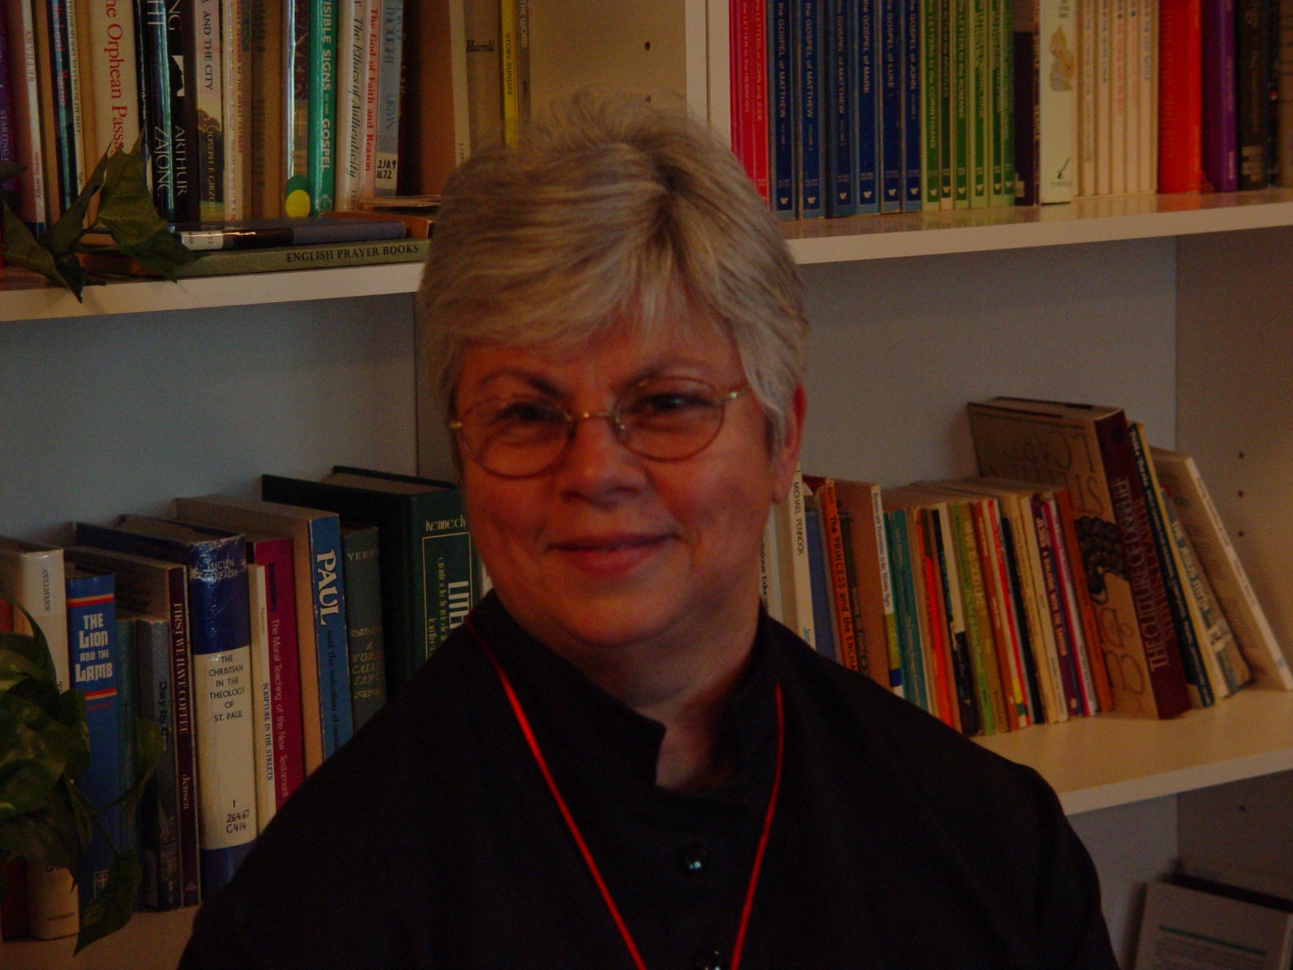 Portrait Pictures 023 Sr. Clare Benedicta Meyers

