28 March 2005 CD with Notes

Identifications by Sr. Martha Lamoy; Br. Thomas Ferrell; Br. Robert Cotton

People are identified in the photos going from left to right.

~Edited by Br. Steven Olderr, 5 May 2022 Please note that this will always be a work in progress. Please let me know of any possible error or omissions.

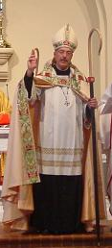

Prior Michael John Austin

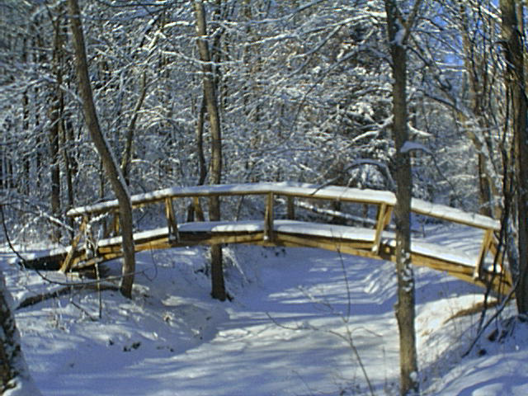
Bridge at Donnellson Priory 2004

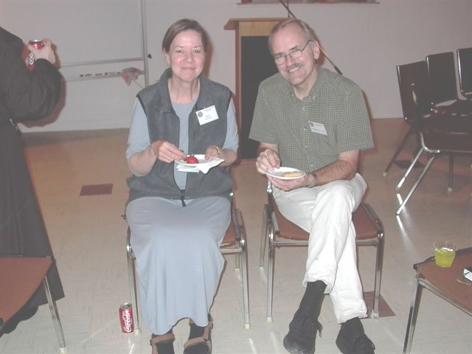
Mary & Br. Daniel Joseph
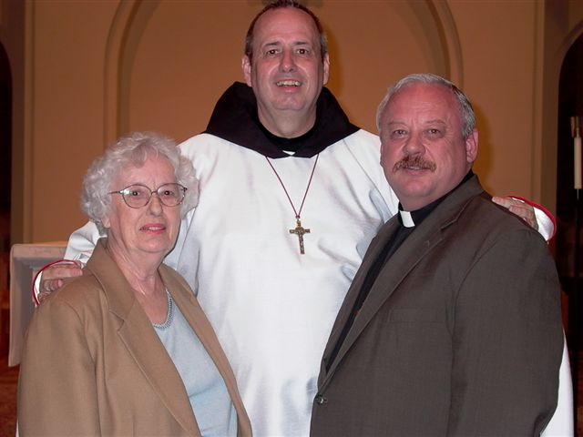

Br. Gabriel Hale with his mother and his brother Rev. Stephen Hale, a Methodist minister

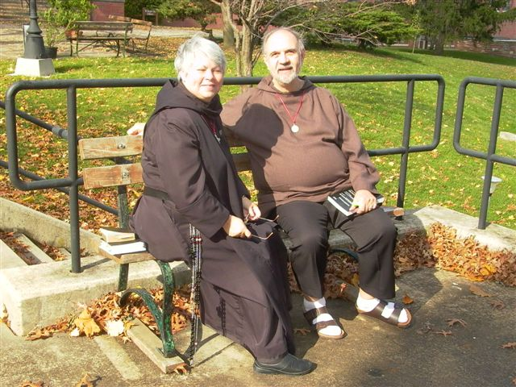
Sr. Clare Benedicta Myers & Br. Joseph Benedict DiMauro, SA *

*Br. Joseph Benedict, SA was a priest in the Jesuit Society of the Atonement, but in an act of ecumenism joined CSL as an oblate. He remained in the CSL until 2009 when Abbot Michael John Austin resigned. He then joined the House of Initia Nova, MJ’s successor community. Br. Joseph Benedict died on 29 Nov 2018.
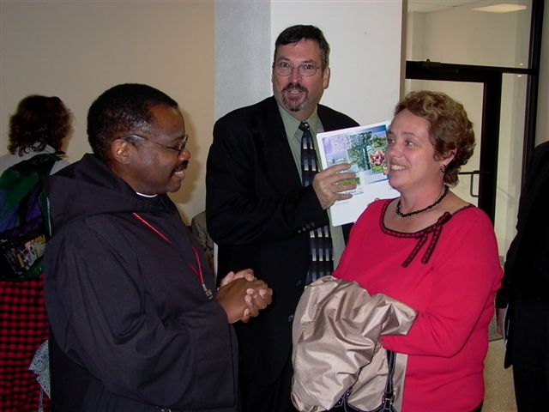
Br Thomas Ferrell; Scott Shovar; Jane Shovar
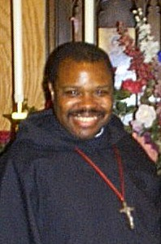
Br. Thomas Ferrell

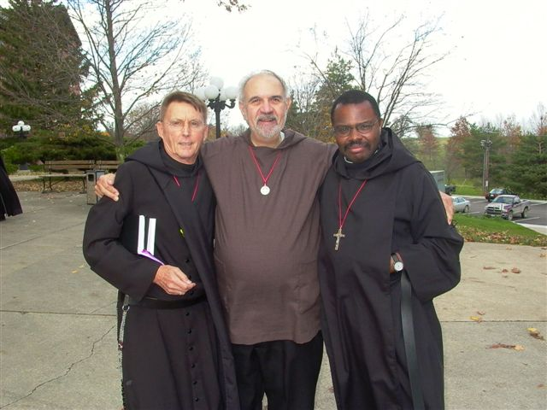
Br. Camillus Converse, Br. Joseph Benedict DiMauro, SA, Br. Thomas Ferrell

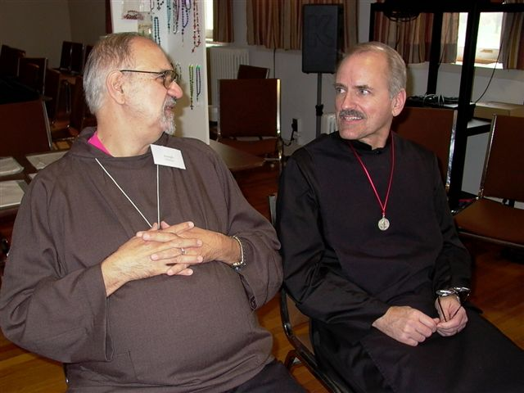
Br. Joseph Benedict DiMauro, SA; Br. Daniel Joseph

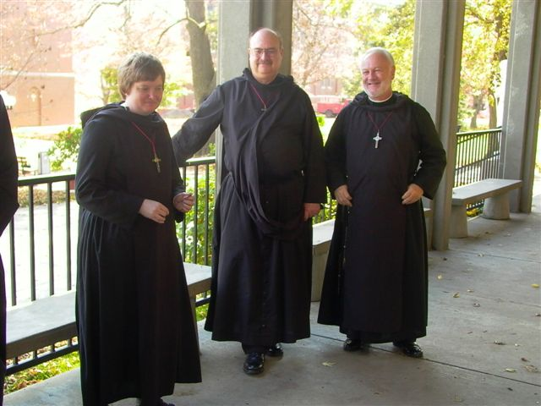
Casual conversation on the terrace; Conception Abbey

Sr. Catherine Untersher; Br. Raymond Owens; Br. Christopher John Baumann

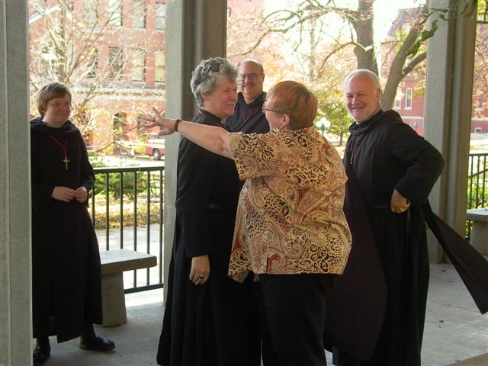
Celebration; Conception Abbey

Sr. Catherine Untersher; Sr. Johanna; Br. Raymond Owens; Lynne Owens (Br. Raymond’s wife); Br. Christopher John Baumann
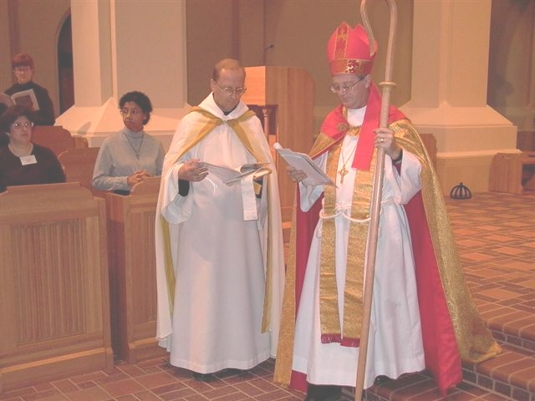
“Consecration 5, 2004”

Consecration of Michael John Austin as abbot

Abbot Gregory of Conception Abbey; Bishop Christopher Epting
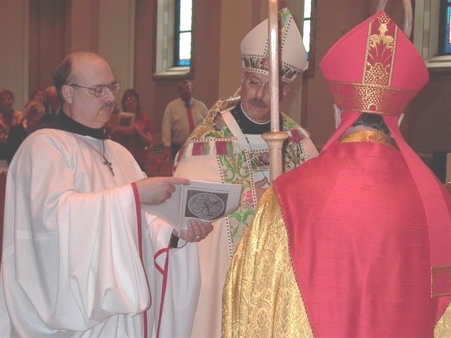
Consecration 6 2004

Consecration of Michael John Austin as abbot

Br. Raymond Owens; Prior Michael John Austin; Bishop Alan Scarfe

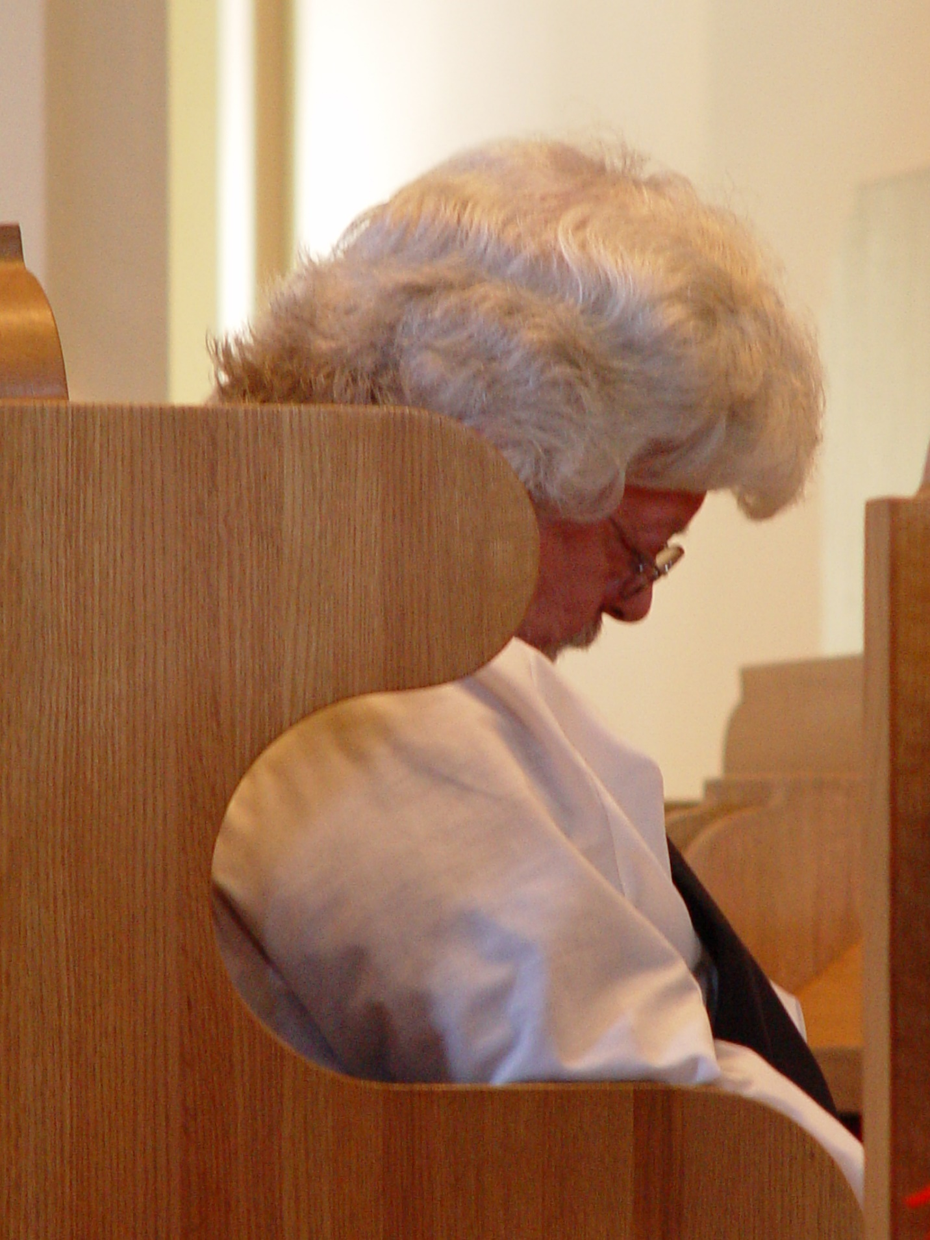
Convocation Fall 2003 010; Fr. Wayne Kamm
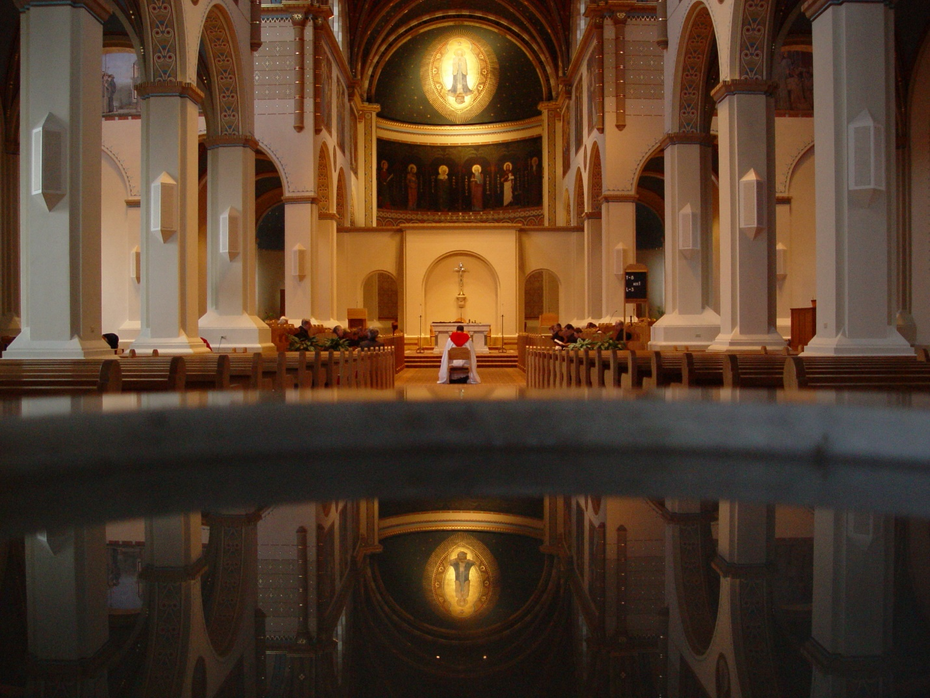
Convocation Fall 2003 016

Conception Abbey Church

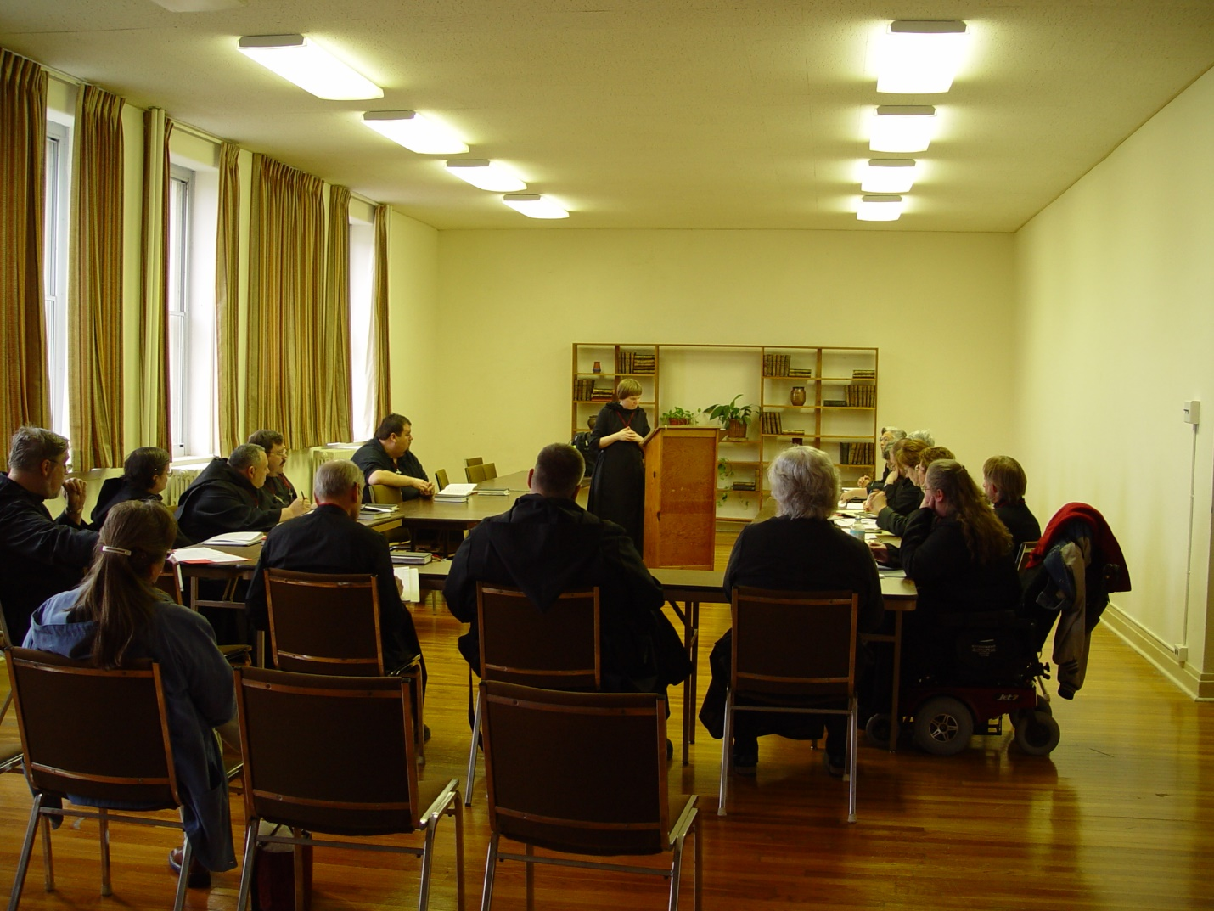
Convocation Fall 2003 024

Lecture by Sr. Catherine Untersher
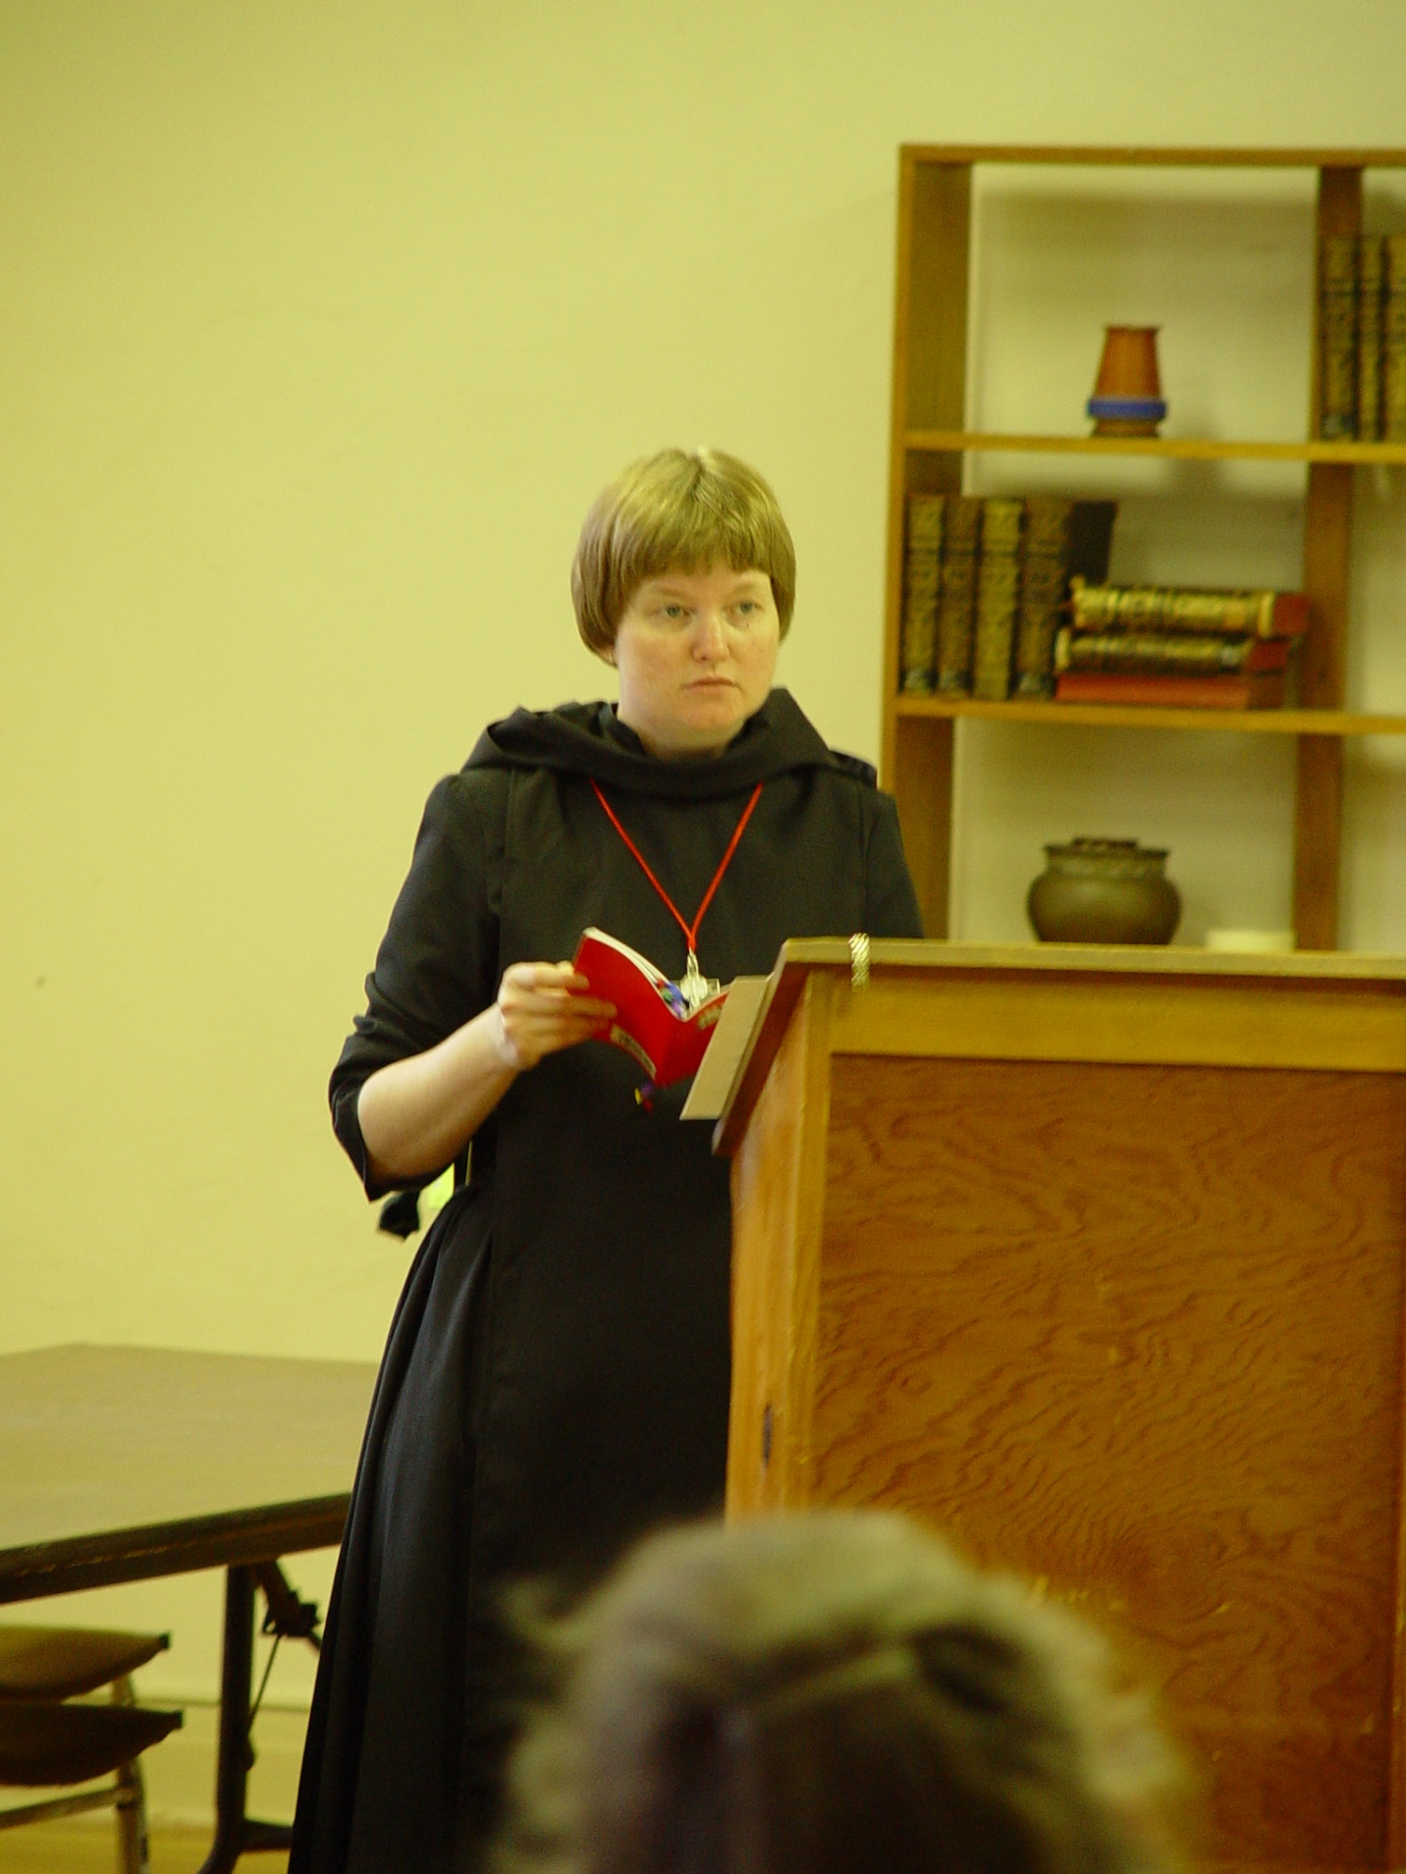
Convocation Fall 2004 027; Conception Abbey; Sr. Catherine Untersher

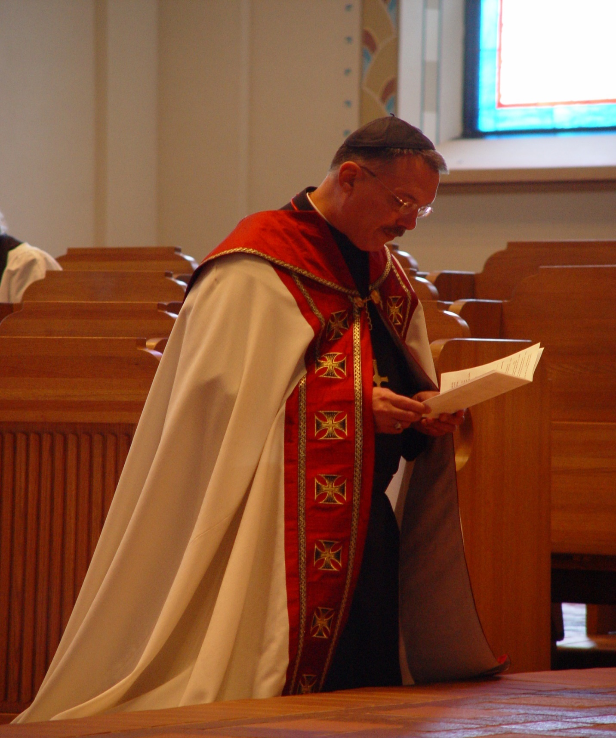
Convocation Fall 2003 033; Prior Michael John Austin at Conception Abbey
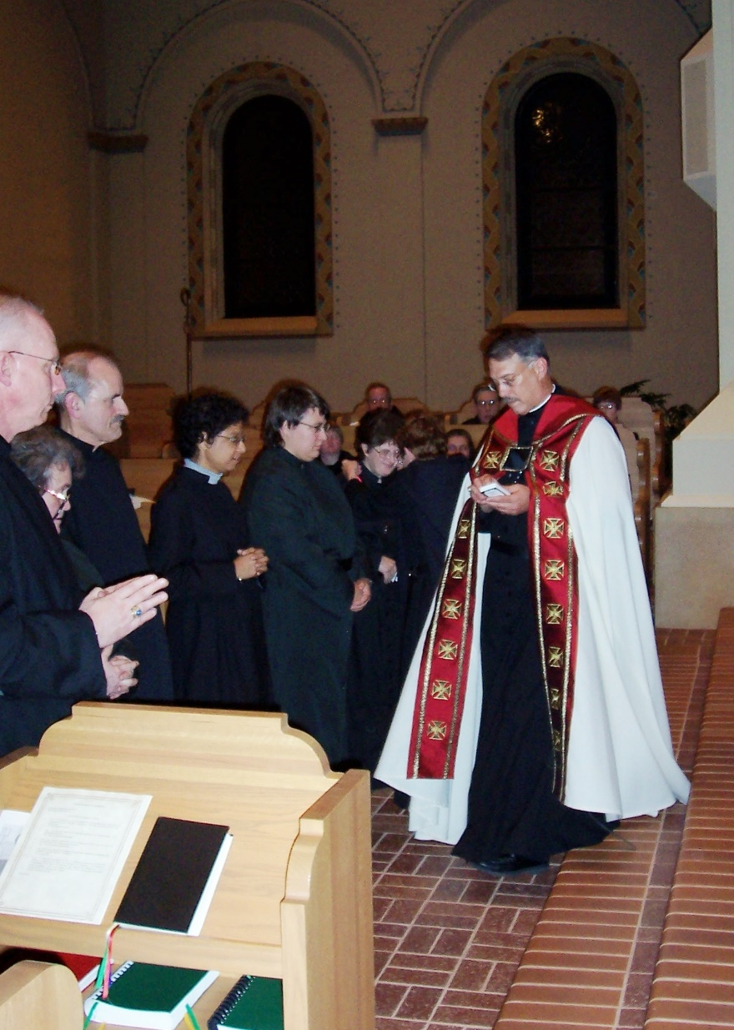
Convocation 2004 Novice Clothing; Conception Abbey

Br. David Vincent Cotton (now Br. Robert); Sr. Vincent Marie Rittenhouse; Br. Daniel Joseph; Sr. Pauline Tysol; Sr. Cecilia Lamoy (now Sr. Martha); Prior Michael John Austin

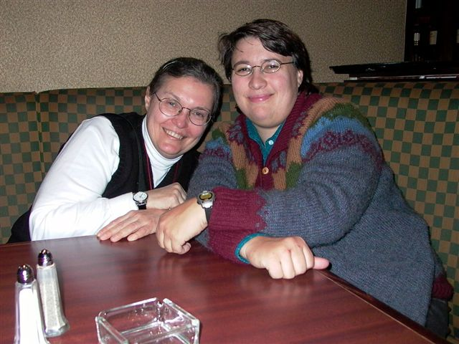
Convocation Picture 1
Sr. Theodora of Jseus Perrecca; Sr. Pauline Tysol

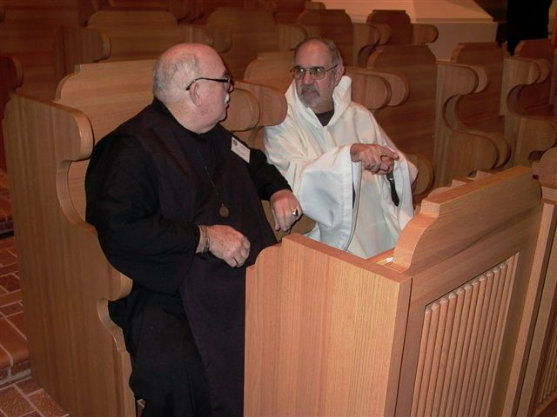

Convocation picture 2; Conception Abbey

Br. Benedict Truitt (given name Roy); Br. Joseph Benedict DiMauro, SA

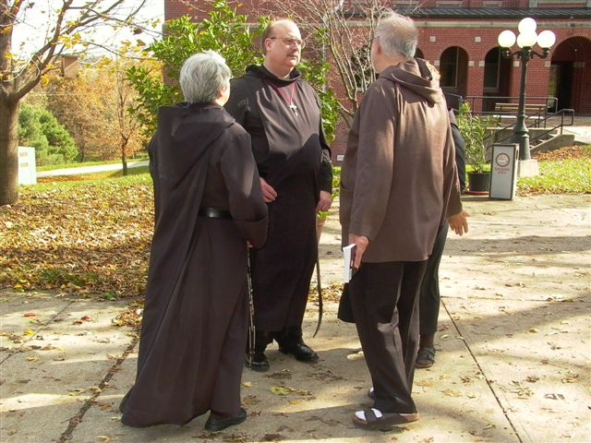
Deep Conversation; Conception Abbey

Sr. Clare Benedicta Myers; Br. Raymond Owens; Br. Joseph Benedict DiMauro, SA with back to camera
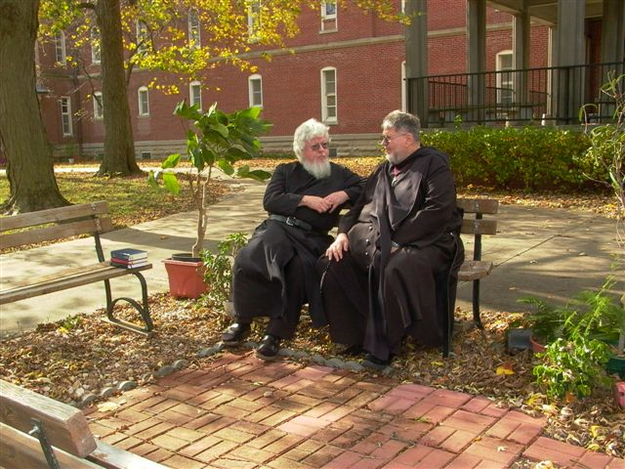
Fr. Wayne Kamm & Br. Nathan Gregory Miller (given name Wayne)
Conception Abbey

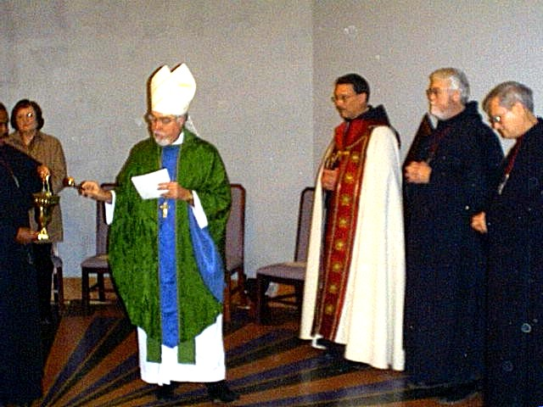
fe 18 002

Dedication of Donnellson Abbey and grounds, and taking of vows by Br. Martin

Br. Thomas; Mary Kamm; Bishop Christopher Epting; Abbot Michael John Austin; Br. Martin Martin Sheridan; Br. James Sills
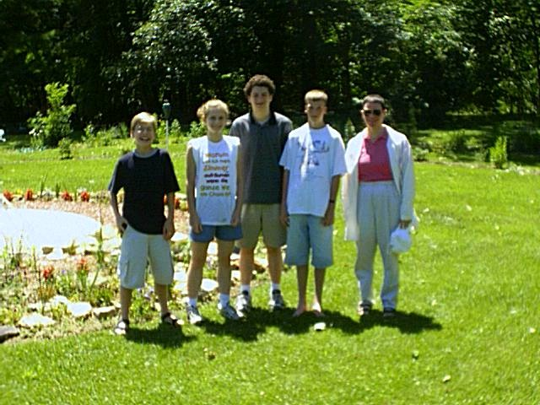
Grinnell Youth Retreat
Donnellson Priory

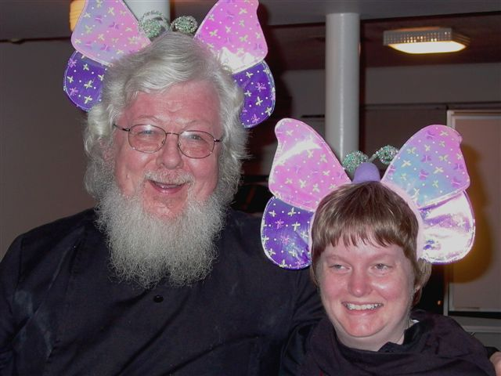

Order of the Sacred Butterfly; Fr. Wayne Kamm & Sr. Catherine

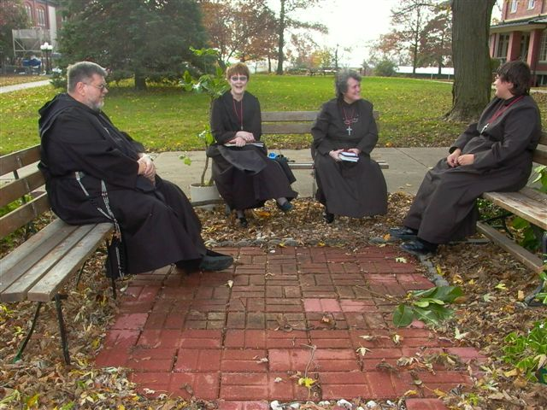
Informal Conversation; Conception Abbey

Br. Nathan Gregory Miller (given name Wayne); Sr. Brigid Gerns; Sr. Vincent Marie Rittenhouse; Sr. Pauline

jn 10 004
Donnellson woods
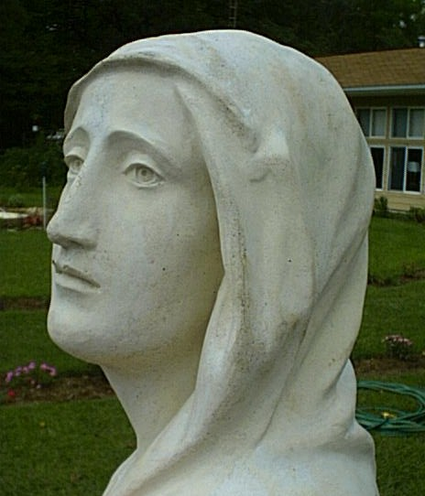
Mary’s Face
Donnellson Priory

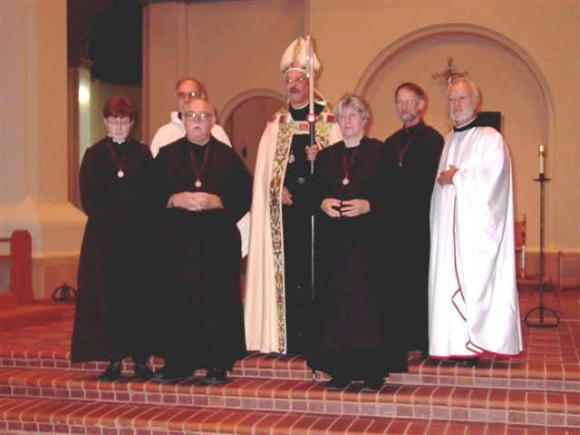
Oblates, master, & abbot; Conception Abbey

Front Row: Sr. Brigid Gerns; Br. Benedict Truitt (given name is Roy); Sr. Johanna
Back Row: Br. Joseph Benedict DiMauro DiMauro, SA; Abbot Michael John Austin; Br. Lawrence Mullen (given name Barry); Br. Christopher John Baumann

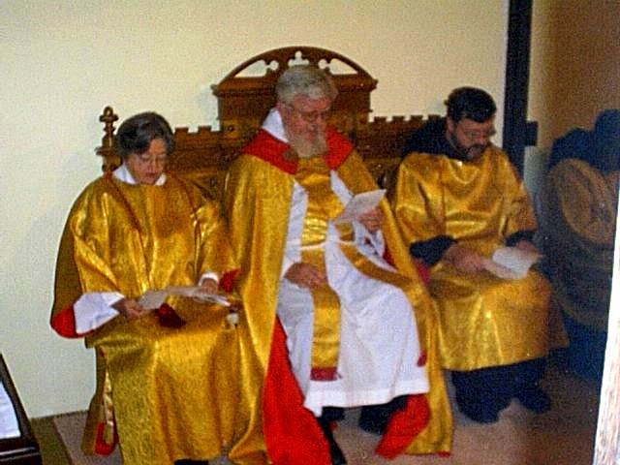
oc08 010

Deacon Diane Ong; Fr. Wayne Kamm; Br. Paul Howard; Br. Thomas Ferrell
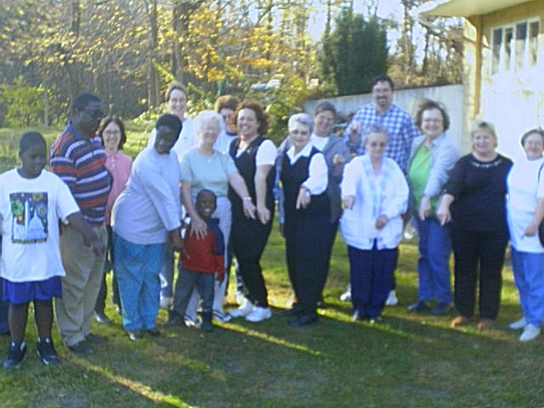
oc21 001; Members to St. Michael’s of Mount Pleasant Lenten quiet day at Donnellson Priory

Front row: Bitris and Gwamma Oblas with their two children; Mrs. Messer; Jane Shovar; Sr. Joseph Kateri (Doris Garretson); Ruby Kitch; Mary Kamm; Romajean Messer; Deacon Dian Ong

Back row: Lady in pink not known; Judge Cyndy Danielson; Carmen Miyoshi; Kirsten Heerdt; Scott Shovar

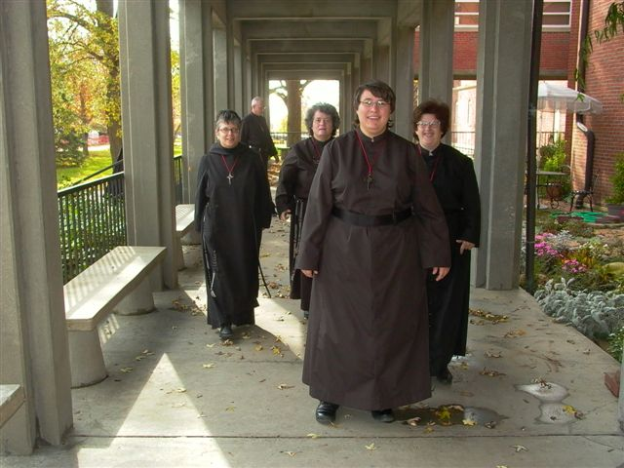
On the Way to Chapel; Conception Abbey

Sr. Pauline in front; Sr. Cecilia Lamoy (now Sr. Martha) on the right; followed by Sr. Anna Grace Madden; Sr. Vincent Marie Rittenhouse; Br. David Vincent Cotton (now Br. Robert)

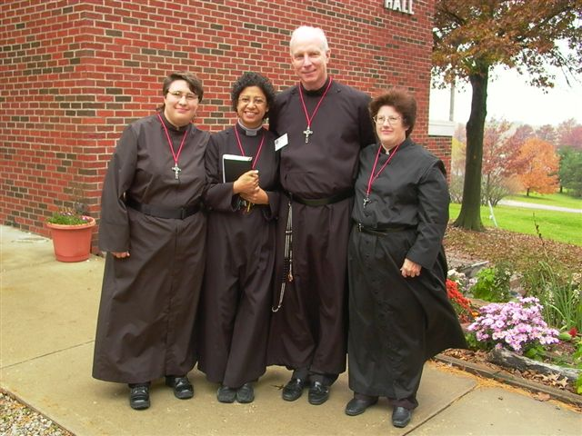
Postulants 2004; Conception Abbey

Sr. Pauline; Sr. Julian Baker; Br. David Vincent Cotton (now Br. Robert); Sr. Cecelia Lamoy (now Sr. Martha)

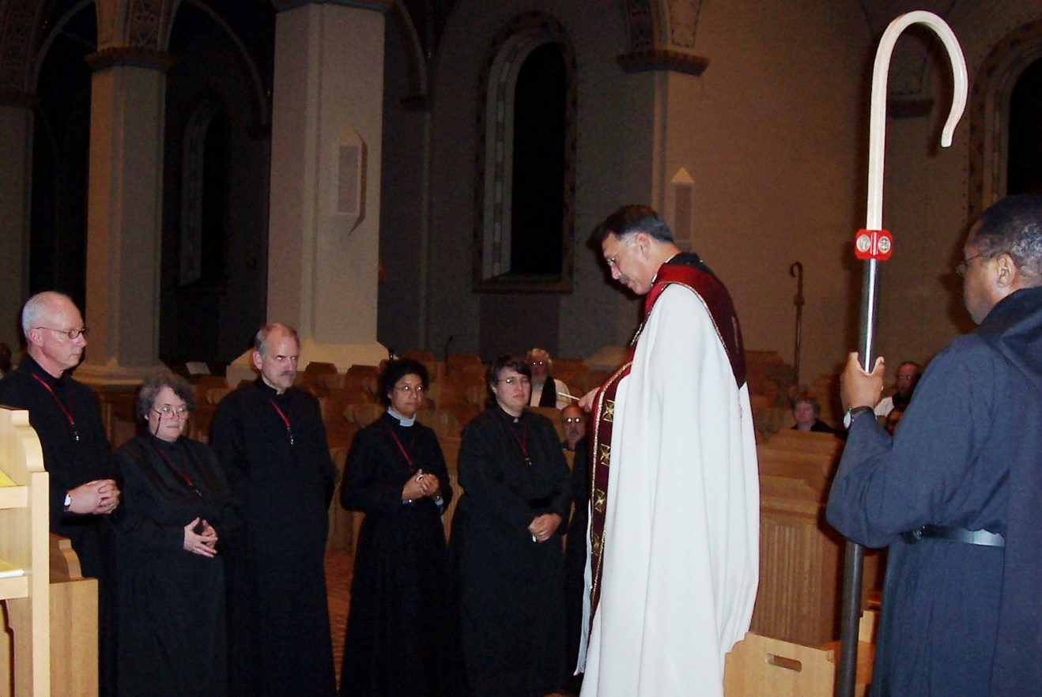
Reception of Postulants 2004; Conception Abbey

Br. David Vincent Cotton (now Br. Robert), Sr. Vincent Marie Rittenhouse; Br. Daniel Joseph; Sr. Julian Baker; Sr. Pauline; Prior Michael John Austin; Br. Thomas Ferrell

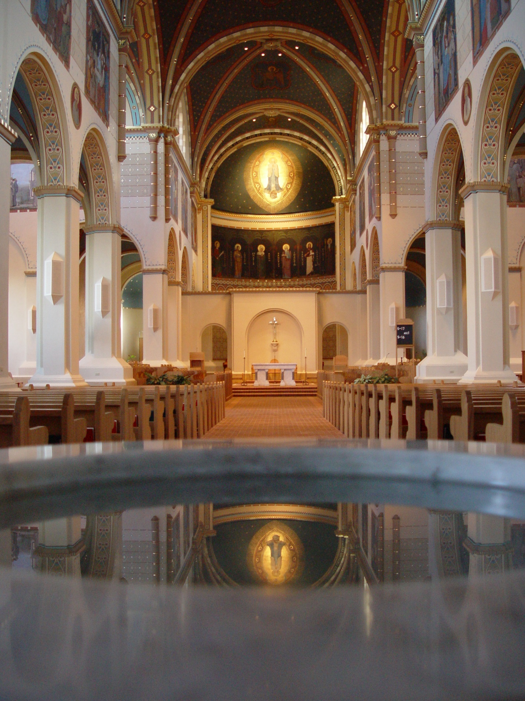
Reflecting Mary 019; Conception Abbey church
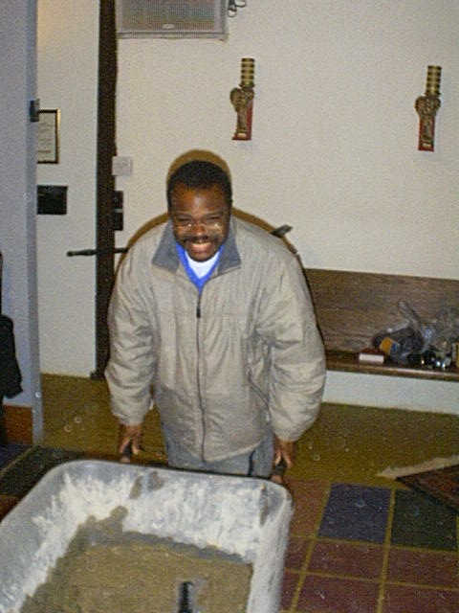

Repairs to chapel 5

Br. Thomas Ferrell at Donnellson

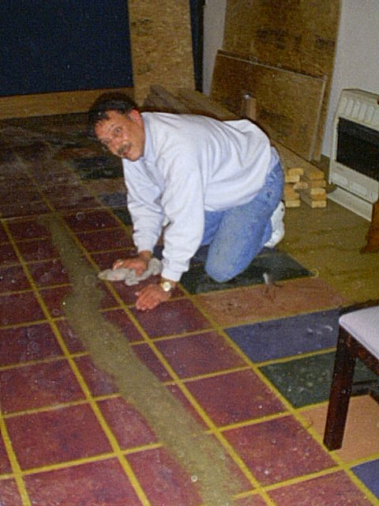
Repairs to Chapel 6

Prior Michael John Austin at Donnellson

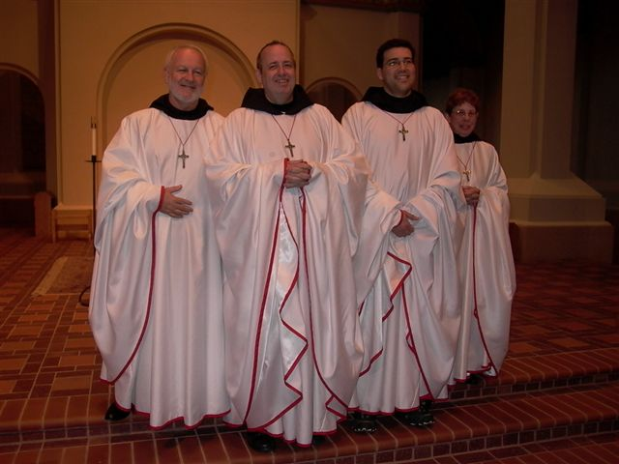
Simple Vows 2 2004

Br. Christopher John; Br. Gabriel Hale; Br. Anthony Bernard Campos; Sr. Monica Ruth Mullen (given name Judy)
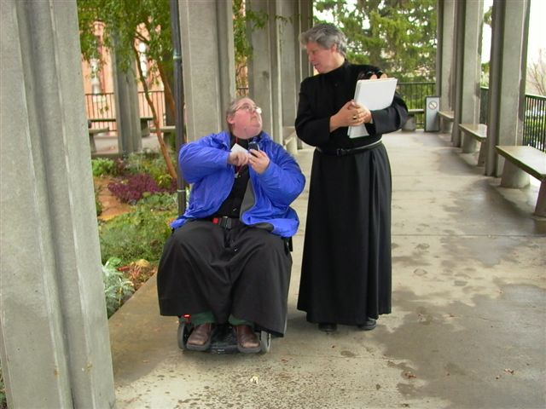
Sr. Margaret Moore (now Sr. Denise) & Sr. Johanna

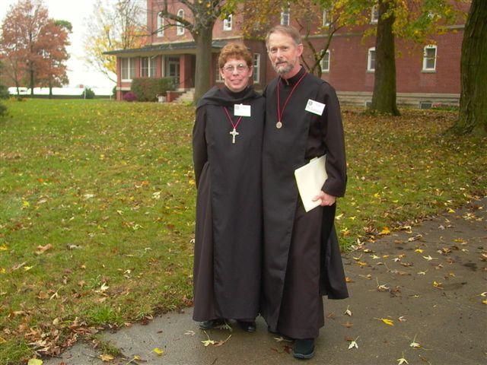
Sr. Monica Ruth Mulllen (given name Judy) & Br. Lawrence Mullen (given name Barry)
Conception Abbey

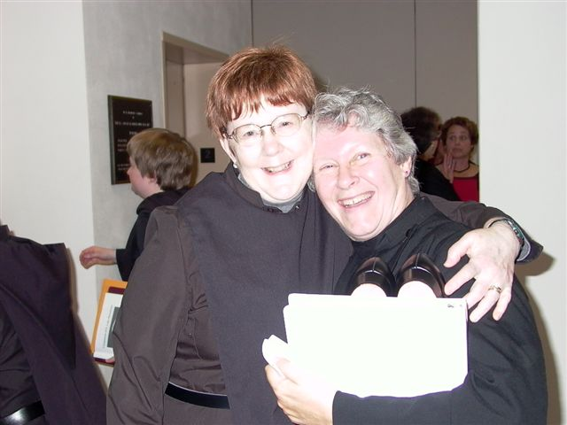
Sr. Brigid Gerns & Sr. Johanna

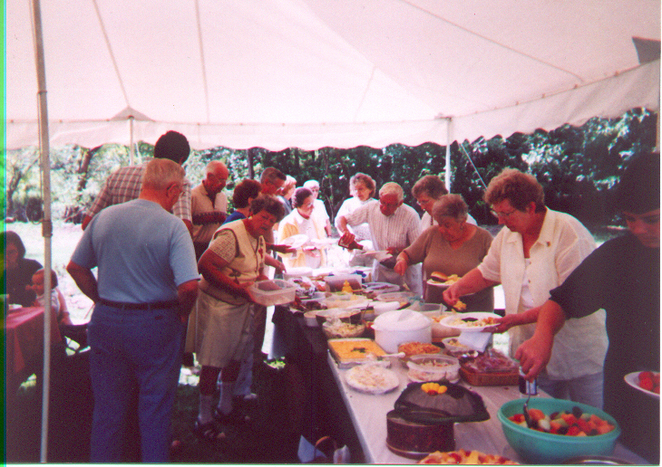
St. John’s Picnic
Donnellson Priory

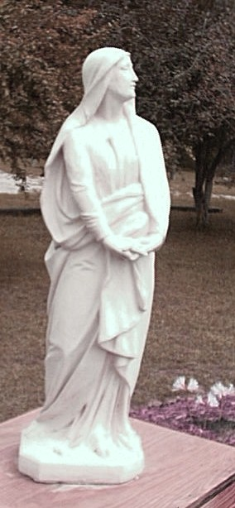
Statue of Mary
Donnellson Priory
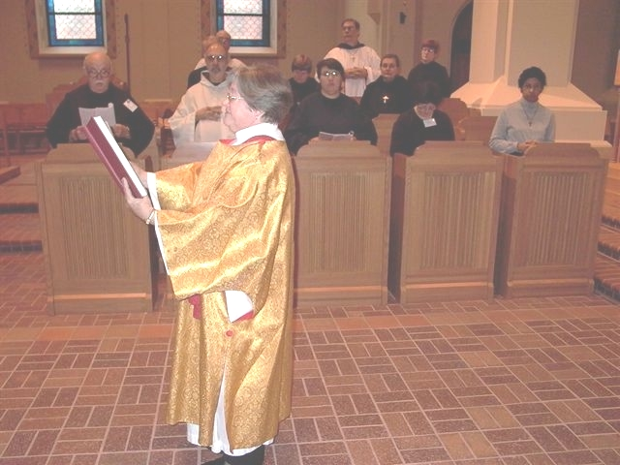
Deacon Dian Ong
Conception Abbey

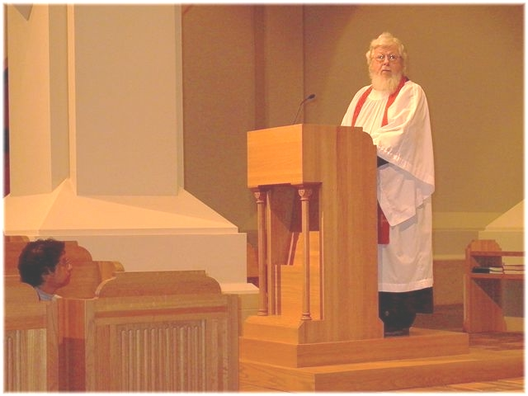

Fr. Wayne Kamm
Conception Abbey

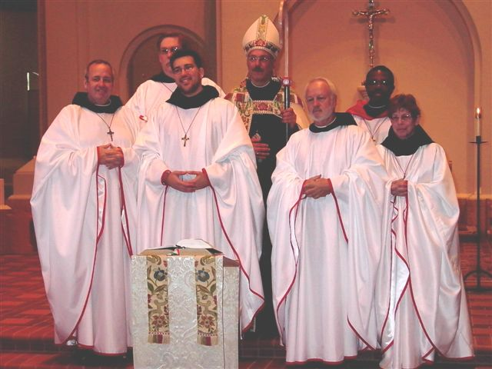
Those in Vows

Conception Abbey

Front row: Br Gabriel Hale; Br. Anthony Bernard Campos; Br. Christopher John Sr. Monica Ruth Mullen (given name Judy)
Back row: Br. Chan Anselm Gerns (now Br. David); Prior Michael John Austin; Br. Thomas Ferrell

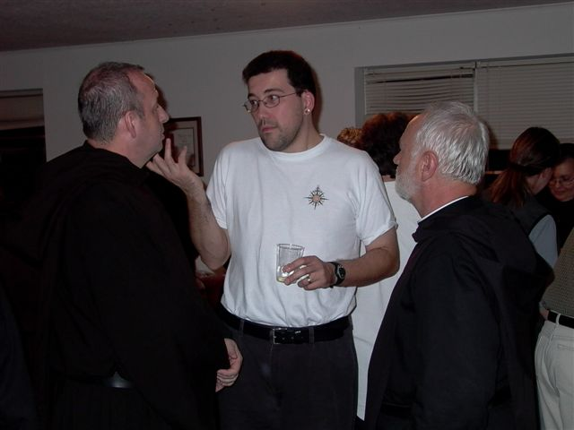

Trinity

Br. Gabriel Hale; Br. Anthony Bernard Campos; Br. Christopher John Baumann

