Life Professed (18)

 | 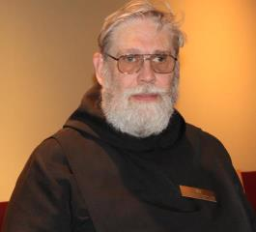 | Br. David Gerns, OSB  Abbot  3 Rolling Hill Avenue  Plaistow, NH 03865  617.834.7326 (cell)  personal/private: br.davidosb@comcast.net  CSL business: cwdxer12@gmail.com
 | 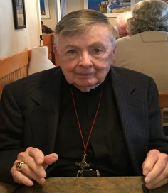 | Br. Matthias Smith, OSB  3610 Highlands Road, #2  Franklin, NC 28734  828.524.6299 (home)  hno.matias@aol.com
 | 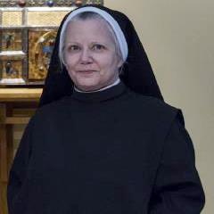 | Sr. Anna Grace Madden, OSB  CSL Council  204 Deville Place  Shreveport, LA 71115  318.934.3836 (home/cell)  srannagrace@gmail.com
 | 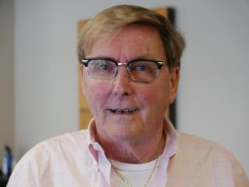 | Br. Camillus Converse, OSB  1201 SE 2nd Ct APT102  Fort Lauderdale, FLA.33301-3626  954-294-2942 (cell)  scripscan@aol.com
 | 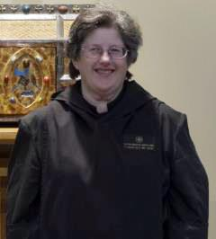 | Sr. Martha Lamoy, OSB,  Prior  2217 East Cedar  Olathe, KS 66062  913.709.3195 (cell)  srmarthaosb@yahoo.com
 | 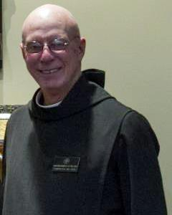 | Br. Robert Cotton, OSB  13 Pond Place Lane  Concord, NH 03301  603.228.3645 (home)  603.892.1410 (cell – best)  rcotton722@gmail.com
 | 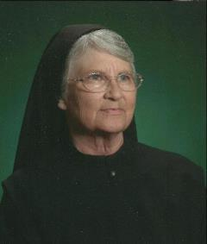 | Sr. Mary Francis Deulen, OSB  1933 Portland Avenue  Abilene, TX 79605  325.268.7214 (cell)  chrpubs@gmail.com
 | 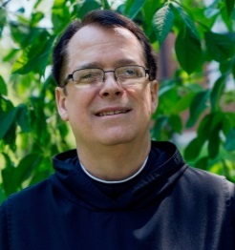 |  |  | Br. Dunstan Townsend, OSB  P. O. Box 928  Stockton, CA 95201  209.481.4100 (cell)  Br.dunstan@comcast.net
 | 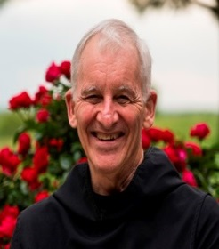 |  |  | Br. Steven Olderr, OSB  1165 S. Wenonah  Oak Park, IL 60304  708.383.8176  olderr@ameritech.net
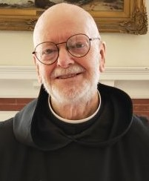 |  |  | Br Thomas Anthony Goddard, OSB  59 Hidden Lake Road  Higganum, CT 06441  860.345.4290  Tagoddard115@comcast.net
 | 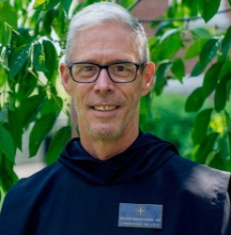 |  |  | Br. Anskar Nonken, OSB  CSL Council  3828 Milflores Dr  Ruskin, FL33573  727-260-1784 (cell)  Scott.nonken@gmail.com
 | 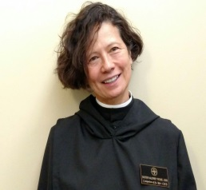 |  |  | Sr. Catherine Ann Ballinger, OSB  La Boheme  3023 Cambridge Place, NW  Washington, DC 20007  202-471-4380 (H)  202-337-2020 (work)  laboheme3023@icloud.com
 | 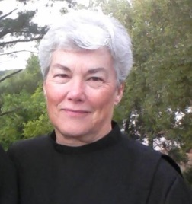 |  |  | Sr. Toni Sylvester, OSB  1125 Wonder Drive  Chapin, SC 29036  tonisyl.smc@gmail.com  803.261.1825 (cell/home)  Skype: managesmc  To make profession in 2022
 | 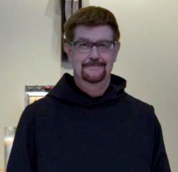 |  |  | Br. Chrysostom Olsen, OSB  Dean of Formation  PO Box 367  Seal Rock OR 97376  425-420-7250 (C)  radkoman@comcast.net

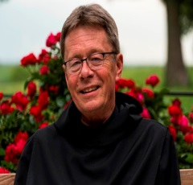 | Br. Raymond Escott, OSB  3200 Rim Cove Dr. Unit 134  Cumming, GA 30041  828-399-1378 cell  revdnray@gmail.com
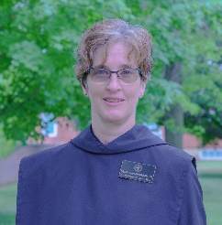 | Sr. Joanna Whitworth, OSB  2109 NW 30th Circle.  Camas, WA 98607  (C) 360-241-0939  Jrimom@gmail.com
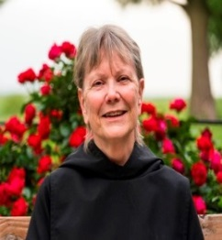 | Sr. Julian Smith-Boyer, OSB  526 Laurel Avenue,  St. Paul, MN 55102  612-210-3078 (Cell)  boyerhelen66@gmail.com
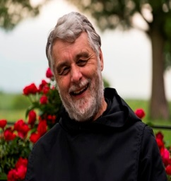 | Br. Gregory Tatchell, OSB  Treasurer  #203 - 2222 Prince Edward St.  Vancouver, BC, Canada V5T 4M6  gregtatchell@hotmail.com  Cell 604.612-9984  Home 604.709-9692  To make profession in 2022
Annually Professed (7)
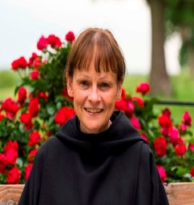 | Sr. Karen Elizabeth Evans, OSB  2, Ollerdale Avenue,  Allerton,  BRADFORD,  West Yorkshire, BD15 9BQ.  email: karen-elizabeth@tiscali.co.uk  (C) 011+44+ 07751076173  Skype: karen.elizabeth2169  In year three of discernment
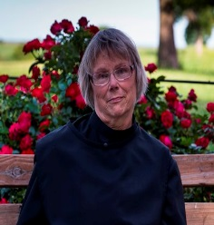 | Sr. Margaret Mary Bergeron, OSB  2515 S.9th Street; No. 1212  Minneapolis, MN 55406  612-203-6233 (cell)  bermouse86@gmail.com  year three of discernment program
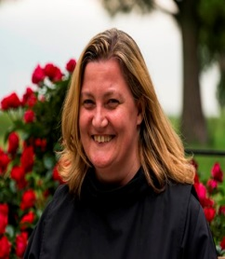 | Sr. Clara Ulson Freirias OSB  R. Gregorio P. Almeida, 1097 -  V. Madalena - S. Paulo – SP  Zip code 05450-001Brazil  email: afreirias@gmail.com  011+ 55 (11) 97546-2876  Skype: afreirias  year three of discernment program
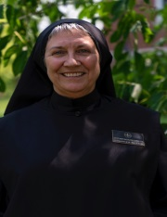 | Sr. Mary Magdalene Clarke, OSB  4701 Monterey Oaks Blvd. #923  Austin, TX 78746  512.226.3916  srmm7759@gmail.com  year three of discernment program
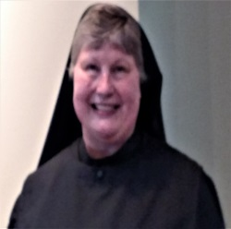 | Sr. Katherine Fleck, OSB  2619 N La Venture Rd. #312  Mt Vernon, WA 98273  360.632.0209  oakharborknits@gmail.com  year three of discernment program
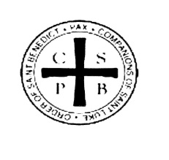 | Sr. Ànah Elizabeth Marshall, OSB  340 Royal Poinciana Way,  Suite 317-349  Palm Beach, FL 33480  libby@landplandesign.com  Home: 561- 373-7174  year one of discernment program
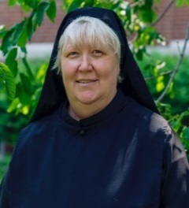 | Sr. Genevieve Lynn Robinson, OSB  1937 Paynes Point  Winder, GA 30680  sulyrobinson@gmail.com  Home: 770-490-0063  year one of discernment program
Novices (6)
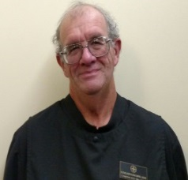 | Br. Florian Campbell, n/OSB  507 West Race St.  Mount Pleasant Iowa 52641  319.531-8867(cell)  brotherjflorian@gardencanals.net  Year 1 of Novitiate
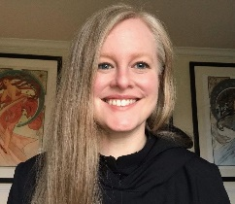 | Sr. Petra, n/OSB  6348 SE 85th Ave  Portland, Or 97266  UK mobile: 44.7312.962790  holly.puckett@law.ua.edu  Year 1 of Novitiate
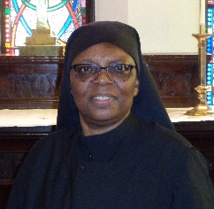 | Sr. Cecilia, n/OSB  P.O. Box 1971  Shreveport, LA 71166  318-572-7554  jhorton175@gmail.com  Year 2 of Novitiate
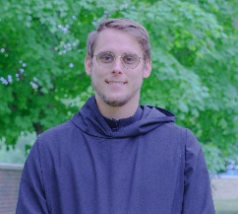 | Br. Peter Francis Kyle n/OSB  CSL Council  6908 Caledonia Circle  Indianapolis, IN 46254  317.260.0358  brpeterfrancis@icloud.com  Year 1 of Novitiate
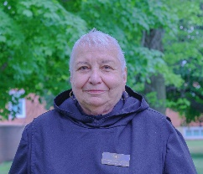 | Sr. Marie Patricia Hughes, n/OSB  79 Fennell St. #21  Skaneateles, NY 13152  315-702-3757  mphughes3139@yahoo.com  Year 1 of Novitiate
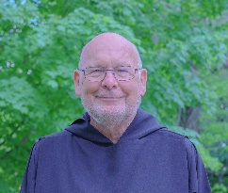 | Br. John David Wynne, n/OSB  208A 64th St..  Virginia Beach, VA 23451  757-802-6812  brjohndavidosb@gmail.com  Year 2 of Novitiate
Postulants (4)
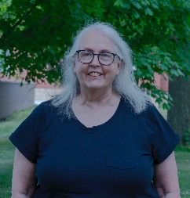 | Robin Smith, p/OSB  107 Allison Rd, Apt. A  Oreland, PA 19075  215-435-9473  rsmith12jm@gmail.com
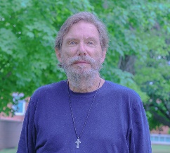 | William (Bill) Page, p/OSB  2326 West Kiowa St.  Colorado Springs, CO. 80904  719-339-0165  wmpage2326kitty@gmail.com
David-Mark Campbell, p/OSB
2217 East Cedar
Olathe, KS 66062
913.709.2786
Dmcampbell13@gmail.com

Oblates (7)
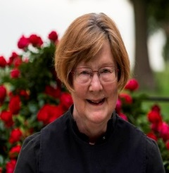 | Sr. Brigid Gerns, Obl/OSB  3 Rolling Hill Avenue  Plaistow, NH 03865  603.819.9659 (cell)  ann2brigidgmail.com
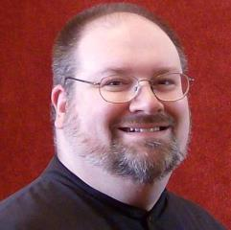 | Br. Daniel Moore, Obl/OSB  CSL Council  1102 48th St.  Apt. D17  Ft. Madison, IA 52627  319-470-6581 (cell-best)  danielmoore@minister.com
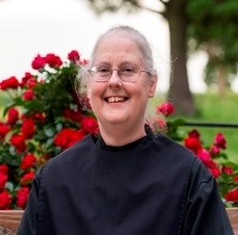 | Sr. Denise Moore, Obl/OSB  1102 48th St.  Apt. D17  Ft. Madison, IA 52627  319.470.2708 (cell)  sisdenise@yahoo.com
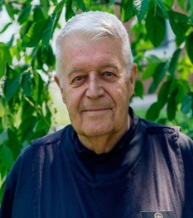 | Br. Michael Anicetus Mc Cabe, Obl/OSB  2517 E Jensen  Mesa, Az. 85213  402-926-1342.  jmmccabe@cox.net
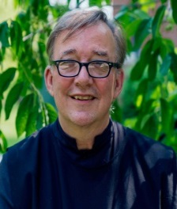 | Br. James Rafael Davies, Obl/OSB  Director of Oblation  1923 3rd Ave. So.  Minneapolis, MN 55404  612.360.4031  aumjames@aol.com
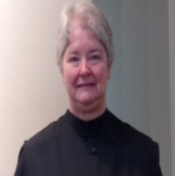 | Sr. Hildegard Longmire, Obl./OSB  1818 Hidaway Lane  Durham, NC 27712  919.308.1211  bwlongmire@mindspring.com

Novice-Oblates (3)
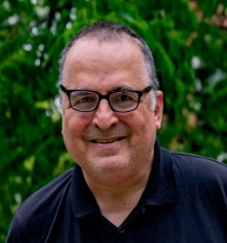 | Jeffrey Kasica  43 Roosevelt St.  Braintree, MA 02184  774.360.4219  jeffreykasica@gmail.com  Year 2 of formation
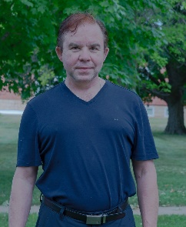 | Kevin Orth  8438 115th Place  Seattle, WA 98178  206-931-3058  kevinorth@icloud.com
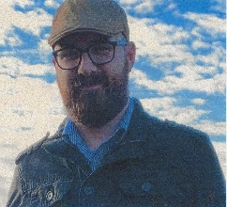 | Adam Wilson  7342 Hodgers Ferry Rd.  Knoxville, TN 37920  423-715-7055  wilsonad@pm.me
Companion Associates
Sr Dawna Clare Sutton, SFCC, ca/OSB
1701 S. Thornburg St. #6
Santa Maria, CA 93458
805.868.5007 (home)
dawnasutton@hotmail.com
Spiritual Support
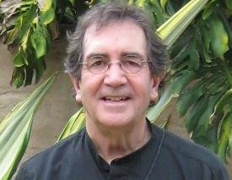 | The Rev. Sidney Breese, Chaplin  434 Deer Trail Drive,  Independence, KS 67301  816-262-4958  ssbreese@aol.com
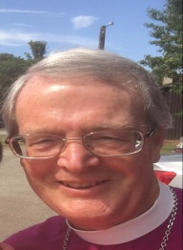 | The Right Reverend Alan Scarfe Bishop Visitor  Episcopal Diocese of Iowa  225 37th Street,  Des Moines IA 50312  515-277-6170 (office)  515-314-1874 (cell)  ascarfe009@gmail.com
OTHERS
 | The Rev. Wayne Kamm  319.258.9503 (home)  319.931.1330 (cell)  1451 Salem Road  Salem, IA 52649  rockermacher@yahoo.com
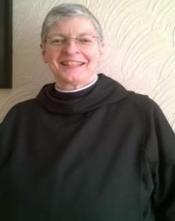 | Sr. Helena Barrett+, OSB  0/1 40 Merryland Street  Glasgow G51 2QD  Scotland  United Kingdom  011+44+794 393 7638  srhelenaosb@hotmail.com  Skype: Srhelenaosb
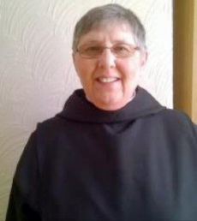 | Sr. Alison Joy Whybrow, OSB  0/1 40 Merryland Street  Glasgow G51 2QD  Scotland  United Kingdom  +44+ 07943937  United Kingdom  011+44+794 393 7638  alisonwhybrow@ymail.com  Skype: Sister Alison Joy Whybrow

